Supplementary Data
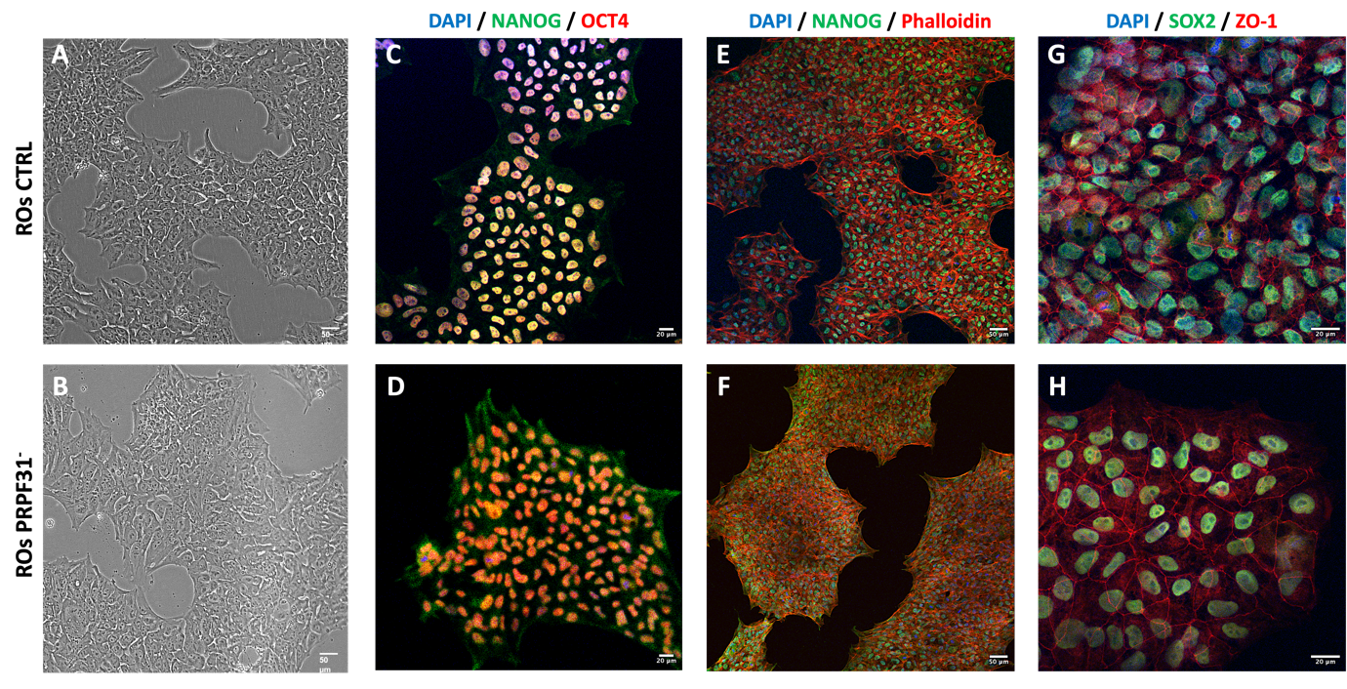 Figure S1 - Characterization of PRPF3 and control hiPSCs: (A–B) Phase-contrast images showing similar undifferentiated morphology of control (A) and PRPF31-mutant (B) hiPSC colonies. (C–D) Immunofluorescence staining for pluripotency markers NANOG (green) and OCT4 (red) with DAPI nuclear counterstain (blue) confirms robust co-expression of core stemness factors in both control (C) and PRPF31-mutant (D) hiPSC lines. (E–F) Staining with NANOG (green) and Phalloidin (red; F-actin marker) reveals intact cytoskeletal organization in control (E) and mutant (F) colonies. (G–H) Expression of SOX2 (green) and ZO-1 (red) further supports maintenance of pluripotency and epithelial colony morphology in both control (G) and mutant (H) hiPSCs. Scale bar: 50 μm (A–B, E–F), 20 μm (C–D, G–H).

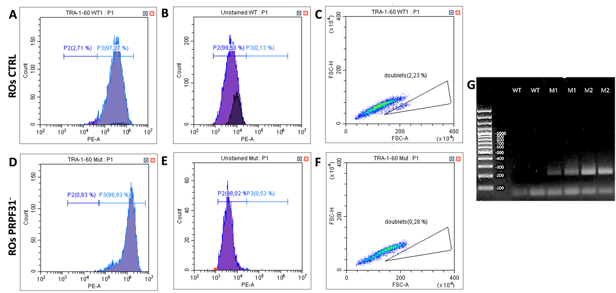
Figure S2 - Flow cytometry of PRPF31 and control hiPSCs and PCR Amplification of PRPF31 Gene: (A-F) Flow cytometry analysis of TRA-1-60 surface marker expression confirms high pluripotency marker expression in both control (A-C) and PRPF31 (D-F) hiPSC lines. Histogram showing ~97% TRA-1-60-positive cells in control (A); ~99% TRA-1-60-positive cells in PRPF31- line (D). (B;E) Unstained controls confirm specificity of TRA-1-60 staining. (C; F) Scatter plots show low percentage of doublets, ensuring high sample purity. (G) PCR-based amplification analysis reveals expected PRPF31 mutation in the PRPF31 hiPSCs (M1, M2) compared to control (WT) hiPSCs, confirming integrity of the patient-specific cell lines.

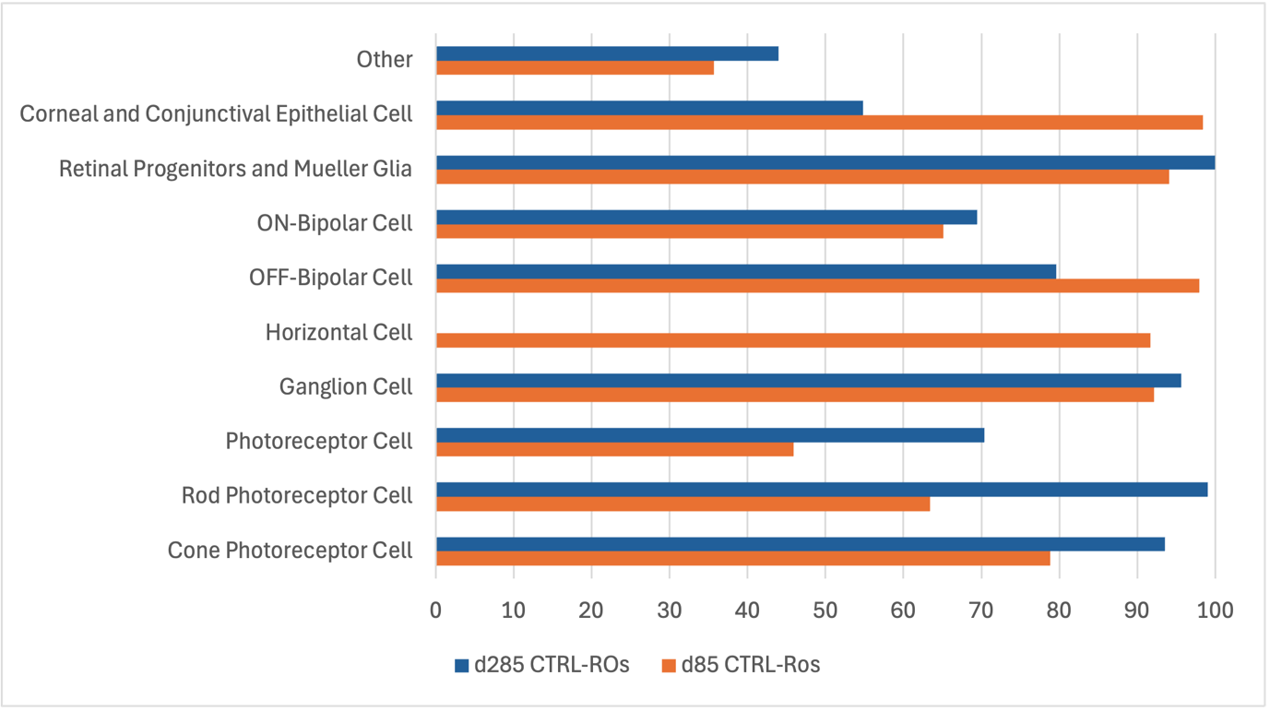
Figure S3 – Annotation of retinal cell populations in control ROs against a reference dataset: Bar graph showing the distribution of annotated retinal cell populations from control organoids at day 85 (orange) and day 285 (blue) mapped onto a reference single-cell retinal dataset (Jones et al., 2023 - GSE220624). The reference dataset included Interneurons, Photoreceptors (PR), Progenitors and RPE. Control-ROs populations have been compared as follows: Cone PR, Rod PR, PR vs. PR; RGCs, Horizontal cells, OFF-BCs, ON-BCs vs Interneurons; Müller Glia vs Progenitors; Corneal/Conjunctival, Others vs RPEs.

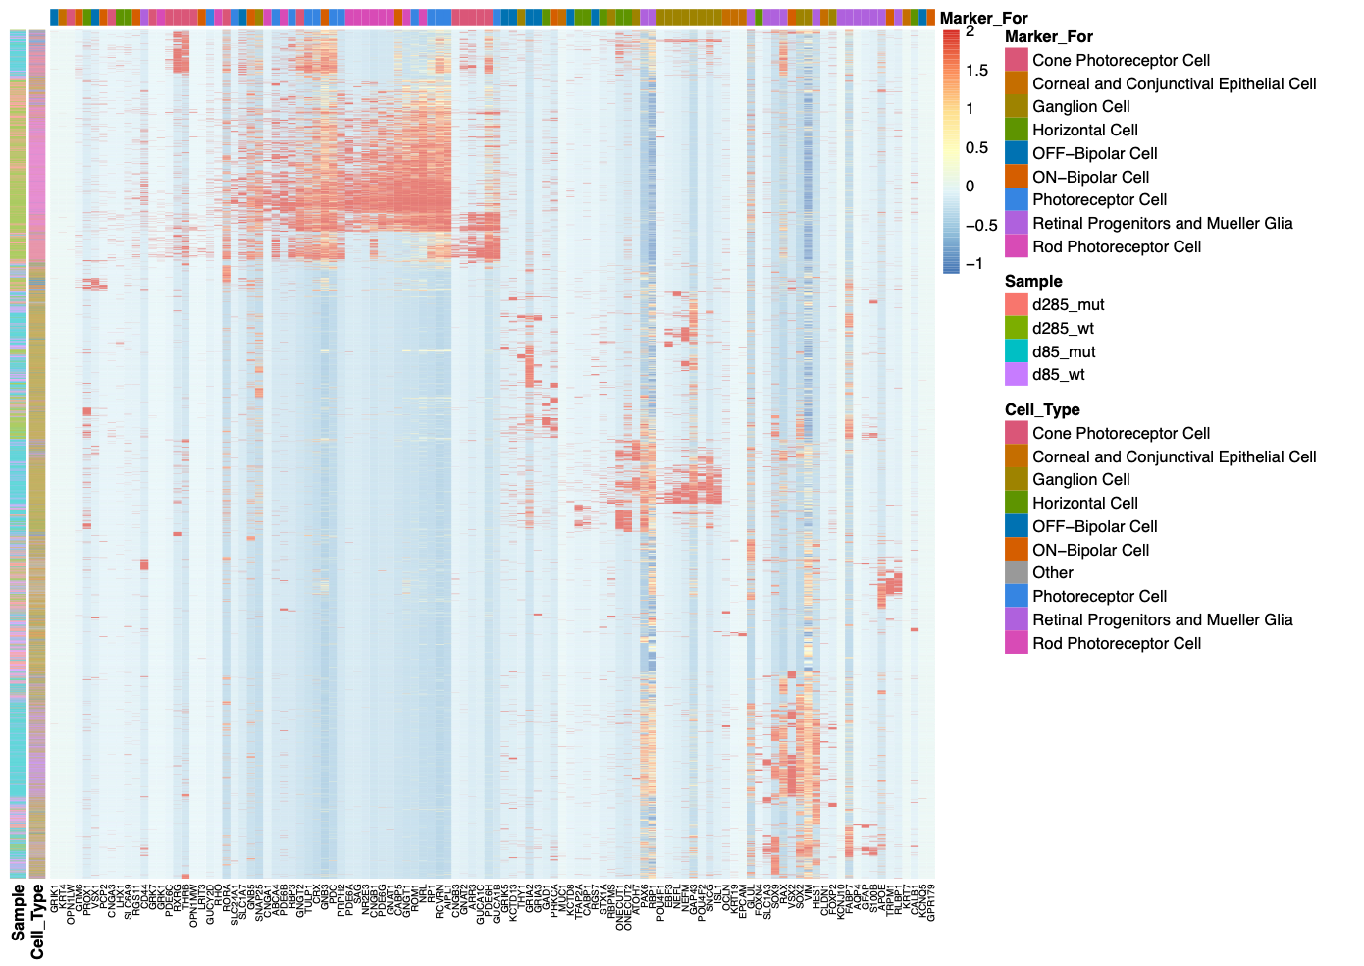
Figure S4 – Global heatmap of retinal cell-type marker expression: Expression profiles of canonical marker genes across all organoids (d85 and d285, WT and PRPF31-mutant). Columns represent cells and rows represent marker genes, color-coded by scaled expression (blue = low, red = high). Distinct transcriptional signatures identify all major retinal cell types, with condition- and stage-dependent shifts in photoreceptor and Müller glial markers.

Table S1. List of Primary Antibodies
Antibody | Species | Concentration | Manifacturer | Catalog # | RRID
Oct-4A | Rabbit | 1:400 | Cell Signaling Technology | 2840 | AB_2167691
ZO-1 | Rabbit | 1:200 | Proteintech | 21773-1-AP | AB_10733242
Nanog | Mouse | 1:200 | Santa Cruz Biotechnology | sc-293121 | AB_2665475
Sox-2 | Mouse | 1:200 | Santa Cruz Biotechnology | sc-365823 | AB_10842165
PAX6 | Rabbit | 1:100 | Proteintech | 12323-1-AP | AB_2159695
TUJ1 (TUBB3) | Mouse | 1:500 | Proteintech | 66375-1-Ig | AB_2814998
OTX2 | Mouse | 1:400 | Santa Cruz Biotechnology | sc-514195 | AB_2921699
VSX2 | Rabbit | 1:400 | Proteintech | 25825-1-AP | AB_2880257
POU4F2 | Rabbit | 1:200 | Proteintech | 55042-1-AP | AB_10888633
Recoverin | Rabbit | 1:400 | Proteintech | 10073-1-AP | AB_2178005
CRX | Mouse | 1:400 | Santa Cruz Biotechnology | sc-377138 | -
Arrestin C | Rabbit | 1:400 | Proteintech | 11100-2-AP | AB_2289959
L/M Opsin | Rabbit | 1:200 | Kerafast | EDK101 | -
Rhodopsin | Mouse | 1:200 | Absolute Antibody | Ab00337-10.7 | -
Phalloidin 555 | Conjugated | 1:200 | Invitrogen | A30106 | -

Table S2. List of Secondary Antibodies
Antibody | Concentration | Manifacturer | Catalog # | RRID
Alexa Fluor 488 Goat anti-rabbit | 1:1000 | Invitrogen | A-11034 | AB_2576217
Alexa Fluor™ 488 Goat anti-Mouse | 1:1000 | Invitrogen | A-11029 | AB_2534088
Alexa Fluor™ 546 Donkey anti-Rabbit | 1:1000 | Invitrogen | A-10040 | AB_2534016
Alexa Fluor™ 555 Goat anti-Mouse | 1:1000 | Invitrogen | A-21424 | AB_141780
Alexa Fluor™ 647 Goat anti-Mouse | 1:1000 | Invitrogen | A-21235 | AB_2535804
Alexa Fluor™ 647 Donkey anti-Goat | 1:1000 | Invitrogen | A32849 | AB_2762840
CoraLite® Plus 750-Goat Anti-Mouse | 1:1000 | Proteintech | RGAM006 | AB_3073504

Table S3. List of Primer sequences
Gene | Forward (F) / Reverse (R) | Sequence
GAPDH | F | CTGGTAAAGTGGATATTGTTGCCAT
GAPGH | R | TGGAATCATATTGGAACATGTAAACC
OPN1MW | F | GAACCAGGTCTATGGCTACTTCG
OPN1MW | R | TCTCACATTGCCAAAGGGCTT
CRX | F | TCCAGGGTTCAGGTTTGGTT
CRX | R | CATCTGTGGAGGGTCTTGGG
RECOVERIN | F | TCTACGACGTGGACGGTAACG
RECOVERIN | R | CGTCCTCGGGAGTGATCATT
RHODOPSIN | F | GGGAGAACCATGCCATCAT
RHODOPSIN | R | TCGTCTCCGTCTTGGA
ARRESTIN 3 | F | CCCAGAGCTTTGCAGTAACC
ARRESTIN 3 | R | CACAGGACACCATCAGGTTG

Table S4. Cell type – specific markers used for scRNAseq Annotation
Retinal Cell Population | Gene Markers
Photoreceptor Cell | CRX, RCVRN, RBP3, PRPH2, ROM1, ABCA4, GUCA1B, PDC, GUCY2D, TULP1, RP1, AIPL1, SLC24A1
Rod Photoreceptor Cell | RHO, GNAT1, SAG, PDE6A, PDE6B, CNGA1, CNGB1, NR2E3, NRL, ROM1, RCVRN, PDE6G, GRK1, GNGT1, ESRRB
Cone Photoreceptor Cell | ARR3, GNAT2, OPN1SW, OPN1MW, OPN1LW, PDE6C, PDE6H, CNGA3, CNGB3, GUCA1C, GUCA1B, GNGT2, RXRG, THRB, RORA, GRK7
Horizontal Cell | PROX1, LHX1, ONECUT1, ONECUT2, GJA10, CALB1, FOXN4, SLC6A9, TFAP2A, STX1A, CABP1
Ganglion Cell | RBPMS, SNCG, POU4F2, POU4F1, THY1, NEFL, NEFM, GAP43, ISL1, EBF3, ATOH7, OPN4, SNAP25, FOXP2, SOX2, VIM
ON-Bipolar Cell | GRM6, TRPM1, GPR179, LRIT3, NYX, PCP2, PRKCA, CABP5, RGS11, GNB3, VSX2, GNB5
OFF-Bipolar Cell | GRIK1, GRIK5, RGS7, KCNQ5, KCTD13, KCTD8, SLC1A7, VSX1, GRIA2, GRIA3
Mueller Glia / Progenitors | RLBP1, GLUL, RBP1, SLC1A3, KCNJ10, AQP4, VIM, SOX9, SOX2, HES1, VSX2, RAX, PAX6, FABP7, GFAP, S100B, CD44, APOE
Corneal / Conjunctival Epithelial Cell | KRT3, KRT12, KRT13, KRT19, KRT4, KRT7, KRT5, KRT14, KRT15, EPCAM, TACSTD2, PAX6, ALDH3A1, CLDN1, OCLN, MUC1, MUC4, MUC16

