Supplementary Data
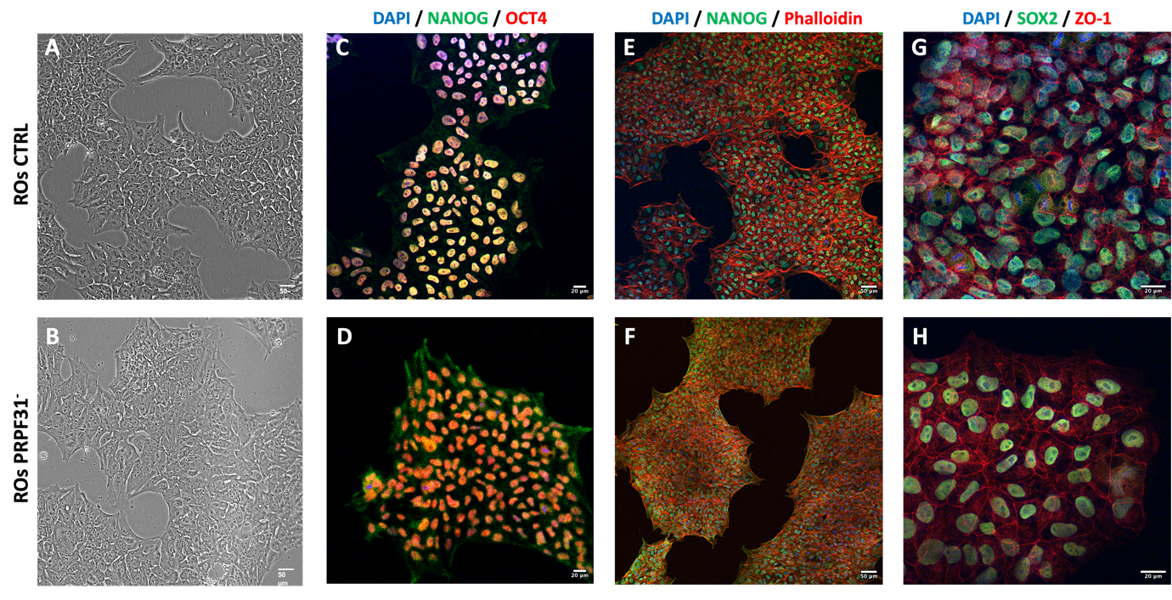 Figure S1 - Characterization of PRPF3 and control hiPSCs: (A–B) Phase-contrast images showing similar undifferentiated morphology of control (A) and PRPF31-mutant (B) hiPSC colonies. (C–D) Immunofluorescence staining for pluripotency markers NANOG (green) and OCT4 (red) with DAPI nuclear counterstain (blue) confirms robust co-expression of core stemness factors in both control (C) and PRPF31-mutant (D) hiPSC lines. (E–F) Staining with NANOG (green) and Phalloidin (red; F-actin marker) reveals intact cytoskeletal organization in control (E) and mutant (F) colonies. (G–H) Expression of SOX2 (green) and ZO-1 (red) further supports maintenance of pluripotency and epithelial colony morphology in both control (G) and mutant (H) hiPSCs. Scale bar: 50 μm (A–B, E–F), 20 μm (C–D, G–H).

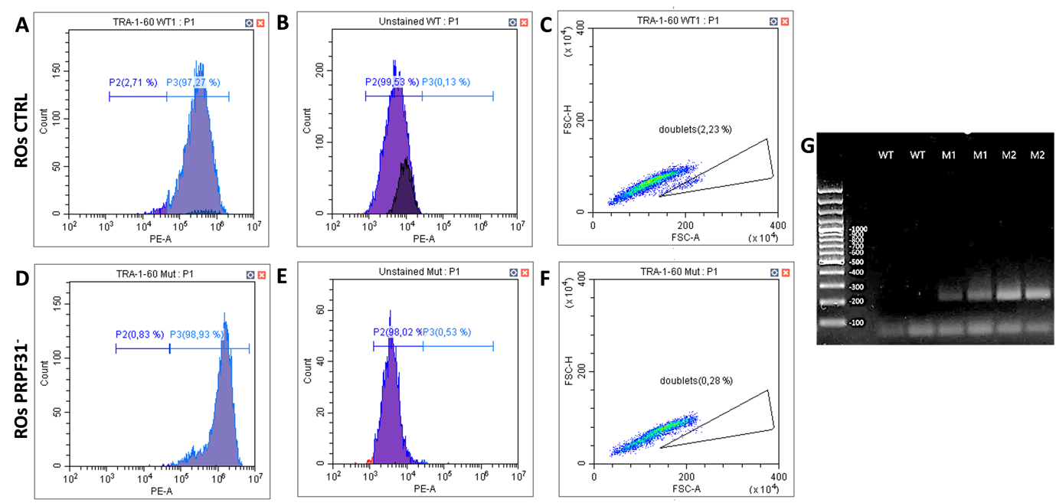
Figure S2 - Flow cytometry of PRPF31 and control hiPSCs and PCR Amplification of PRPF31 Gene: (A-F) Flow cytometry analysis of TRA-1-60 surface marker expression confirms high pluripotency marker expression in both control (A-C) and PRPF31 (D-F) hiPSC lines. Histogram showing ~97% TRA-1-60-positive cells in control (A); ~99% TRA-1-60-positive cells in PRPF31- line (D). (B;E) Unstained controls confirm specificity of TRA-1-60 staining. (C; F) Scatter plots show low percentage of doublets, ensuring high sample purity. (G) PCR-based amplification analysis reveals expected PRPF31 mutation in the PRPF31 hiPSCs (M1, M2) compared to control (WT) hiPSCs, confirming integrity of the patient-specific cell lines.

Table1 - Antibodies
PRIMARY
Antibody | Species | Concentration | Manifacturer | Catalog # | RRID
Oct-4A | Rabbit | 1:400 | Cell Signaling Technology | 2840 | AB_2167691
ZO-1 | Rabbit | 1:200 | Proteintech | 21773-1-AP | AB_10733242
Nanog | Mouse | 1:200 | Santa Cruz Biotechnology | sc-293121 | AB_2665475
Sox-2 | Mouse | 1:200 | Santa Cruz Biotechnology | sc-365823 | AB_10842165
PAX6 | Rabbit | 1:100 | Proteintech | 12323-1-AP | AB_2159695
TUJ1 (TUBB3) | Mouse | 1:500 | Proteintech | 66375-1-Ig | AB_2814998
OTX2 | Mouse | 1:400 | Santa Cruz Biotechnology | sc-514195 | AB_2921699
VSX2 | Rabbit | 1:400 | Proteintech | 25825-1-AP | AB_2880257
POU4F2 | Rabbit | 1:200 | Proteintech | 55042-1-AP | AB_10888633
Recoverin | Rabbit | 1:400 | Proteintech | 10073-1-AP | AB_2178005
CRX | Mouse | 1:400 | Santa Cruz Biotechnology | sc-377138 | -
Arrestin C | Rabbit | 1:400 | Proteintech | 11100-2-AP | AB_2289959
L/M Opsin | Rabbit | 1:200 | Kerafast | EDK101 | -
Rhodopsin | Mouse | 1:200 | Absolute Antibody | Ab00337-10.7 | -
Phalloidin 555 | Conjugated | 1:200 | Invitrogen | A30106 | -

SECONDARY
Antibody | Concentration | Manifacturer | Catalog # | RRID
Alexa Fluor 488 Goat anti-rabbit | 1:1000 | Invitrogen | A-11034 | AB_2576217
Alexa Fluor™ 488 Goat anti-Mouse | 1:1000 | Invitrogen | A-11029 | AB_2534088
Alexa Fluor™ 546 Donkey anti-Rabbit | 1:1000 | Invitrogen | A-10040 | AB_2534016
Alexa Fluor™ 555 Goat anti-Mouse | 1:1000 | Invitrogen | A-21424 | AB_141780
Alexa Fluor™ 647 Goat anti-Mouse | 1:1000 | Invitrogen | A-21235 | AB_2535804
Alexa Fluor™ 647 Donkey anti-Goat | 1:1000 | Invitrogen | A32849 | AB_2762840
CoraLite® Plus 750-Goat Anti-Mouse | 1:1000 | Proteintech | RGAM006 | AB_3073504

Table2 - Primers
GAPDH | Forward ( F ) | CTGGTAAAGTGGATATTGTTGCCAT
GAPDH | Reverse ( R ) | TGGAATCATATTGGAACATGTAAACC
OPN1MW | Forward ( F ) | GAACCAGGTCTATGGCTACTTCG
OPN1MW | Reverse ( R ) | TCTCACATTGCCAAAGGGCTT
CRX | Forward ( F ) | TCCAGGGTTCAGGTTTGGTT
CRX | Reverse ( R ) | CATCTGTGGAGGGTCTTGGG
RECOVERIN | Forward ( F ) | TCTACGACGTGGACGGTAACG
RECOVERIN | Reverse ( R ) | CGTCCTCGGGAGTGATCATT
RHODOPSIN | Forward ( F ) | GGGAGAACCATGCCATCAT
RHODOPSIN | Reverse ( R ) | TCGTCTCCGTCTTGGA
ARR3 | Forward ( F ) | CCCAGAGCTTTGCAGTAACC
ARR3 | Reverse ( R ) | CACAGGACACCATCAGGTTG

