Supplementary Material for
A novel strategy applied to hyperspectral imaging for intelligent classification and identification of trace adulterants in food matrix
Xiangdong Qing^{a*}, Wei Heª, Wei Mengª, Qingling Chen^{b}, Xiaohua Zhang^{c}
ªHunan Provincial Key Laboratory of Dark Tea and Jin-hua, College of Materials and Chemical Engineering, Hunan City University, Yiyang, 413000, PR China
^{b}Analytical Instrumentation Center of Hunan University, Changsha, 410082, PR China
^{c}Department of Chemistry and Chemical Engineering, Hunan Institute of Science and Technology, Yueyang, 414006, PR China

* Corresponding author: xdqing123@hnu.edu.cn.

a) The milk sample and its Raman images b) 3D PCA scores
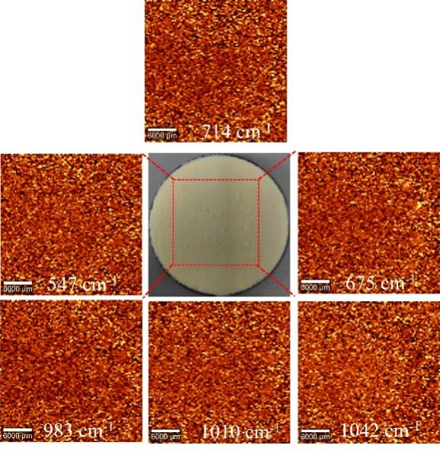

c) Scree plot of eigenvalues

d) 2D Feature space for t-SNE-HAC e) Contribution map by t-SNE-HAC
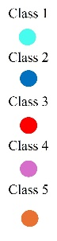
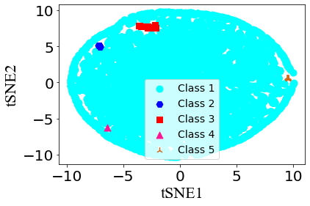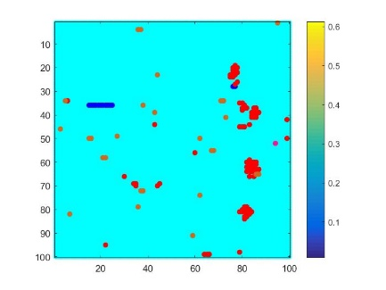
f) Extracted 93 spectra g) 2D Feature space for UMAP-HAC
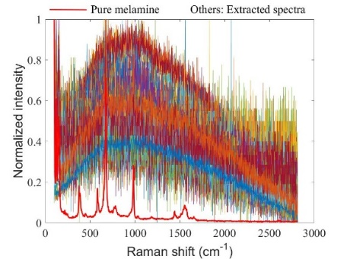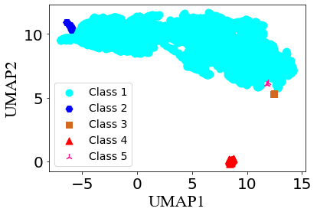
h) Contribution map by UMAP-HAC i) Extracted 97 spectra
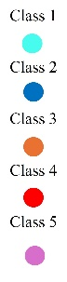
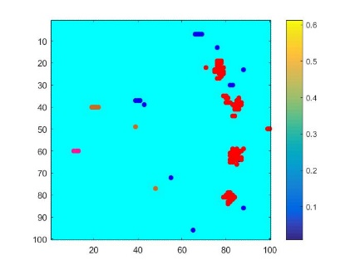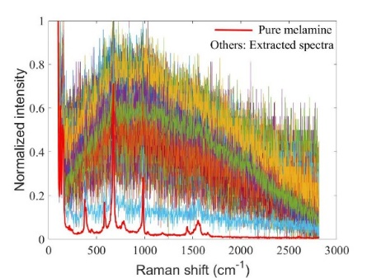
Fig. S1. Analysis of the second real Raman hyperspectral imaging (HSI) data with t-SNE-HAC and UMAP-HAC, respectively.

a) The milk sample and its Raman images b) 3D PCA scores
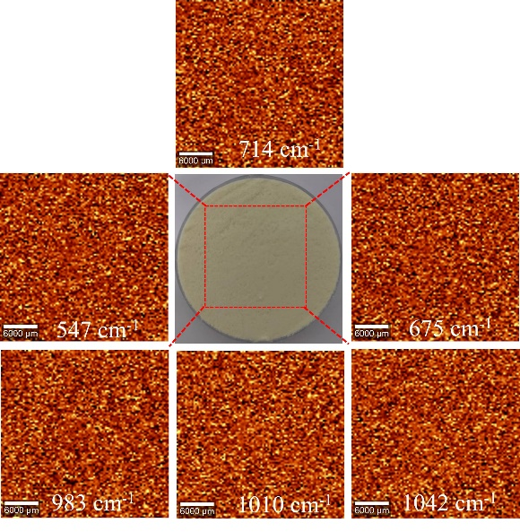

Fig. S2. A milk powder samples falsified with 0.014% mass melamine and its Raman images as well as 3D PCA scores after analysis of its Raman HSI data by PCA.

a) Mean Raman spectrum b) Scree plot of eigenvalues c) PC1 (93.06%)
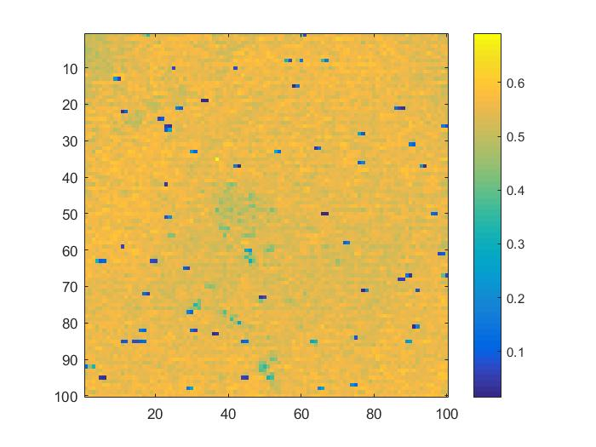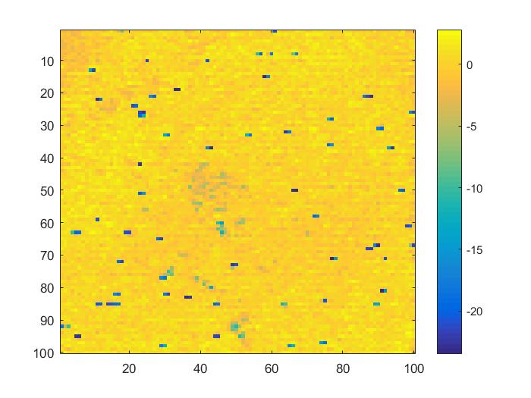
PC2 (1.31%) PC3 (0.32%) PC4 (0.28%)
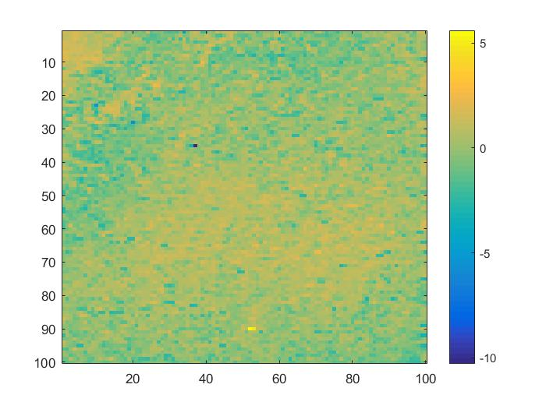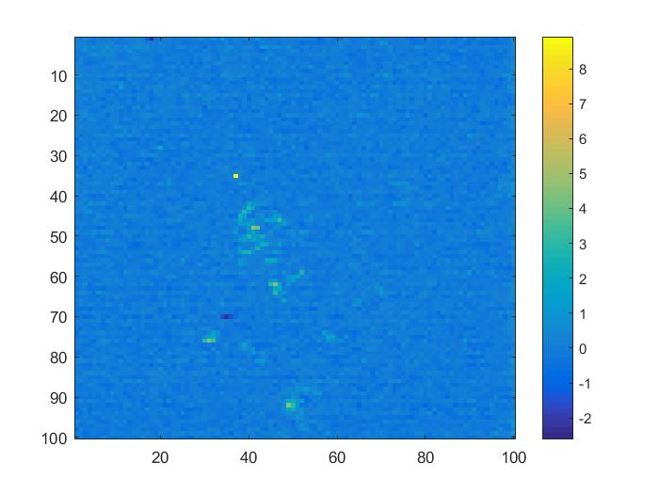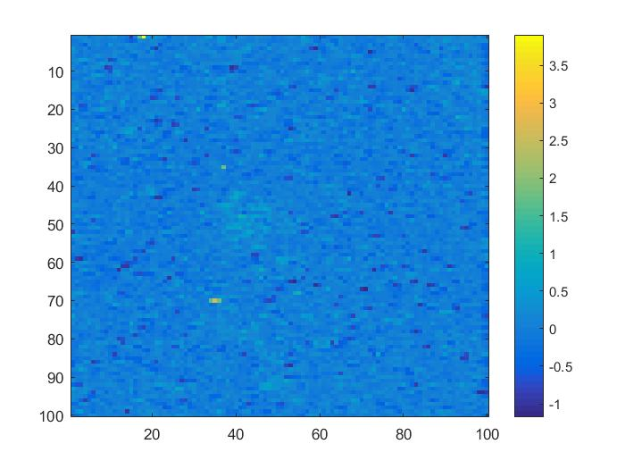 PC5 (0.23%) d) t-SNE-HAC e) Contribution map
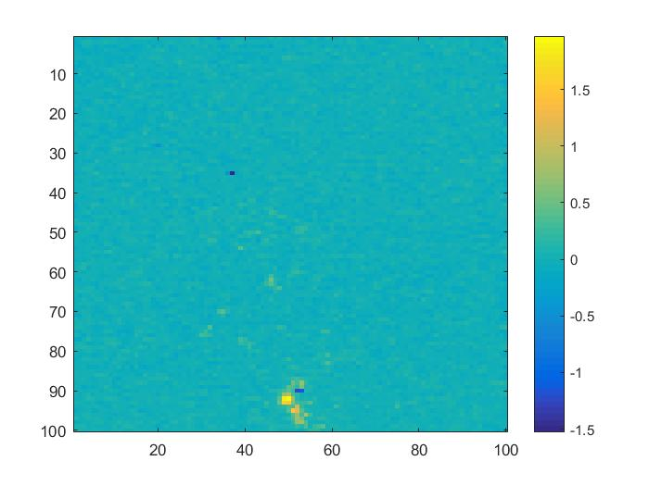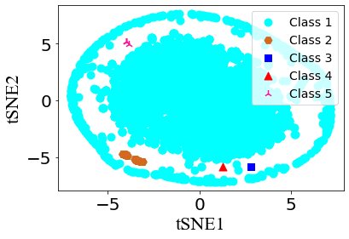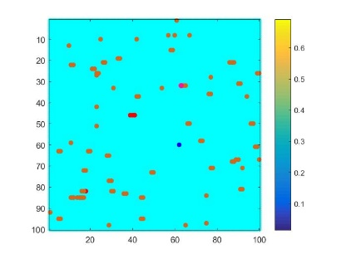
f) Separated 4 pixels g) UMAP-HAC h) Contribution map
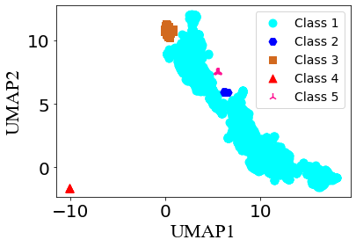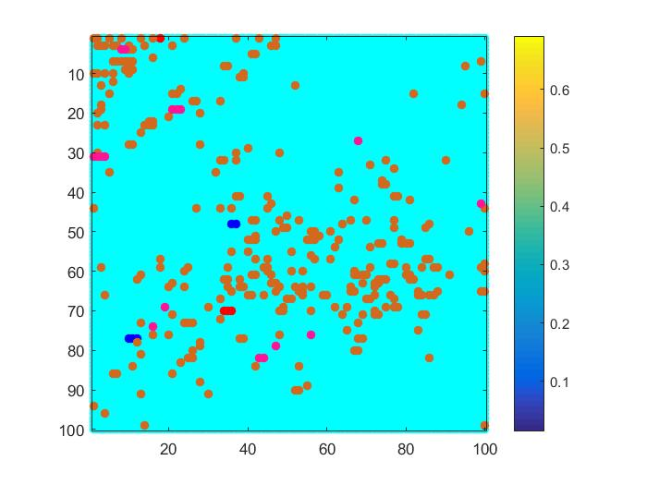
i) Separated 4 pixels
Fig. S3. Application of t-SNE-HAC and UMAP-HAC on the full Raman dataset 3, respectively. a) The normalized mean integration image. b) The scree plot of eigenvalues after PCA analyzing the full data. c) Images of the first five principal components (PC1-PC5) and their explained variance ratios (EVRs). d) The clustering result, e) the corresponding contribution map and f) separated 4 pixels without melamine by using t-SNE-HAC with 5 clusters to directly analyze the full data. g) The clustering result, h) the corresponding contribution map and i) separated 4 pixels without melamine by using UMAP-HAC with 5 clusters.

a) IFPs (RVs=100,000) b) Determining the best NoC c) 2D Feature space
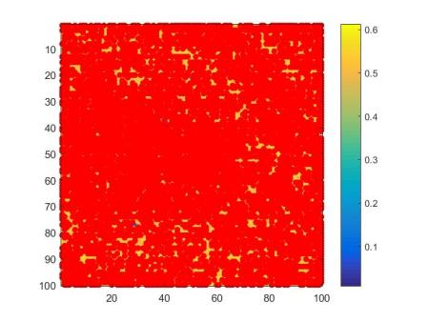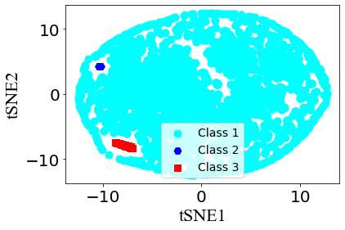d) Contribution map for IFF-t-SNE-HAC e) Separated 77 pixels
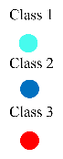
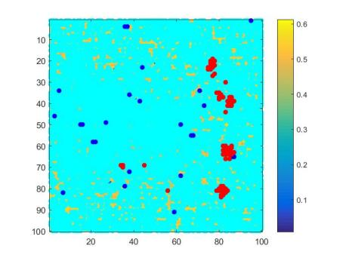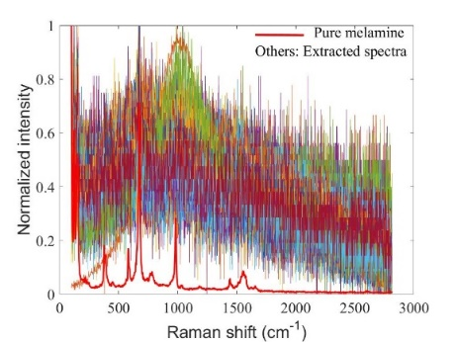
f) Determining the best NoC g) Feature space for IFF-UMAP-HAC
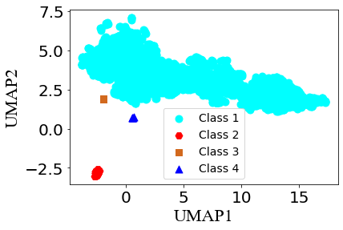
h) Contribution map for IFF-UMAP-HAC i) Separated 80 pixels
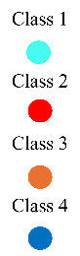
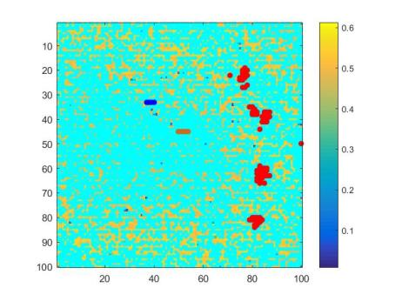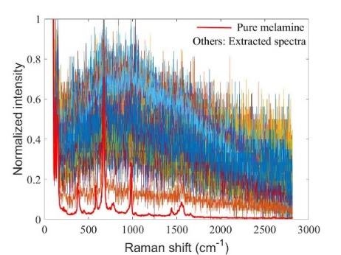
Fig. S4. Obtained results by the analysis of Raman dataset 2. a-e) for IFF-t-SNE-HAC, f -i) for IFF-UMAP-HAC.

IFPs (RVs=100,000) Determining the best NoC Feature space
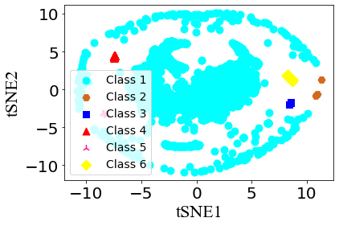
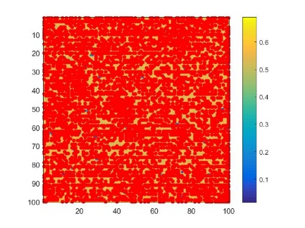
Separated 14 pixels without melamine Contribution map
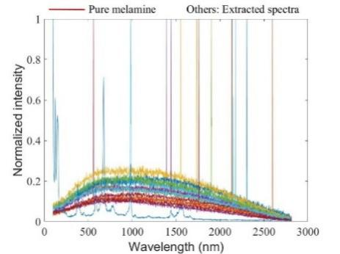
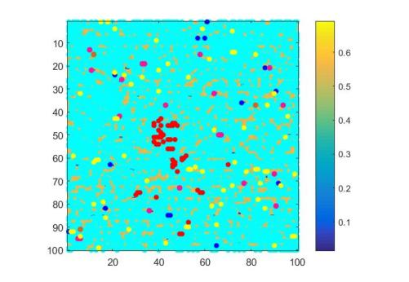

Fig. S5. Analysis of the third Raman HSI data with IFF-t-SNE-HAC.

a) IFPs (RVs=100,000) Determining the best NoC
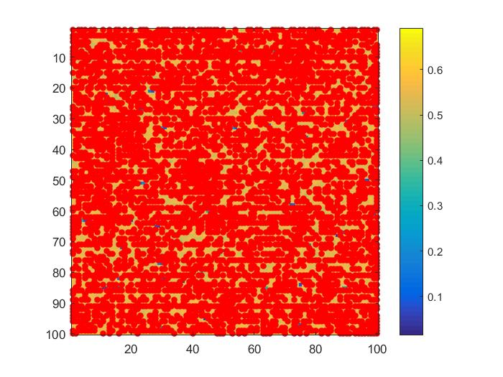
Contribution map Feature space
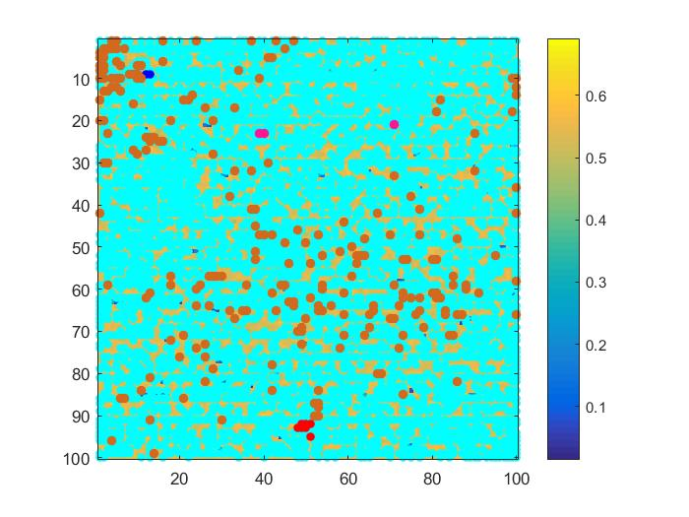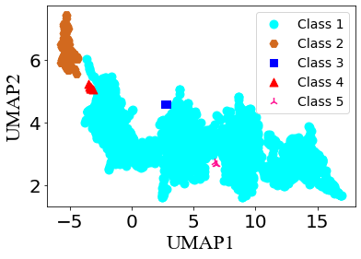
b) Separated 7 pixels containing melamine
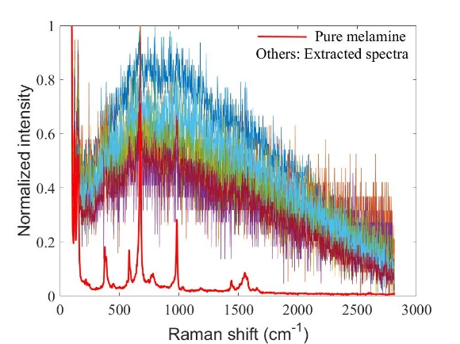
Fig. S6. Analysis of the third Raman HSI data with IFF-UMAP-HAC.

a) Raw data b) After preprocessing c) Scree plot of eigenvalues
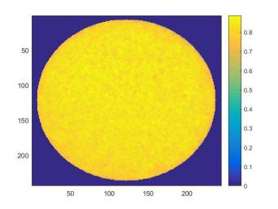
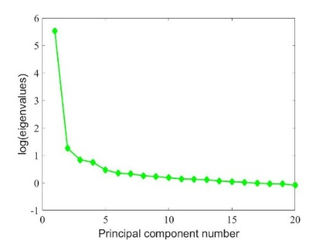
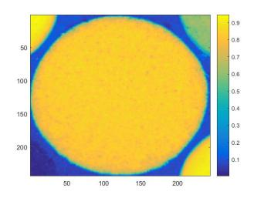

d) UMAP-HAC e) Contribution map f) Separated 9 pixels
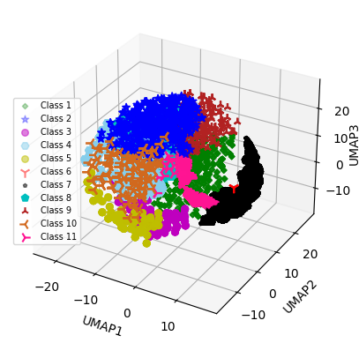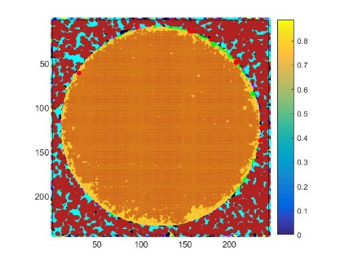
Fig. S7. Analysis of the second real NIR HSI data with UMAP-HAC.

a) Raw data b) After preprocessing c) Scree plot of eigenvalues
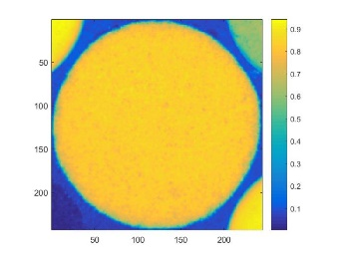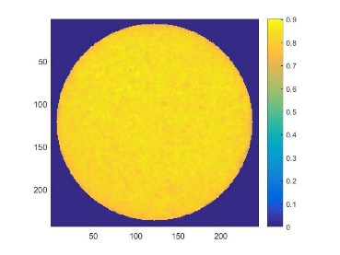
d) UMAP-HAC e) Contribution map f) Separated 3 pixels
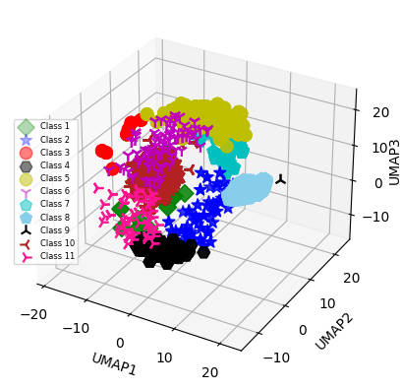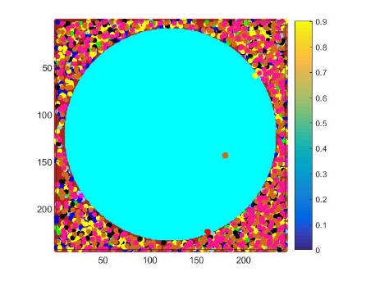
Fig. S8. Analysis of the third real NIR HSI data with UMAP-HAC.

a) Raw data b) After preprocessing c) Scree plot of eigenvalues
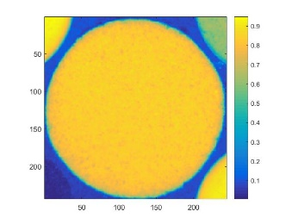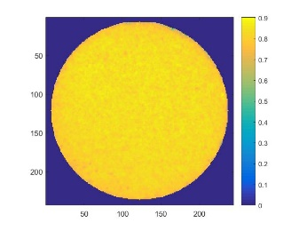
d) UMAP-HAC e) Contribution map f) Separated 389 pixels
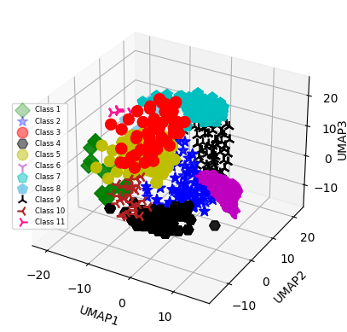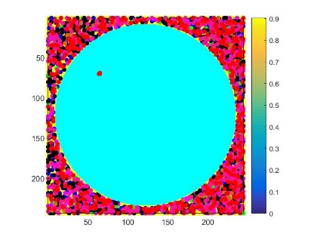
Fig. S9. Analysis of the fourth real NIR HSI data with UMAP-HAC.

a) Determining the best NoC b) Feature space and contribution map for dataset 6
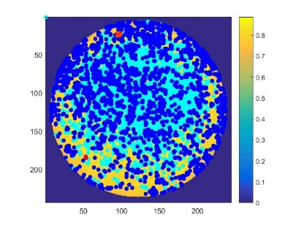
Separated 26 pixels c) Feature space and contribution map for dataset 7
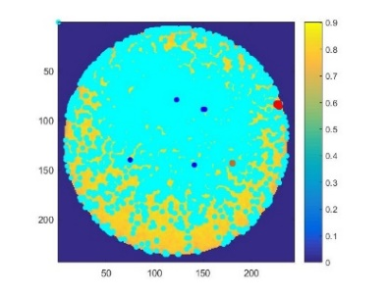
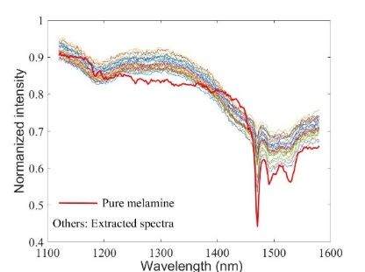
Separated 7 pixels d) Feature space and contribution map for dataset 8
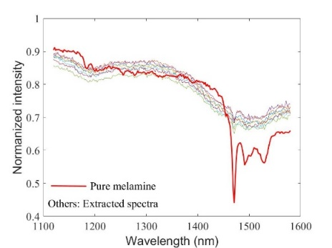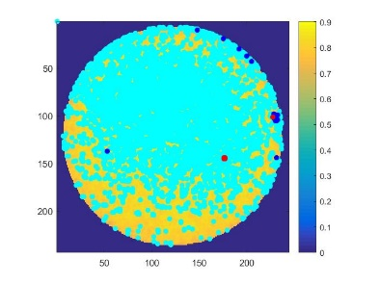
Separated 5 pixels from the reduced dataset 8
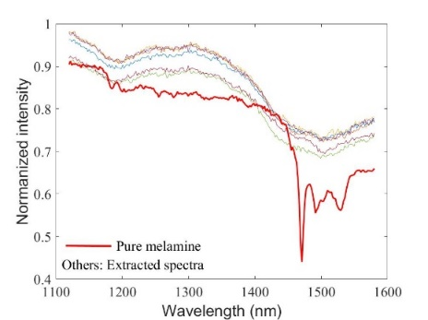
Fig. S10. Application of IFF-UMAP-HAC on the NIR HSI datasets 6 to 8, respectively.
a) Raman mappings of the milk powder sample b) 3D PCA scores
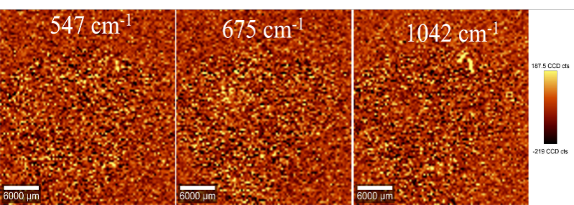
c) The scree plot of eigenvalues d) 3D feature space e) Contribution map
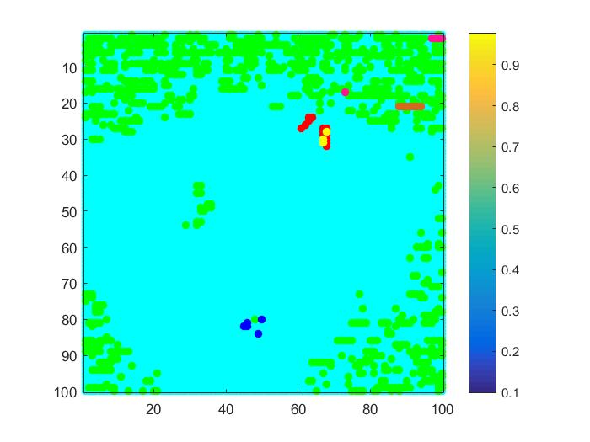
Fig. S11. Analysis of the full Raman HSI dataset 4 using UMAP-HAC.

Supplementary method: NbClust
NbClust was developed by M. Charrad et. al in 2014. It contains 30 indices which are used to determine the relevant number of clusters (NoC) in a data set with a “majority vote” approach. Each index can offer a value for the best NoC to the user. Finally, the method offers the best NoC from the results of 30 indices according to the majority rule. The reader can learn more from the reference[1]. The following steps can be utilized to run the NbClust method in R environment for the determination of the optimal NoC in a given dataset.
- First, install “Clust_2.0.3” packages in R environment.
- Then, install “flexclust” packages and its library.
- Nest, install “readxl” package and library to read excel data in .xlsx format.
- Use the following function to import the data: data = read_excel("E:/… /u.xlsx").
- Determine the best NoC according to the following function:
A=NbClust(data, diss=NULL, distance="euclidean", min.nc=2, max.nc=20, method="single", index="all", alphaBeale=0.1).
The linkage methods of “single” and “average” were used to analyze Raman and NIR HSI data, respectively.

Reference
1 Charrad M, Ghazzali N, Boiteau V, et al. Nbclust: An R package for determining the relevant number of clusters in a data set. Journal of statistical software, 2014, 61: 1-36

