Supplement Table 1: Used TagMan Gene Expression Assays and primers.
Gene | Assay ID / primer sequence
COL10A1 | Hs00166657_m1
CXCL12 | Hs00171022_m1
CXCR4 | Hs00237052_m1
ACKR3 | Hs00604567_m1
GAPDH | Hs02758991_g1
HPRT1 | Hs02800695_m1
MMP13 | Hs00942584_m1

Supplement Table 2: Assessment of neo-cartilage formation. Adapted from Riegger et al. 2018. The scoring system uses the pellet size (diameter), collagen type II, safranin O staining intensity, cell-cell distance (matrix production), and cell morphology. The categories were classified from 0 (= evidence for failed chondrogenic differentiation) to 3-5 (=evidence for successful chondrogenic differentiation). The overall score was calculated by adding up all individual scores of the categories.
Scoring categories | Score
1) Pellet size (diameter)
< 900 µm | 0
> 900 µm | 1
> 1200 µm | 2
> 1500 µm | 3
> 1800 µm | 4
> 2200 µm | 5
2) Collagen type II/ Safranin O staining intensity
No staining | 0
Weak staining (> 5 % positive) | 1
Scattered moderate staining (> 25 % positive) | 2
Even moderate stain (> 50 % positive) | 3
Even intensive stain (> 85 % positive) | 4
3) Cell-Cell distance (matrix production)
High cell density; no matrix between cells | 0
High cell density; little matrix between cells | 1
Moderate cell density; little matrix between cells | 2
Low cell density; extensive matrix between cells | 3
4) Cell morphology
Condensed/necrotic/pycnotic bodies | 0
Spindel/fibrous | 1
Mixed spindle/fibrous and rounded/chondrogenic | 2
Majority rounded/chondrogenic | 3

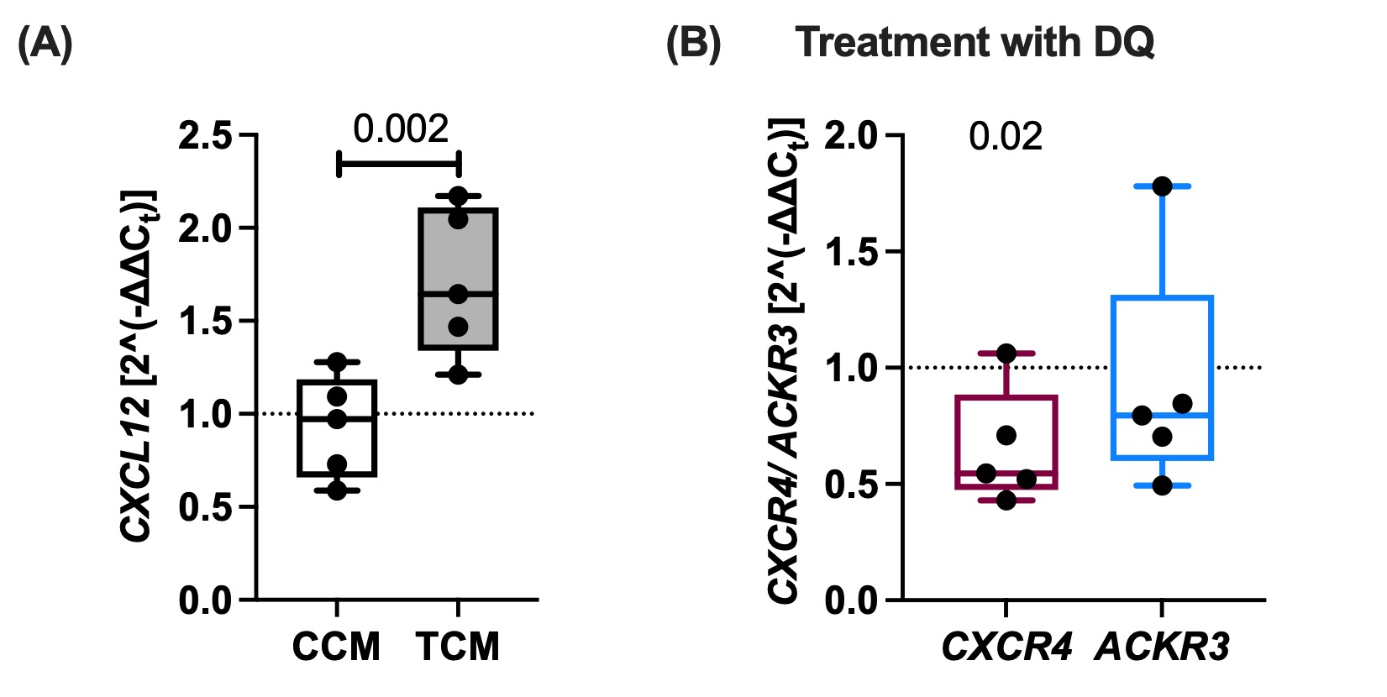
Supplement Figure 1: (A) Gene expression of CXCL12 in human fibroblast-like synoviocytes isolated from OA patients, treated with trauma-conditioned medium (TCM) for 4 days. TCM was collected 7 days after cartilage trauma. Cartilage conditioned medium (CCM) was collected from unimpacted cartilage explants and used as control. Paired t test; n = 5. (B) mRNA levels of CXCR4 and ACKR3 after senolysis. Human articular chondrocytes were treated with Dasatinib (250 mM) and Quercetin (5 µM) for 3 days, followed by a cultivation for 4 days without D+Q. Unpaired t test; n = 5.

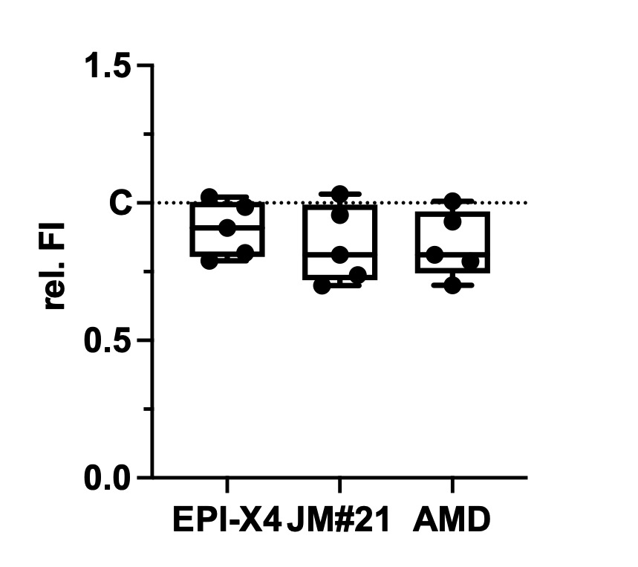
Supplement Figure 2: Relative fluorescence intensity (FI) of the alamarBlue assay at 24h after stimulation of isolated hAC with addition of the CXCR4 inhibitors [1 µM]; n = 5.

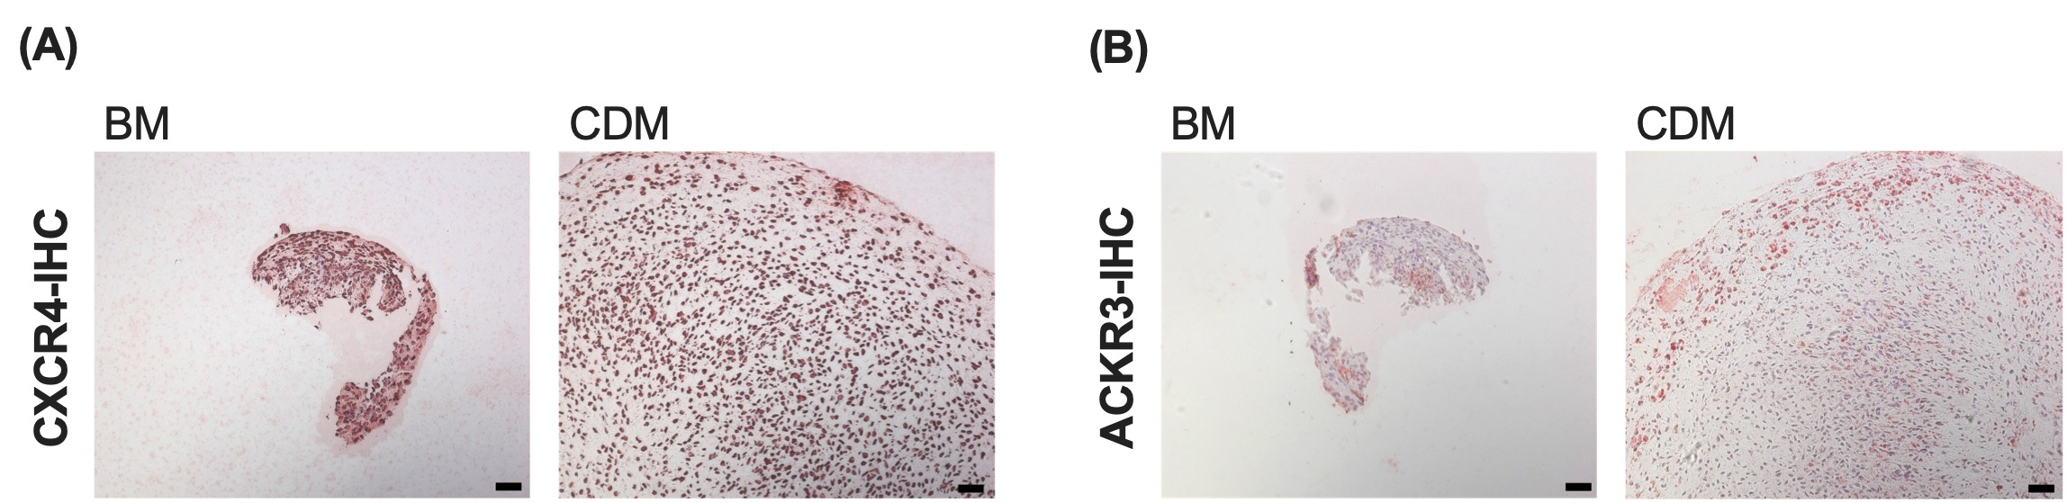
Supplement Figure 3: Representative (A) CXCR4 and (B) ACKR3 staining of chondrogenic re-differentiation of isolated hAC by means of immunohistochemistry (IHC). Scale bars equal 50 µm. BM = basal medium; CDM = chondrogenic differentiation medium.

