Microwave-alkali co-activated persulfate enables minute-scale fertilization of food waste with high fulvic-like acid yield
Yanping Zhuª, Yi Qiaoª, Dongfang Wangª, Shihu Shuª, Pan Zhao^{c}, Yongle Yuª, Weijia Liª, Li Liu^{d}, Jiping Shi^{d}, Weijian Zhang^{e}, Kaimin Zhu^{f}, Rongjun Zhang^{g}, Dongqing Cai^{a,b,}*
ª College of Environmental Science and Engineering, Donghua University, Shanghai 201620, People’s Republic of China
^{b} State Key Laboratory of Advanced Fiber Materials, College of Environmental Science and Engineering, Donghua University, Shanghai 201620, China
^{c} Institute of Microbiology, Chinese Academy of Sciences, Beijing 100101, PR China
^{d} Shanghai Advanced Research Institute, Chinese Academy of Sciences, Shanghai 201210, PR China
^{e} Shanghai Agricultural Development Promotion Center, Shanghai 200335, China
^{f} Shanghai Agricultural Technology Extension Service Center, Shanghai 201103, China
^{g} Weifang Shangchang Ecological Agriculture Technology Co., LTD, Weifang, PR China

*Corresponding author: Dongqing Cai
Email address: dqcai@dhu.edu.cn

Lists of Captions
Fig. S1 3D-EEM spectra of treated WP (50 g) under different conditions. S3
Fig S2 The stability of product under the optimal conditions (50 g WP, 2%KOH/2%PS, MW 10 min) after standing for (A) 24 h and (B) 7 d. S4
Fig. S3 SEM-mapping results of SRF release before and after in the slow-release
experiment. S5
Fig. S4 Biosafety experiment of Product. S6
Fig. S5 Scaling-up efficacy of MW/KOH/PS in humification of WP. S7
Fig. S6 Fertilization of the humification products derived from VR and CKW in field test. S10
Fig. S7 Plankton counting method for comparing the live bacteria counts before and after treatment with WP, VR and CKW experiments. S7
Table S1 Percentage fluorescence response (P_{region number}) in 3D-EEM five regions of WP under different humification conditions based on FRI method. S11
Table S2 2D-FTIR-COS results on the assignment and sign of each cross-peak in synchronous and asynchronous maps of time-dependent FLA within initial 10 min.
S12
Table S3 Effective viable bacteria count by quality. S15
Text S1 Quantitative analysis of 3D-EEM results. S16
Text S2 Biosafety experiment of Product. S17
References S18

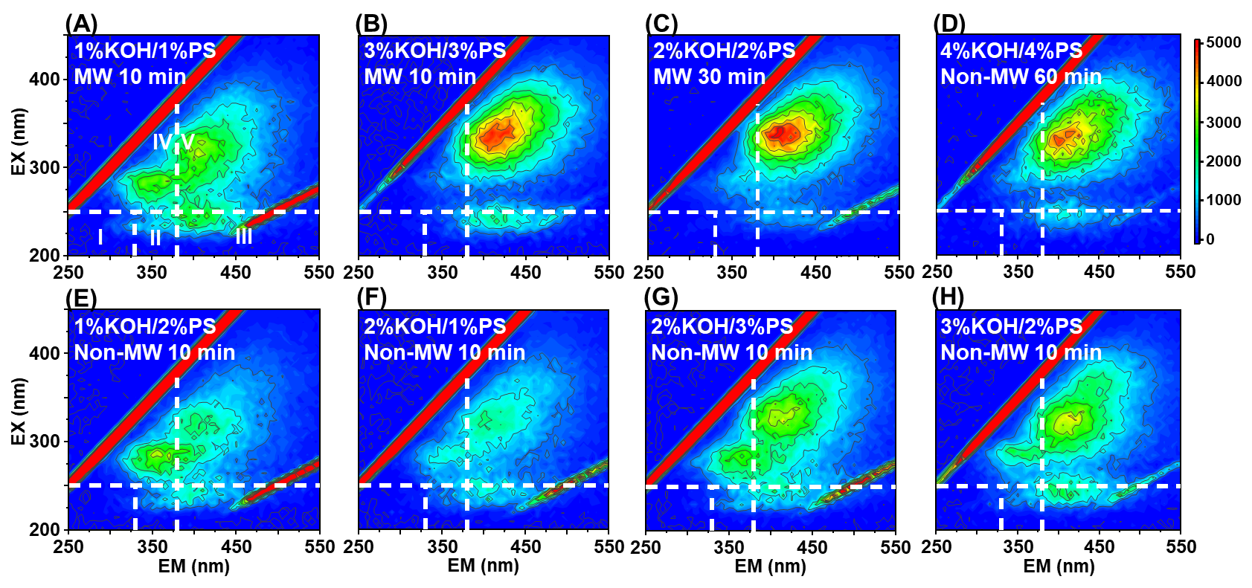Fig. S1 3D-EEM spectra of treated WP (50 g) under different conditions.

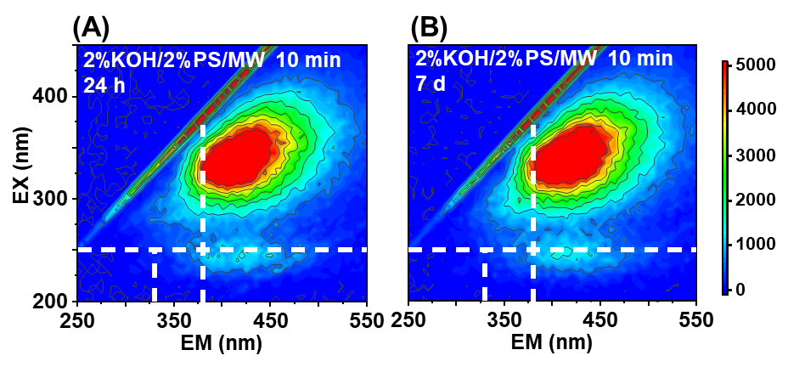
Fig S2 The stability of product under the optimal conditions (50 g WP, 2%KOH/2%PS, MW 10 min) after standing for (A) 24 h and (B) 7 d.

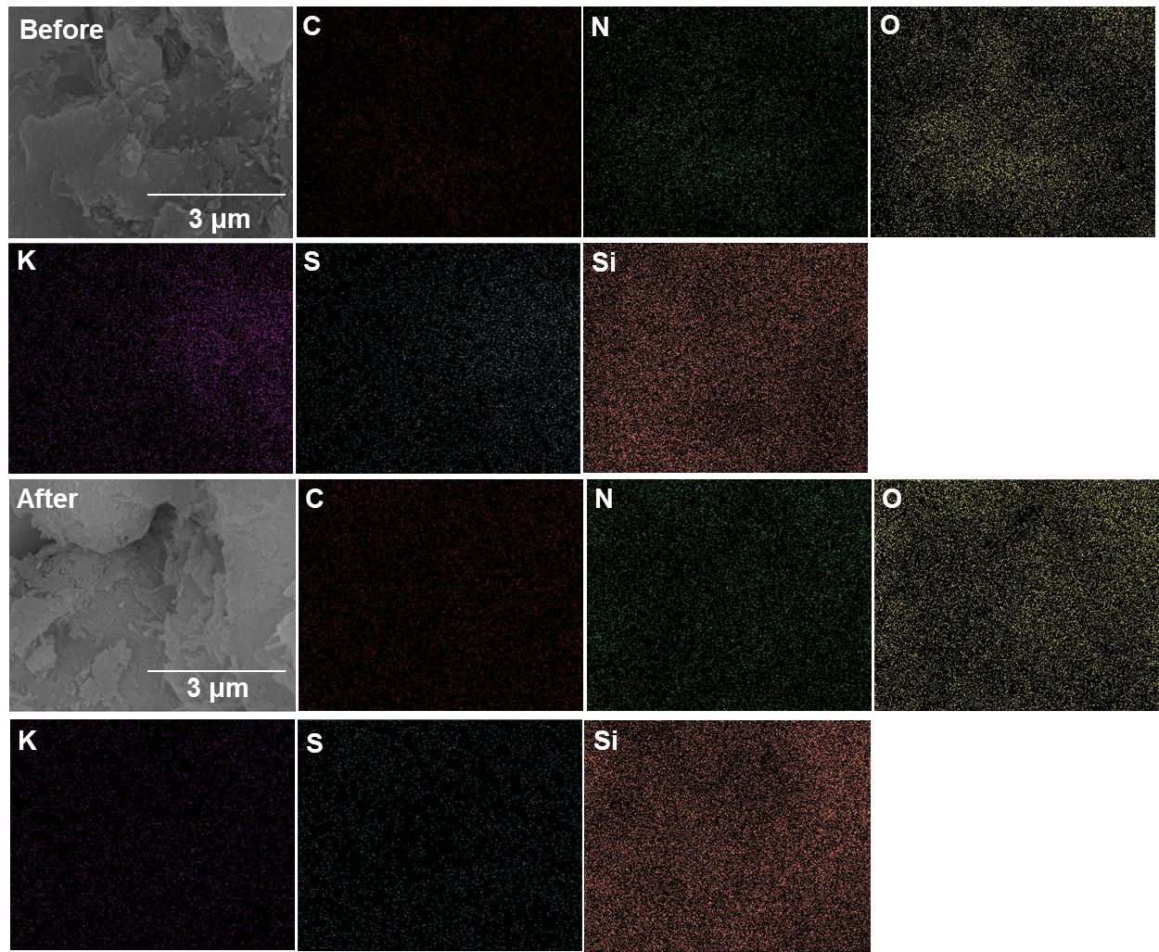
Fig. S3 SEM-mapping of SRF before and after release in the slow-release experiment.

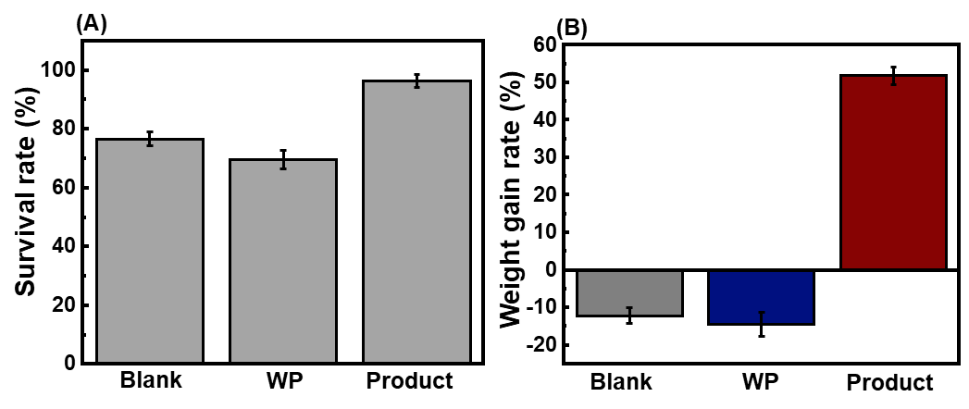
Fig. S4 Biosafety of the Product. (A) Earthworm survival rate and (B) weight gain rate with different treatments in 14 d. Treatment conditions: Blank, WP and Product referred to 300 g soil + 5 earthworms, 300 g soil + 5 earthworms + 7.8 g WP, and 300 g soil + 5 earthworms + 7.8 g product respectively. Each treatment was in triplicate with error bars representing standard deviations.

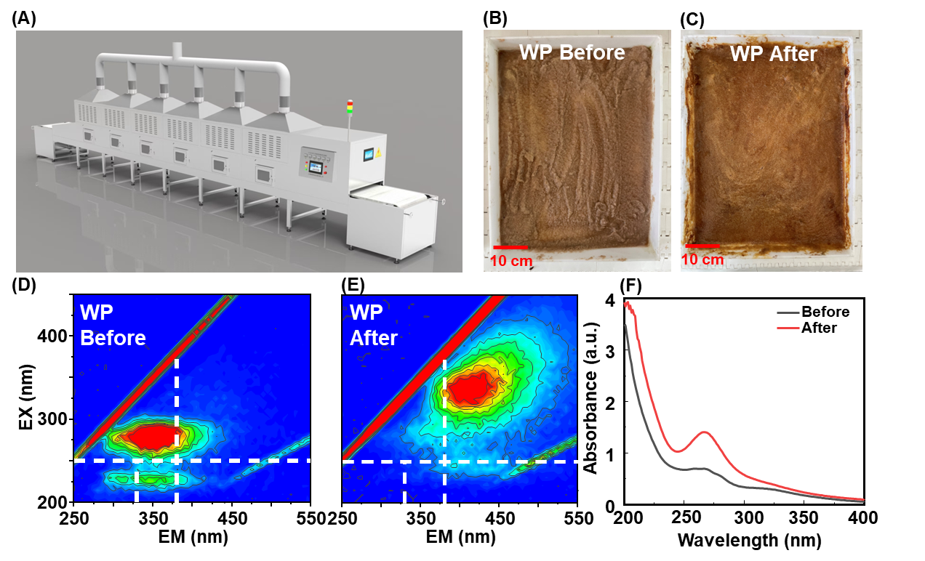Fig. S5 Scaling-up efficacy of MW/KOH/PS in humification of WP. (A) The industrial microwave oven’s structure. (B, C) WP images, (D, E) 3D-EEM spectra, and (F) UV-vis results of WP before and after treatment. Conditions: 1 kg WP slurry, MW 3 kW, 6 min.

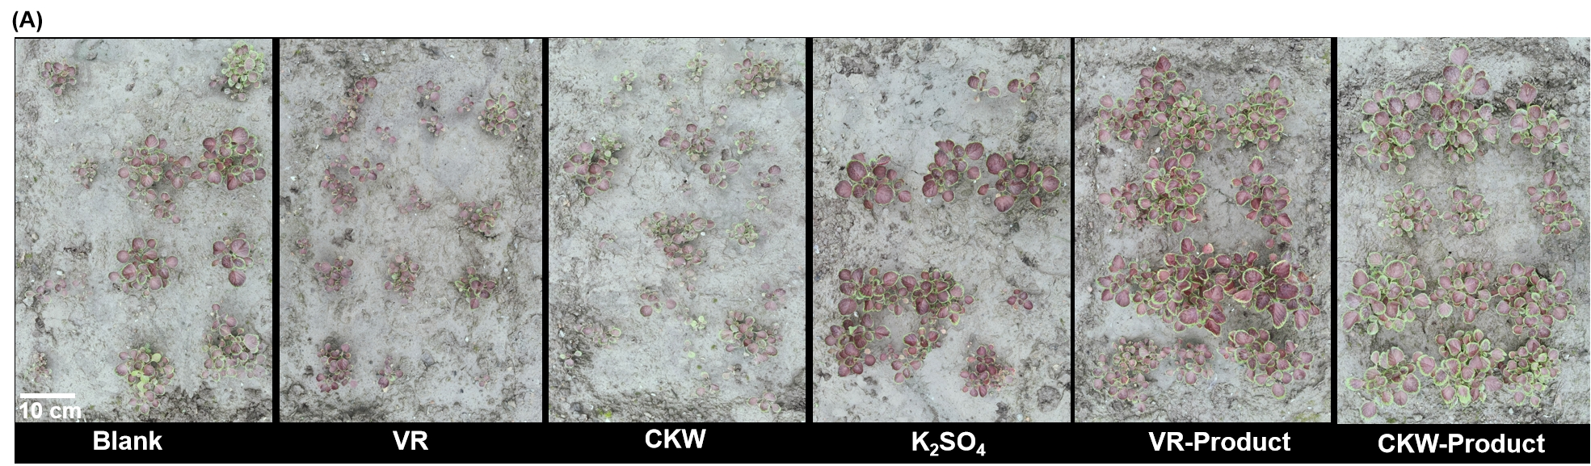
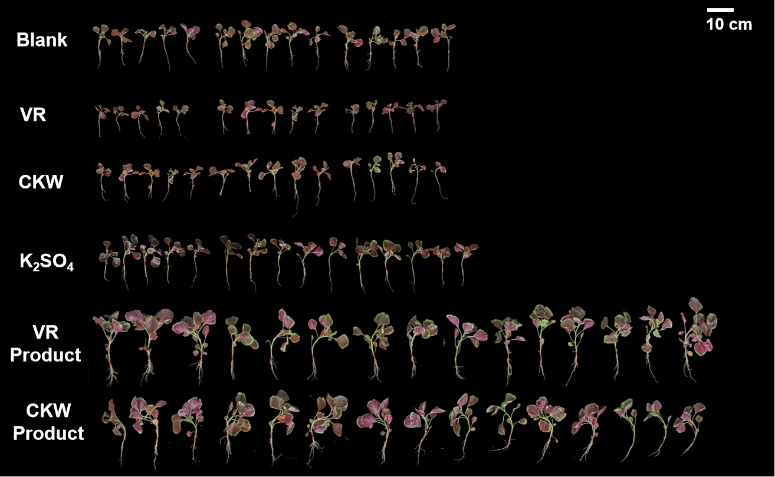
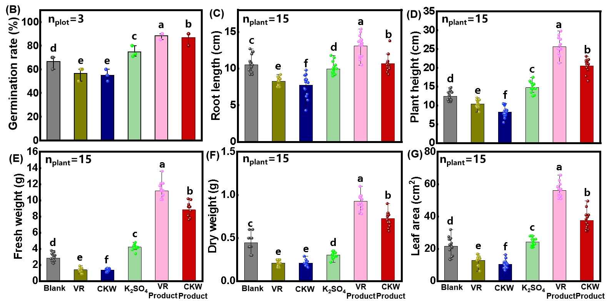
Fig. S6 Fertilization of the humification products derived from VR and CKW in field test. (A) Digital images, (B) germination rate, (C) root length, (D)plant height, (E)fresh weight, (F) dry weight, (G)leaf area of three-colored amaranth with different treatments: WP, CKW, K2SO4, WP-Product, and CKW-Product referred to 1.18 kg WP, 1.18 kg CKW, 110 g K₂SO₄, 1.18 kg WP-Product and 1.18 kg CKW-Product respectively. Each plot contained 160 three-colored amaranth seeds and each plot of land is 3 meters long and 1 meter wide. Each group was in triplicates and error bars represent the standard deviations. n_{plot} indicated the number of plots selected for analysis, and n_{plant} referred to the number of plants selected in each group for analysis. Comparison among results of different treatments were via one-way ANOVA analysis, and different letters refer to significant differences with Tukey’s t test at p<0.05 (n=3).

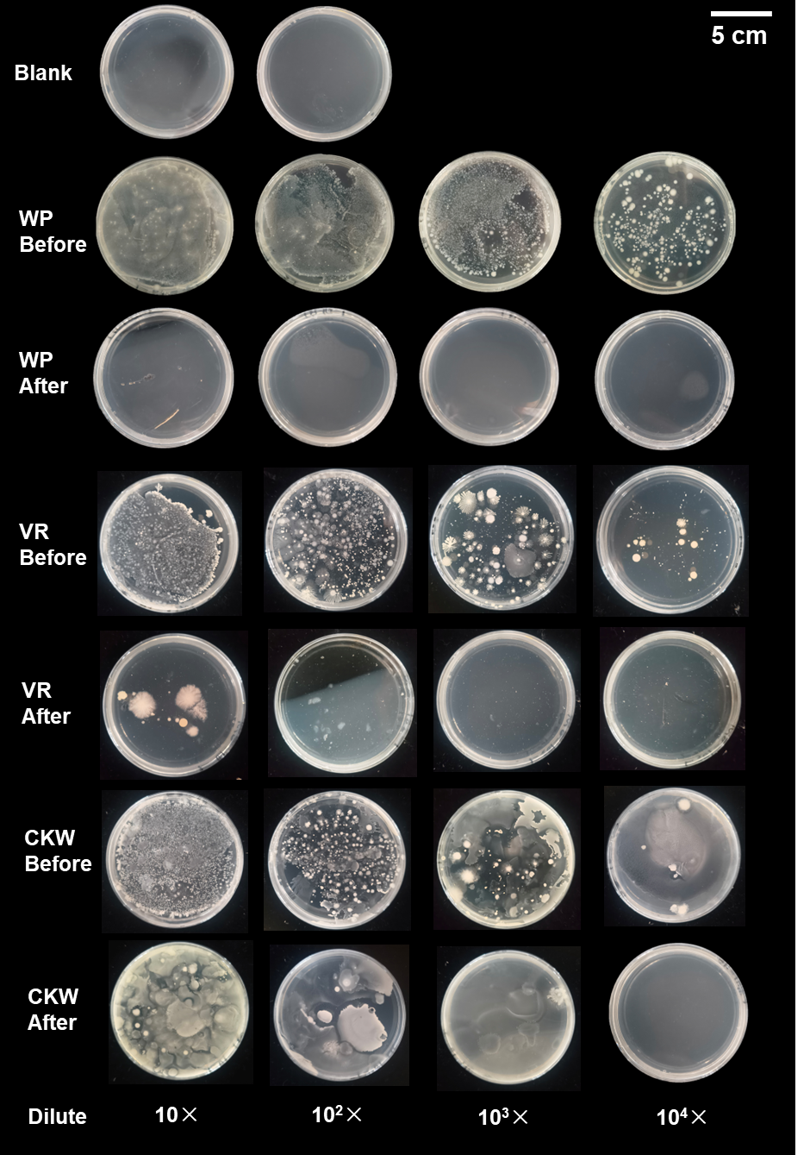
Fig. S7 The live bacteria counts based on Plankton counting method before and after WM/KOH/PS humification in WP, VR and CKW systems. Experimental conditions: ambient temperature=37±1 ºC, 0.2 g/L samples with dilution times of 10, 10², 10³, 10⁴ respectively.

Table S1 Percentage fluorescence response (P_{region number}) in 3D-EEM five regions of WP under different humification conditions based on FRI method.
Figure No. | P_{Ⅰ} (%) | P_{Ⅱ} (%) | P_{Ⅲ} (%) | P_{Ⅳ} (%) | P_{Ⅴ} ( %)
2A | 18.4±0.3 | 31.9±0.1 | 4.9±0.1 | 39.1±0.2 | 5.7±0.4
2B | 14.1±0.1 | 25.4±0.2 | 6.2±0.3 | 33.1±0. 1 | 21.2±0.5
C | 8.4±0.5 | 18.3±0.4 | 14.6±0.4 | 37.6±0.2 | 21.1±0.6
D | 7.9±0.2 | 17.7±0.5 | 16.5±0.8 | 32.3±0.2 | 25.6±0.1
E | 17.8±0.6 | 33.5±0.2 | 5.1±0.6 | 38.8±0.1 | 4.8±0.9
F | 5.9±0.1 | 20.3±0.8 | 23.9±0.3 | 28.5±0.6 | 21.4±0.9
G | 5.2±0.4 | 28.7±0.9 | 25.5±0.2 | 22.8±0.8 | 27.8±0.2
H | 0.3±0.02 | 11.4±0.9 | 14.4±0.8 | 21.2±0.3 | 52.7±0.3
I | 11.3±0. 5 | 15.4±0.2 | 25.4±0.3 | 15.8±0.7 | 32.1±0.9
J | 7.2±0.5 | 16.5±0.7 | 23.7±0.8 | 16.4±0.1 | 36.2±0.7
K | 6.4±0.2 | 15.7±0.7 | 25.6±0.3 | 16.2±0.8 | 36.1±0.2
L | 5.3±0.5 | 14.1±0.5 | 28.9±0.8 | 13.6±0.2 | 38.1±0.1
M | 5.1±0.6 | 25.5±0.4 | 26.2±0.2 | 15.1±0.2 | 28.1±0.3
N | 4.1±0.1 | 10.4±0.2 | 29.5±0.8 | 24.9±0.3 | 31.1±0.9
O | 0.4±0.1 | 11.3±0.5 | 28.3±0.3 | 24.1±0.1 | 35.9±0.2
P | 0.7±0.1 | 13.7±0.9 | 24.5±0.2 | 20.2±0.3 | 40.9±0.7
3A | 1.2±0.1 | 11.2±0.2 | 23.8±0.3 | 24.5±0.4 | 39.3±0.8
3B | 0.6±0.1 | 8.2±0.1 | 24.9±0.7 | 23.5±0.5 | 42.8±0.4
3C | 0.3±0.1 | 7.6±0.2 | 20.3±0.3 | 26.4±0.4 | 45.4±0.3
S1C | 5.2±0.3 | 9.6±1.2 | 23.4±0.6 | 25.5±0.2 | 36.3±0.2
Note: error bars represent the standard deviations from triplicate tests.

Table S2 2D-FTIR-COS results on the assignment and sign of each cross-peak in synchronous and asynchronous maps of time-dependent FLA within initial 10 min.
Position (cm⁻¹) |  | Possible assignment | Sign
 |  | Possible assignment | 1578 | 1400 | 1100 | 1020
1578 | Aromatic C=C  stretching |  | + | +(-) | +(-) | +(+)
1400 | Carboxyl O-H  stretching |  |  | + | +(-) | +(+)
1100 | Aromatic C-O  stretching |  |  |  | + | +(+)
1020 | C-N  stretching |  |  |  |  | +

Table S3 Effective viable bacteria count by quality (billion/g)
Dilute | 10× | 10²× | 10³× | 10⁴×
WP Before | ND | ND | ND | 2.23×10⁵
WP After | 0 | 0 | 0 | 0
VR Before | ND | ND | 2.81×10⁶ | 5.8×10⁴
VR After | 1300 | 0 | 0 | 0
CKW Before | ND | ND | 8×10⁵ | 4.3×10⁵
CKW After | ND | ND | 1500 | 0
Note: ND referred to not detected.

Text S1 Quantitative analysis of 3D-EEM results
Fluorescence regional integration (FRI) was applied as a quantitative technique for analysis of EEM results. EEM spectra were delineated into five excitation-emission regions according to defined regional boundaries. Volumetric integration within each region, normalized to the projected excitation-emission area within that region, resulted in a normalized region-specific EEM volume (P_{i,n}). Note that Milli-Q water blank EEMs were deducted from the sample EEM to decrease the influence of the Rayleigh and Raman scattering.

Text S2 Biosafety evaluation of the Product
Earthworm was used as a bioindicator to evaluate the biological safety of Product and SRF. Consistent with the pot experiment, four different treatments with three replicates were set up. The soil (200 g) was dried, crushed, and sieved through a 30-40 mesh screen. After mixing evenly with an appropriate amount of water, it was placed in a plastic container (height 6.8 cm, bottom width 7.5 cm, bottom length 13.4 cm, top width 11.2 cm, top length 17 cm) and maintained at a humidity of about 30%. WP (3 g) and Product (3 g) were evenly sprinkled on the soil surface. Then, five earthworms with similar length and weight were placed in the container, and the initial weight of each earthworm was recorded. Several small holes were punched on the top cover of the container, which was then placed in the dark for 14 d. During 14 d growth period, 30 mL of tap water was evenly sprayed on the soil surface every 3 days. After the experiment, the earthworms were rinsed with deionized water and weighed after air drying.

References
Chen, W., Westerhoff, P., Leenheer, J.A. and Booksh, K. Fluorescence excitation−emission matrix regional integration to quantify spectra for dissolved organic matter. Environ. Sci. Technol. 37, 5701-5710 (2003).
Prachi Arora, Suman Tewary, Srinivasan Krishnamurthi, Neelam Kumari, An experimental setup and segmentation method for CFU counting on agar plate for the assessment of drinking water, J. Microbiol. Methods, 214, 106829 (2023).
Danielle de Sousa Severo, Wiaslan Figueiredo Martins, Marília Miotto, Silvani Verruck, Rafael R., Gláucia Maria Falcão de Aragão, Comparative assessment of plate count and PMA-qPCR methods for modeling the growth of lactic acid bacteria in smoked Turkey ham, Food Control, 168, 110857 (2025).
Indra P., Alya P., Fujen W., Performance evaluation of contamination control and pressurization in a biosafety laboratory, Energy, 335, 115545 (2025).
Stedmon, C.A. and Bro, R. Characterizing dissolved organic matter fluorescence with parallel factor analysis: A tutorial. Limnol Oceanogr-meth. 6, 572-579 (2008).

