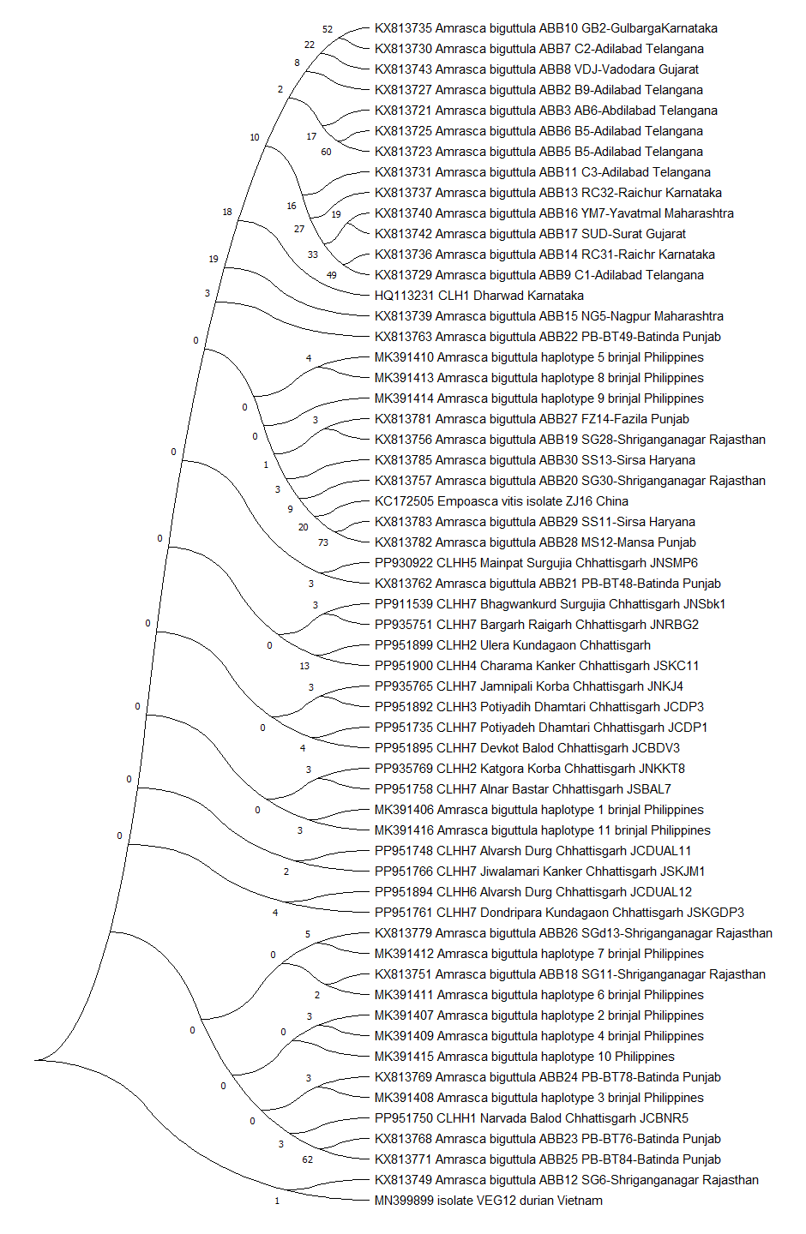

Supplementary material 1: NJ tree of Mt COI gene sequences of A. biguttula on cotton, brinjal. Okra, durian.

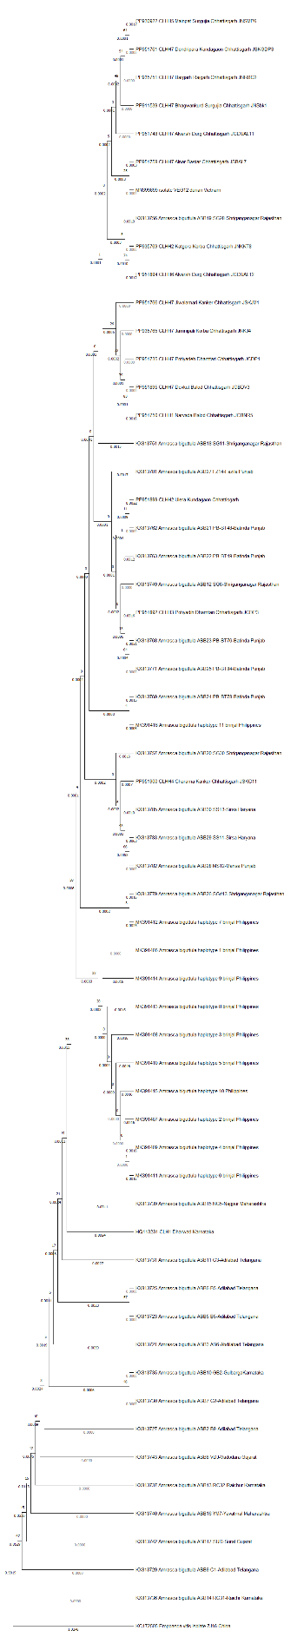

Supplementary material 2: NJ tree of Mt COI gene sequences of A. biguttula on cotton, brinjal. Okra, durian with boot strap values.

