Appendix 1: Copy of the post-event questionnaire


Climate Emergency Educators Assembly - Research Information & Questionnaire

Many thanks for joining us at the Climate Emergency Educators Assembly today, we very much appreciate your attendance and participation at this event.

We would now like to invite you to take part in a separate research project being undertaken by staff at the University of Worcester reflecting on the content of today's assembly and your views and concerns regarding the climate emergency more generally via an online questionnaire. Please note, that this is completely voluntary, and you are under no obligation having attended the event to take part in this research. The survey is anonymous, and you will not be requested to provide any personal identifiable information.

Before you decide whether to take part, it is important that you understand why the research is being done, what it will involve for you, what information we will ask from you, and what we will do with that information. Please take time to read the following information carefully.

* What is the purpose of the research?

This study aims to explore educator stakeholder attitudes and experiences in relation to education in climate & ecological emergency. The findings will help shape the development of a 12 hour enhancement activity on ‘Education in Climate Change’ for Secondary PGCE trainees.

* Who is undertaking the research?

Name: Elena Lengthorn

Position: Senior Lecturer Teacher Education

Project role: Lead Researcher

Name: Dr Sian Evans

Position: Lecturer Geography

Project role: Researcher

Name: Megan Asbury

Position: Student

Project role: Green Impact Project Assistant

* Who has oversight of the research?

The research has been approved by the Research Ethics Panel for the College of Arts, Humanities and Education (CAHE) in line with the University’s Research Ethics Policy. The University of Worcester acts as the “Data Controller” for personal data collected through its research projects and is subject to the UK GDPR and the Data Protection Act 2018. We are registered with the Information Commissioner’s Office and our Data Protection Officer is Helen Johnstone (infoassurance@worc.ac.uk). For more on our approach to Information Assurance and Security visit: https://www.worcester.ac.uk/informationassurance/index.html.

* Why have I been invited to take part?

You have received this invitation because you are a stakeholder in Secondary education in the West Midlands. We are hoping to recruit a minimum of 40 participants for this study.

* Do I have to take part?

No. It is up to you to decide whether or not you want to take part in this research. Please take your time to decide and talk to others about it if you wish. Deciding to take part or not will not impact on your ability to participate in future opportunities with the Educator Assembly or to work or study at the University of Worcester. If you do decide to take part, you will be asked to agree with the consent form prior to completing the questionnaire.

* What will happen if I agree to take part?

If you agree to take part you will complete a questionnaire . This includes questions reflecting on the content of today's assembly and your personal and professional views and concerns regarding delivering climate emergency education more generally.

The questionnaire is anonymous. However, if you wish to withdraw your contribution, the questionnaire includes the opportunity for you to incorporate a code (known only to yourself). If you decide within two weeks of completing the questionnaire that you wish to withdraw your contribution, you can share this code with the lead researcher, Elena Lengthorn, and your specific contribution will be withdrawn. Elena can be contacted on 01905 542151 or e.lengthorn@worc.ac.uk

Spreadsheets containing data from the questionnaires will be securely stored on the University cloud, linked to a staff account, and will be deleted by September 2023. There is no information held alongside the questionnaire data that could be used to identify participants.

- Required
Section 1
Consent
Prior to completing the questionnaire, please read and confirm you understand and agree to each point (If you have any questions please email e.lengthorn@worc.ac.uk)

- If you agree to participate in the research, please provide your consent to each item below *

I agree
I understand that taking part in the study has minimal potential risk of climate anxiety.
I understand that participation in this study involves the completion of a questionnaire.
I have read and understood the information about the project, as provided in the Information Sheet outlined above.
I have been able to ask questions about the project and my participation and my questions have been answered to my satisfaction.


I give permission for the data I provide to be stored on the secure UoW OneDrive, so that it can be used to explore community responses to education in our time of climate emergency.
I understand that there will be no personal information collected about me that can identify me, such as my name, or where I live and that the data collected will not be shared beyond the study team.
The procedures regarding confidentiality have been clearly explained (e.g. use of names, pseudonyms, anonymisation of data, etc.) to me.
I understand that my real name will not be requested, and pseudonyms will be used for quotes from open ended questions.
I understand that the information I provide will be used for developing a PGCE Enhancement Activity entitled ‘Education in Climate Emergency’, and other publications on education and the climate & ecological emergency.
I understand I can withdraw my questionnaire within 14 days of the event using a code selected during the completion of the questionnaire, without giving reasons, and that I will not be penalised for withdrawing nor will I be questioned on why I have withdrawn.

I understand that I should only complete the questionnaire once and that the link provided is for my use only.
I know who to contact if I have any concerns about this research.
I voluntarily agree to participate in the project.

- Sometimes participants decide after they have completed a questionnaire that they no longer want their research contributions to be included. If you decide within two weeks of completing the questionnaire that you want to withdraw your contribution, you can share this code with the lead researcher, Elena Lengthorn, and your specific contribution will be withdrawn. Elena can be contacted on 01905 542151 or e.lengthorn@worc.ac.uk. This is necessary because there are no questions that can be used to identify your individual response.

Please insert a memorable personal code word into the box below should you wish to withdraw your response. Please do not use your name.*

Section 2
Attitudes to our climate emergency
This section includes questions about your attitudes to our climate emergency.

- How confident do you feel in your knowledge of our climate emergency? *

- Please can you explain how attending the climate emergency educators assembly has influenced your answer to this question. *

- If you are an educator, how confident do you feel in teaching about our climate emergency? *
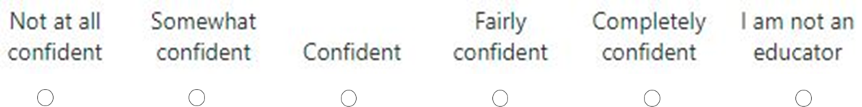

- Please can you explain how attending the climate emergency educators assembly has influenced your answer to this question. *

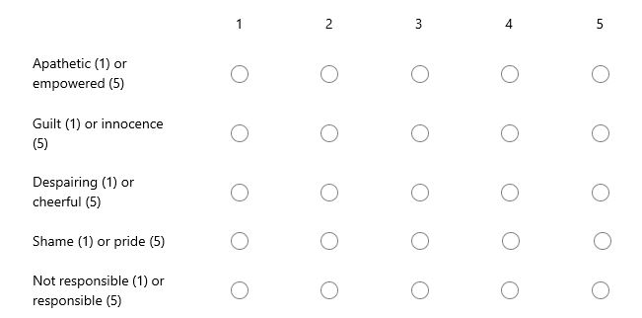
- How do you feel about our climate emergency? *

- Please can you explain how attending the climate emergency educators assembly has influenced your answers about any of these feelings. *

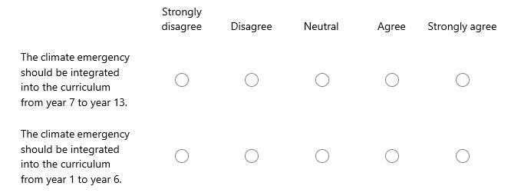
- To what extent do you agree / disagree with this statement?*

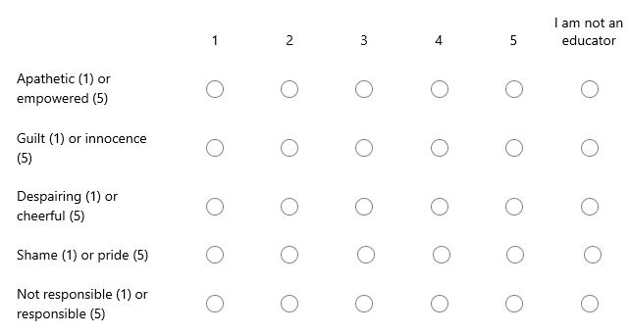
- If you are an educator, how do you feel about teaching about our climate emergency?*

- If you are an educator, please can you explain how attending the climate emergency educators assembly has influenced how you feel about teaching about our climate and ecological emergency.

- What do you feel is the role of teachers in our climate emergency?*

- What do you feel is the role of schools in our climate emergency?*

- How important do you think it is to provide yr7 to yr13 children with local examples of climate change impacts and solutions?
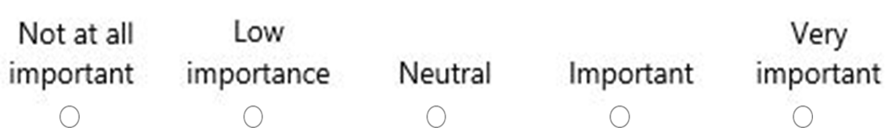

- What research would you like to be done on Education in Climate Emergency?*

- How useful did you find the discussion groups that took place during the Climate Assembly? Please explain your answer.*

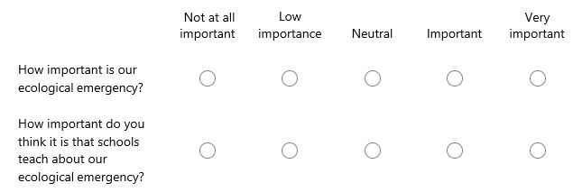
- During the Climate Emergency Assembly, the matter of our ecological emergency was also raised.

- If you think it is important to teach about our ecological emergency, please summarise your views on the role of teachers and schools in this process and whether attendance at the Climate Assembly has influenced your ideas.*

- Please use the box below to share any other thoughts about education in climate emergency or the citizens assembly process.

Section 3
About you
Please can you share with us a little bit of information about you?

- Gender?

- What is your role in or beyond education?

- If you are a teacher, how long have you been in teaching (please answer in number of years)?

Section 4
Many thanks for participating in this research
If you would like to be involved in future collaborative learning events and / or research on education for our climate emergency or to be informed about research outputs from this specific study, please contact e.lengthorn@worc.ac.uk.

