Supplementary Material
Tailoring Aromatic-to-Cycloalkane Ratios for Sustainable Aviation Fuel by Hydrodeoxygenation of Isoeugenol over Nickel Aluminate Spinel-based Catalyst

Daniel Gallego-García ¹, Mark E. Martínez-Klimov ², Päivi Mäki-Arvela ², Johan Wärnå ², Unai Iriarte-Velasco ³, Miguel Angel Gutiérrez-Ortiz ¹, Jose Luis Ayastuy ^{1*}, Dmitry Yu. Murzin ^{2*}

¹ Department of Chemical Engineering, Faculty of Science and Technology, University of the Basque Country UPV/EHU, Sarriena S/N 48940 Leioa, Spain
² Johan Gadolin Process Chemistry Centre, Åbo Akademi University, Turku/Åbo FI-20500, Finland
³ Department of Chemical Engineering, Faculty of Pharmacy, University of the Basque Country UPV/EHU, Paseo de la Universidad, 7, 01006 Vitoria, Spain
* Corresponding authors emails: joseluis.ayastuy@ehu.eus; dmitry.murzin@abo.fi

CONTENT
 | Page
Methods | 3
Reagents | 3
NiAl catalyst synthesis | 3
Catalyst characterization | 3
Reaction procedure | 5
Products analysis | 6
Definitions and metrics | 6
Ex-situ catalyst reduction and passivation | 7
Table S1. Physicochemical properties of catalysts | 8
Table S2. Acidity of catalysts | 8
Table S3. Summary of EXAFS results | 9
Figure S1. XRD diffractograms | 10
Figure S2. UV-vis DRS spectra | 11
Figure S3. Raman spectra | 12
Figure S4. XPS spectra | 13
Figure S5. Py-FTIR spectra | 14
Figure S6. Electronic microscope images of NiAl | 15
Figure S7. Electronic microscope images of HTC-600 | 16
Figure S8. Repeatability test | 17
Figure S9. PCHol vs PCH | 18
Figure S10. Pore size distributions | 19
Figure S11. TPH of used catalyst | 19
Figure S12. NiAl vs HTC-600 performances | 20
References | 20

Methods
1.1 Reagents
The chemicals used for the synthesis of the catalyst were: nickel(II) nitrate hexahydrate (Ni(NO₃)₂·6H₂O, M_{n} = 290.79, 99.999%, Alfa Aesar), aluminium nitrate nonahydrate (Al(NO₃)₃·9H₂O, M_{n} = 375.13, 99+%, Supelco), citric acid (C₆H₈O₇, M_{n} = 192.12, ≥ 99.5%, Sigma-Aldrich), and deionised water. Isoeugenol (Sigma Aldrich, 98%, mixture of cis and trans) and n-dodecane (Acros Organics, 99%) were used for the catalytic reactions.
1.2 NiAl catalyst synthesis
Stoichiometric nickel aluminate was synthesized using the sol-gel method in a one-pot synthesis. Initially, appropriate quantities of nickel(II) nitrate hexahydrate and aluminum nitrate nonahydrate were dissolved in deionized water separately at room temperature. Subsequently, the two solutions were mixed together. Additionally, an aqueous solution of the chelating agent citric acid was prepared at a molar ratio of citric acid to metals of 1.2:1. Subsequently, the latter solution was added dropwise to the metal-containing solution while stirring for an hour under room temperature conditions. The solution was then heated to 70 °C and continuously stirred magnetically to remove excess water, which yielded a green gel. The gel was then dried overnight at 100 °C to produce a foamy solid. Subsequently, the solid was subjected to calcination in air at 850 °C in a muffle furnace at a heating rate of 2 °C/min for a period of 4 hours. The obtained catalyst was named NiAl.
1.3 Catalyst characterization
The catalyst was characterized in both calcined and reduced (at 700 °C for 2 h using 10% H₂/Ar) forms. The bulk chemical composition of the synthesized solid was assessed via X-ray fluorescence (XRF) using the AXIOS equipment.
For textural properties (specific surface area, volume and pore size distribution) N₂ adsorption-desorption isotherms were utilized at 77 K in Micromeritics TRISTAR II 3020 equipment. The sample underwent outgassing at 300 °C for 10 h to eliminate any moisture and adsorbed impurities. The BET equation was utilized to determine the specific surface area, while the BJH method was used to obtain the pore size distribution (PSD) through the desorption branch of the isotherms.
The crystalline phases were identified via X-ray diffraction (XRD) using the PANalytical Xpert PRO diffractometer, equipped with a copper tube (λ = 1.5418 Å). The PANalytical X′pert HighScore software has been utilized with the ICDD database to identify the phases present in the samples. The Scherrer equation was applied to calculate the crystallite size of each species from the line broadening of its most prominent peak.
Reducibility was assessed by H₂-TPR in a Micromeritics Autochem 2920. A calcined sample (~50 mg) was pre-treated in He at 550 °C (10 °C/min, 1 h) to remove impurities, then cooled to 50 °C. It was subsequently exposed to 5% H₂/Ar while heating to 950 °C (10 °C/min, 30 min). The TPR profile was recorded by a TCD analyzing the reactor exhaust after water trapping.
The H₂-TPD experiments were carried out in a Micromeritics Autochem 2920 instrument. About 20 mg of the sample was first reduced in a 5% H₂/Ar flow at temperatures up to 700 ºC, with a heating rate of 10 ºC/min. The sample was then held for 2 h, and subsequently cooled to 40 ºC in He flow before being saturated in pure H₂ flow for 1 hour. The temperature was then gradually increased up to 700 ºC, with a heating rate of 10 ºC/min, in an Ar flow, and the exhaust gases were monitored by TCD.
The number of atoms of metallic Ni per gram of catalyst was determined using the double isotherm method via static H₂ chemisorption on a Micromeritics ASAP 2020 apparatus. A U-shaped quartz tube containing ca. 0.3 g of catalyst was ex-situ reduced at 700 °C, thereafter passivated and placed between two layers of quartz wool. Preparation for the experiment involved the following steps: first, degassing at 350 °C under He to remove any adsorbed compounds; second, reduction under a flow of hydrogen at 350 °C for one hour; third, evacuation at 360 °C for 1.5 h; and finally cooling down the sample to 35 °C under vacuum. Subsequently, two consecutive H₂ adsorption isotherms were collected with an in-between evacuation. The quantity of Ni⁰ atoms that were exposed was calculated by considering the volume of chemisorbed H₂, assuming a H/Ni stoichiometry of 1/1.
The coordination and oxidation states of nickel cations were analyzed by UV–VIS diffuse reflectance spectroscopy. The instrument utilized was a UV–vis–NIR Cary 5000 coupled with an integrating sphere of diffuse reflectance (Varian), operating in a range of 200 to 2500 nm. The reflectance data was converted to absorption via the Kubelka-Munk transformation.
The Brønsted and Lewis acid sites of the catalyst were quantified using Fourier transform infrared spectroscopy of adsorbed pyridine (Py-FTIR, ATI Mattson FTIR Infinity Series) using the corresponding molar extinction coefficients. Determination of the total, weak, medium, and strong acid sites was done by desorbing pyridine at 150, 250, 350, and 450 °C, respectively, with the measurements taken at 100 °C. Pellets of ca. 20 mg and 1 cm of diameter were prepared for each analyzed material.
Raman spectroscopy was used to provide the structural features and the nature of the carbon deposits in the spent catalyst. The measurements were conducted using a Renishaw InVia Raman spectrometer, which was attached to a Leica DMLM microscope. A 514 nm laser (ion-argon laser, Modu-Laser) was employed while reducing the laser power to prevent samples from undergoing photo-decomposition via neutral density filters. To enhance the signal-to-noise ratio, the spectra were captured for 40 s with an accumulation of 10 scans at 10% of the maximum 514 nm laser power within the spectral window ranging from 200 cm⁻¹ to 2000 cm⁻¹.
X-ray photoelectron spectroscopy (XPS) was utilized to conduct a surface chemical-state analysis of Ni and Al. The measurements were done using a SPECS spectrometer with a Phoibos 150 1D-DLD analyzer and a monochromatic Al Kα (1486.7 eV) radiation source. The detailed peaks were deconvoluted after Shirley background subtraction utilizing a mixed Gaussian-Lorentzian function through the use of CASA XPS software. The binding energies (BE) were calibrated with the reference to the C 1 s peak (284.6 eV) of adventitious carbon. Concentrations were determined by adjusting the values with relative atomic sensitivity factors (Scofield).
Imaging with scanning transmission electron microscopy (STEM) and EDS were conducted with a probe-corrected FEI Titan 60–300 operating at 300 kV. The instrument was installed with a high brightness X-FEG and a Cs CESCOR corrector for the condenser system, allowing for sub-angstrom probe size. To analyze the chemical composition, elemental maps were generated using an Ultim Max detector (Oxford Instruments) to obtain X-ray Energy Dispersive Spectra (EDS). For STEM observations, ethanolic suspension containing NPs was dropped onto a holey carbon-coated copper micro-grid. SEM-EDS of the spent catalysts was performed in the Carl Zeiss EVO 40 equipment equipped with an Oxford Instrument X-Max EDS detector.
In situ X-ray absorption spectra (XAS, in terms of XANES and EXAFS) at Ni K absorption edge were recorded at the P65 beamline of PETRA III synchrotron radiation source (DESY, Hamburg) in the transmission mode. Higher harmonics were rejected by a pair of Si plane mirrors installed in front of the monochromator. The energy of the X-ray photons was selected by a Si (111) double-crystal monochromator and the beam size was set by means of slits to 0.3 (vertical) x 1.5 (horizontal) mm².
The spent catalysts were also subjected to temperature-programmed hydrogenation analysis, the reactor exhaust being monitored by MS (TPH-MS). A mass of 0.03 g of the spent catalyst was initially subjected to a heating process under a He flow at 150 °C for 1 h (with a heating ramp of 5 °C/min) in order to remove any adsorbed organics. Following a cooling period to 40 °C in He flow, the gas was switched to 5 % H₂/Ar flow and the sample was heated at 10 °C/min up to 950 °C. The m/z signal 15 (CH₄) was recorded on the exhaust stream as the heating process proceeded. The mass spectrometer (Pffeifer Vacuum OmniStar) was calibrated for methane, allowing quantification of the carbonaceous deposits.
1.4 Reaction procedure
HDO of isoeugenol was performed as a model reaction to determine the activity of nickel aluminate catalyst. The reactions were performed in a 300 mL stainless steel batch reactor (PARR Instruments) equipped with a mechanical stirrer. For HDO of isoeugenol, 0.05 g of the catalyst, 0.1 g of the reactant, and 50 mL of dodecane were used. The size of the catalyst particles was < 63 μm, to ensure the absence of internal mass-transfer limitations. The stirring speed was set to 900 rpm to avoid external mass-transfer limitations. The liquid samples were taken at regular time intervals.
Prior to each experiment, 0.05 g of catalyst was externally reduced according to the protocol detailed in the Supplementary Information. After cooling under He flow, 5 mL of dodecane was added to prevent nickel oxidation, and the catalyst was transferred to the batch reactor. A solution containing 0.1 g of isoeugenol in 45 mL of dodecane was then added. Following reactor loading, an initial aliquot (~250 µL) was collected and designated as the time zero sample. The system was purged twice with Ar, followed by a 10-minute purge with H₂. Following pressurization to 10 bar below the target using residual H₂, heating was initiated. As the temperature increased, the system pressure rose to the desired value. Upon reaching the target temperature, stirring was set to 900 rpm and the reaction time was recorded. The samples were collected at defined intervals over the 4-hour reaction, during which H₂ flow was carefully regulated to maintain the constant pressure.
1.5 Products analysis
The liquid samples were analyzed by gas chromatography using flame ionization detector (GC-FID). In GC analysis, a DB-1 capillary column (Agilent, Model 122-103e) of 30 m length, 250 μm internal diameter and 0.5 μm film thickness was utilized. Helium was applied as a carrier gas with the flow rate of 1.7 mL/min. The temperature program for GC analysis was as follows: 60 °C (5 min), 3 °C/min to 135 °C, and 15 °C/min to 300 °C.
1.6 Definitions and metrics
The conversion was calculated according to Equation 1:
$X_{t} \left(\%\right)= \frac{C_{0}-C_{IE}}{C_{0}}×100$ (1)
where X_{t} is conversion at time t, C₀ initial molar concentration (mol/L) of isoeugenol, and C_{IE} is the molar concentration of isoeugenol at time t. The yields of individual liquid products were calculated using Equation 2:
$Y_{i,t} \left(\%\right)= \frac{C_{i}}{C_{0}}×100$ (2)
where Y_{i,t} is the yield of the product i at time t, C_{i} molar concentration (mol/L) of the product i, and C₀ is the initial molar concentration of isoeugenol.
The carbon balance (CB) was calculated according to Equation 3:
$C_{balance}(\%)= \frac{\sum{n_{i}·C_{i}}}{10·C_{0}}×100$ (3)
where n_{i} is the number of carbons of the product i in the liquid phase, the C_{i} molar concentration (mol/L) of the product i, and C₀ is the initial molar concentration of isoeugenol.

Ex-situ catalyst reduction and passivation
To ensure consistency with the experimental setup, the catalyst was reduced in a quartz tubular reactor at 700 °C for two hours, with a heating ramp of 5 °C/min and a gas flow rate of 50 mL/min, utilizing a 10% H₂/He gas mixture. Subsequently, the catalysts were subjected to passivation through exposure to a flow rate of 50 mL/min of 1.25% O₂/He at 5 °C for a period of 10 minutes. This step facilitates the formation of a passivation layer on the active surface, thereby preventing further oxidation.
The H₂-TPR profile consists on a sharp peak at 218 ºC accompanied by a minor shoulder at ca. 300 ºC, complete reduction of the passivated layer occurring at 325 °C. Accordingly, the reduction of the passivated catalysts was performed at 350 °C for 1 hour under a 10% H₂/Ar gas mixture (40 mL/min) with a heating rate of 5 °C/min using an external tubular quartz reactor.

Supplementary Tables

Table S1. Some physicochemical properties of the reduced NiAl and commercial HTC-600 catalysts.
Catalyst | Ni/Al  (at./at.) ª | S_{BET}  (m²/g_{cat}) ^{b} | d_{pore}  (nm) ^{b} | Metal sites density  (sites/nm²) ^{c} | d_{XRD,Niº}  (nm) | d_{TEM,Niº}  (nm)
NiAl | 0.495 | 43 (31) | 5.4 (4.9) | 0.49 | 12.0 (8.2) | 11.8
HTC-600 | 0.357 | 182 | 6.8 | 1.79 | n.d. | 4.1
ª atom ratio.
^{b} for catalyst reduced at 700 ºC.
^{c} by H₂ chemisorption.
Values in parenthesis correspond to catalyst used for 4 h reaction at 275 °C and 30 bar H₂.

Table S2. Acid sites of the NiAl and commercial HTC-600 catalysts.
Catalyst | Lewis (µmol/g_{cat})* |  |  | Brønsted (µmol/g_{cat}) | Total  (µmol/g_{cat}) | Acid sites density (sites/nm²)
Catalyst | Weak | Medium | Strong | Brønsted (µmol/g_{cat}) | Total  (µmol/g_{cat}) | Acid sites density (sites/nm²)
NiAl | 21 | 10 | 6 | ~0 | 37 | 0.52
HTC-600 | 106 | 67 | ~0 | ~0 | 173 | 0.57
* Desorption of pyridine at 150, 250, 350, and 450 ºC was done to determine the total, weak, medium, and strong acid sites, respectively; measurements taken at 100 ºC.
Table S3. A summary of Ni first shell coordination environments determined from the analysis of EXAFS spectra of the reduced NiAl and HTC-600 catalysts and a reference metal foil.
Parameter | Ni foil (reference) | NiAl | HTC-600
Fraction of NiAl₂O₄ | n.a. | 31 ± 1% | n.a.
Ni-O distance (Å) | n.a. | 2.01 ± 0.03 | 2.02 ± 0.03
CN (O) | n.a. | 1.8 ± 0.6 | 0.8 ± 0.3
O: σ² (10⁻³ Å²) | n.a. | 5.9 ± 5.6 | 10.1 ± 0.9
Ni-Ni distance (Å) | 2.482 ± 0.003 | 2.477 ± 0.006 | 2.476 ± 0.003
CN (Ni) | 12  S₀² = 0.79 ± 0.04 | 7.2 ± 0.9 | 7.1 ± 0.4
Ni: σ² (10⁻³ Å²) | 5.8 ± 0.4 | 6.6 ± 0.9 | 6.6 ± 0.4
δE₀ (eV) | 6.1 ± 0.5 | 5.5 ± 1.0 | 5.3 ± 0.4
ρ (%) | 0.3 | 0.5 | 0.2
Comments: The fitting model has been built as a sum of two independent first shells containing O (octahedral coordination) and Ni (fcc Ni, 12 nearest neighbors). Oxygen contribution is observed for both catalysts. The coordination number of O in the spectra of NiAl catalyst corresponds to a fraction of 0.3 relative to the octahedral geometry which is the same value as obtained via LCA of XANES spectra. This similarity confirms the assumption of co-existence of fully reduced Ni nanoparticles and Ni aluminate phase independently on each other. Taking the same assumption for the HTC-600 catalyst and correcting Ni-Ni coordination numbers by the fraction of reduced Ni species obtained from EXAFS according to equation CN(Ni)_{corr.} = CN(Ni)·6/(6-CN(O)), we obtain CN(NI)_{corr.} of 8.2 and 10.3 for HTC-600 and NiAl, respectively. The CN(Ni)_{corr.} allows establishing the trend of the size of reduced Ni nanoparticles. Assuming spherical nanoparticles, the particle diameters are approximately 1 nm and 2.4 nm for the HTC-600 and NiAl, respectively (with large error bars due to uncertainty in CN determination and asymptotic behavior of the model [1].

Supplementary Figures
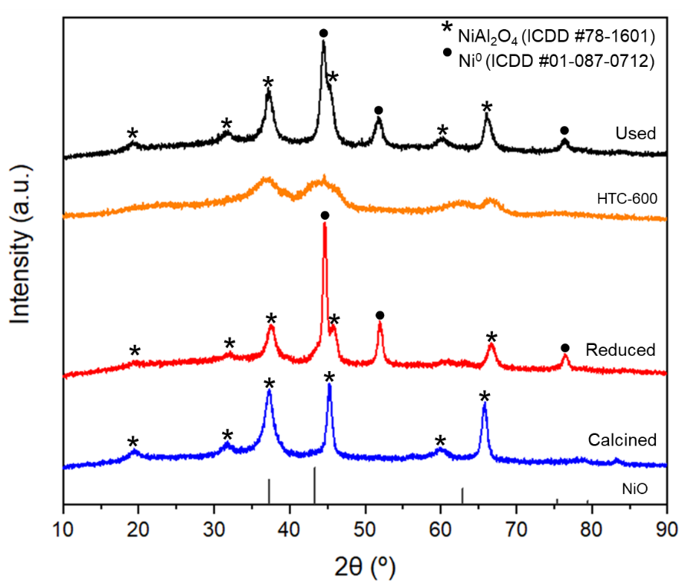
Figure S1. XRD of the NiAl and commercial HTC-600 catalysts.
Comments: The dominant diffraction peaks of the calcined NiAl catalyst are consistent with a face centred cubic NiAl₂O₄ spinel phase (ICDD #78-1601). The absence of a NiO signal in the diffractogram suggests a high degree of dispersion, consistent with its low content (4.5%), as determined by H₂-TPR. The lattice parameter for the calcined NiAl solid is 8.005 Å. Upon reduction at 700 °C, the diffraction peaks from the spinel phase remain indicating that the employed temperature is insufficient to reduce nickel ions in the stoichiometric NiAl₂O₄ lattice. Additionally, new XRD peaks at 2θ = 44.5º, 51.9º and 76.5º appear, which corresponded to metallic nickel (ICDD #01-087-0712). These outcomes conclusively confirms the exsolution of metallic Ni from the spinel lattice to create supported Ni⁰ catalysts. Following this, Al³⁺ ions fill the vacant nickel positions, resulting in the formation of Ni-deficient spinel structure. As the ionic radius of Al³⁺ ion is smaller than that of Ni²⁺ (53.5 vs 70 pm), the lattice constant reduced to 7.938 Å, indicating the enrichment in γ-alumina (ICDD #79-1558). The XRD diffractogram of commercial HTC-600 indicates very low crystallinity with peaks position compatible with spinel structure. The XRD spectrum of the used NiAl catalyst is similar to the reduced forms, exhibiting characteristic peaks from spinel and metallic nickel. The only discernible difference is the broadening of the metallic nickel peaks, attributed to a reduction in crystallite size. The presence of metallic nickel at the bulk level is confirmed by the persistence of its signals and the absence of NiO reflections. There are no any peak from graphitic carbon, indicating low amount and/or low degree of graphitization.
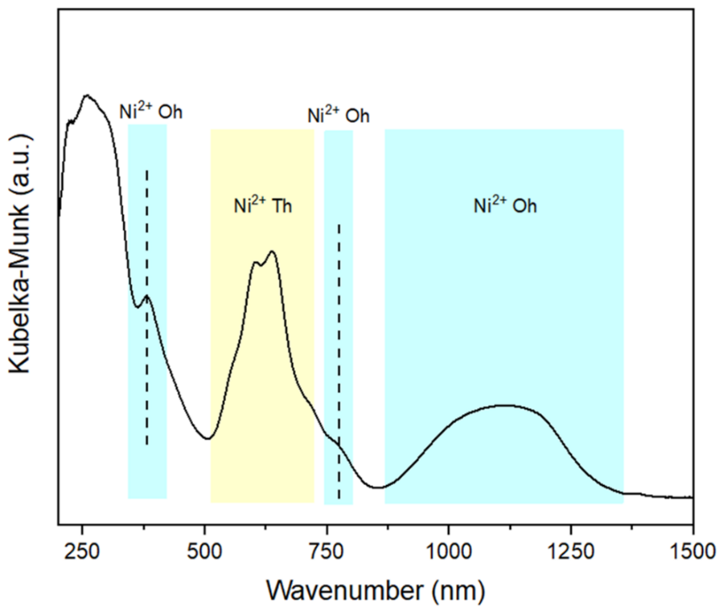
Figure S2. UV-vis DRS spectra of NiAl catalyst (calcined).
Comments: The pronounced absorption band below 350 nm corresponds to the ligand-to-metal charge transfer (LMCT) of oxygen (O²⁻) to Ni²⁺. The absorption strength within the range of 500-700 nm is due to the d-d electron transition of Ni²⁺in tetrahedral coordination, with limited input from octahedral nickel at 760 nm. The broad band within the range of 860-1350 nm is due to d-d electron transition of Ni²⁺ ions hosted in octahedral sites. The band positioned at 375 nm corresponds to octahedral Ni²⁺ species. All these features confirm the complete formation of a NiAl₂O₄ spinel structure in the calcined catalysts.

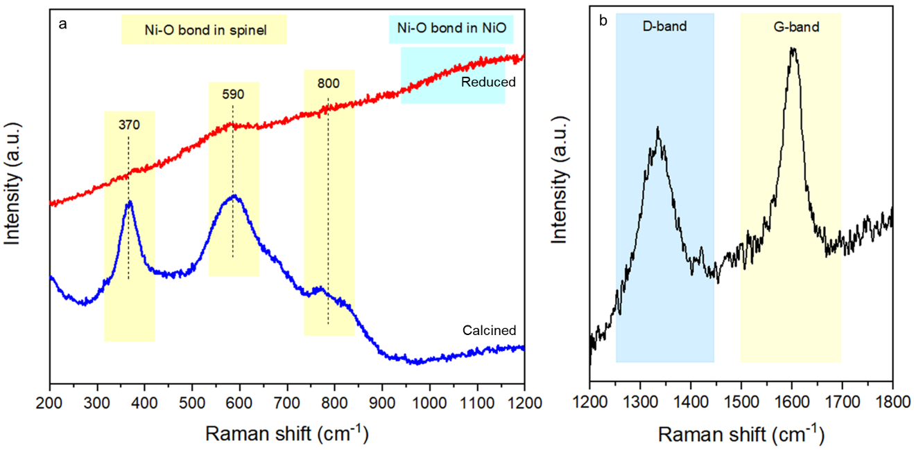
Figure S3. a Raman spectra of NiAl catalyst (calcined and reduced), b Raman spectrum of the spent catalyst in the carbon region.
Comments: a The Raman spectrum of calcined NiAl exhibits three bands at approximately 370, 590, and 800 cm⁻¹, which are associated with the Eg, T2g, and A1g modes of the spinel phase, respectively. The absence of Raman lines from NiO (at around 500 cm⁻¹) indicates that it is highly dispersed, consistent with the XRD and H₂-TPR results. The bands characteristic of spinel at 370 and 590 cm⁻¹ are weakened on the reduced catalysts which indicates that the H₂ treatment at 700 ºC does not fully reduce nickel. The band at 1000-1100 cm⁻¹ is due to the NiO layer in the passivated catalyst. b The Raman spectrum of used NiAl catalyst in the carbon region consist of two well-defined peaks at ca. 1340 and 1595 cm⁻¹, attributed to the disordered carbon species (D-band) and graphitic carbon with a high degree of crystallinity (G-band), respectively. The I_{D}/I_{G} intensity ratio has been used to calculate the graphitization degree.

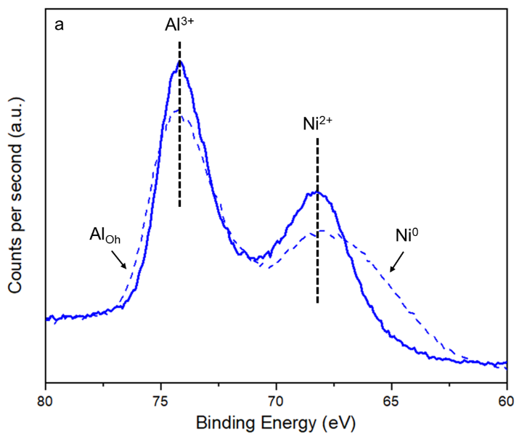
Figure S4. XPS spectra of Al2pNi3p from NiAl catalyst, in calcined (solid lines) and reduced form (dashed lines).
Comments: The Al2pNi3p spectrum from the calcined catalyst exhibits a partial overlap of Al 2p and Ni 3p peaks, resulting from the small energy separation. Measurements of the calcined materials reveals the presence of NiAl₂O₄ spinel, as indicated by the main peak at 74.2 eV [2]. In reduced state, the shoulder at lower BE indicates the presence of metallic nickel.

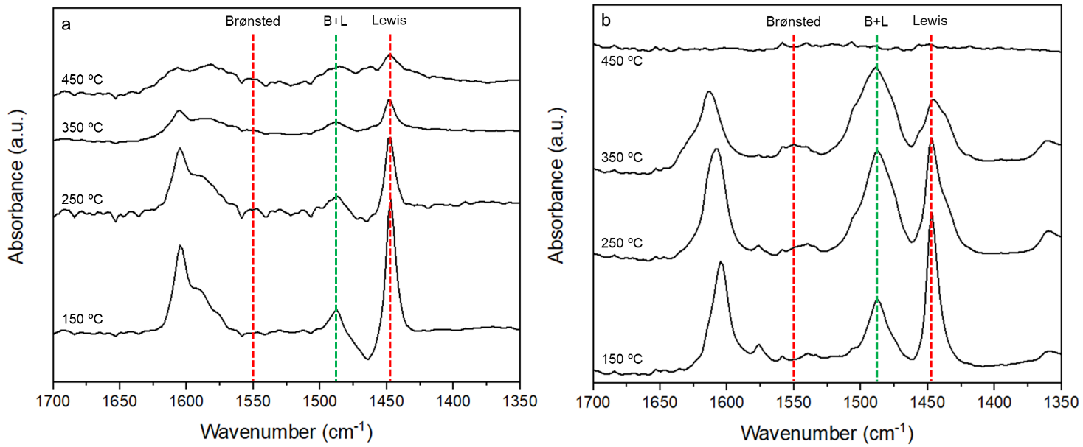
Figure S5. FTIR spectra of the Pyridine region after desorption at different temperatures for a NiAl catalyst, b HTC-600 catalyst. All the measurements are taken at 100 ºC.
Comments: The FTIR spectra for NiAl (a) and HTC-600 (b) catalyst have been collected after desorption at 150 °C, 250 ºC, 350 °C and 450 °C, which correspond to total, weak, medium, and strong acid sites, respectively. Bands at ~1550 and ~1450 cm⁻¹ correspond to the Brønsted and Lewis acid sites, respectively, while the band at 1490 cm⁻¹ is attributed to both Lewis and Brøsnted acid sites [3]. In both catalysts the contribution of Brønsted acid sites is null. The higher intensity of the bands for HTC-600 catalyst indicates higher acidity of this sample. The amount of Lewis (L) and Brønsted (B) acid sites per gram of catalyst is calculated according to:
$$C\left(L\right)=1.42 \frac{IA\left(L\right)*R^{2}}{W}$$
$$C\left(B\right)=1.88 \frac{IA\left(B\right)*R^{2}}{W}$$
where R is the pellet radius (0.65 cm), W is the mass of catalyst (in g), and IA is the integrated intensity of the band (in cm⁻¹). 1.42 and 1.88 are the extinction coefficients of Lewis and Brønsted sites, respectively.

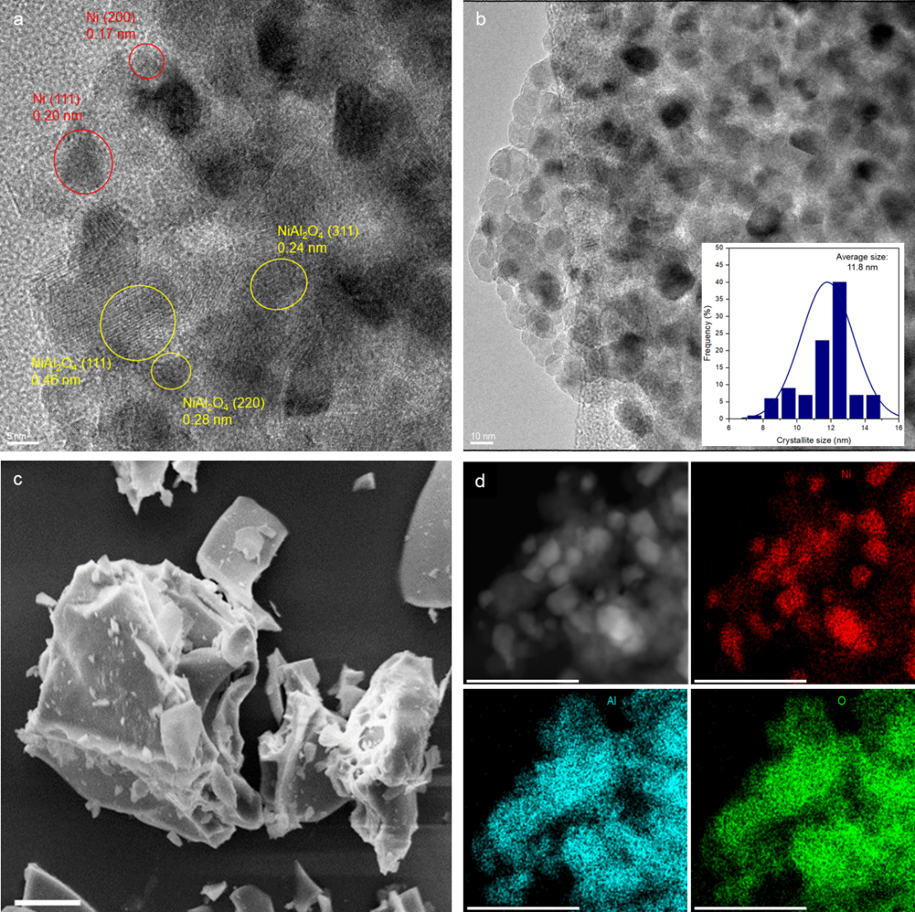

Figure S6. Characterizations of the reduced NiAl catalyst. a HRTEM image of NiAl. b HAADF-STEM image of NiAl. Inset shows the Ni crystal size distribution. c SEM image of NiAl. Scale bar equal 10 µm. d STEM-EDS elemental mapping for NiAl. Scale bar equal 50 nm.
Comments: In HRTEM images (Figure S6a) lattice fringes of metallic nickel and Ni-defective Ni_{1-X}Al₂O_{4-X} spinel are identified. HAADF-STEM (Figure S6b) shows metallic Ni particles ranging from 7 to 15 nm. SEM (Figure S6c) images reveal the generation of irregular particles (~40 µm) with smooth, densely packed surfaces and uniform nickel distribution.

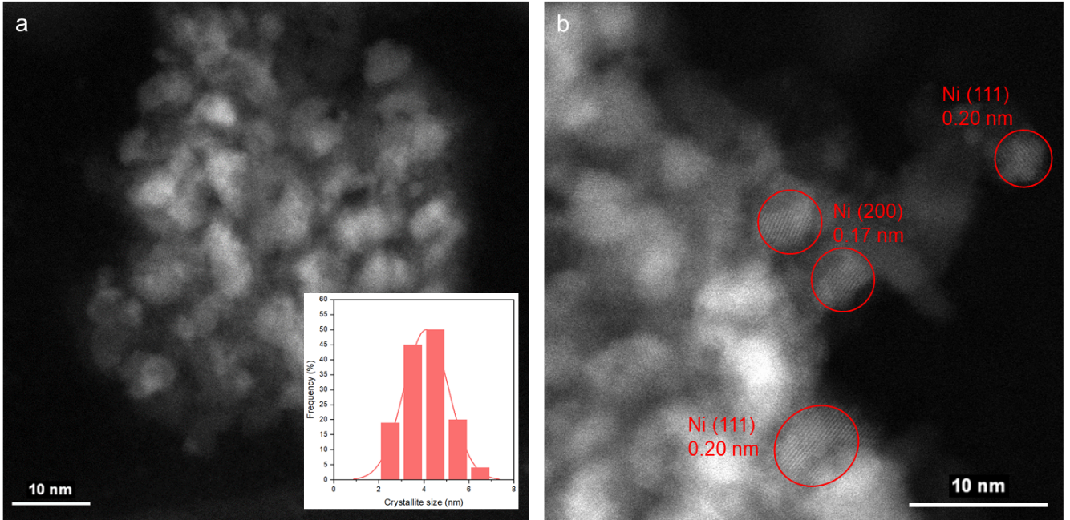
Figure S7. a HAADF-STEM image of HTC-600. Inset shows the Ni crystal size distribution. b HRTEM image of HTC-600.
Comments: a Ni nanoparticles are homogeneously distributed throughout the sample. A total of 135 particles were measured, revealing a size distribution with an average diameter of 4.1 nm and a standard deviation of 1.02 nm. b High-resolution transmission electron microscopy image shows lattice fringes with spacings of 0.17 nm and 0.20 nm, corresponding to the (200) and (111) facets of metallic Ni, respectively. No lattice fringes associated with alumina are observed, consistent with its highly amorphous nature as confirmed by XRD analysis.
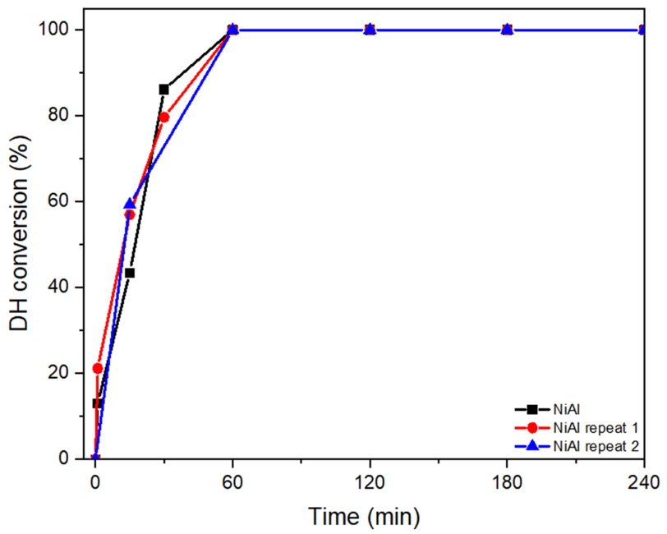
Figure S8. Repeatability test, dihydroeugenol conversion as function of time. Reactions condition: isoeugenol (0.1 g), catalyst (0.05 g), dodecane (50 mL), 275 ºC, 30 bar H₂; reaction mixture stirred at 900 rpm.
Comments: Concentration profiles obtained from three independent experiments were interpolated to a common time grid and found to be in excellent agreement within experimental uncertainty. Assuming a first order kinetics, the average apparent constant is 0.0537 min⁻¹ (standard deviation = 0.0068), supporting the reproducibility and reliability of the experimental data.
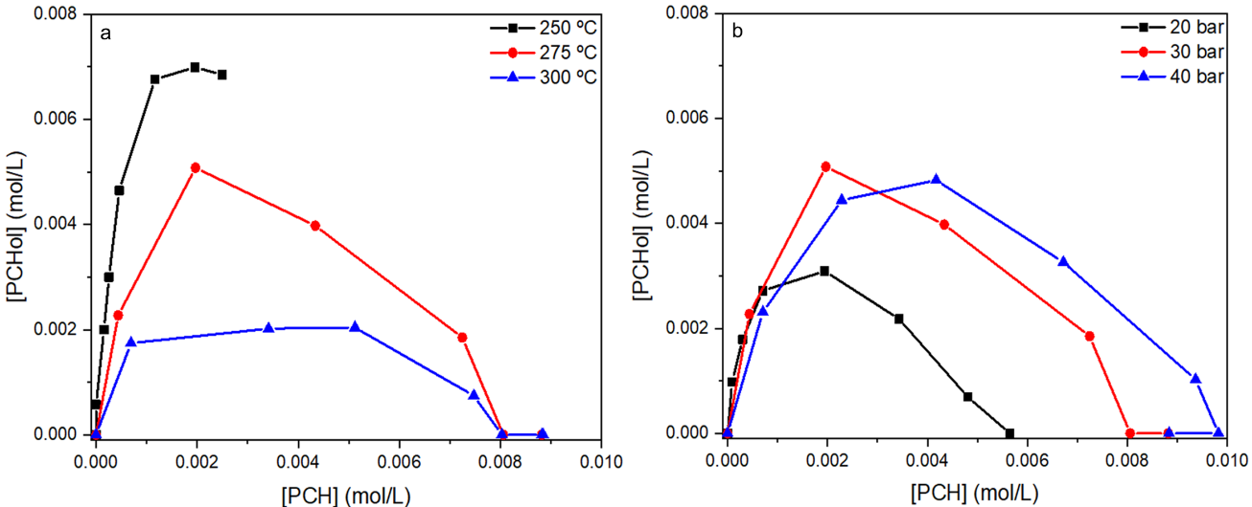

Figure S9. a Concentration of PCHol vs PCH at different temperatures under 30 bar, and b pressures at 275 ºC.
Comments: Most studies on SAFs production from HDO of isoeugenol and similar molecules are focused on the activity and yields to the end product PCH. The ratio of the experimentally measured initial formation rates ($\frac{r_{0,PCHol}}{r_{0,PCH}}$) under 30 bar was 12.8, 5.2 and 2.5 at 250 °C, 275 °C and 300 °C, respectively, reflecting the promotion of dehydroxylation step with temperature. That is, dehydroxylation of PCHol hardly occurred at 250 °C, while at 275 ºC and above, independent of the pressure (i.e. 20-40 bar), full conversion to PCH was achieved. At varying pressures, under 20, 30 and 40 bar, the ($\frac{r_{0,PCHol}}{r_{0,PCH}}$) ratio varied insignificantly, giving values of 3.8, 5.2 and 3.3, respectively.

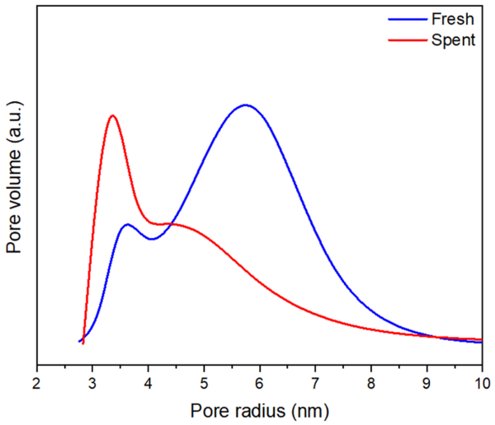
Figure S10. Pore size distribution of fresh and NiAl catalyst used at 275 ºC and 30 bar H₂.
Comments: The fresh catalyst exhibits a bimodal pore size distribution, with peaks centered at 3.5 and 6.0 nm, the latter being predominant. The average pore diameter is 5.4 nm. After use, the distribution shifts toward a higher contribution of smaller pores, resulting in a reduced average pore diameter of 4.9 nm.
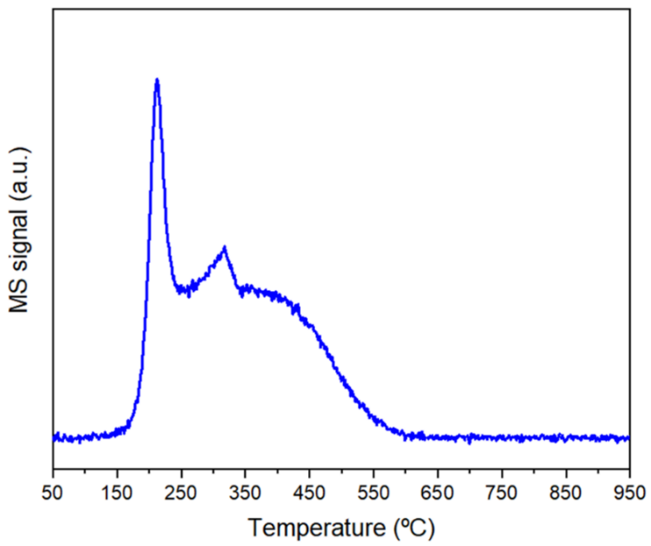

Figure S11. m/z = 15 signal from CH₄ released during TPH of NiAl catalyst used at 275 ºC and 30 bar H₂.

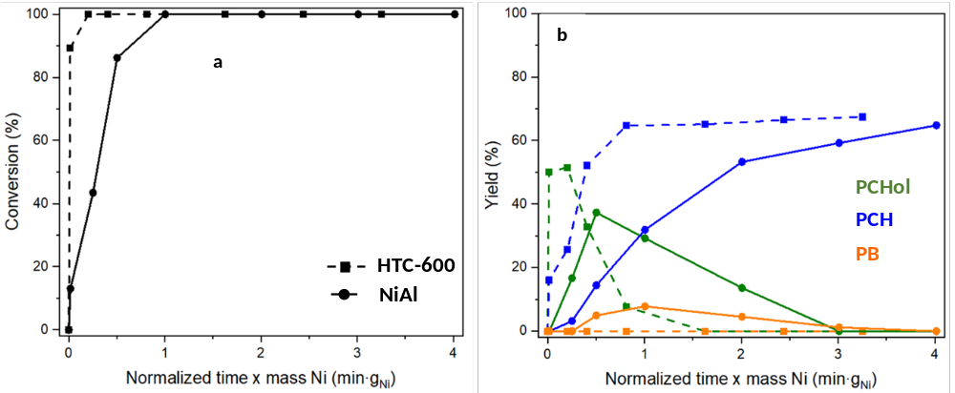

Figure S12. a Conversion of DH in function of normalized time mass of nickel. b Yield of PCHol, PCH and PB. Reactions conditions: isoeugenol (0.1 g), catalyst (0.05 g), dodecane (50 mL), 275 °C, 30 bar H₂; reaction mixture stirred at 900 rpm.

Comments: DH is converted much faster over HTC-600 compared to NiAl. Our NiAl catalyst reached a maximum of 7.8% at 1 ming_{Ni}; on the contrary, no PB was formed over HTC-600. Regarding PCHol, which is a hydrogenation product, it peaked at a shorter normalized reaction time and at a notably higher yield (i.e. 51.5% vs. 39%) over the HTC-600 catalyst.

References
1. Puig-Molina, A., Morales-Cano, F. & Janssens, T. V. W. The Cu Promoter in an Iron-Chromium-Oxide Based Water-Gas Shift Catalyst under Industrial Conditions Studied by in-Situ XAFS. J. Phys. Chem. C, 114, 15410-15416 (2010).
2. Velon, A. & Olefjord, I. Oxidation Behaviour of Ni3Al and Fe3Al: II. Early Stage of Oxide Growth. Oxid. Met. 56, 425-452 (2001).
3. Emeis, C. A. Determination of Integrated Molar Extinction Coefficients for Infrared Absorption Bands of Pyridine Adsorbed on Solid Acid Catalysts. J. Catal. 141, 347-354 (1993).

