Homocatenated Ga₄ Complexes with Unsaturated Ga-Ga=Ga-Ga Chains: Synthesis, Structural Characterization, and Diverse Reactivity

Ning Zhang,^{1,2} Bing Wang,^{1,2} Yanliang Wu,¹ Wenhao Chen,¹ Shuxia Zhu,¹ Linfang Lu,¹ Zhigang Ni,¹ Di Wu*¹

¹College of Materials, Chemistry and Chemical Engineering, Key Laboratory of Organosilicon Chemistry and Material Technology, Ministry of Education, Hangzhou Normal University, Hangzhou 311121, China; wudi@hznu.edu.cn
²Ning Zhang and Bing Wang contributed equally.
Corresponding authors E-mail addresses: wudi@hznu.edu.cn (D. Wu)

CONTENTS
- Regeneration of 2 and 1a
- Crystal Structure Determination
- UV-Vis spectrum of 1a and 1b
- STEM images and EDX elemental maps
- Theoretical calculations
- References
- NMR spectra

1. Regeneration of 2 and 1a
Regeneration of 2 from 1a: 1a (0.035 g, 0.250 mmol) and C₆D₆ (0.3 mL) were loaded in a dried J-Young Tube under argon atmosphere. The tube was sealed, shaken and the reaction was monitored by NMR spectroscopy. After 20 days at room temperature, formation of 2 was confirmed.
20 days
7 days
2 days
1 day
0 day
1a
1a
1a
2
2
2
Supplemental Figure S1 | ¹H NMR (C₆D₆) spectrum of 1a after 20 days at ambient temperature, indicating the formation of 2.

Regeneration of 1a from 7: 7 (0.030 g, 0.025 mmol) and D₈-THF (0.5 mL) were loaded in a dried J-Young Tube under argon atmosphere. The tube was sealed, shaken and the reaction was monitored by ¹H NMR spectroscopy. After 14 days, formation of 1a was confirmed.
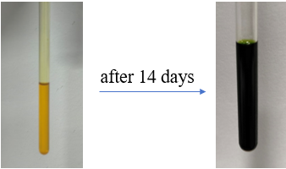
Supplemental Figure S2 | Comparison of solution color for compound 7 before and after 14 days at ambient temperature.

2. Crystal Structure Determination
X-ray data collection and structural refinement. Intensity data for compounds 1a and 1b were collected using a Bruker APEX-II CCD diffractometer and intensity data for compounds 2, 3, 4, 5, 6, and 7 were collected using a Bruker D8 Venture diffractometer. The crystals of 1a, 1b, 2, 3, 4, 5, 6, and 7 were measured at 170 K. Using Olex2¹, the structure was solved with the ShelXT² structure solution program using Intrinsic Phasing and refined with the ShelXL refinement package using Least Squares minimisation. All non-hydrogen atoms were subjected to anisotropic refinement. The hydrogen atoms were generated geometrically and allowed to ride in their respective parent atoms; they were assigned appropriate isotropic thermal parameters and included in the structure-factor calculations. CCDC: 2291195-2291196 and 2443687-2443692 contains the supplementary crystallographic data for this paper. The data can be obtained free of charge from the Cambridge Crystallography Data Center via www.ccdc.cam.ac.uk/data_request/cif.

Supplemental Table S1 | Summary of Data Collection and Structure Refinement of 1a, 1b, and 2.
 | 1a·(Toluene)₄ | 1b | 2
Formula | C₁₀₂H₁₄₄Ga₄N₈ | C₇₄H_{115.26}Ga₄N₈ | C₃₇H₅₇GaN₄
Fw | 1761.12 | 1395.88 | 627.58
cryst system | triclinic | monoclinic | orthorhombic
space group | P-1 | P2₁/n | P2₁2₁2₁
Size (mm³) | 0.05 × 0.03 × 0.03 | 0.217 × 0.154 × 0.041 | 0.48 × 0.35 × 0.30
T, K | 170.00 | 170.00 | 170.00
a, Å | 13.440(4) | 13.6465(7) | 12.6105(4)
b, Å | 14.183(5) | 19.1173(10) | 15.4880(5)
c, Å | 14.856(7) | 14.6407(8) | 18.2307(5)
α, deg | 90.51(5) | 90 | 90
β, deg | 100.64(4) | 100.627(2) | 90
γ, deg | 116.401(19) | 90 | 90
V, A³ | 2479.7(17) | 3754.0(3) | 3560.66(19)
Z | 1 | 2 | 4
ρ_{calcd}g·cm⁻³ | 1.179 | 1.235 | 1.171
μ, mm⁻¹ | 1.077 | 1.464 | 0.802
Refl collected | 26036 | 75661 | 74913
T_{min}/ T_{max} | 0.653/0.751 | 0.646/0.746 | 0.721/0.786
Independent refl | 9043 [R_{int} = 0.0681, R_{sigma} = 0.1079] | 8623 [R_{int} = 0.1426, R_{sigma} = 0.0789] | 7852 [R_{int} = 0.0441, R_{sigma} = 0.0276]
[R_{int}] | 0.0681 | 0.1426 | 0.0441
R [I>2sigma(I)] | 0.0663 | 0.0853 | 0.0222
R_{w}[I>2sigma(I)] | 0.1686 | 0.1662 | 0.0523
GOF | 1.110 | 1.072 | 1.034
Largest diff peak/hole[e·Å⁻³] | 1.73/-0.63 | 1.53/-0.88 | 0.20/-0.20

Supplemental Table S2 | Summary of Data Collection and Structure Refinement of 3, 4, and 5.

 | 3 | 4·(Toluene) | 5
Formula | C₃₇H₅₈GaN₄ | C₈₁H₁₂₀Ga₄I₂N₈ | C₈₆H₁₂₂Ga₄N₈S₂
Fw | 628.59 | 1738.52 | 1610.91
cryst system | monoclinic | triclinic | monoclinic
space group | P2₁/n | P-1 | C2/c
Size (mm³) | 0.363 × 0.258 × 0.195 | 0.05 × 0.03 × 0.03 | 0.08 × 0.06 × 0.04
T, K | 170.00 | 170.00 | 170.00
a, Å | 13.0363(6) | 13.166(3) | 22.905(4)
b, Å | 18.9681(8) | 14.419(3) | 13.390(2)
c, Å | 15.1215(6) | 44.430(19) | 28.905(5)
α, deg | 90 | 91.50(3) | 90
β, deg | 102.014(2) | 94.888(12) | 105.023(6)
γ, deg | 90 | 95.940(12) | 90
V, A³ | 3657.3(3) | 8354(4) | 8562(3)
Z | 4 | 4 | 4
ρ_{calcd}g·cm⁻³ | 1.142 | 1.382 | 1.250
μ, mm⁻¹ | 0.781 | 5.183 | 1.476
Refl collected | 74169 | 153237 | 106573
T_{min}/ T_{max} | 0.669/0.746 | 0.680/0.752 | 0.650/0.728
Independent refl | 8105 [R_{int} = 0.0620, R_{sigma} = 0.0312] | 38231 [R_{int} = 0.0677, R_{sigma} = 0.0654] | 9880 [R_{int} = 0.1149, R_{sigma} = 0.0616]
[R_{int}] | 0.0620 | 0.0677 | 0.1149
R [I>2sigma(I)] | 0.0443 | 0.0505 | 0.0528
R_{w}[I>2sigma(I)] | 0.1198 | 0.1179 | 0.1613
GOF | 1.032 | 1.054 | 1.122
Largest diff peak/hole[e·Å⁻³] | 1.63/-0.64 | 1.71/-0.73 | 0.53/-0.75

Supplemental Table S3 | Summary of Data Collection and Structure Refinement of 6 and 7.

 | 6·(Hexane)_{0.5} | 7·(Et₂O)_{0.5}
Formula | C₇₇H₁₁₉Ga₄N₈S | C₈₉H₁₂₇Ga₄N₈O_{1.5}
Fw | 1467.73 | 1611.86
cryst system | triclinic | monoclinic
space group | P-1 | P2₁/c
Size (mm³) | 0.08 × 0.06 × 0.04 | 0.13 × 0.08 × 0.04
T, K | 170.00 | 170.00
a, Å | 13.2381(10) | 23.9327(14)
b, Å | 14.6550(11) | 16.5933(10)
c, Å | 21.4397(16) | 23.8819(14)
α, deg | 93.237(3) | 90
β, deg | 99.157(3) | 109.544(2)
γ, deg | 99.405(3) | 90
V, A³ | 4036.6(5) | 8937.6(9)
Z | 2 | 4
ρ_{calcd}g·cm⁻³ | 1.208 | 1.198
μ, mm⁻¹ | 1.377 | 1.140
Refl collected | 60676 | 109188
T_{min}/ T_{max} | 0.668/0.752 | 0.680/0.752
Independent refl | 18364 [R_{int} = 0.0680, R_{sigma} = 0.0798] | 20477 [R_{int} = 0.0751, R_{sigma} = 0.0700]
[R_{int}] | 0.0680 | 0.0751
R [I>2sigma(I)] | 0.0758 | 0.0671
R_{w}[I>2sigma(I)] | 0.1675 | 0.1734
GOF | 1.059 | 1.046
Largest diff peak/hole[e·Å⁻³] | 0.76/-0.47 | 1.39/-1.14

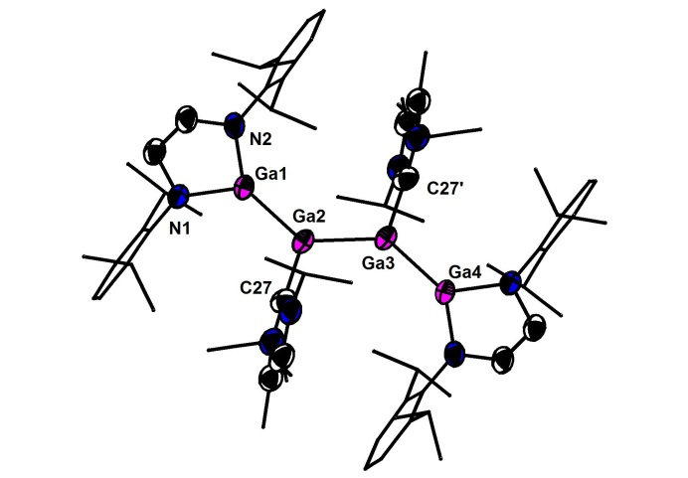

Supplemental Figure S3 | Molecular structure of 1b (H atoms are omitted for clarity; Me-, ^{i}Pr-, and Dip-substituents are depicted as a wireframe for simplicity). Selected bond lengths (Å) and angles (°): Ga2-Ga3 2.374(12), Ga1-Ga2 2.430(9), Ga3-Ga4 2.430(9), Ga2-C27 2.079(71), Ga3-C27’ 2.079(71), Ga1-N1 1.887(50), Ga1-N2 1.886(45); Ga1-Ga2-Ga3 130.94(6), C27-Ga2-Ga3 106.51(19), Ga1-Ga2-C27 99.32(16).
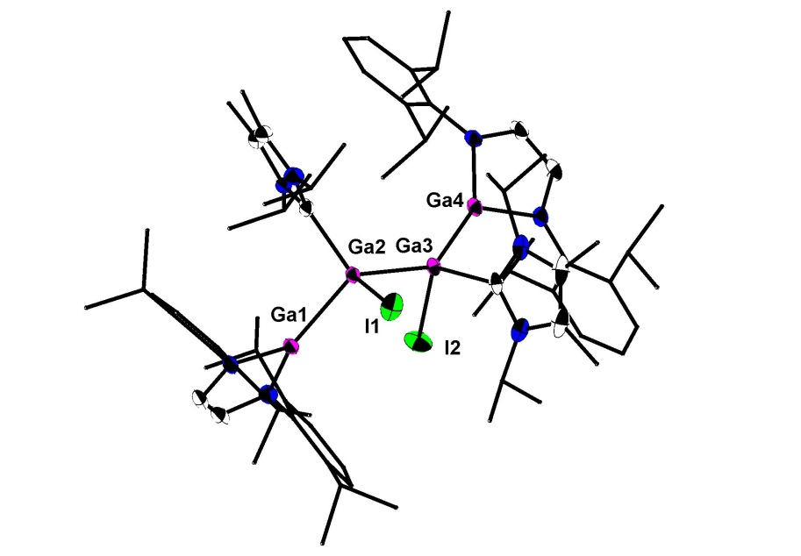

Supplemental Figure S4 | Molecular structure of 4 (H atoms are omitted for clarity; Me-, ^{i}Pr-, and Dip-substituents are depicted as a wireframe for simplicity). Selected bond lengths (Å) and angles (°): Ga2-I1 2.677(11), Ga3-I2 2.663(5), Ga1-Ga2 2.458(5), Ga2-Ga3 2.447(5), Ga3-Ga4 2.421(8); I1-Ga2-Ga3 100.62(29), I2-Ga3-Ga2 100.30(23), Ga1-Ga2-Ga3 119.23(40), Ga2-Ga3-Ga4 139.75(37).

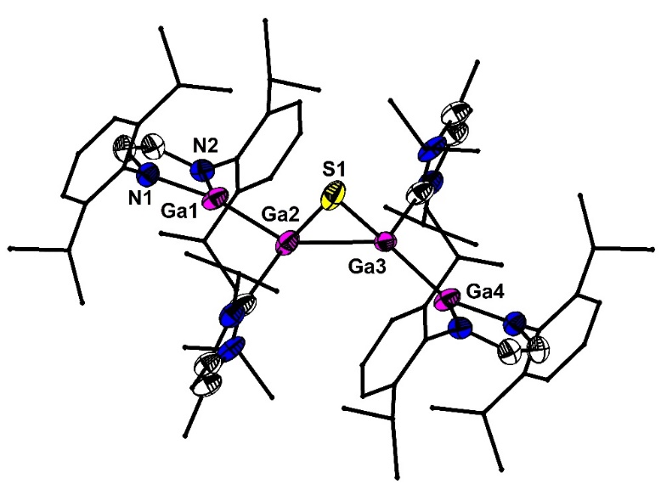

Supplemental Figure S5 | Molecular structure of 6 (H atoms are omitted for clarity; Me-, ^{i}Pr-, and Dip-substituents are depicted as a wireframe for simplicity). Selected bond lengths (Å) and angles (°): Ga2-S1 2.313(2), Ga3-S1 2.290(2), Ga1-Ga2 2.506(2), Ga2-Ga3 2.492(1), Ga3-Ga4 2.346(1); Ga2-S1-Ga3 65.57(5), S1-Ga2-Ga3 56.76(4), S1-Ga3-Ga2 57.67(4).

3. UV-Vis spectra of 1a and 1b
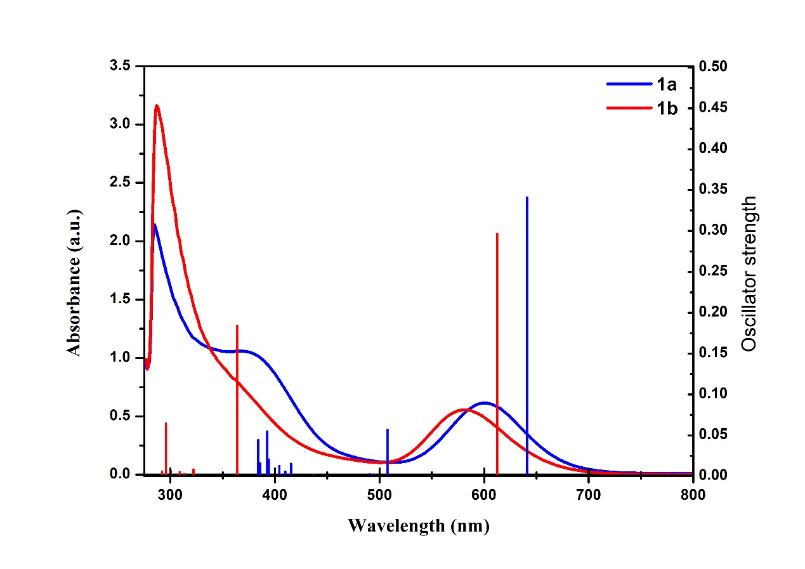
Supplemental Figure S6 | UV-Vis absorption spectra of 1a and 1b measured in toluene solution at room temperature and solid vertical bars indicate their calculated transitions. Ultraviolet spectrum was recorded on a Perkin Elmer Lambda 750 UV/Vis spectrophotometer. The time-dependent DFT (TD-DFT) method was used for calculation of 1a and 1b on the absorption features at the M06-2X/6-311G(d,p) level of theory on the basis of the optimized structures.³

Supplemental Table S4 | Selected calculated excited wavelengths (λ) and oscillator strengths (f) of selected transitions of 1a and 1b.

Compound Excited state Wavelength (nm) f Transition Nature ----------------------------------------------------------------------------------------------------------------------
1a S₁ 637.01 0.3762 HOMO→LUMO 98%
S₆ 383.71 0.1135 HOMO-3→LUMO 70%
HOMO→LUMO+4 20%
S₇ 374.64 0.1031 HOMO→LUMO+4 63%
HOMO-2→LUMO 22%
1b S₁ 611.74 0.2975 HOMO→LUMO 99%
S₆ 363.23 0.1851 HOMO→LUMO+4 64%
S₁₆ 295.09 0.0653 HOMO-2→LUMO 78%
----------------------------------------------------------------------------------------------------------------------

4. STEM images and EDX elemental maps
The filter residue from compound 1a: Cp*Ga (0.820 g) was added into a mixture of [(L¹)K₂] (0.910 g) and IiPr (0.360 g) in toluene (35.0 mL) at room temperature. After stirring for one month, the color of the solution changed from deep blue to yellow. After filtration, the residual solid was washed with toluene (20.0 mL) and then dried under vacuum to afford the grey powder (0.110 g), which was used for SEM or EDX measurements. (STEM images and EDX elemental maps were collected by Supra55).

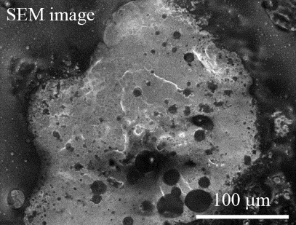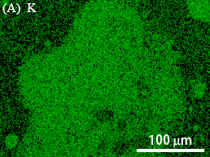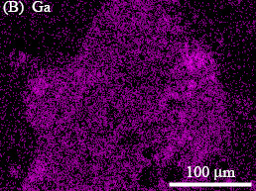
Supplemental Figure S7 | STEM image and EDX elemental maps of the filter residue produced during the synthesis of compound 1a.

5. Theoretical calculations

Gaussian 09 (Revision D.01) was used for all density functional theory (DFT) calculations.⁴ Geometry optimization, frequency calculations, and Natural bond order (NBO) analysis on compounds 1a, 1b, A (Ga₂(^{t}Bu₂MeSi)₂(IiPr)₂) and B (ArGaGaAr, Ar = 2,6-Dip₂C₆H₃) were performed at the M06-2X/6-311G(d,p) level of theory. The Natural Bond Orbital (NBO) analysis was performed using the NBO 7.0 software.⁵
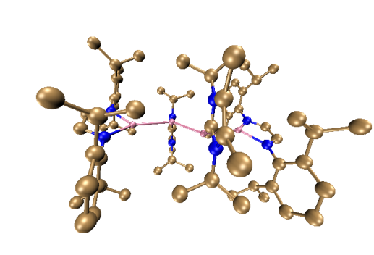

Supplemental Figure S8 | Calculated optimized structure for 1a at M06-2X/6-311G(d,p) level of theory. Hydrogen atoms are omitted for clarity.

Supplemental Table S5 | Optimized structure of 1a (atom, x-, y-, z- positions in Å).
Ga | 3.27235000 | -0.75786200 | -0.00886300
N | 4.05724400 | -2.48022500 | 0.21333900
N | 5.02069700 | -0.17807600 | -0.52296500
N | 1.76584200 | 3.35037400 | 0.45608800
N | 1.47076300 | 2.34062900 | 2.33544300
C | 5.42167700 | -2.43842500 | -0.08412600
H | 6.01352700 | -3.33968100 | 0.01762900
C | 5.92004700 | -1.24525000 | -0.47600500
H | 6.95655400 | -1.08018200 | -0.74367500
C | 3.53735600 | -3.69157600 | 0.73748000
C | 3.61520400 | -3.94445800 | 2.12184500
C | 3.08695800 | -5.13310600 | 2.62465900
H | 3.13131500 | -5.32671600 | 3.69150500
C | 2.51635600 | -6.07720500 | 1.78265100
H | 2.11896500 | -7.00075700 | 2.18805500
C | 2.46396400 | -5.83223400 | 0.41866800
H | 2.02132800 | -6.57297500 | -0.24027400
C | 2.96450100 | -4.64767200 | -0.12268200
C | 4.24635000 | -2.94550600 | 3.07420800
H | 4.68942500 | -2.14807100 | 2.47460000
C | 3.17889500 | -2.32254600 | 3.98000200
H | 2.40944700 | -1.82301200 | 3.38289300
H | 3.63049100 | -1.59023600 | 4.65459300
H | 2.68816300 | -3.08818200 | 4.58839900
C | 5.36876000 | -3.57981900 | 3.90242600
H | 4.98787200 | -4.36454200 | 4.56162700
H | 5.85060600 | -2.82430300 | 4.52819600
H | 6.12714000 | -4.02174300 | 3.25298300
C | 2.85498500 | -4.40958900 | -1.61675000
H | 3.35038100 | -3.46181100 | -1.83670900
C | 1.38064500 | -4.28670300 | -2.01430500
H | 0.83516600 | -5.20702400 | -1.78030400
H | 1.27659400 | -4.09754000 | -3.08703800
H | 0.90074100 | -3.46613000 | -1.47081000
C | 3.55704900 | -5.50684300 | -2.42292600
H | 4.60708400 | -5.58810300 | -2.13502400
H | 3.51038700 | -5.28226300 | -3.49170000
H | 3.08683100 | -6.48150700 | -2.26519100
C | 5.48024500 | 1.03753600 | -1.09175800
C | 6.09852900 | 2.01016000 | -0.27738800
C | 6.57566600 | 3.18141400 | -0.86472700
H | 7.05763600 | 3.93218400 | -0.24852600
C | 6.44565100 | 3.40344200 | -2.22995400
H | 6.82369300 | 4.31839700 | -2.67140300
C | 5.83277600 | 2.44649900 | -3.02385600
H | 5.73603200 | 2.61975100 | -4.09100300
C | 5.35402700 | 1.25341400 | -2.47839300
C | 6.19217300 | 1.81110900 | 1.22458100
H | 6.14035000 | 0.73707000 | 1.41588200
C | 4.97983000 | 2.47169200 | 1.89568000
H | 4.96069200 | 3.54494800 | 1.67590500
H | 5.01722400 | 2.34821500 | 2.98259800
H | 4.04756600 | 2.03520300 | 1.52667000
C | 7.49555800 | 2.33939100 | 1.82838400
H | 8.36557100 | 1.94608300 | 1.29866800
H | 7.56786600 | 2.03968300 | 2.87655900
H | 7.54417200 | 3.43123700 | 1.79953100
C | 4.73516500 | 0.21170400 | -3.39401600
H | 4.50523800 | -0.66731800 | -2.78855800
C | 3.42715500 | 0.72445400 | -4.00697800
H | 2.69061000 | 0.94772800 | -3.22898100
H | 2.99772400 | -0.02871500 | -4.67352400
H | 3.59781900 | 1.63377700 | -4.59145200
C | 5.71933400 | -0.22638600 | -4.48475400
H | 5.96683500 | 0.60055500 | -5.15604400
H | 5.28443100 | -1.02765300 | -5.08755200
H | 6.64753500 | -0.59426700 | -4.04287000
C | 1.46517400 | 2.15173200 | 0.99708100
C | 1.95924000 | 4.29996300 | 1.44732500
C | 1.76877400 | 3.66282300 | 2.63727000
C | 1.77900900 | 3.56740600 | -1.00763300
H | 1.76295100 | 2.55675500 | -1.42242700
C | 3.06815100 | 4.22393700 | -1.48495100
H | 3.08473500 | 5.30003200 | -1.30611600
H | 3.16317100 | 4.06441400 | -2.56098300
H | 3.93598600 | 3.76195800 | -1.00817500
C | 0.50270700 | 4.27056000 | -1.45414700
H | 0.38137100 | 3.68975900 | -1.17439700
H | 0.50719700 | 4.38145200 | -2.54082400
H | 0.40553100 | 5.26517100 | -1.01452300
C | 2.32962200 | 5.72499800 | 1.20652300
H | 3.37674100 | 5.81996600 | 0.90936200
H | 2.18839600 | 6.29902300 | 2.12162600
H | 1.71407400 | 6.17921100 | 0.42939000
C | 1.84904500 | 4.23927000 | 4.01197400
H | 1.04734900 | 3.86970200 | 4.65132600
H | 1.75049500 | 5.32305400 | 3.95772100
H | 2.80343400 | 4.01177700 | 4.49286200
C | 1.15744500 | 1.25178700 | 3.28448100
H | 1.18778400 | 0.35043800 | 2.66776000
C | 2.21472200 | 1.10611900 | 4.37244400
H | 3.21250900 | 1.03742000 | 3.93361300
H | 2.02012900 | 0.18087600 | 4.91670000
H | 2.19536500 | 1.92241000 | 5.09412500
C | 0.26011600 | 1.37361100 | 3.82949000
H | 0.39133800 | 2.26215000 | 4.45109300
H | 0.47849300 | 0.49412900 | 4.43932800
H | 0.98243500 | 1.40046900 | 3.00992600
Ga | 1.09671300 | 0.41306800 | -0.11121000
Ga | 3.27270100 | 0.75778300 | 0.00880900
N | 4.05752000 | 2.48033000 | -0.21245200
N | 5.02088800 | 0.17796900 | 0.52332600
N | 1.76537300 | -3.35006300 | -0.45640200
N | 1.47026700 | -2.34032000 | -2.33575300
C | 5.42185700 | 2.43850800 | 0.08544100
H | 6.01370300 | 3.33981600 | -0.01588300
C | 5.92017900 | 1.24522700 | 0.47706200
H | 6.95660800 | 1.08012800 | 0.74501200
C | 3.53785900 | 3.69160300 | -0.73700900
C | 3.61649300 | 3.94435700 | -2.12136500
C | 3.08833200 | 5.13284800 | -2.62461700
H | 3.13321900 | 5.32633700 | -3.69146100
C | 2.51711700 | 6.07696300 | -1.78303000
H | 2.11979300 | 7.00039700 | -2.18877100
C | 2.46405000 | 5.83217100 | -0.41904700
H | 2.02098500 | 6.57294400 | 0.23957300
C | 2.96444800 | 4.64773400 | 0.12272100
C | 4.24825600 | 2.94529300 | -3.07320400
H | 4.69202200 | 2.14856700 | -2.47316700
C | 3.18106600 | 2.32097400 | -3.97838200
H | 2.41199800 | 1.82140800 | -3.38080400
H | 3.63302100 | 1.58844200 | -4.65249400
H | 2.68976900 | 3.08588300 | -4.58724600
C | 5.37005900 | 3.57980200 | -3.90208200
H | 4.98850900 | 4.36359600 | -4.56199800
H | 5.85246400 | 2.82410400 | -4.52719900
H | 6.12813800 | 4.02293500 | -3.25311100
C | 2.85426300 | 4.40985400 | 1.61676800
H | 3.34943000 | 3.46202700 | 1.83703500
C | 1.37976300 | 4.28722300 | 2.01376600
H | 0.83450100 | 5.20762600 | 1.77957700
H | 1.27528300 | 4.09806500 | 3.08646000
H | 0.89994600 | 3.46673100 | 1.47008300
C | 3.55618100 | 5.50712200 | 2.42305900
H | 4.60635700 | 5.58813900 | 2.13559900
H | 3.50901200 | 5.28275200 | 3.49185500
H | 3.08620900 | 6.48184100 | 2.26492400
C | 5.48034100 | -1.03780300 | 1.09185800
C | 6.09836100 | -2.01038800 | 0.27725600
C | 6.57538700 | -3.18181500 | 0.86435600
H | 7.05713400 | -3.93257800 | 0.24797300
C | 6.44555400 | -3.40401000 | 2.22956700
H | 6.82352100 | -4.31908600 | 2.67082900
C | 5.83294300 | -2.44708500 | 3.02370600
H | 5.73629000 | -2.62050300 | 4.09083400
C | 5.35427100 | -1.25386800 | 2.47848300
C | 6.19188000 | -1.81110200 | -1.22469200
H | 6.14010800 | -0.73702700 | -1.41579200
C | 4.97943400 | -2.47148400 | -1.89580700
H | 4.96019200 | -3.54477100 | -1.67619300
H | 5.01677800 | -2.34784500 | -2.98271000
H | 4.04723000 | -2.03496600 | -1.52668500
C | 7.49519800 | -2.33935200 | -1.82867300
H | 8.36525500 | -1.94615600 | -1.29894400
H | 7.56745400 | -2.03948500 | -2.87680600
H | 7.54377200 | -3.43120200 | -1.79998600
C | 4.73542000 | -0.21228800 | 3.39426600
H | 4.50590500 | 0.66699400 | 2.78903100
C | 3.42706300 | -0.72496800 | 4.00656200
H | 2.69077600 | -0.94783100 | 3.22820400
H | 2.99751200 | 0.02805200 | 4.67319900
H | 3.59733500 | -1.63453700 | 4.59077400
C | 5.71928400 | 0.22519900 | 4.48551200
H | 5.96630300 | -0.60198400 | 5.15667900
H | 5.28436200 | 1.02641000 | 5.08836900
H | 6.64775700 | 0.59295900 | 4.04409900
C | 1.46481800 | -2.15138900 | -0.99739600
C | 1.95845600 | -4.29972600 | -1.44763300
C | 1.76797300 | -3.66258400 | -2.63757500
C | 1.77872200 | -3.56703500 | 1.00732400
H | 1.76263300 | -2.55636800 | 1.42207400
C | 3.06796300 | -4.22345500 | 1.48451700
H | 3.08463300 | -5.29954300 | 1.30564500
H | 3.16305800 | -4.06396000 | 2.56054800
H | 3.93572000 | -3.76139200 | 1.00768000
C | 0.50254800 | -4.27026700 | 1.45406900
H | 0.38163700 | -3.68966400 | 1.17426400
H | 0.50715000 | -4.38089200 | 2.54077400
H | 0.40548600 | -5.26500800 | 1.01471100
C | 2.32862700 | -5.72481300 | -1.20681100
H | 3.37577800 | -5.81994500 | -0.90981700
H | 2.18714100 | -6.29887300 | -2.12185200
H | 1.71312300 | -6.17886800 | -0.42955200
C | 1.84796500 | -4.23902700 | -4.01229200
H | 1.04584300 | -3.86981600 | -4.65132800
H | 1.74992000 | -5.32285000 | -3.95797500
H | 2.80205700 | -4.01112400 | -4.49356500
C | 1.15703900 | -1.25143700 | -3.28477000
H | 1.18796700 | -0.35006000 | -2.66812000
C | 2.21391900 | -1.10624100 | -4.37319500
H | 3.21201900 | -1.03888100 | -3.93487100
H | 2.02003100 | -0.18045100 | -4.91677600
H | 2.19327000 | -1.92206400 | -5.09537200
C | 0.26073700 | -1.37274700 | -3.82931600
H | 0.39248400 | -2.26136600 | -4.45070000
H | 0.47888600 | -0.49330500 | -4.43929300
H | 0.98286300 | -1.39910600 | -3.00956600
Ga | 1.09674300 | -0.41258400 | 0.11086100

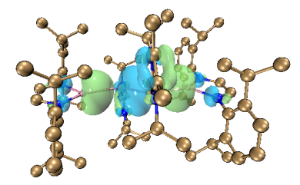
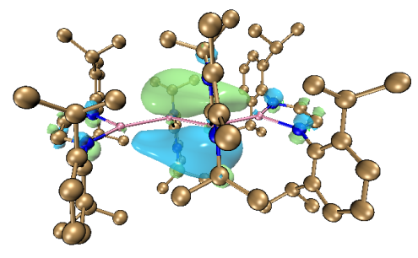

HOMO-3 (–6.38 eV) HOMO (–4.13 eV)
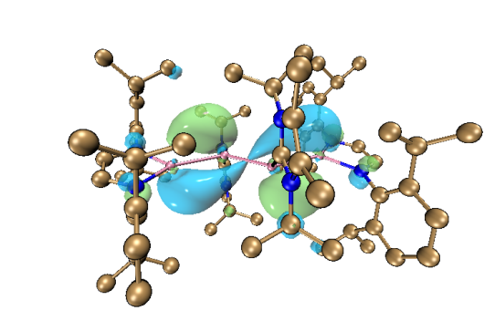

LUMO (–0.54 eV)

Supplemental Figure S9 | Plots of the frontier orbitals of 1a (isosurface value = 0.03).

Supplemental Table S6 | Selected data of NPA charges of 1a.

Natural Population
Natural ---------------------------------------------------------------------------
Atom No Charge Core Valence Rydberg Total
-------------------------------------------------------------------------------------------------------------
Ga 1 1.50539 27.99732 1.45495 0.04234 29.49461
Ga 99 -0.36729 27.99892 3.34120 0.02716 31.36729
Ga 100 1.50539 27.99732 1.45495 0.04234 29.49461
Ga 198 -0.36718 27.99892 3.34110 0.02716 31.36718
--------------------------------------------------------------------------------------------------------------

Supplemental Table S7 | Selected WBI values of 1a.
Atom No 1 99 100 198
--------------------------------------------------------------------------
1. Ga 0.0000 0.9570 0.0139 0.0611
99. Ga 0.9570 0.0000 0.0611 1.5996
100. Ga 0.0133 0.0585 0.0000 0.9652
198. Ga 0.0585 1.5919 0.9570 0.0000
--------------------------------------------------------------------------

Supplemental Table S8 | Selected data of Natural Bond Orbital Analysis of 1a.
(Occupancy) Bond orbital/ Coefficients/ Hybrids
----------------------------------------------------------------------------------------------------------------------
151. (1.94684) BD ( 1)Ga 1 -Ga 99
( 45.60%) 0.6753*Ga 1 s( 86.34%)p 0.15( 13.35%)d 0.00( 0.31%)
0.0000 0.0000 0.0000 0.9291 0.0112
0.0009 0.0000 0.0000 0.0000 0.0000
-0.3258 -0.0416 -0.0167 0.0065 0.0001
0.0000 0.0000 0.1568 0.0229 0.0102
-0.0038 0.0000 0.0000 0.0000 0.0069
-0.0002 -0.0033 0.0013 0.0000 0.0000
-0.0357 -0.0115 0.0000 -0.0019 0.0025
0.0000 -0.0009 0.0018 0.0000 0.0246
0.0078 0.0000 -0.0319 -0.0029
( 54.40%) 0.7376*Ga 99 s( 32.32%)p 2.08( 67.23%)d 0.01( 0.45%)
0.0000 0.0000 0.0000 0.5680 -0.0228
0.0015 0.0002 0.0000 0.0000 0.0000
0.7185 0.0215 -0.0056 0.0012 0.0000
0.0000 0.0000 -0.3809 -0.0079 0.0019
-0.0009 0.0000 0.0000 0.0000 0.1016
0.0011 -0.0056 0.0002 0.0000 0.0000
-0.0475 0.0013 0.0000 0.0228 -0.0039
0.0000 -0.0016 -0.0027 0.0000 0.0255
0.0002 0.0000 -0.0325 0.0033
259. (1.89525) BD ( 1)Ga 99 -Ga 198
( 50.00%) 0.7071*Ga 99 s( 48.69%)p 1.05( 51.07%)d 0.00( 0.24%)
0.0000 0.0000 0.0000 0.6973 0.0260
0.0001 0.0000 0.0000 0.0000 0.0000
-0.6759 -0.0065 -0.0087 0.0019 0.0000
0.0000 0.0000 -0.2197 0.0075 -0.0026
0.0008 0.0000 0.0000 0.0000 0.0730
0.0057 0.0017 0.0000 0.0000 0.0000
0.0307 0.0007 0.0000 -0.0209 -0.0011
0.0000 -0.0068 -0.0034 0.0000 0.0286
0.0018 0.0000 -0.0123 -0.0009
( 50.00%) 0.7071*Ga198 s( 48.68%)p 1.05( 51.08%)d 0.00( 0.24%)
0.0000 0.0000 0.0000 0.6973 0.0260
0.0001 0.0000 0.0000 0.0000 0.0000
0.6759 0.0065 0.0087 -0.0019 0.0000
0.0000 0.0000 0.2199 -0.0075 0.0026
-0.0008 0.0000 0.0000 0.0000 -0.0731
-0.0057 -0.0017 0.0000 0.0000 0.0000
0.0307 0.0007 0.0000 -0.0209 -0.0011
0.0000 -0.0068 -0.0034 0.0000 0.0285
0.0018 0.0000 -0.0122 -0.0009
260. (1.76689) BD ( 2)Ga 99 -Ga 198
( 50.00%) 0.7071*Ga 99 s( 8.32%)p11.01( 91.61%)d 0.01( 0.06%)
0.0000 0.0000 0.0000 -0.2882 0.0131
0.0011 0.0004 0.0000 0.0000 0.0000
-0.0849 -0.0086 0.0027 0.0009 0.0000
0.0000 0.0000 -0.3578 0.0053 0.0054
0.0006 0.0000 0.0000 0.0000 0.8835
-0.0074 -0.0145 -0.0012 0.0000 0.0000
0.0087 0.0023 0.0000 -0.0011 -0.0068
0.0000 -0.0186 -0.0010 0.0000 -0.0061
0.0016 0.0000 0.0097 -0.0016
( 50.00%) 0.7071*Ga198 s( 8.33%)p11.00( 91.61%)d 0.01( 0.06%)
0.0000 0.0000 0.0000 0.2883 -0.0131
-0.0011 -0.0004 0.0000 0.0000 0.0000
-0.0847 -0.0086 0.0027 0.0009 0.0000
0.0000 0.0000 -0.3578 0.0053 0.0054
0.0006 0.0000 0.0000 0.0000 0.8835
-0.0074 -0.0145 -0.0012 0.0000 0.0000
-0.0087 -0.0023 0.0000 0.0011 0.0068
0.0000 0.0186 0.0010 0.0000 0.0061
-0.0016 0.0000 -0.0097 0.0017
261. (1.94684) BD ( 1)Ga100-Ga198
( 45.60%) 0.6753*Ga100 s( 86.34%)p 0.15( 13.35%)d 0.00( 0.31%)
0.0000 0.0000 0.0000 0.9291 0.0112
0.0009 0.0000 0.0000 0.0000 0.0000
0.3258 0.0416 0.0167 -0.0065 -0.0001
0.0000 0.0000 -0.1568 -0.0229 -0.0102
0.0038 0.0000 0.0000 0.0000 -0.0070
0.0002 0.0033 -0.0013 0.0000 0.0000
-0.0357 -0.0115 0.0000 -0.0019 0.0025
0.0000 -0.0009 0.0018 0.0000 0.0246
0.0078 0.0000 -0.0319 -0.0029
( 54.40%) 0.7376*Ga198 s( 32.32%)p 2.08( 67.22%)d 0.01( 0.45%)
0.0000 0.0000 0.0000 0.5681 -0.0228
0.0015 0.0002 0.0000 0.0000 0.0000
-0.7186 -0.0215 0.0056 -0.0012 0.0000
0.0000 0.0000 0.3807 0.0079 -0.0019
0.0009 0.0000 0.0000 0.0000 -0.1016
-0.0011 0.0056 -0.0002 0.0000 0.0000
-0.0475 0.0013 0.0000 0.0228 -0.0039
0.0000 -0.0016 -0.0027 0.0000 0.0255
0.0002 0.0000 -0.0325 0.0033
----------------------------------------------------------------------------------------------------------------------

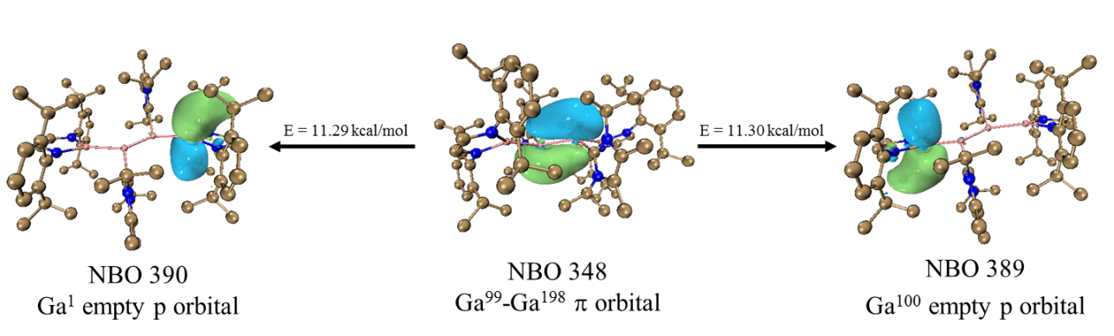

Supplemental Figure S10 | Selected NBOs of 1a for the second-order perturbation theory analysis (isosurface value = 0.03).

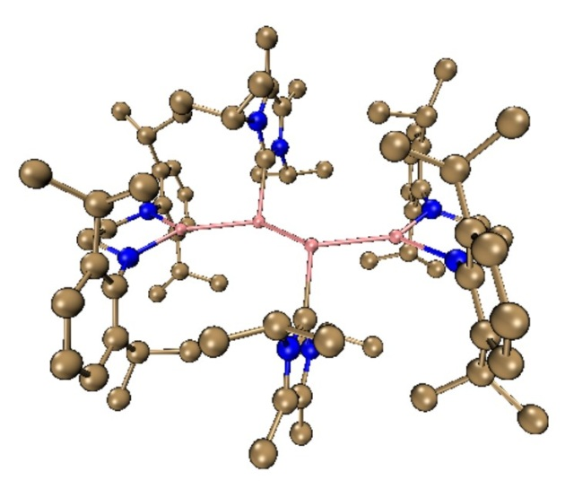

Supplemental Figure S11 | Calculated optimized structure for 1b at M06-2X/6-311G(d,p) level of theory. Hydrogen atoms are omitted for clarity.

Supplemental Table S9 | Optimized structure of 1b (atom, x-, y-, z- positions in Å).
Ga | -3.25661116 | -0.63931589 | 0.13455282
N | -5.01829937 | 0.05204150 | -0.05695221
N | -4.01018307 | -2.33047563 | 0.51981296
Ga | -1.07143768 | 0.46788521 | -0.20208679
C | -6.00060129 | -1.03048503 | -0.01188610
C | -5.39865015 | 1.14188592 | -0.88027886
C | -5.43626439 | -2.17619154 | 0.83070521
C | -3.46741100 | -3.57941951 | 0.89743377
N | -1.35761921 | 2.37646478 | 2.26381364
C | -1.30943295 | 2.22528550 | 0.92190137
C | -1.44338858 | 3.72191768 | 2.59802599
C | -1.42887485 | 1.22082625 | 3.18175609
N | -1.36067258 | 3.47101892 | 0.40976646
C | -1.44530088 | 4.41488567 | 1.42400395
C | -1.40319281 | 3.71296448 | -1.04857396
H | -6.22242678 | -1.40390384 | -1.02624777
H | -6.95127023 | -0.68395573 | 0.41600842
H | -5.59646317 | -1.96127775 | 1.90136693
H | -5.97853375 | -3.10221265 | 0.60420735
C | -5.92939980 | 2.31013296 | -0.28916221
C | -5.26871990 | 1.07573103 | -2.28774814
C | -6.31190610 | 3.37925985 | -1.09757485
C | -5.99587203 | 2.44271955 | 1.22037776
H | -6.71025502 | 4.27940170 | -0.64171201
C | -6.18269711 | 3.31503183 | -2.47800034
H | -6.48575337 | 4.15275915 | -3.09544798
C | -5.66065576 | 2.17005422 | -3.06077523
H | -5.55743931 | 2.12249597 | -4.14028061
C | -4.71519672 | -0.15011864 | -2.99995268
H | -5.91785802 | 1.43408131 | 1.63169096
C | -4.77631012 | 3.24323518 | 1.69736557
C | -7.29637026 | 3.07508080 | 1.72051048
H | -4.79500152 | 4.25489784 | 1.27742040
H | -3.85283676 | 2.76137258 | 1.36523646
H | -4.75334258 | 3.32565352 | 2.78870032
H | -7.33541327 | 3.03843385 | 2.81215360
H | -8.16781094 | 2.54676734 | 1.32807977
H | -7.37729040 | 4.12532027 | 1.42770830
H | -4.46499068 | -0.90410388 | -2.24910804
C | -3.43231906 | 0.17868145 | -3.77349096
C | -5.76107381 | -0.77282057 | -3.93380978
H | -3.62410785 | 0.91956588 | -4.55470321
H | -3.03917996 | -0.72130126 | -4.25548203
H | -2.65869291 | 0.57446131 | -3.10948453
H | -6.68399947 | -0.99969451 | -3.39619693
H | -5.37798398 | -1.69922866 | -4.37067765
H | -6.00901917 | -0.09256611 | -4.75327983
C | -3.26263630 | -4.56634003 | -0.09781855
C | -3.19635522 | -3.88732471 | 2.24571469
C | -2.87735354 | -5.85026161 | 0.28284188
C | -3.43435686 | -4.19494345 | -1.55966329
H | -2.74652967 | -6.61880187 | -0.47052320
C | -2.68367888 | -6.17265666 | 1.62218991
H | -2.40768458 | -7.18196283 | 1.90537547
C | -2.82337635 | -5.18946413 | 2.58825090
H | -2.63156505 | -5.43253279 | 3.62891478
C | -3.24415274 | -2.82115065 | 3.32653465
H | -4.24614241 | -3.46413577 | -1.60809762
C | -2.15628399 | -3.51088365 | -2.07230118
C | -3.79292226 | -5.37427006 | -2.46444315
H | -3.59479807 | -1.89597960 | 2.86320089
C | -4.20874335 | -3.17968136 | 4.46111541
C | -1.82907362 | -2.56602189 | 3.86511405
H | -3.87365476 | -4.07029331 | 4.99987270
H | -5.21076351 | -3.37767318 | 4.07475096
H | -4.27281916 | -2.36009414 | 5.18226441
H | -1.84159076 | -1.80984423 | 4.65583554
H | -1.16353732 | -2.22312079 | 3.06575643
H | -1.40605077 | -3.47994522 | 4.29264199
C | -1.45218890 | 5.89253567 | 1.21570993
C | -1.44164774 | 4.26039779 | 3.99000516
H | -1.12817340 | 2.74660803 | -1.47963045
C | -0.33938039 | 4.70451236 | -1.49421431
C | -2.82123722 | 4.03805755 | -1.50105339
H | -0.59546081 | 5.74007934 | -1.26708982
H | -0.21670055 | 4.62582351 | -2.57623243
H | 0.62106421 | 4.46465016 | -1.03242769
H | -3.50628738 | 3.22940475 | -1.23524477
H | -2.83999086 | 4.15266781 | -2.58712002
H | -3.19444140 | 4.96376263 | -1.05593163
H | -1.75158323 | 6.39125687 | 2.13666916
H | -2.15200934 | 6.18918164 | 0.43410679
H | -0.45873539 | 6.25630280 | 0.93901086
H | -0.44336572 | 4.20825769 | 4.43235086
H | -2.13042785 | 3.72176776 | 4.64077555
H | -1.74836026 | 5.30552729 | 3.97768902
H | -1.18961448 | 0.36597262 | 2.54655945
C | -2.84830930 | 1.03802870 | 3.71229782
C | -0.35568234 | 1.26863929 | 4.26236790
H | -3.17981532 | 1.88940555 | 4.31018100
H | -2.88952293 | 0.14632028 | 4.34120744
H | -3.55414971 | 0.90817635 | 2.88627140
H | 0.61245840 | 1.50465917 | 3.81537129
H | -0.28045788 | 0.27962370 | 4.71997223
H | -0.57637937 | 1.98827089 | 5.05170598
Ga | 1.07146383 | -0.46788784 | 0.20200901
H | -1.31434210 | -4.21195020 | -2.03750924
H | -1.88214548 | -2.64266991 | -1.46467195
H | -2.28430260 | -3.17848060 | -3.10791282
H | -4.03923270 | -5.01245404 | -3.46553872
H | -4.65263634 | -5.92677270 | -2.07928769
H | -2.95739168 | -6.07266285 | -2.56871395
Ga | 3.25659939 | 0.63934838 | -0.13455375
C | 1.30939722 | -2.22528049 | -0.92196733
H | 1.12825500 | -2.74656633 | 1.47962375
H | 1.18955051 | -0.36600401 | -2.54662007
N | 1.35754066 | -2.37650189 | -2.26386784
C | 1.42875542 | -1.22086282 | -3.18182466
N | 5.01827936 | -0.05201840 | 0.05696088
N | 4.01021163 | 2.33049374 | -0.51976124
C | 6.00059880 | 1.03048982 | 0.01197650
C | 5.43629656 | 2.17624920 | -0.83058662
H | 4.46513337 | 0.90397296 | 2.24920573
N | 1.36065608 | -3.47100079 | -0.40978377
C | 1.40323478 | -3.71293169 | 1.04855500
C | 1.44327607 | -3.72196139 | -2.59804413
C | 2.84816209 | -1.03809721 | -3.71246773
C | 0.35550358 | -1.26863874 | -4.26237435
C | 5.39863174 | -1.14194342 | 0.88017814
C | 3.46743275 | 3.57946415 | -0.89728134
H | 6.22239868 | 1.40386745 | 1.02635612
H | 6.95127811 | 0.68396332 | -0.41590472
H | 5.59655012 | 1.96140407 | -1.90125120
H | 5.97856148 | 3.10225688 | -0.60400033
C | 4.71532524 | 0.14990923 | 2.99997798
C | 1.44520355 | -4.41489760 | -1.42400187
C | 0.33944476 | -4.70447571 | 1.49424549
C | 2.82129161 | -4.03804067 | 1.50098579
C | 1.44148847 | -4.26047405 | -3.99000728
H | 3.17958018 | -1.88948487 | -4.31039098
H | 2.88937631 | -0.14637764 | -4.34135754
H | 3.55406637 | -0.90830516 | -2.88648814
H | -0.61263751 | -1.50457258 | -3.81533326
H | 0.28034808 | -0.27963099 | -4.72000585
H | 0.57611603 | -1.98831494 | -5.05169621
C | 5.92932990 | -2.31015585 | 0.28893387
C | 5.26877614 | -1.07590021 | 2.28764858
C | 3.26274723 | 4.56633332 | 0.09804126
C | 3.19630217 | 3.88745695 | -2.24552645
C | 3.43244949 | -0.17889851 | 3.77350921
C | 5.76124997 | 0.77248284 | 3.93386822
C | 1.45202356 | -5.89253842 | -1.21566764
H | 0.59551071 | -5.74004034 | 1.26709615
H | 0.21683105 | -4.62579213 | 2.57627159
H | -0.62103013 | -4.46460942 | 1.03252658
H | 3.50634833 | -3.22940968 | 1.23512892
H | 2.84007936 | -4.15260367 | 2.58705714
H | 3.19447343 | -4.96377188 | 1.05589766
H | 0.44319474 | -4.20832291 | -4.43233051
H | 2.13025942 | -3.72186457 | -4.64080671
H | 1.74818899 | -5.30560698 | -3.97767677
C | 6.31187192 | -3.37934475 | 1.09723903
C | 5.99571211 | -2.44261464 | -1.22061804
C | 5.66073524 | -2.17029171 | 3.06057537
C | 2.87746416 | 5.85028452 | -0.28251243
C | 3.43457020 | 4.19484650 | 1.55984876
C | 2.82329877 | 5.18961881 | -2.58795675
C | 3.24408620 | 2.82136933 | -3.32642667
H | 3.62419584 | -0.91988767 | 4.55463425
H | 3.03938575 | 0.72105522 | 4.25561628
H | 2.65878079 | -0.57454507 | 3.10947352
H | 6.68417806 | 0.99935433 | 3.39625961
H | 5.37820931 | 1.69887545 | 4.37081110
H | 6.00917184 | 0.09214700 | 4.75327874
H | 1.75138137 | -6.39130529 | -2.13661550
H | 2.15183398 | -6.18919445 | -0.43405937
H | 0.45855181 | -6.25625047 | -0.93895814
H | 6.71019623 | -4.27945358 | 0.64128910
C | 6.18273081 | -3.31522626 | 2.47768292
H | 5.91769911 | -1.43394648 | -1.63184894
C | 4.77610041 | -3.24308016 | -1.69759817
C | 7.29614689 | -3.07498938 | -1.72089437
H | 5.55757282 | -2.12280940 | 4.14008954
H | 2.74671761 | 6.61878144 | 0.47091083
C | 2.68368860 | 6.17275752 | -1.62183015
H | 4.24626612 | 3.46393127 | 1.60817250
C | 2.15646224 | 3.51093278 | 2.07257994
C | 3.79339340 | 5.37408172 | 2.46465319
H | 2.63142123 | 5.43275404 | -3.62859344
H | 3.59465834 | 1.89614017 | -2.86314727
C | 4.20876243 | 3.17999013 | -4.46091413
C | 1.82904616 | 2.56634159 | -3.86514093
H | 6.48582047 | -4.15300574 | 3.09504287
H | 4.79479349 | -4.25475510 | -1.27767939
H | 3.85264447 | -2.76122032 | -1.36542338
H | 4.75309094 | -3.32546223 | -2.78893410
H | 7.33509889 | -3.03827015 | -2.81253871
H | 8.16763811 | -2.54673195 | -1.32850143
H | 7.37705317 | -4.12525277 | -1.42817150
H | 2.40768604 | 7.18208131 | -1.90494456
H | 1.31461443 | 4.21212504 | 2.03797029
H | 1.88210863 | 2.64282686 | 1.46488904
H | 2.28456370 | 3.17839911 | 3.10813763
H | 4.03975807 | 5.01217349 | 3.46570266
H | 4.65313982 | 5.92649012 | 2.07943771
H | 2.95796541 | 6.07257918 | 2.56904888
H | 3.87369544 | 4.07065851 | -4.99959542
H | 5.21075697 | 3.37796062 | -4.07447315
H | 4.27289390 | 2.36047821 | -5.18214264
H | 1.84163950 | 1.81025420 | -4.65594609
H | 1.16344159 | 2.22335763 | -3.06587722
H | 1.40606903 | 3.48031858 | -4.29260437

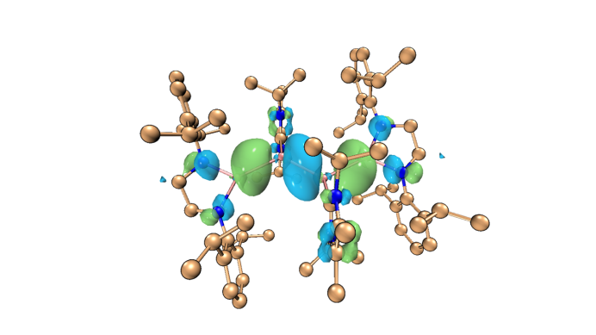
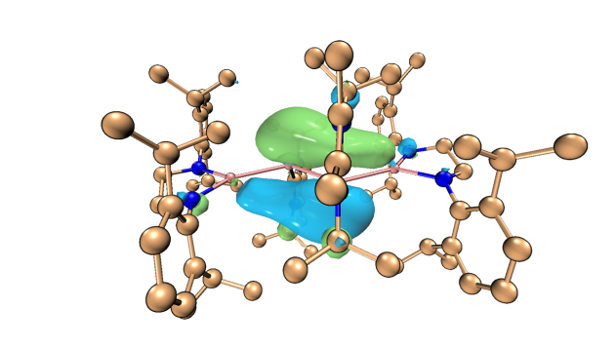

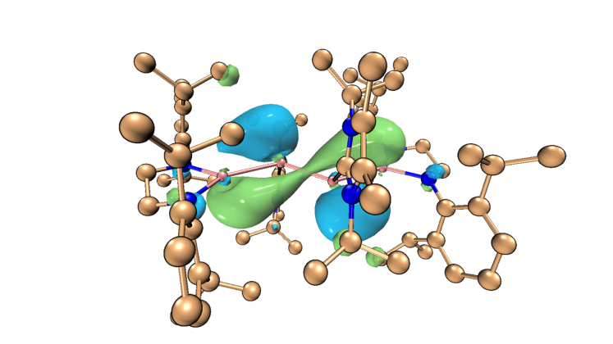
HOMO-1 (–6.16 eV) HOMO (–4.31 eV)

LUMO (–0.60 eV)

Supplemental Figure S12 | Plots of the frontier orbitals of 1b (isosurface value = 0.03).

Supplemental Table S10 | Selected data of NPA charges of 1b.
Natural Population
Natural ---------------------------------------------------------------------------
Atom No Charge Core Valence Rydberg Total
-------------------------------------------------------------------------------------------------------------
Ga 1 1.57791 27.99716 1.36881 0.05612 29.42209
Ga 4 -0.35484 27.99894 3.32487 0.03103 31.35484
Ga 96 -0.35489 27.99894 3.32492 0.03103 31.35489
Ga 103 1.57793 27.99716 1.36879 0.05612 29.42207
--------------------------------------------------------------------------------------------------------------

Supplemental Table S11 | Selected WBI values of 1b.
Atom No 1 4 96 103
--------------------------------------------------------------------------
1. Ga 0.0000 0.9276 0.0659 0.0142
4. Ga 0.9276 0.0000 1.5460 0.0659
96. Ga 0.0659 1.5460 0.0000 0.9276
103. Ga 0.0142 0.0659 0.9276 0.0000
--------------------------------------------------------------------------

Supplemental Table S12 | Selected data of Natural Bond Orbital Analysis of 1b.
(Occupancy) Bond orbital/ Coefficients/ Hybrids
----------------------------------------------------------------------------------------------------------------------
151. (1.93991) BD ( 1)Ga 1-Ga 4
( 45.12%) 0.6717*Ga 1 s( 89.24%)p 0.12( 10.46%)d 0.00( 0.30%)
0.0000 0.0000 0.0000 0.9446 0.0120
0.0013 -0.0001 0.0000 0.0000 0.0000
0.2843 0.0724 0.0083 -0.0067 0.0000
0.0000 0.0000 0.1210 0.0355 0.0071
-0.0031 0.0000 0.0000 0.0000 -0.0469
-0.0160 -0.0013 0.0018 0.0000 0.0000
0.0328 0.0115 0.0000 -0.0105 -0.0042
0.0000 -0.0052 0.0012 0.0000 0.0261
0.0083 0.0000 -0.0292 -0.0011
( 54.88%) 0.7408*Ga 4 s( 31.51%)p 2.15( 67.88%)d 0.02( 0.61%)
0.0000 0.0000 0.0000 0.5607 -0.0262
0.0012 0.0002 0.0000 0.0000 0.0000
-0.7291 -0.0180 0.0062 -0.0010 0.0000
0.0000 0.0000 -0.3515 -0.0055 0.0047
-0.0005 0.0000 0.0000 0.0000 0.1524
0.0028 -0.0093 0.0009 0.0000 0.0000
0.0522 -0.0012 0.0000 -0.0365 0.0037
0.0000 -0.0055 -0.0024 0.0000 0.0312
0.0005 0.0000 -0.0315 0.0022
156. (1.85895) BD ( 1)Ga 4-Ga 96
( 50.00%) 0.7071*Ga 4 s( 47.49%)p 1.10( 52.24%)d 0.01( 0.27%)
0.0000 0.0000 0.0000 0.6886 0.0267
0.0004 0.0000 0.0000 0.0000 0.0000
0.6693 0.0045 0.0080 -0.0019 -0.0001
0.0000 0.0000 -0.2471 0.0056 -0.0050
0.0006 0.0000 0.0000 0.0000 0.1148
0.0098 0.0019 -0.0002 0.0000 0.0000
-0.0332 -0.0018 0.0000 0.0286 0.0023
0.0000 -0.0104 -0.0039 0.0000 0.0230
0.0024 0.0000 -0.0082 -0.0011
( 50.00%) 0.7071*Ga 96 s( 47.49%)p 1.10( 52.24%)d 0.01( 0.27%)
0.0000 0.0000 0.0000 0.6886 0.0267
0.0004 0.0000 0.0000 0.0000 0.0000
-0.6693 -0.0045 -0.0080 0.0019 0.0001
0.0000 0.0000 0.2471 -0.0056 0.0050
-0.0006 0.0000 0.0000 0.0000 -0.1148
-0.0098 -0.0019 0.0002 0.0000 0.0000
-0.0332 -0.0018 0.0000 0.0286 0.0023
0.0000 -0.0104 -0.0039 0.0000 0.0230
0.0024 0.0000 -0.0082 -0.0011
157. (1.76505) BD ( 2)Ga 4-Ga 96
( 50.00%) 0.7071*Ga 4 s( 11.41%)p 7.76( 88.51%)d 0.01( 0.08%)
0.0000 0.0000 0.0000 -0.3377 0.0086
0.0011 0.0004 0.0000 0.0000 0.0000
0.0773 0.0076 -0.0029 -0.0006 0.0001
0.0000 0.0000 -0.3207 0.0040 0.0045
0.0010 -0.0001 0.0000 0.0000 0.8809
-0.0031 -0.0139 -0.0010 0.0000 0.0000
-0.0078 -0.0024 0.0000 0.0011 0.0072
0.0000 -0.0192 -0.0015 0.0000 -0.0055
0.0011 0.0000 0.0180 -0.0020
( 50.00%) 0.7071*Ga 96 s( 11.41%)p 7.76( 88.50%)d 0.01( 0.08%)
0.0000 0.0000 0.0000 0.3377 -0.0086
-0.0011 -0.0004 0.0000 0.0000 0.0000
0.0773 0.0076 -0.0029 -0.0006 0.0001
0.0000 0.0000 -0.3207 0.0040 0.0045
0.0010 -0.0001 0.0000 0.0000 0.8809
-0.0031 -0.0139 -0.0010 0.0000 0.0000
0.0078 0.0024 0.0000 -0.0011 -0.0072
0.0000 0.0192 0.0015 0.0000 0.0055
-0.0011 0.0000 -0.0180 0.0020
262. (1.93992) BD ( 1)Ga 96-Ga103
( 54.88%) 0.7408*Ga 96 s( 31.51%)p 2.15( 67.88%)d 0.02( 0.61%)
0.0000 0.0000 0.0000 0.5607 -0.0262
0.0012 0.0002 0.0000 0.0000 0.0000
0.7291 0.0180 -0.0062 0.0010 0.0000
0.0000 0.0000 0.3515 0.0055 -0.0047
0.0005 0.0000 0.0000 0.0000 -0.1524
-0.0028 0.0093 -0.0009 0.0000 0.0000
0.0522 -0.0012 0.0000 -0.0365 0.0037
0.0000 -0.0055 -0.0024 0.0000 0.0312
0.0005 0.0000 -0.0315 0.0022
( 45.12%) 0.6717*Ga103 s( 89.24%)p 0.12( 10.46%)d 0.00( 0.30%)
0.0000 0.0000 0.0000 0.9446 0.0120
0.0013 -0.0001 0.0000 0.0000 0.0000
-0.2843 -0.0724 -0.0083 0.0067 0.0000
0.0000 0.0000 -0.1210 -0.0355 -0.0071
0.0031 0.0000 0.0000 0.0000 0.0468
0.0160 0.0013 -0.0018 0.0000 0.0000
0.0328 0.0115 0.0000 -0.0105 -0.0042
0.0000 -0.0052 0.0012 0.0000 0.0261
0.0083 0.0000 -0.0292 -0.0011
----------------------------------------------------------------------------------------------------------------------

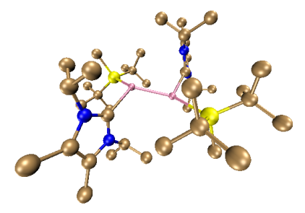

Supplemental Figure S13 | Calculated optimized structure for A at M06-2X/6-311G(d,p) level of theory. Hydrogen atoms are omitted for clarity.

Supplemental Table S13 | Optimized structure of A (atom, x-, y-, z- positions in Å).
Ga | -1.02858757 | 0.41335061 | 0.50209922
Ga | 0.99950033 | -0.50506921 | -0.44580208
Si | -2.04018560 | 2.69855746 | 0.37804359
Si | 1.99804076 | -2.79549793 | -0.55397778
C | -3.68804981 | 2.93580014 | -0.64009098
C | -0.67951661 | 3.98501078 | -0.16473582
C | -2.52995136 | 3.26414358 | 2.13993626
H | -2.65889825 | 4.35041178 | 2.19299983
H | -3.47409547 | 2.80835400 | 2.45251021
H | -1.77064837 | 2.97670685 | 2.87197260
C | -4.42518253 | 4.23513369 | -0.27704504
H | -3.84215448 | 5.12898559 | -0.50034746
H | -5.36042567 | 4.30131084 | -0.84909137
H | -4.68924851 | 4.26249121 | 0.78357563
C | -3.41694680 | 2.92309560 | -2.14901462
H | -2.81611143 | 2.05727712 | -2.44619688
H | -4.36144075 | 2.88649863 | -2.70862760
H | -2.88247189 | 3.82197901 | -2.46791854
C | -4.64170214 | 1.77985975 | -0.30392753
H | -5.58617946 | 1.90130862 | -0.85171115
H | -4.21878806 | 0.80892914 | -0.56549086
H | -4.88460995 | 1.76024669 | 0.76327692
C | 0.03347739 | 3.54666046 | -1.44966213
H | 0.83676611 | 4.25777366 | -1.69531665
H | 0.47205841 | 2.55437738 | -1.32954401
H | -0.64522177 | 3.50632824 | -2.30575335
C | -1.21363539 | 5.40889143 | -0.36522461
H | -0.37366875 | 6.10153709 | -0.51229492
H | -1.85234303 | 5.48388346 | -1.24848378
H | -1.78291481 | 5.76371758 | 0.49889678
C | 0.36297156 | 4.02839092 | 0.96293088
H | -0.05956101 | 4.42913291 | 1.88920920
H | 0.76111918 | 3.03105253 | 1.17299531
H | 1.20467046 | 4.67316110 | 0.67092291
C | 3.91305869 | -2.97120744 | -0.23439848
C | 4.24406822 | -3.04105310 | 1.26044999
H | 3.71438495 | -2.27442749 | 1.83357026
H | 3.97975537 | -4.01462031 | 1.68113566
H | 5.32123782 | -2.89742529 | 1.41943784
C | 4.60855845 | -1.74086453 | -0.83351737
H | 4.35721435 | -1.62331643 | -1.89392589
H | 4.32141477 | -0.82095215 | -0.31717432
H | 5.69942059 | -1.84765909 | -0.76337599
C | 4.50618576 | -4.21028531 | -0.92427650
H | 5.56977343 | -4.30262736 | -0.66794989
H | 4.01163211 | -5.13619388 | -0.62210267
H | 4.43697777 | -4.13496930 | -2.01216474
C | 0.95428125 | -4.02044038 | 0.53733090
C | 1.82085851 | -3.43412394 | -2.34792065
H | 0.79636089 | -3.37172734 | -2.71648349
H | 2.44044630 | -2.83517625 | -3.02371228
H | 2.14756149 | -4.47399179 | -2.44123998
C | 0.99894919 | -3.65331139 | 2.02703804
H | 0.74429821 | -2.60135016 | 2.18524334
H | 0.27649398 | -4.26440764 | 2.58444579
H | 1.98109059 | -3.83440331 | 2.46586702
C | -0.50800970 | -3.90998605 | 0.07104589
H | -1.14271901 | -4.58315210 | 0.66424528
H | -0.89226244 | -2.89253762 | 0.20186934
H | -0.62707202 | -4.18933999 | -0.98072647
C | 1.40596505 | -5.47846194 | 0.38131595
H | 1.41260064 | -5.79909392 | -0.66443261
H | 2.40643094 | -5.63639425 | 0.79288304
H | 0.72226782 | -6.14350137 | 0.92556411
C | 2.52613817 | 1.00791572 | -0.10791431
C | -2.64453694 | -0.99113438 | 0.20258137
C | -4.13333283 | -2.66482442 | 0.53849785
C | -3.96602810 | -2.54040324 | -0.80378254
C | 3.43815769 | 2.71179997 | 1.08815131
C | 3.54998644 | 3.02674061 | -0.22721911
N | 2.82144954 | 1.46621896 | 1.13911002
N | 3.00653331 | 1.96383364 | -0.94251622
N | -3.06004039 | -1.50157659 | -0.98757868
N | -3.33206173 | -1.69848317 | 1.13259122
C | -4.62967480 | -3.32117288 | -1.89091736
H | -5.03033828 | -4.24671052 | -1.47856722
H | -5.45758399 | -2.76803612 | -2.33965210
H | -3.93310937 | -3.59064655 | -2.68371076
C | -4.97991812 | -3.62133375 | 1.30908109
H | -5.78949412 | -3.11345693 | 1.83950741
H | -5.43285331 | -4.34237867 | 0.63045310
H | -4.38902817 | -4.17663674 | 2.04171148
C | 3.73200156 | 3.58247291 | 2.26517274
H | 4.23657267 | 3.05070706 | 3.06975775
H | 4.37912202 | 4.40333700 | 1.95817594
H | 2.80915898 | 4.01228686 | 2.66500694
C | 3.99230170 | 4.30279670 | -0.86217485
H | 4.38840486 | 4.97553667 | -0.10316549
H | 4.76733398 | 4.15695259 | -1.61609308
H | 3.14715254 | 4.80629879 | -1.34095212
C | -2.61592141 | -0.96290291 | -2.28861088
H | -2.07450392 | -0.05201508 | -2.01859460
C | -3.26748976 | -1.53246259 | 2.59988486
H | -4.14174961 | -2.06677876 | 2.97357195
C | -3.41212332 | -0.07545903 | 3.01889185
H | -2.51837411 | 0.50092557 | 2.77477249
H | -4.27395160 | 0.38489850 | 2.53279592
H | -3.55574651 | -0.03067758 | 4.10099588
C | -2.01507667 | -2.18956494 | 3.16589206
H | -1.93968177 | -3.22954658 | 2.84098204
H | -1.12927050 | -1.65186285 | 2.82265988
H | -2.04422861 | -2.16233684 | 4.25762743
C | -1.61548446 | -1.88977923 | -2.96162607
H | -0.76435678 | -2.03798687 | -2.29859001
H | -2.04806726 | -2.85882313 | -3.21974396
H | -1.24834702 | -1.42112318 | -3.87835422
C | -3.78420142 | -0.58159232 | -3.19705938
H | -4.22211461 | -1.44590473 | -3.69767606
H | -4.56451810 | -0.05342474 | -2.64565567
H | -3.41072514 | 0.09089057 | -3.97226297
C | 3.17095676 | 1.90300379 | -2.41027455
H | 2.94930245 | 2.91304297 | -2.76667591
C | 2.22844403 | 0.94023530 | -3.11201499
H | 2.44319849 | -0.09623754 | -2.83896837
H | 1.18158584 | 1.14307726 | -2.89244337
H | 2.38940561 | 1.04153463 | -4.18823239
C | 4.62513816 | 1.54882144 | -2.73319776
H | 4.82944846 | 0.52451145 | -2.41684976
H | 4.79362175 | 1.62019818 | -3.80960104
H | 5.33386420 | 2.20450806 | -2.22687222
C | 2.66070152 | 0.63710103 | 2.35249303
H | 2.15897320 | -0.26378024 | 1.99091500
C | 1.74758072 | 1.26753686 | 3.39535220
H | 2.17406938 | 2.16750018 | 3.83984667
H | 0.77478895 | 1.49471856 | 2.95459228
H | 1.58835094 | 0.54047016 | 4.19569635
C | 4.02604816 | 0.23297364 | 2.90849254
H | 4.66537768 | -0.15924533 | 2.11537972
H | 4.54231387 | 1.06259124 | 3.39333140
H | 3.88914218 | -0.55220353 | 3.65534876

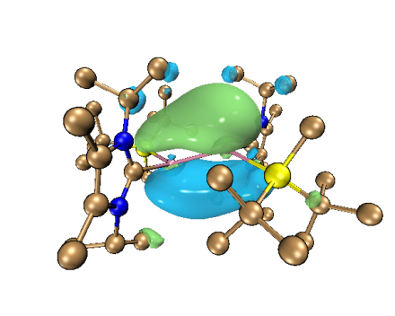
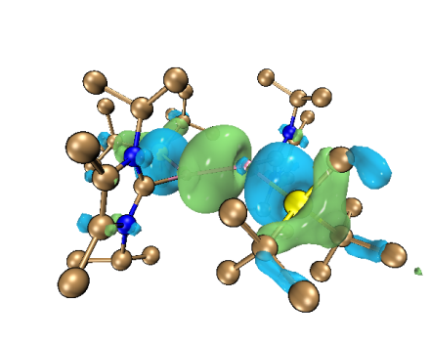

HOMO-1 (–5.61 eV) HOMO (–3.42 eV)
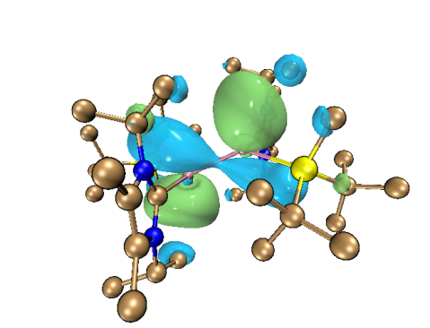

LUMO (0.62 eV)
Supplemental Figure S14 | Plots of the frontier orbitals of A (isosurface value = 0.03).

Supplemental Table S14 | Selected data of NPA charges of A.

Natural Population
Natural ---------------------------------------------------------------------------
Atom No Charge Core Valence Rydberg Total
-------------------------------------------------------------------------------------------------------------
Ga 1 0.00999 27.99908 2.96894 0.02199 30.99001
Ga 2 0.20373 27.99907 2.77429 0.02291 30.79627
--------------------------------------------------------------------------------------------------------------

Supplemental Table S15 | Selected WBI values of A.
Atom No 1 2 3 4
-----------------------------------------------------------------------------
1. Ga 0.0000 1.5623 0.8485 0.0408
2. Ga 1.5623 0.0000 0.0370 0.8242
3. Si 0.8485 0.0370 0.0000 0.0181
4. Si 0.0408 0.8242 0.0181 0.0000
-----------------------------------------------------------------------------

Supplemental Table S16 | Selected data of Natural Bond Orbital Analysis of A.
(Occupancy) Bond orbital/ Coefficients/ Hybrids
----------------------------------------------------------------------------------------------------------------------
85. (1.87089) BD ( 1)Ga 1-Ga 2
( 50.87%) 0.7132*Ga 1 s( 46.59%)p 1.14( 53.21%)d 0.00( 0.20%)
0.0000 0.0000 0.0000 0.6823 0.0172
0.0009 0.0000 0.0000 0.0000 0.0000
0.6200 -0.0015 0.0108 -0.0009 0.0000
0.0000 0.0000 -0.2804 -0.0109 -0.0069
0.0005 0.0000 0.0000 0.0000 -0.2620
-0.0128 0.0005 -0.0008 0.0000 0.0000
-0.0198 -0.0024 0.0000 -0.0311 0.0004
0.0000 0.0200 -0.0021 0.0000 0.0151
-0.0001 0.0000 -0.0043 0.0044
( 49.13%) 0.7009*Ga 2 s( 45.41%)p 1.20( 54.41%)d 0.00( 0.18%)
0.0000 0.0000 0.0000 0.6737 0.0154
0.0010 0.0000 0.0000 0.0000 0.0000
-0.6097 0.0024 -0.0104 0.0007 0.0000
0.0000 0.0000 0.2558 0.0116 0.0072
-0.0012 0.0000 0.0000 0.0000 0.3262
0.0124 -0.0003 0.0003 0.0000 0.0000
-0.0173 -0.0026 0.0000 -0.0291 -0.0001
0.0000 0.0198 -0.0026 0.0000 0.0136
0.0006 0.0000 -0.0042 0.0054
86. (1.76120) BD ( 2)Ga 1-Ga 2
( 54.21%) 0.7363*Ga 1 s( 7.17%)p12.94( 92.74%)d 0.01( 0.10%)
0.0000 0.0000 0.0000 0.2645 -0.0414
0.0009 -0.0001 0.0000 0.0000 0.0000
0.0814 -0.0006 -0.0078 0.0011 -0.0001
0.0000 0.0000 -0.0749 0.0043 0.0029
0.0003 0.0000 0.0000 0.0000 0.9562
0.0152 -0.0219 0.0001 0.0001 0.0000
-0.0038 0.0026 0.0000 0.0171 0.0020
0.0000 -0.0008 -0.0016 0.0000 -0.0011
-0.0011 0.0000 -0.0256 0.0028
( 45.79%) 0.6767*Ga 2 s( 8.17%)p11.22( 91.69%)d 0.02( 0.13%)
0.0000 0.0000 0.0000 -0.2839 0.0341
-0.0010 0.0002 0.0000 0.0000 0.0000
0.1403 0.0166 -0.0078 -0.0003 0.0000
0.0000 0.0000 -0.1200 -0.0036 0.0025
-0.0004 0.0000 0.0000 0.0000 0.9389
0.0197 -0.0251 0.0007 0.0001 0.0000
0.0033 -0.0029 0.0000 -0.0186 -0.0020
0.0000 0.0010 0.0026 0.0000 -0.0020
0.0011 0.0000 0.0303 -0.0037
----------------------------------------------------------------------------------------------------------------------
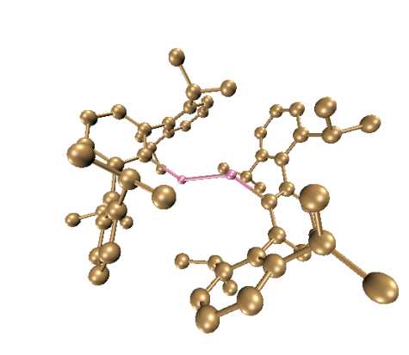

Supplemental Figure S15 | Calculated optimized structure for B at M06-2X/6-311G(d,p) level of theory. Hydrogen atoms are omitted for clarity.

Supplemental Table S17 | Optimized structure of B (atom, x-, y-, z- positions in Å).
Ga | 1.24949089 | -0.00039372 | 0.52463341
C | 2.83569456 | 0.00004408 | -0.76078617
Ga | -1.25011869 | -0.00013516 | -0.52544932
C | 3.40382851 | 1.20547426 | -1.19911018
C | 3.40381836 | -1.20561098 | -1.19855361
C | 4.48888040 | -1.20350720 | -2.07686290
C | 2.90534431 | -2.51696416 | -0.66717068
C | 5.02461006 | -0.00040909 | -2.52260274
C | 4.48882901 | 1.20289300 | -2.07752602
C | 2.90560417 | 2.51708533 | -0.66814984
C | 3.54511367 | -3.08451820 | 0.45136585
C | 1.83652307 | -3.18606895 | -1.29795588
C | 3.14138254 | -4.34667160 | 0.89043819
C | 4.63991678 | -2.35314836 | 1.21363747
C | 2.12117306 | -5.03024652 | 0.24766151
C | 1.46513840 | -4.44578674 | -0.82745555
C | 1.13542050 | -2.58648130 | -2.50734403
C | 4.15203365 | -1.98014555 | 2.61900386
C | 5.93398073 | -3.17095294 | 1.27700520
C | -0.35034923 | -2.95023662 | -2.57207336
C | 1.84473186 | -3.01270929 | -3.80010420
C | 3.54617328 | 3.08531775 | 0.44959317
C | 1.83617039 | 3.18568056 | -1.29842517
C | 3.14222020 | 4.34739249 | 0.88867729
C | 4.64170109 | 2.35443721 | 1.21129803
C | 2.12129316 | 5.03041253 | 0.24644370
C | 1.46478079 | 4.44546560 | -0.82810939
C | 1.13445557 | 2.58554005 | -2.50718546
C | 5.93434486 | 3.17422952 | 1.27772738
C | 4.15305233 | 1.97772223 | 2.61541271
C | 1.84328728 | 3.01100877 | -3.80046069
C | -0.35130877 | 2.94941656 | -2.57150392
H | 4.92141039 | -2.14750950 | -2.39338036
H | 5.86981815 | -0.00057409 | -3.20110581
H | 4.92135062 | 2.14674028 | -2.39452476
H | 3.62862509 | -4.79599339 | 1.74931751
H | 1.82405288 | -6.01411319 | 0.59436805
H | 0.64813007 | -4.97404137 | -1.30393322
H | 4.86420594 | -1.42425249 | 0.68621545
H | 3.25568357 | -1.35424067 | 2.56997945
H | 4.92428718 | -1.42868828 | 3.16147337
H | 3.90022704 | -2.87361435 | 3.19771588
H | 6.28174718 | -3.42775809 | 0.27414040
H | 5.79170275 | -4.10093272 | 1.83347400
H | 6.71930982 | -2.59984351 | 1.77806077
H | 1.20565093 | -1.49735687 | -2.42989179
H | -0.84461229 | -2.81191562 | -1.60585148
H | -0.50109475 | -3.99220672 | -2.87010334
H | -0.85453609 | -2.32064982 | -3.30964037
H | 1.34053178 | -2.58455740 | -4.67025749
H | 1.82942681 | -4.10229073 | -3.89588971
H | 2.88460660 | -2.68204743 | -3.80998782
H | 3.62985805 | 4.79711917 | 1.74711266
H | 1.82405125 | 6.01426120 | 0.59309962
H | 0.64734169 | 4.97335823 | -1.30423974
H | 4.86814760 | 1.42704659 | 0.68217689
H | 4.92589768 | 1.42702815 | 3.15782596
H | 3.25817534 | 1.34987005 | 2.56424013
H | 3.89850243 | 2.86964278 | 3.19533155
H | 6.72028589 | 2.60291888 | 1.77758623
H | 5.79039838 | 4.10235002 | 1.83684728
H | 6.28228911 | 3.43447093 | 0.27581189
H | 1.20460355 | 1.49644926 | -2.42920927
H | -0.84520687 | 2.81175770 | -1.60499148
H | -0.85587334 | 2.31943137 | -3.30847376
H | -0.50205794 | 3.99122258 | -2.87011000
H | 2.88312550 | 2.68023252 | -3.81057721
H | 1.82805664 | 4.10054087 | -3.89681790
H | 1.33869735 | 2.58244269 | -4.67018428
C | -2.83563930 | 0.00018078 | 0.76083300
C | -3.40354584 | 1.20567547 | 1.19927017
C | -3.40383959 | -1.20540134 | 1.19867979
C | -4.48840920 | 1.20323456 | 2.07785084
C | -2.90517397 | 2.51720599 | 0.66825117
C | -4.48876378 | -1.20317163 | 2.07716002
C | -2.90552703 | -2.51677219 | 0.66720169
H | -4.92075358 | 2.14713139 | 2.39494343
C | -5.02428126 | -0.00001012 | 2.52298569
C | -3.54563465 | 3.08545916 | -0.44954048
C | -1.83568300 | 3.18570853 | 1.29853158
H | -4.92136734 | -2.14712034 | 2.39373725
C | -3.54531165 | -3.08417129 | -0.45140282
C | -1.83675106 | -3.18599787 | 1.29793447
H | -5.86939338 | -0.00007741 | 3.20160804
C | -3.14160392 | 4.34752549 | -0.88858893
C | -4.64130316 | 2.35474338 | -1.21120243
C | -1.46419361 | 4.44546790 | 0.82823544
C | -1.13399559 | 2.58546194 | 2.50725315
C | -3.14159594 | -4.34627596 | -0.89063962
C | -4.64018491 | -2.35273316 | -1.21351018
C | -1.46540164 | -4.44567007 | 0.82729174
C | -1.13568911 | -2.58656038 | 2.50741803
H | -3.62921551 | 4.79729746 | -1.74701800
C | -2.12066209 | 5.03048091 | -0.24631374
H | -4.86711585 | 1.42686937 | -0.68265290
C | -4.15342875 | 1.97924544 | -2.61590890
C | -5.93423632 | 3.17420560 | -1.27616242
H | -0.64671459 | 4.97329039 | 1.30437792
H | -1.20440386 | 1.49638642 | 2.42930937
C | 0.35186059 | 2.94900599 | 2.57141119
C | -1.84259575 | 3.01114397 | 3.80058369
H | -3.62884163 | -4.79547678 | -1.74958084
C | -2.12141784 | -5.02996130 | -0.24793207
H | -4.86439470 | -1.42386984 | -0.68599848
C | -4.15253163 | -1.97965061 | -2.61893362
C | -5.93426537 | -3.17052911 | -1.27672427
H | -0.64843368 | -4.97402032 | 1.30373395
H | -1.20591252 | -1.49742977 | 2.43006333
C | 0.35007382 | -2.95033027 | 2.57217535
C | -1.84504640 | -3.01293702 | 3.80010419
H | -1.82336104 | 6.01432190 | -0.59294040
H | -3.25822453 | 1.35177913 | -2.56578021
H | -4.92639984 | 1.42855990 | -3.15814982
H | -3.89972004 | 2.87165557 | -3.19543643
H | -6.28176739 | 3.43329206 | -0.27380378
H | -5.79076981 | 4.10296559 | -1.83434879
H | -6.72026091 | 2.60320731 | -1.77624900
H | 0.84563553 | 2.81122941 | 1.60484997
H | 0.50287924 | 3.99078546 | 2.86997477
H | 0.85636146 | 2.31892917 | 3.30834855
H | -1.33801186 | 2.58250347 | 4.67027466
H | -1.82711583 | 4.10067669 | 3.89689529
H | -2.88250532 | 2.68059677 | 3.81082146
H | -1.82431574 | -6.01378950 | -0.59476384
H | -4.92488257 | -1.42816520 | -3.16123721
H | -3.25617692 | -1.35374008 | -2.57003968
H | -3.90082859 | -2.87308240 | -3.19774726
H | -6.71966273 | -2.59940237 | -1.77765323
H | -5.79206089 | -4.10049348 | -1.83323831
H | -6.28189090 | -3.42736388 | -0.27381819
H | 0.84439515 | -2.81184759 | 1.60600856
H | 0.85421303 | -2.32087077 | 3.30988499
H | 0.50080705 | -3.99234837 | 2.87004586
H | -2.88491985 | -2.68227373 | 3.80999618
H | -1.82974887 | -4.10252980 | 3.89576510
H | -1.34087480 | -2.58488900 | 4.67032561

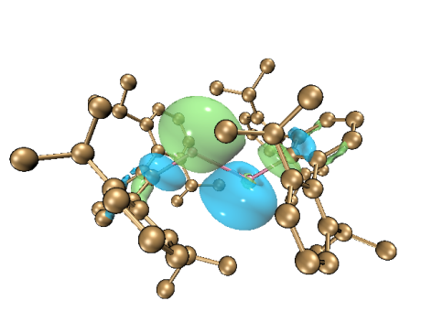
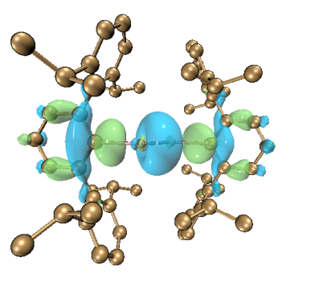

HOMO-1 (–7.49 eV) HOMO (–5.59 eV)
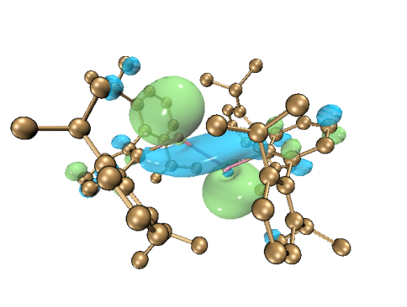

LUMO (–1.27 eV)
Supplemental Figure S16 | Plots of the frontier orbitals of B (isosurface value = 0.03).

Supplemental Table S18 | Selected data of NPA charges of B.

Natural Population
Natural ---------------------------------------------------------------------------
Atom No Charge Core Valence Rydberg Total
-------------------------------------------------------------------------------------------------------------
Ga 1 0.71531 27.99885 2.22741 0.05843 30.28469
Ga 3 0.71501 27.99885 2.22773 0.05840 30.28499
--------------------------------------------------------------------------------------------------------------

Supplemental Table S19 | Selected WBI values of B.
Atom No 1 2 3 70
-----------------------------------------------------------------------------
1. Ga 0.0000 0.2560 0.8853 0.0737
2. C 0.2560 0.0000 0.0737 0.0088
3. Ga 0.8853 0.0737 0.0000 0.2561
70. C 0.0737 0.0088 0.2561 0.0000
-----------------------------------------------------------------------------

Supplemental Figure S17 | Computed relative energy (E) (kcal/mol) for the formation of 1a at the M06-2X/6-311G(d,p) level of theory.

Supplemental Table S20 | Optimized structure of (L¹)K₂ (atom, x-, y-, z- positions in Å).

------------------------------------------------------------------------------------------

Atom Coordinates (Angstroms)

X Y Z
------------------------------------------------------------------------------------------

N 1.47113900 -0.52562900 -0.62578200

N -1.42429200 -0.38533500 -0.33954800

C 0.64593900 0.21395700 -1.48017100

H 1.08676700 0.72612700 -2.33751900

C -0.71410100 0.26162300 -1.34560700

H -1.27474000 0.81032400 -2.10710500

C 2.70964700 -0.09068900 -0.24224700

C 3.15458200 1.26998000 -0.13011200

C 4.45529200 1.53829400 0.30769800

H 4.78090600 2.57320700 0.35947900

C 5.33840500 0.54560900 0.68881500

H 6.33811600 0.78892300 1.02566400

C 4.90570500 -0.77858600 0.63043300

H 5.59109600 -1.56486300 0.92571900

C 3.63857200 -1.10984900 0.18497600

C 2.28408500 2.48886300 -0.44232600

H 1.26098500 2.16426500 -0.63205500

C 2.23627500 3.49558300 0.71899600

H 1.98172600 3.02016000 1.67306500

H 1.49843800 4.27729900 0.51617500

H 3.20059800 3.98619300 0.86777100

C 2.74500800 3.19848500 -1.72187100

H 3.77322000 3.55393300 -1.61118900

H 2.10754000 4.05858200 -1.94667900

H 2.71992600 2.51475000 -2.57214800

C 3.19792100 -2.56033100 0.10670500

H 2.66441400 -2.65585000 -0.84703000

C 2.22183800 -2.90614700 1.24327400

H 2.74242500 -2.86090400 2.20372200

H 1.82027500 -3.92137400 1.13678400

H 1.39415400 -2.19351100 1.27246800

C 4.34366300 -3.57323200 0.09882600

H 5.07738000 -3.33718100 -0.67425000

H 3.95580500 -4.57772100 -0.09038100

H 4.86041800 -3.60178900 1.06179000

C -2.70264600 0.05112500 -0.04766700

C -3.09984300 1.41820800 0.03772700

C -4.42963700 1.73739300 0.32204400

H -4.71810000 2.78364500 0.37166700

C -5.38235800 0.76736500 0.57997400

H -6.40553500 1.04139100 0.80512900

C -4.99132000 -0.56963400 0.56656000

H -5.72731300 -1.33369000 0.79022300

C -3.69091000 -0.93822500 0.25913900

C -2.10858800 2.57622300 -0.03300100

H -1.11828000 2.18156200 -0.26243400

C -2.02750800 3.30981700 1.31553600

H -2.96605500 3.82292900 1.53867100

H -1.23031000 4.05966800 1.30889900

H -1.85319200 2.61432000 2.14399500

C -2.42848400 3.56673700 -1.15769500

H -2.43302700 3.06181400 -2.12542200

H -1.68746200 4.37070400 -1.18978800

H -3.41168800 4.02145600 -1.01239900

C -3.29361400 -2.40071400 0.16943900

H -2.28737600 -2.47485800 0.59812500

C -4.19593100 -3.35533400 0.95171300

H -4.29917900 -3.04143400 1.99252800

H -3.77951300 -4.36609700 0.93703900

H -5.19557200 -3.41108900 0.51353800

C -3.23688600 -2.82887300 -1.30698300

H -4.24907400 -2.85668500 -1.71804400

H -2.81073700 -3.83377100 -1.42538800

H -2.66941400 -2.10712300 -1.90033300

K -0.10486000 -2.50779700 -1.08191700

K 0.28821900 0.72451100 1.37254800

Supplemental Table S21 | Optimized structure of Cp*Ga (atom, x-, y-, z- positions in Å).

------------------------------------------------------------------------------------------

Atom Coordinates (Angstroms)

X Y Z
------------------------------------------------------------------------------------------

C -1.21069400 0.01294700 -0.57802800

C -0.38627500 -1.14740900 -0.57801800

C 0.97204100 -0.72188900 -0.57782100

C -0.36189800 1.15552000 -0.57782900

C 0.98709100 0.70129700 -0.57767600

C 2.17613300 -1.61591900 -0.64540200

H 2.45277000 -1.81892000 -1.68449300

H 3.04051000 -1.16186100 -0.15775700

H 1.99035700 -2.57608000 -0.16101300

C -0.86464800 -2.56881200 -0.64574800

H -0.97204700 -2.89431700 -1.68493200

H -0.16624900 -3.25102900 -0.15798600

H -1.83537000 -2.68873000 -0.16159500

C 2.20977500 1.56965600 -0.64529300

H 3.06434100 1.09780300 -0.15723900

H 2.49068200 1.76605600 -1.68449400

H 2.04421800 2.53382900 -0.16152000

C -0.80989700 2.58679200 -0.64539700

H -0.09798800 3.25356100 -0.15576400

H -0.90841500 2.91530600 -1.68452700

H -1.77875900 2.72696600 -0.16302400

C -2.71034100 0.02885600 -0.64540800

H -3.05348700 0.03410200 -1.68445900

H -3.14291300 -0.84805700 -0.16072300

H -3.12438300 0.91304400 -0.15776200

Ga -0.00035400 -0.00025500 1.50700000

Supplemental Table S22 | Optimized structure of Int1 [(L¹)K₂ + Cp*Ga] (atom, x-, y-, z- positions in Å).

------------------------------------------------------------------------------------------

Atom Coordinates (Angstroms)

X Y Z
------------------------------------------------------------------------------------------

N 1.79185600 0.15935400 1.00443400

N -1.16889900 0.75208300 0.58957000

C 1.05534400 1.16831300 1.62905500

H 1.56005900 1.82656500 2.34468700

C -0.28569600 1.37209800 1.49097800

H -0.71640500 2.14985200 2.12484900

C 3.04145000 0.38020900 0.47309100

C 3.83511600 -0.79788000 0.22245400

C 5.08882100 -0.70822100 -0.35371300

H 5.66192400 -1.61275700 -0.52338400

C 5.64331100 0.52056100 -0.71000500

H 6.63444600 0.57953000 -1.14151900

C 4.88664500 1.65774800 -0.51035000

H 5.30388400 2.61733000 -0.79939200

C 3.59534500 1.62832600 0.03261500

C 3.30580400 -2.14262400 0.68949800

H 2.21428100 -2.11638200 0.58681600

C 3.81250800 -3.34294800 -0.11227500

H 3.29651700 -4.25150800 0.20756600

H 4.88328000 -3.50692400 0.03302400

H 3.63062700 -3.21014800 -1.18120600

C 3.67423700 -2.32730900 2.17298500

H 4.74622800 -2.51985500 2.26341200

H 3.15111900 -3.17944300 2.62576600

H 3.48143700 -1.41319900 2.74337800

C 2.86747000 2.97278600 0.09654200

H 1.82250800 2.80684700 0.35359800

C 2.88698100 3.71814100 -1.24791900

H 3.89098800 4.05782300 -1.51022800

H 2.24520800 4.60228100 -1.20116100

H 2.54203500 3.09143000 -2.07799100

C 3.44196500 3.87614000 1.19517300

H 3.37902600 3.38909900 2.17001700

H 2.90098400 4.82571000 1.24491200

H 4.49607900 4.09171300 0.99900000

C -2.35008800 1.51009800 0.35387500

C -3.63042400 1.01364000 0.72855100

C -4.77215800 1.74748400 0.41140500

H -5.74694800 1.36427600 0.68332100

C -4.69870800 2.97591600 -0.23098200

H -5.60138900 3.52586000 -0.46819700

C -3.45523700 3.49170800 -0.54376300

H -3.38646500 4.46178600 -1.02601300

C -2.28426300 2.78754200 -0.25977000

C -3.77183400 -0.26592100 1.54494700

H -3.22064100 -1.06516000 1.04250500

C -5.20709500 -0.78016200 1.67432600

H -5.68882500 -0.89414700 0.70113500

H -5.81919400 -0.11114800 2.28580000

H -5.19763000 -1.75680800 2.16395700

C -3.17248000 -0.08111900 2.94638000

H -2.12893100 0.23349400 2.89446800

H -3.23464800 -1.01491800 3.51298200

H -3.73239500 0.68594900 3.48886800

C -0.97014100 3.45424800 -0.64442200

H -0.16026600 2.80344200 -0.32698300

C -0.86151400 3.69519500 -2.15660300

H -1.02222500 2.77668200 -2.72943600

H 0.11844100 4.10789600 -2.41487300

H -1.61668900 4.40959900 -2.49266600

C -0.75658800 4.76291200 0.12645100

H 0.21365900 5.20274000 -0.12244800

H -0.78631600 4.58241200 1.20289100

H -1.53072800 5.49535700 -0.11528100

K 0.86865600 0.87673500 -1.39026700

K 0.90010400 -1.34963600 2.97054100

C -1.28908300 -1.42245800 -2.02410700

C -2.34354500 -2.20339700 -1.44970100

C -1.80832100 -3.47842300 -1.13135300

C -0.10716700 -2.22416700 -2.01338200

C -0.44579400 -3.48501200 -1.46605400

C -2.52779200 -4.61305900 -0.46349700

H -3.53037600 -4.32005300 -0.14646100

H -2.63315300 -5.47207900 -1.13403000

H -1.98682500 -4.95688700 0.42423800

C -3.79617400 -1.81925500 -1.49336900

H -4.23613900 -2.07145600 -2.46506300

H -4.37439800 -2.34487200 -0.72994900

H -3.94000000 -0.74627100 -1.33522700

C 0.50095100 -4.60695300 -1.15854500

H 1.42862800 -4.52420600 -1.72945400

H 0.77434900 -4.62371600 -0.09590900

H 0.05229900 -5.57620800 -1.39284300

C 1.24244200 -1.86731200 -2.58040800

H 1.16991500 -1.08337500 -3.34346400

H 1.97485200 -1.55087100 -1.82324700

H 1.68442000 -2.72915300 -3.08533200

C -1.55071500 -0.14866700 -2.78464700

H -0.70333000 0.13141200 -3.42089100

H -2.39786400 -0.27994300 -3.46369400

H -1.80653400 0.69668400 -2.13314000

Ga -0.92862800 -1.40284800 0.40091300

Supplemental Table S23 | Optimized structure of TS1 [(L¹)K₂+ Cp*Ga] (atom, x-, y-, z- positions in Å).

------------------------------------------------------------------------------------------

Atom Coordinates (Angstroms)

X Y Z
------------------------------------------------------------------------------------------

N 1.72157400 -0.06194900 1.27693200

N -1.18755200 0.55189300 0.93910600

C 1.06709600 1.02719400 1.84835500

H 1.63329200 1.72607300 2.47505700

C -0.27419100 1.24782100 1.75663300

H -0.67452500 2.08686600 2.32889000

C 2.95392700 0.05086300 0.66611300

C 3.71722700 -1.16455400 0.55210900

C 4.92008900 -1.19383300 -0.12882800

H 5.46766400 -2.12649800 -0.19667400

C 5.45837200 -0.04906600 -0.71425500

H 6.40622300 -0.08349200 -1.23588700

C 4.75173100 1.13163600 -0.59984600

H 5.17168500 2.03206400 -1.03550800

C 3.51432600 1.21769600 0.05180100

C 3.23734100 -2.40227800 1.28830400

H 2.14451500 -2.43297800 1.20115200

C 3.78287100 -3.72293000 0.74433700

H 3.27623500 -4.56447400 1.22444600

H 4.85255300 -3.82718300 0.94602300

H 3.62791100 -3.80506600 -0.33156200

C 3.64521900 -2.27238800 2.76817500

H 4.72616700 -2.40505400 2.85936700

H 3.17311300 -3.03998800 3.39566200

H 3.42836100 -1.27084000 3.15169300

C 2.87057900 2.60543400 0.07033800

H 1.83491700 2.52127900 0.40009100

C 2.85502800 3.28036000 -1.31105100

H 3.85713100 3.57238800 -1.63100800

H 2.24723900 4.18904300 -1.28294400

H 2.45846500 2.62619600 -2.09541900

C 3.57305300 3.52134100 1.08121500

H 3.53752400 3.09141600 2.08386100

H 3.10787900 4.51096600 1.10836800

H 4.62601000 3.64375100 0.81135900

C -2.39473300 1.27182200 0.69512100

C -3.64676500 0.73825200 1.11031100

C -4.82387000 1.41873400 0.81227300

H -5.77578200 1.00118200 1.11400000

C -4.81275700 2.63475700 0.14035700

H -5.74146400 3.14261900 -0.09167700

C -3.59691400 3.18716200 -0.21551300

H -3.58062800 4.14490800 -0.72686600

C -2.38879600 2.53729500 0.05392500

C -3.71299100 -0.54112100 1.93308000

H -3.10923400 -1.30316900 1.43090700

C -5.10944500 -1.15252000 2.05241200

H -5.57134100 -1.29656300 1.07342900

H -5.77088200 -0.52795400 2.65901100

H -5.03586800 -2.12693700 2.54081500

C -3.13269700 -0.31742100 3.33753900

H -2.12392400 0.09875700 3.29091800

H -3.10850800 -1.25906200 3.89505600

H -3.76260100 0.38602100 3.88958700

C -1.11733300 3.24311200 -0.40554800

H -0.26440500 2.65762200 -0.06769000

C -1.06412200 3.37307400 -1.93412200

H -1.22267700 2.41354100 -2.43007000

H -0.10207700 3.78399100 -2.25684600

H -1.84816200 4.04334300 -2.29618100

C -0.94312000 4.62128200 0.24439800

H 0.00024700 5.07172500 -0.07990400

H -0.93227300 4.54360300 1.33276900

H -1.75146700 5.30071900 -0.03875900

K 0.71092400 0.68855300 -1.21134200

K 0.87559400 -1.31341000 3.45715300

C -1.12424800 -1.24649500 -2.40884200

C -2.11507900 -1.87457400 -1.62032700

C -1.54963400 -3.07844500 -1.09885400

C 0.06258400 -2.01742900 -2.33613000

C -0.19698000 -3.14398800 -1.52235900

C -2.31224500 -4.21326800 -0.46731200

H -2.65392500 -4.01419600 0.55698700

H -3.19413300 -4.46233200 -1.06767500

H -1.67922600 -5.10273300 -0.42821900

C -3.56602200 -1.48121500 -1.58859100

H -4.07842000 -1.76391000 -2.51657500

H -4.09509200 -1.96649700 -0.76343700

H -3.68467100 -0.40075300 -1.46145000

C 0.77260500 -4.23444400 -1.16474300

H 1.75497700 -4.03182700 -1.59314000

H 0.91041800 -4.32373100 -0.07995300

H 0.45244400 -5.21487700 -1.53328300

C 1.33845400 -1.74758900 -3.10005600

H 1.12599200 -1.38213200 -4.10931100

H 2.03389600 -1.03060600 -2.63415200

H 1.91896700 -2.66356000 -3.21498200

C -1.41659700 -0.14537000 -3.39291000

H -0.51895400 0.39569900 -3.71823800

H -1.86376500 -0.55312200 -4.30803200

H -2.13074100 0.58081400 -2.99495900

Ga -0.84158200 -1.55904500 0.79159500

Supplemental Table S24 | Optimized structure of Int2 [(L¹)GaK + Cp*K] (atom, x-, y-, z- positions in Å).

------------------------------------------------------------------------------------------

Atom Coordinates (Angstroms)

X Y Z
------------------------------------------------------------------------------------------

N -1.48304400 -0.48303700 -1.14973500

N 1.35570400 -0.34647300 -0.95460900

C -0.68966000 -0.02345200 -2.20933100

H -1.15504000 0.28935500 -3.14616800

C 0.66715100 -0.03018000 -2.12725600

H 1.25398500 0.25792300 -2.99935700

C -2.68398000 0.13340200 -0.81046100

C -3.67329700 -0.69849200 -0.18681700

C -4.82755200 -0.15512600 0.35054500

H -5.54668400 -0.80420100 0.83648100

C -5.09881700 1.20784400 0.25971500

H -6.00400900 1.62339000 0.68425500

C -4.19934200 2.01121200 -0.41208200

H -4.42551300 3.06647500 -0.52256800

C -3.00198600 1.52202800 -0.95081800

C -3.49836000 -2.20628600 -0.24534900

H -2.44387200 -2.43028900 -0.05619100

C -4.32203900 -2.99781700 0.77133800

H -4.03644900 -4.05235500 0.73929700

H -5.39197600 -2.94301100 0.55333600

H -4.16102300 -2.63499200 1.78753300

C -3.87216100 -2.67124000 -1.66586100

H -4.94975700 -2.56795200 -1.81359600

H -3.62401100 -3.72825100 -1.82987300

H -3.39596800 -2.04428200 -2.42665400

C -2.14300300 2.54276800 -1.70363000

H -1.14516600 2.13618800 -1.86361900

C -1.97929500 3.88265200 -0.96456300

H -2.89530800 4.47597300 -0.99707800

H -1.19394600 4.47714700 -1.43960000

H -1.72611000 3.76160200 0.09400200

C -2.72187900 2.80516700 -3.10093000

H -2.78742200 1.88040500 -3.67702800

H -2.10340300 3.51826600 -3.65359500

H -3.73175200 3.21614000 -3.01815600

C 2.71097400 0.06262700 -0.91167400

C 3.73668900 -0.87971200 -0.62895700

C 5.06052300 -0.46099900 -0.55366100

H 5.83676700 -1.18084200 -0.32687400

C 5.41825400 0.86377700 -0.76962800

H 6.45539600 1.17017800 -0.70740700

C 4.42797200 1.78296600 -1.06130500

H 4.69782600 2.82294400 -1.21436700

C 3.08301800 1.41235000 -1.13071500

C 3.39806100 -2.34963100 -0.45276900

H 2.53848600 -2.42569000 0.22005000

C 4.49973700 -3.18695800 0.19666900

H 4.82854100 -2.75161200 1.14350100

H 5.37110800 -3.28793400 -0.45606700

H 4.12117400 -4.19163500 0.39812900

C 2.99063000 -2.96737300 -1.79702500

H 2.20631100 -2.37251500 -2.27140700

H 2.63350300 -3.99219800 -1.65706700

H 3.85242100 -2.98955900 -2.47006500

C 2.07174000 2.53503400 -1.32644900

H 1.08677200 2.09343800 -1.46500500

C 2.04381100 3.43850100 -0.08404200

H 1.96267800 2.85000700 0.83539200

H 1.21585500 4.15532300 -0.12893000

H 2.97106000 4.01137700 -0.00369300

C 2.32648100 3.35699000 -2.59422000

H 1.55461300 4.12297600 -2.71270200

H 2.31525200 2.71695900 -3.47896100

H 3.29361200 3.86336700 -2.55766800

K -0.32343500 1.46531400 0.47393000

K -0.91895000 -2.87276200 -2.33406100

C 0.68832400 1.35004500 3.09143900

C 1.45246000 0.28126800 2.65901900

C 0.58088000 -0.87064000 2.48482700

C -0.68689200 0.92107500 3.20412200

C -0.75364200 -0.41541800 2.86089200

C 1.05697700 -2.22749400 2.99643900

H 0.32738300 -3.01514700 2.79161200

H 2.00066900 -2.54273700 2.53901800

H 1.21281800 -2.18344900 4.08058400

C 2.95119500 0.25443100 2.52292400

H 3.43960200 0.41559000 3.48980300

H 3.29275100 -0.70825300 2.13732800

H 3.33046200 1.01417500 1.83011800

C -1.95059200 -1.31720400 2.94985300

H -2.88181700 -0.77943400 2.75298800

H -1.88258700 -2.13332200 2.22363300

H -2.02929100 -1.77808000 3.94138100

C -1.82078400 1.83103000 3.58465100

H -1.66504000 2.26840200 4.57600100

H -1.93642200 2.67582200 2.89069900

H -2.77286400 1.29867000 3.60100600

C 1.16402400 2.73681000 3.42334600

H 0.66691400 3.51552700 2.82777100

H 0.96336500 2.97935900 4.47189000

H 2.23960700 2.83605000 3.26082700

Ga 0.26708000 -1.68616000 0.26614700

Supplemental Table S25 | Optimized structure of Cp*K (atom, x-, y-, z- positions in Å).

------------------------------------------------------------------------------------------

Atom Coordinates (Angstroms)

X Y Z

------------------------------------------------------------------------------------------

K -0.00022200 -0.00175900 2.09081100

C 1.20609900 -0.00013200 -0.45790700

C 0.37328500 1.14726700 -0.45747300

C -0.97532700 0.70975900 -0.45790900

C 0.37220900 -1.14674500 -0.45855500

C -0.97598000 -0.70802100 -0.45835900

C -2.18986200 1.59298600 -0.56579800

H -3.06815700 1.14256000 -0.09321200

H -2.03085400 2.56817700 -0.09539000

H -2.46128500 1.78877200 -1.60954100

C 0.83801600 2.57532400 -0.56495200

H 0.94029700 2.89417600 -1.60864800

H 0.13830900 3.27134200 -0.09211400

H 1.81468200 2.72531600 -0.09465100

C -2.19134000 -1.59005500 -0.56681100

H -2.03374400 -2.56533000 -0.09607900

H -3.06937800 -1.13853000 -0.09483200

H -2.46228200 -1.78590000 -1.61066800

C 0.83563300 -2.57509400 -0.56744200

H 0.94016600 -2.89224900 -1.61142600

H 1.81088000 -2.72730500 -0.09485300

H 0.13373900 -3.27094900 -0.09766100

C 2.70782200 -0.00085500 -0.56601300

H 3.15240900 -0.88371100 -0.09645900

H 3.04235300 0.00109000 -1.60979800

H 3.15374800 0.87936200 -0.09276100

Supplemental Table S26 | Optimized structure of Int3 [(L¹)GaK] (atom, x-, y-, z- positions in Å).

------------------------------------------------------------------------------------------

Atom Coordinates (Angstroms)

X Y Z

------------------------------------------------------------------------------------------

N 1.28961800 -0.24492100 0.18879200

N -1.31134200 -0.24228400 0.16251500

C 0.65752200 0.04386300 1.39868800

H 1.24474200 0.26029300 2.28716800

C -0.69893800 0.05167200 1.38382500

H -1.30217000 0.26921100 2.26090700

C 2.66022700 0.10032400 0.06834000

C 3.61479000 -0.90658000 -0.20405100

C 4.95369100 -0.56004300 -0.35977300

H 5.68900000 -1.32608000 -0.57458700

C 5.36759100 0.76111100 -0.24445600

H 6.41315300 1.01725800 -0.36694200

C 4.43058400 1.74752700 0.01418800

H 4.75167900 2.78189200 0.08238100

C 3.07600100 1.44474500 0.16214900

C 3.17752500 -2.36124800 -0.25484700

H 2.21266600 -2.37950400 -0.77222500

C 4.11880100 -3.27948900 -1.03393500

H 3.67762900 -4.27461400 -1.13215200

H 5.07790400 -3.39843400 -0.52395900

H 4.30833600 -2.88941600 -2.03542700

C 3.00263000 -2.88469900 1.18083300

H 3.97664600 -2.92899700 1.67404600

H 2.58704700 -3.90085400 1.19871100

H 2.38279000 -2.21062800 1.78081800

C 2.08765100 2.58485000 0.35184700

H 1.09700900 2.15936500 0.50731900

C 2.01971200 3.45833600 -0.90664800

H 2.98595800 3.92611400 -1.11547200

H 1.27981800 4.25336800 -0.77720200

H 1.73666300 2.86320200 -1.77844700

C 2.41539200 3.42650600 1.58974800

H 2.44115900 2.80617200 2.48852800

H 1.66012800 4.20382700 1.73088300

H 3.38646200 3.91950400 1.49308400

C -2.66748400 0.15555300 0.03116900

C -3.68077200 -0.81805800 -0.11024800

C -5.00859400 -0.41454800 -0.22009100

H -5.79201100 -1.15483700 -0.32997300

C -5.34966300 0.93198900 -0.18990500

H -6.38796700 1.23206300 -0.26606300

C -4.35148400 1.88694800 -0.08406400

H -4.61773000 2.93899300 -0.08858700

C -3.00683800 1.52430200 0.00603500

C -3.31125600 -2.29172600 -0.08829700

H -2.37240800 -2.38007100 -0.64590000

C -4.32747400 -3.20640600 -0.77205200

H -4.54843400 -2.86216700 -1.78384600

H -5.26511800 -3.25316800 -0.21286800

H -3.93577300 -4.22487200 -0.83423200

C -3.09055300 -2.74622800 1.36398600

H -2.41036600 -2.07465900 1.89692200

H -2.72172400 -3.77898200 1.41674900

H -4.04009300 -2.71774700 1.90400900

C -1.94499700 2.61156900 0.02547800

H -0.96939700 2.12512900 -0.02433300

C -2.06282100 3.52243600 -1.20240400

H -2.01800400 2.93860700 -2.12427900

H -1.24483300 4.24713300 -1.21472700

H -3.00285300 4.08044100 -1.19858400

C -1.98480900 3.42909600 1.32060600

H -1.19314400 4.18371900 1.31771900

H -1.84322800 2.78828800 2.19318700

H -2.94341200 3.94530600 1.42804600

K -0.04625800 -2.65115500 0.76315000

Ga 0.00491100 -0.21526600 -1.42504500

Supplemental Table S27 | Optimized structure of Int4 [(L¹)GaK + Cp*Ga] (atom, x-, y-, z- positions in Å).

------------------------------------------------------------------------------------------

Atom Coordinates (Angstroms)

X Y Z
------------------------------------------------------------------------------------------

N 1.06338300 1.23608300 0.54119100

N -1.54012800 1.05476800 0.74227500

C 0.41739000 2.21074600 1.30809600

H 0.98661900 3.00721000 1.76792900

C -0.93060000 2.12903400 1.40257200

H -1.53479000 2.85705200 1.93460000

C 2.43522300 1.40554700 0.20791900

C 3.45055000 1.42104400 1.20009500

C 4.78732700 1.44147100 0.80695000

H 5.56210500 1.43896100 1.56535900

C 5.15224300 1.45803800 -0.53086200

H 6.19744900 1.44617200 -0.81496900

C 4.16103800 1.52387800 -1.49412300

H 4.44048800 1.58369800 -2.54064500

C 2.80828400 1.53189900 -1.15275400

C 3.15605200 1.48571300 2.69381800

H 2.11084200 1.20262900 2.84615500

C 4.03440600 0.55200600 3.54017000

H 3.65521300 0.50968000 4.56497900

H 5.05949800 0.92410900 3.59765900

H 4.06962600 -0.46071900 3.13935000

C 3.33564400 2.92358700 3.20865900

H 4.38438200 3.21708100 3.11254500

H 3.05882300 2.99658100 4.26401600

H 2.74557900 3.64453000 2.64230300

C 1.80757800 1.74069700 -2.28239900

H 0.81532700 1.86526000 -1.84404900

C 1.76551200 0.55622100 -3.25592200

H 2.71590300 0.46358300 -3.79029500

H 0.97266600 0.69601200 -3.99659600

H 1.58532600 -0.38602200 -2.73125300

C 2.09382400 3.04637200 -3.03724300

H 2.11122500 3.89636000 -2.35212400

H 1.32016500 3.22200800 -3.78953600

H 3.05546400 3.00827200 -3.55452600

C -2.89577800 1.23438400 0.33917100

C -3.93940100 0.64963900 1.08427300

C -5.25041100 0.76597000 0.62944300

H -6.06073000 0.31744300 1.19147200

C -5.53899400 1.46070100 -0.53840000

H -6.56220000 1.53562500 -0.88671100

C -4.51528200 2.07035200 -1.24541700

H -4.74760000 2.62649100 -2.14763400

C -3.18944000 1.98192000 -0.81848700

C -3.61571300 -0.10431400 2.36214700

H -2.79334100 0.44447800 2.83814900

C -3.15187400 -1.53163600 2.04364500

H -2.33117400 -1.54755000 1.31870300

H -3.97512900 -2.09574500 1.59673900

H -2.84675200 -2.06548200 2.95130500

C -4.76742400 -0.14300600 3.36848700

H -5.16071100 0.85676900 3.56193000

H -4.42569900 -0.56879700 4.31516000

H -5.58760200 -0.76978900 3.01074800

C -2.10457800 2.69293100 -1.61287700

H -1.16370200 2.59338600 -1.06656400

C -1.92858200 2.07274300 -3.00495300

H -1.72622700 0.99916400 -2.94840200

H -1.09957900 2.55189900 -3.53438600

H -2.83288600 2.20453500 -3.60553800

C -2.38352800 4.19673200 -1.72120700

H -1.55750900 4.69626600 -2.23394100

H -2.49507400 4.64322800 -0.73102900

H -3.29723500 4.39352800 -2.28802000

K -0.22105400 -0.40632000 2.69717400

Ga -0.24144800 0.07396200 -0.41154400

C 1.44868000 -2.52240900 0.78890000

C 1.97350500 -2.49933700 -0.51872900

C 1.11413700 -3.24784200 -1.35525300

C 0.22850900 -3.23429500 0.77180300

C 0.01348700 -3.70387700 -0.55418900

C 1.48425000 -3.73037600 -2.73553400

H 2.21920400 -4.54059100 -2.67616300

H 0.62246700 -4.11074700 -3.28852700

H 1.92989000 -2.93267700 -3.33869700

C 3.31970800 -1.95146700 -0.89984600

H 3.33544200 -1.55957000 -1.91972500

H 3.63082300 -1.13699300 -0.23988200

H 4.08866000 -2.73234500 -0.84628400

C -0.94149400 -4.81756100 -0.90442600

H -1.07058000 -4.92117700 -1.98402400

H -0.57517500 -5.77844600 -0.52468300

H -1.93713400 -4.65466500 -0.47950900

C -0.53498800 -3.75745200 1.95850400

H -1.60423000 -3.84350000 1.75423300

H -0.18128000 -4.75680100 2.23956400

H -0.42640800 -3.14027600 2.85932100

C 2.18817200 -1.98213300 1.97891700

H 1.73244200 -2.28589200 2.92984100

H 3.21185700 -2.36763500 2.00575200

H 2.28415300 -0.88887100 1.94839800

Ga -0.96165700 -1.96328800 -2.04712600

Supplemental Table S28 | Optimized structure of TS2 [(L¹)GaK + Cp*Ga] (atom, x-, y-, z- positions in Å).

------------------------------------------------------------------------------------------

Atom Coordinates (Angstroms)

X Y Z
------------------------------------------------------------------------------------------

N 0.91580800 1.14791200 0.18622500

N -1.64779200 0.75379100 0.57408200

C 0.25070300 2.06010700 1.01050800

H 0.80031600 2.88694800 1.44223000

C -1.07671700 1.87271000 1.19940800

H -1.69534700 2.54375100 1.78501800

C 2.28774700 1.32815900 -0.12560300

C 3.28590900 1.35013700 0.87741100

C 4.62688600 1.37061900 0.49841100

H 5.39314200 1.37030900 1.26634500

C 5.00690200 1.37903400 -0.83447200

H 6.05492200 1.36430000 -1.10706500

C 4.02687600 1.45119200 -1.81054200

H 4.31779600 1.52295300 -2.85383900

C 2.67253500 1.46499600 -1.48037600

C 2.97591800 1.39245000 2.36884200

H 1.90132400 1.26136800 2.50269200

C 3.68513700 0.28831400 3.15641400

H 3.34326600 0.27710800 4.19619400

H 4.76689200 0.43903700 3.17257700

H 3.49009300 -0.68402800 2.71251600

C 3.34498700 2.75796100 2.96682300

H 4.42540800 2.91579800 2.89935700

H 3.06665700 2.79989000 4.02426000

H 2.85616000 3.58179400 2.44279900

C 1.67308200 1.73032600 -2.59792100

H 0.67967200 1.81257400 -2.15570100

C 1.64114400 0.62065700 -3.65303400

H 2.60392600 0.54125700 -4.16591400

H 0.87783100 0.83056400 -4.40967200

H 1.43250700 -0.35382700 -3.20205000

C 1.95138500 3.08798400 -3.25706700

H 1.95013000 3.88579500 -2.51155800

H 1.18372300 3.30760300 -4.00469100

H 2.92171100 3.09595600 -3.75969800

C -2.99683400 0.85153200 0.12203000

C -4.03529300 0.20943400 0.82563000

C -5.31204300 0.17269800 0.26666100

H -6.11586100 -0.33082000 0.79080600

C -5.58017700 0.78909600 -0.94836700

H -6.57611100 0.74491400 -1.37267600

C -4.57716900 1.49600600 -1.59384500

H -4.80558700 2.02727700 -2.51187800

C -3.28472000 1.55361200 -1.07051300

C -3.76602900 -0.39970100 2.19109200

H -2.97441500 0.20716600 2.64535400

C -3.26229300 -1.84212600 2.07647200

H -2.37017600 -1.91745000 1.44593300

H -4.03062300 -2.47564500 1.62301700

H -3.03878200 -2.25533100 3.06630400

C -4.98183700 -0.33350400 3.12165300

H -5.40674700 0.67213300 3.15019000

H -4.69627900 -0.61582500 4.13769300

H -5.76691900 -1.02450300 2.80521100

C -2.25837900 2.46434100 -1.73268300

H -1.29337500 2.32333900 -1.24086200

C -2.07423100 2.21011200 -3.23133500

H -1.74760500 1.18795200 -3.44265900

H -1.31595700 2.88733600 -3.63398700

H -3.00026900 2.37814900 -3.78571000

C -2.64402000 3.93056900 -1.49317900

H -1.87460300 4.59575500 -1.89344000

H -2.75264500 4.12945000 -0.42537800

H -3.59246800 4.16689100 -1.98332900

K -0.02714300 -0.67564100 2.43898900

Ga -0.35922700 -0.03045500 -0.71204400

C 1.36400200 -2.86516500 1.25120900

C 1.81666200 -2.55585700 -0.04637100

C 0.80927900 -2.95023000 -0.96507300

C 0.04931900 -3.40077000 1.14677200

C -0.29037900 -3.46270900 -0.22207800

C 1.13490800 -3.26800700 -2.40478800

H 1.71723200 -4.19816000 -2.45206300

H 0.25743100 -3.43557900 -3.03607300

H 1.75196500 -2.50041800 -2.88304500

C 3.20731200 -2.14533400 -0.44568800

H 3.20462000 -1.40077000 -1.24766000

H 3.76339900 -1.70244300 0.38419200

H 3.78317500 -3.00694400 -0.80633600

C -1.48657400 -4.18418200 -0.78860600

H -2.08180800 -3.60380300 -1.50328300

H -1.18253400 -5.09589500 -1.31550900

H -2.18002100 -4.48046700 0.00033900

C -0.68961300 -4.04182300 2.29009500

H -1.73742100 -4.22967600 2.04974600

H -0.24092900 -5.00534200 2.56039500

H -0.68505600 -3.44001200 3.21183500

C 2.22454900 -2.99786600 2.48000900

H 1.75617500 -2.65155400 3.41544400

H 2.48434400 -4.04888400 2.65630000

H 3.17097900 -2.47148600 2.37019400

Ga -1.39383900 -1.40888000 -2.68801600

Supplemental Table S29 | Optimized structure of Int5 [(L¹)GaGa + Cp*K] (atom, x-, y-, z- positions in Å).

------------------------------------------------------------------------------------------

Atom Coordinates (Angstroms)

X Y Z
------------------------------------------------------------------------------------------

N -1.21106000 -0.70570700 0.88013600

N 1.28950200 0.13148800 1.12951700

C -0.66768000 -0.69037700 2.16408800

H -1.27103900 -1.01886100 3.00423100

C 0.61226000 -0.28141600 2.29891400

H 1.12800200 -0.27007300 3.25431100

C -2.54575000 -1.11168100 0.67298700

C -3.63173800 -0.39381500 1.22928700

C -4.92989400 -0.71237900 0.83621400

H -5.76078600 -0.14367100 1.24156700

C -5.18332000 -1.72062600 -0.08266800

H -6.19718300 -1.93093900 -0.40081500

C -4.12483000 -2.48199400 -0.55499200

H -4.32386900 -3.31577700 -1.22089200

C -2.81170200 -2.22406300 -0.16246100

C -3.44853400 0.73349100 2.23788200

H -2.38956400 0.80258500 2.48486000

C -3.89269800 2.09043700 1.68152500

H -3.74111200 2.88289800 2.42225600

H -4.95455300 2.08214900 1.42167500

H -3.34060300 2.34086300 0.77352600

C -4.17396900 0.42134100 3.55303200

H -5.25444900 0.36304900 3.40175100

H -3.98178500 1.20220400 4.29362400

H -3.84308900 -0.53517600 3.96293800

C -1.72894600 -3.22348200 -0.54990900

H -0.78894900 -2.88828900 -0.10971600

C -1.52654800 -3.35126100 -2.06251900

H -2.43721200 -3.70319900 -2.55541900

H -0.73196700 -4.07187100 -2.27968900

H -1.25107600 -2.39490000 -2.51211400

C -2.03927100 -4.59655900 0.06330000

H -2.15574500 -4.52106800 1.14643400

H -1.23017600 -5.29998100 -0.15184900

H -2.96318900 -5.01325300 -0.34641500

C 2.64885100 -0.26731500 1.00612700

C 3.66888500 0.70195200 1.07957400

C 4.96567100 0.35847500 0.69240900

H 5.74976100 1.10664500 0.71670500

C 5.27544200 -0.93469500 0.29730300

H 6.28106800 -1.18298900 -0.01973200

C 4.30248200 -1.92382600 0.37147400

H 4.57263100 -2.95031700 0.14900900

C 2.99199100 -1.62238200 0.74718500

C 3.36562700 2.07554800 1.66102200

H 2.51894500 1.93146600 2.34031300

C 2.94173200 3.09074000 0.59899400

H 2.04541200 2.75907600 0.07373500

H 3.73169700 3.22013000 -0.14757700

H 2.74563900 4.06833500 1.05149800

C 4.53093100 2.63128800 2.48552100

H 4.89921800 1.89582800 3.20341600

H 4.20802800 3.51907300 3.03465000

H 5.36594500 2.93248000 1.84785500

C 2.01340700 -2.75752500 1.03990900

H 1.00428000 -2.34824900 1.08203100

C 2.00418000 -3.90584600 0.02707300

H 1.68641500 -3.59263400 -0.97249900

H 1.29366400 -4.66945400 0.35464200

H 2.98068700 -4.38572600 -0.06793600

C 2.32518100 -3.31663600 2.43796200

H 1.58791700 -4.07303300 2.71967600

H 2.30831100 -2.52249400 3.18568800

H 3.31717800 -3.77747800 2.45242200

K -0.52334100 2.18145300 1.22359300

Ga 0.17754900 -0.37105200 -0.52636500

C -1.59948000 3.27063100 -1.21396300

C -1.92507900 1.97113800 -1.54857400

C -0.70969700 1.27307500 -1.95281300

C -0.17544900 3.45502000 -1.41026600

C 0.35483700 2.27392000 -1.89068800

C -0.86154500 0.42787000 -3.21378600

H -1.15595100 1.06562500 -4.05653400

H 0.05723200 -0.08464900 -3.51403700

H -1.63574800 -0.33391000 -3.09338500

C -3.29628700 1.39436300 -1.76588200

H -3.36600500 0.35572500 -1.43300200

H -4.07602900 1.95691600 -1.24997900

H -3.54123300 1.41026300 -2.83462200

C 1.75608400 2.01812000 -2.36639700

H 2.33885600 1.39695500 -1.66990100

H 1.75324000 1.50982600 -3.33792200

H 2.31653900 2.94601100 -2.49238300

C 0.53000900 4.75466700 -1.14166300

H 1.58460600 4.70812700 -1.41657000

H 0.07240100 5.57101900 -1.70859500

H 0.48807000 5.05061800 -0.08441300

C -2.51621800 4.37586500 -0.76739800

H -2.30615700 4.72274200 0.25461500

H -2.41239000 5.25165600 -1.41473000

H -3.56263200 4.06901700 -0.79668200

Ga 1.98495200 -1.38164900 -2.25714000

Supplemental Table S30 | Optimized structure of Int6 [(L¹)GaGa] (atom, x-, y-, z- positions in Å).

------------------------------------------------------------------------------------------

Atom Coordinates (Angstroms)

X Y Z
------------------------------------------------------------------------------------------

Ga 0.00465400 -0.59484600 0.45939900

N 1.31320100 0.10441700 -0.73547200

N -1.29335900 0.16230000 -0.71702600

C 0.69260100 0.76772800 -1.79156900

H 1.30112600 1.21612000 -2.56708400

C -0.66024600 0.78558700 -1.78867100

H -1.26016700 1.24287800 -2.56585100

C 2.68580300 0.38629100 -0.49759900

C 3.05276900 1.64504700 0.01822400

C 4.40587200 1.91490300 0.22305800

H 4.70323800 2.88376100 0.61069300

C 5.37662500 0.96309000 -0.05160500

H 6.42315800 1.18929000 0.11531600

C 5.00277700 -0.28223400 -0.53852500

H 5.76723100 -1.02144700 -0.74858400

C 3.66365600 -0.58819100 -0.77557000

C 2.01493500 2.69775600 0.37737800

H 1.02368600 2.25573300 0.24981800

C 2.14385700 3.12789500 1.84331200

H 2.06679500 2.26701300 2.51194800

H 1.35232300 3.83559400 2.10215800

H 3.10228500 3.61711300 2.03493500

C 2.10043600 3.90943800 -0.55713700

H 3.07265300 4.40315100 -0.46974400

H 1.32577300 4.63961500 -0.30666500

H 1.96372800 3.60827800 -1.59739100

C 3.25408200 -1.95848300 -1.28273000

H 2.28813300 -1.83956400 -1.77801700

C 3.06502100 -2.91636900 -0.09822600

H 4.01411900 -3.07181200 0.42258300

H 2.68810200 -3.88775100 -0.43000400

H 2.35917900 -2.49722500 0.62621700

C 4.23753600 -2.55599900 -2.29181000

H 4.44167700 -1.85607800 -3.10427500

H 3.82136500 -3.46985000 -2.72217800

H 5.18871000 -2.82152400 -1.82346900

C -2.69486200 0.32917600 -0.55884100

C -3.21518000 1.60133800 -0.23322800

C -4.59268000 1.73971400 -0.07629200

H -5.00799500 2.70923700 0.17185900

C -5.44662100 0.65359300 -0.21781500

H -6.51468700 0.78119200 -0.08693500

C -4.92617800 -0.59327800 -0.52506000

H -5.59693400 -1.43837400 -0.63318900

C -3.55498500 -0.77568700 -0.70898400

C -2.28957600 2.77699400 0.04686900

H -1.38047400 2.64999600 -0.54246200

C -1.88396600 2.77136500 1.52804700

H -2.76317300 2.91103100 2.16384000

H -1.17586700 3.57830700 1.73676100

H -1.41252500 1.82468400 1.80416000

C -2.89093900 4.13308800 -0.33022900

H -3.26995600 4.12997100 -1.35442700

H -2.12725100 4.91012200 -0.24979800

H -3.71004600 4.41499300 0.33638000

C -3.00811600 -2.15671800 -1.02003900

H -1.99454800 -2.02340400 -1.40258000

C -2.93356900 -2.99067000 0.26692100

H -2.42999200 -2.43091900 1.06284200

H -2.40254100 -3.93305500 0.10219200

H -3.93779300 -3.22231100 0.63337300

C -3.81429100 -2.89966500 -2.08911200

H -4.81995800 -3.14724100 -1.74081700

H -3.31801600 -3.83799700 -2.34867900

H -3.90697700 -2.29830000 -2.99515700

Ga 0.03657700 -2.40684700 2.43495900

Supplemental Table S31 | Optimized structure of IiPr (atom, x-, y-, z- positions in Å).

------------------------------------------------------------------------------------------

Atom Coordinates (Angstroms)

X Y Z
------------------------------------------------------------------------------------------

C 0.00000500 -1.23112400 0.33931400

C -0.67994900 0.91375600 -0.11027000

C 0.67993900 0.91376100 -0.11028100

C -1.61104500 2.06626300 -0.30519600

H -2.06076300 2.38927500 0.63709400

H -1.06636100 2.91466600 -0.71917700

H -2.42013100 1.82795300 -0.99745500

C 1.61102000 2.06627700 -0.30523100

H 1.06633300 2.91465100 -0.71926700

H 2.06070700 2.38934000 0.63705700

H 2.42012700 1.82795100 -0.99745700

C 2.42365000 -0.94339200 0.21338600

H 2.26739900 -1.94614300 0.61292700

C -2.42364400 -0.94340400 0.21339400

H -2.26740000 -1.94614200 0.61296800

C -3.00985900 -1.07657000 -1.19056400

H -3.97760600 -1.58135500 -1.14555100

H -3.16059100 -0.10194200 -1.66001400

H -2.33791400 -1.66307400 -1.81864200

C -3.34489700 -0.18419000 1.16626300

H -3.67831000 0.76720800 0.74920700

H -4.23443700 -0.78656800 1.36159900

H -2.84259900 0.00415800 2.11687000

C 3.00989200 -1.07652300 -1.19056400

H 3.16065300 -0.10188400 -1.65998200

H 3.97762900 -1.58132600 -1.14554500

H 2.33795200 -1.66299700 -1.81867400

C 3.34488600 -0.18421500 1.16630100

H 4.23442500 -0.78659800 1.36162500

H 3.67830300 0.76720100 0.74929200

H 2.84257200 0.00409100 2.11690800

N 1.06295900 -0.39801800 0.17191600

N -1.06295600 -0.39802500 0.17192800

Supplemental Table S32 | Optimized structure of Int7 [(L¹)GaGa(IiPr)] (atom, x-, y-, z- positions in Å).

------------------------------------------------------------------------------------------

Atom Coordinates (Angstroms)

X Y Z
------------------------------------------------------------------------------------------

Ga 0.68498200 0.13374400 -0.13874800

N 2.32717200 0.13992900 0.84971500

N 0.09185900 1.44157900 1.14262400

N -3.04887800 -0.92430000 -1.30054400

N -2.14025300 -2.59245300 -0.30236500

C 2.25740100 1.02426600 1.92547700

H 3.10925000 1.12726100 2.58725800

C 1.10201000 1.70626000 2.07507000

H 0.92051200 2.42343000 2.86679200

C 3.59350800 -0.35504500 0.45346300

C 3.88413600 -1.72826100 0.55156300

C 5.14588700 -2.18282300 0.16117800

H 5.37899900 -3.23981100 0.24146600

C 6.10706800 -1.30971600 -0.31848500

H 7.08394700 -1.67807500 -0.60884000

C 5.80504500 0.04148100 -0.44065200

H 6.55253500 0.71566800 -0.84224200

C 4.55641800 0.53690600 -0.07618100

C 2.86664000 -2.73416100 1.06200600

H 1.96263700 -2.18095900 1.32652500

C 2.51543200 -3.74818100 -0.03397900

H 2.13416000 -3.24813700 -0.93043100

H 1.76428400 -4.46208900 0.31920000

H 3.39610300 -4.32208300 -0.33411600

C 3.36156700 -3.44779800 2.32479300

H 4.26232000 -4.03307300 2.12112400

H 2.59782800 -4.13231700 2.70593600

H 3.59813600 -2.72611900 3.10883100

C 4.19493600 1.98822300 -0.36032500

H 3.42543500 2.29869600 0.34761600

C 3.60106900 2.09694100 -1.77358200

H 4.35118900 1.82673900 -2.52268800

H 3.26698100 3.11994000 -1.97377200

H 2.74665800 1.42608000 -1.90091900

C 5.37073900 2.95606500 -0.20682100

H 5.86042100 2.83546400 0.76195300

H 5.01401300 3.98593500 -0.28478600

H 6.12109900 2.81368800 -0.98890100

C -0.99282100 2.34982800 1.08131000

C -2.08660600 2.20355800 1.96140000

C -3.15471900 3.09356900 1.86855100

H -3.99973900 2.99216900 2.53987200

C -3.15398000 4.11587700 0.92588900

H -3.99372900 4.79834700 0.86349600

C -2.06686700 4.26895400 0.07930200

H -2.06308500 5.07934700 -0.64255100

C -0.96805400 3.40951400 0.15240300

C -2.11535400 1.04176300 2.93837700

H -1.08194900 0.81353800 3.20779000

C -2.69373100 -0.18853400 2.22882100

H -3.73352300 -0.00216900 1.93866500

H -2.67433300 -1.06617300 2.88346900

H -2.12093200 -0.41293800 1.32519100

C -2.89034400 1.33509500 4.22365200

H -2.54810300 2.25972900 4.69317400

H -2.75139800 0.51811600 4.93550600

H -3.96433600 1.42448600 4.03844600

C 0.22576800 3.63467300 -0.76087300

H 1.03555800 2.98903200 -0.41152400

C -0.11052800 3.24360100 -2.20480200

H -0.42354300 2.19645300 -2.26319700

H 0.75748900 3.37225500 -2.85685000

H -0.92604600 3.86203700 -2.59301300

C 0.73862100 5.07700500 -0.69461500

H 0.00873700 5.78669700 -1.09310600

H 1.65281700 5.17680800 -1.28572700

H 0.96274900 5.36105500 0.33534700

C -1.88189400 -1.58199100 -1.15744700

C -4.05409600 -1.52350500 -0.54472200

C -3.47811100 -2.58016600 0.09117900

C -3.13844800 0.26309500 -2.16946700

H -2.09416600 0.49430700 -2.40247500

C -3.70977200 1.47551200 -1.44281200

H -4.79606800 1.42507900 -1.35298600

H -3.46399700 2.37740400 -2.00688900

H -3.26887500 1.57784500 -0.44855700

C -3.85374800 -0.06578500 -3.47550100

H -3.37029700 -0.90684200 -3.97539900

H -3.81983300 0.80015000 -4.13927500

H -4.90216300 -0.31642300 -3.30221700

C -5.44832300 -1.00736300 -0.41989300

H -5.48530900 -0.11284300 0.20730600

H -6.08018200 -1.76582300 0.04110200

H -5.88203700 -0.75866800 -1.38910100

C -4.08747800 -3.50533300 1.09167800

H -3.75901800 -4.53510600 0.95334600

H -5.17239000 -3.49076000 0.99157100

H -3.84261200 -3.20296200 2.11331600

C -1.06534800 -3.50667700 0.11910400

H -0.16028800 -3.06728500 -0.31159500

C -0.87370700 -3.50956400 1.63241400

H -0.79189300 -2.48746100 2.00916500

H 0.05251400 -4.03567200 1.87397300

H -1.68980400 -4.01689100 2.14906300

C -1.24142000 -4.89623600 -0.48415100

H -2.11148500 -5.41045200 -0.07242300

H -0.36016800 -5.50316700 -0.26759800

H -1.35513000 -4.82719500 -1.56721900

Ga -0.02384000 -1.24135100 -2.30460800

Supplemental Table S33 | Optimized structure of 1a (atom, x-, y-, z- positions in Å).

------------------------------------------------------------------------------------------

Atom Coordinates (Angstroms)

X Y Z
------------------------------------------------------------------------------------------

Ga 3.33961900 -0.31114100 0.20617000

N 4.39486200 -1.71298000 0.97806600

N 4.91114000 0.12403200 -0.80634200

N 1.24150400 3.18600000 -1.10541800

N 1.35703300 3.58101600 1.00782900

C 5.66799700 -1.73269400 0.40241200

H 6.38269100 -2.47942500 0.72640100

C 5.93366000 -0.78612500 -0.52108900

H 6.88488600 -0.68916800 -1.03035900

C 4.05657700 -2.82587300 1.79246700

C 4.18839400 -2.73652900 3.19294200

C 3.84858200 -3.84161500 3.97296200

H 3.94466100 -3.78613100 5.05140800

C 3.40494100 -5.02213800 3.38962300

H 3.15503700 -5.87501600 4.01081200

C 3.29772500 -5.10875200 2.00836500

H 2.96156400 -6.03610200 1.55490900

C 3.62686100 -4.02496400 1.19219300

C 4.68138000 -1.45029400 3.83216200

H 5.26786200 -0.92536800 3.07506500

C 3.49616400 -0.55370200 4.21337300

H 2.85538100 -0.35099300 3.35109000

H 3.84903700 0.40072500 4.61519000

H 2.88481000 -1.04074300 4.98012100

C 5.58069700 -1.68937800 5.04768200

H 5.01974800 -2.09351600 5.89465200

H 6.02261500 -0.74484400 5.37364600

H 6.38992300 -2.38384000 4.81255300

C 3.49293200 -4.14529600 -0.31604400

H 3.96116500 -3.26654600 -0.76196900

C 2.01476900 -4.15737600 -0.72219200

H 1.50785500 -5.03085800 -0.29883400

H 1.91509200 -4.19923800 -1.81106800

H 1.49464500 -3.26014400 -0.36663300

C 4.21989500 -5.37641700 -0.86583000

H 5.27009500 -5.37316800 -0.56704600

H 4.17431800 -5.38338700 -1.95793200

H 3.76822400 -6.30633700 -0.50959400

C 5.07512200 0.87133300 -2.00307500

C 5.60703300 2.17653500 -1.95424000

C 5.80418700 2.87109600 -3.14734400

H 6.21776300 3.87292300 -3.12296800

C 5.49219300 2.29432300 -4.37253800

H 5.65803200 2.84523400 -5.29114800

C 4.97664500 1.00788400 -4.41372200

H 4.73898100 0.55737600 -5.37241800

C 4.76492800 0.27767500 -3.24294800

C 5.92231800 2.82231500 -0.61787400

H 6.13941200 2.01491300 0.08481400

C 4.68344300 3.57043300 -0.10795400

H 4.39029300 4.35007100 -0.81964200

H 4.88632000 4.04847100 0.85550700

H 3.83843300 2.88695200 0.01226600

C 7.13119700 3.75932300 -0.66271400

H 7.99714000 3.27044800 -1.11378900

H 7.40020300 4.06641500 0.35064400

H 6.91897300 4.66905800 -1.23102600

C 4.22022900 -1.13785900 -3.33459300

H 4.17691300 -1.54442800 -2.32277800

C 2.79797700 -1.14917800 -3.90581600

H 2.11620300 -0.57492400 -3.27054400

H 2.42021000 -2.17409600 -3.96588000

H 2.77221600 -0.72257300 -4.91341100

C 5.15106200 -2.04473200 -4.14667700

H 5.22426900 -1.71487200 -5.18683100

H 4.77451300 -3.07119100 -4.14540100

H 6.15528300 -2.04760500 -3.71819700

C 1.21223600 2.58656100 0.10420500

C 1.39845500 4.55721900 -0.96700800

C 1.47214600 4.80807200 0.37062100

C 1.06834500 2.42988600 -2.36448300

H 1.19653500 1.38916800 -2.05948400

C 2.14378600 2.74973500 -3.39478700

H 1.95309100 3.68154400 -3.92903900

H 2.16747000 1.94475600 -4.13183400

H 3.13011100 2.79496900 -2.92886800

C -0.35060400 2.57559200 -2.89958700

H -1.07970500 2.26329600 -2.14831100

H -0.46701200 1.92662000 -3.77090300

H -0.57115500 3.60174300 -3.20345200

C 1.48474600 5.52627100 -2.09820400

H 2.45717100 5.47801500 -2.59426800

H 1.34623300 6.53968400 -1.72324100

H 0.71331300 5.34199000 -2.84654800

C 1.65312400 6.11898700 1.06000600

H 0.95628300 6.23959400 1.89064300

H 1.46983200 6.92909000 0.35517400

H 2.66884100 6.23425400 1.44562900

C 1.28747000 3.33049200 2.46343800

H 1.40598300 2.24808100 2.55249800

C 2.43657400 3.97577800 3.23148100

H 3.38770700 3.80587000 2.72349000

H 2.49134300 3.51405900 4.21906600

H 2.29490100 5.04668900 3.37808200

C -0.09122900 3.69317600 2.99934200

H -0.30992500 4.75545400 2.87316400

H -0.14808500 3.46063300 4.06510000

H -0.87092600 3.12353100 2.48524400

Ga 1.02569200 0.55100300 0.60194500

Ga -3.27164700 0.51347300 -0.03418900

N -4.19441500 1.97969400 0.76270200

N -4.92201300 0.12977600 -0.92441800

N -1.46040100 -3.36722400 -0.90180400

N -0.98740300 -3.20944100 1.19235000

C -5.52395200 2.00915400 0.33254200

H -6.18337300 2.78300900 0.70572900

C -5.90169100 1.04991100 -0.53793000

H -6.90078300 0.96308900 -0.94702400

C -3.84582600 2.87799300 1.80422500

C -3.92824800 2.45836600 3.14743200

C -3.59588700 3.36101300 4.15805800

H -3.64271100 3.04254200 5.19416400

C -3.22628100 4.66524500 3.86134700

H -2.98596900 5.35844400 4.65955000

C -3.16836200 5.07707500 2.53741100

H -2.87431100 6.09647400 2.30797200

C -3.46584200 4.19850300 1.49622400

C -4.35691800 1.04698900 3.50613900

H -4.76161900 0.58902700 2.60111500

C -3.14827100 0.21951900 3.96064400

H -2.35818600 0.23341300 3.20418000

H -3.44199300 -0.81841200 4.14335900

H -2.73012500 0.62515700 4.88759700

C -5.46422900 1.02564800 4.56440400

H -5.11356700 1.41116100 5.52537000

H -5.80825800 0.00088400 4.72667300

H -6.31783200 1.62808500 4.24734700

C -3.31196500 4.65314800 0.05666100

H -3.75279800 3.88511000 -0.58103900

C -1.81907700 4.75482300 -0.27825000

H -1.33535100 5.50860000 0.35280500

H -1.66537700 5.03894100 -1.32432200

H -1.31484200 3.79855000 -0.10245600

C -4.03182300 5.97413000 -0.22738200

H -5.08939000 5.90681100 0.03587200

H -3.95797100 6.22306200 -1.28901700

H -3.59496300 6.80274700 0.33656700

C -5.36057300 -0.95214200 -1.73217100

C -5.89958700 -2.10585000 -1.12582400

C -6.38179800 -3.13278100 -1.93860300

H -6.80271300 -4.02295500 -1.48427400

C -6.34377700 -3.02804800 -3.32190700

H -6.73113200 -3.83041800 -3.93930600

C -5.81904800 -1.88648100 -3.91231600

H -5.80704600 -1.80668900 -4.99347900

C -5.32757700 -0.83556100 -3.13690500

C -5.93538400 -2.24269500 0.38678400

H -5.88333700 -1.23581900 0.80706900

C -4.70716600 -3.02488700 0.87429000

H -4.70273500 -4.03631600 0.45288300

H -4.71559200 -3.10995100 1.96516700

H -3.77858100 -2.53082800 0.57531600

C -7.22254300 -2.89357900 0.90054100

H -8.10541000 -2.39175200 0.49958800

H -7.25927600 -2.83332100 1.99087800

H -7.27970700 -3.95169100 0.63163400

C -4.76129100 0.41399400 -3.78941800

H -4.89607800 1.23520700 -3.08177600

C -3.25547600 0.25002900 -4.03740300

H -2.70917000 0.10245500 -3.10174500

H -2.84666500 1.13869600 -4.52668800

H -3.06832900 -0.61178400 -4.68746800

C -5.47258200 0.78945400 -5.09204800

H -5.24781400 0.08302800 -5.89578800

H -5.13861100 1.77468900 -5.42524000

H -6.55595100 0.82099000 -4.95903400

C -1.21695200 -2.47572300 0.08329600

C -1.35115900 -4.66554000 -0.42417300

C -1.04944400 -4.56606800 0.90158900

C -1.75586100 -2.93043800 -2.28345900

H -2.07240900 -1.89100200 -2.16938300

C -2.92700900 -3.67725300 -2.90676900

H -2.64710200 -4.66572400 -3.27215500

H -3.28991000 -3.09726200 -3.75671300

H -3.75520600 -3.76644800 -2.20082200

C -0.49361000 -2.95290000 -3.13575200

H 0.28979000 -2.35565500 -2.66439100

H -0.71015700 -2.52665100 -4.11823200

H -0.12795800 -3.97336200 -3.27722600

C -1.49611300 -5.89700900 -1.25454700

H -2.53918300 -6.10310600 -1.50194200

H -1.10702100 -6.75319400 -0.70473100

H -0.93272400 -5.81847800 -2.18592200

C -0.76487800 -5.66114500 1.87575300

H 0.12806300 -5.44298600 2.46486000

H -0.58300300 -6.58969700 1.33506400

H -1.59880800 -5.83198900 2.55930500

C -0.72815100 -2.58469200 2.50682300

H -1.02942900 -1.54487000 2.36302100

C -1.59731000 -3.17569000 3.61287700

H -2.62899100 -3.30059900 3.27686000

H -1.59453100 -2.48241200 4.45598100

H -1.21853800 -4.13224300 3.97378300

C 0.75406000 -2.59692300 2.84023200

H 1.14604400 -3.60671000 2.97141700

H 0.92014500 -2.04035600 3.76548200

H 1.32469300 -2.10592300 2.05062300

Ga -0.97841400 -0.41788000 -0.22048500

6. References
S1. Dolomanov, O. V.; Bourhis, L. J.; Gildea, R. J.; Howard, J. A. K.; Puschmann, H. OLEX2: a complete structure solution, refinement and analysis program. J. Appl. Cryst. 42, 339–341 (2009).
S2. Sheldrick, G. M. Acta Crystallogr. Crystal structure refinement with SHELXL. A71, 3–8 (2015).
S3. Stratmann, R. E.; Scuseria, G. E.; Frisch, M. J. An efficient implementation of time-dependent density-functional theory for the calculation of excitation energies of large molecules. J. Chem. Phys. 109, 8218–8224 (1998).
S4. Gaussian 09, Revision D.01, Frisch, M. J.; Trucks, G. W.; Schlegel, H. B.; Scuseria, G. E.; Robb, M. A.; Cheeseman, J. R.; Scalmani, G.; Barone, V.; Mennucci, B.; Petersson, G. A.; Nakatsuji, H.; Caricato, M.; Li, X.; Hratchian, H. P.; Izmaylov, A. F.; Bloino, J.; Zheng, G.; Sonnenberg, J. L.; Hada, M.; Ehara, M.; Toyota, K.; Fukuda, R.; Hasegawa, J.; Ishida, M.; Nakajima, T.; Honda, Y.; Kitao, O.; Nakai, H.; Vreven, T.; Montgomery, J. A.; Jr.,; Peralta, J. E.; Ogliaro, F.; Bearpark, M.; Heyd, J. J.; Brothers, E.; Kudin, K. N.; Staroverov, V. N.; Keith, T.; Kobayashi, R.; Normand, J.; Raghavachari, K.; Rendell, A.; Burant, J. C.; Iyengar, S. S.; Tomasi, J.; Cossi, M.; Rega, N.; Millam, J. M.; Klene, M.; Knox, J. E.; Cross, J. B.; Bakken, V.; Adamo, C.; Jaramillo, J.; Gomperts, R.; Stratmann, R. E.; Yazyev, O.; Austin, A. J.; Cammi, R.; Pomelli, C.; Ochterski, J. W.; Martin, R. L.; Morokuma, K.; Zakrzewski, V. G.; Voth, G. A.; Salvador, P.; Dannenberg, J. J.; Dapprich, S.; Daniels, A. D.; Farkas, O.; Foresman, J. B.; Ortiz, J. V.; Cioslowski, J. and Fox, D. J. Gaussian, Inc., Wallingford CT, (2013).
S5. NBO 7.0. E. D. Glendening, J. K. Badenhoop, A. E. Reed, J. E. Carpenter, J. A. Bohmann, C. M. Morales, P. Karafiloglou, C. R. Landis, and F. Weinhold, Theoretical Chemistry Institute, University of Wisconsin, Madison, WI (2018).

- NMR spectra
Supplemental Figure S18 | ¹H NMR (500 MHz) spectrum of compound 1a in C₆D₆.
Supplemental Figure S19 | ¹³C{¹H} NMR (126 MHz) spectrum of compound 1a in D₈-THF.

Supplemental Figure S20 | ¹H NMR (500 MHz) spectrum of compound 1b in D₈-THF.
Supplemental Figure S21 | ¹³C{¹H} NMR (101 MHz) spectrum of compound 1b in D₈-THF and C₆D₆.

Supplemental Figure S22 | ¹H NMR (500 MHz) spectrum of compound 2 in C₆D₆.

Supplemental Figure S23 | ¹³C{¹H} NMR (126 MHz) spectrum of compound 2 in C₆D₆.
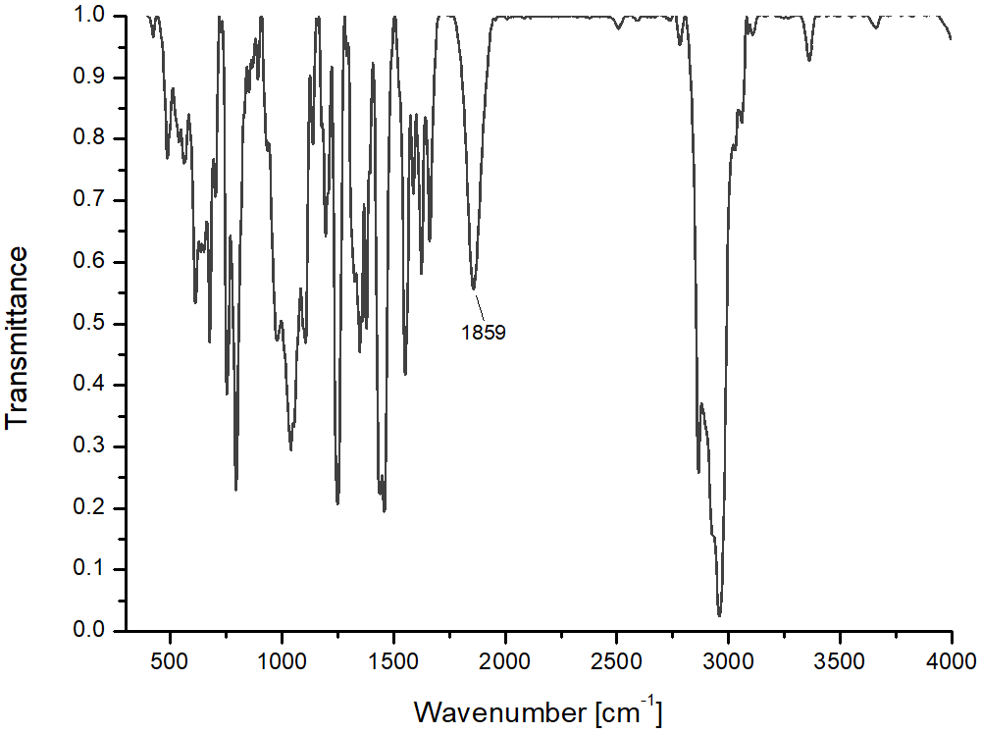
Supplemental Figure S24 | FT-IR spectrum of 2 (the preparation of 2 in toluene solution).
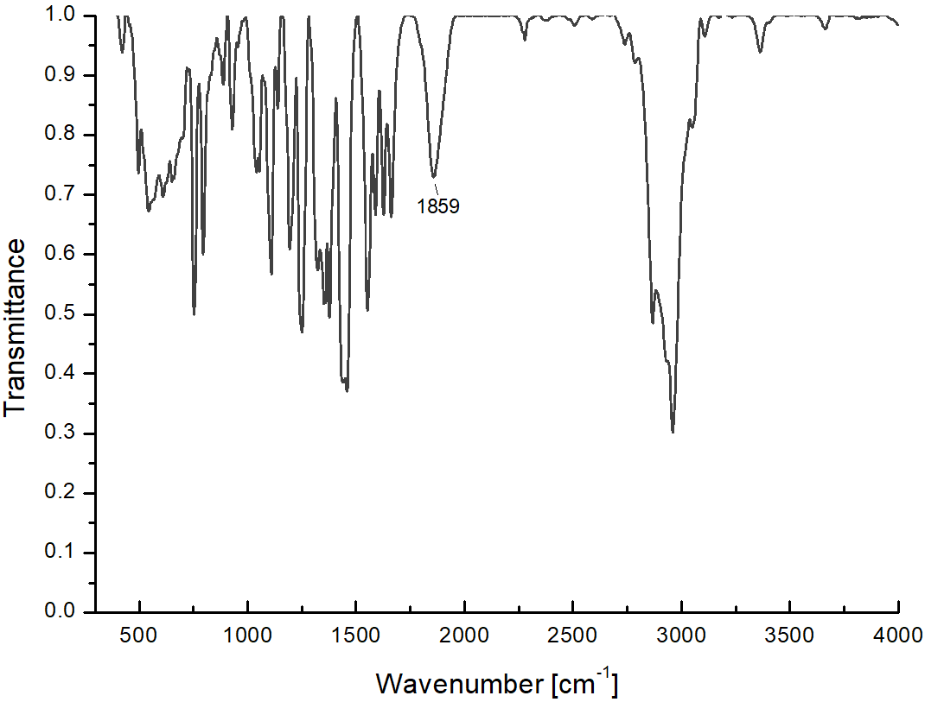
Supplemental Figure S25 | FT-IR spectrum of 2 (the preparation of 2 in toluene-d₈ solution).

Supplemental Figure S26 | ¹H NMR (500 MHz) spectrum of compound 4 in C₆D₆.

Supplemental Figure S27 | ¹³C{¹H} NMR (126 MHz) spectrum of compound 4 in C₆D₆.

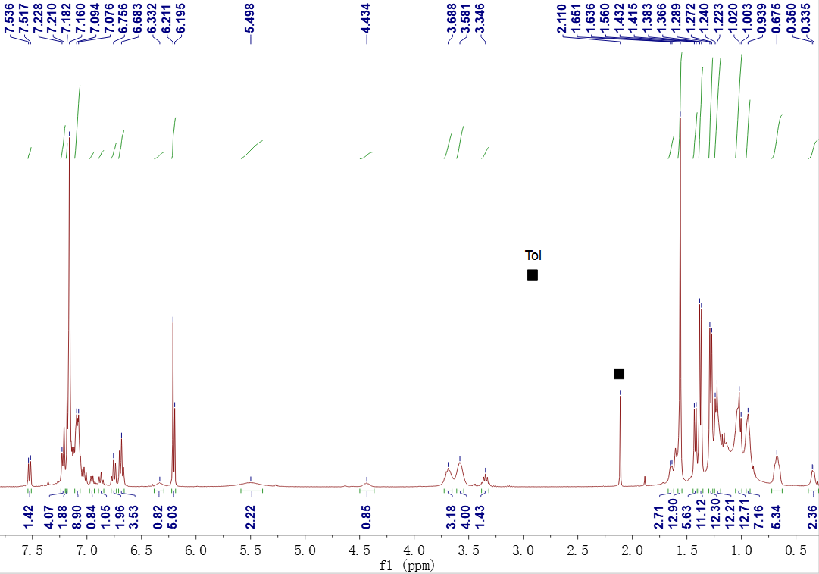
Supplemental Figure S28 | ¹H NMR (400 MHz) spectrum of compound 5 in C₆D₆ (■ = Tol).
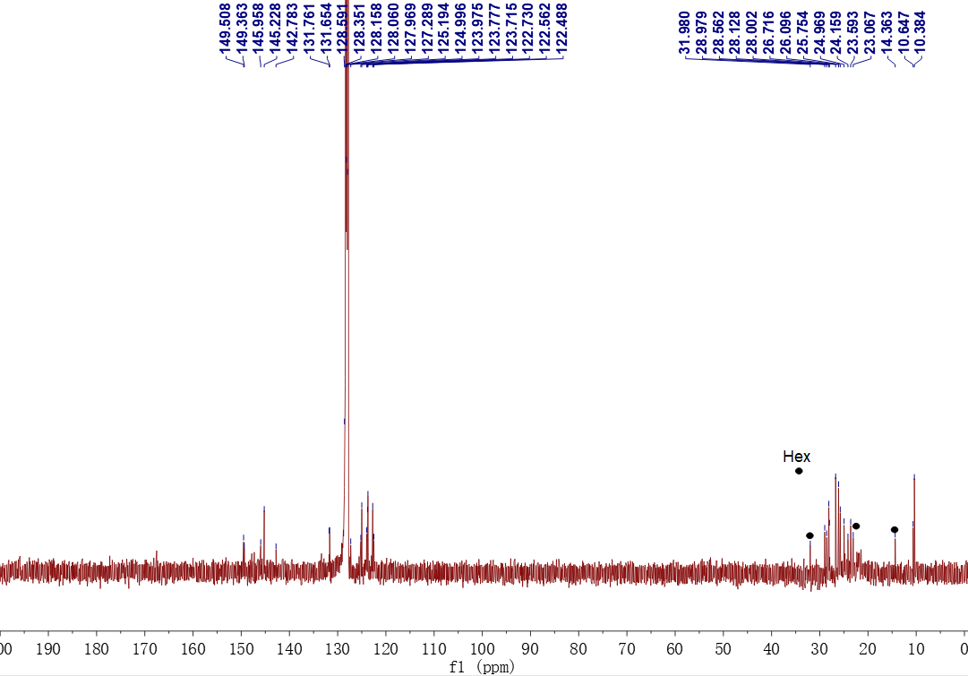
Supplemental Figure S29 | ¹³C{¹H} NMR (126 MHz) spectrum of compound 5 in C₆D₆ (• = Hex).
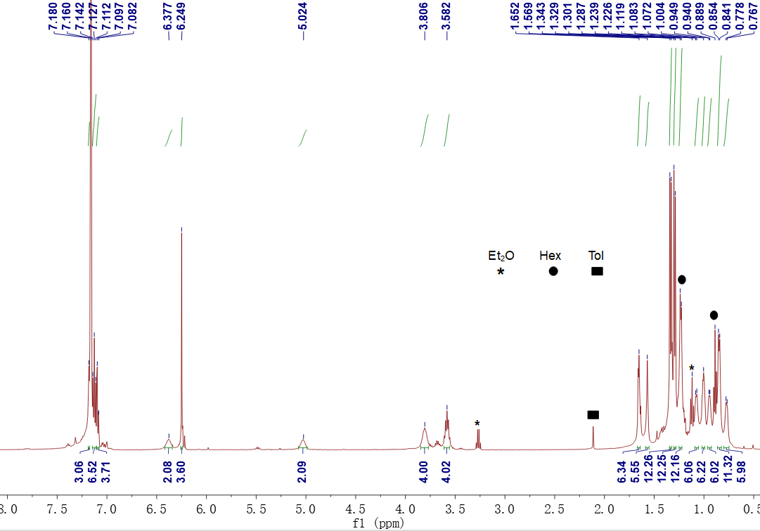
Supplemental Figure S30 | ¹H NMR (500 MHz) spectrum of compound 6 in C₆D₆ ( * = Et₂O, • = Hex, ■ = Tol).
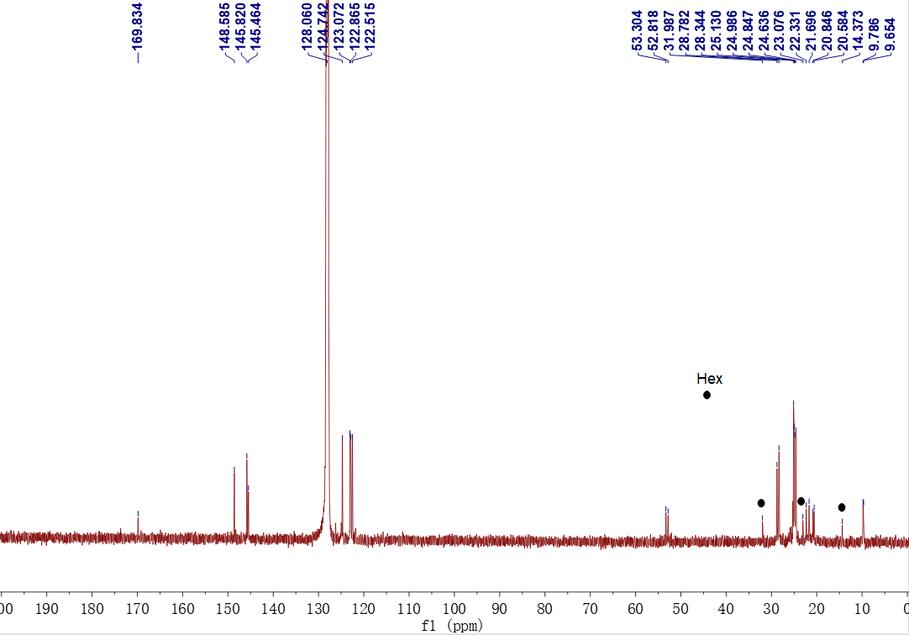
Supplemental Figure S31 | ¹³C{¹H} NMR (126 MHz) spectrum of compound 6 in C₆D₆ (• = Hex).
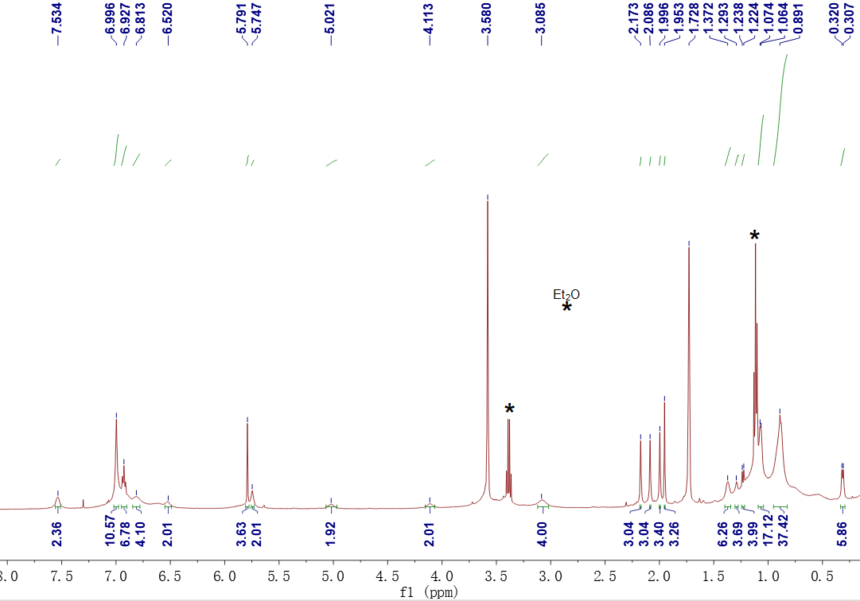
Supplemental Figure S32 | ¹H NMR (500 MHz) spectrum of compound 7 in D₈-THF (* = Et₂O).
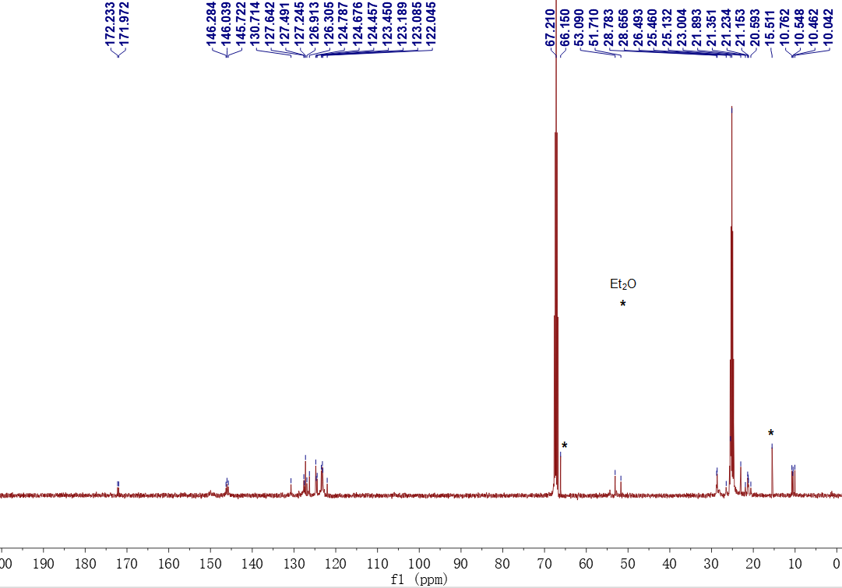
Supplemental Figure S33 | ¹³C{¹H} NMR (101 MHz) spectrum of compound 7 in D₈-THF (∗ = Et₂O).

