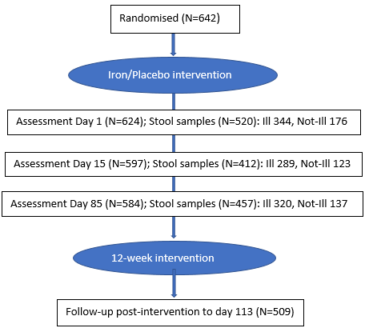
Supp. Fig. 1 | Trial profile and stool sample collection overview.
A total of 642 children were randomized to receive either iron supplementation or placebo for 12 weeks. Assessment visits were conducted at Day 1 (N = 624), Day 15 (N = 597), and Day 85 (N = 584). Stool samples were collected at each timepoint: Day 1 (N = 520; Ill = 344, Not-Ill = 176), Day 15 (N = 412; Ill = 289, Not-Ill = 123), and Day 85 (N = 457; Ill = 320, Not-Ill = 137). Post-intervention follow-up was completed for 509 children by Day 113.

Supp. Table 1 | Summary of all adverse events
AE diagnosis | Number*
Abdominal pain | 6
Abscesses/soft tissue infections | 26
Acute ear infection | 18
Acute respiratory infection | 362
Burns | 6
Chicken pox | 1
Conjunctivitis | 12
Diarrhoea with no dehydration | 165
Diarrhoea with some dehydration | 3
Dysentery | 16
Fever | 33
Infected skin lesions | 58
Malaria | 4
Oral sores/gingivitis | 5
Persistent diarrhoea | 3
Poor appetite | 2
Skin lesions | 32
Trauma | 2
Urinary Tract Infection (UTI) | 5
Vomiting | 14
Worms | 8
Other | 9

AE No=722; Infections=708
*Multiple diagnoses per AE incident sometimes occurred

(A) Alpha Diversity by Iron Treatment
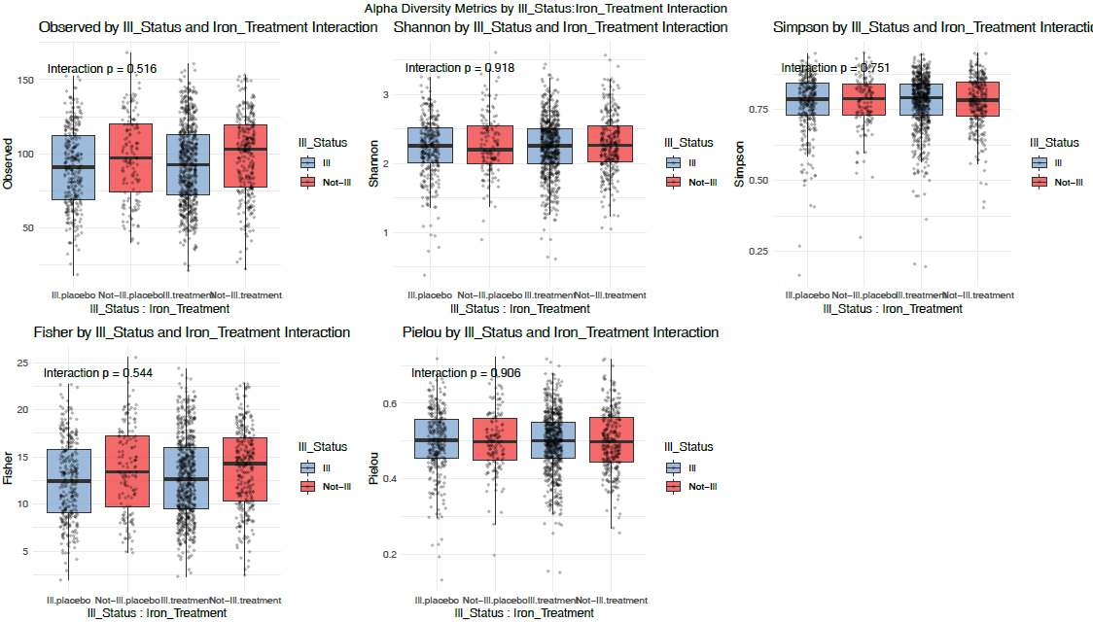
(B) Beta Diversity by Iron Treatment
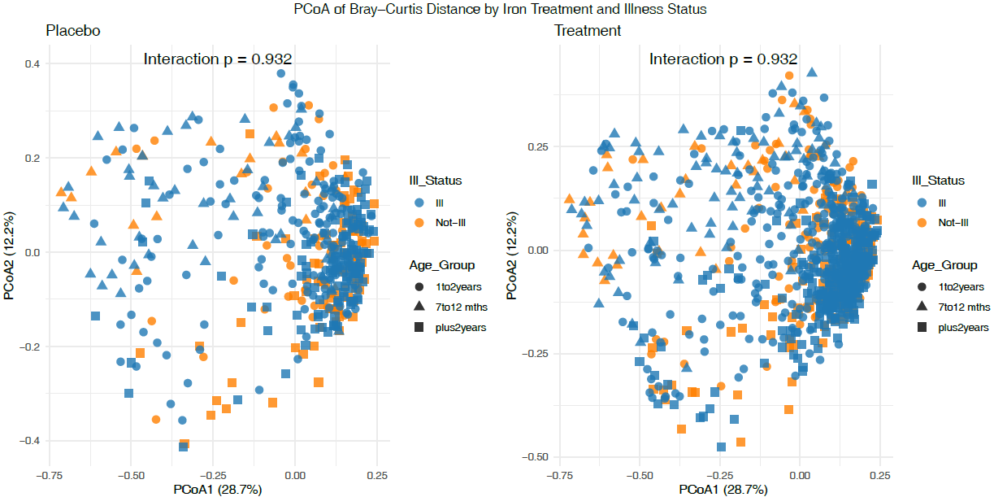
(C) Taxa by Iron Treatment (D) Ill Status by Iron Treatment
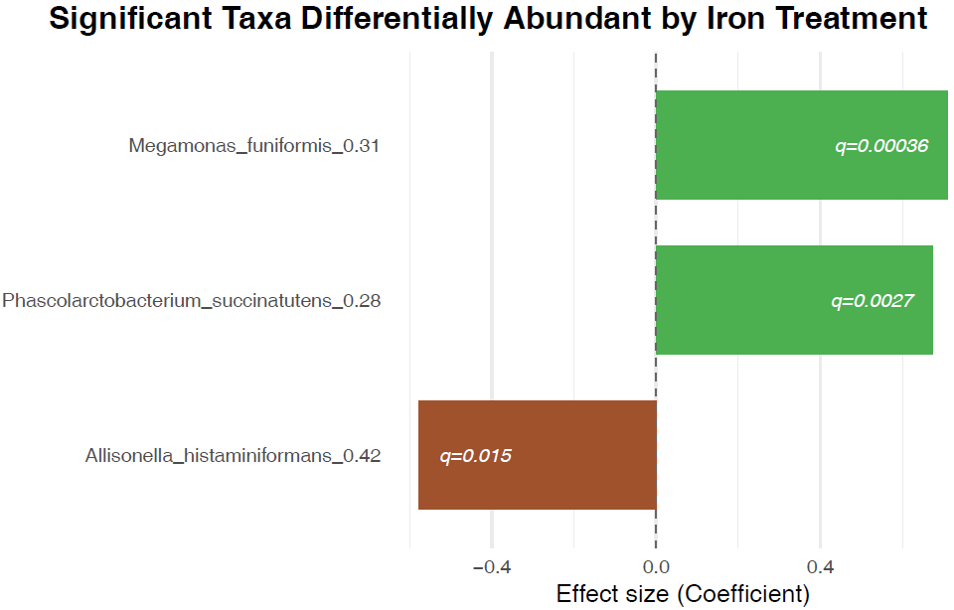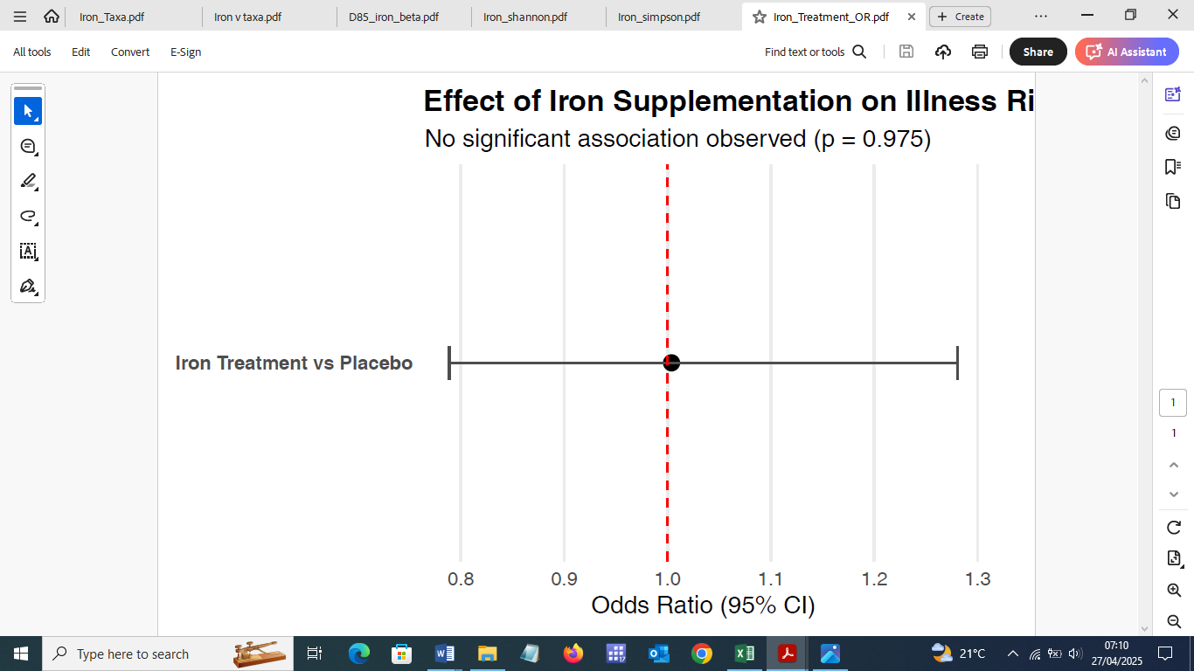
Supp. Fig. 2 | Impact of Iron Treatment on Gut Microbiome Diversity, Differential Taxa Abundance, and Illness Risk
(A) Alpha diversity indices (Observed richness, Shannon, Simpson, Pielou, Fisher) show no significant interaction between iron treatment and illness groups.
(B) Principal Coordinates Analysis (PCoA) of Bray–Curtis dissimilarity for microbiome profiles in iron-treated and control groups indicates no significant interaction between iron treatment and illness groups.
(C) MaAsLin2 analysis identifies significant differential abundance of Megamonas funiformis, Phascolarctobacterium succinatutens, and Allisonella histaminiformans in response to iron treatment. Each bar represents the log₂ fold change for each taxon, with color indicating direction of change (green: increased; brown: decreased); q-values are provided.
(D) Iron supplementation does not increase illness risk. Odds ratio (OR) for iron treatment versus placebo on the likelihood of illness (defined as any infection, diarrhea, or ARI during follow-up) was estimated using logistic regression. No significant difference was found (OR = 1.00, 95% CI: 0.79–1.28, p = 0.975). Error bars represent 95% confidence intervals.
(A) Alpha Diversity Comparisons Across Illness and Timepoint (FDR and age adjusted)
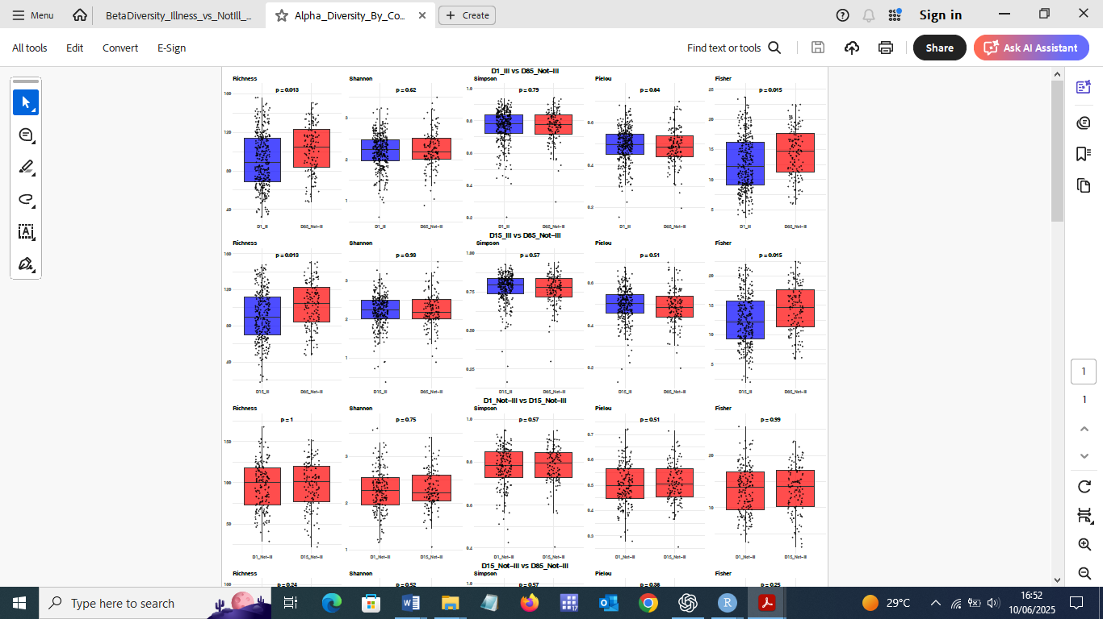

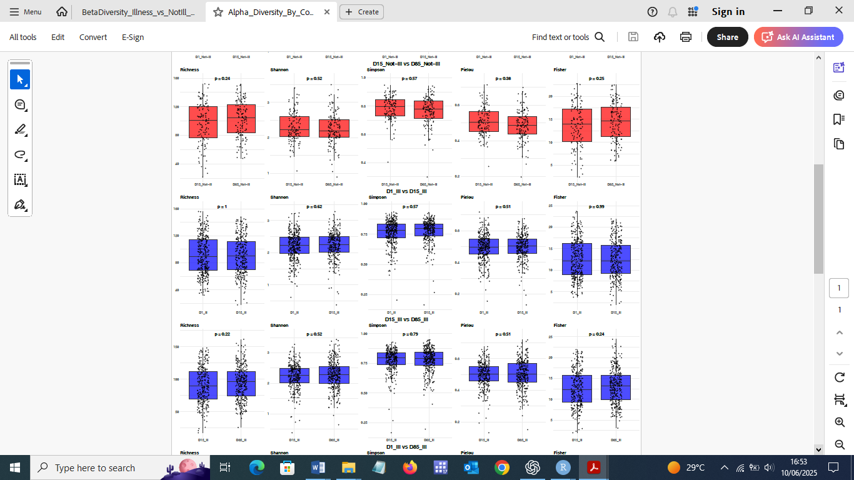
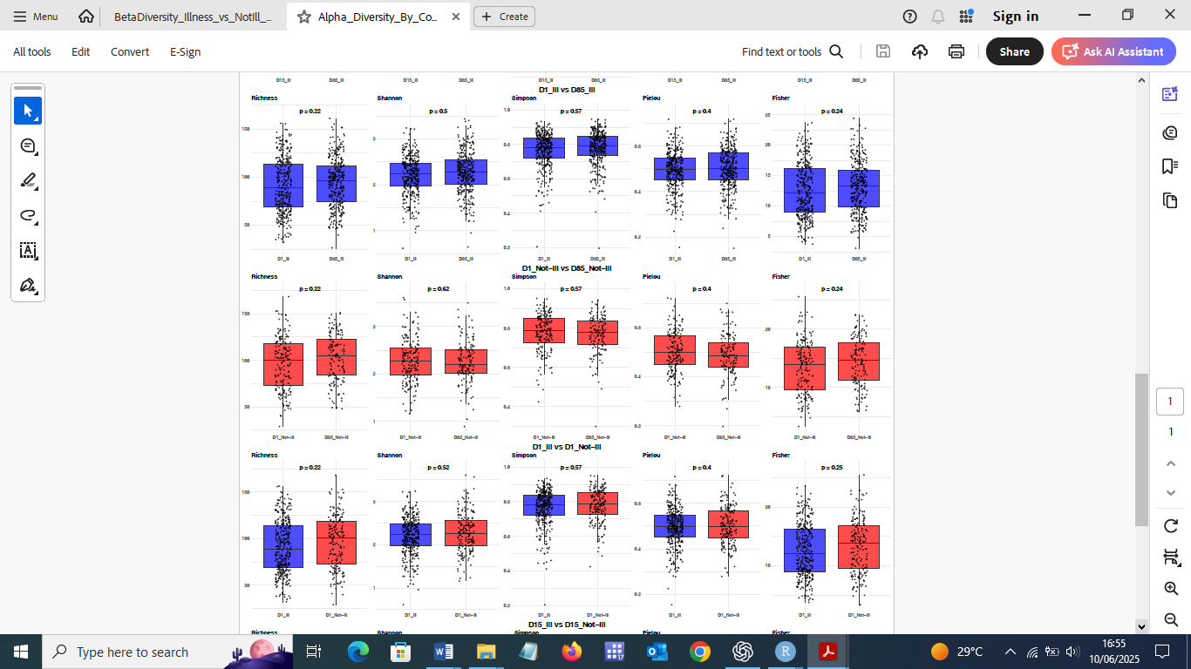
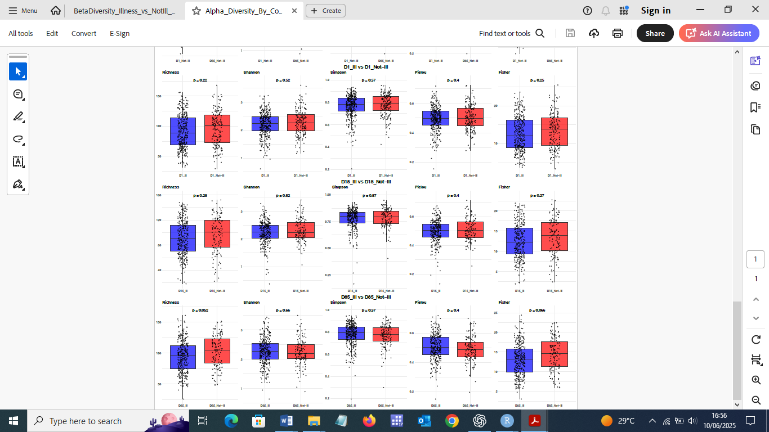

(B) Alpha Diversity Two way ANOVA: Ill vs Not−Ill across Timepoints (FDR and age adjusted)
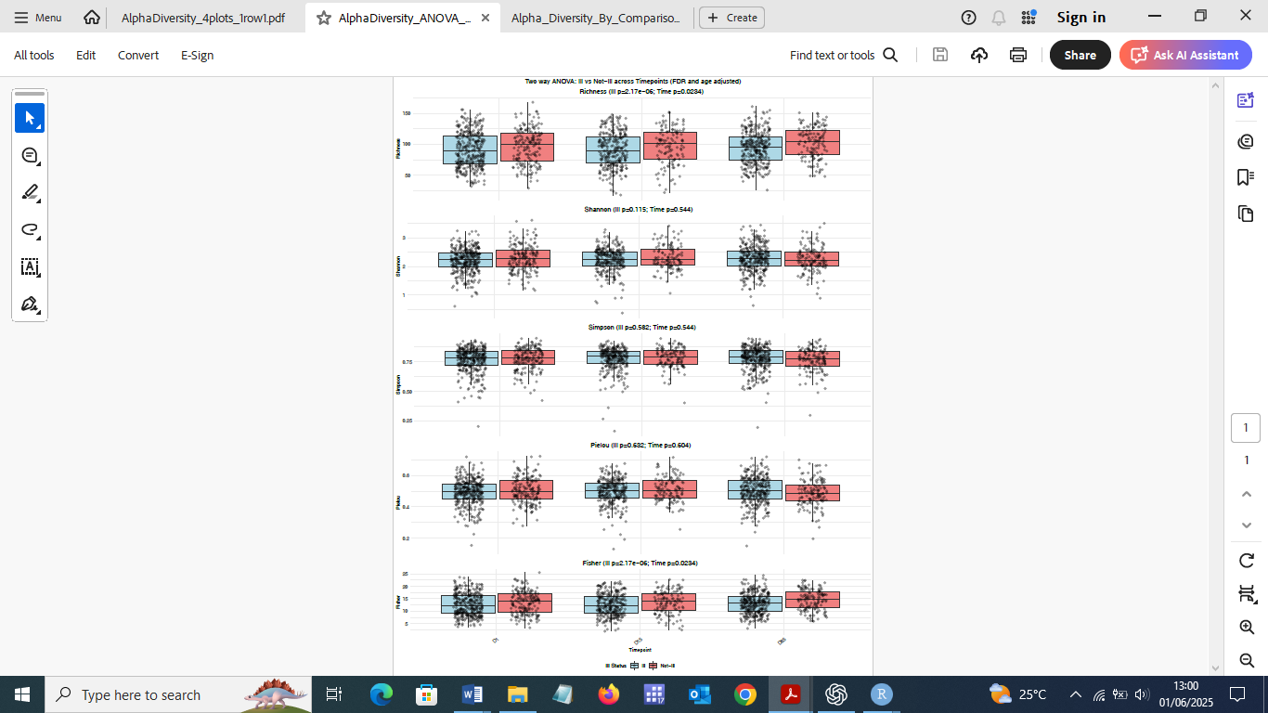
Supp. Fig. 3 | Alpha diversity comparisons between Ill and Not-Ill children.
(A) Age-adjusted alpha diversity comparisons between Ill and Not-Ill children at the same timepoints (D1, D15, D85) showed no significant differences across Shannon, Richness, or Fisher’s alpha metrics after false discovery rate (FDR) correction, indicating comparable within-sample diversity when controlling for developmental stage. Pairwise comparisons of alpha diversity metrics between Ill and Not-Ill groups at early timepoints versus the D85 Not-Ill reference revealed significantly lower diversity in Ill children at D1 (Richness FDR p = 0.013; Fisher’s alpha FDR p = 0.015) and D15 (Richness FDR p = 0.013; Fisher’s alpha FDR p = 0.015).
(B) Longitudinal assessment of alpha diversity metrics, adjusting for age, revealed no significant group-by-timepoint interactions (p_int_FDR > 0.2), indicating that within-sample diversity evolved similarly over time between Ill and Not-Ill children. However, consistent main effects of illness status were observed for Richness and Fisher’s alpha (p_ill_FDR = 2.2×10⁻⁶; FDR-adjusted), highlighting an overall lower alpha diversity in Ill children compared to Not-Ill peers.
Boxplots show median and interquartile range; p-values are FDR-adjusted. These results highlight disrupted microbiome maturation in children who develop illness.

Supp. Table 2 | FDR p-values for Alpha Diversity Metrics Across Illness and Timepoint Comparisons (adjusted for age)

Comparison | Richness | Shannon | Simpson | Pielou | Fisher
D15_Ill vs D85_Ill | 0.2216 | 0.5206 | 0.7908 | 0.5123 | 0.2403
D1_Ill vs D85_Ill | 0.2216 | 0.4994 | 0.5713 | 0.3954 | 0.2403
D1_Not-Ill vs D85_Not-Ill | 0.2216 | 0.6184 | 0.5713 | 0.3954 | 0.2403
D1_Ill vs D1_Not-Ill | 0.2216 | 0.5206 | 0.5713 | 0.3954 | 0.2480
D15_Ill vs D15_Not-Ill | 0.2513 | 0.5206 | 0.5713 | 0.3954 | 0.2677
D85_Ill vs D85_Not-Ill | 0.0516 | 0.6560 | 0.5713 | 0.3954 | 0.0658
D1_Ill vs D85_Not-Ill | 0.0130 | 0.6184 | 0.7908 | 0.8378 | 0.0151
D15_Ill vs D85_Not-Ill | 0.0130 | 0.9316 | 0.5713 | 0.5123 | 0.0151
D1_Not-Ill vs D15_Not-Ill | 0.9985 | 0.7473 | 0.5713 | 0.5123 | 0.9940
D15_Not-Ill vs D85_Not-Ill | 0.2430 | 0.5206 | 0.5713 | 0.3848 | 0.2480
D1_Ill vs D15_Ill | 0.9985 | 0.6184 | 0.5713 | 0.5123 | 0.9940

Supp. Table 3 | Alpha Diversity two way ANOVA results: Ill vs Not−Ill across Timepoints (adjusted for age)
Metric | df (Ill_Status) | F (Ill_Status) | FDR p (Ill_Status) | df (Time) | F (Time) | Timepoint (FDR p) | Interaction (FDR p)
Richness | 1 | 25.07 | 2.17×10⁻⁶ | 2 | 4.69 | 0.0234 | 0.9202
Shannon | 1 | 3.32 | 0.1145 | 2 | 0.90 | 0.5436 | 0.3256
Simpson | 1 | 0.53 | 0.5820 | 2 | 0.83 | 0.5436 | 0.4039
Pielou | 1 | 0.23 | 0.6316 | 2 | 0.50 | 0.6045 | 0.2613
Fisher | 1 | 24.42 | 2.17×10⁻⁶ | 2 | 4.71 | 0.0234 | 0.9202

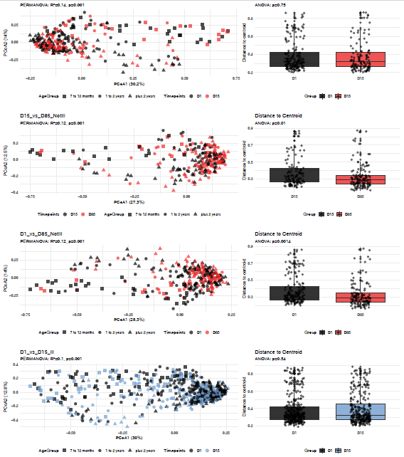
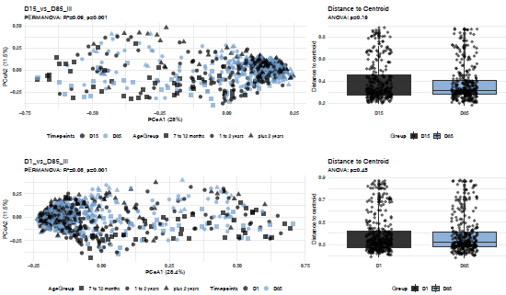
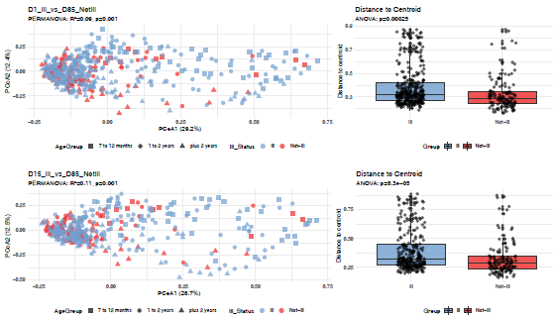

Supp. Fig 4 | Beta diversity comparisons across timepoints and illness status.
Bray–Curtis-based Principal Coordinates Analysis (PCoA) plots (left) and distance-to-centroid boxplots (right) compare microbial community composition across timepoints (D1, D15, D85) in Ill (blue) and Not-Ill (red) children. Each row corresponds to a specific pairwise comparison. PERMANOVA R² and p-values indicate significant differences in overall community structure across all comparisons (p = 0.001). Betadisp ANOVA tests show significant differences in dispersion for: D15 vs D85 (Not-Ill) (p = 0.0099), D1 vs D85 (Not-Ill) (p = 0.0014), D1 Ill vs D85 Not-Ill (p = 0.0003), and D15 Ill vs D85 Not-Ill (p < 0.0001), suggesting variation in beta diversity heterogeneity. P-values are annotated on respective plots.

Supp. Table 4 | Beta Diversity PERMANOVA & Dispersion ANOVA Results (adjusted for age)
Comparison / Group | PERMANOVA_Df | PERMANOVA_SumOfSqs | PERMANOVA_R2 | PERMANOVA_F | PERMANOVA_P | Dispersion_Df | Dispersion_F | Dispersion_P
D1_vs_D15_NotIll | 3 | 7.3962 | 0.1434 | 16.4658 | 0.001* | 1 | 0.0996 | 0.7525
D15_vs_D85_NotIll | 3 | 4.6490 | 0.1194 | 11.5673 | 0.001* | 1 | 6.7347 | 0.0100*
D1_vs_D85_NotIll | 3 | 5.7582 | 0.1183 | 13.8208 | 0.001* | 1 | 10.3282 | 0.0014*
D1_vs_D15_Ill | 3 | 11.5746 | 0.1009 | 23.5324 | 0.001* | 1 | 0.3722 | 0.5420
D15_vs_D85_Ill | 3 | 10.0961 | 0.0938 | 20.8683 | 0.001* | 1 | 1.7327 | 0.1886
D1_vs_D85_Ill | 3 | 9.3913 | 0.0817 | 19.5828 | 0.001* | 1 | 0.5648 | 0.4526
D1_Ill_vs_D1_NotIll | 3 | 9.5418 | 0.1043 | 20.0365 | 0.001* | 1 | 0.0365 | 0.8486
D15_Ill_vs_D15_NotIll | 3 | 9.1780 | 0.1229 | 19.0518 | 0.001* | 1 | 0.8698 | 0.3516
D85_Ill_vs_D85_NotIll | 3 | 5.6854 | 0.0793 | 12.9968 | 0.001* | 1 | 10.0260 | 0.0016*
D1_Ill_vs_D85_NotIll | 3 | 7.2135 | 0.0910 | 15.9240 | 0.001* | 1 | 13.5825 | 0.0003*
D15_Ill_vs_D85_NotIll | 3 | 8.0954 | 0.1120 | 17.7422 | 0.001* | 1 | 15.8052 | 0.0001*
Soon-Ill | 3 | 4.9770 | 0.0930 | 11.0021 | 0.001* | 1 | 14.0731 | 0.0002*
Later-Ill | 3 | 3.1822 | 0.0946 | 8.1107 | 0.001* | 1 | 4.2962 | 0.0393*
Much-Later-Ill | 3 | 2.4658 | 0.0920 | 6.2123 | 0.001* | 1 | 5.5544 | 0.0195*
Early-Ill | 3 | 2.3477 | 0.0742 | 5.7724 | 0.001* | 1 | 7.8916 | 0.0054*
Recent-Ill | 3 | 2.7517 | 0.0897 | 7.1640 | 0.001* | 1 | 2.4842 | 0.1164

(A) D1 D15
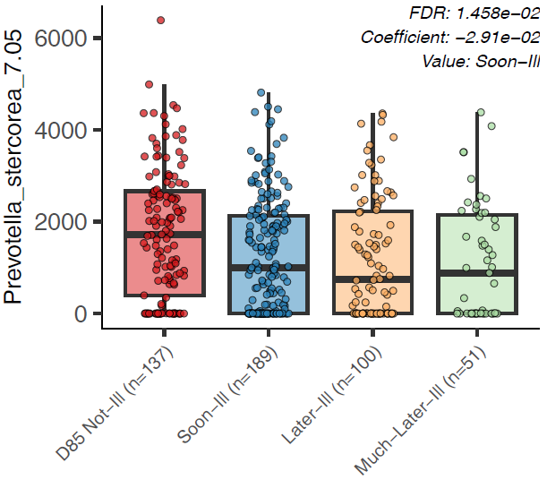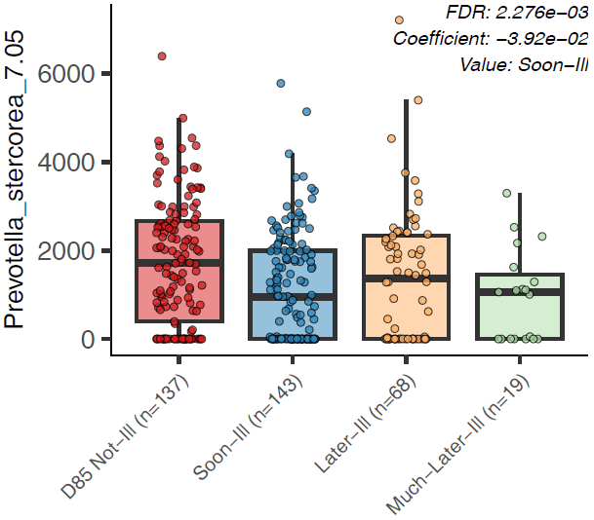
(B) D1 D15
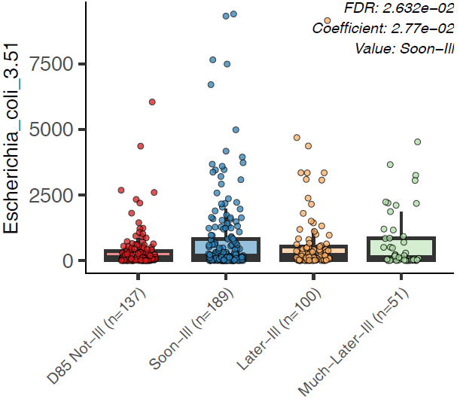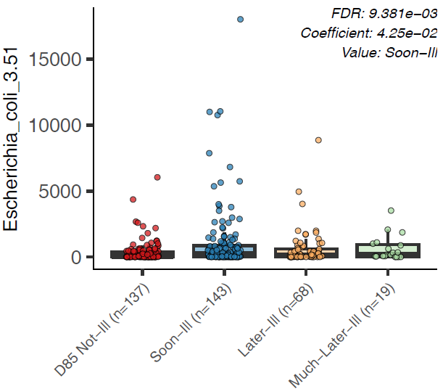

Supp. Fig. 5 | MaAsLin2 plot of age adjusted differential abundance of P. stercorea and E. coli across D1 and D15 Ill groups.
(A) Boxplot depicting relative abundance of Prevotella stercorea in stool samples from children categorized as Not Ill, Soon Ill (illness onset ≤35 days), Later Ill (36–70 days), and Much Later Ill (>70 days). MaAsLin2 analysis of significant negative association of Soon Ill compared to Not Ill (D1 q = 0.01458; D15 q = 0.002276) is displayed in the plots.
(B) Boxplot showing relative abundance of Escherichia coli across the same groups, with the significant association observed for Soon Ill versus Not Ill (D1 q = 0.02632; D15 q = 0.009381) shown.
Each boxplot displays the distribution of relative abundance values for the given taxon within each illness group. The central line represents the median. The box boundaries indicate the interquartile range (IQR), spanning from the 25th percentile (Q1) to the 75th percentile (Q3). Whiskers extend to the most extreme data points within 1.5 times the IQR above Q3 and below Q1. Data points outside this range are plotted individually as outliers. All q-values reported are adjusted for multiple testing using the Benjamini-Hochberg method.

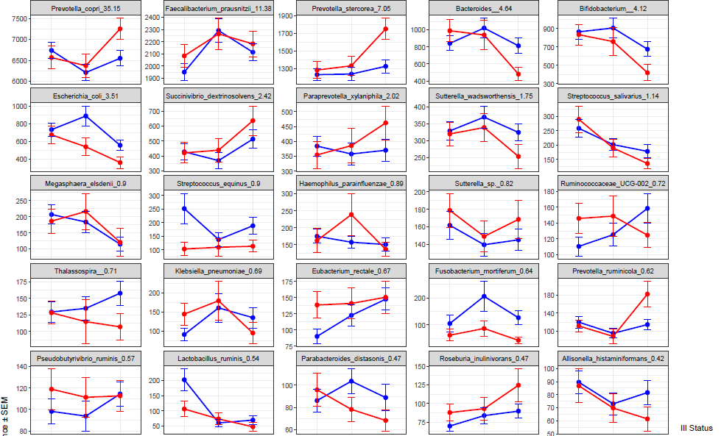 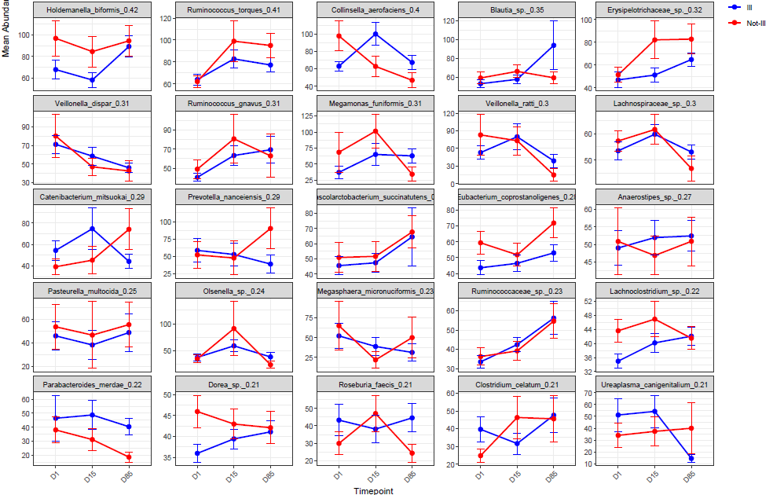Supp. Fig. 6 | Top 50 most abundant taxa in Ill and Not-Ill children across timepoints.
Relative abundances (%) of the 50 most abundant bacterial taxa, shown as mean ± standard error, stratified by Illness Status (Ill, Not-Ill) and timepoint (D1, D15, D85). Taxa are displayed in individual panels using faceted plots. Each line traces the average relative abundance over time within each illness group.
Participant’s characteristics |  | All age  groups |  | Youngest age  7-12 months |  | Middle age  13-24 months |  | Oldest age  25-37 months
Number of children  Age^{N633} min-max (mean, SD)  Female |  | 633  7-37 (22, 8)  305 (48%) |  | 88  7-12 (10, 1.4)  39 (44%) |  | 282  13-25 (18, 3.3)  140 (50%) |  | 263  25-37 (30, 3.4)  126 (48%)
Sample characteristics |  | Sampling timepoint
 |  | All time points |  | Day 1 |  | Day 15 |  | Day 85
Age groups | All age groups  Youngest  Middle  Oldest | 1389  190  616  583 |  | 520  72  238  210 |  | 412  60  181  171 |  | 457  58  197  20
Geographic location of health facility | Chamoi  Darsilami  Kuwonkuba  Taibatu  Yorrobawol | 154  252  131  412  440 |  | 67  91  47  162  153 |  | 42  73  46  126  125 |  | 45  88  38  124  162
Adverse Events (AE) age distribution
Adverse Event |  | Yes | No | Yes | No | Yes | No | Yes | No
 |  | 423 | 210 | 59 | 29 | 200 | 82 | 162 | 101
Supp. Table 5 | Participant Adverse Events and cohort characteristics from 1389 stool samples collected from 633 study participants over three time points. Day 1, Day 15, and Day 85 characteristics are shown for all children (N=633) separately for the three different age groups (youngest age N=88, middle age N=282, oldest age N=263). Sample characteristics are shown for the three sampling points and for the geographic location.

