Supplementary data
In the process of simulating the step-by-step increase of sample size, the sample size was incremented by 10 cases each time, starting from 99 cases. Simulations were conducted for sample sizes of 109, 119, 129, and so on. The Bootstrap method (obtaining different simulated datasets through multiple samplings), was used to generate simulated data for each incremented sample size dataset. Each simulated dataset with an increased sample size was then analyzed. The odds ratio (OR) at different sample sizes were calculated, along with the corresponding 95% confidence intervals.
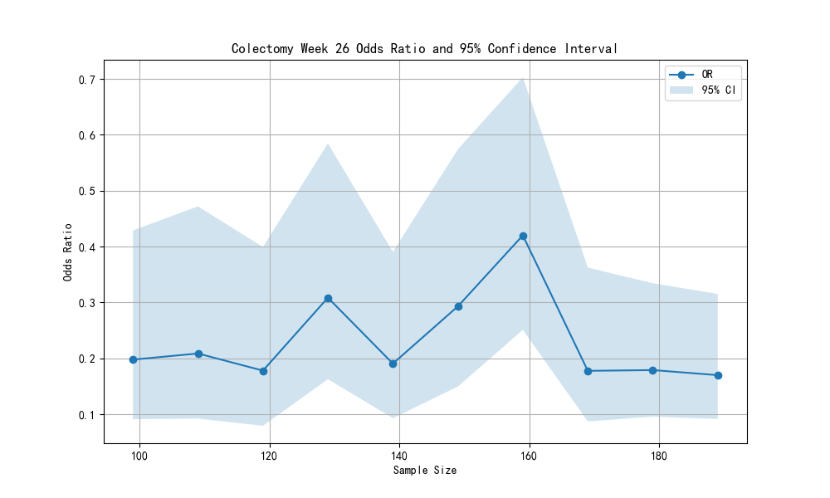
Figure S1: Visualization of the Stability of the Effect of Immunosuppressant Therapy on Colectomy at 26 Weeks as the Sample Size Increases in Sensitivity Analysis

