Supplementary Information

Table S1. Chromatographic gradient conditions (water/acetonitrile (98:2) 0.1% formic acid (phase A) and acetonitrile (phase B)) for the analysis of melanin samples.
Time (min) | Flow (mL min⁻¹) | Phase A (%) | Phase B (%)
Initial | 0.25 | 85.0 | 15.0
2.00 | 0.25 | 85.0 | 15.0
2.10 | 0.30 | 5.0 | 95.0
5.50 | 0.30 | 5.0 | 95.0
5.55 | 0.25 | 85.0 | 15.0
7.00 | 0.25 | 85.0 | 15.0

Table S2. Optimized MRM parameters (cone voltage (CV) and collision energy (CE)) and chromatographic retention time (RT) of standards.
Compound | Polarity | Parent ion (m/z) | Product ion (m/z) | CV (V) | CE (V)
PDCA | + | 155.98 | 64.04 | 30.0 | 15.0
PDCA | + | 155.98 | 120.06 | 30.0 | 15.0
PDCA | + | 155.98 | 138.01 | 30.0 | 8.0
TDCA | + | 174.01 | 111.99 | 30.0 | 15.0
TDCA | + | 174.01 | 127.86 | 30.0 | 15.0
TDCA | + | 174.01 | 155.95 | 30.0 | 8.0

Table S3. Chromatographic gradient conditions (methanol 0.1% acid formic (phase A) and water + methanol (98:2) 0.1% acid formic (phase B)) for the analysis of melanin samples.
Time (min) | Flow (mL min⁻¹) | Phase A (%) | Phase B (%)
Initial | 0.30 | 70.0 | 30.0
2.00 | 0.30 | 70.0 | 30.0
3.00 | 0.30 | 95.0 | 5.0
3.10 | 0.30 | 95.0 | 5.0
3.50 | 0.30 | 70.0 | 30.0
5.00 | 0.30 | 70.0 | 30.0

Table S4. Optimized MRM parameters (cone voltage (CV) and collision energy (CE)) and chromatographic retention time (RT) of standards.
Compound | Polarity | Parent ion (m/z) | Product ion (m/z) | CV (V) | CE (V)
1,8-DHN | - | 158.77 | 129.93 | 35.0 | 25.0
1,8-DHN | - | 158.77 | 140.85 | 35.0 | 20.0

Figure S1
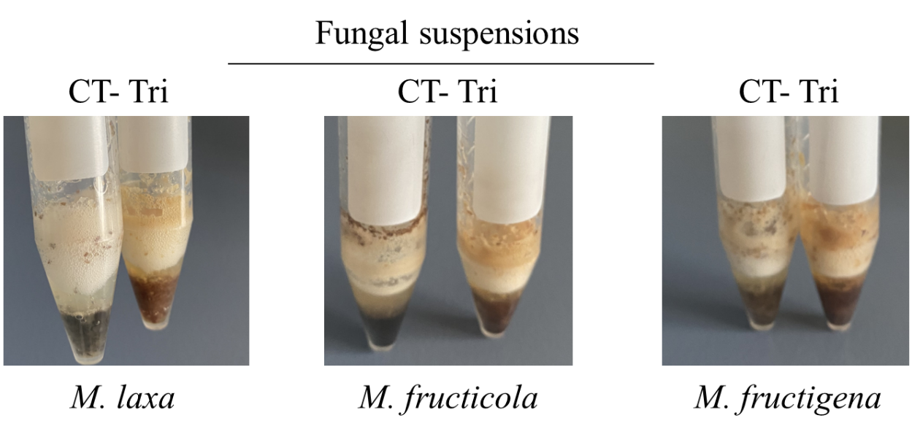
Figure S1. Changes in the colour of the fungal suspensions of Monilinia spp. between control (CT) and tricyclazole (TRI) conditions.

