Supplemental Figures
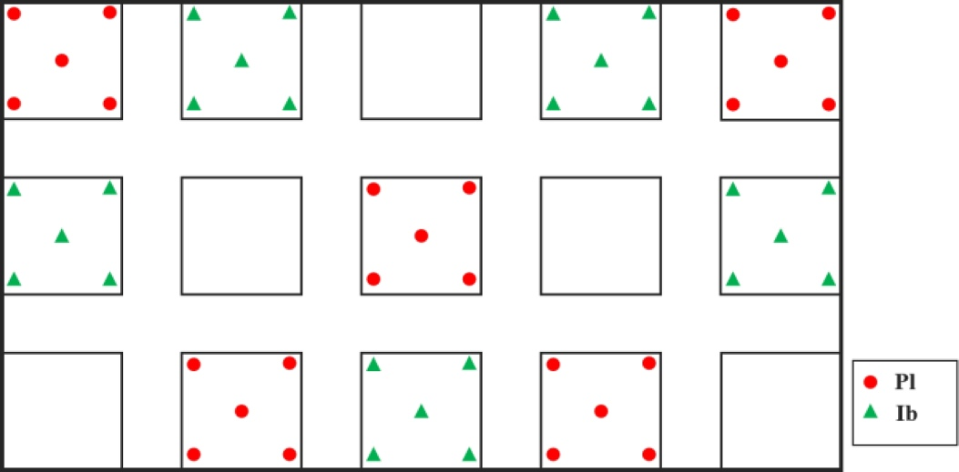
Fig.S1 Planting design for field plots.
Fig.S2 Changes of above-ground biomass of Mm, Pl and Ib under intra-interspecific competition with planting duration (AV±SD, n=5). Note: Mm(Mm) means M. micrantha under intraspecific competition; Mm(Pl) means M. micrantha growing with thomson kudzu under interspecific competition; Mm(Ib) means M. micrantha growing with sweet potato under interspecific competition; Pl(Pl) means thomson kudzu under intraspecific competition; Pl(Mm) means thomson kudzu growing with M. micrantha under interspecific competition; Ib(Ib) means sweet potato under intraspecific competition; Ib(Mm) means sweet potato growing with M. micrantha under interspecific competition.
Fig. S3 Changes in soil nitrogen and microbial biomass nitrogen of Pl, Ib and Mm plots in the field (AV±SD, n=5). Note: Mm means M. micrantha control plots; Ib means sweet potato replacement plots; Pl means thomson kudzu replacement plots. Different letters above columns indicate significant differences between three plots (Mm, Ib and Pl) in the same replacement period according to Duncan’s test (P < 0.05).

Fig. S4 Variation of Shannon index of the nifH functional gene sequencing in root nodules and rhizosphere soil under intra-/inter-specific competition with M. micrantha (AV±SD, n=3). Pl(Pl) means thomson kudzu under intraspecific competition; Pl(Mm) means thomson kudzu growing with M. micrantha under interspecific competition; Mm+Mm and Pl+Pl means the soil of M. micrantha and thomson kudzu under intraspecific competition, respectively. Pl+Mm means the soil of thomson kudzu growing with M. micrantha under interspecific competition. Different letters above columns in the figure S3B indicate significant differences between competition treatments according to Duncan’s test (P < 0.05). **P<0.01 (Independent Sample T-test).

