Supplementary material
Table S1 Detection Rates of BCoV, BNoV, and BRV
Viruses | Total (n=194) |  | Slaughterhouse (n=57) |  | Dairy farms (n=100) |  | Villages (n=37)
Viruses | Positive Number (per) | Positive Rate (%) | Positive Number (per) | Positive Rate (%) | Positive Number (per) | Positive Rate (%) | Positive Number (per) | Positive Rate (%)
BCoV (All) | 17 | 8.76 | 17 | 29.80 | 0 | 0.00 | 0 | 0.00
BNoV (All) | 31 | 15.98 | 20 | 35.09 | 10 | 10.00 | 1 | 2.70
BRVC (All) | 11 | 5.67 | 11 | 19.30 | 0 | 0.00 | 0 | 0.00
BCoV+BNoV | 3 | 1.55 | - | - | - | - | - | -
BCoV+BRVC | 3 | 1.55 | - | - | - | - | - | -
BNoV+BRVC | 0 | 0 | - | - | - | - | - | -
BCoV+BNoV+BRVC | 6 | 3.09 | - | - | - | - | - | -
≥2 types of viruses | 12 | 6.19 | - | - | - | - | - | -

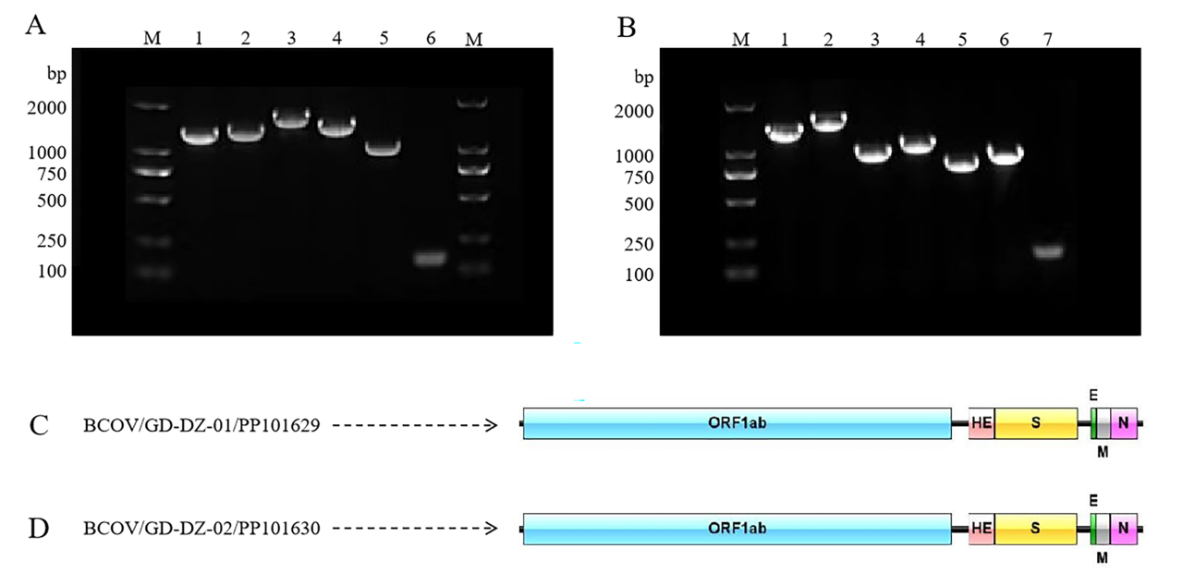
Fig. S1:PCR amplification of the segmented gene sequences of BCoV. (A) Lane M, DL2000 marker; Lanes 1–5, PCR fragments using primer pairs BCoV1–BCoV5. The lengths of the respective amplified fragments plus 100 bp of vector plasmid DNA are 1247, 1310, 1590, 1410, and 1007 bp; Lane 6, Negative control. (B) Lane M, DL2000 marker; Lanes 1–5, PCR fragments using primer pairs BCoV6–BCoV11. The lengths of the respective amplified fragments plus 100 bp of vector plasmid DNA are 1512, 1689, 920, 961, 784, and 917 bp; Lane 7, Negative control. (C, D) Gene structures of coronavirus PP101629 and PP101630.

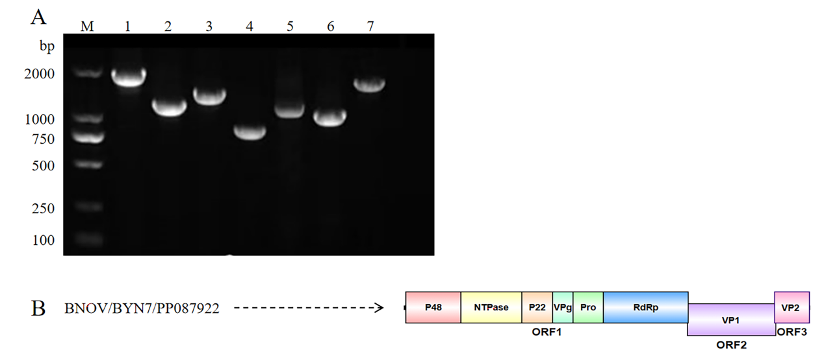
Fig. S2:PCR amplification of the segmented gene sequences of BNoV. (A) Lane M, DL2000 marker; Lanes 1–7, PCR fragments using primer pairs BNoV1–BNoV7. The lengths of the respective amplified fragments plus 100 bp of vector plasmid DNA are 1772, 1104, 1322, 793, 1087, 985 and 1559 bp. (B) Gene structures of coronavirus PP087922.

Table S2 Similarity of the BCoV/PP101629 and BCoV/PP101630 strains with reference strains (%)
Strains | Full genome |  | ORF1ab (nt/aa) (21285/7094) |  | S (nt/aa) (4092/1363) |  | HE (nt/aa) (1275/424)
Strains | PP101629 | PP101630 | PP101629 | PP101630 | PP101629 | PP101630 | PP101629 | PP101630
AB354579 | 98.3 | 97.8 | 98.6/99.2 | 98.6/99.1 | 97.4/97.1 | 94.6/95.8 | 96.7/96.7 | 97.0/97.2
AY597011 | 73.1 | 73.2 | 74.7/72.7 | 74.7/72.6 | 69.3/66.0 | 69.1/66.5 | 65.7/58.5 | 65.7/58.5
KM349742 | 73.5 | 73.6 | 74.7/75.3 | 74.7/75.2 | 69.4/67.8 | 69.5/68.4 | 69.0/70.3 | 68.8/70.0
KU886219 | 98.9 | 98.2 | 99.1/99.3 | 99.1/99.2 | 89.4/98.8 | 86.1/96.1 | 98.3/98.1 | 98.5/98.6
MG757142 | 98.0 | 97.4 | 98.3/98.9 | 98.2/98.8 | 97.0/97.8 | 94.0/95.9 | 97.2/97.9 | 97.7/98.3
MH810163 | 97.6 | 97.0 | 97.7/97.1 | 97.7/96.9 | 96.8/95.6 | 93.9/93.8 | 96.6/93.6 | 96.9/94.1
OR077307 | 98.6 | 99.4 | 99.6/99.7 | 99.6/99.6 | 99.4/96.0 | 99.3/99.6 | 98.1/98.3 | 97.7/98.3
AY391777 | 96.1 | 96.1 | 97.0/97.5 | 97.0/97.4 | 94.0/95.7 | 92.8/92.6 | 94.6/93.9 | 94.5/93.6
AF304460 | 49.0 | 49.1 | 48.6/34.9 | 48.6/34.9 | 38.5/23.5 | 38.7/23.4 | - | -
AY274119 | 48.1 | 48.0 | 51.8/42.6 | 51.8/42.6 | 42.6/30.1 | 42.4/29.6 | - | -
AY567487 | 49.8 | 50.0 | 49.1/34.6 | 49.1/34.6 | 38.3/24.0 | 38.5/24.3 | - | -
EF203065 | 50.1 | 50.1 | 48.2/34.7 | 48.2/34.7 | 46.3/24.5 | 46.4/24.1 | - | -
EU111742 | 46.0 | 46.2 | 48.7/34.8 | 48.8/34.8 | 39.5/20.2 | 39.4/20.1 | - | -
FJ376619 | 44.1 | 44.0 | 45.5/31.0 | 45.5/31.0 | 40.3/24.3 | 40.3/24.5 | - | -
HM245925 | 48.9 | 48.9 | 48.5/35.4 | 48.6/35.4 | 38.3/24.1 | 38.8/24.1 | - | -
JQ065048 | 44.2 | 44.3 | 45.1/31.0 | 45.2/31.0 | 37.9/23.3 | 38.0/23.4 | - | -
JX869059 | 52.2 | 52.3 | 51.6/43.1 | 51.7/43.1 | 43.8/32.1 | 43.7/32.0 | - | -
KC545383 | 53.1 | 53.2 | 52.7/43.2 | 52.8/43.2 | 42.7/32.2 | 42.8/31.8 | - | -
KF636752 | 46.8 | 47.0 | 51.4/42.3 | 51.5/42.3 | 41.8/28.5 | 41.4/28.5 | - | -
M95169 | 46.3 | 46.3 | 48.4/36.0 | 48.5/36.0 | 42.8/22.5 | 42.4/22.5 | - | -
MK359255 | 48.4 | 48.4 | 49.2/36.1 | 49.2/36.1 | 41.5/22.4 | 41.3/22.5 | - | -
NC_045512 | 52.2 | 52.3 | 51.9/42.3 | 52.0/42.2 | 43.0/29.9 | 43.0/29.3 | - | -

Table S2 Continued from the previous page (%)
Strains | E (nt/aa) (261/85) |  | M (nt/aa) (693/230) |  | N (nt/aa) (1347/448)
Strains | PP101629 | PP101630 | PP101629 | PP101630 | PP101629 | PP101630
AB354579 | 96.5/98.8 | 94.1/94.0 | 98.4/97.4 | 97.0/97.8 | 98.2/98.4 | 97.9/98.0
AY597011 | 65.5/54.3 | 66.7/55.6 | 74.9/78.0 | 75.9/79.8 | 67.2/66.4 | 67.2/66.2
KM349742 | 79.9/80.5 | 78.7/76.8 | 83.4/89.1 | 84.0/90.4 | 75.6/76.0 | 75.8/76.0
KU886219 | 97.3/100.0 | 94.9/95.2 | 99.1/98.7 | 97.7/98.3 | 98.1/98.7 | 97.9/97.8
MG757142 | 97.3/100.0 | 94.9/95.2 | 97.7/98.3 | 96.7/97.8 | 98.5/98.7 | 98.1/97.8
MH810163 | 95.3/97.6 | 92.9/92.9 | 97.5/95.2 | 96.1/94.8 | 99.6/99.3 | 99.3/98.9
OR077307 | 95.7/98.8 | 96.5/96.4 | 99.7/100.0 | 97.4/97.8 | 99.6/99.6 | 99.3/99.1
AY391777 | 93.9/97.6 | 92.0/92.9 | 94.4/93.0 | 94.7/93.9 | 96.4/96.4 | 96.1/96.0
AF304460 | 37.6/19.7 | 37.2/17.1 | 45.3/33.6 | 45.3/34.1 | 39.7/22.9 | 40.1/22.6
AY274119 | 39.8/19.7 | 39.4/19.7 | 47.5/40.3 | 47.4/40.7 | 45.4/33.5 | 45.5/33.3
AY567487 | 38.5/17.1 | 38.5/17.1 | 49.4/35.7 | 49.6/34.8 | 40.9/22.3 | 41.3/22.1
EF203065 | 36.4/14.7 | 37.3/16.0 | 47.6/35.3 | 47.6/35.7 | 41.6/22.5 | 41.7/22.5
EU111742 | 32.5/15.7 | 32.9/13.3 | 38.8/30.3 | 39.2/30.3 | 37.6/25.4 | 37.4/25.4
FJ376619 | 36.9/25.0 | 34.9/23.6 | 38.9/27.8 | 39.9/27.8 | 36.8/25.9 | 36.6/25.6
HM245925 | 41.1/21.8 | 42.3/23.1 | 50.5/34.9 | 51.1/35.4 | 40.7/25.1 | 40.5/25.1
JQ065048 | 39.3/15.3 | 38.5/13.9 | 39.1/26.1 | 39.4/27.1 | 36.0/24.6 | 35.9/24.6
JX869059 | 43.4/28.0 | 43.0/28.0 | 51.3/44.7 | 51.4/45.7 | 46.7/33.3 | 46.7/33.1
KC545383 | 41.8/26.8 | 41.0/26.8 | 51.6/43.6 | 51.8/44.0 | 47.3/33.2 | 47.1/32.9
KF636752 | 40.4/25.3 | 39.6/24.1 | 48.9/41.0 | 49.0/41.0 | 45.2/31.3 | 45.5/31.1
M95169 | 35.3/23.2 | 34.5/19.5 | 44.2/31.9 | 44.5/31.9 | 36.0/23.3 | 36.0/22.5
MK359255 | 35.0/14.1 | 34.2/14.1 | 45.0/32.3 | 45.3/31.3 | 34.0/23.1 | 33.9/23.4
NC_045512 | 41.2/21.3 | 40.8/21.3 | 46.1/38.3 | 45.8/38.3 | 45.1/33.5 | 45.3/33.3

Table S3 Similarity analysis of BNoV/BYN7 with reference strains (%)
Strains | Length  (bp) | Full genome (%) | ORF1 (nt/aa)  (5043/1644) (%) | VP1 (nt/aa) (1569/522) (%) | VP2 (nt/aa) (651/216) (%)
AJ011099 | 7338 | 71.1 | 73.3/85.0 | 68.1/70.4 | 61.9/65.7
AY228235 | 7382 | 51.2 | 54.5/46.8 | 48.4/42.6 | 38.3/31.2
AF097917 | 7311 | 82.7 | 83.9/96.2 | 78.4/85.1 | 80.8/85.6
AY126474 | 7311 | 83.0 | 84.2/96.0 | 78.5/86.0 | 80.7/85.1
EU794907 | 7317 | 82.8 | 80.6/95.8 | 78.2/85.8 | 81.3/85.6
HQ392821 | 7548 | 53.5 | 54.8/52.8 | 51.2/46.2 | 39.6/37.1
JF781268 | 7839 | 54.4 | 56.2/51.9 | 49.9/42.7 | 44.6/37.4
JX145650 | 7313 | 84.2 | 82.9/96.9 | 77.7/84.5 | 80.2/85.6
KC894731 | 7525 | 54.0 | 54.8/51.8 | 50.9/44.9 | 44.5/34.7
KY934262 | 7778 | 57.8 | 59.0/61.9 | 54.8/49.6 | 43.1/44.7
MG601447 | 7556 | 53.1 | 54.8/51.5 | 50.1/44.9 | 39.8/37.1
MK159169 | 7321 | 89.8 | 93.2/98.5 | 68.3/73.0 | 64.6/65.2
MN122335 | 7342 | 87.5 | 92.1/98.2 | 78.4/85.1 | 79.4/85.1
MN480761 | 7320 | 85.6 | 90.1/98.0 | 78.0/84.5 | 78.6/84.6
MW662289 | 7965 | 53.3 | 55.1/52.4 | 49.3/43.5 | 39.3/36.5
MZ573179 | 7316 | 88.5 | 90.2/98.0 | 78.5/84.9 | 79.9/85.1
MW810333 | 8092 | 72.4 | 74.6/86.9 | 67.7/72.2 | 66.8/66.0
OK032546 | 7272 | 88.1 | 90.7/98.0 | 67.6/72.0 | 66.1/66.7
MZ679045 | 7299 | 71.7 | 72.9/86.2 | 67.0/72.6 | 65.3/71.1
OM991740 | 7242 | 88.6 | 90.3/98.1 | 79.0/85.6 | 78.7/84.5
OM992315 | 7316 | 88.4 | 90.1/98.5 | 78.6/85.1 | 79.3/86.1
ON076888 | 7316 | 88.5 | 90.2/98.5 | 78.6/85.1 | 79.6/86.1
LC048991 | 7551 | 52.9 | 54.1/51.5 | 50.1/45.8 | 42.8/37.6
AB985418 | 7545 | 52.6 | 54.2/51.7 | 51.2/44.1 | 39.9/36.3
OR702991 | 7320 | 88.4 | 90.1/98.5 | 69.9/85.3 | 68.6/86.1
OL831112 | 5489 | - | 96.7/99.4 | - | -
OK254099 | 5055 | - | 90.9/98.2 | - | -
OL304917 | 5055 | - | 91.0/98.2 | - | -

Table S4 Nested-PCR primers for detection of target viruses
Primer ID |  | Sequence | Length (bp) | Reference
BCoV-RdRpª | F1 | AARTTYTAYGGHGGYTGG | 668 | (Drzewnioková et al., 2021)
BCoV-RdRpª | R1 | GARCARAATTCATGHGGDCC | 668 | (Drzewnioková et al., 2021)
BCoV-RdRpª | F2 | GGTTGGGACTATCCTAAGTGTGA | 440 | (Drzewnioková et al., 2021)
BCoV-RdRpª | R2 | CCATCATCAGATAGAATCATCAT | 440 | (Drzewnioková et al., 2021)
BNoV-RdRpª | F1 | AGTTAYTTTTCCTTYTAYGGBGA | 532 | (Cui et al., 2022)
BNoV-RdRpª | R1 | AGTGTCTCTGTCAGTCATCTTCAT | 532 | (Cui et al., 2022)
BNoV-RdRpª | F2 | GTCGACGGYCTKGTBTTCCT | 324 | (Cui et al., 2022)
BNoV-RdRpª | R2 | CACAGCGACAAATCATGAAA | 324 | (Cui et al., 2022)
 | F1 | CCTCAACTAGGCACGACTCT | 995 | (Chang et al., 1999)
BRVC-VP6 | R1 | ATCACCATTCTCTTCACGGATG | 995 | (Chang et al., 1999)
 | F1 | GAAGCTGTATGTGATGATGA | 620 | (Chang et al., 1999)
 | R2 | CATAGCAGCTGGTCTAATCA | 620 | (Chang et al., 1999)
ª RdRp, RNA-dependent RNA polymerase gene.

Table S5 PCR primers for verify and amplified sequence
Primer ID | Numberª | Sequence | Length (bp) | Annealing temperature(℃)
BCoV1 | F-2638 | ACCATGCCTAGTCAAGTTCAGA | 1147 | 52
BCoV1 | R-3784 | CACACTGCCAATCACATAAGGT | 1147 | 52
BCoV2(first round) | F-5121 | AGGCAATGTGTTCTGTGATGG | 1494 | 51
BCoV2(first round) | R-6614 | GCAGTCCTAACAACATACCTACAA | 1494 | 51
BCoV2(second round) | F-5374 | TCTTGCTTAATGCTCCAGAG | 1210 | 48
 | R-6583 | GCCACATATCATACACATCAAC
BCoV3(first round) | F-12200 | GTTCTAGTGGTTCTGCTAATC | 1589 | 47
BCoV3(first round) | R-13788 | GCACACGACTACCTTCTAC | 1589 | 47
BCoV3(second round) | F-12299 | AGTTGGAGCGTATGGCAGAT | 1490 | 52
BCoV3(second round) | R-13788 | GCACACGACTACCTTCTACATC | 1490 | 52
BCoV4 | F-20501 | TTCATACGACTCCAGCATAC | 1310 | 48
BCoV4 | R-21810 | GAATATCCAGCATAGCAAGAC | 1310 | 48
BCoV5 | F-28378 | ATGCTTGGTGCCGTAATC | 907 | 48
BCoV5 | R-29284 | CGTATTATTGTGACCGTAAGG | 907 | 48
BCoV6(N) | N-F | CTTGGACACCGCATTGTTGAG | 1412 | 59
BCoV6(N) | N-R | TGCCGACATAAGGTTCATTCTC | 1412 | 59
ª F, upstream primer; R, downstream primer.

Table.S5 Continued from the previous page
Primer ID | Numberª | Sequence | Length (bp) | Annealing temperature(℃)
BCoV7(ORF1ab) | F-12200 | GTTCTAGTGGTTCTGCTAATC | 1589 | 47
BCoV7(ORF1ab) | R-13788 | GCACACGACTACCTTCTAC | 1589 | 47
BCoV8(S) | S1-F | TACTGTCGATGTTACTAATGG | 820 | 48
BCoV8(S) | S1-R | CGGTAAACATCTGCAATTGGC | 820 | 48
BCoV9(S) | S2-F | GAATATGGTAGCTTCTGTG | 861 | 48
 | S2-R | CATACTTAGTAGGGACATAGC
BCoV10(HE) | HE-F | TGACGAGTATATCGTACCACTT | 684 | 49
BCoV10(HE) | HE-R | CTAAGCATCATGCAGCCTAGTACC | 684 | 49
BCoV11(M) | M-F | CCACCAGTTCTTGATGTGGA | 817 | 52
BCoV11(M) | M-R | CCAGAACGATTTCCAGAGGA | 817 | 52
BNoV1 | F-1 | GTGAATGAAGACTTTGACGATATGG | 1672 | 50
BNoV1 | R-1672 | AGTCTGCGGCAATGTTGGCCATG | 1672 | 50
BNoV2 | F-1491 | GCCCCCTGGCATCGGGAAGACC | 1004 | 61
BNoV2 | R-2495 | GCCCGATGGTASCKRCAGTTRTGGGACTC | 1004 | 61
BNoV3 | F-2329 | CTTGCCACCCCCCAGCCCACTGTTG | 1222 | 67
BNoV3 | R-3550 | GCGCGACCGACTCCTGGGAGTTTGG | 1222 | 67
BNoV4 | F-3526 | CCAAACTCCCAGGAGTCGGTCGCGC | 693 | 57
BNoV4 | R-4218 | CTCGATGGCATTCATCCCGATCTTG | 693 | 57
BNoV5 | F-4135 | GCCATGGCYTTTGGSCCCTTCTG | 987 | 62
BNoV5 | R-5121 | GGGAGGACYTGBCCRAGSGCCGGAGC | 987 | 62
BNoV6 | F-4983 | CCGCTCCATGTTTGCTTGGATGAG | 885 | 58
BNoV6 | R-5867 | GATCACCGGAGAGGGTGCAGCGGC | 885 | 58
BNoV7 | F-5786 | CCSATAGCCCARATGATGAG | 1459 | 51
BNoV7 | R-7244 | CAATGGCATCCGRTCTGTATTAAACC | 1459 | 51
ª F, upstream primer; R, downstream primer.

