Supplemental Information for “Magnesium sub-silicates in exoplanetary interiors”
Yanlei Geng^{1,2}, Fangfei Li^{1*}, Ho-kwang Mao², Qingyang Hu^{1,2*}

1. Synergetic Extreme Condition High-Pressure Science Center, State Key Laboratory of High Pressure and Superhard Materials, College of Physics, Jilin University, Changchun, 130012, China
2. Center for High Pressure Science and Technology Advanced Research, Beijing, 100193, China

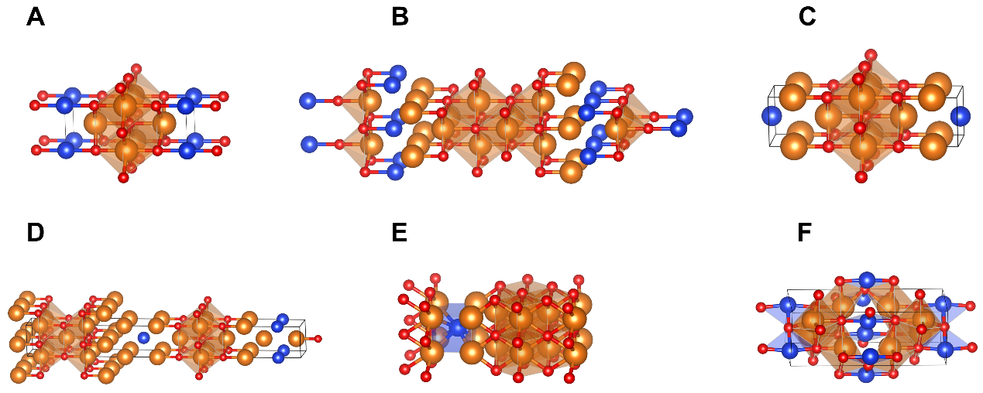
Fig. S1 The crystal structures of the stable Mg-Si-O compounds at high pressure. (A), P4/mmm phase for Mg₃SiO₃, (B), P4/nmm phase for Mg₄SiO₃, (C), P4/mmm phase for Mg₅SiO₃, (D), I4mm phase for Mg₆SiO₃, (E), Pmm2 phase for Mg₅SiO₄, (F), P4₂/mnm phase for Mg₄Si₂O₅.

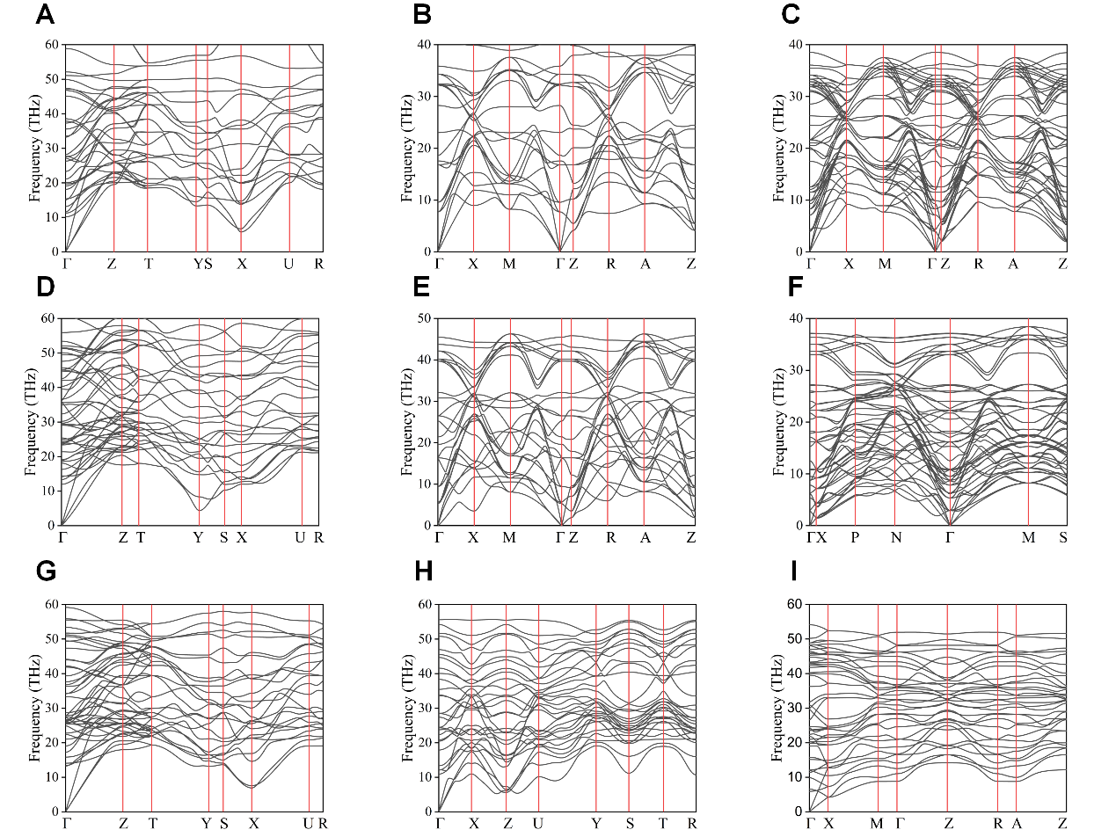
Fig. S2 The phonon spectrum at the corresponding pressure. (A), Cmmm phase for Mg₂SiO₃ at 1000 GPa, (B), Cmmm phase for Mg₄SiO₃ at 1500 GPa, (C), P4/mmm phase for Mg₃SiO₃ at 300 GPa, (D), P4/nmm phase for Mg₄SiO₃ at 300 GPa, (E), P4/mmm phase for Mg₅SiO₃ at 1000 GPa, (F), I4mm phase for Mg₆SiO₃ at 300 GPa, (G), Cmmm phase for Mg₃SiO₄ at 1000 GPa, (H), Pmm2 phase for Mg₅SiO₄ at 1000 GPa, (I), P4₂/mnm phase for Mg₄Si₂O₅ at 800 GPa.

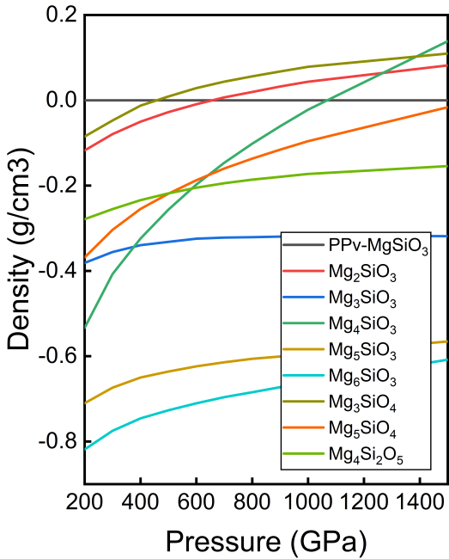
Fig. S3 The density of several sub-Mg-silicates as a function of pressure.

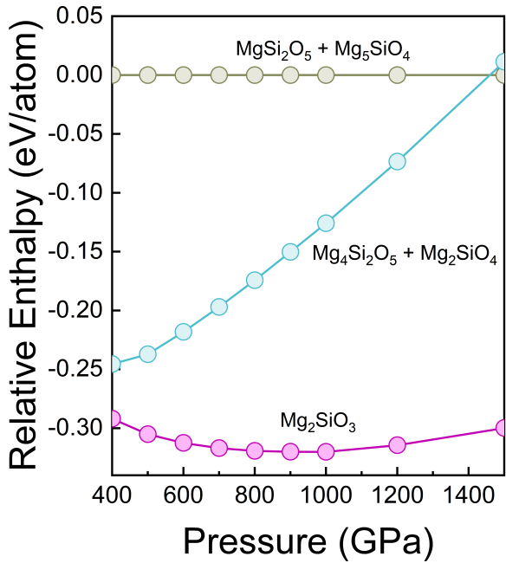
Fig. S4 Pressure-dependent relative enthalpies of Mg₂SiO₃ and its aggregation of possible dissociation products. Mg₂SiO₃ is more stable than combinations such as MgSi₂O₅ + Mg₅SiO₄ and Mg₄Si₂O₅ + Mg₂SiO₄ above 400 GPa.

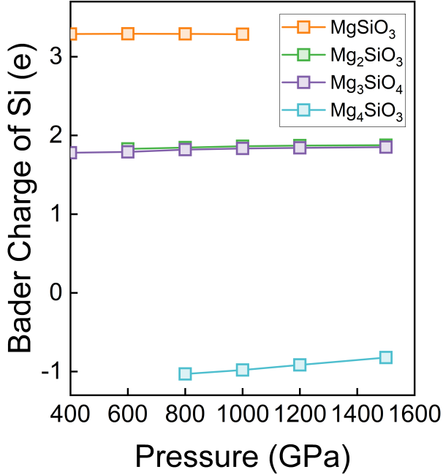
Fig. S5 Bader charge of Si as a function of pressure in MgSiO₃ (PPv phase), Mg₂SiO₃ (Cmmm phase), Mg₃SiO₄ (Cmmm phase), and Mg₄SiO₃ (Cmmm phase).

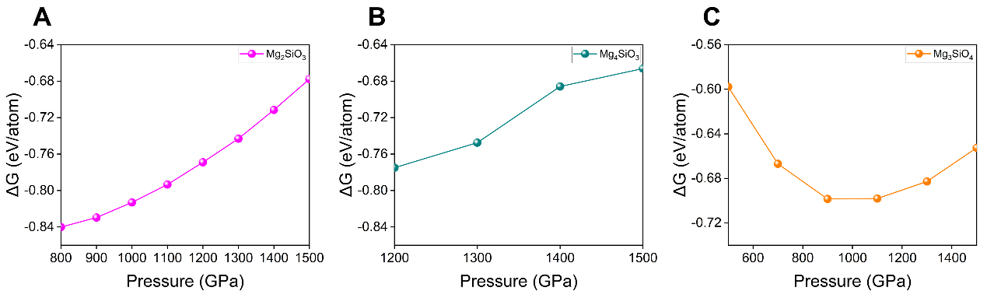
Fig. S6 Free energy calculation as a function of pressure. (A), Formation Gibbs free energy (ΔG) of Mg₂SiO₃ (Cmmm phase) relative to MgSiO₃ and Mg at 10000 K. (B), Formation Gibbs free energy (ΔG) of Mg₄SiO₃ (Cmmm phase) relative to MgSiO₃ and Mg at 10000 K. (C), Formation Gibbs free energy (ΔG) of Mg₃SiO₄ (Cmmm phase) relative to Mg₂SiO₄ and Mg at 10000 K.

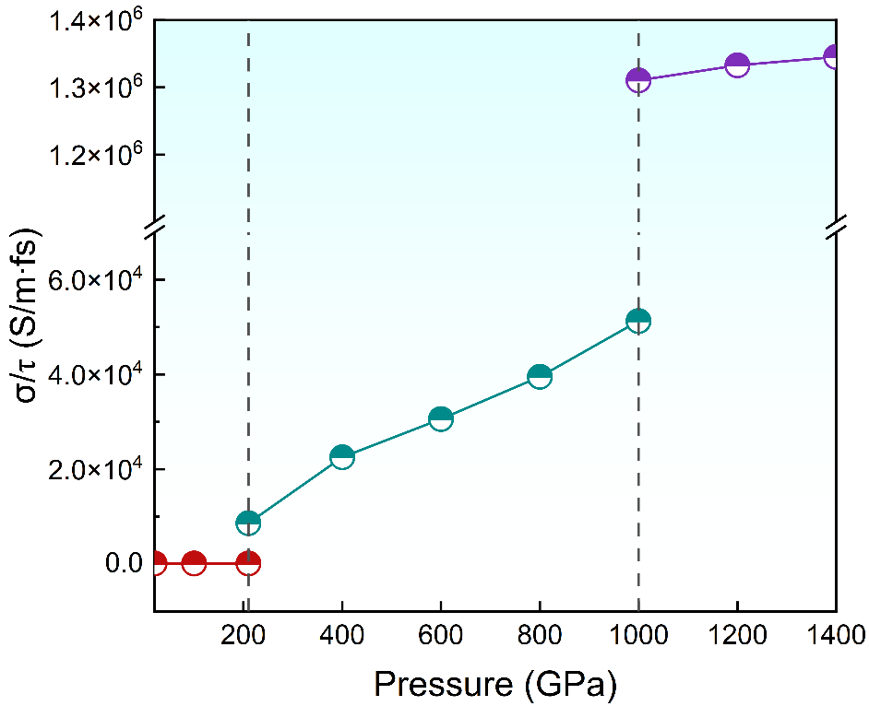
Fig. S7 Generalized average conductivity curve of silicate mantle, sub-silicate mantle and conductive mantle.

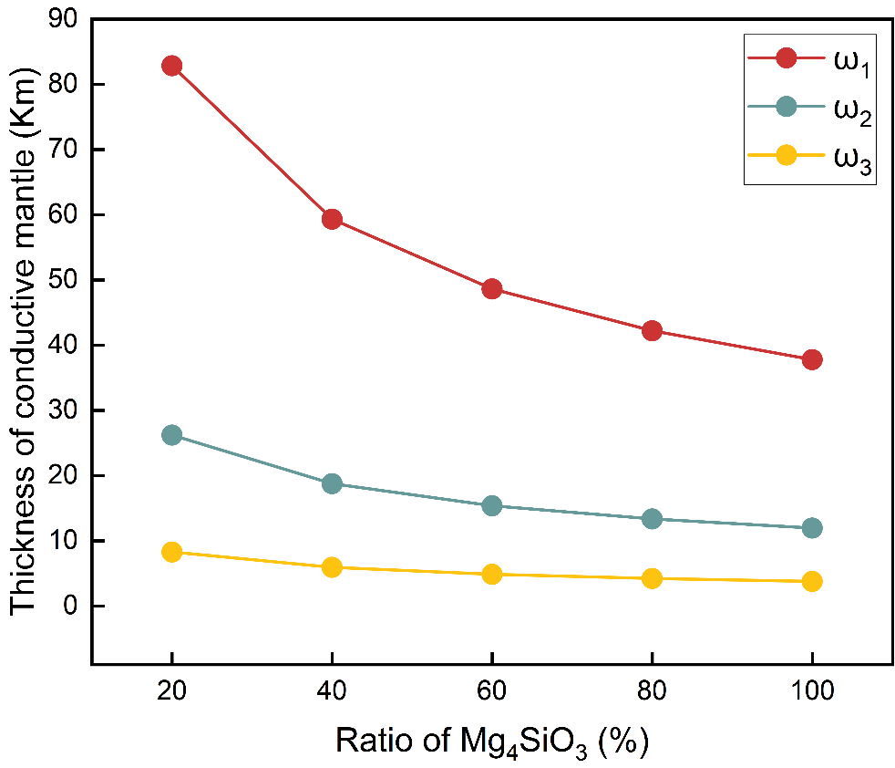
Fig. S8 Relationship between thickness of conductive mantle layer and Mg₄SiO₃ fraction in CMB layer. The curves correspond to the angular frequencies (ω) of the time-varying magnetic field at 10⁻⁸ rad/s, 10⁻⁷ rad/s, and 10⁻⁶ rad/s, respectively, and illustrate the conditions for achieving > 95% magnetic shielding efficiency.
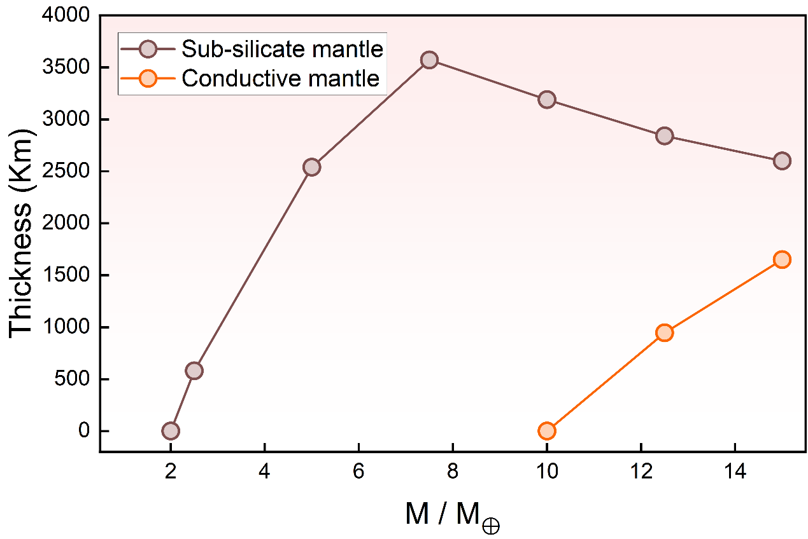
Fig. S9 Plot of thickness as a function of super-Earth mass (M/M⊕), for sub-silicate mantle (purple dots) and conductive mantle layer (orange dots), respectively.

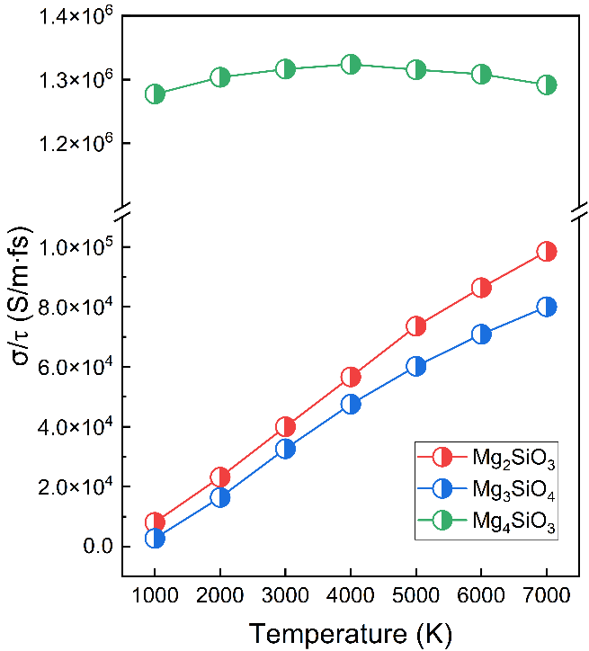
Fig. S10 Generalized average conductivity curve of Mg₂SiO₃ (Cmmm phase), Mg₃SiO₄ (Cmmm phase), and Mg₄SiO₃ (Cmmm phase) with temperature varying from 1000 K to 7000 K under a pressure of 1000 GPa.

Table
Table S1 The parameters of predicted structures.
Space group | Pressure  (GPa) | Lattice parameter  (Å) |  | Atom site |  | Wyckoff position
Mg₂SiO₃  (Cmmm) | 1000 | a=2.8067  b=8.2251  c=1.9299 | α=90.00  β=90.00  γ=90.00 | Mg  Si  O1  O2 | 4i  2d  4j  2c | 0.0000  0.0000  0.0000  0.5000 | 0.3399  0.0000  0.1768  0.0000 | 0.0000  0.5000  0.5000  0.5000
Mg₃SiO₃  (P4/mmm) | 300 | a=2.4550  b=2.4550  c=6.5844 | α=90.00  β=90.00  γ=90.00 | Mg1  Mg2  Si  O1  O2 | 2h  1b  1a  2g  1d | 0.5000  0.0000  0.0000  0.0000  0.5000 | 0.5000  0.0000  0.0000  0.0000  0.5000 | 0.2164  0.5000  0.0000  0.2455  0.5000
Mg₄SiO₃  (P4/nmm) | 300 | a=2.4593  b=2.4593  c=15.6632 | α=90.00  β=90.00  γ=90.00 | Mg1  Mg2  Mg3  Mg4  Si  O1  O2 | 2c  2c  2c  2c  2c  2c  2c | 0.0000  0.0000  0.5000  0.5000  0.5000  0.5000  0.5000 | 0.5000  0.5000  0.0000  0.0000  0.0000  0.0000  0.0000 | 0.2280  0.4458  0.3281  0.9362  0.1547  0.0485  0.6642
Mg₄SiO₃  (Cmmm) | 1500 | a=6.6533  b=4.4014  c=1.8366 | α=90.00  β=90.00  γ=90.00 | Mg  Si  O1  O2 | 8p  2d  4h  2c | 0.1371  0.0000  0.2201  0.0000 | 0.2934  0.0000  0.0000  0.5000 | 0.0000  0.5000  0.5000  0.5000
Mg₅SiO₃  (P4/mmm) | 500 | a=2.3293  b=2.3293  c=8.7693 | α=90.00  β=90.00  γ=90.00 | Mg1  Mg2  Mg3  Si  O1  O2 | 2g  1b  2h  1c  2g  1d | 0.0000  0.0000  0.5000  0.5000  0.0000  0.5000 | 0.0000  0.0000  0.5000  0.5000  0.0000  0.5000 | 0.8686  0.5000  0.3009  0.0000  0.3148  0.5000
Mg₆SiO₃  (I4mm) | 300 | a=2.4427  b=2.4427  c=21.2432 | α=90.00  β=90.00  γ=90.00 | Mg1  Mg2  Mg3  Mg4  Mg5  Mg6  Si  O1  O2  O3 | 2a  2a  2a  2a  2a  2a  2a  2a  2a  2a | 0.5000  0.5000  0.5000  0.0000  0.0000  0.0000  0.0000  0.5000  0.5000  0.0000 | 0.5000  0.5000  0.5000  0.0000  0.0000  0.0000  0.0000  0.5000  0.5000  0.0000 | 0.1365  0.9762  0.8580  0.7969  0.0513  0.2221  0.9182  0.2169  0.0556  0.1363
Mg₃SiO₄  (Cmmm) | 1000 | a=3.9044  b=7.7477  c=1.9415 | α=90.00  β=90.00  γ=90.00 | Mg1  Mg2  Si  O | 4j  2c  2a  8p | 0.5000  0.5000  0.0000  0.7316 | 0.2624  0.0000  0.0000  0.1309 | 0.5000  0.5000  0.0000  0.0000
Mg₅SiO₄  (Pmm2) | 1000 | a=2.6696  b=1.9164  c=7.5720 | α=90.00  β=90.00  γ=90.00 | Mg1  Mg2  Mg3  Mg4  Mg5  Si  O1  O2  O3  O4 | 1a  1a  1a  1c  1c  1d  1d  1d  1b  1b | 0.0000  0.0000  0.0000  0.5000  0.5000  0.5000  0.5000  0.5000  0.0000  0.0000 | 0.0000  0.0000  0.0000  0.0000  0.0000  0.5000  0.5000  0.5000  0.5000  0.5000 | 0.2674  0.6156  0.9895  0.7891  0.4232  0.1534  0.6083  0.9640  0.4354  0.7973
Mg₄Si₂O₅  (P4₂/mnm) | 800 | a=3.2468  b=3.2468  c=8.7027 | α=90.00  β=90.00  γ=90.00 | Mg1  Si1  O1  O2 | 8j  4g  8j  2b | 0.7309  0.8000  0.2709  0.0000 | 0.7309  0.2000  0.2709  0.0000 | 0.8556  0.0000  0.6738  0.5000

