Supplementary Information

ICD2Vec: Mathematical representation of diseases
Yeong Chan Lee^{1,&}, Sang-Hyuk Jung^{1,2,&}, Aman Kumar^{3,&}, Injeong Shim¹, Minku Song¹, Min Seo Kim¹, Kyunga Kim^{1,4}, Woojae Myung⁵, Woong-Yang Park⁶, Hong-Hee Won^{1,6*}

¹Department of Digital Health, Samsung Advanced Institute for Health Sciences & Technology (SAIHST), Sungkyunkwan University, Samsung Medical Center, Seoul, 06355, Republic of Korea
²Department of Biostatistics, Epidemiology and Informatics, Perelman School of Medicine, University of Pennsylvania, Philadelphia, 19104, USA
³Department of Computer Science and Engineering, Indian Institute of Technology Kharagpur, 721302, West Bengal, India
⁴Statistics and Data Center, Research Institute for Future Medicine, Samsung Medical Center, Seoul, 06355, Republic of Korea
⁵Department of Neuropsychiatry, Seoul National University Bundang Hospital, Seongnam, 13620, Republic of Korea
⁶Samsung Genome Institute, Samsung Medical Center, Seoul, 06351, Republic of Korea

&These authors contributed equally
*Corresponding author, wonhh@skku.edu

Contents

Supplementary Materials 5
Supplementary Tables 6
Supplementary Table 1 | Disease definitions for epidemiological studies in UK Biobank 6
Supplementary Table 2 | Results for CAD risk according to baseline and IRIS derivation 7
Supplementary Table 3 | Results for T2D risk according to baseline and IRIS derivation 8
Supplementary Table 4 | Results for dementia risk according to baseline and IRIS derivation 9
Supplementary Table 5 | Results for liver cancer risk according to baseline and IRIS derivation 10
Supplementary Table 6 | Results for four diseases according to baseline and IRIS derivation using data of Samsung Medical Center (SMC) 11
Supplementary Table 7 | Twenty most prevalent diseases in the 10th decile risk group of IRIS for CAD 12
Supplementary Figures 13
Supplementary Fig. 1 | Example of an epidemiological study design for identifying the association between IRISCAD and CAD 13
Supplementary Fig. 2 | Adjusted hazard ratios (HRs) for the target diseases according to IRIS 14
Supplementary Fig. 3 | Adjusted HRs for the target diseases according to IRIS 15
Supplementary Fig. 4 | Cumulative incidences of subgroups by IRISCAD and 10-year atherosclerotic cardiovascular disease (ASCVD) risk 16
References 16

Supplementary Materials

Related works

NLP algorithms have been developed based on innovative neural networks. In particular, with the advantages of neural networks, high-dimensional concepts can be represented with meaningful low-dimensional vectors. A skip-gram is an algorithm for vectorizing a word by predicting the adjacent words in a sentence¹. It enables a semantic relationship between vectors, such as “king-queen” to “man-woman.” However, it cannot represent a completely new word. FastText constructs a general model to train words in a sentence, and a subword model to additionally train a bag of characters in a word². It can estimate out-of-vocabulary words using subwords. We used the FastText model to manage uncommon medical words. Recently, state-of-the-art results have been achieved by BERT and the Generative Pre-trained Transformer-3, with a new algorithm and numerous parameters^{3, 4}.

These representation-learning methods are now very relevant in the medical field. In particular, medical concept embedding has been an active area of research. Previous studies have attempted to summarize sparse and high-dimensional medical concepts using compressed vectors. Choi et al. transformed medical concepts into arithmetic vectors using a skip-gram from electrical health data⁵. A medical concept was trained for by predicting based on the time-adjacent diagnostic records of a subject. The transformed medical concept vectors improved the performance of a heart-failure-risk prediction model. Minarro-Gimenez et al. applied a skip-gram to medical corpora collected from medical websites⁶. Bai et al. proposed a pipeline for calculating a modified pointwise mutual information score and used skip-grams with negative sampling from different medical ontologies⁷. BioBERT is a pretrained representation model for biomedical texts⁸. The authors provided weights and source codes for the model. In general, existing models have successfully learned the concept of embedding particular tasks at various levels, but they have not been able to effectively identify the similarities and causal interactions between all diagnosis codes.

Study population for epidemiological studies

The UK Biobank. Of approximately 500,000 participants aged 40 to 69 years in the UK Biobank, we selected eligible patients for the epidemiological studies of CAD, T2D, dementia, and liver cancer, as follows. First, we defined the epidemiological baseline as a specific n year period (3, 5, 7, and 9 years) before the date of a participant’s initial assessment. We excluded patients who were diagnosed with the definition of the target disease at the baseline (Supplementary Table 1). Additionally, we excluded participants who had missing values for the variables included in the analysis. We included participants who were diagnosed at least once to derive the IRIS. The date of onset of the target disease as the primary outcome was considered as the first date of diagnosis of the target disease. The participants were followed up until the earliest date among those of the event, the last hospital visit or death.

Samsung Medical Center (SMC). We collected 209,523 patients who visited the SMC, were diagnosed at least once, and underwent blood tests between 2010 and 2012. We defined the baseline as 2010–2012. We excluded patients who were diagnosed with the target disease, and patients who died before January 1, 2013. We followed the eligible patients from January 1st, 2013, and the last follow-up date was the earliest date among the dates of the event, the last hospital visit (December 31st, 2020), or death.

Supplementary Tables

Supplementary Table 1 | Disease definitions for epidemiological studies in UK Biobank
Target disease | ICD-10 | ICD-9 | OPCS-4 | Self-reported fields (code) | Algorithmically defined outcomes
CAD | I200, I208, I209,  I21-I24, I25, I251, I250, I252, I255, I256, I258, I259 | 410, 411, 412, 4111, 4119, 4129, 4130, 4139, 4140, 4148, 4149, 4109, | K40, K401, K402, K403, K404, K408, K409, K41, K411, K412, K413, K414, K418, K419, K42, K421, K422, K423, K424, K428, K429, K43, K431, K432, K433, K434, K438, K439, K44, K441, K442, K448, K449, K451, K452, K453, K454, K455, K456, K458, K459, K46, K461, K462, K463, K464, K465, K468, K469, K471, K491, K492, K493, K494, K498, K499, K501, K502, K504, K751, K752, K753, K754, K758, K759 | 20002 (1075), 20004 (1095, 1070, 1523) | 42001 (0,1,2), 42003 (0,1,2), 42005 (0,1,2)
T2D | E11 | 25000, 25010 | - | 20002 (1223) | -
Dementia | F01-F03, G30, G31 | 290, 331 | - | - | -
Liver cancer | C22, C787 | 155, 1977 | - | - | -

Supplementary Table 2 | Results for CAD risk according to baseline and IRIS derivation
Baseline  (risk score derivation) | Top 10% of IRIS [N (events)] | Bottom 10% of IRIS [N (events)] | Top 10% of IRIS (mean ± SD) | Bottom 10% of IRIS (mean ± SD) | Hazard ratio** (95% CI)
3 years (maximum) | 11,293 (1,615) | 11,294 (819) | 0.891 ± 0.012 | 0.618 ± 0.055 | 1.72 (1.58–1.87)
3 years (top three average) | 11,293 (1,443) | 11,294 (784) | 0.859 ± 0.014 | 0.587 ± 0.052 | 1.65 (1.51–1.80)
5 years (maximum) | 15,011 (2,181) | 15,012 (1,021) | 0.891 ± 0.012 | 0.625 ± 0.054 | 1.80 (1.67–1.94)
5 years (top three average) | 15,011 (2,070) | 15,012 (979) | 0.861 ± 0.013 | 0.593 ± 0.052 | 1.85 (1.72–2.00)
7 years (maximum) | 17,647 (2,680) | 17,648 (1,170) | 0.891 ± 0.013 | 0.631 ± 0.053 | 1.84 (1.71–1.97)
7 years (top three average) | 17,647 (2,502) | 17,648 (1,102) | 0.861 ± 0.013 | 0.597 ± 0.051 | 1.96 (1.83–2.11)
9 years (maximum) | 19,670 (2,905) | 19,671 (1,246) | 0.891 ± 0.013 | 0.635 ± 0.053 | 1.91 (1.79–2.04)
9 years (top three average) | 19,670 (2,848) | 19,671 (1,170) | 0.863 ± 0.013 | 0.600 ± 0.052 | 2.08 (1.94–2.23)
* Hazard ratio was estimated using a Cox proportional hazard model adjusted for sex and age.
** All p-values for hazard ratios were estimated under ${2 × 10}^{-16}$.

Supplementary Table 3 | Results for T2D risk according to baseline and IRIS derivation
Baseline  (risk score derivation) | Top 10% of IRIS [N (events)] | Bottom 10% of IRIS [N (events)] | Top 10% of IRIS (mean ± SD) | Bottom 10% of IRIS (mean ± SD) | Hazard ratio** (95% CI)
3 years (maximum) | 10,790 (1,040) | 10,791 (577) | 0.852 ± 0.013 | 0.567 ± 0.063 | 1.61 (1.45-1.78)
3 years (top three average) | 10,790 (1,103) | 10,791 (615) | 0.833 ± 0.011 | 0.537 ± 0.059 | 1.61 (1.45-1.77)
5 years (maximum) | 14,211 (1,432) | 14,212 (808) | 0.852 ± 0.013 | 0.575 ± 0.064 | 1.55 (1.42-1.69)
5 years (top three average) | 14,211 (1,545) | 14,212 (837) | 0.834 ± 0.011 | 0.542 ± 0.059 | 1.63 (1.50-1.77)
7 years (maximum) | 16,592 (1,768) | 16,593 (875) | 0.853 ± 0.013 | 0.582 ± 0.063 | 1.74 (1.60-1.88)
7 years (top three average) | 16,592 (1,955) | 16,593 (912) | 0.836 ± 0.011 | 0.547 ± 0.059 | 1.85 (1.71-2.00)
9 years (maximum) | 18,379 (1,974) | 18,380 (957) | 0.854 ± 0.013 | 0.586 ± 0.063 | 1.77 (1.64-1.91)
9 years (top three average) | 18,379 (2,230) | 18,380 (971) | 0.836 ± 0.010 | 0.550 ± 0.059 | 1.95 (1.81-2.11)
* Hazard ratio was estimated using a Cox proportional hazard model adjusted for sex and age.
** All p-values for hazard ratios were estimated under ${2 × 10}^{-16}$.

Supplementary Table 4 | Results for dementia risk according to baseline and IRIS derivation
Baseline  (risk score derivation) | Top 10% of IRIS [N (events)] | Bottom 10% of IRIS [N (events)] | Top 10% of IRIS (mean ± SD) | Bottom 10% of IRIS (mean ± SD) | Hazard ratio** (95% CI)
3 years (maximum) | 11,532 (302) | 11,533 (81) | 0.862 ± 0.016 | 0.571 ± 0.058 | 2.85 (2.23–3.64)
3 years (top three average) | 11,532 (287) | 11,533 (87) | 0.831 ± 0.015 | 0.547 ± 0.056 | 2.51 (1.97–3.19)
5 years (maximum) | 15,222 (387) | 15,223 (102) | 0.863 ± 0.015 | 0.575 ± 0.059 | 2.67 (2.15–3.32)
5 years (top three average) | 15,222 (383) | 15,223 (106) | 0.833 ± 0.014 | 0.548 ± 0.056 | 2.54 (2.05–3.15)
7 years (maximum) | 17,816 (457) | 17,817 (94) | 0.864 ± 0.015 | 0.579 ± 0.059 | 3.29 (2.63–4.11)
7 years (top three average) | 17,816 (460) | 17,817 (101) | 0.834 ± 0.014 | 0.550 ± 0.055 | 3.09 (2.49–3.83)
9 years (maximum) | 19,791 (502) | 19,792 (94) | 0.865 ± 0.015 | 0.581 ± 0.059 | 3.49 (2.80–4.36)
9 years (top three average) | 19,791 (499) | 19,792 (105) | 0.836 ± 0.014 | 0.551 ± 0.055 | 3.10 (2.51–3.83)
* Hazard ratio was estimated using a Cox proportional hazard model adjusted for sex and age.
** All p-values for hazard ratios were estimated under ${2 × 10}^{-16}$.

Supplementary Table 5 | Results for liver cancer risk according to baseline and IRIS derivation
Baseline  (risk score derivation) | Top 10% of IRIS [N (events)] | Bottom 10% of IRIS [N (events)] | Top 10% of IRIS (mean ± SD) | Bottom 10% of IRIS (mean ± SD) | Hazard ratio** (95% CI)
3 years (maximum) | 11,516 (417) | 11,517 (125) | 0.902 ± 0.017 | 0.582 ± 0.064 | 3.26 (2.67–3.99)
3 years (top three average) | 11,516 (420) | 11,517 (123) | 0.873 ± 0.017 | 0.549 ± 0.063 | 3.24 (2.65–3.97)
5 years (maximum) | 15,205 (509) | 15,206 (150) | 0.905 ± 0.016 | 0.589 ± 0.065 | 3.20 (2.67–3.84)
5 years (top three average) | 15,205 (501) | 15,206 (141) | 0.875 ± 0.017 | 0.555 ± 0.064 | 3.27 (2.71–3.95)
7 years (maximum) | 17,801 (588) | 17,802 (162) | 0.906 ± 0.016 | 0.597 ± 0.064 | 3.34 (2.81–3.98)
7 years (top three average) | 17,801 (567) | 17,802 (159) | 0.876 ± 0.016 | 0.56 ± 0.064 | 3.15 (2.64–3.76)
9 years (maximum) | 19,777 (638) | 19,778 (191) | 0.908 ± 0.015 | 0.601 ± 0.064 | 2.99 (2.54–3.52)
9 years (top three average) | 19,777 (613) | 19,778 (182) | 0.878 ± 0.015 | 0.563 ± 0.064 | 2.91 (2.46–3.43)
* Hazard ratio was estimated using a Cox proportional hazard model adjusted for sex and age.
** All p-values for hazard ratios were estimated under ${2 × 10}^{-16}$.

Supplementary Table 6 | Results for four diseases according to baseline and IRIS derivation using data of Samsung Medical Center (SMC)
Target Disease | Baseline  (risk score derivation) | Top 10% of IRIS  [no. of samples, (no. of events)] | Bottom 10% of IRIS  [no. of samples, (no. of events)] | Top 10% of IRIS  (mean ± SD) | Bottom 10% of IRIS  (mean ± SD) | Hazard ratio** (95% CI)
CAD | 3 years (maximum) | 13,664 (1,565) | 13,665 (474) | 0.920 ± 0.023 | 0.496 ± 0.110 | 2.26 (2.04-2.51)
CAD | 3 years (top three average) | 13,664 (1,532) | 13,665 (437) | 0.914 ± 0.023 | 0.470 ± 0.077 | 2.41 (2.16-2.69)
T2D | 3 years (maximum) | 13,036 (1,413) | 13,037 (474) | 0.873 ± 0.015 | 0.449 ± 0.125 | 2.62 (2.36-2.91)
T2D | 3 years (top three average) | 13,036 (1,355) | 13,037 (494) | 0.868 ± 0.015 | 0.418 ± 0.080 | 2.49 (2.24-2.76)
Dementia | 3 years (maximum) | 14,737 (1,021) | 14,738 (135) | 0.885 ± 0.009 | 0.505 ± 0.114 | 2.64 (2.20-3.17)
Dementia | 3 years (top three average) | 14,737 (1,030) | 14,738 (109) | 0.879 ± 0.013 | 0.476 ± 0.080 | 3.15 (2.57-3.85)
Liver cancer | 3 years (maximum) | 14,790 (724) | 14,790 (131) | 0.939 ± 0.011 | 0.465 ± 0.144 | 5.98 (4.96-7.21)
Liver cancer | 3 years (top three average) | 14,790 (658) | 14,790(131) | 0.933 ± 0.019 | 0.431 ± 0.105 | 5.54 (4.59-6.69)
* Hazard ratio was estimated using a Cox proportional hazard model adjusted for sex and age.
** All p-values for hazard ratios were estimated under ${2 × 10}^{-16}$.

Supplementary Table 7 | Twenty most prevalent diseases in the 10th decile risk group of IRIS for CAD
Participants with non-event |  |  | Participants with event
Code | Disease | Prevalence | Code | Disease | Prevalence
I10 | Essential (primary) hypertension | 0.49 | I10 | Essential (primary) hypertension | 0.60
J459 | Asthma, unspecified | 0.17 | J459 | Asthma, unspecified | 0.18
K449 | Diaphragmatic hernia without obstruction or gangrene | 0.16 | E780 | Pure hypercholesterolaemia | 0.17
E780 | Pure hypercholesterolaemia | 0.10 | K449 | Diaphragmatic hernia without obstruction or gangrene | 0.17
G560 | Carpal tunnel syndrome | 0.10 | R074 | Chest pain, unspecified | 0.13
K529 | Non-infective gastro-enteritis and colitis, unspecified | 0.10 | E119 | Non-insulin-dependent diabetes mellitus without complications | 0.13
D649 | Anaemia, unspecified | 0.08 | I48 | Atrial fibrillation and flutter | 0.13
K20 | Oesophagitis | 0.08 | Z867 | Personal history of diseases of the circulatory system | 0.11
Z867 | Personal history of diseases of the circulatory system | 0.08 | Z720 | Tobacco use | 0.10
E119 | Non-insulin-dependent diabetes mellitus without complications | 0.07 | K529 | Non-infective gastro-enteritis and colitis, unspecified | 0.10
R074 | Chest pain, unspecified | 0.07 | K297 | Gastritis, unspecified | 0.09
K297 | Gastritis, unspecified | 0.07 | D649 | Anaemia, unspecified | 0.08
E039 | Hypothyroidism, unspecified | 0.06 | R69 | Unknown and unspecified causes of morbidity | 0.08
R69 | Unknown and unspecified causes of morbidity | 0.06 | K20 | Oesophagitis | 0.08
I48 | Atrial fibrillation and flutter | 0.06 | K573 | Diverticular disease of large intestine without perforation or abscess | 0.08
R104 | Other and unspecified abdominal pain | 0.06 | E039 | Hypothyroidism, unspecified | 0.07
Z871 | Personal history of diseases of the digestive system | 0.06 | R104 | Other and unspecified abdominal pain | 0.07
Z720 | Tobacco use | 0.06 | G560 | Carpal tunnel syndrome | 0.07
K573 | Diverticular disease of large intestine without perforation or abscess | 0.06 | J449 | Chronic obstructive pulmonary disease, unspecified | 0.07
D259 | Leiomyoma of uterus, unspecified | 0.05 | Z871 | Personal history of diseases of the digestive system | 0.06

Supplementary Figures

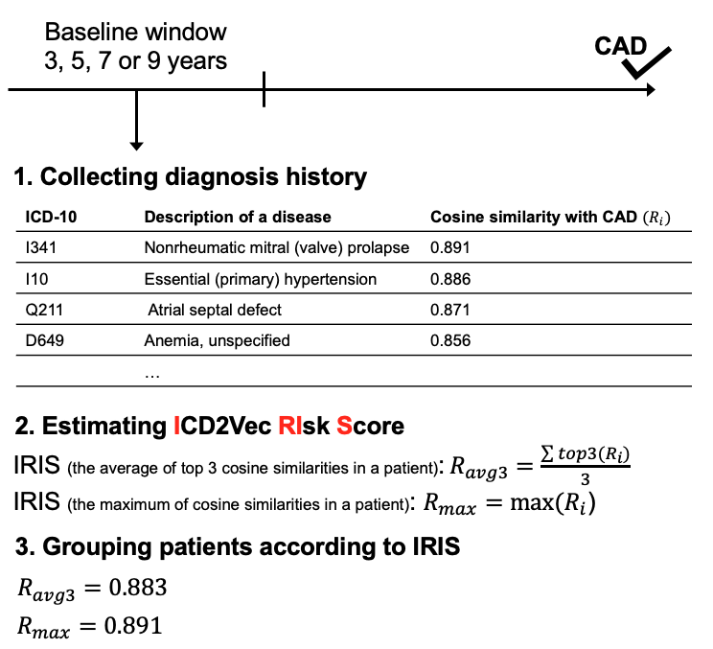
Supplementary Fig. 1 | Example of an epidemiological study design for identifying the association between IRISCAD and CAD. We designed a cohort study to identify the associations between the IRIS and CAD. The time window of the baseline was defined as 3, 5, 7, or 9 years (only 3 years with SMC data). The disease-wide risk score (R_{i}) was defined as cosine similarity between the target disease and other diseases. We defined the maximum (R_{max}) or top three average (R_{avg3}) of the cosine similarities as the IRIS in a patient who was diagnosed with several diseases at the baseline. Finally, the study participants were grouped into a decile according to the IRIS values.

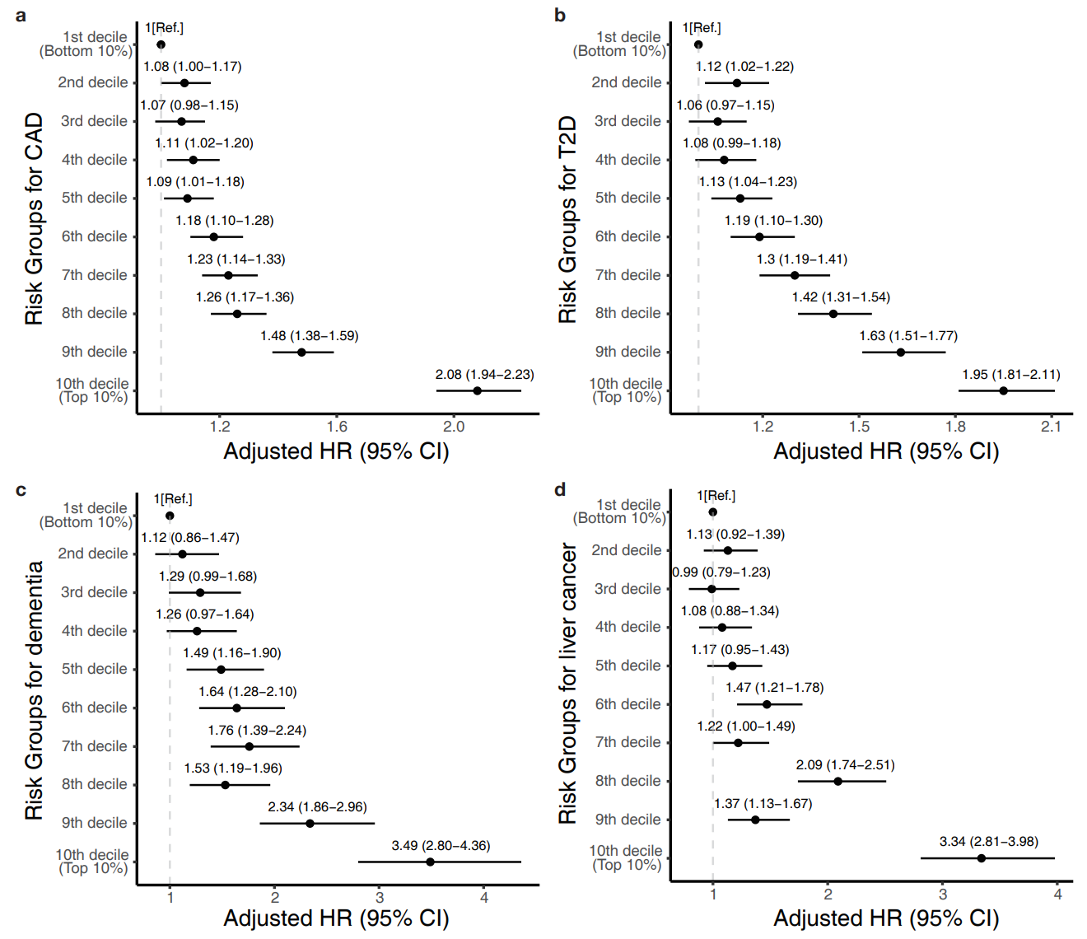
Supplementary Fig. 2 | Adjusted hazard ratios (HRs) for the target diseases according to IRIS. The adjusted HRs for each disease are presented according to risk score described in Table 3 (the UK Biobank). a, CAD. b, T2D. c, dementia. d, liver cancer.

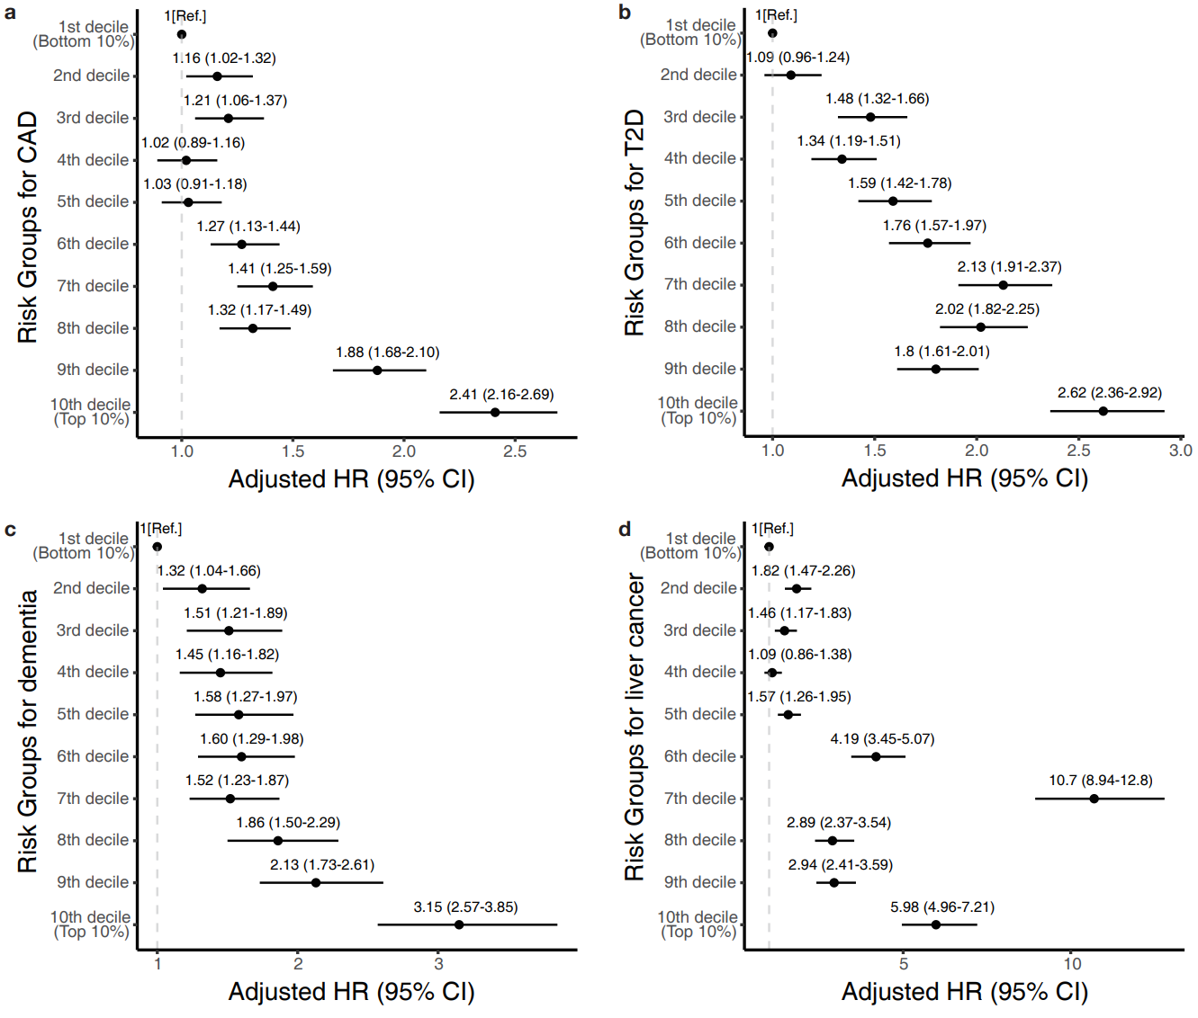
Supplementary Fig. 3 | Adjusted HRs for the target diseases according to IRIS. The adjusted HRs for each disease are presented according to risk score described in Table 3 (SMC). a, CAD. b, T2D. c, dementia. d, liver cancer.

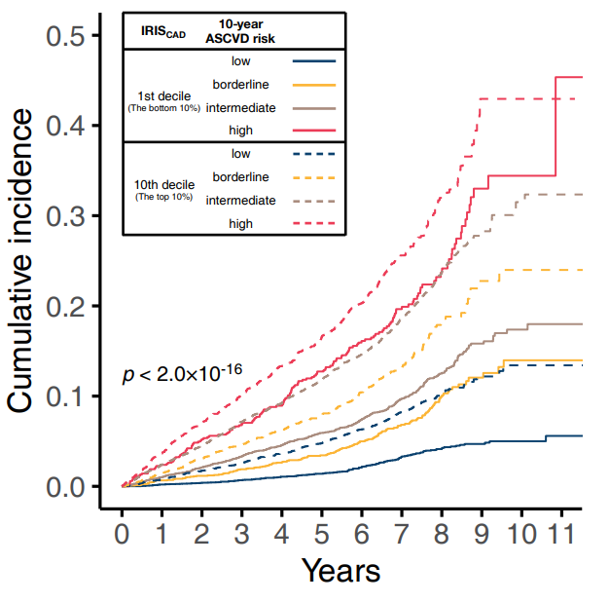
Supplementary Fig. 4 | Cumulative incidences of subgroups by IRISCAD and 10-year atherosclerotic cardiovascular disease (ASCVD) risk.

References

1. Mikolov, T., Chen, K., Corrado, G. & Dean, J. Efficient estimation of word representations in vector space. arXiv preprint arXiv:1301.3781 (2013).
2. Bojanowski, P., Grave, E., Joulin, A. & Mikolov, T. Enriching word vectors with subword information. Transactions of the Association for Computational Linguistics 5, 135-146 (2017).
3. Brown, T.B. et al. Language models are few-shot learners. arXiv preprint arXiv:2005.14165 (2020).
4. Devlin, J., Chang, M.-W., Lee, K. & Toutanova, K. Bert: Pre-training of deep bidirectional transformers for language understanding. arXiv preprint arXiv:1810.04805 (2018).
5. Choi, E., Schuetz, A., Stewart, W.F. & Sun, J. Medical concept representation learning from electronic health records and its application on heart failure prediction. arXiv preprint arXiv:1602.03686 (2016).
6. Minarro-Giménez, J.A., Marin-Alonso, O. & Samwald, M. Exploring the application of deep learning techniques on medical text corpora. Studies in health technology and informatics 205, 584-588 (2014).
7. Bai, T., Egleston, B.L., Bleicher, R. & Vucetic, S. in IJCAI: proceedings of the conference, Vol. 2019 4897 (NIH Public Access, 2019).
8. Lee, J. et al. BioBERT: a pre-trained biomedical language representation model for biomedical text mining. Bioinformatics 36, 1234-1240 (2020).
9. Menche, J. et al. Uncovering disease-disease relationships through the incomplete interactome. Science 347 (2015).
10. Bulik-Sullivan, B. et al. An atlas of genetic correlations across human diseases and traits. Nature genetics 47, 1236 (2015).

