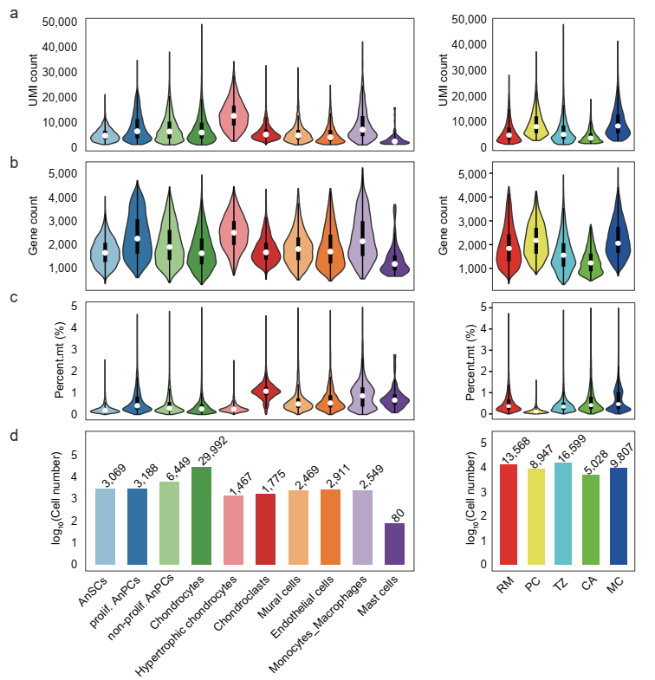
Figure S1 Quality control of snRNA-seq data
- Violin plot showing the UMI counts for each cell type (left) and tissue layer (right) after stringent quality control filtering.
- Violin plot showing the number of detected genes per cell for each cell type (left) and tissue layer (right) after filtering.
- Violin plot showing the percentage of mitochondrial transcripts (Percent.mt) for each cell type (left) and tissue layer (right) after filtering.
- Bar plot showing the number of cells retained for each cell type (left) and tissue layer (right) after filtering. Antler stem cells (AnSCs); antler progenitor cells (AnPCs); reserve mesenchyme (RM), pre-cartilage (PC), transition zone (TZ), cartilage (CA), and mineralized cartilage (MC).
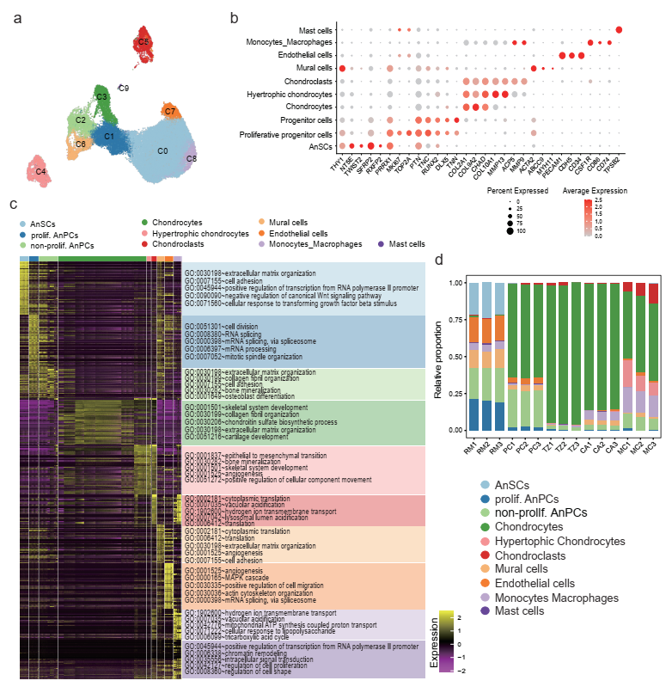
Figure S2 snRNA-seq analysis of five tissue layers in the AGC
- UMAP plot showing the unsupervised clustering of all cells from the five tissue layers.
- Dot plot displaying the expression patterns of marker genes across different cell types.
- Heat map illustrating the expression profiles of the top 50 highly expressed genes in all cell types. The BPs enriched by DAVID GO analysis (adjusted P < 0.05) are listed on the right side of the heat map.
- Bar plot showing the inferred proportions of each cell type in the five tissue layers based on deconvolution analysis of bulk RNA-seq data (Ba et al., 2019).
Antler stem cells (AnSCs); antler progenitor cells (AnPCs); reserve mesenchyme (RM), pre-cartilage (PC), transition zone (TZ), cartilage (CA), and mineralized cartilage (MC).
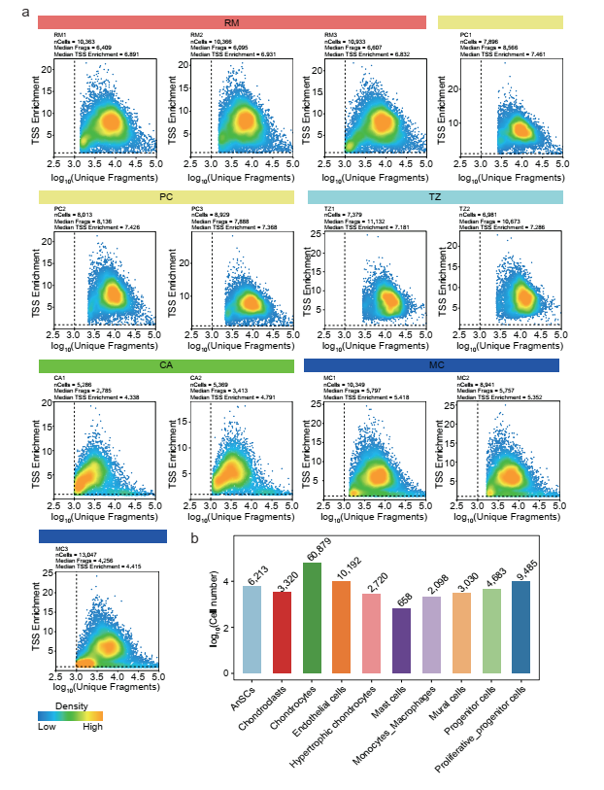
Figure S3 Quality control of snATAC-seq data based on unique fragments and TSS enrichment.
- Density scatter plot showing the transcription start site (TSS) enrichment scores and the log-transformed number of unique fragments per nucleus. Each dot represents a single nucleus, and color intensity reflects cell density. Dashed lines indicate commonly used quality control thresholds (e.g., log₁₀ [Unique Fragments] > 3 and TSS Enrichment > 1) for filtering low-quality nuclei. High-quality nuclei cluster in the upper-right quadrant and were retained for downstream analysis.
- Bar plot showing the number of cells retained for each cell type (left) and tissue layer (right) after filtering.
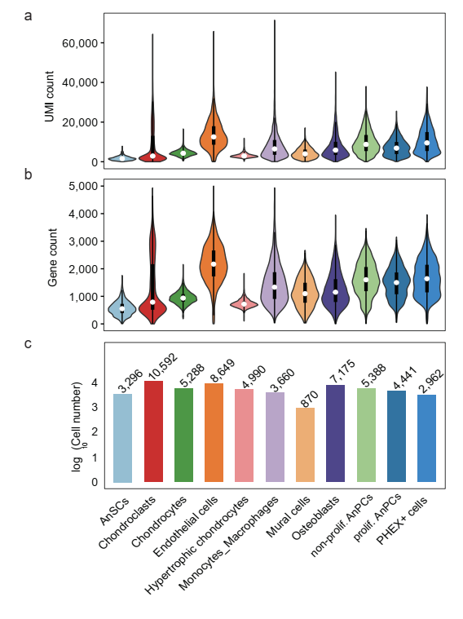
Figure S4 Quality control of Stereo-seq data
- Violin plot showing the UMI counts for each cell type after stringent quality control filtering.
- Violin plot showing the number of detected genes per cell for each cell type after filtering.
- Bar plot showing the number of cells retained for each cell type after filtering.
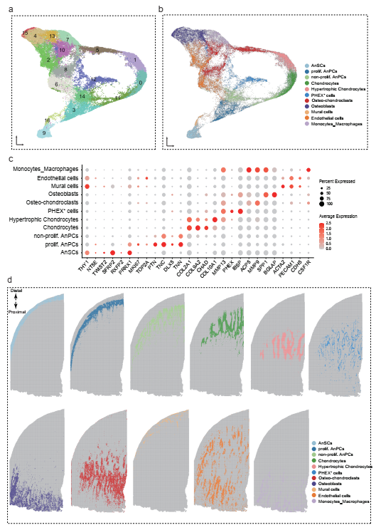
Figure S5 Stereo-seq analysis of the AGC
- UMAP plot showing the unsupervised clustering of all cells of the AGC.
- UMAP plot showing all cell types of the AGC.
- Dot plot displaying the expression patterns of marker genes across different cell types.
- Spatial map visualizing the distribution of 11 distinct cell populations/types.
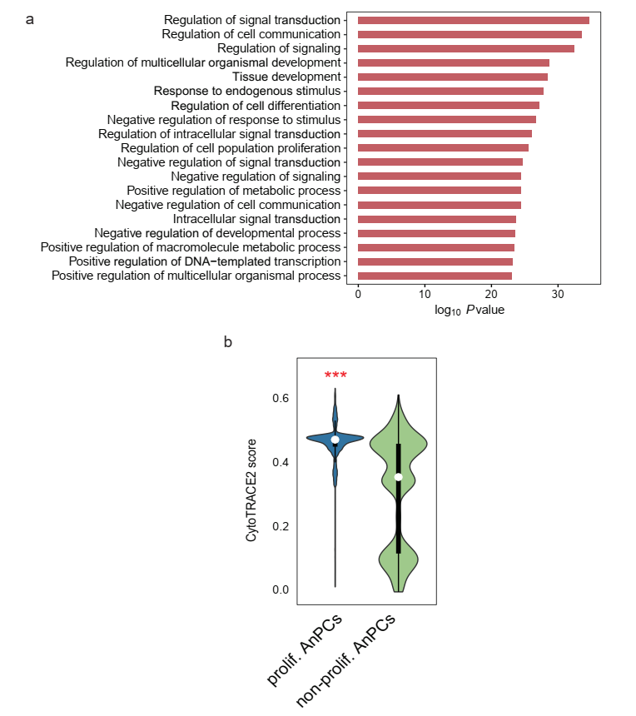
Figure S6 Characterization of AnPCs
- Bar plot showing the top 20 enriched GO BP terms associated with TFs enriched in non-proliferative AnPCs and their predicted target genes based on DAVID analysis.
- Violin plots of CytoTRACE2 scores for proliferative AnPCs and non-proliferative AnPCs. Wilcoxon Rank Sum test was performed between the proliferative and non-proliferative AnPCs: ***P < 0.001.
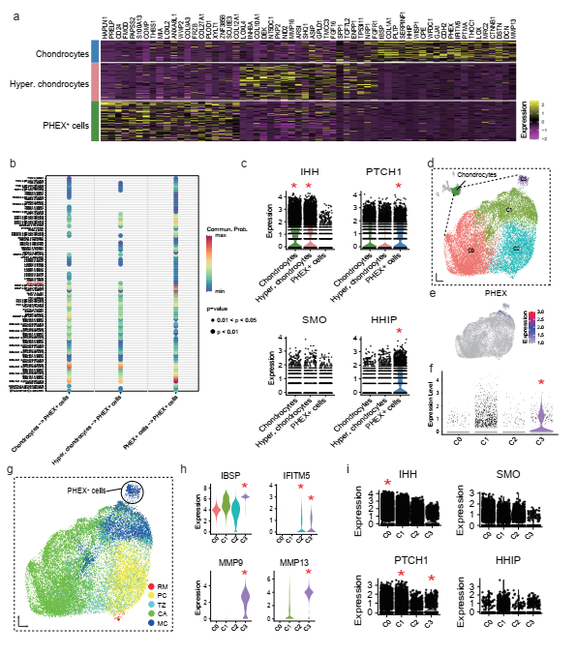
Figure S7 Characterization of PHEX⁺ cells and hedgehog (HH) signaling in chondrocytes
- Heatmap illustrating the expression profiles of the top 20 most highly expressed genes in chondrocytes, hypertrophic chondrocytes, and PHEX⁺ cells.
- Dot plots showing predicted ligand-receptor interactions (calculated as communication probability) with chondrocytes, hypertrophic chondrocytes, and PHEX⁺ cells as sender cells and PHEX⁺ cells as receivers.
- Violin plots depicting the expression levels of key genes involved in HH signaling pathways across chondrocytes, hypertrophic chondrocytes, and PHEX⁺ cells. Wilcoxon Rank Sum test was performed between the specified cell type/cluster and other cells: *P < 0.05.
- UMAP plot showing the unsupervised clustering of all chondrocytes.
- UMAP plot displaying the expression levels of PHEX.
- Violin plots showing PHEX expression levels across four chondrocyte clusters. *P < 0.05
- UMAP plot showing chondrocytes derived from all five tissue layers.
- Violin plots showing the expression levels of several key osteogenesis-related genes across four chondrocyte clusters. *P < 0.05
- Violin plots illustrating the expression levels of key genes in HH signaling pathway across four chondrocyte clusters. *P < 0.05
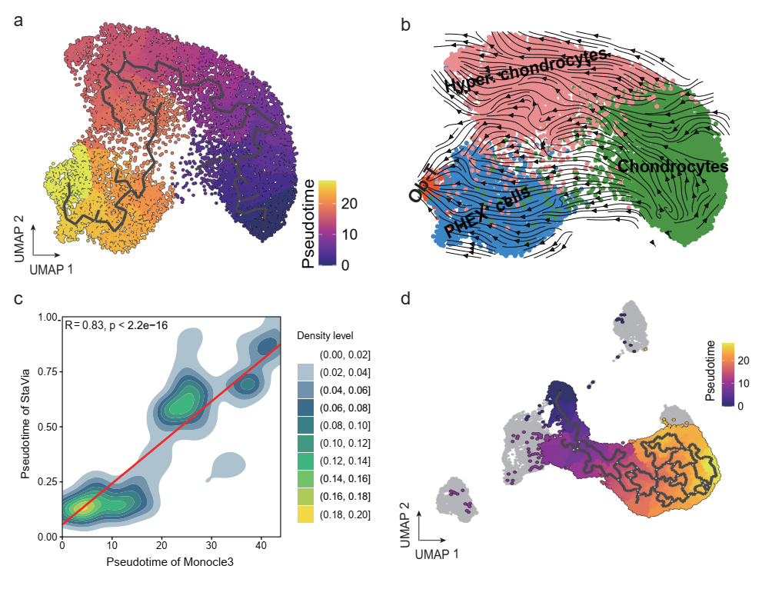
Figure S8. Analysis of pseudotime trajectories based on Stereo-seq data and snRNA-seq data
- Monocle3-inferred pseudotime trajectory (Stereo-seq data), illustrating the developmental progression from chondrocytes and hypertrophic chondrocytes through PHEX⁺ cells toward OB-D.
- Differentiation flow embedded in the UMAP space of cell types (Stereo-seq data), illustrating the developmental progression from chondrocytes and hypertrophic chondrocytes through PHEX⁺ cells toward OB-D.
- Pearson correlation analysis between pseudotime values inferred by StaVia and Monocle3 (Stereo-seq data).
- Monocle3-inferred pseudotime trajectory of AnSC-derived cells (snRNA-seq data).

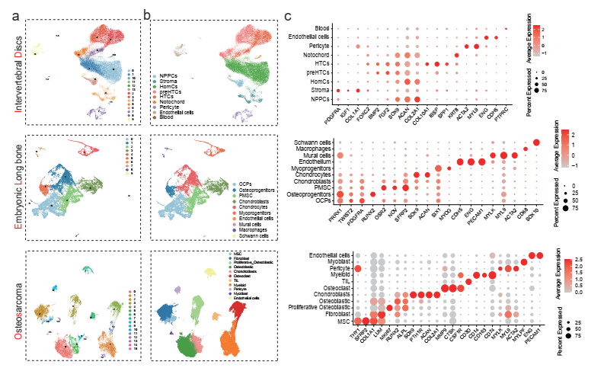
Figure S9 Analysis of the previous published snRNA-seq data
- UMAP plots showing the unsupervised clustering of all cells from the intervertebral disc (ID; top), embryonic long bone (EL; middle) and osteosarcoma (Os; bottom).
- UMAP plots depicting all identified cell types in ID (top), EL (middle), and Os (bottom). Cell type abbreviations: NPPCs, nucleus pulposus progenitor cells; HomCs, homeostatic chondrocytes; preHTCs, prehypertrophic chondrocytes; HTCs, hypertrophic chondrocytes; PMSCs, perichondrial mesenchymal stromal cells; OCPs, osteo-chondrogenic progenitors; MSCs, mesenchymal stem cells; TILs, tumor-infiltrating lymphocytes.
- Dot plots illustrating the expression patterns of representative marker genes across different cell types in ID (top), EL (middle), and Os (bottom).
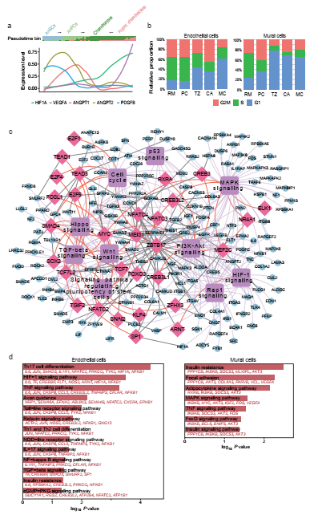
Figure S10 Analysis of snRNA-seq and snATCA-seq data for vascular cells
- Expression dynamics of key marker genes along the pseudotime axis. The proportion of AnSC-derived cells along the pseudotime axis is also displayed in bins (top panel)..
- Bar plots of cell cycle phase distributions (G1, G2/M and S) in endothelial and mural cells across five layers. RM and PC had more mitotically active vascular cells.
- Network diagram of activated TFs in activated mural cells, their targets, and enriched KEGG terms.
- Bar plot showing enriched KEGG pathways associated with TFs enriched in quiescent states for endothelial (left) and mural cells (right) and their predicted target genes based on DAVID analysis.

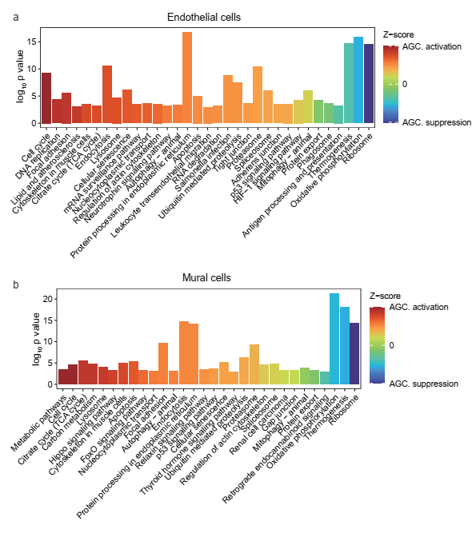
Figure S11 Bar plots of KEGG pathways enriched in AGC vs. ID and Os for endothelial (a) and mural cells (b). Z-scores indicating enrichment (positive = activation, negative = suppression).

