Supplementary Figures

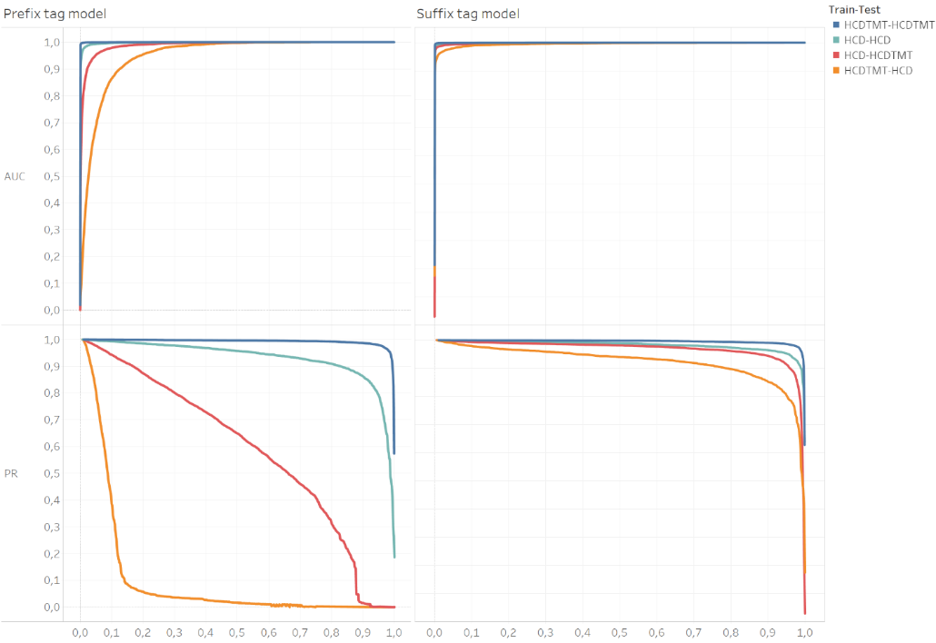

Supplementary Fig. 1 | AUC and PR curves for the HCD and HCDTMT prefix and suffix tag scoring models. The legend explains what training and testing set was used (e.g. for HCD-HCDTMT, the GBT model was fitted on the HCD training set and evaluated on the HCDTMT testing set).

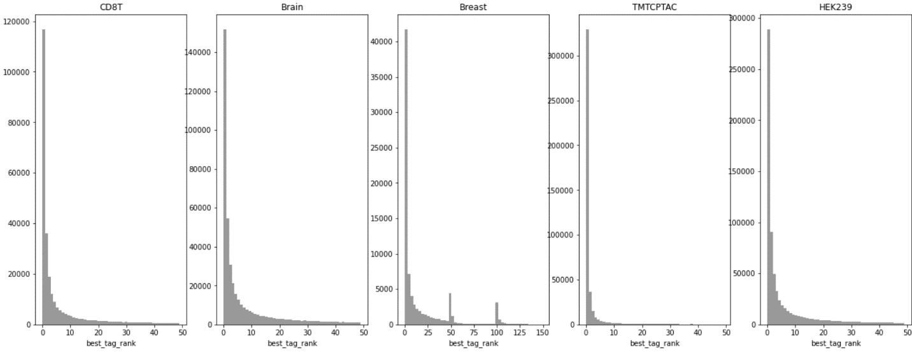

Supplementary Fig. 2 | Distribution of tag ranks for PSMs identified in open search. For each PSM, the rank of the highest ranked prefix or suffix tag is recorded as the rank for that PSM.
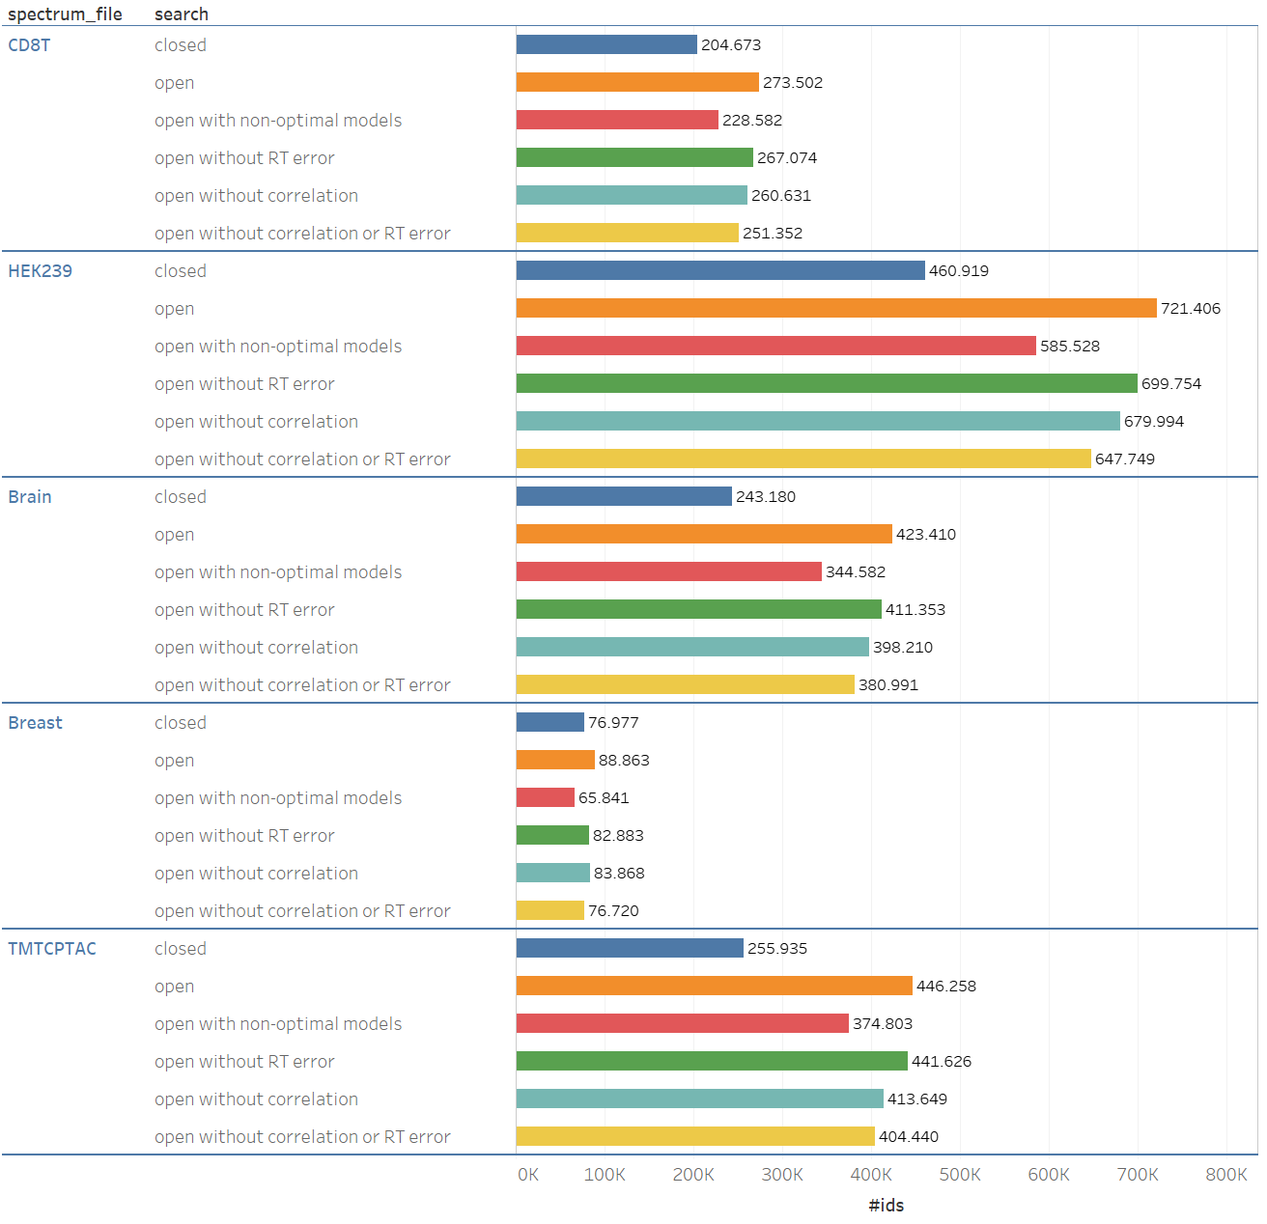

Supplementary Fig. 3 | Number of identified PSMs (x-axis) for the five evaluation datasets using different search approaches. First, a closed search (dark blue). Second, a standard open search (orange). Third, an open search using non-optimal models (red), i.e. for the TMTCPTAC dataset, models (tag-models, MS2PIP and DeepLC) trained on unlabeled HCD were used, while for all other datasets models trained on TMT labeled data were used. Fourth, an open search without using the RT-pred-error feature (green). Fifth, an open search without using the intensity-correlation feature and biased scoring function (light blue). Sixth, an open search without intensity-correlation and RT-pred-error (yellow).

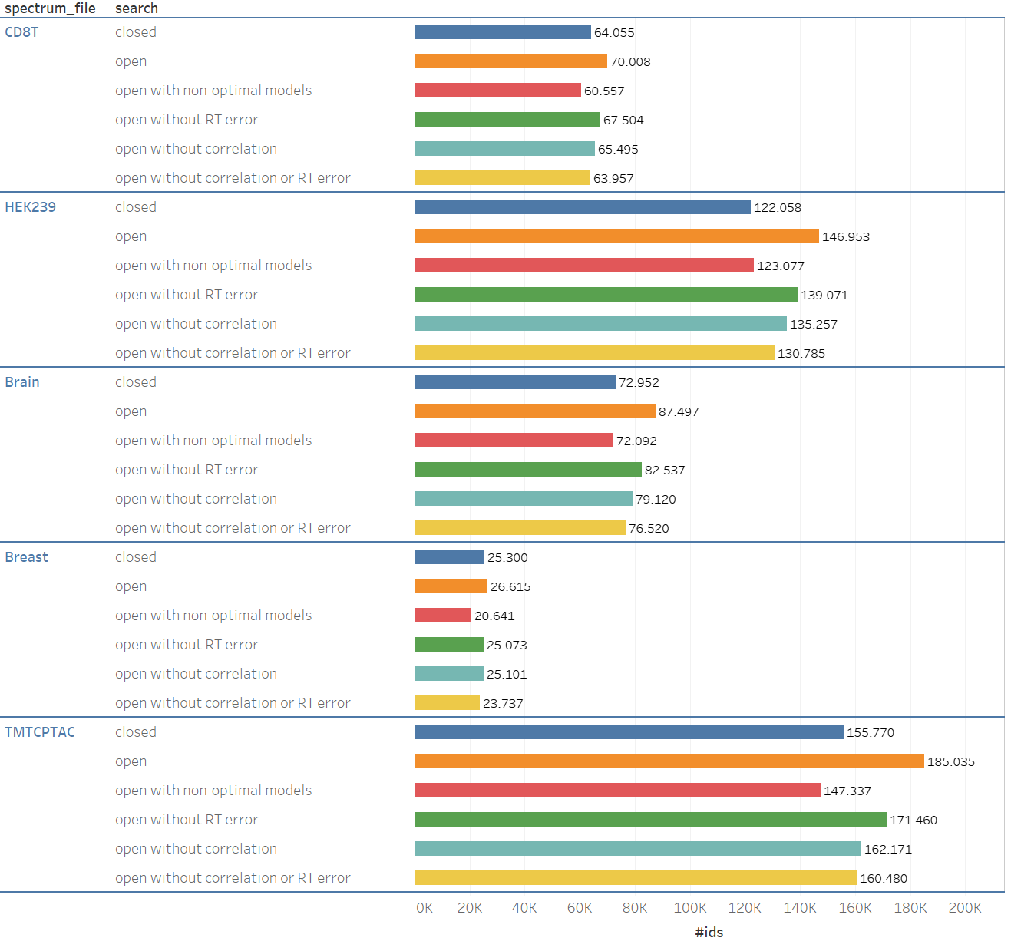

Supplementary Fig. 4 | Number of identified peptides (x-axis) for the five evaluation datasets using different search approaches. First, a closed search (dark blue). Second, a standard open search (orange). Third, an open search using non-optimal models (red), i.e. for the TMTCPTAC dataset, models (tag-models, MS2PIP and DeepLC) trained on unlabeled HCD were used, while for all other datasets models trained on TMT labeled data were used. Fourth, an open search without using the RT-pred-error feature (green). Fifth, an open search without using the intensity-correlation feature and biased scoring function (light blue). Sixth, an open search without intensity-correlation and RT-pred-error (yellow).

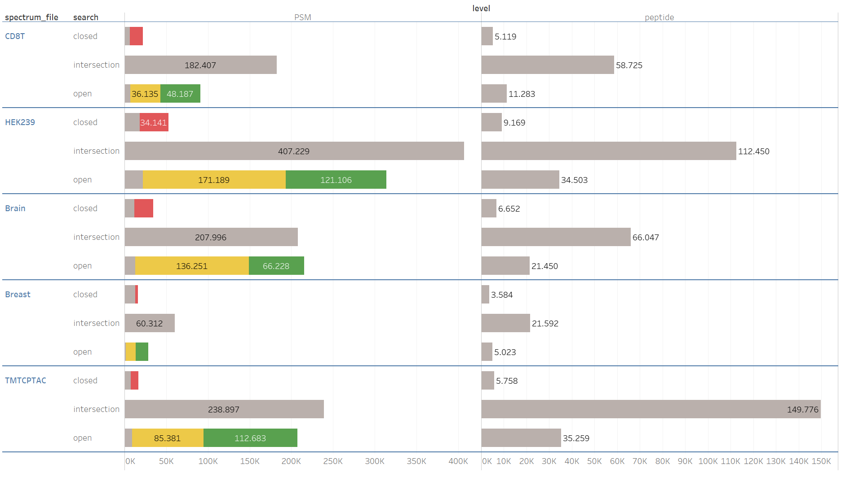

Supplementary Fig. 5 | PSM and peptide identification overlap between a closed and open search. For the closed searches, spectra with overruled identifications are shown in red. For open searches, matches with an unexpected modification are shown in green, while wide error matches are shown in yellow.

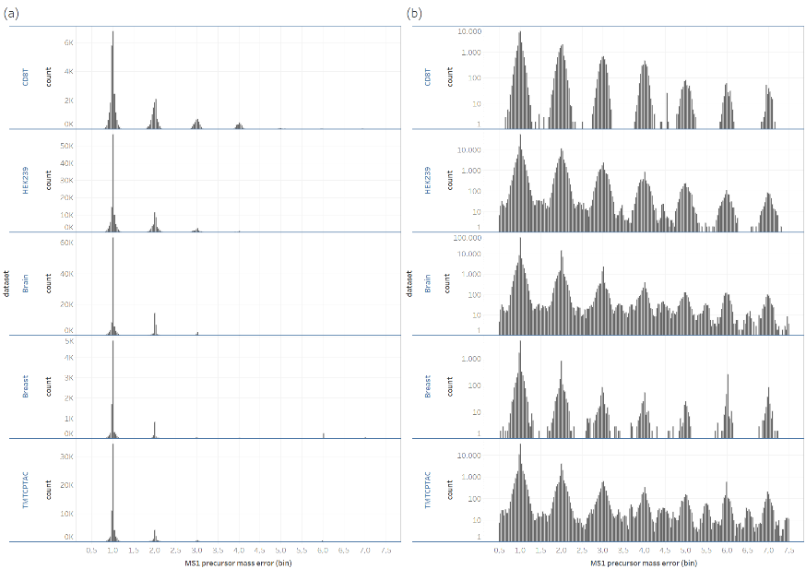

Supplementary Fig. 6 |MS1 precursor error for wide error matches. In (a) the MS1 precursor error distribution for PSM identifications with error larger than 0.5 Da is shown. In (b) the same information is shown as in (a) but with y-axis in log₁₀-scale.
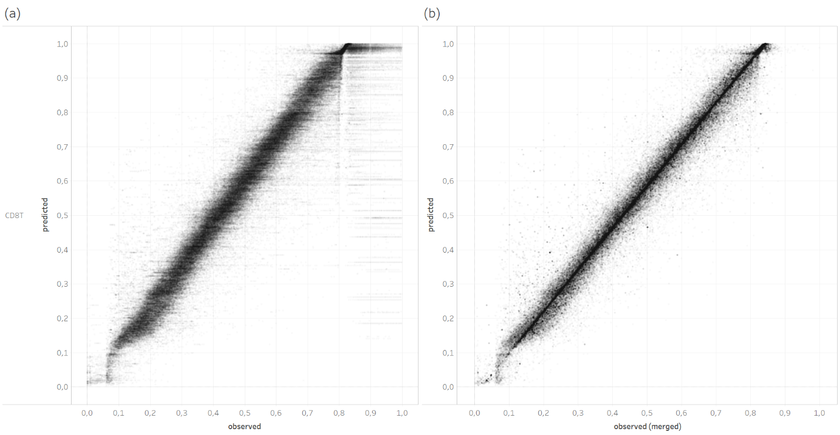

Supplementary Fig. 7 | The effect of grouping peptidoforms to compute the corrected observed retention time. Both plots show the observed versus predicted retention time for PSMs identified in an open ionbot search for CD8T. In (a) the true observed retention time for each PSM is plotted. In (b) the corrected observed retention time is plotted for the same dataset (CD8T). Retention times are normalized by dividing by the maximum observed retention time.
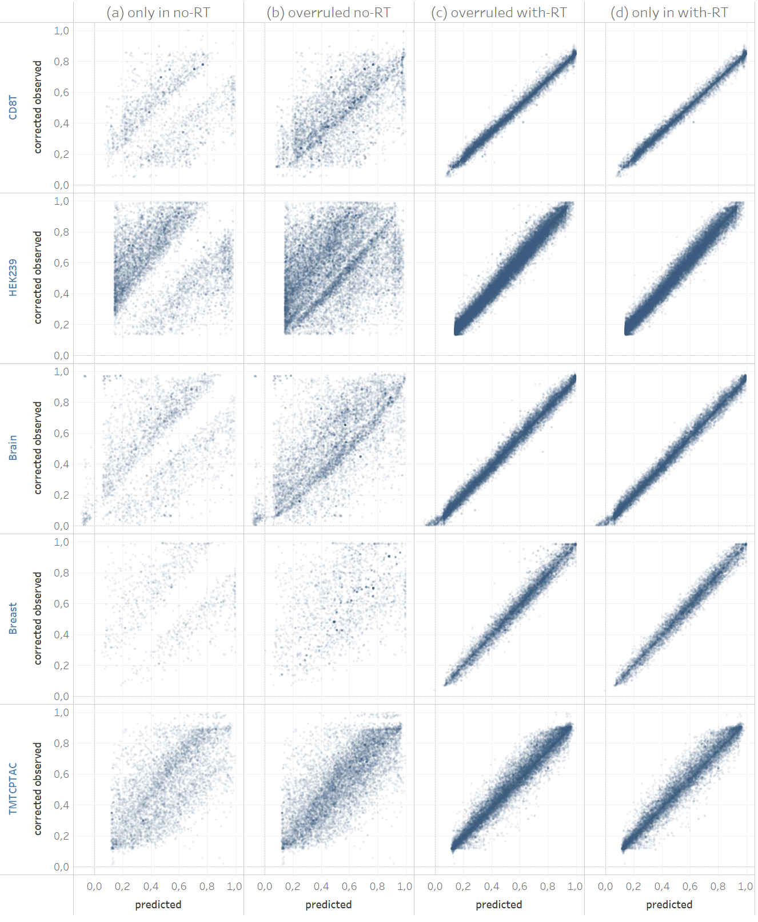

Supplementary Fig. 8 | Corrected observed versus predicted retention times for PSMs identified in two ionbot open searches; one does not the RT-pred-error feature in the PSM scoring function (no-RT), while the other performs a normal open search that does use this feature (with-RT). In (a) all matches identified in the no-RT search only are shown. In (b) all matches identified in the no-RT search that were overruled by another match in the with-RT search are shown. In (c) these overruled matches for the with-RT search are shown. In (d) all matches identified in the with-RT search only are shown.
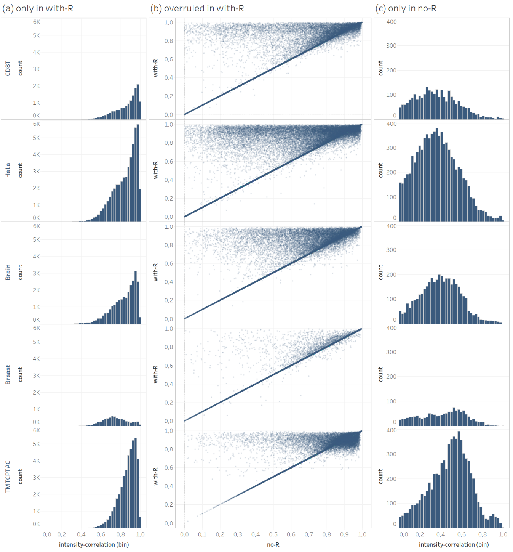

Supplementary Fig. 9 | Comparing peak intensity pattern correlations for PSMs identified in two ionbot open searches; one does not the intensity-correlation feature in the PSM scoring function or as a biased scoring function (no-R), while the other performs a normal open search that does use this feature (with-R). In (a) all matches identified in the no-R search only are shown. In (b) all PSMs identified in the no-R search that were overruled by another match in the with-R search are plotted. For each such PSM, the intensity-correlation of the match in the no-R search (x-axis) is plotted against the intensity-correlation of the match in the R search (y-axis). In (c) all matches identified in the with-R search only are shown.
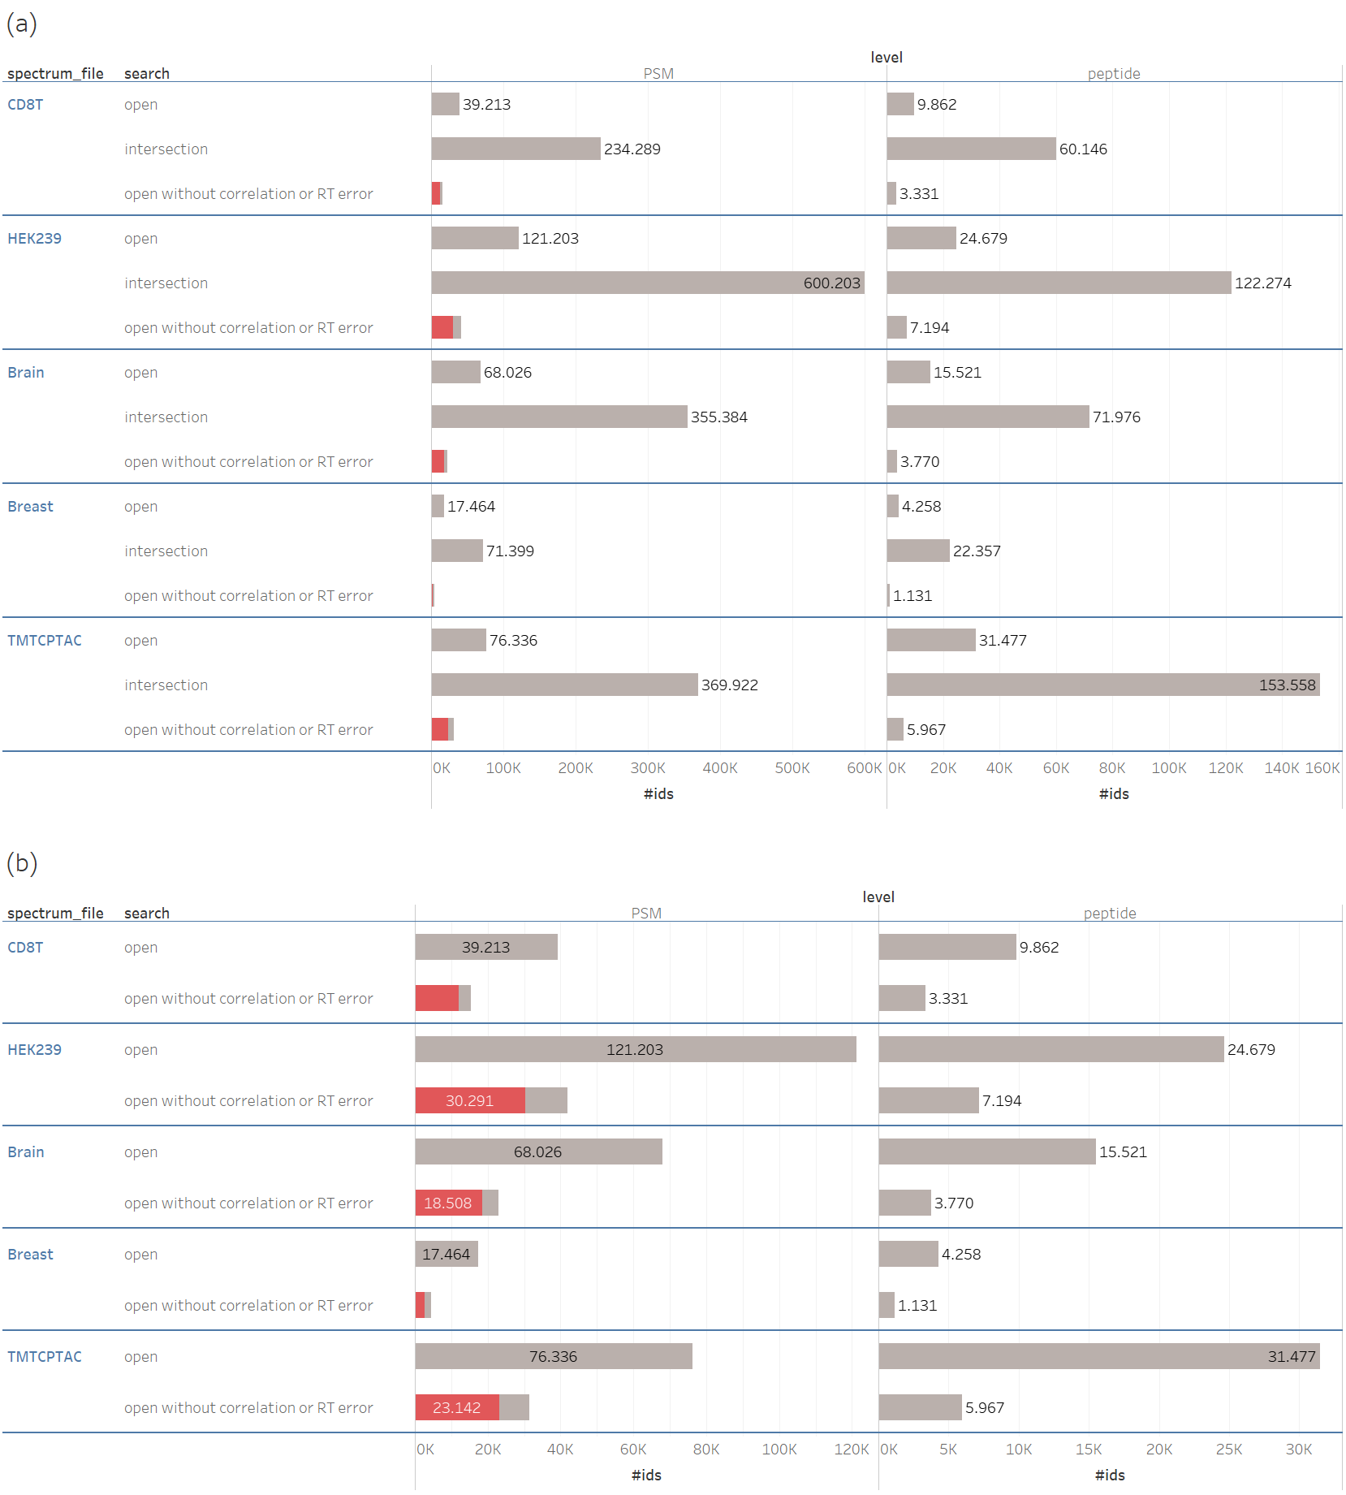
Supplementary Fig. 10 | Comparing a normal ionbot open search with an open search that does not use the RT-pred-error and the intensity-correlation in the PSM scoring function or as a biased PSM scoring function. Matches overruled in the normal open search are shown in red. The first column shows identification overlap at PSM level, while the second column shows identification overlap at the unique peptide level. The bars in (a) show the same counts as in (b), but also shows the number of matches that were the same in both searches (intersection).
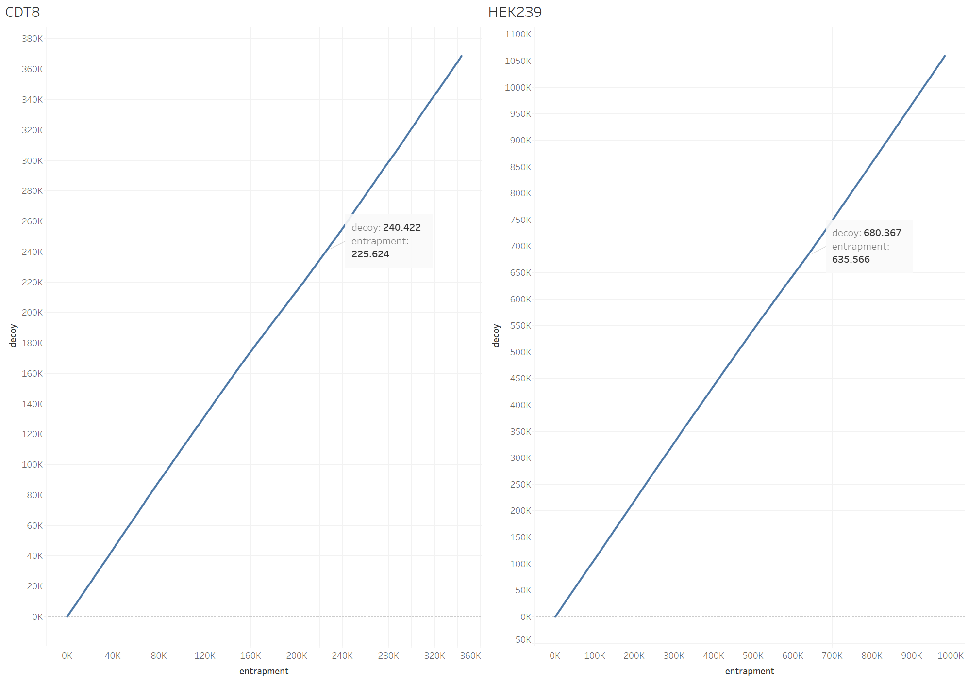

Supplementary Fig. 11 | The number of matches in the entrapment database (x-axis) against the number of matches in the decoy database (y-axis) for sets of PSMs obtained by varying the PSM score threshold that calls a PSM identified. This threshold is high for sets in the bottom left and becomes gradually lower towards sets in the top right. The exact number of decoy and entrapment matches in one such set is shown as a label.
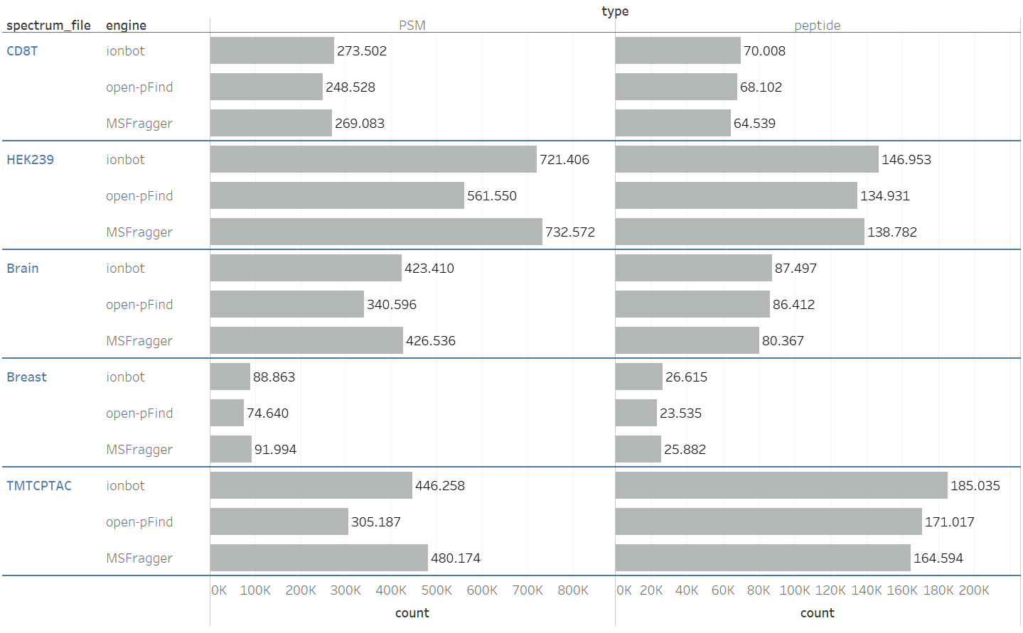

Supplementary Fig. 12 | The number of PSM (first column) and unique peptide (second column) identifications for each search engine.
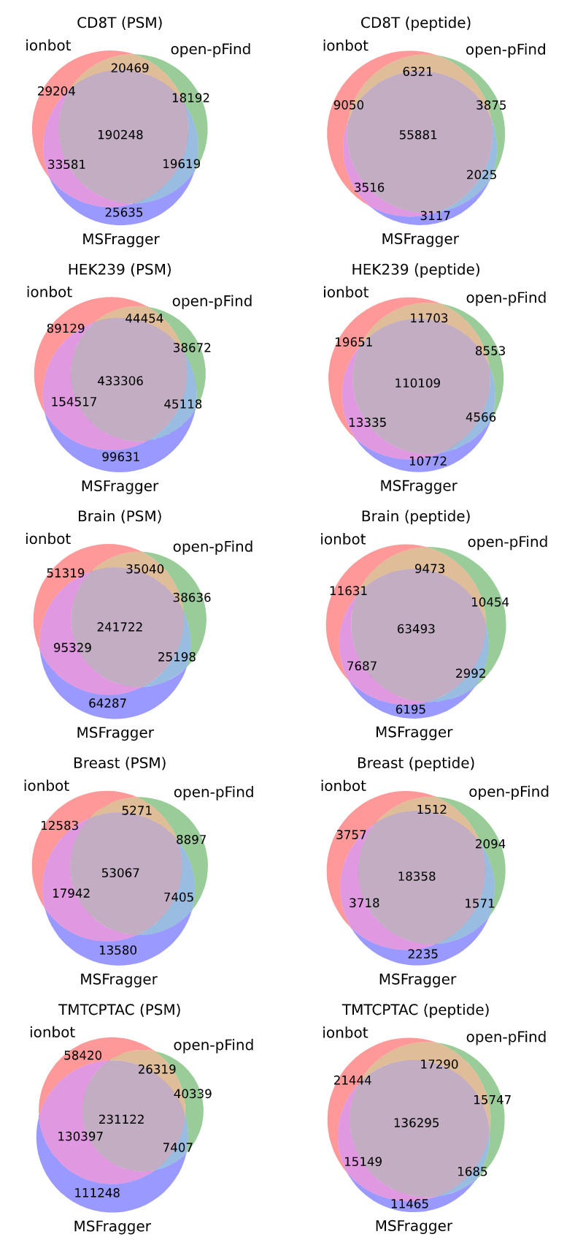

Supplementary Fig. 13 | The identification overlap between three open modification identification engines at PSM level (first column), and at unique peptide sequences level (second column).
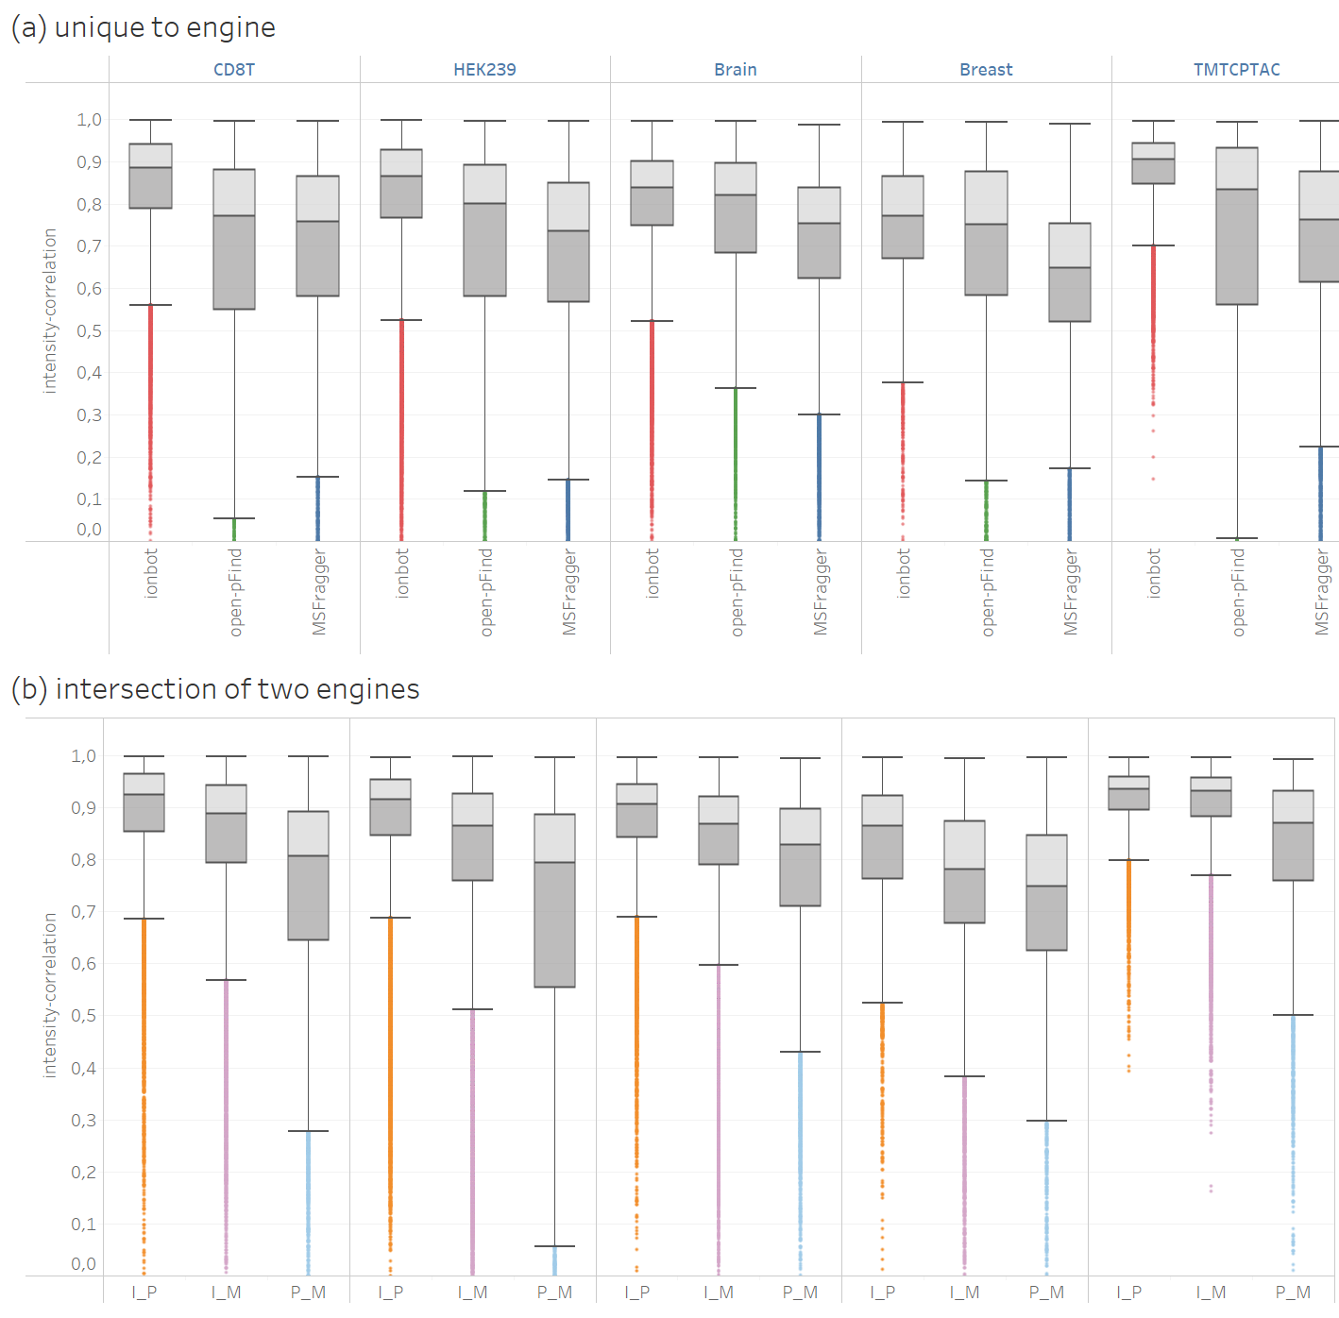

Supplementary Fig. 14 | The value of the intensity-correlation feature for matches in the different sections of the venn diagrams shown in Figure R.5.2. In (a), the intensity-correlation for all matches unique to each engine is plotted as boxplots. In (b), for each pair of two engines, the intensity-correlation for all matches identified by both engines is plotted as boxplots. The colors of the outliers follow the colors of the corresponding sections in Figure R.5.3. On the x-axis, I_M is the intersection between ionbot and MSFragger, I_P the intersection between ionbot and open-pFind, and P_M the intersection between open-pFind and MSFragger.
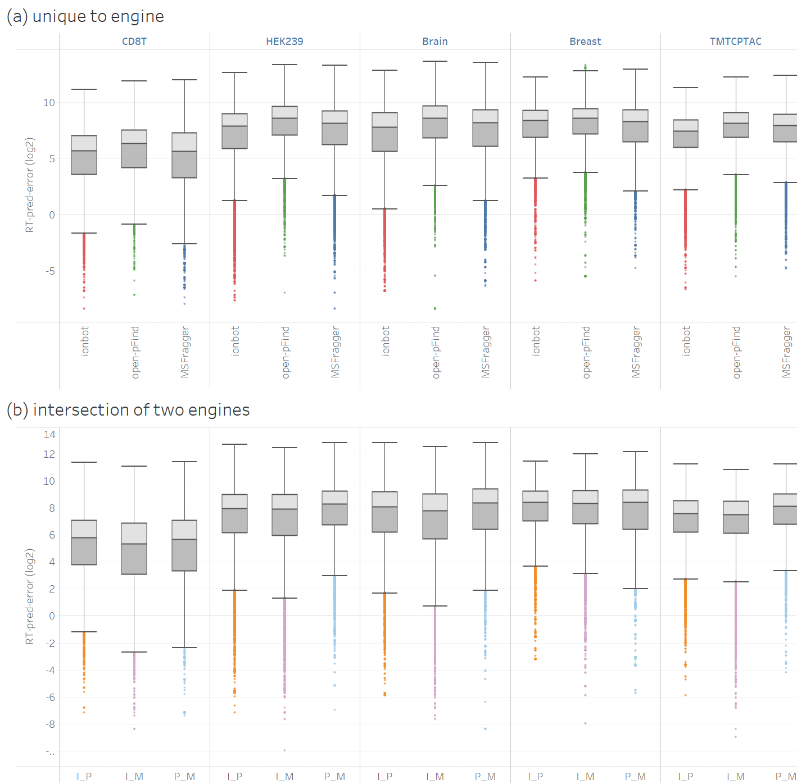

Supplementary Fig. 15 | The value of the RT-pred-error feature for matches in the different sections of the venn diagrams shown in Figure R.5.2. In (a), the RT-pred-error for all matches unique to each engine is plotted as boxplots. In (b), for each pair of two engines, the RT-pred-error for all matches identified by both engines is plotted as boxplots. The colors of the outliers follow the colors of the corresponding sections in Figure R.5.3. On the x-axis, I_M is the intersection between ionbot and MSFragger, I_P the intersection between ionbot and open-pFind, and P_M the intersection between open-pFind and MSFragger. To better show the differences between the distributions, the feature values are plotted in log₂-scale.
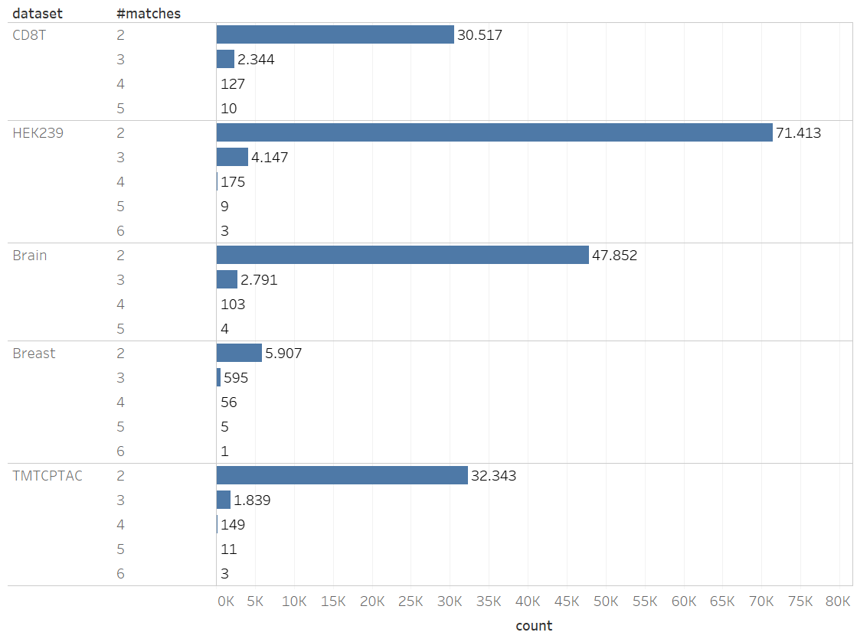
Supplementary Fig 16 | The number of different matches for an MS2 spectrum. Spectra with a single match are not shown.
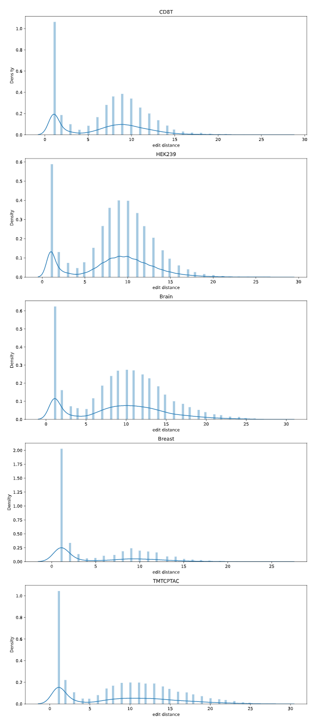

Supplementary Fig. 17 | The edit distance between two peptide matches in one MS2 spectrum. Only MS2 spectra with two identified matches are shown. Both histogram, with bin size equal to one, and density plot are shown.

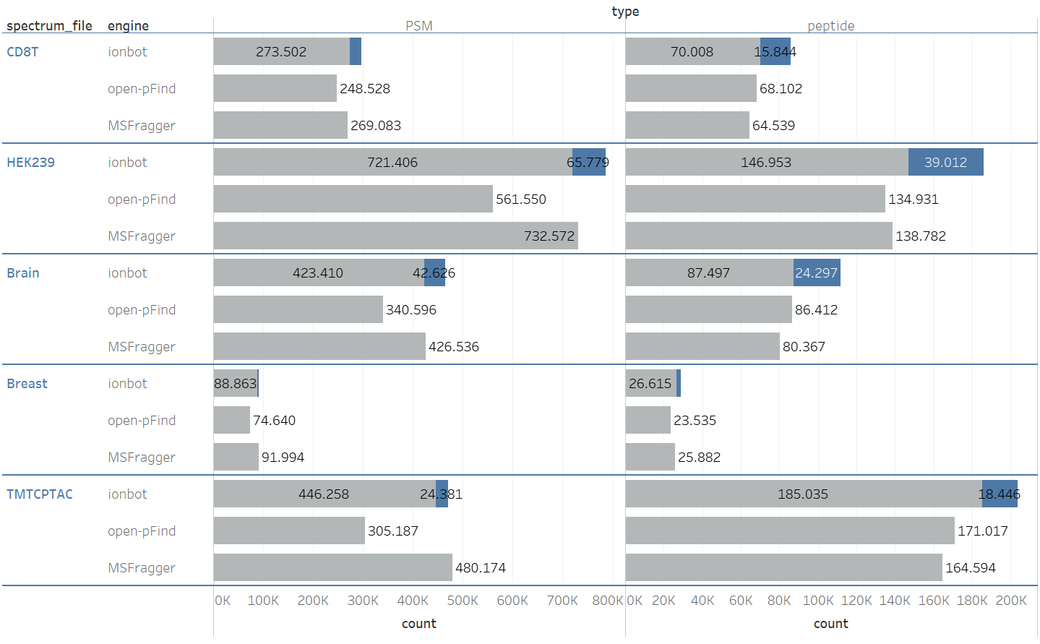
Supplementary Fig. 18 | Comparing the number of ionbot co-eluting lower-ranked PSMs (blue section) with first-ranked matches (grey section). The first column shows PSM identifications, the second column shows uniquely identified peptide sequences.
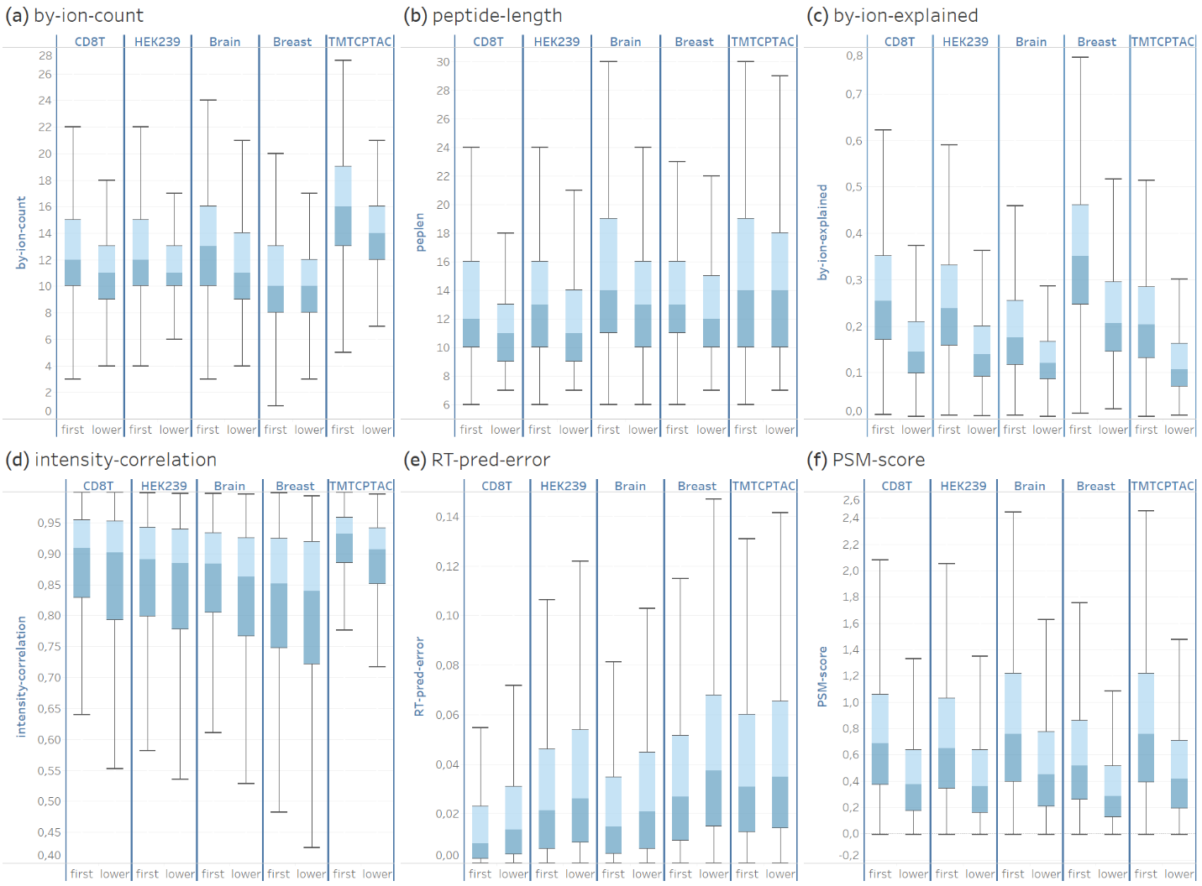

Supplementary Fig. 19 | A comparison of different types of PSM information between first-ranked and lower-ranked (x-axis) co-eluting PSMs. This information is the number of b- and y-ion peaks matched (a), the length of the matched peptide (b), the total explained intensity of the b- and y-ion peaks matched (c), the intensity-correlation (d), the RT-pred-error (e) and the PSM score (f).
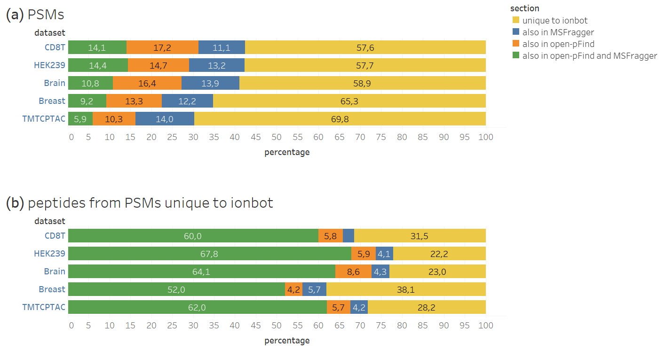

Supplementary Fig. 20 | Comparing lower-ranked co-eluting matches with first-ranked matches in open-pFind and MSFragger. In (a), the percentage of these lower-ranked matches identified as first-ranked PSM in both MSFragger and open-pFind (green), only open-pFind (orange), and only MSFragger (blue) is shown. In (b), for the lower-ranked PSMs unique to ionbot (yellow section in (a)), the percentage of unique peptide matches identified as first-ranked PSM (from another MS2 spectrum) in both MSFragger and open-pFind (green), only open-pFind (orange), and only MSFragger (blue) is shown.

