Supplementary Information
A Conformable Shape-Stable Self-Healing Polymer Platform for Continuous Wireless Arterial Pulse Monitoring
Haechang Lee^{1,†}, Joohyuk Kang^{1,†}, Jaewoo Kim² and Wonryung Lee^{1,*}
¹ Sensor System Research Center, Advanced Materials and Systems Research Division, Korea Institute of Science and Technology (KIST), Seoul 02792, Republic of Korea
² Department of Materials Science and Engineering, Seoul National University, Seoul 08826, Republic of Korea

† These authors contributed equally to this work.
*Corresponding authors.
E-mail: W. Lee (wrlee@kist.re.kr)

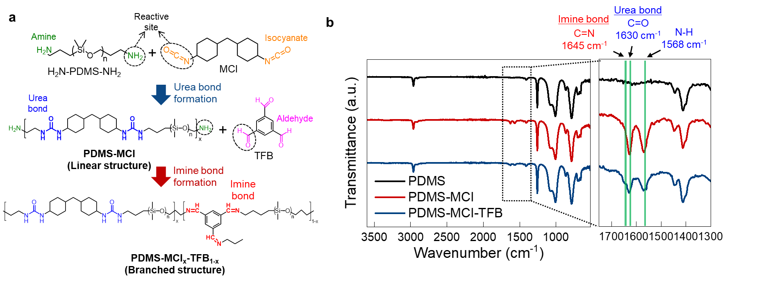
Supplementary Fig. 1 | Synthesis of PDMS-MCI and PDMS-MCI-TFB. a, Chemical reaction scheme illustrating the synthesis of PDMS-MCI and PDMS-MCI-TFB. b, FT-IR spectra of H₂N-PDMS-NH₂, PDMS-MCI, and PDMS-MCI-TFB, confirming the formation of urea bonds in PDMS-MCI and imine bonds in PDMS-MCI-TFB.

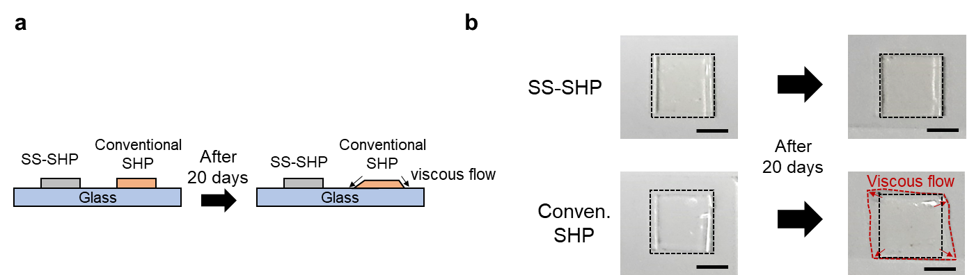
Supplementary Fig. 2 | Time-dependent shape deformation of shape-stable self-healing polymer (SS-SHP) and conventional SHP. a, Schematic illustration of the experiment for evaluating long-term shape-stability. SS-SHP and conventional SHP samples (2 cm × 2 cm) were placed on a flat glass surface and stored under ambient conditions (20 °C, 40% relative humidity) for 20 days. b, Photographs after 20 days show that the SS-SHP maintained its original shape, while the conventional SHP underwent noticeable deformation due to viscous flow. Scale bars, 1 cm.

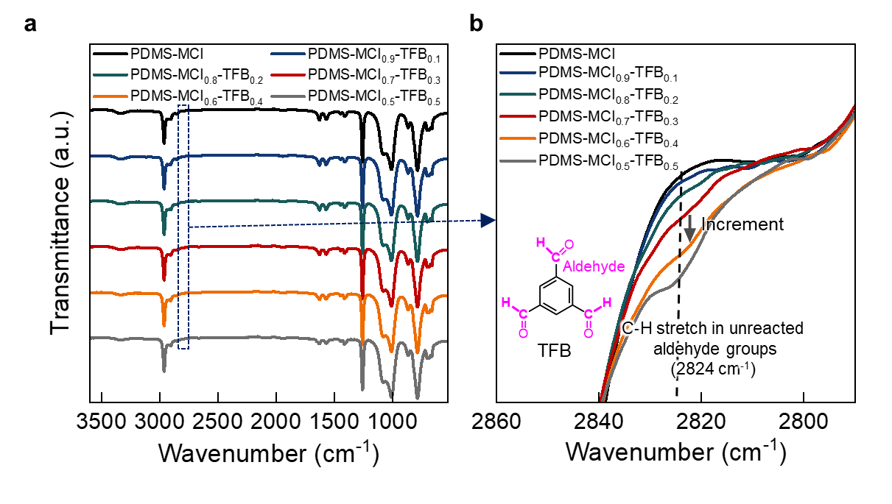
Supplementary Fig. 3 | FT-IR analysis of SHP samples with varying MCI and TFB molar ratios. a, FT-IR spectra of PDMS-based SHPs synthesized with different molar ratios of MCI and TFB. b, Enlarged view of the aldehyde C–H stretching region. PDMS-MCI_{0.6}-TFB_{0.4} and PDMS-MCI_{0.5}-TFB_{0.5} exhibited stronger peaks at 2824 cm⁻¹, suggesting a higher level of unreacted aldehyde groups. Although a weak peak was also observed in PDMS-MCI_{0.7}-TFB_{0.3}, this composition exhibited the highest mechanical robustness, likely due to its optimal crosslinking density, and was selected for subsequent experiments.

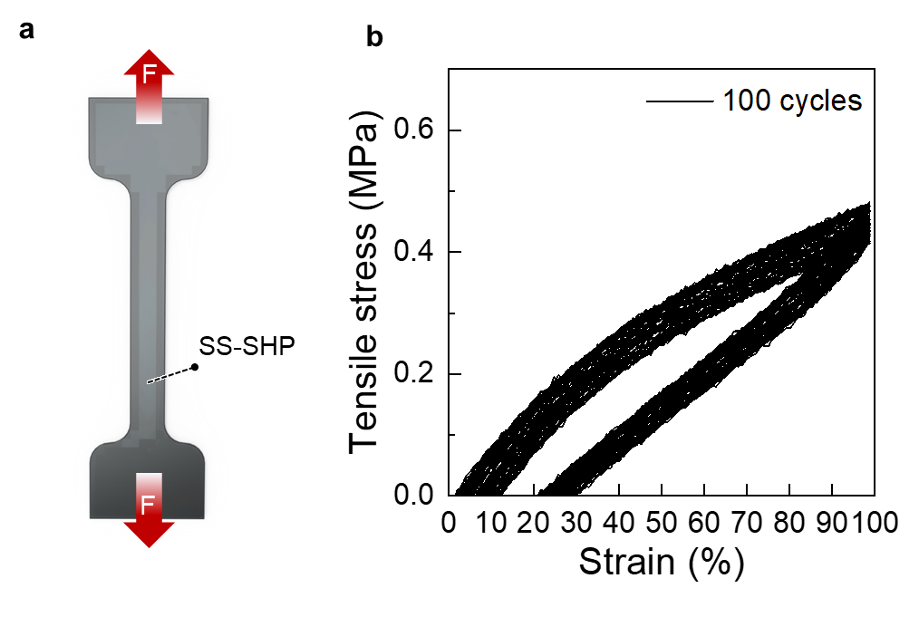
Supplementary Fig. 4 | Cyclic tensile test of SS-SHP. a, Illustration of dog-bone-shaped SS-SHP sample (1 cm × 7 cm) used for tensile testing. b, Cyclic stress-strain curves at 100% strain for 100 cycles. The first cycle showed ~0.5 MPa tensile stress at 100% strain with full shape recovery. Minimal change in strain–stress curves over 100 cycles demonstrates excellent mechanical stability and elastic resilience.

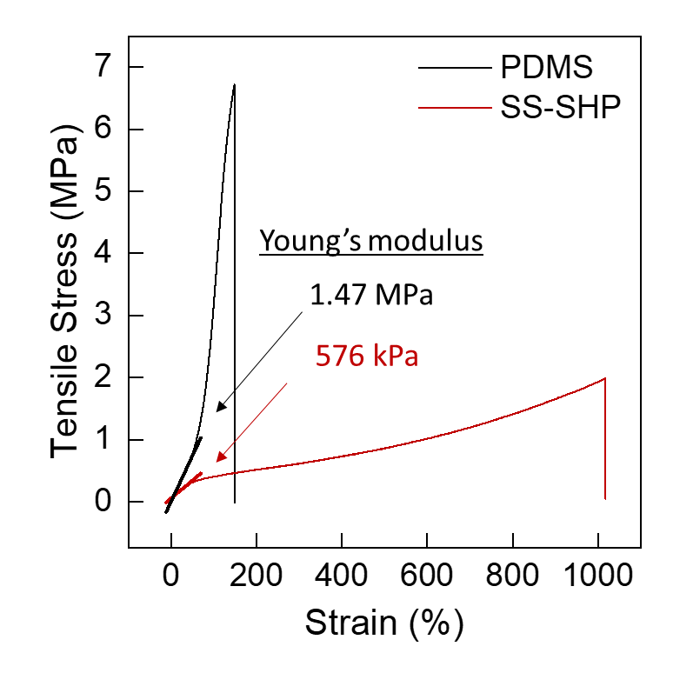
Supplementary Fig. 5 | Stress-strain curves of PDMS and the SS-SHP.

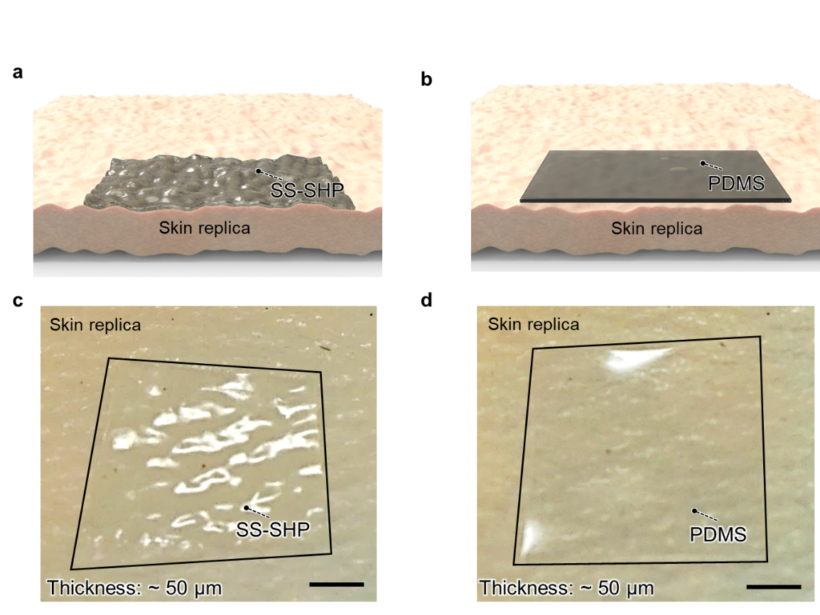
Supplementary Fig. 6 | Comparison of the conformability of SS-SHP and PDMS on a skin replica. a and b, Schematic illustrations comparing the conformability of SS-SHP and PDMS on a skin-mimicking surface. c, Photograph of a 1 cm × 1 cm SS-SHP sample placed on a skin replica, showing excellent conformity to fine wrinkle structures. Scale bar, 500 μm. d, Photograph of a 1 cm × 1 cm PDMS sample on a skin replica, showing poor conformity with noticeable detachment from the wrinkled surface. Scale bar, 500 μm.

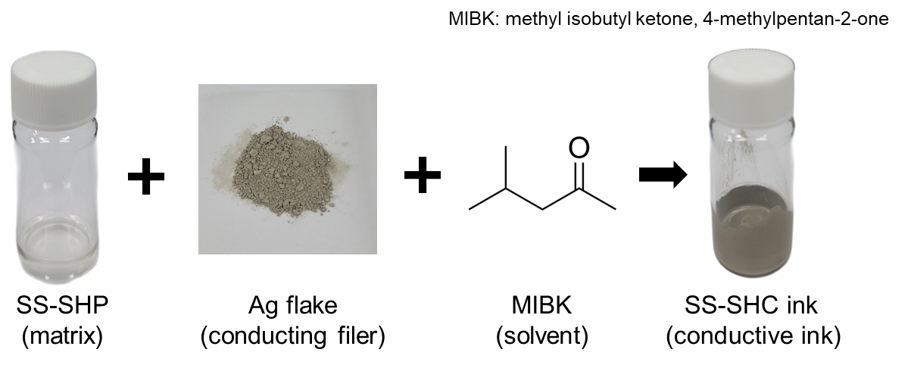
Supplementary Fig. 7 | Fabrication of shape-stable self-healing conductor (SS-SHC) ink. SS-SHC ink was prepared by uniformly mixing Ag flakes (AgFs) into the SS-SHP matrix, resulting in a conductive solution suitable for electrode fabrication.

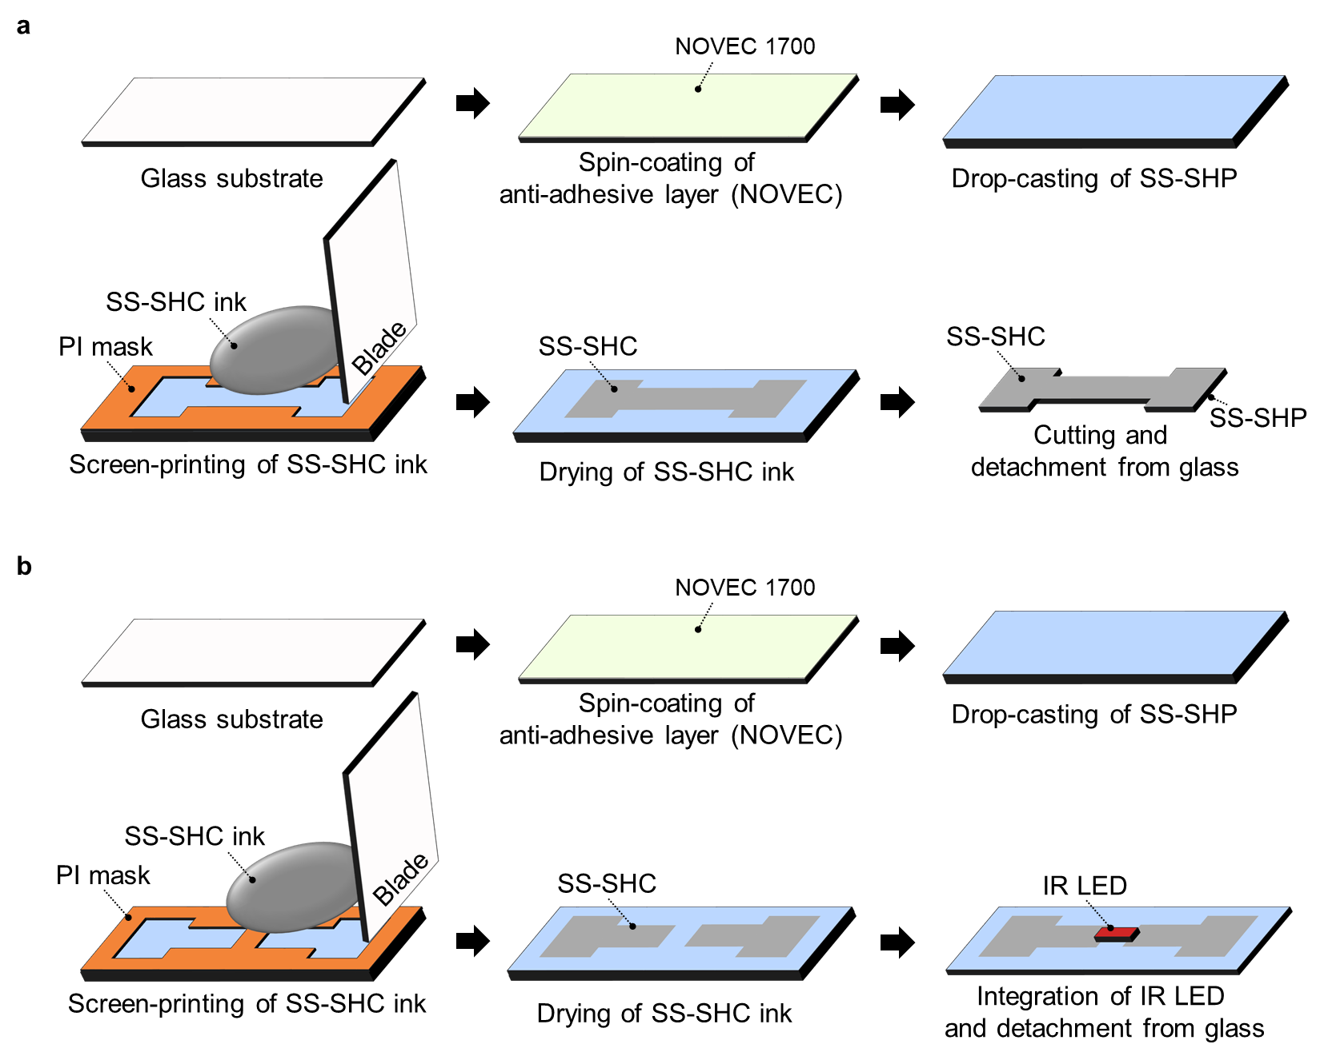
Supplementary Fig. 8 | Fabrication of dog-bone-shaped SS-SHC electrodes and IR LED-integrated device. a, Dog-bone-shaped SS-SHC electrodes were fabricated by screen-printing SS-SHC ink—a composite of SS-SHP and AgFs—onto the SS-SHP substrate through a polyimide (PI) mask with a dog-bone-shaped opening. The ink was applied using a blade, followed by drying and cutting along the mask pattern. The electrode was then detached from the glass substrate. b, An infrared light-emitting diode (IR LED)-integrated device was fabricated using the same SS-SHC ink. The ink was screen-printed onto the SS-SHP substrate through a PI stencil mask, dried at room temperature (20 °C), and used to mount an IR LED. This setup was used to evaluate the self-healing capability and restoration of electrical conductivity after damage.

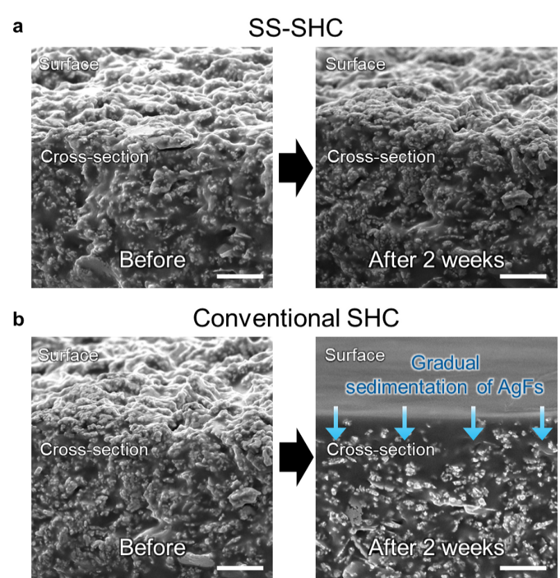
Supplementary Fig. 9 | SEM tilted cross-sectional images of SS-SHC and conventional SHC before and after 2 weeks of aging. a, SS-SHC maintained a stable distribution of AgFs even after 2 weeks, with a consistent AgF-rich surface layer that preserved conductive pathways. b, The conventional SHC exhibited structural collapse over time, causing AgFs to sediment toward the bottom of the matrix. This led to a loss of surface-level AgFs and degradation of the conductive pathways near the surface. Scale bars, 5 μm.

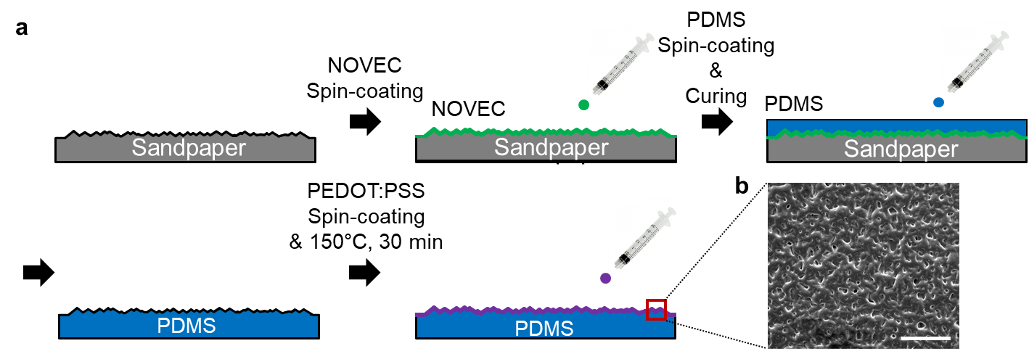
Supplementary Fig. 10 | Fabrication process of the imprinted PDMS/PEDOT:PSS used as the sensing material in the pressure sensor. a. First, sandpaper was used as a mold to create microstructures on the surface, and a spin-coated layer of NOVEC was applied to the mold to improve release properties. PDMS precursor was then spin-coated onto the sandpaper mold and cured at room temperature (20 °C) for 24 hr to allow the surface pattern to be transferred. After curing, the PDMS was carefully peeled off from the sandpaper to obtain imprinted PDMS with microstructures. Finally, to use the imprinted PDMS as a resistive sensing material, a layer of PEDOT:PSS was spin-coated onto its surface and thermally cross-linked at 150 °C for 30 minutes to enhance conductivity and stability. b. SEM image of the imprinted PDMS coated with PEDOT:PSS used as the sensing material in the pressure sensor. Scale bar, 500 μm.

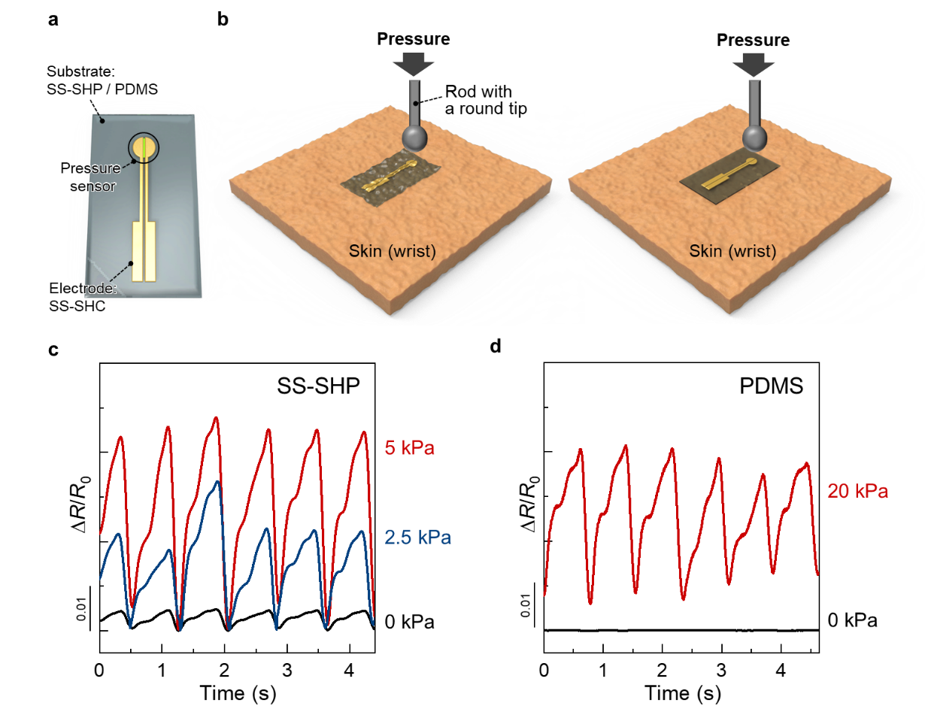
Supplementary Fig. 11 | Pulse signal detection performance of pressure sensors based on SS-SHP and PDMS substrates. a, Schematic illustration of pressure sensors using SS-SHP or PDMS as substrates. b, Illustrations of sensors mounted on the wrist with external pressure applied using a universal testing machine. c, Resistance-based pulse signals measured by the SS-SHP-based pressure sensor under different applied pressures. Even without external pressure, the sensor detects clear pulse signals due to its high conformability and seamless contact with the skin. Increasing external pressure enhances the amplitude and clarity of the waveform. d, Resistance-based pulse signals measured by the PDMS-based pressure sensor. Pulse signals are only detected when external pressure is applied, as the low conformability of PDMS causes interfacial gaps that hinder signal transmission without added pressure.

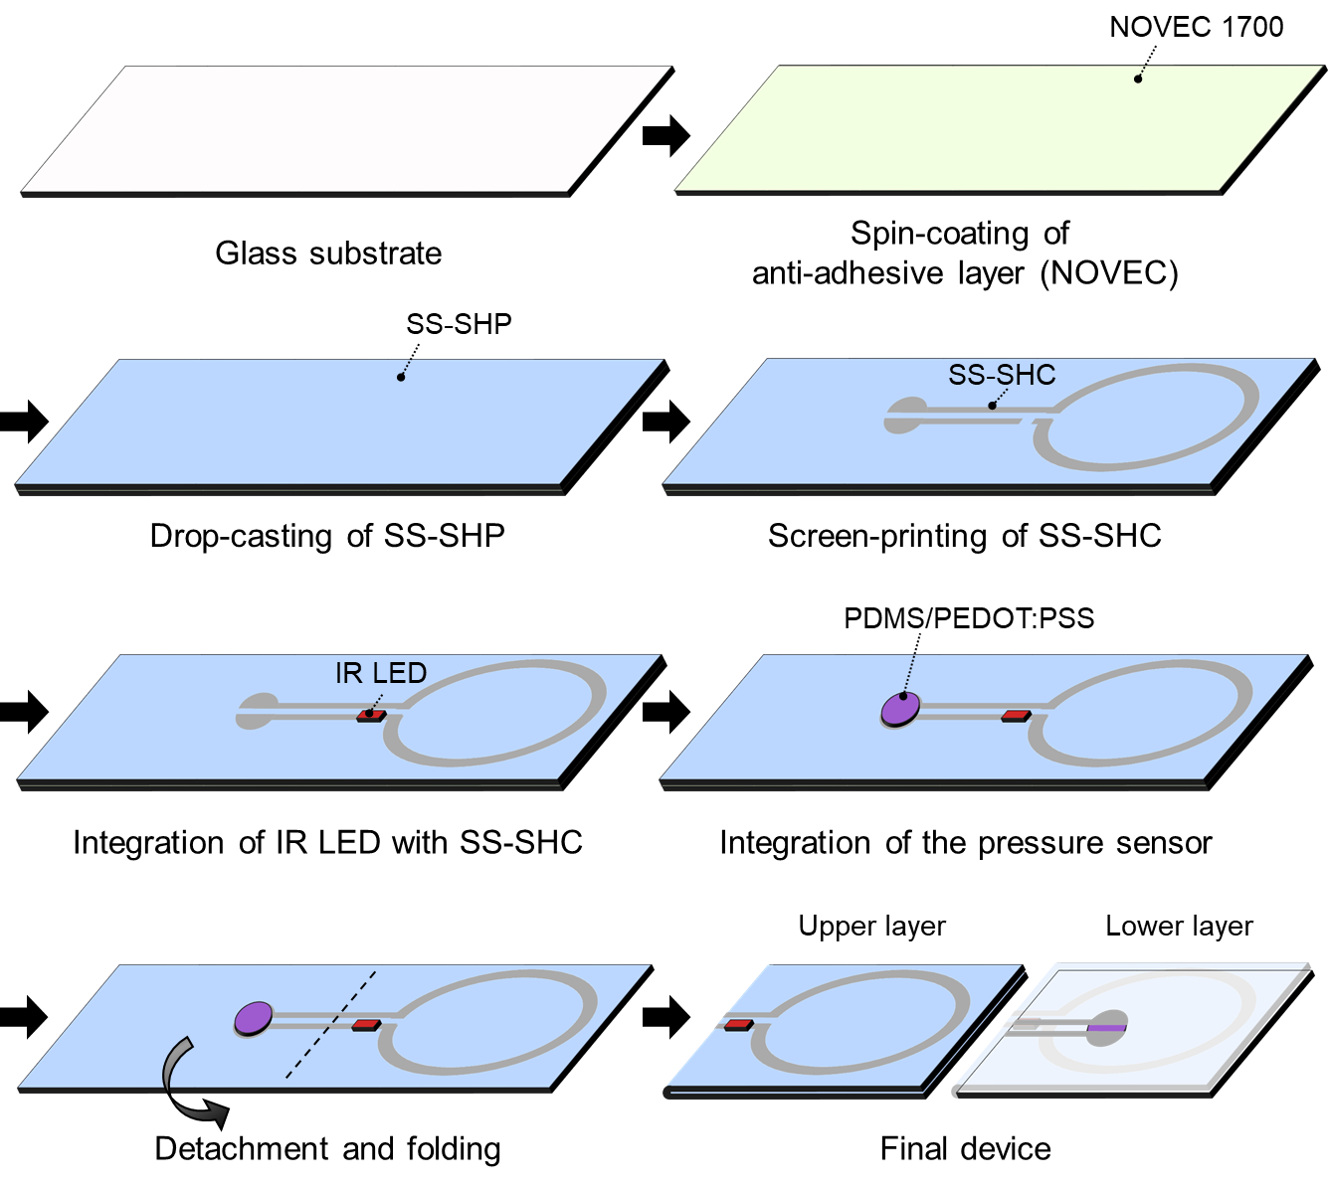
Supplementary Fig. 12 | Fabrication process of the wireless pulse sensor integrated on the SS-SHP platform

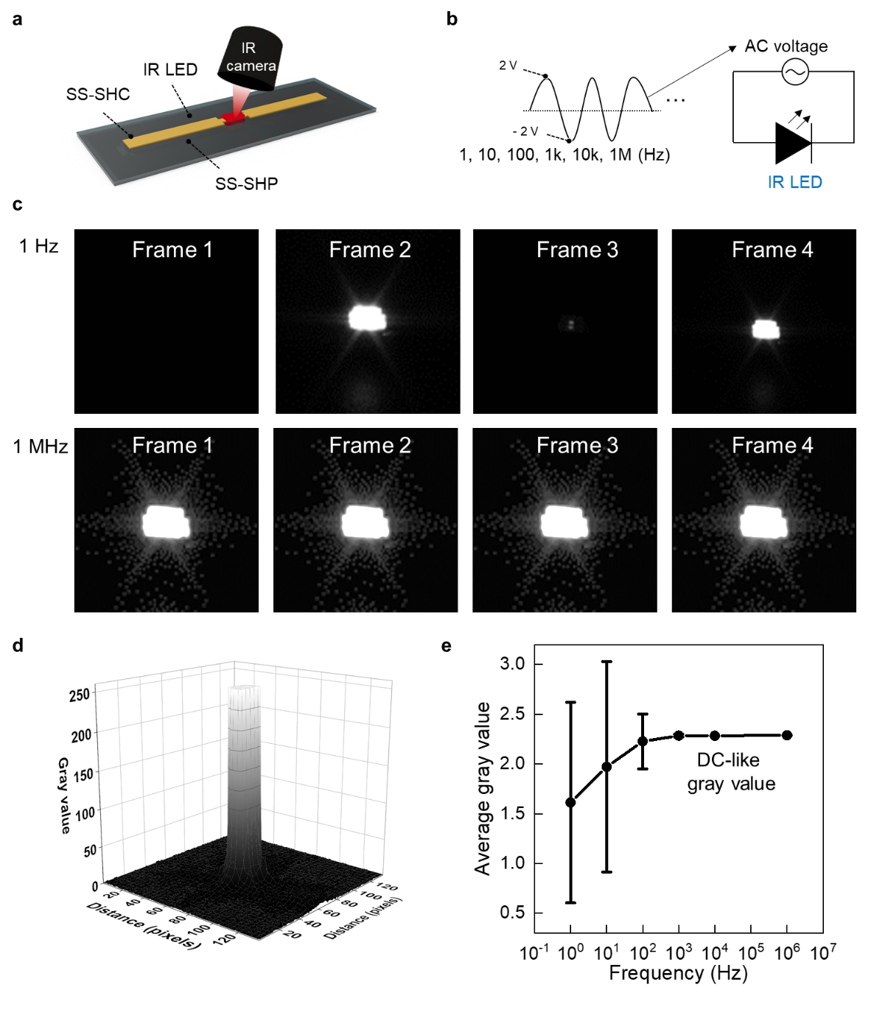
Supplementary Fig. 13 | Evaluation of IR LED emission stability under AC voltage using SS-SHC electrodes. a, Schematic illustration of the IR LED device structure, where the IR LED was mounted on SS-SHC electrodes, and its emission was monitored using an IR camera. b, Circuit diagram used to drive the IR LED. An AC voltage with a 2 V amplitude was applied at various frequencies (1 Hz, 10 Hz, 100 Hz, 1 kHz, 10 kHz, and 1 MHz) to evaluate frequency-dependent emission characteristics. c, Time-sequential IR camera images of the IR LED emission taken over multiple frames at 1 Hz and 1 MHz. At low frequency (1 Hz), the LED brightness varies between frames due to the alternating current, while at high frequency (1 MHz), frame-to-frame intensity remains constant, indicating visually continuous emission. d, Gray value of the brightly glowing IR LED at 1 MHz. e, Quantitative analysis of the average gray value of the IR images across different frequencies. As frequency increases, the fluctuation in gray value decreases, and the average converges to ~2.29, demonstrating that high-frequency AC produces a visually stable emission similar to DC due to temporal averaging by the IR camera.

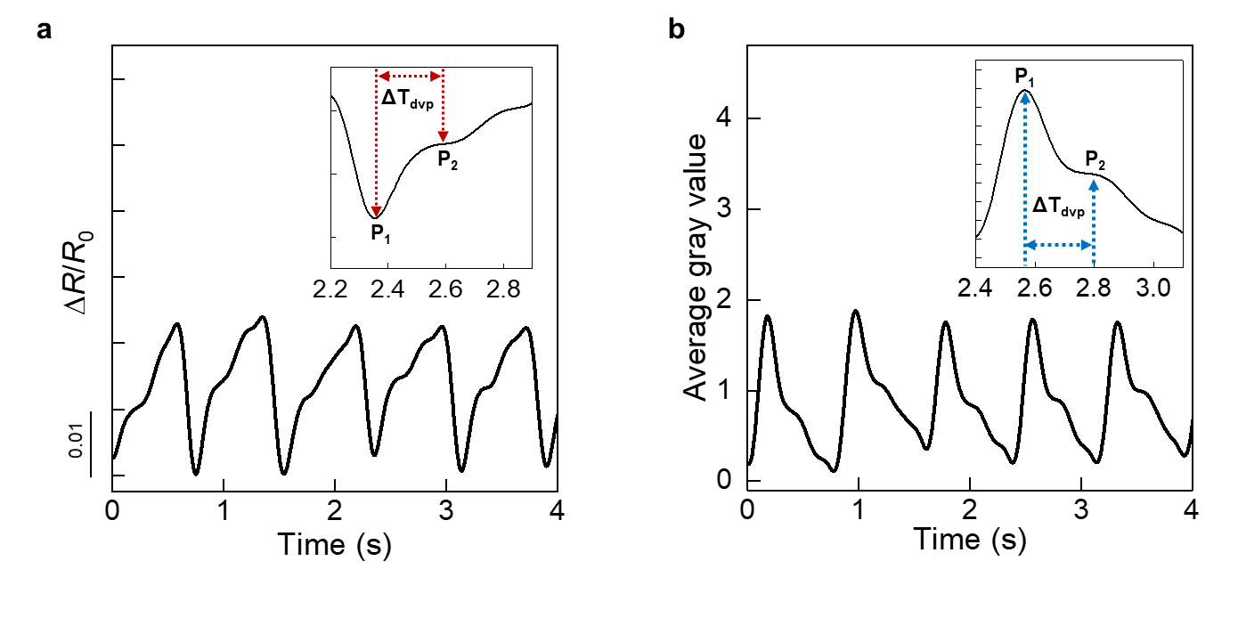
Supplementary Fig. 14 | Comparison of pulse signals acquired optically and electrically using the SS-SHP-based pressure sensor. a, Time-dependent resistance changes measured from the pressure sensor placed on the wrist. Inset: A magnified view of a single pulse waveform, showing two characteristic peaks (P₁ and P₂) and the time difference between them (ΔT_{dvp}), which are associated with the systolic ejection (P₁) and reflected wave (P₂) of the arterial pulse. ΔT_{dvp} represents the temporal delay between the two peaks and can provide insights into vascular stiffness and cardiovascular condition. b, Time-dependent variation of IR LED gray value recorded via optical signal acquisition. Inset: A magnified optical pulse signal showing P₁, P₂, and ΔT_{dvp}, which closely correspond to those obtained through electrical measurements, demonstrating strong agreement between the two sensing modalities.

