Extended Tables and Figures
Extended Table 1: PBMC samples for flow cytometry

Phenotype | Number of donors | Median Age in years (±SD) | Sex ratio male: female (%) | Median EDSS (±SD) | Patients in Relapse (%) | Patients with SDW (%)
RRMS | 31 | 53 (±15.4) | 10 (32.3) : 21 (67.7) | 2 (±1.4) | 5 (16.1) | -
PPMS | 8 | 61 (±7.6) | 4 (50) : 4 (50) | 6.5 (±2.0) | - | 6 (75)
SPMS | 10 | 59.5 (±6.8) | 5 (50) : 5 (50) | 6.5 (±0.8) | - | 4 (40)
HC | 25 | 46 (±12.8) | 7 (28) : 18 (72) | - | - | -

Extended Table 2: CNS-tissue sections for immunohistofluorescence

Donor | Age | Sex | Phenotype
1 | 26 | Male | RRMS
2 | 60 | Female | SPMS
3 | 61 | Male | SPMS
4 | 44 | Female | RRMS to SPMS
5 | 33 | Female | RRMS
6 | 51 | Female | RRMS
7 | 67 | Male | Nephrectomy, non-neurological disease
8 | 37 | Female | Biopsy, Epilepsy
9 | 31 | Female | Biopsy, Epilepsy
10 | 42 | Male | Biopsy, Epilepsy

Extended Table 3: Autopsied brain tissue and PBMCs for flow cytometry

Donor | Age | Sex | Phenotype | EDSS | Sample / Regions | Comments
1 | 60 | Male | SPMS | 7 | 1 PBMC  1 PVWML | PM delay 4 hours 8 minutes, Perfused
2 | 81 | Female | ALS | - | 1 NAWM | PM delay 3 hours 22; Not perfused
3 | 56 | Male | PPMS | 8 | 1 PBMC  3 PVWML  1 NAWM | PM delay 5 hours 15 minutes; Perfused
4 | 62 | Male | ALS | - | 1 PBMC  2 NAWM | Perfused

Extended Table 4: CSF and blood samples for flow cytometry

Donor | Age | Sex | Phenotype / Activity | EDSS | Oligoclonal bands
 | 44 | Male | RRMS | 1.5 | Positive
  1
 | 39 | Female | RIS | 0 | 1 band
  2
 | 25 | Female | RRMS | 1 | Positive
  3
 | 29 | Female | RRMS to SPMS | 4 | Positive
  4
 | 44 | Female | RRMS | 2.5 | Positive
  5
 | 66 | Female | RRMS | 2 | 1 band
  6

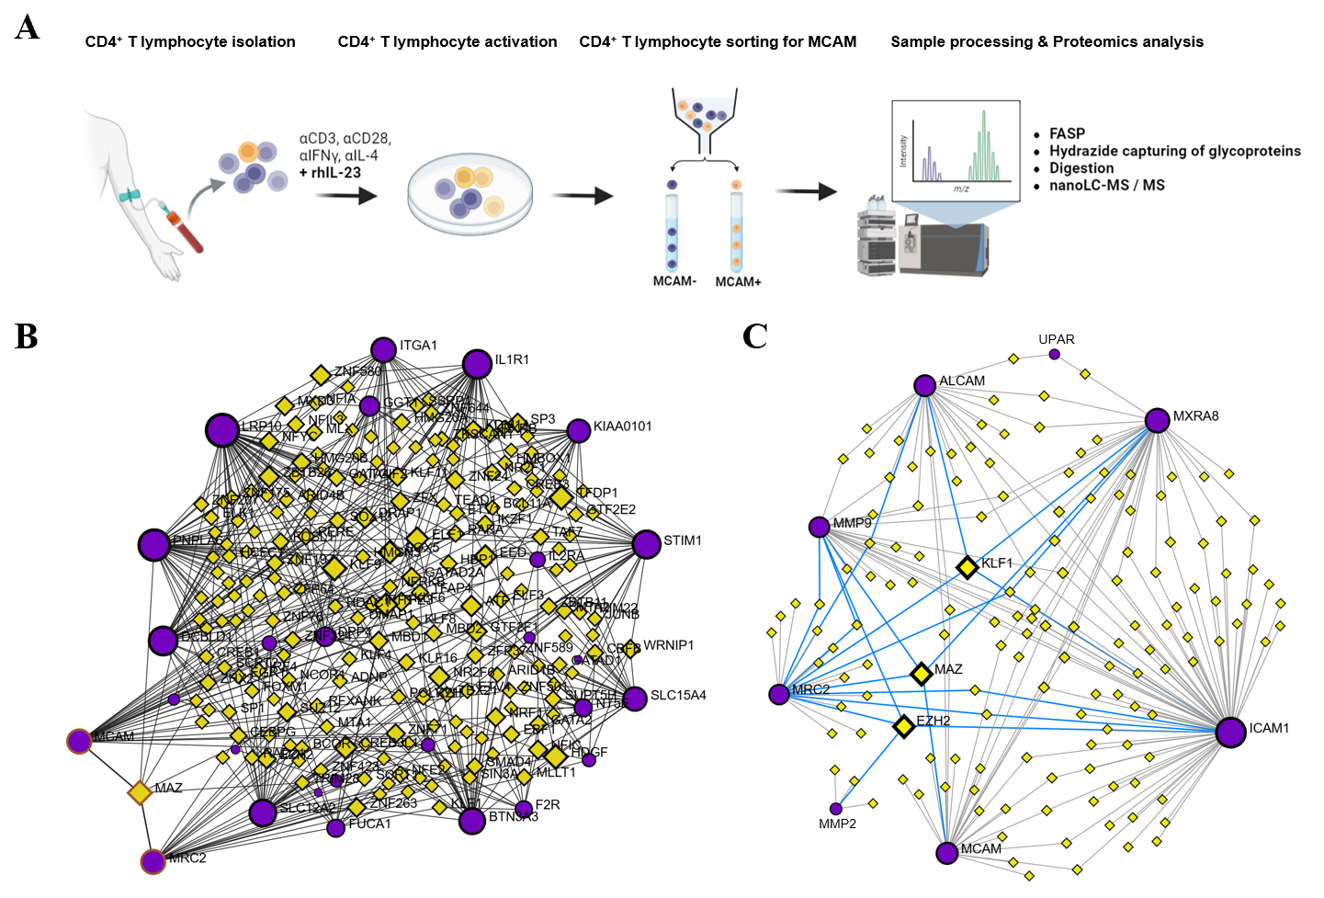
Extended Figures:
Extended Figure 1: Proteomics analysis and predicted transcription factor–gene interactions identified using NetworkAnalyst. (A) Scheme showing experimental design. (B) Analysis of the top 30 proteins upregulated in MCAM⁺ T lymphocytes compared to MCAM⁻ T lymphocytes reveals MYC-Associated Zinc Finger Protein (MAZ) as a potential common transcriptional regulator of MCAM and MRC2. (B) Analysis of MRC2-associated proteins and selected cell adhesion molecules (CAMs) identifies MAZ, along with additional transcription factors KLF1 and EZH2, as potential regulators. Purple circles represent input (query) proteins, yellow diamonds highlight predicted transcription factors. Blue lines in (B) indicate transcription factors predicted to regulate both MRC2 and the respective query proteins.

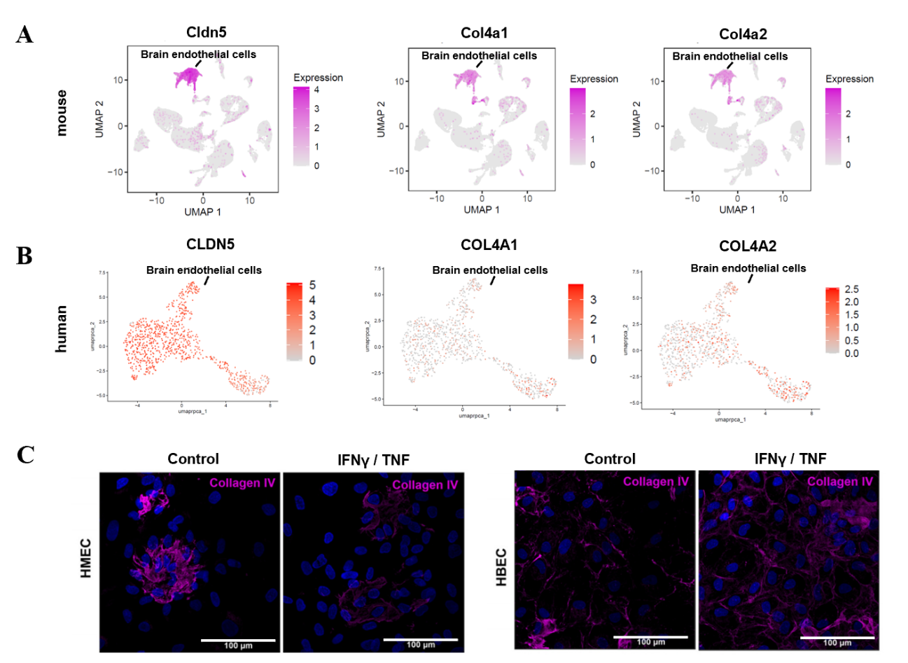
Extended Figure 2: Col IV expression on murine and human BBB-ECs. (A-D) Single cell RNA-Seq data analysis reveals Col IV expression on mouse CD31+ enriched brain ECs (re-analysis from Fournier et al, 2022)¹⁹ and human ECs from rapid autopsied brain tissue (from 1 ALS patient). (E) Representative images from Col IV staining on in vitro cultured human meningeal ECs (HMEC) and human brain ECs (HBEC) under control and pro-inflammatory conditions (IFNγ/TNF).

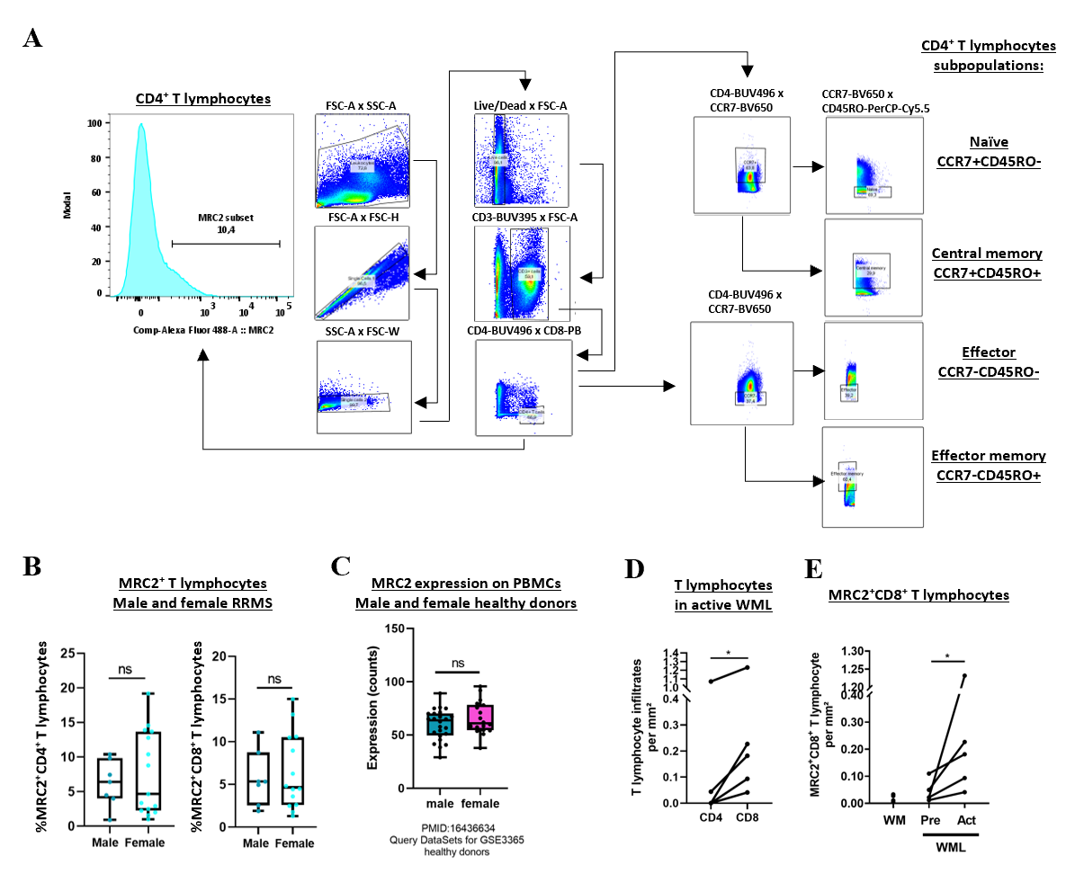
Extended figure 3: MRC2 expression analysis on PBMCs. (A) Gating strategy to analyze different T cell subpopulations in PBMC samples from patients with MS and healthy donors. (B) Comparison of MRC2⁺CD4⁺ T cells and CD8⁺ T cells in male and female RRMS patients in remission. (C) Re-analysis of publicly available microarray data sets (GSE3365) to compare MRC2 expression in PBMCs from healthy donors. (D-E) Confocal microscopy on postmortem tissue from patients with MS. Pairwise comparison of MRC2⁺CD8⁺ T lymphocytes in pre-active lesions and active lesions per donor (D, n = 5) and of CD4⁺ and CD8⁺ T lymphocytes (E, n = 5 ). For statistical analysis unpaired Student’s t test in (B-C) and paired Student’s t test in (D -E) were performed. ns = not significant

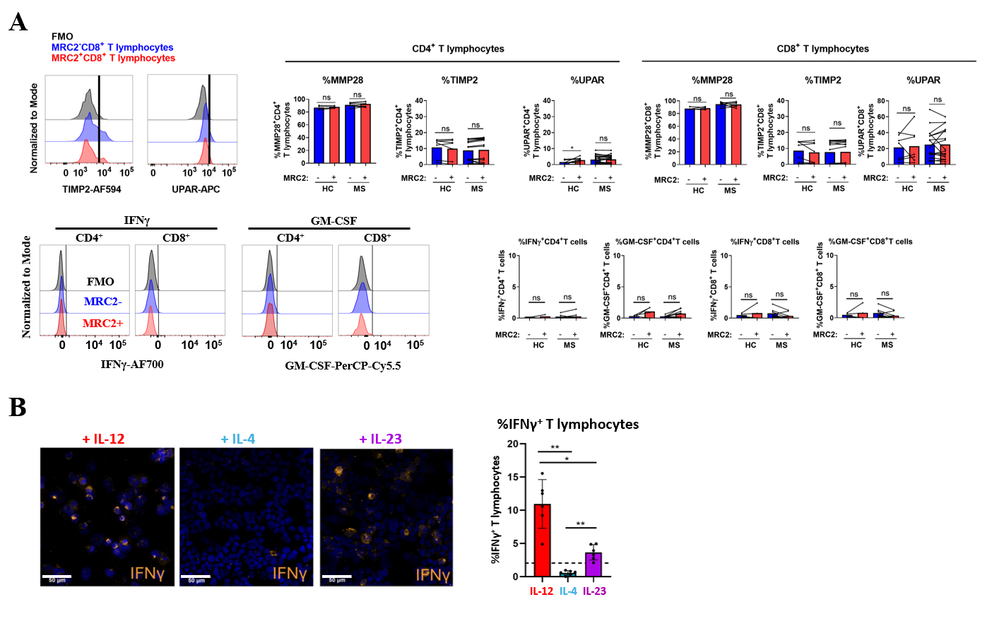
Extended figure 4: (A) Flow cytometry analysis of ex vivo PBMC samples from PwMS (MS) and healthy controls (HC) indicating high MMP28 expression, but low IFNγ and GM-CSF expression in both MRC2+ and MRC2 negative T lymphocyte populations. Additionally, no significant differences regarding TIMP-2 and UPAR between these populations were observed. (B) Microscopy analysis to assess the frequency of IFNγ+ T lymphocytes after stimulation with IL-12, IL-4, and IL-23. Horizontal dashed line indicates mean levels of cells without cytokine stimulation. For statistical analysis ratio paired Student’s t test in (A), one-way ANOVA and Sidak’s multiple comparison test in (B) were performed. * p < 0.05, ** p < 0.01, ns = not significant

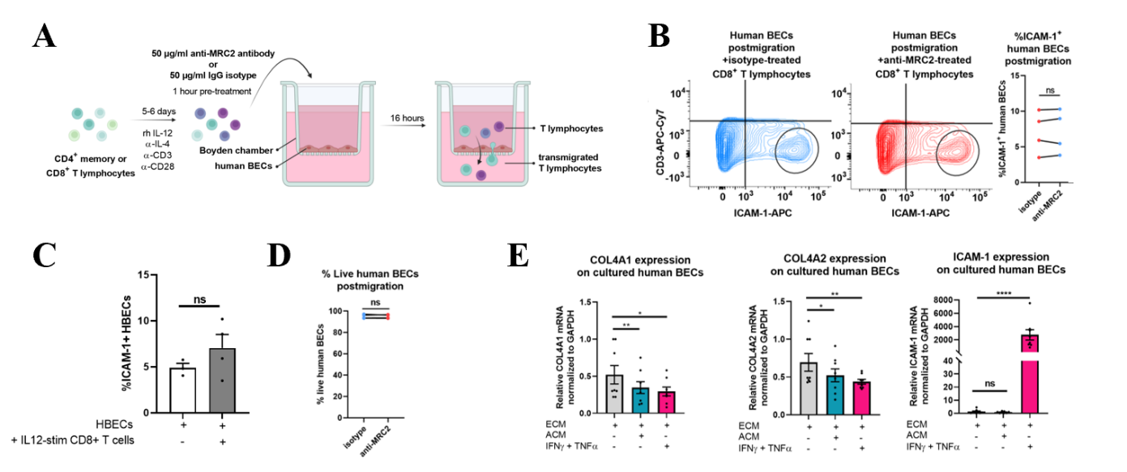
Extended figure 5: (A) Scheme of experiment design to assess T lymphocyte migration across human BECs. (B) Representative flow cytometry plots and pairwise analysis of ICAM-1⁺ BECs (n = 4). (C) Flow cytometry analysis of human BECs cultured with no T lymphocytes, and co-cultured with IL-12 stimulated CD8+ T cells for 16 hours displaying percentage of surface ICAM-1 on BECs.
(D) Viability staining of BECs postmigration cultured with either iso-treated CD8+ T lymphocytes or with anti-MRC2-blocking antibody (n = 4). (E) Pairwise assessment of COL4A1, COL4A2, ICAM-1 mRNA levels normalized to GAPDH by RT-qPCR comparing ECM, ACM and TNF and IFNγ-stimulated BECs after 24 hours (8 BEC cultures from 6 brain surgeries).
For statistical analysis ratio paired Student’s t test with Bonferroni correction in (B & D - E), and unpaired Student’s t test in (C) were performed. * p < 0.05, ** p < 0.01, **** p < 0.0001, ns = not significant

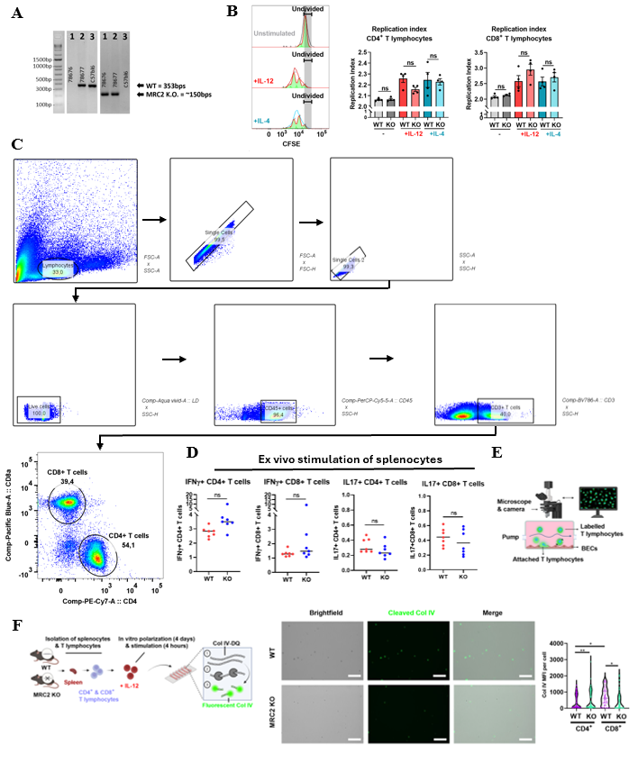
Extended figure 6: (A) Exemplary genotyping blot displaying PCR products from (1) MRC2 KO (MRC2^{-/-}), (2) heterozygous (MRC2 ^{+/-}), and (3) WT (MRC2^{+/+}) mice. (B) Flow cytometry of splenocyte-derived T lymphocytes to determine proliferation (n = 4 animals per genotype). (C) Gating strategy to analyze T cell populations from murine spleens and / or CNS tissue. (D) Flow cytometry analysis of ex vivo stimulated splenocytes with PMA / Ionomycin for intracellular staining to determine the frequency of IFNγ and IL17a+ T cells in MRC2 KO and wildtype (WT) littermates. (E) Scheme flow adhesion assay. (F) Scheme Col IV degradation assay, and representative live imaging and analysis. Data was pooled from 2 mice per condition. For statistical analysis Kruskal-Wallis and Dunn’s multiple comparison test in (A), unpaired Student’s t test in (D), and one-way ANOVA and Sidak’s multiple comparison in (F) were performed. * p < 0.05, ** p < 0.01, ns = not significant.

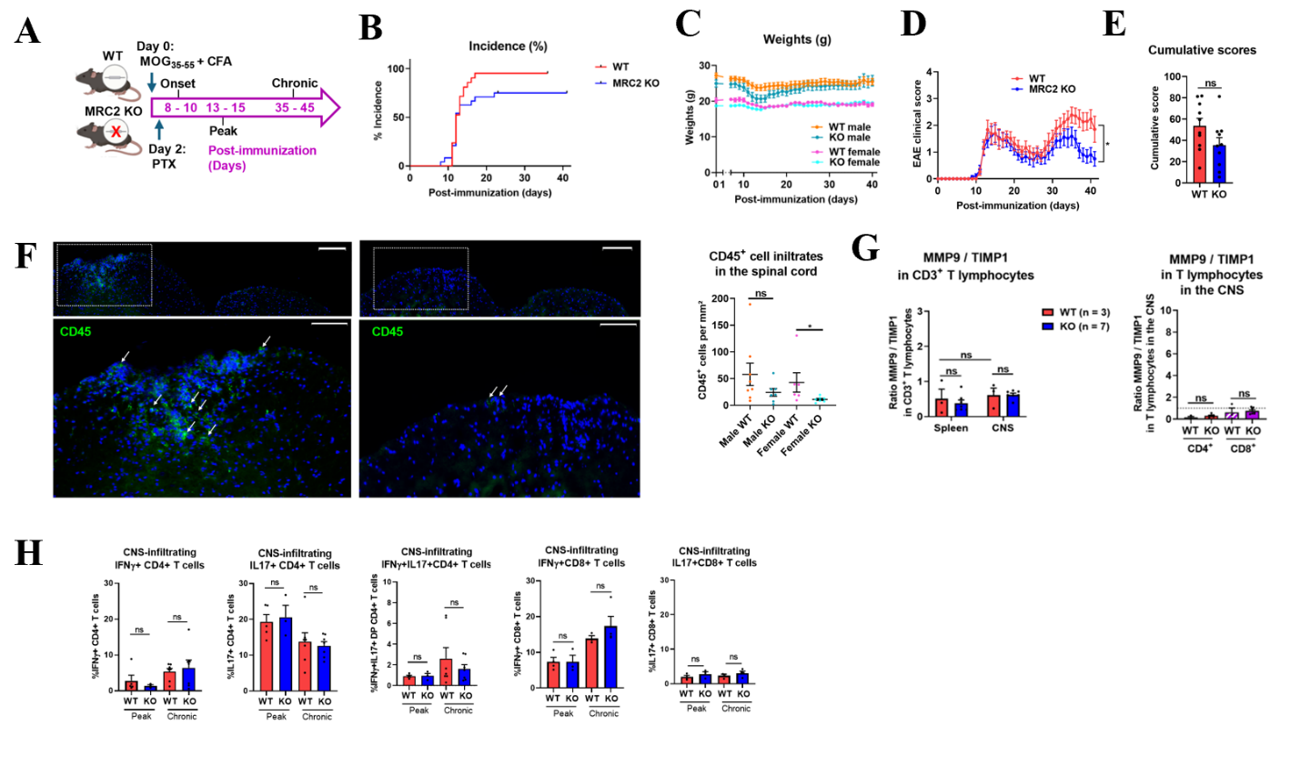
Extended figure 7. (A) Scheme of timeline MOG₃₅₋₅₅-induced EAE. (B) Pooled data from both sexes indicating disease incidence. (C) Weights in gram (g) over time shown for each group. (D-E) Pooled data from both sexes indicating clinical scores (D) and cumulative clinical scores at day 40 post-immunization (E). (F) Representative scans of immunofluorescence staining on postmortem spinal cord tissue and quantification of CD45+ immune cell infiltrates in the chronic EAE disease of MRC2 KO and WT littermates (n = 6 – 8 animals per group, as indicated). (G-H) Flow cytometry analysis of CNS-infiltrating T lymphocytes from MRC2 KO mice and WT littermates in peak and / or chronic EAE disease as indicated. Single cell suspensions were stimulated with PMA / Ionomycin prior intracellular staining. For statistical analysis mixed effects model (REML) in (D), unpaired Student’s t test in (E), Mann Whitney test in (F), two-way ANOVA and Sidak’s multiple comparison test (in G; left panel), and one-way ANOVA and Sidak's multiple comparison test in (H) were performed. * p < 0.05, ns = not significant

