Appendix A Ethical approval UMST
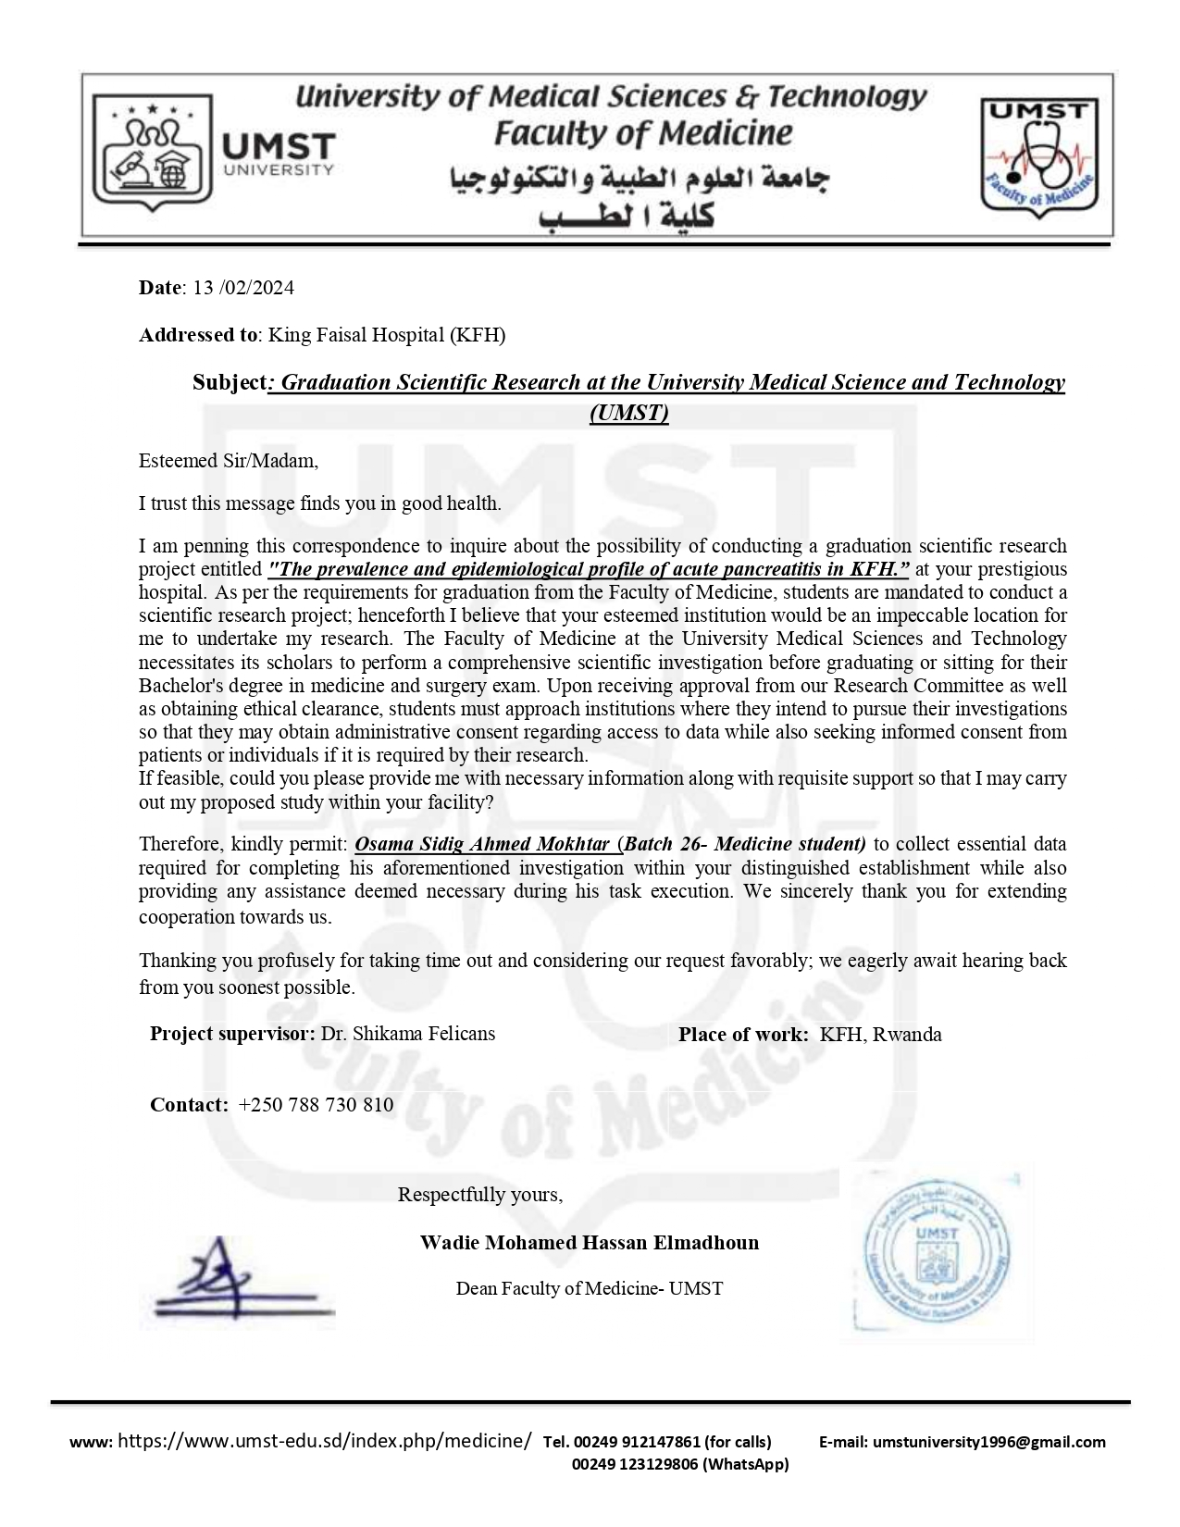

Appendix B Ethical approval of the KFH
