Biosolids Amendment Enriches Soil Resistome, Virulence Factors, and ESKAPE Pathogens: A Longitudinal Metagenomic Study

John Ste. Marieª, Catherine Maysª, Bing Guo^{b}, Tyler S. Radnieckiª, Joy Waite-Cusic^{c}, Tala Navab-Daneshmandª

ª School of Chemical, Biological, and Environmental Engineering, Oregon State University
^{b} Department of Civil and Environmental Engineering, University of Surrey
^{c} Department of Food Safety and Technology, Oregon State University

Results
Metagenomic Sequencing Data
An average of 18 ± 4.0 (± indicates the standard error) million and 20 ± 2.8 million reads were generated from the pristine and biosolids-amended soils, respectively (Table S1). Trimmed reads had an average of 17.6 ± 4.0 million clean reads for pristine soils and 19.8 ± 2.9 million clean reads for biosolids-amended soils. Read assembly resulted in a total of 4,641,285 contigs with an average of 143,670 ± 21,757 contigs in pristine soils compared to an average of 403,955 ± 25,612 contigs in biosolids-amended samples (Table S2). The average N50 for all samples was 583 ± 28.8, with significantly higher values in biosolids-amended samples (average 657 ± 31.5) compared to pristine samples (average 457 ± 19.7; one-sided t-test p < 0.01; Table S2). During weeks 6 and 11, one pristine sample had too little DNA to adequately sequence and was removed from further analysis. The average number of mapped reads to microbial taxa for each time point and condition can be found in supplementary Table S1.

Table S1. The number of raw and trimmed reads and the number of reads annotated by Kaiju and ARGs-OAP in all samples (Menzel et al., 2016, Yin et al., 2018a). Treatments include pristine soil (without any amendment) and biosolids-amended soil. Soil core samples were collected during weeks 0, 6, and 11 during carrots cultivation in a replicated greenhouse study.
Treatment | Week | Sample ID | Raw | Trimmed | Kaiju  annotated reads | ARGs-OAP annotated reads
Pristine | 0 | S014 | 13,342,500 | 12,998,034 | 69,376 | 56,202
Pristine | 0 | S015 | 15,698,695 | 15,389,999 | 81,894 | 63,256
Pristine | 0 | S016 | 21,484,135 | 21,081,486 | 124,885 | 98,109
Pristine | 6 | S007 | 16,031,417 | 15,957,118 | 144,101 | 77,829
Pristine | 6 | S012 | 17,982,061 | 17,019,522 | 139,248 | 74,609
Pristine | 11 | S008 | 24,982,893 | 24,874,784 | 243,950 | 118,438
Pristine | 11 | S013 | 16,534,041 | 16,165,375 | 202,237 | 59,865
Biosolids-amended | 0 | S009 | 20,891,440 | 20,399,186 | 470,370 | 68,434
Biosolids-amended | 0 | S010 | 21,000,859 | 20,630,512 | 484,753 | 69,177
Biosolids-amended | 0 | S011 | 16,594,751 | 15,964,463 | 449,036 | 56,889
Biosolids-amended | 6 | S001 | 24,739,104 | 24,537,511 | 492,343 | 114,036
Biosolids-amended | 6 | S003 | 16,019,127 | 15,945,296 | 253,815 | 62,976
Biosolids-amended | 6 | S005 | 20,388,738 | 20,303,184 | 358,489 | 94,571
Biosolids-amended | 11 | S002 | 19,613,886 | 19,418,974 | 372,837 | 104,406
Biosolids-amended | 11 | S004 | 22,935,428 | 22,868,089 | 428,553 | 117,903
Biosolids-amended | 11 | S006 | 18,080,416 | 18,020,637 | 325,398 | 91,760

Table S2. Assembly statistics for all samples including the number of contigs, total base pairs, minimum, maximum, and average length, and average N50. Treatments include pristine soil (without any amendment) and biosolids-amended soil. Soil core samples were collected during weeks 0, 6, and 11 during carrots cultivation in a replicated greenhouse study.

Treatment | Week | Sample ID | Sample label | Contigs | Total base pair | Min length | Max length | Avg length | N50
Pristine | 0 | S014 | 1-B-0 | 69,376 | 36,069,801 | 200 | 69,345 | 519 | 495
Pristine | 0 | S015 | 2-B-0 | 81,894 | 43,445,440 | 200 | 69,345 | 530 | 514
Pristine | 0 | S016 | 1-C-0 | 124,885 | 61,625,460 | 200 | 69,345 | 493 | 454
Pristine | 6 | S007 | 1-B-6 | 144,101 | 82,340,250 | 200 | 106,282 | 571 | 565
Pristine | 6 | S012 | 1-A-6 | 139,248 | 58,766,287 | 204 | 19,033 | 422 | 392
Pristine | 11 | S008 | 1-E-11 | 243,950 | 118,454,278 | 200 | 61,202 | 485 | 465
Pristine | 11 | S013 | 1-F-11 | 202,237 | 110,243,778 | 200 | 92,298 | 545 | 526
Biosolids-amended | 0 | S009 | 3-C-0 | 470,370 | 356,388,703 | 200 | 445,550 | 757 | 791
Biosolids-amended | 0 | S010 | 3-B-0 | 484,753 | 372,221,476 | 200 | 557,991 | 767 | 803
Biosolids-amended | 0 | S011 | 4-C-0 | 449,036 | 300,239,910 | 200 | 240,962 | 668 | 660
Biosolids-amended | 6 | S001 | 3-B-6 | 492,343 | 338,804,060 | 200 | 695,968 | 688 | 710
Biosolids-amended | 6 | S003 | 3-C-6 | 253,815 | 160,394,571 | 200 | 245,261 | 631 | 626
Biosolids-amended | 6 | S005 | 3-A-6 | 358,489 | 196,911,151 | 200 | 58,657 | 549 | 523
Biosolids-amended | 11 | S002 | 3-E-11 | 372,837 | 223,773,173 | 200 | 85,826 | 600 | 623
Biosolids-amended | 11 | S004 | 3-D-11 | 428,553 | 235,763,690 | 200 | 49,082 | 550 | 522
Biosolids-amended | 11 | S006 | 3-F-11 | 325,398 | 210,181,296 | 200 | 59,778 | 645 | 659

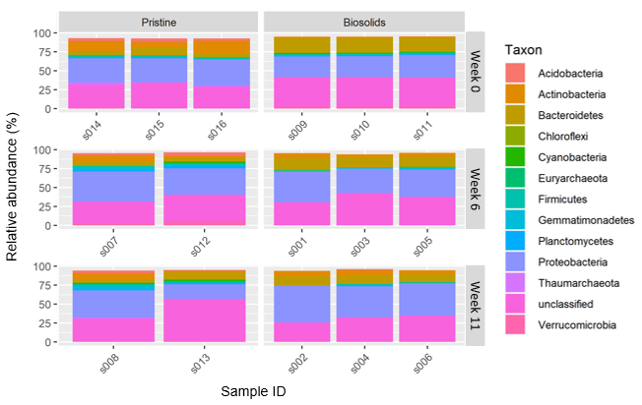
Figure S1. Relative abundance (%) of the dominant phyla in each sample. Samples are grouped horizontally by treatment and vertically by week of sampling. Treatments include pristine soil (without any amendment) and biosolids-amended soil. Soil core samples were collected in weeks 0, 6, and 11 during carrots cultivation in a replicated greenhouse study.

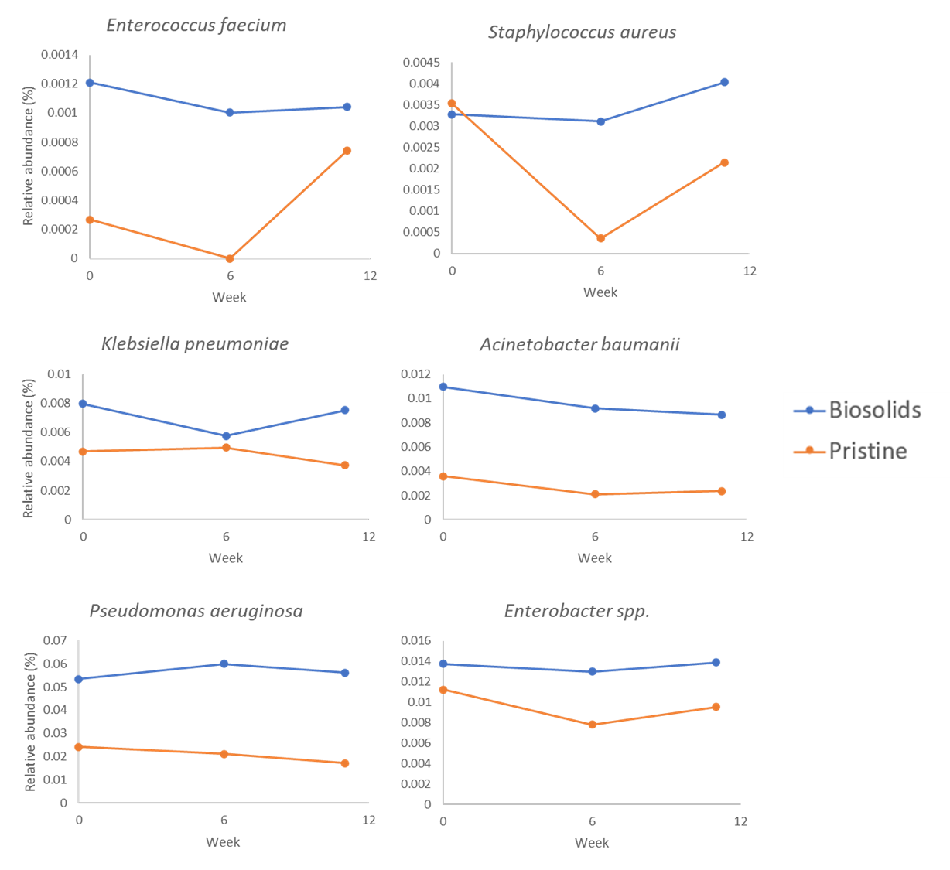
Figure S2 Relative abundance of ESKAPE Pathogens (Enterococcus faecium, Staphylococcus aureus, Klebsiella pneumoniae, Acinetobacter baumanii, Pseudomonas aeruginosa, and Enterobacter spp.) in biosolids-amended and pristine soils.

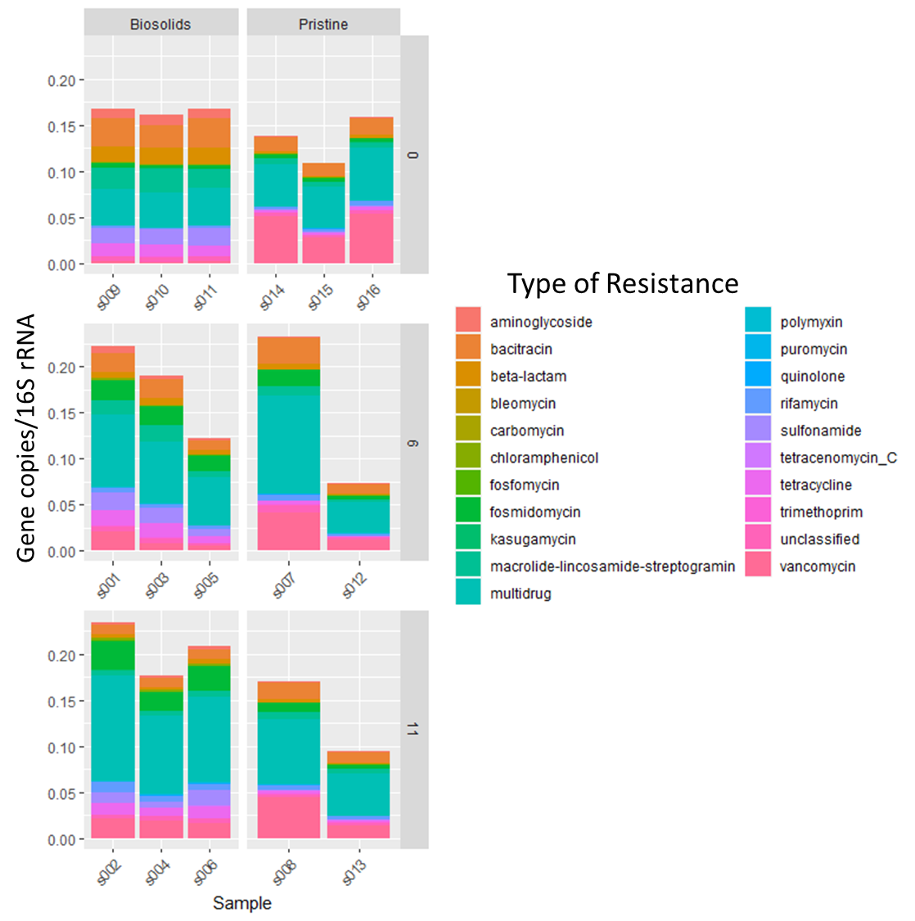
Figure S3 Most abundant antibiotic resistance gene types (class of antibiotics resisted).

