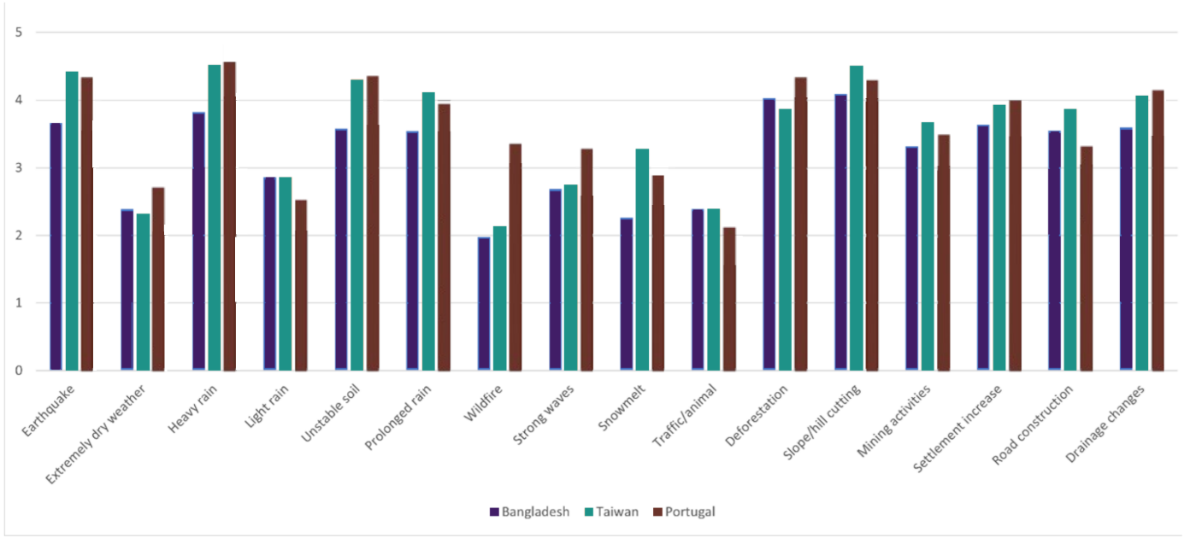

Figure S1. Potential landslide triggers reported by respondents from each country

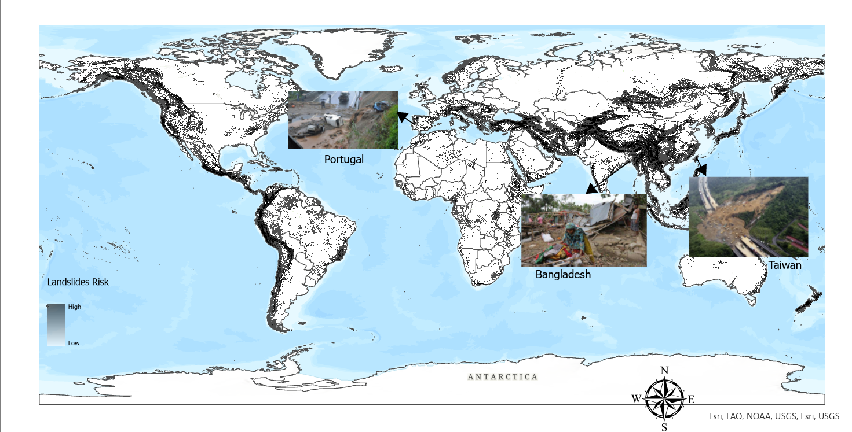
Figure S2. The study areas on the global landslide risk map

Question A: What does your community do when there are threats or warnings of large-scale weather events with the potential to trigger landslides?

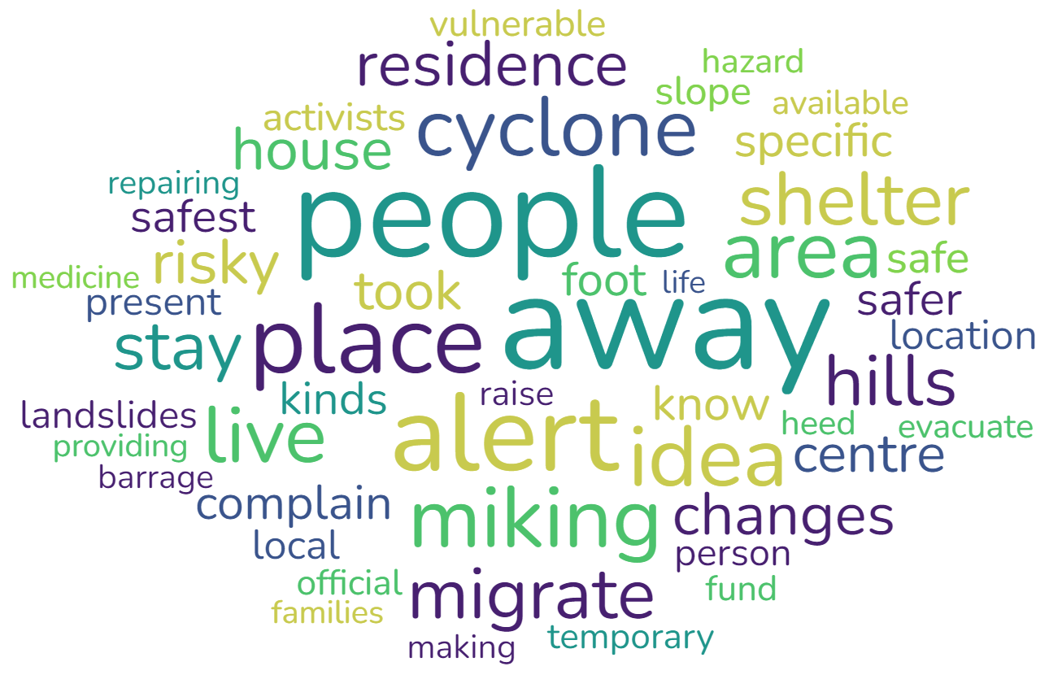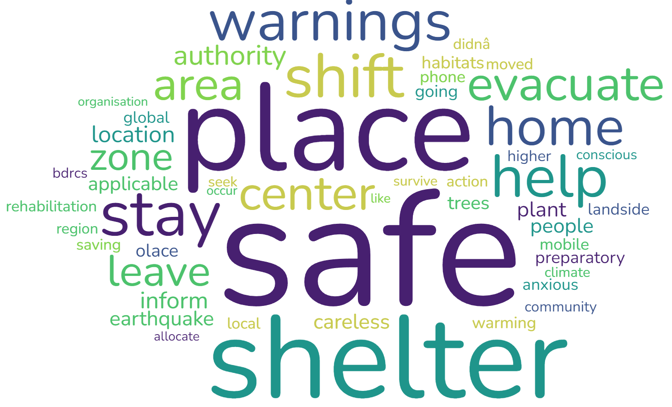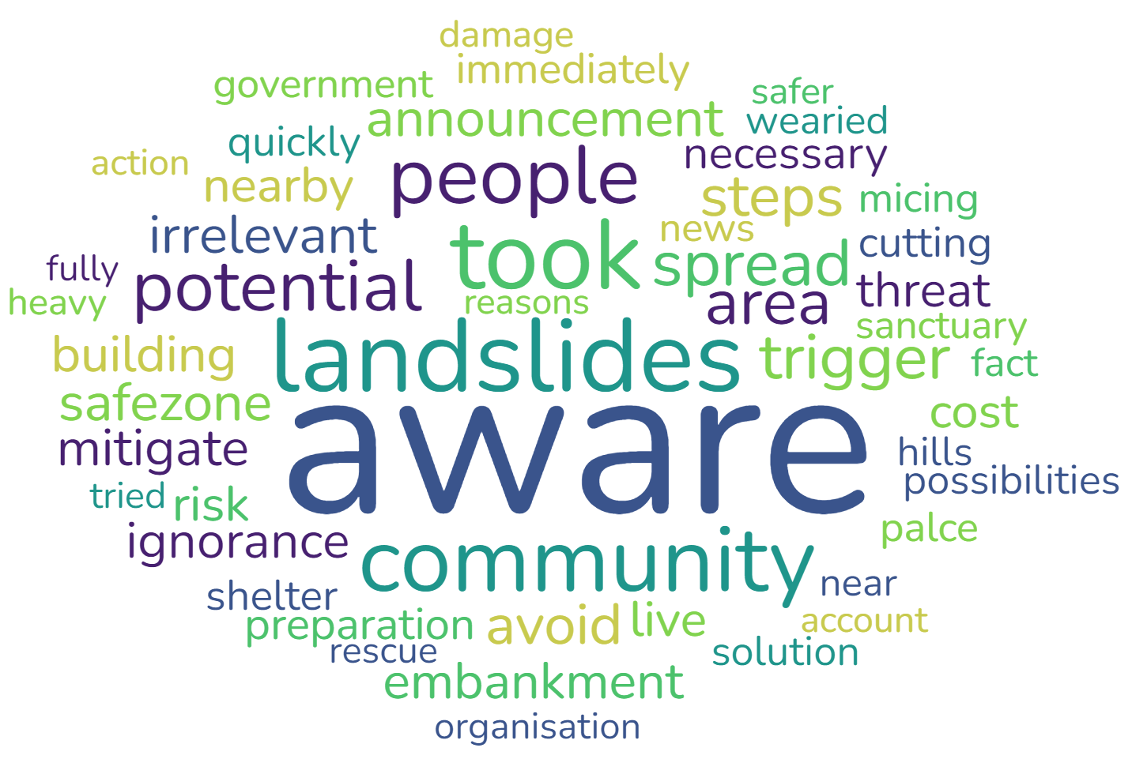

Topic #1 Topic #2 Topic #3

Fig. S3A. Word Cloud for Community response to landslide threat in Bangladesh

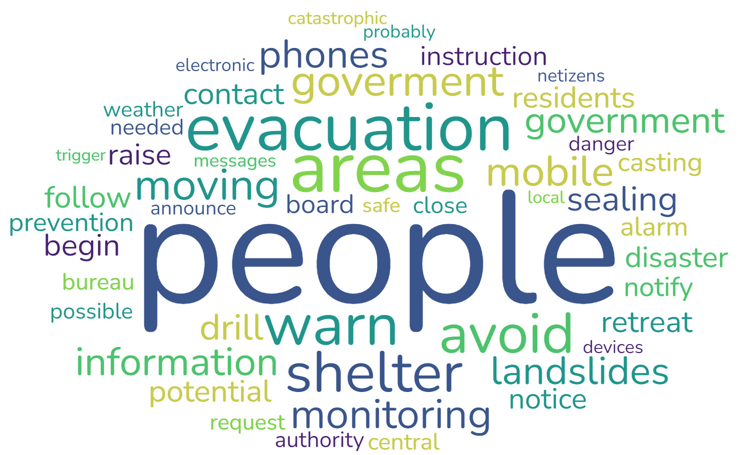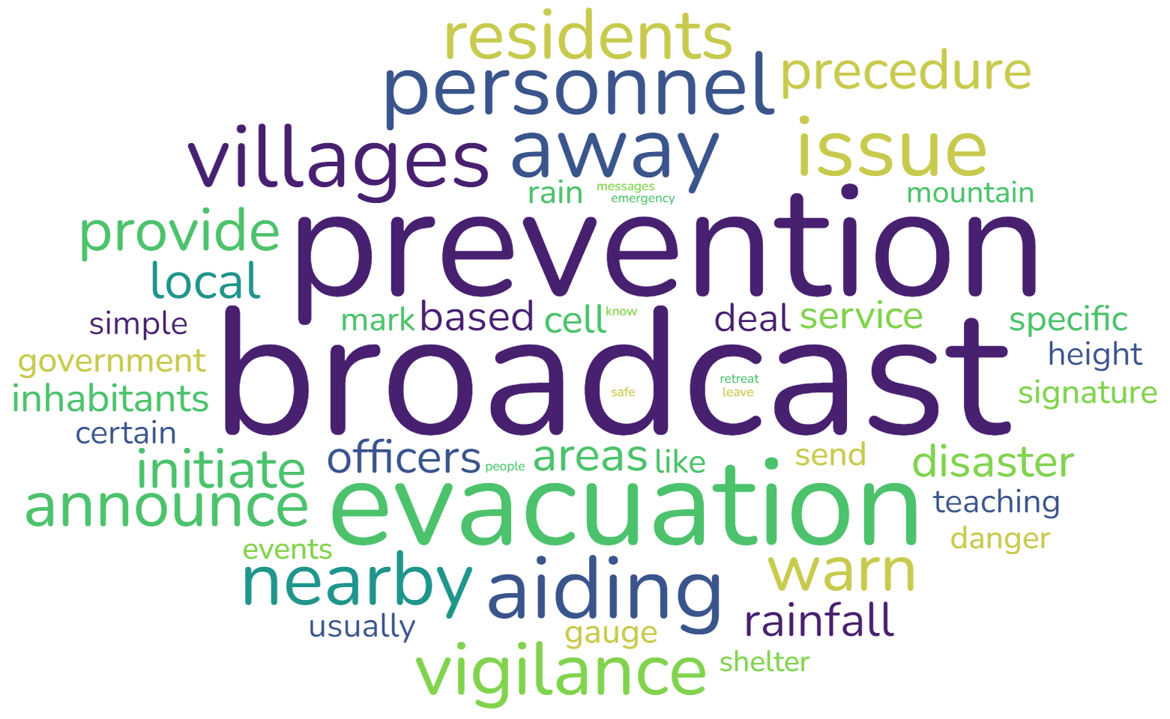

Topic #1 Topic #2 Topic #3

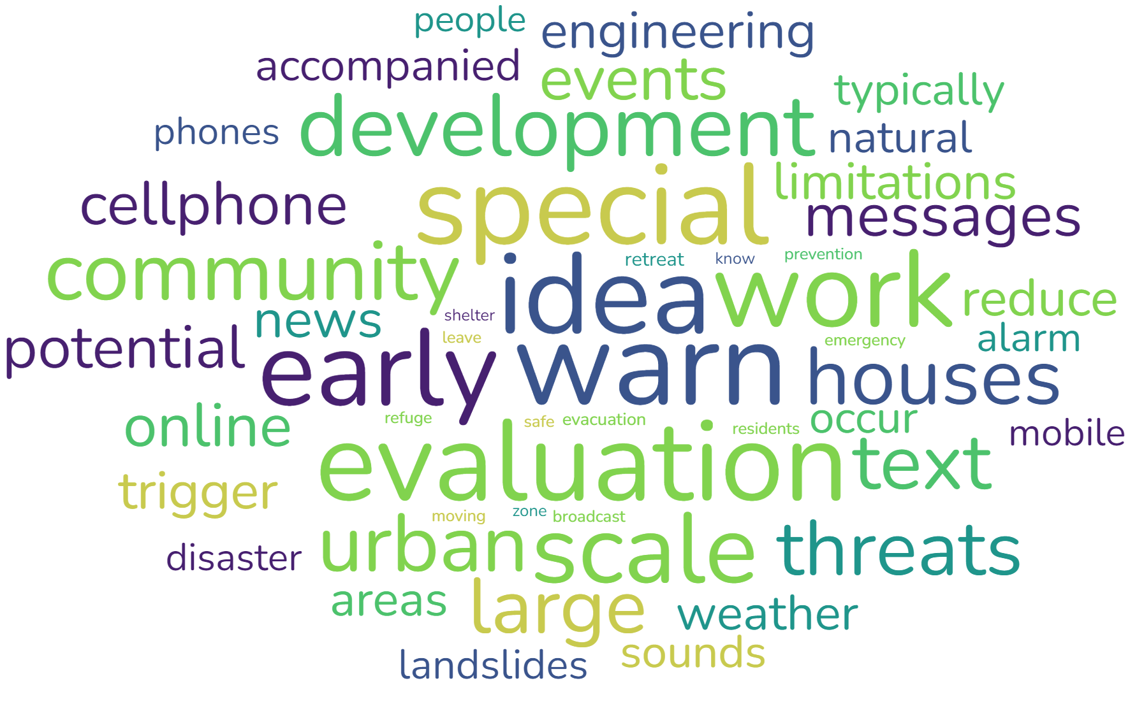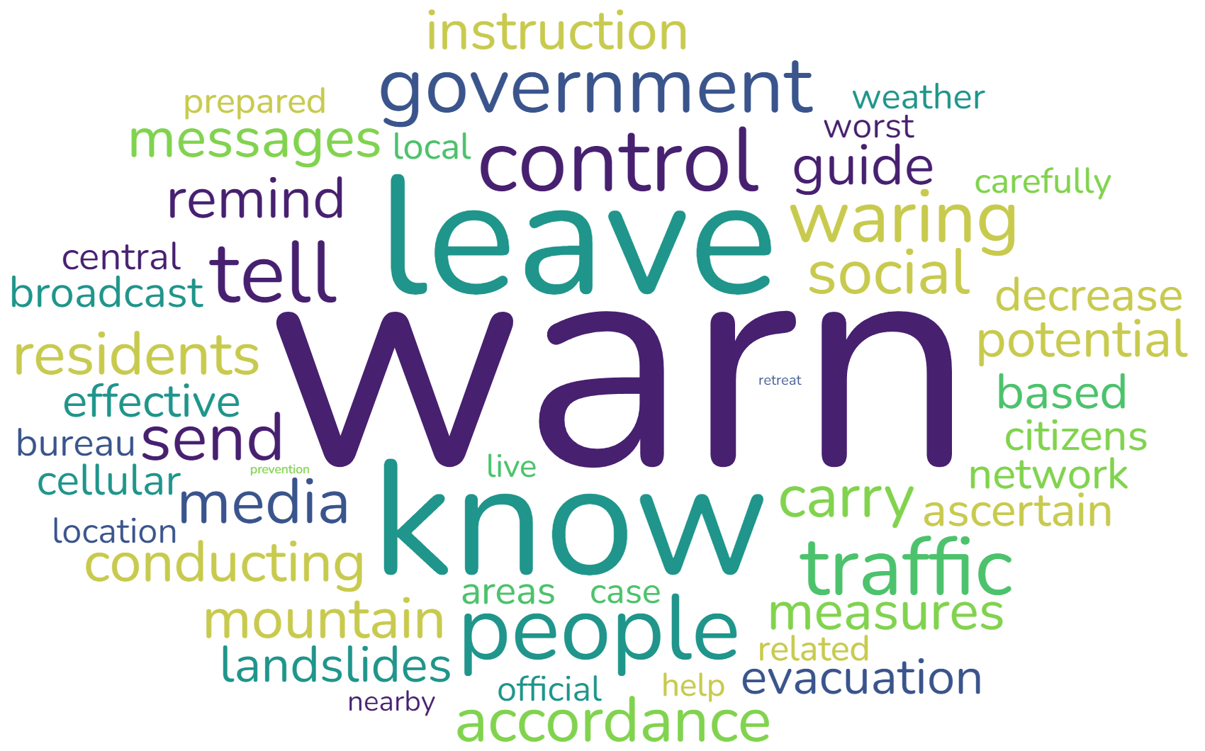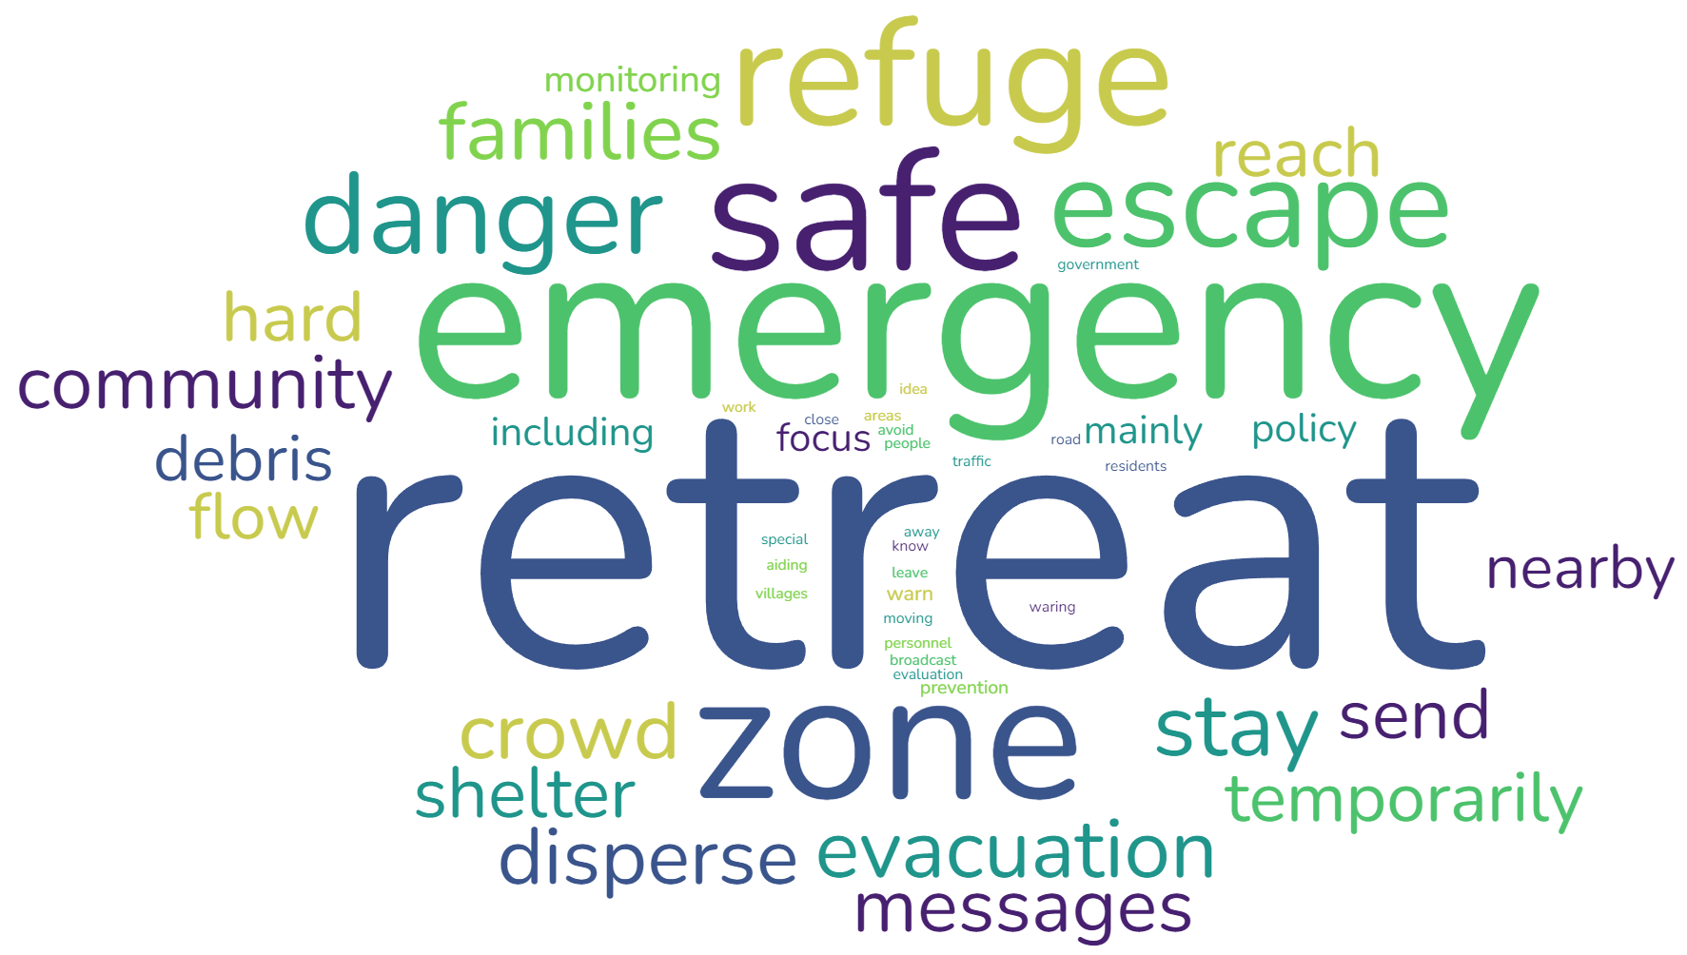

Topic #4 Topic #5 Topic #6

Fig. S3B. Word Cloud for Community response to landslide threat in Taiwan

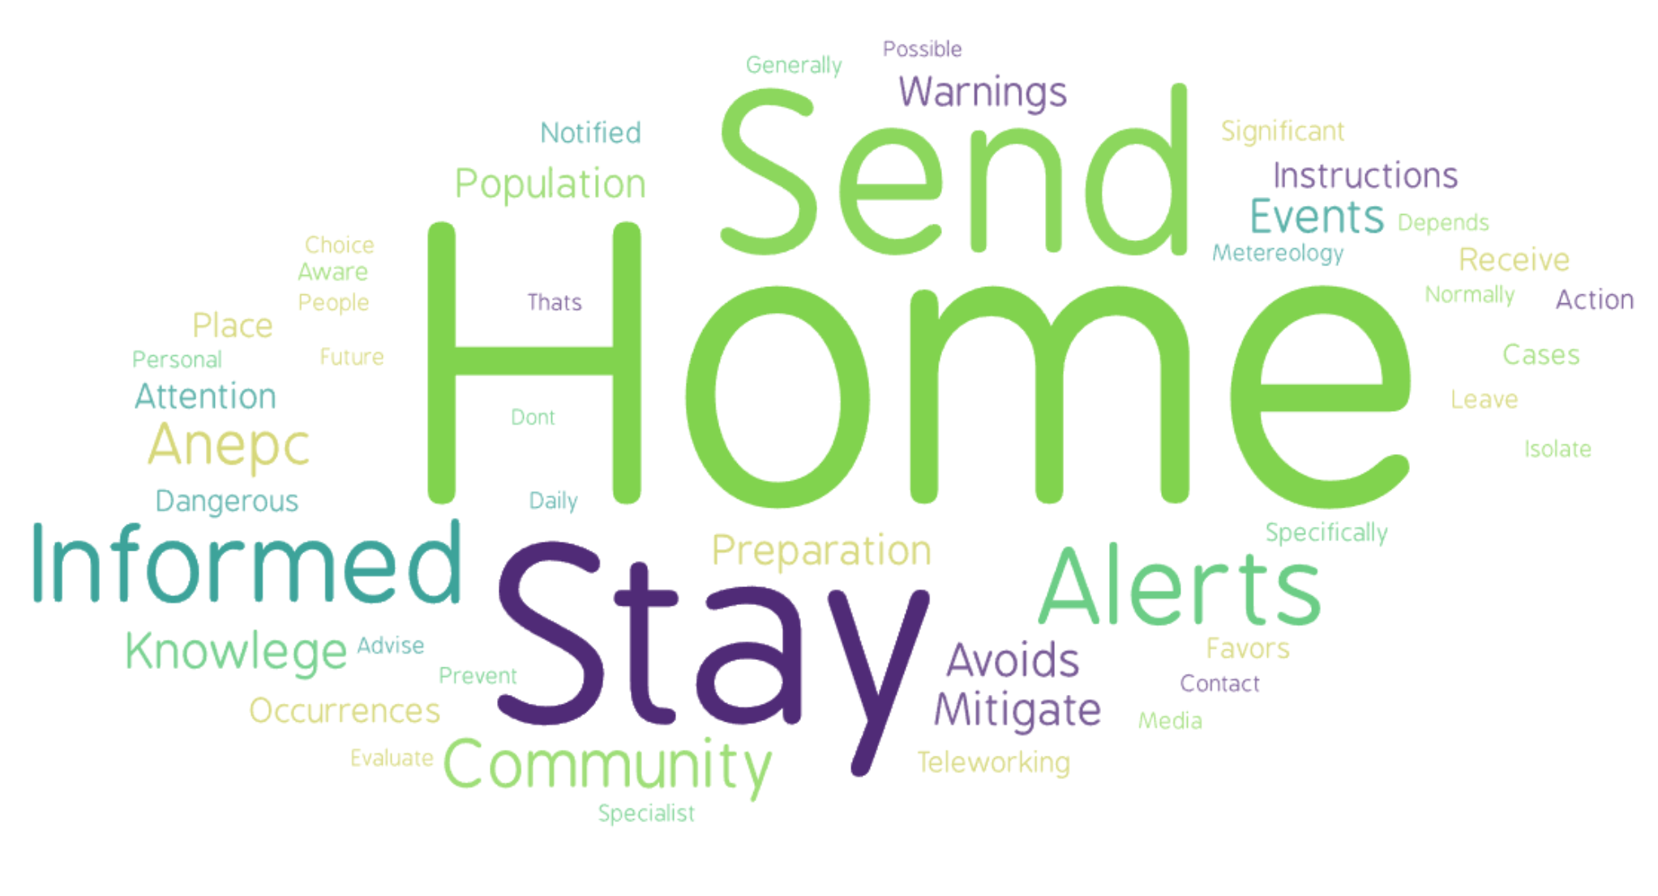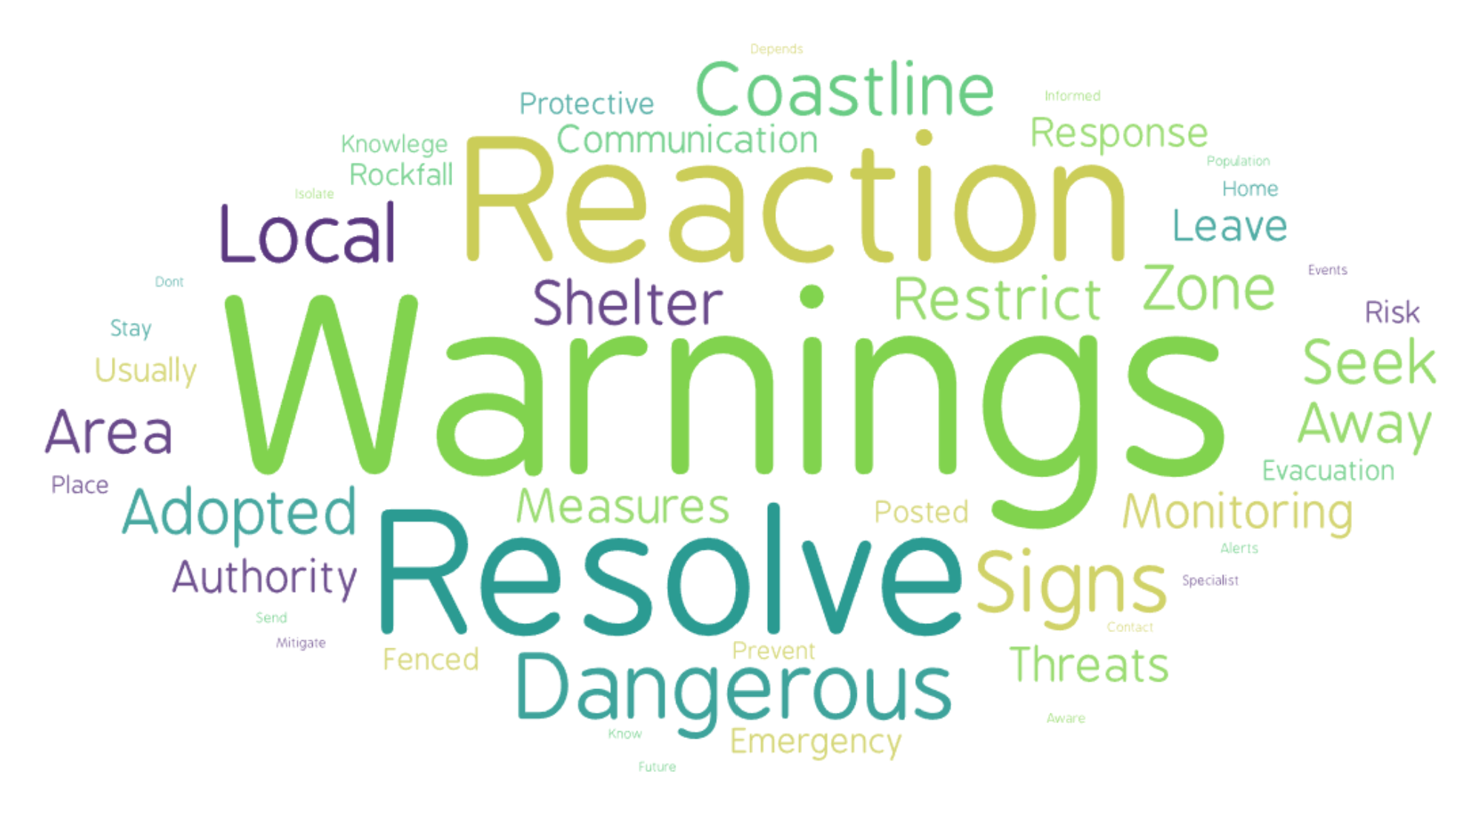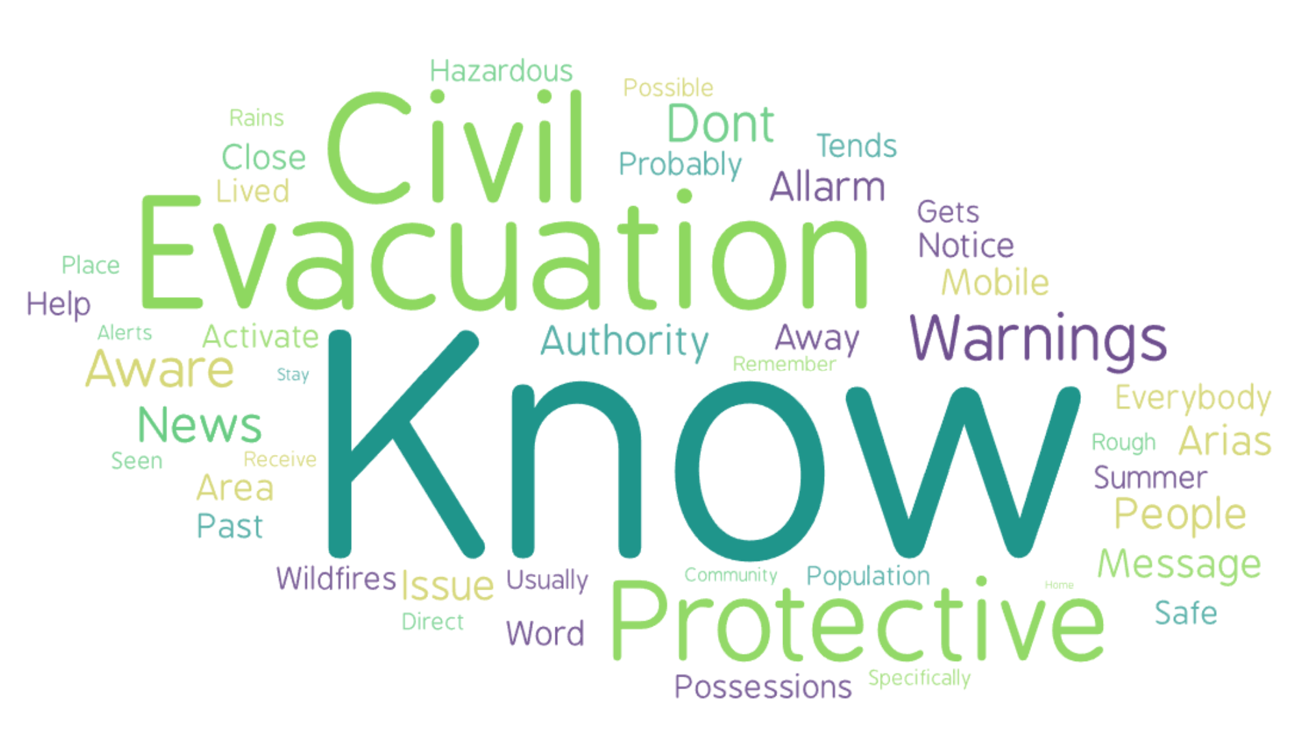

Topic #1 Topic #2 Topic #3

Fig. S3C. Word Cloud for Community response to landslide threat in Portugal

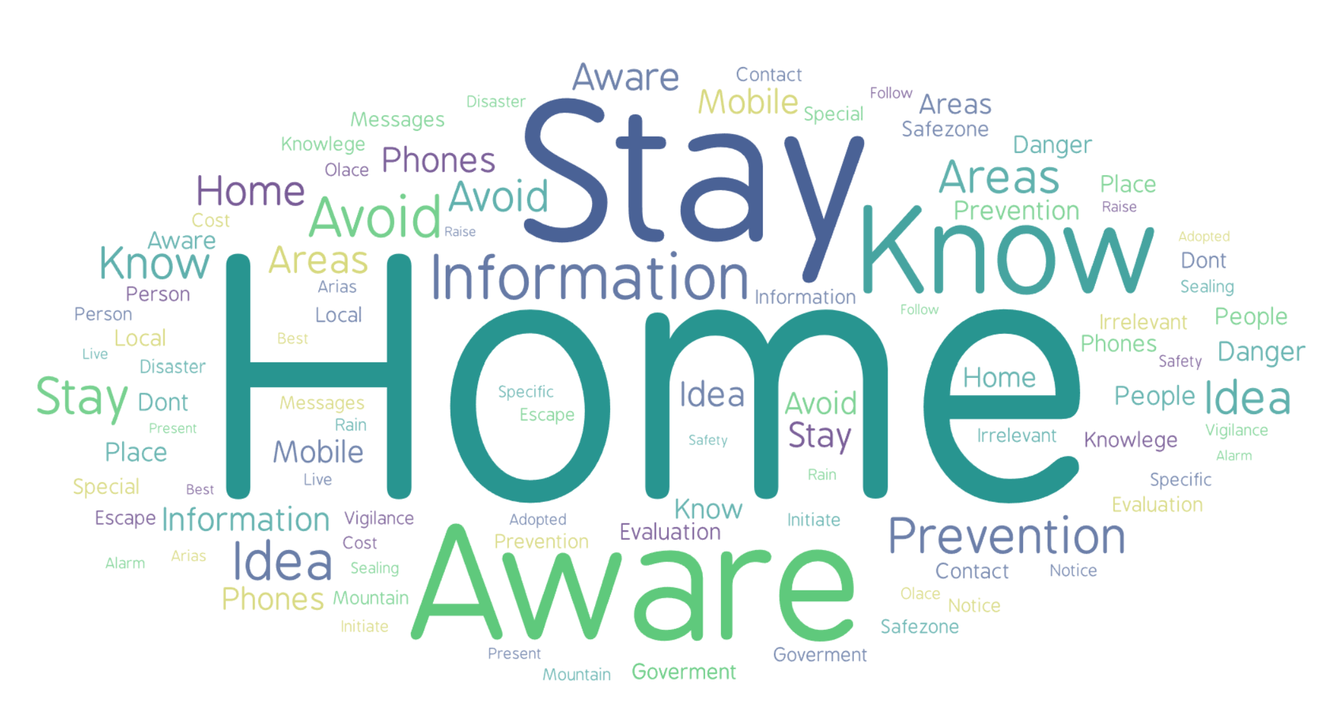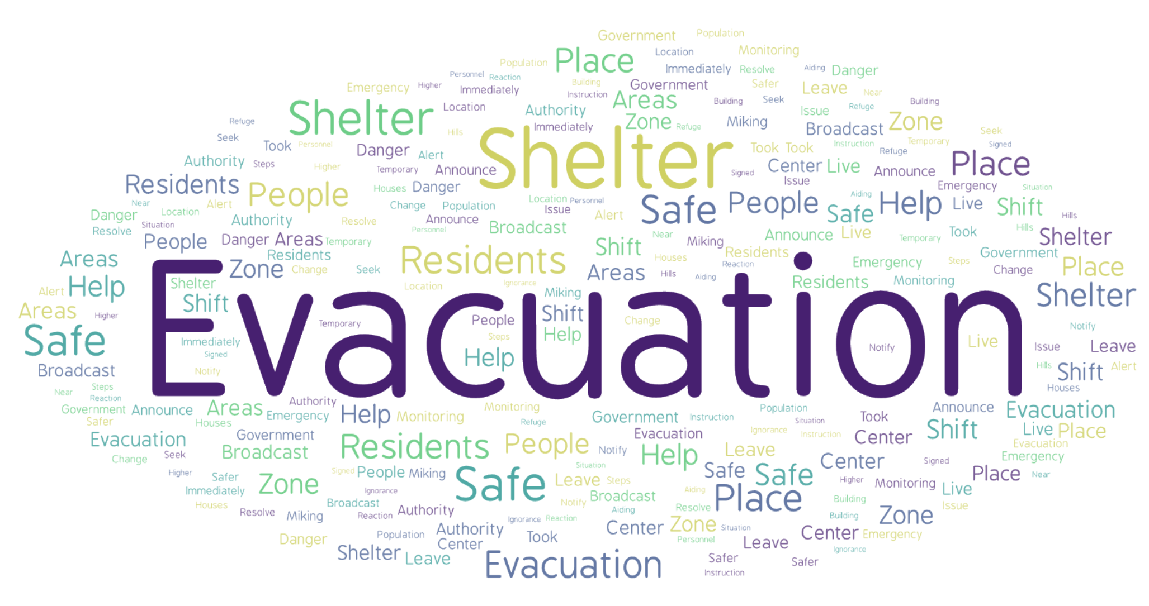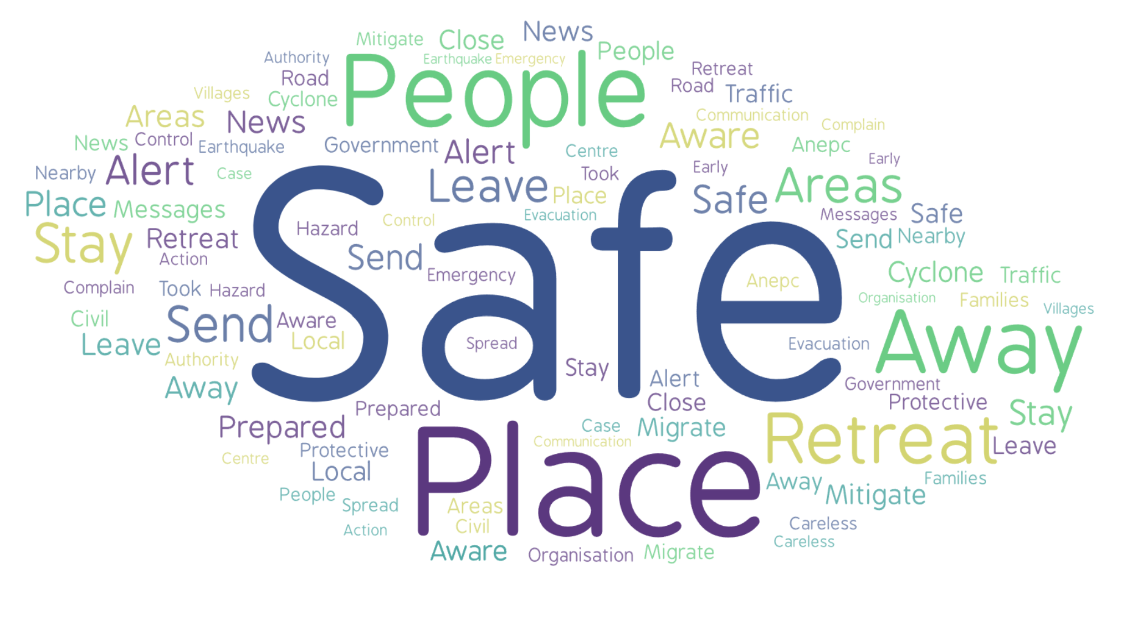

Topic #1 Topic #2 Topic #3

Fig. S3D. Combined Word Cloud of Bangladesh, Taiwan, and Portugal for Community response to landslide threat

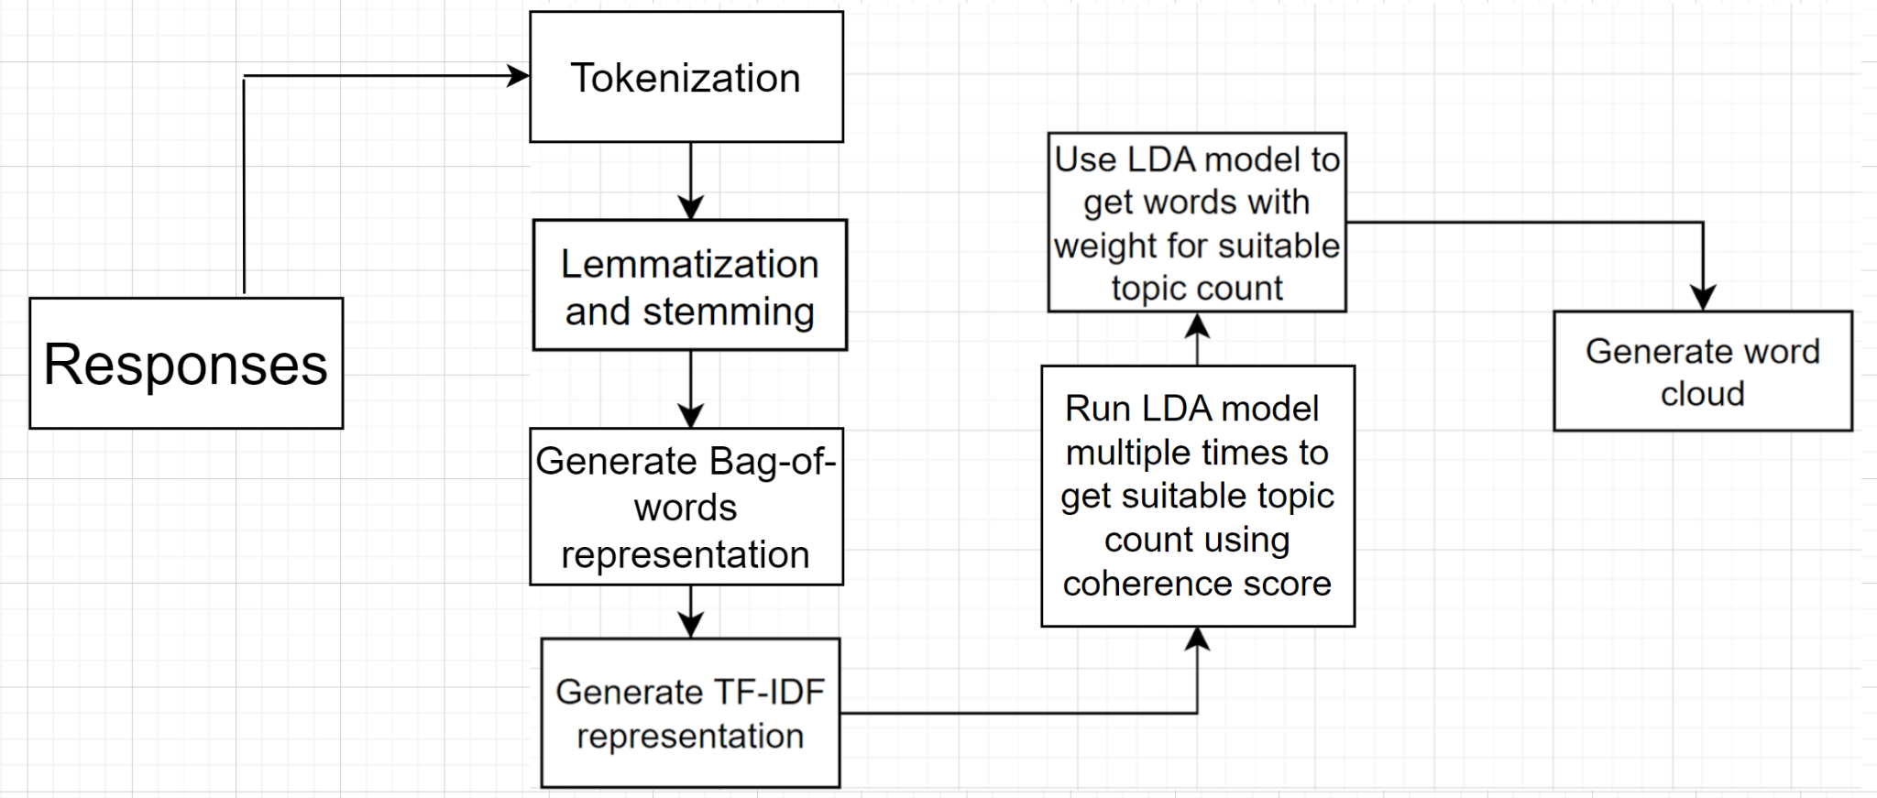
Fig. S4A. The steps of the topic modeling pipeline. Responses are lemmatized, and stems are generated. Then Bag-of-words representation is generated. After that, TF-IDF representation is generated. The representation is given the training data of the LDA model. A word cloud is generated for further analysis of the topic count with the best coherence score.

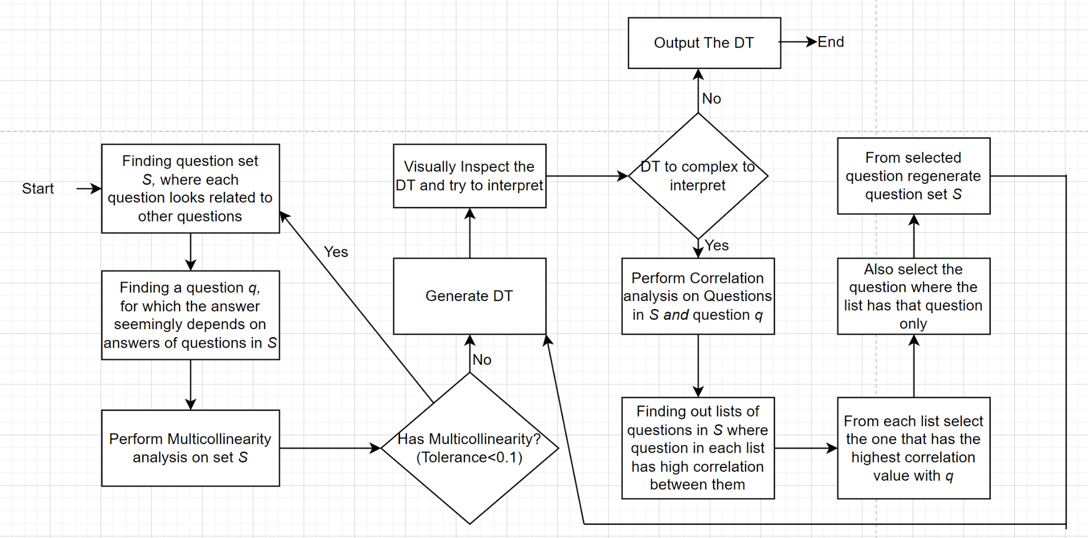
Fig. S4B. For decision tree generation. Multicollinearity analysis is performed upon finding a related question set S and q. Then, after generating DT, depending on whether the tree is visually understandable, correlation analysis is performed to reduce the number of questions for generating a simpler tree.

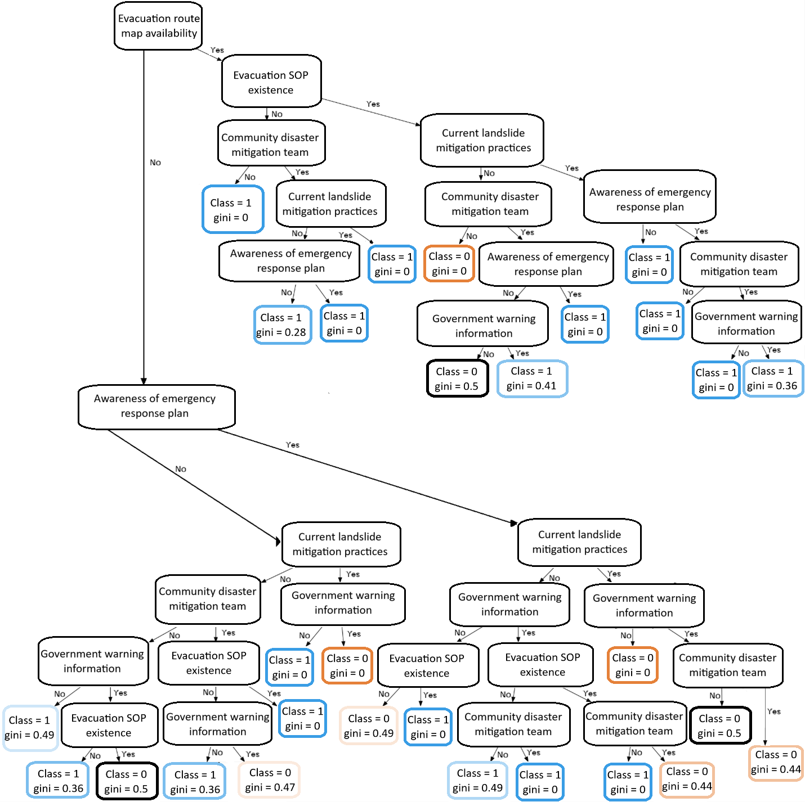

Fig. S5A. Decision tree of Bangladesh considering variables in Table S7

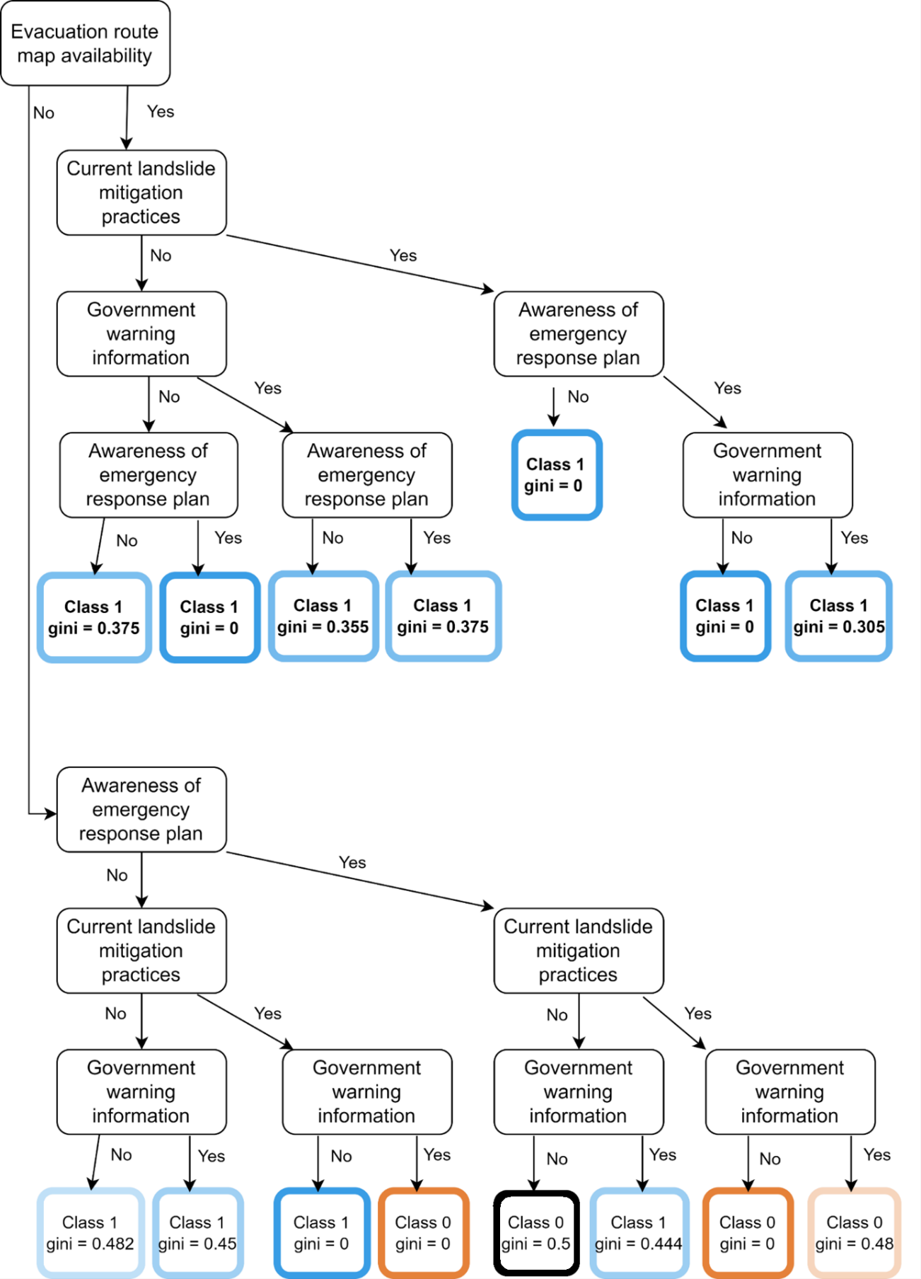

Fig. S5B. Simplified Decision tree of Bangladesh considering variables in Table S7

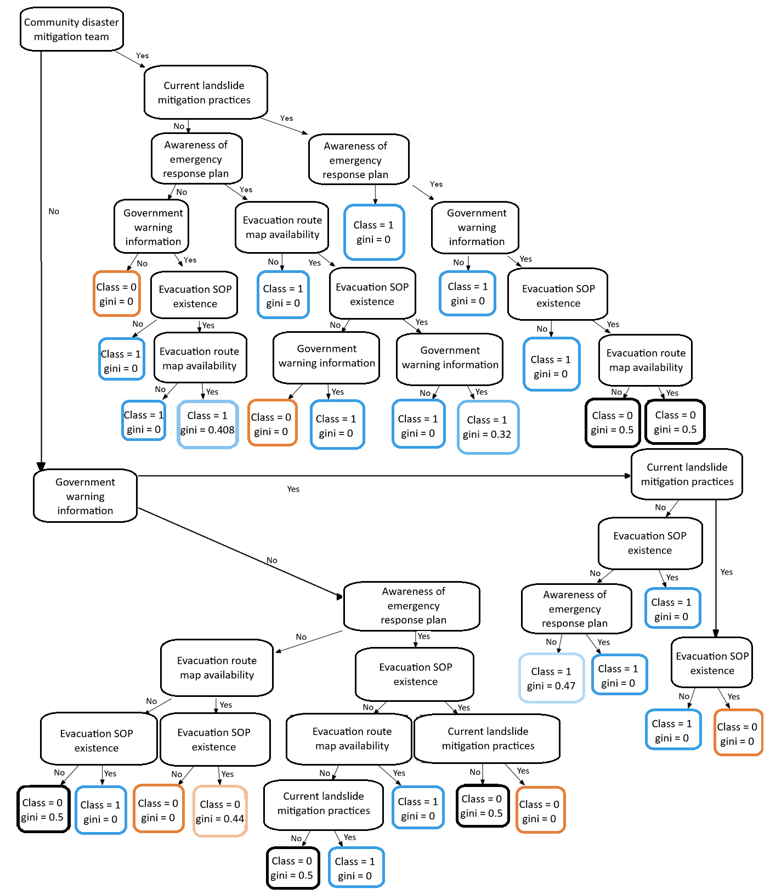
Fig. S5C. Decision tree of Taiwan considering variables in Table S7

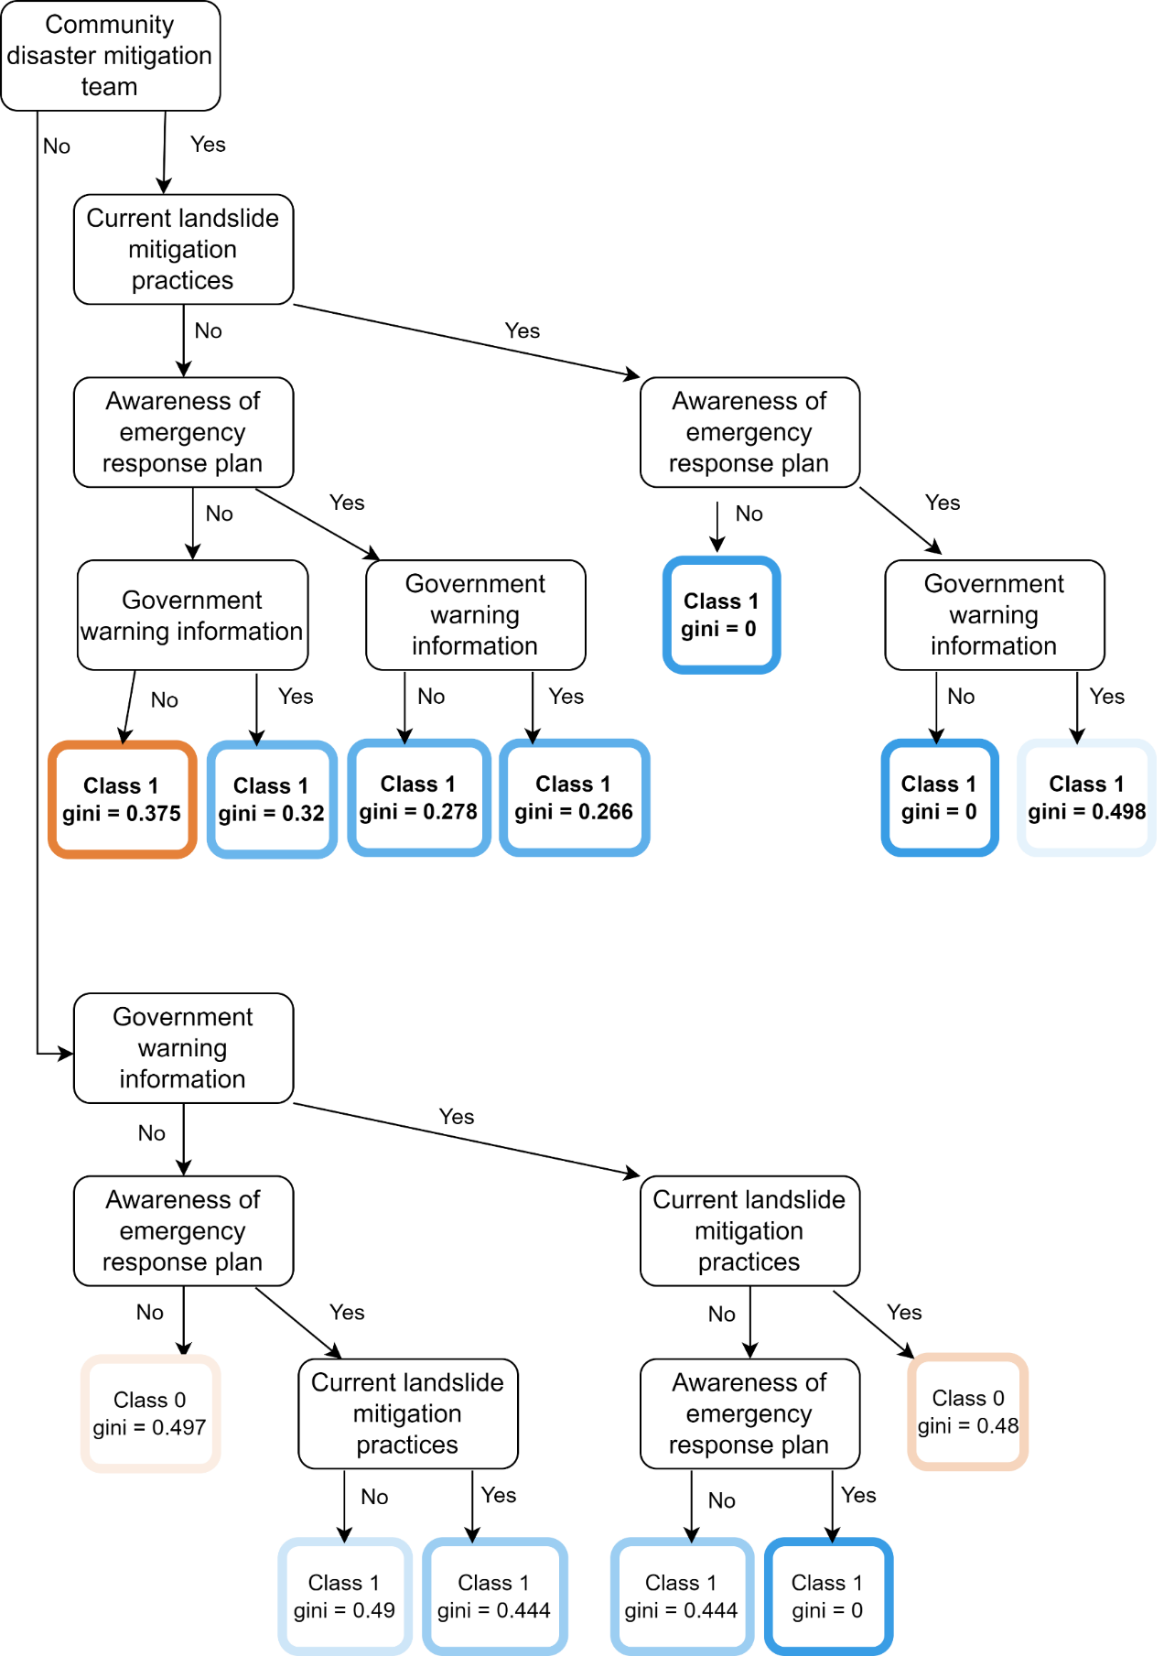
Fig. S5D. Simplified Decision tree of Taiwan considering variables in Table S7

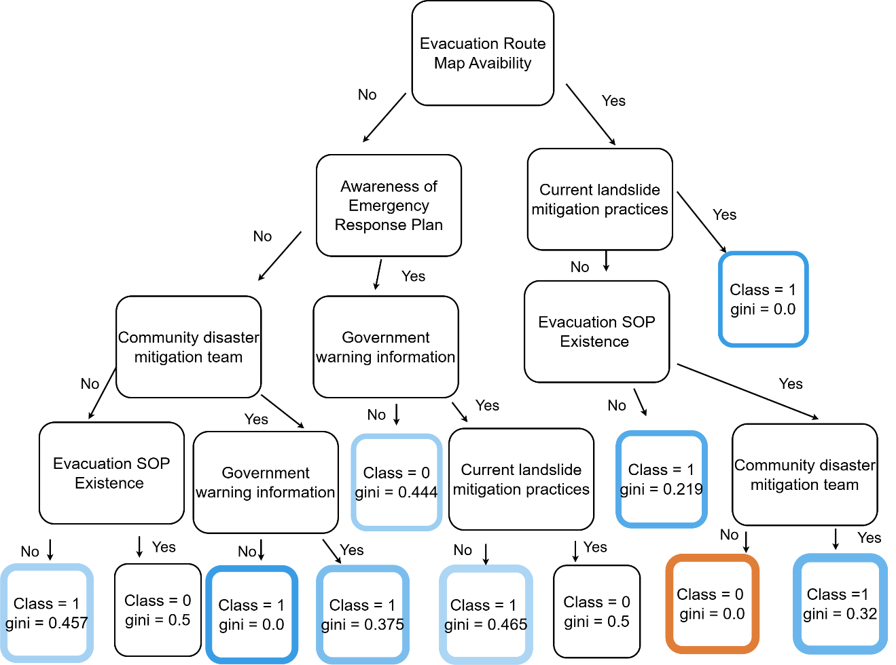
Fig. S5E. Simplified decision tree of Portugal considering variables in Table S7.

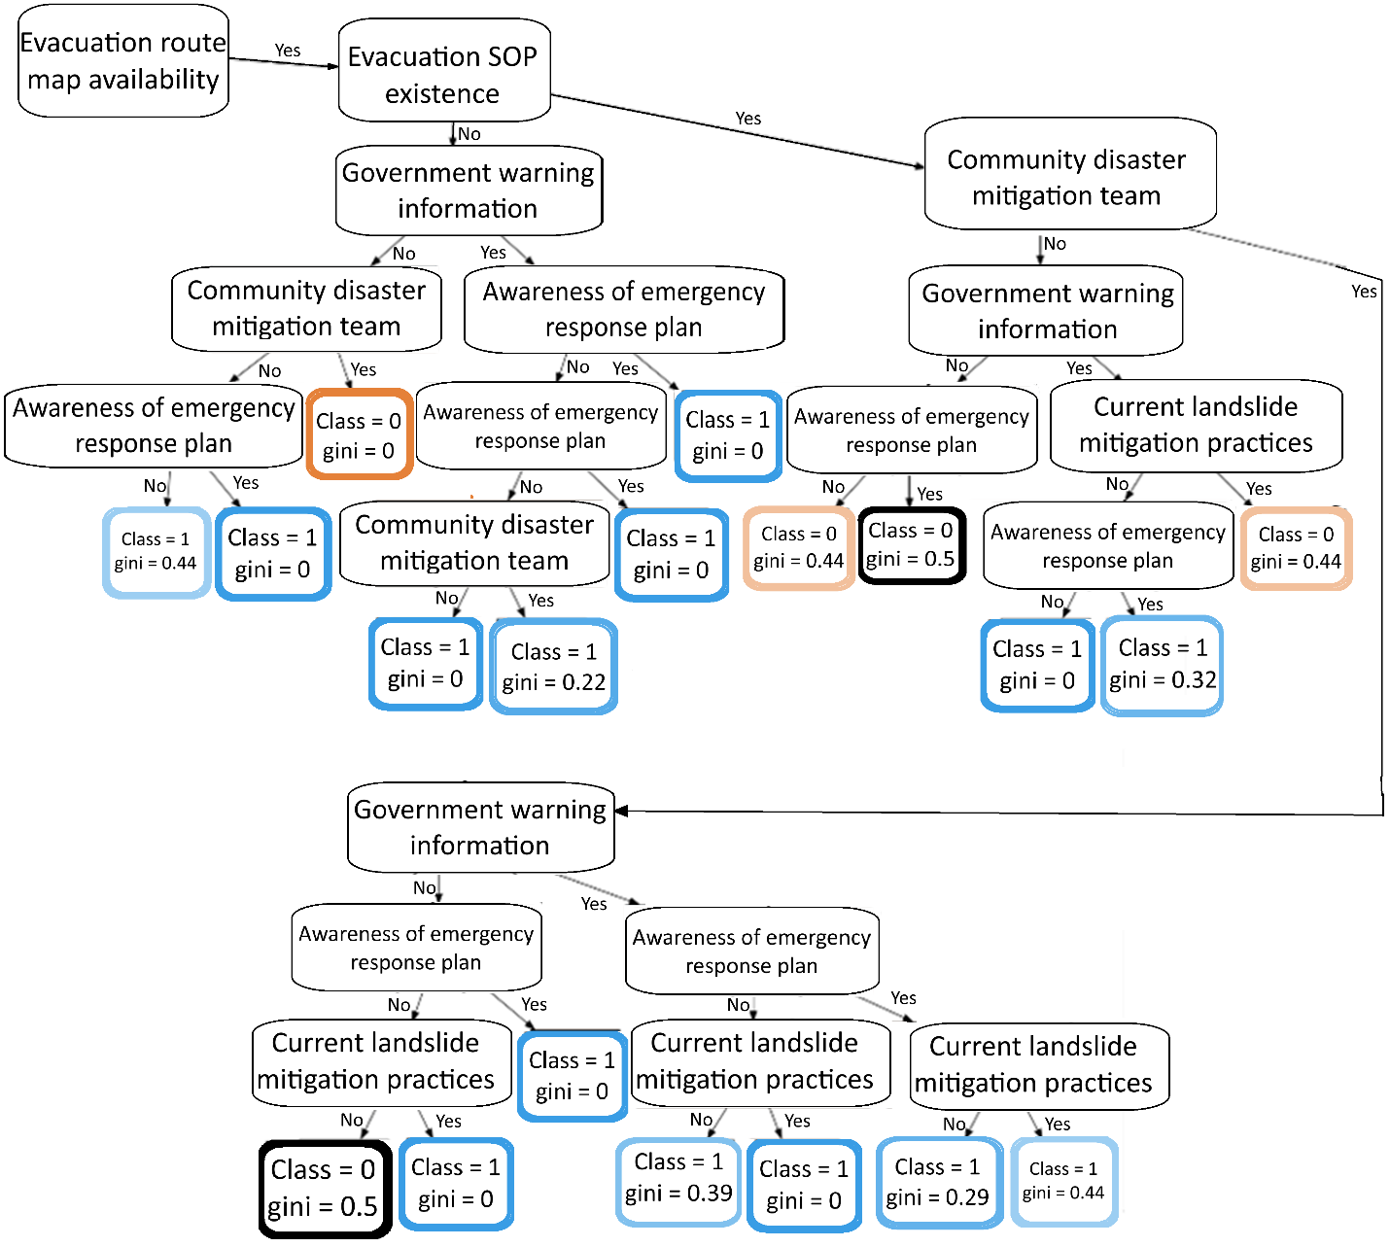

(a)
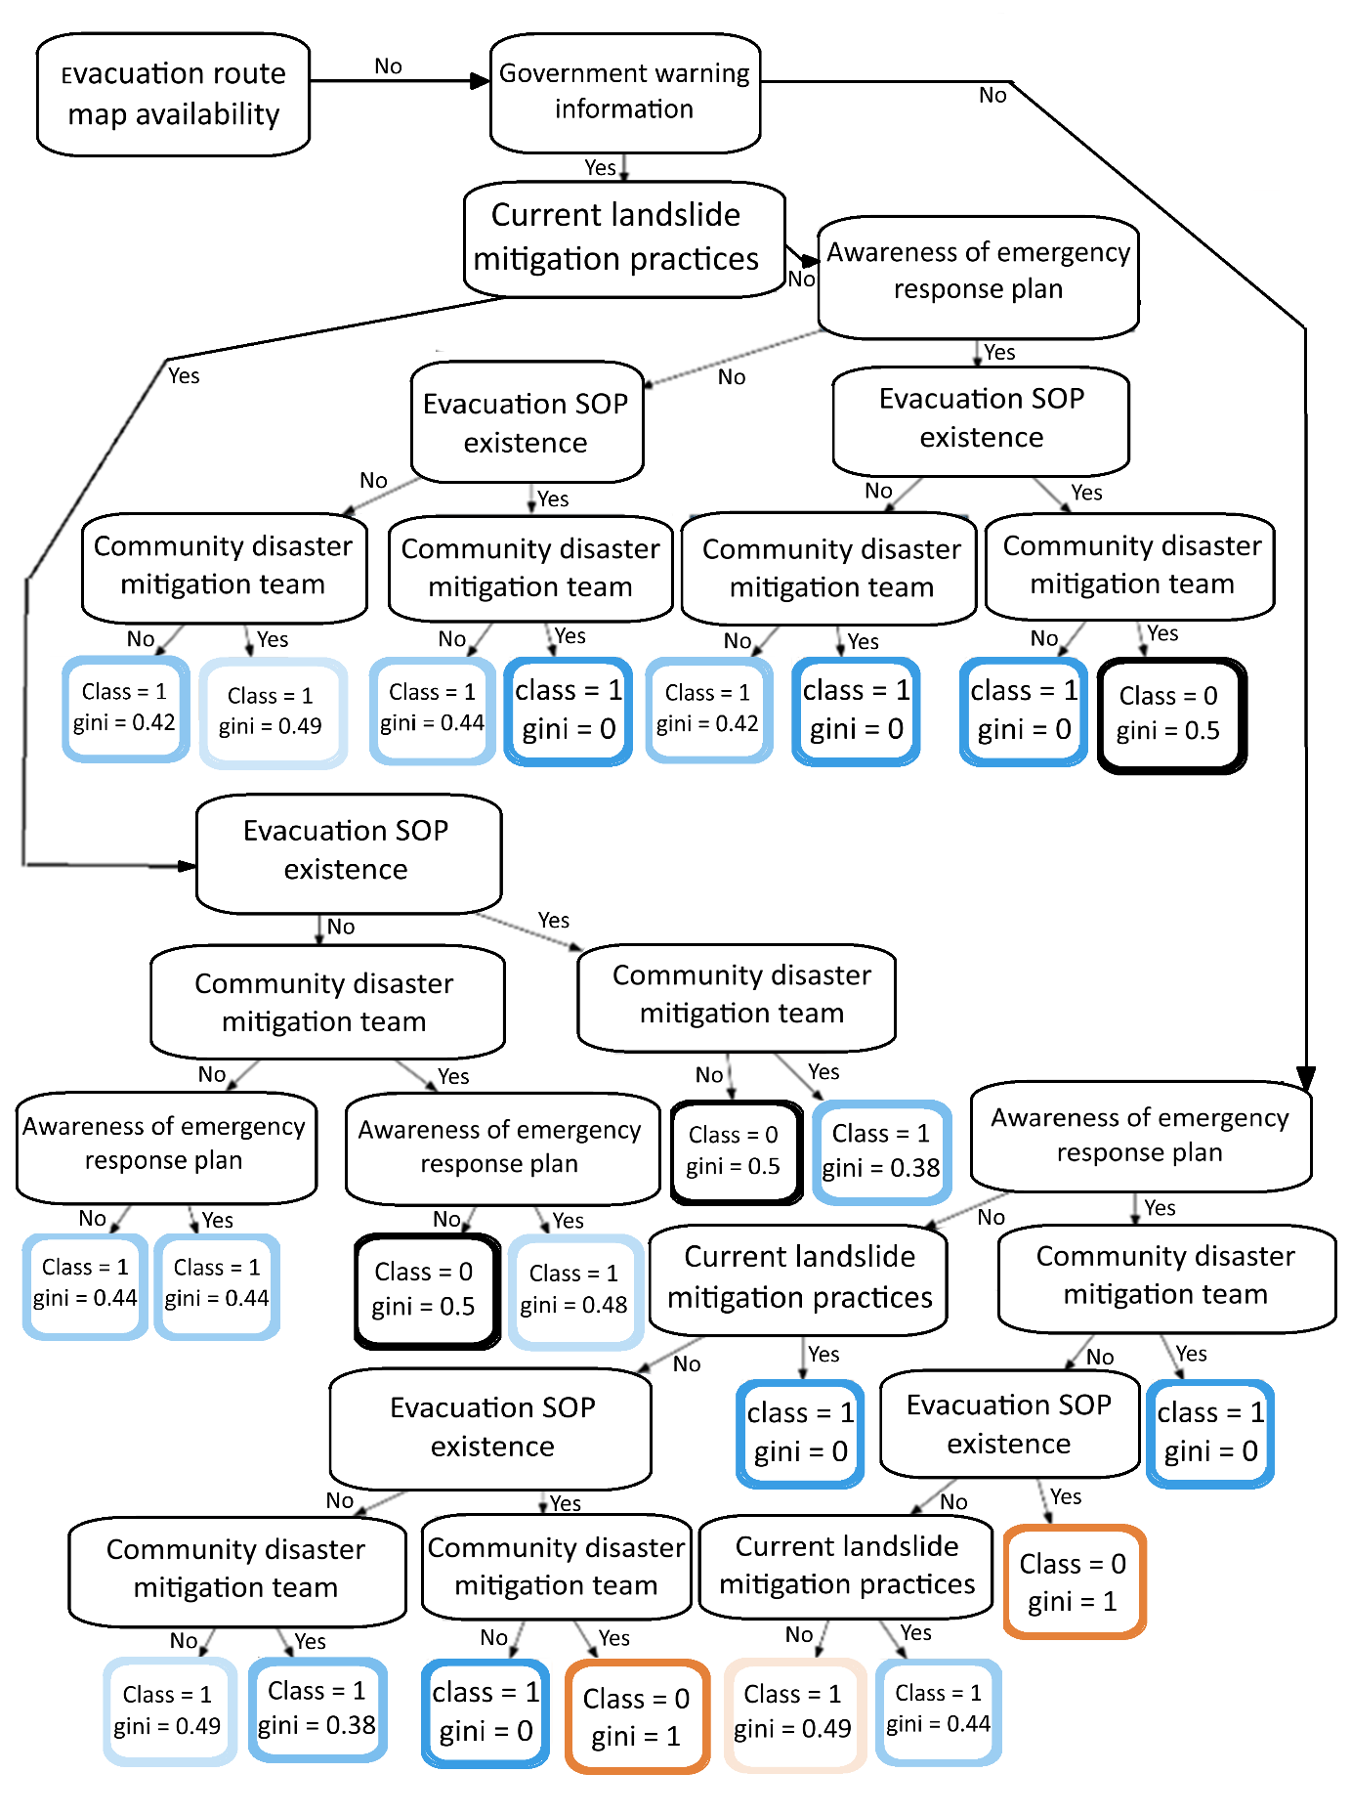

(b)
Fig. S5F. Combined Decision tree considering variables in Table S7. (a) Portion of the Decision tree when the Evacuation route map is available. (b) Portion of the Decision tree when the Evacuation route map is not available.

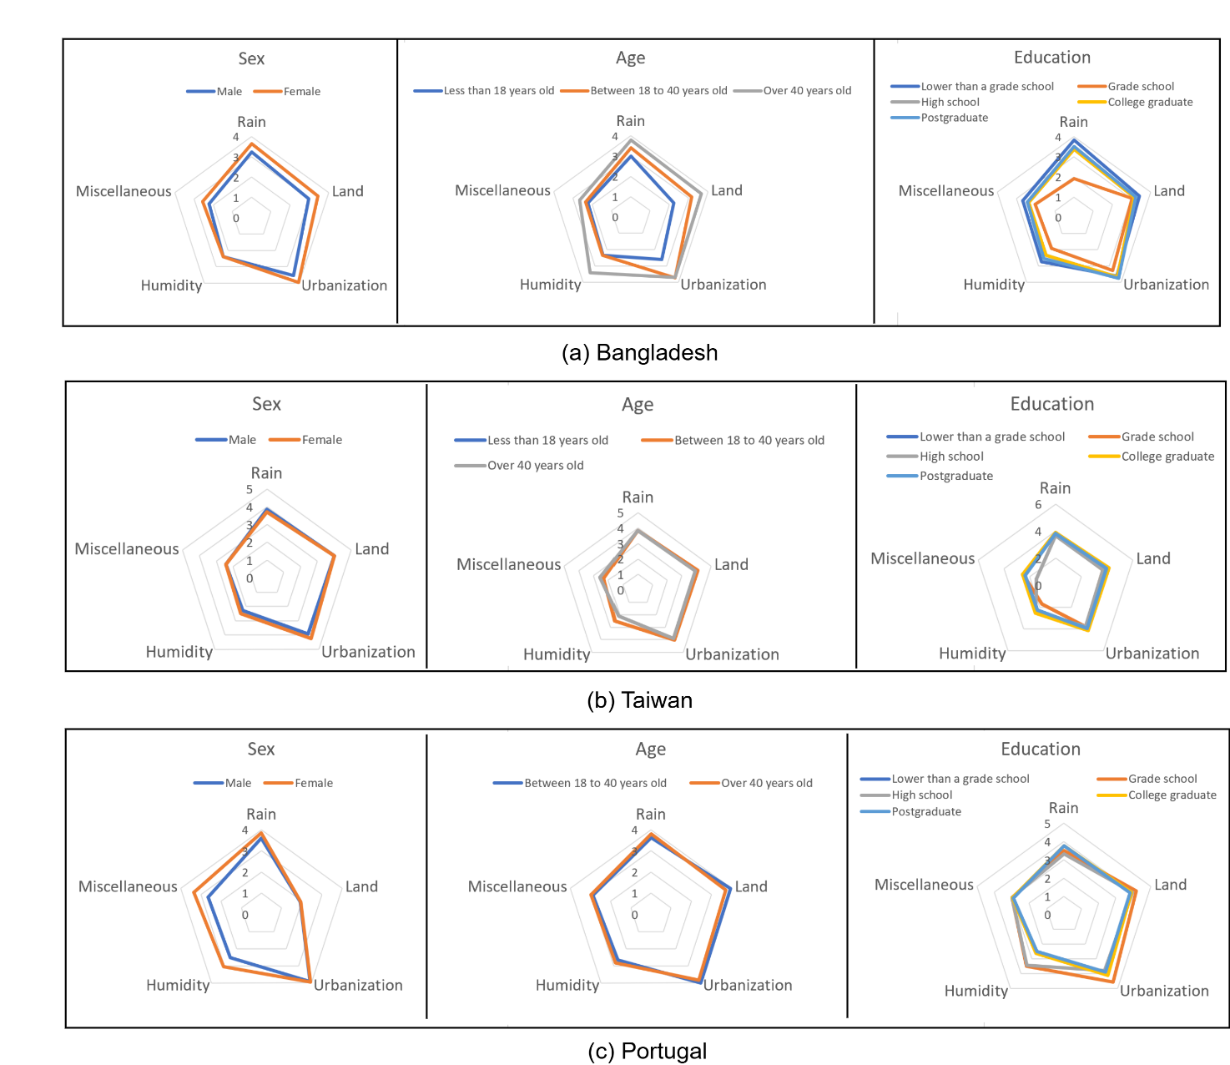

Figure S6: The average susceptibility for causes under the Rain, Land, Urbanization, Humidity, and Miscellaneous categories mentioned in Table S9. Average susceptibility values for different demographic groups are shown for Bangladesh, Taiwan, and Portugal.

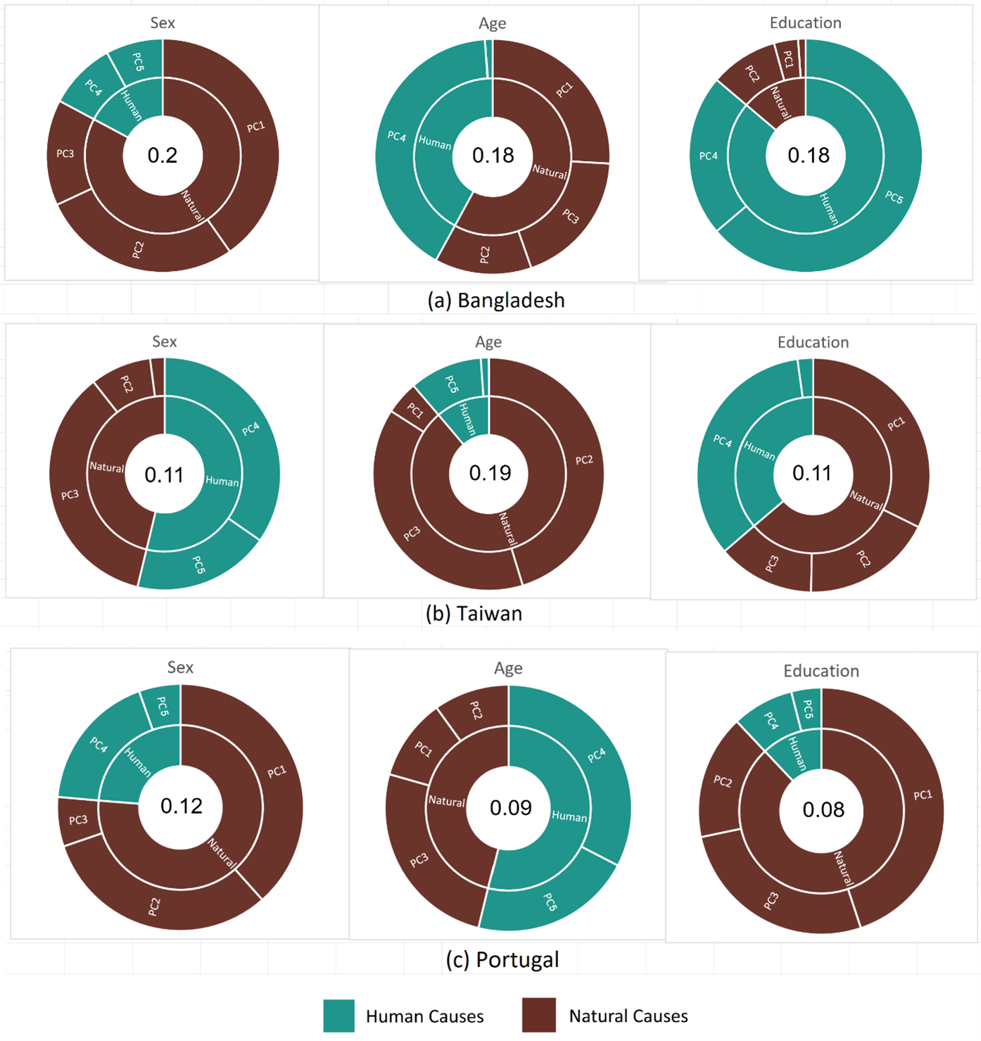

Figure S7: Sobol sensitivity analysis on the PCA of the outcome variable.

