Supplementary Table 1. Complete Individual Water Insecurity Experiences Scale item phrasing.
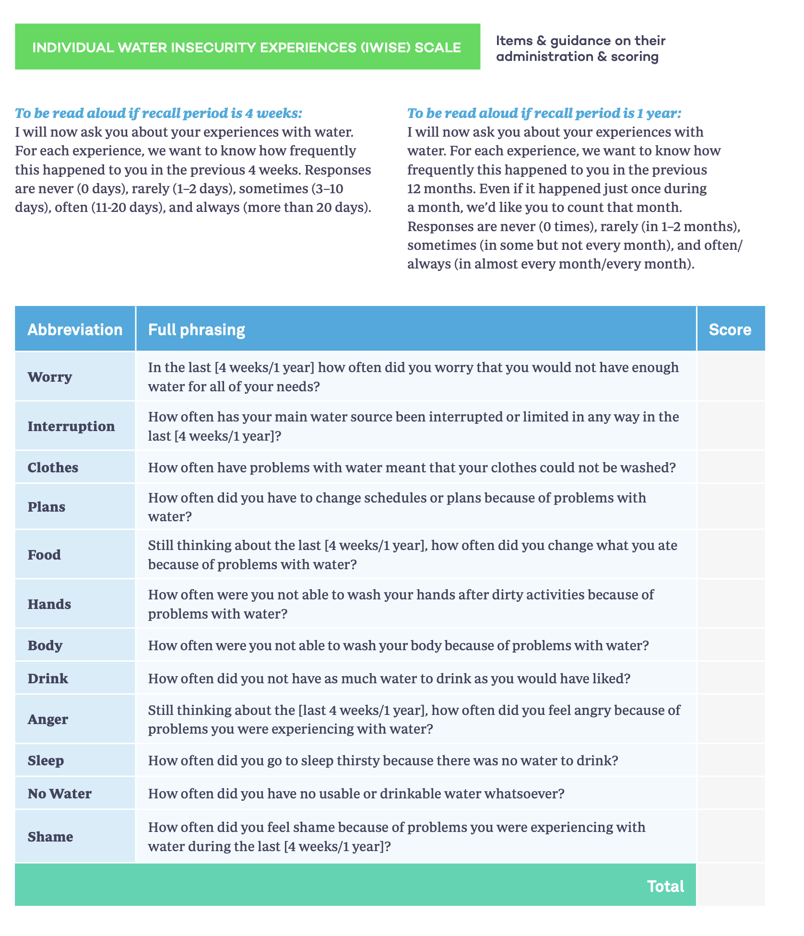

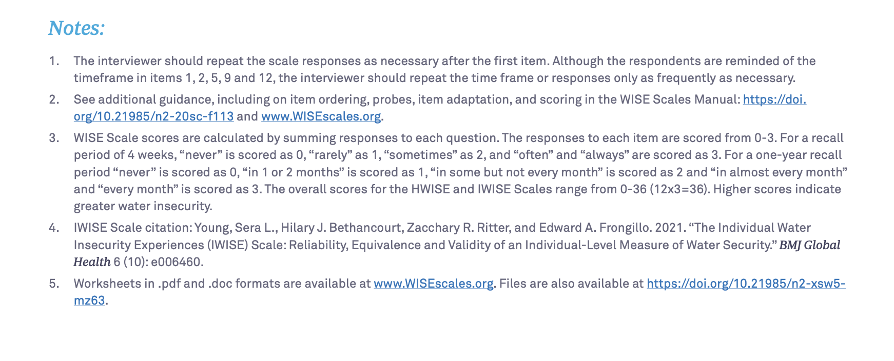

Supplementary Tables 2-8. Pairwise assessment of measurement invariance of Individual Water Insecurity Experiences data, comparing two high-income countries (Australia and USA) to three low- and middle-income countries (Bangladesh, Brazil, and Uganda) in the Gallup World Poll (n=4,928).
Table 2. USA & Bangladesh*
 | Configural invariance | Scalar invariance
RMSEA (<0.06) | 0.046 | 0.048
Upper RMSEA 90% CI (<0.06) | 0.052 | 0.053
CFI (>0.95) | 0.997 | 0.995
TLI (>0.95) | 0.996 | 0.996
SRMR (<0.08) | 0.035 | 0.038

Table 3. USA & Brazil*
 | Configural invariance | Scalar invariance
RMSEA (<0.06) | 0.055 | 0.061
Upper RMSEA 90% CI (<0.06) | 0.060 | 0.066
CFI (>0.95) | 0.983 | 0.973
TLI (>0.95) | 0.980 | 0.975
SRMR (<0.08) | 0.048 | 0.053

Table 4. USA & Uganda*
 | Configural invariance | Scalar invariance
RMSEA (<0.06) | 0.060 | 0.051
Upper RMSEA 90% CI (<0.06) | 0.065 | 0.056
CFI (>0.95) | 0.980 | 0.981
TLI (>0.95) | 0.976 | 0.982
SRMR (<0.08) | 0.039 | 0.043

Table 5. Australia & Bangladesh*
 | Configural invariance | Scalar invariance
RMSEA (<0.06) | 0.040 | 0.037
Upper RMSEA 90% CI (<0.06) | 0.046 | 0.042
CFI (>0.95) | 0.998 | 0.997
TLI (>0.95) | 0.997 | 0.998
SRMR (<0.08) | 0.050 | 0.049

Table 6. Australia & Brazil*
 | Configural invariance | Scalar invariance
RMSEA (<0.06) | 0.047 | 0.049
Upper RMSEA 90% CI (<0.06) | 0.052 | 0.053
CFI (>0.95) | 0.986 | 0.981
TLI (>0.95) | 0.983 | 0.982
SRMR (<0.08) | 0.060 | 0.069

Table 7. Australia & Uganda*
 | Configural invariance | Scalar invariance
RMSEA (<0.06) | 0.050 | 0.043
Upper RMSEA 90% CI (<0.06) | 0.055 | 0.048
CFI (>0.95) | 0.984 | 0.985
TLI (>0.95) | 0.981 | 0.986
SRMR (<0.08) | 0.053 | 0.062

Table 8. USA & Australia*
 | Configural invariance | Scalar invariance
RMSEA (<0.06) | 0.037 | 0.029
Upper RMSEA 90% CI (<0.06) | 0.043 | 0.034
CFI (>0.95) | 0.988 | 0.990
TLI (>0.95) | 0.985 | 0.991
SRMR (<0.08) | 0.054 | 0.060
a Values in parentheses indicate suggested parameters; red shading indicates estimates outside the parameter.
RMSEA: root mean square error of approximation; CI: confidence interval; CFI: comparative fit index; TLI: Tucker-Lewis index; SRMR: standardized root mean square residual

Supplementary Table 9. Individual Water Insecurity Experiences Scale scores were associated with lower wealth and household size in US and Australia (Gallup World Poll 2022, n=1,992).ª
 | IWISE score
 | Coefficient | 95% CI | p
Wealth quintile (ref: high)
Mid-high | 0.13 | (-0.14, 0.39) | 0.035
Middle | 0.37 | (0.04, 0.70) | 0.026
Mid-low | 0.51 | (0.17, 0.84) | 0.003
Low | 1.11 | (0.58, 1.63) | <0.001
Difficult getting by on income (ref: getting by on income) | 2.21 | (1.55, 2.87) | <0.001
Number of household members | 0.13 | (0.03, 0.23) | 0.013
ª Each model includes the exposure of interest and adjusts for site and the complex sampling strategy (to ensure proper standard errors).
CI: confidence interval

