Supplementary Materials

Supplementary Methods

pH microprofiling
pH profiles were measured with a microprofiling system equipped with a pH microelectrode (pH-50, tip diameter 40-60 μm, spatial resolution 75-150 μm, response time <10 s; Unisense) and an external reference electrode (Radiometer analytical), calibrated daily with NBS buffers. The reference electrode was positioned orthogonally to a reference line connecting the cathode and anode to minimize interference from the electrolysis system. Values of pH_{NBS} were converted to pH_{T} using seacarb by first converting to the seawater-scale (pHnbs2sws) and subsequently to the total scale (pHconv) using the default arguments. Microelectrodes were connected to a multimeter (fx-6 UniAmp, Unisense) and continuously recorded at 0.33 Hz with the Unisense SensorTrace software. The microelectrode tip was initially positioned in the center of the cathode at the electrode surface with the aid of a camera connected to a macroscopic lens and moved vertically upward into the water column with a micromanipulator (MM33-2, Unisense). Based on the analysis of preliminary profiles, a protocol was defined with 100 µm steps between 0-500 µm, 250 µm steps between 500-3,000 µm, 500 µm steps between 3,000-8,000 µm, 1,000 µm steps between 8,000-15,000 µm, and 2,500 µm steps between 15,000-25,000 µm for a total of 37 steps spanning 2.5 cm for each profile. Each step took a total of 45 seconds, with 5 s to move between steps, 10 s for the sensor measurement to stabilize, and 30 s of measuring at 0.33 Hz, granting a total profiling time of approximately 30 minutes. Due to the lack of measured pH changes above the inert substrates during preliminary analysis, a simplified protocol was defined with 250 µm steps between 0-500 µm, 500 µm steps between 500-5,000 µm, 1,000 µm steps between 5,000-10,000 µm and 5,000 µm steps between 10,000-25,000 µm. Treatment of the inert and eAE profiles were otherwise identical. The 10 measurements at each step were averaged and taken as the individual step pH. Profiles were recentered to account for the small variation among replicate profiles by first converting to H⁺ concentration, using the conversion [H⁺] = 10^{-pH}, then dividing the concentration at any given step by the mean of the profile’s bulk seawater [H⁺], defined by the average of the final three steps. This non-dimensional [H⁺] was then multiplied by the mean of all the profile’s bulk [H⁺] to convert back to a standardized [H⁺] and back to pH units prior to further analysis (Hurd et al. 2011; Schoepf et al. 2018).

Alternative boundary layer height derivations
We analyzed four methods commonly used to determine the boundary layer height from the pH microprofiles including the intersection of the profile with 99% of the bulk concentration, intersection of the profile to its fitted hyperbolic tangent model, the extraction of the inflection point denoting the boundary layer height from the fitted hyperbolic tangent model, and the consecutive percent reductions in the hydrogen ion concentration (Jorgensen and Revsbech 1985; Nishihara and Ackerman 2007; Hurd et al. 2011). For all profiles, there was an initial rapid decrease in pH followed by a linear decrease throughout the boundary layer before coalescing to bulk pH values, approximating a hyperbolic tangent function. To aid in the analysis and improve the fit of the hyperbolic tangent model, the initial pH values > 8.5 were omitted for all four boundary layer height protocols. The 99% method and the two hyperbolic tangent methods were in close agreement with each other and could discern differences across the profiles. The consecutive percent reduction method, on the other hand, was on average 1 cm less than the other methods and could not differentiate between profiles illustrated in its near uniform assessment of boundary layer heights (Figure S2). When the percentage threshold (ƒ), 10%, or consecutive count, n=4, was altered from the recommendations of Hurd et al. (2011), the boundary layer heights increased, but the variance was too high to discern differences between profiles or could not determine the boundary layer height (Figure S3). Further, the boundary layer heights from the 99% method and the hyperbolic tangent data intersection method were limited to the discrete sampling locations of the microsensor protocol. As such, the values locked in on discrete integer heights and had artificially low variances (Figure S2). Consequently, the fitted hyperbolic tangent model’s boundary layer height was used for all analysis in the manuscript.

Supplementary Figures
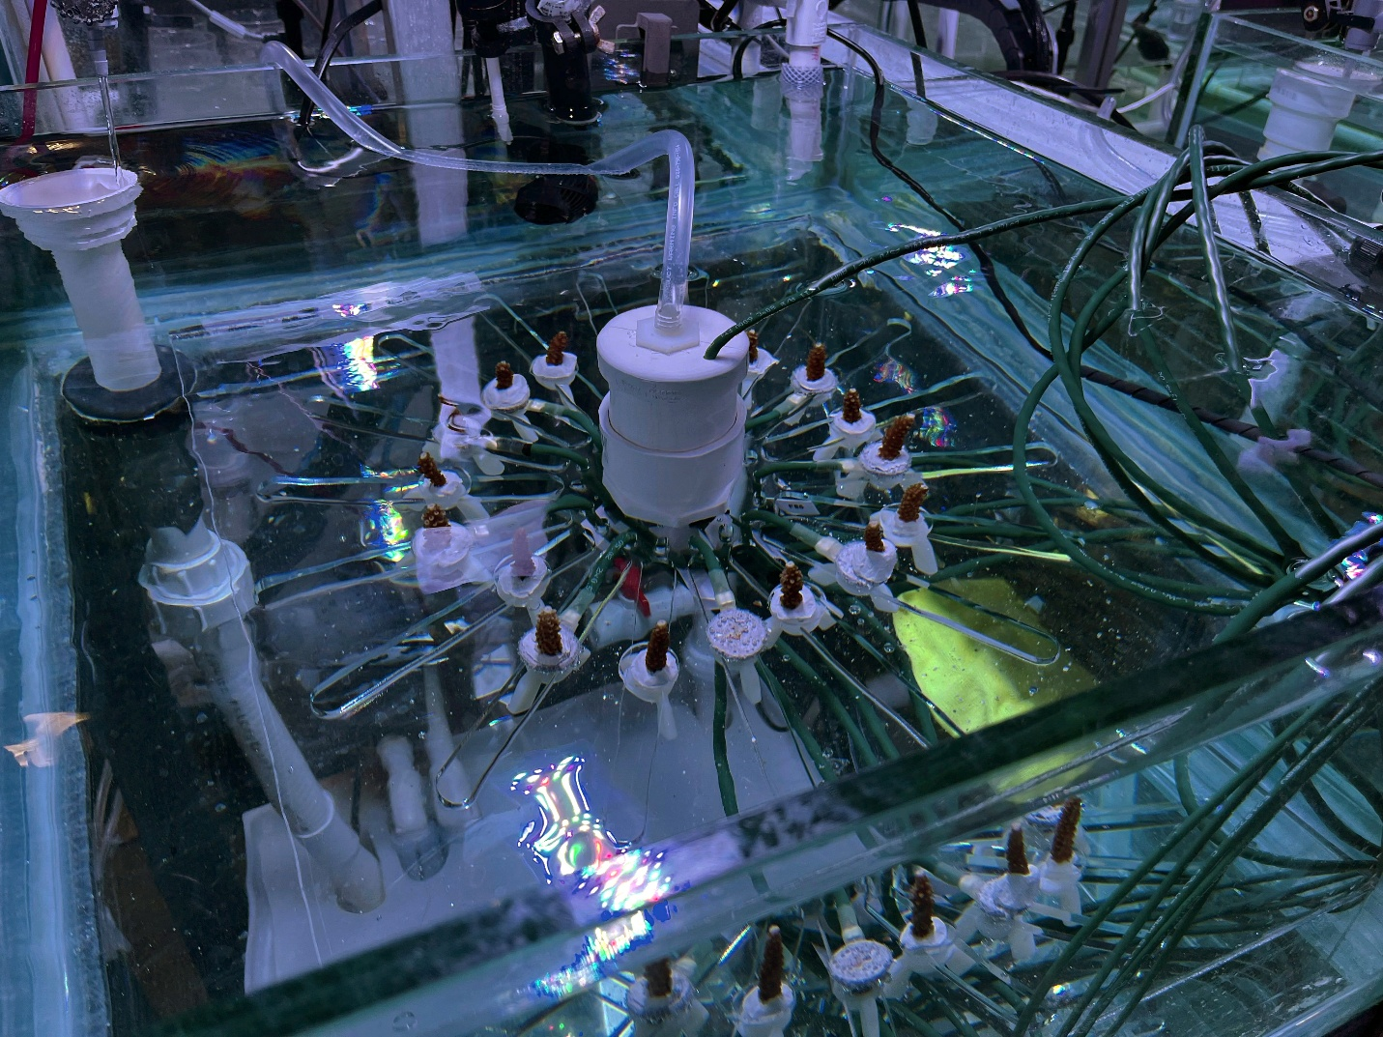
Figure S1 Assembled eAE system in the Experimental Reef Ecology Laboratory, University of Miami.
Figure S2 Alternative methods to determine the boundary layer height revealed peak-locking and low discernability that precluded their usefulness. From left to right, the methods are the intersection of the profile with 99% of its bulk concentration (99), the intersection of the profile with its fitted hyperbolic tangent model (htandata), the extraction of the inflection point denoting the boundary layer height from the fitted hyperbolic tangent model (htanmodel), and the consecutive percent reductions method (consecutive).
Figure S3 Decreasing the percentage threshold (ƒ) below the 10% recommendation from Hurd et al. (2011) increased the variance of the calculated boundary layer height.
Figure S4. eAE carbonate chemistry incubations altered carbonate chemistry with increasing current density (A m⁻²). The observed shifts reflect the combined effects of abiotic precipitation at the cathode and oxidative reactions at the anode, highlighting the influence of electrochemical processes on the seawater carbonate system in a closed system.
Figure S5. pH microsensor profiles above eAE (circles) and inert acrylic pucks (triangles) at three distinct electrical current densities (J, A m⁻²), each measured with a flow speed of 1 cm s⁻¹. Vertical line segments centered on each point indicate ± 1 SD about the mean. Vertical dashed lines with surrounding ribbons represent the mean ± 1 SD of the boundary layer heights (δ) derived from the hyperbolic tangent model for each flow speed.
Figure S6. Genet-specific photochemical efficiency (Fv/Fm) highlight differences in photophysiology among genets at the conclusion of the experiment.
Figure S7. Carbonate chemistry property-property plot depicting the enhancement of the bulk water (triangle) to microenvironment carbonate chemistries (circles) with the electrochemical water reduction reaction (OH⁻) and direct carbonate ion addition (CO₃²⁻). Modeled water reduction reaction increased aragonite saturation states (Ω_{Ar}) from its initial value of 3.85 to 4.68, concomitant with a pH_{T} enhancement from 8.02 to 8.16. This contrasts with direct CO₃²⁻ addition, which would yield an Ω_{Ar} of 4.99 with the same pH_{T} of 8.16. Contour lines depict pH_{T} isopleths; parenthetically defined contour lines depict Ω_{Ar} within the dashed isopleth surrounding a pH_{T} of 8.16 ± 0.02. Arrows indicate the ionic additions required to raise the microenvironment pH_{T} with the respective ion.

Supplementary Figures
Table S1. ANOVA model outputs for the effect of electrical current density (J) on carbonate chemistry parameters; degrees of freedom (df), sum of squares (SS), mean square (MS)
Term | Fixed Effect | df | SS | MS | F | p-value
TA | J | 2 | 37763 | 18881 | 51.9 | 1.63e-4
DIC | J | 2 | 485.0 | 242.52 | 3.136 | 0.117
pCO2 | J | 2 | 1417859 | 708929 | 16.61 | 3.58e-3
CO2 | J | 2 | 1.069e-09 | 5.347e-10 | 17.17 | 3.29e-3
HCO3 | J | 2 | 2.553e-09 | 1.276e-09 | 14.16 | 5.34e-3
CO3 | J | 2 | 1.06e-08 | 5.299e-09 | 169.2 | 5.28e-06
Table S2 Average pH_{T} at heights (mm) above the cathode as a function of flow speed (cm s⁻¹) and current density (A m⁻²) data, see vertical dashed lines in Figure 2.
Flow speed (cm s⁻¹) | Current density (A m⁻²) | Height (mm) | pH_{T} | SD | N
0 | 1 | 5 | 8.218 | 0.008 | 3
0 | 1 | 15 | 8.052 | 0.001 | 3
1 | 0.5 | 5 | 8.061 | 0.006 | 3
1 | 0.5 | 15 | 8.020 | 0.001 | 3
1 | 1 | 5 | 8.160 | 0.022 | 6
1 | 1 | 15 | 8.022 | 0.002 | 6
1 | 3 | 5 | 8.187 | 0.013 | 3
1 | 3 | 15 | 8.040 | 0.001 | 3
3 | 1 | 5 | 8.035 | 0.013 | 3
3 | 1 | 15 | 8.020 | 0.000 | 3
Table S3. ANOVA model outputs for the effect of flow speed (v) and electrical current density (J) on pH boundary layer heights; degrees of freedom (df), sum of squares (SS), mean square (MS)
Term | Fixed Effect | df | SS | MS | F | p-value
Boundary layer | J | 2 | 180143675 | 90071838 | 145.6 | 8.23e-6
pH-0mm | J | 2 | 0.16982 | 0.08491 | 59.99 | 1.08e-4
pH-5mm | J | 2 | 0.25858 | 0.012929 | 50.76 | 1.74e-4
pH-15mm | J | 2 | 7.02e-04 | 3.51e-04 | 139.2 | 9.38e-6
Boundary layer | V | 2 | 360885100 | 180442550 | 100.5 | 2.44e-5
pH-0mm | v | 2 | 0.0000816 | 0.0000408 | 0.091 | 0.915
pH-5mm | v | 2 | 0.05338 | 0.026688 | 100.9 | 2.41e-5
pH-15mm | v | 2 | 0.0019677 | 0.0009838 | 358.3 | 5.72e-7
Table S4. Linear mixed effects model output for the effect of eAE and inert substrates on the calcification rates of A. cervicornis; standard error (se), degrees of freedom (df).
Fixed Effect | Estimate | df | se | t-value | p-value
substrate | -0.05197 | 59.76384 | 0.039 | -1.348 | 0.183
Table S5. Generalized linear mixed-effects model output for the effect of growth experiments on the carbonate chemistry system; standard error (se), degrees of freedom (df).
Fixed Effect | estimate | se | t-value | p-value
experiment | -0.212 | 0.017 | -12.365 | 4.04E-35
CO3 | 2.882 | 0.016 | 185.311 | 0.00E+00
DIC | 5.125 | 0.016 | 329.478 | 0.00E+00
HCO3 | 5.006 | 0.016 | 321.830 | 0.00E+00
Omega | -1.242 | 0.016 | -79.860 | 0.00E+00
pCO2 | 3.634 | 0.016 | 233.662 | 0.00E+00
salinity | 1.006 | 0.016 | 64.674 | 0.00E+00
spectrophotometric pH | -0.451 | 0.016 | -29.006 | 5.48E-185
TA | 5.260 | 0.016 | 338.203 | 0.00E+00
Temperature | 0.799 | 0.016 | 51.400 | 0.00E+00
experiment:CO3 | 0.362 | 0.024 | 14.946 | 1.65E-50
experiment:DIC | 0.205 | 0.024 | 8.459 | 2.71E-17
experiment:HCO3 | 0.186 | 0.024 | 7.662 | 1.83E-14
experiment:Omega | 0.368 | 0.024 | 15.173 | 5.35E-52
experiment:pCO2 | -0.008 | 0.024 | -0.345 | 7.30E-01
experiment:salinity | 0.185 | 0.024 | 7.652 | 1.98E-14
experiment:spectrophotometric pH | 0.223 | 0.024 | 9.216 | 3.10E-20
experiment:TA | 0.227 | 0.024 | 9.362 | 7.84E-21
experiment:Temperature | 0.207 | 0.024 | 8.538 | 1.37E-17
Table S6. Linear mixed effects model output for the effect of eAE and inert substrates, fragment height, and their interaction on the calcification rates of P. clivosa; standard error (se), degrees of freedom (df).
Fixed Effect | Estimate | se | df | t-value | p-value
Substrate | -0.223 | 0.044 | 4.952 | -5.020 | 4.14e-3
Height | -0.181 | 0.038 | 42.299 | 04.738 | 2.45e-5
Substrate:Height | 0.201 | 0.054 | 41.987 | 3.740 | 5.52e-4
Table S7. Linear mixed effects model output for the effect of experiment on the abiotic mineral precipitation bulk mass change rates; standard error (se), degrees of freedom (df).
Fixed effect | Estimate | se | df | t-value | p-value
experiment | -8.218 | 5.037 | 10.791 | -1.632 | 0.132
Table S8. Linear mixed-effects model output for the effect of substrate, height, and their interaction on planar areas. Fixed effects each interact with time to calculate planar tissue growth rates (cm⁻² day⁻¹); standard error (se), degrees of freedom (df).
Fixed Effect | Estimate | se | df | t-value | p-value
Days | 0.032 | 0.002 | 136.8 | 19.020 | <2e-16
Days:substrate | -0.011 | 0.002 | 136.4 | -4.500 | 1.44e-05
Days:height | -0.013 | 0.002 | 136.7 | -5.447 | 2.31e-07
Days:substrate:height | 0.010 | 0.003 | 136.4 | 2.976 | 0.00346
Table S9. Linear mixed-effects model output for the effect of substrate and height on photochemical efficiency values (Fv/Fm).
Fixed Effect | Estimate | SE | df | T value | P value
substrate | -0.018 | 2.20e-2 | 2.46 | -0.827 | 0.481
height | 0.000 | 1.0e-2 | 37.0 | 0.070 | 0.945
substrate:height | -0.009 | 1.35e-2 | 37.0 | -0.634 | 0.530

Table S10. ANOVA model outputs for the effect of genet on photochemical efficiency values (Fv/Fm); degrees of freedom (df), sum of squares (SS), mean square (MS)
Term | Fixed Effect | df | SS | MS | F | p-value
Fv/Fm | genet | 5 | 2.10e-2 | 4.20e-3 | 4.82 | 1.44e-3

