Supplementary material – Description of Global Energy Transition (GET) version 11.0

GET Model description
GET is a bottom-up energy system model that uses linear optimization to minimize the total cost of the energy system. The model was first developed by Azar and Lindgren [1] and was developed further continuously for different studies [2-6]. The model includes a large number of technologies and also techno-economic interactions between the technologies. Technology and interactions are parametrized using, e.g. costs, efficiencies, load factors, and lifetime. While the model minimizes total system cost, several constraints including annual or total extraction limits on the respective available energy sources, expansion rates for technologies in the energy system, load balance constraints, atmospheric CO₂ constraints, trading of some energy carriers are restricted (e.g. electricity), and maximum allowable permanent storage capacity for CO₂. Another important constraint is the satisfaction of a set of demands for energy services in all end-use sectors of the economy. The GET model considers both the supply and demand side and includes the following nine modules: primary energy supply, energy conversion and storage, carbon capture and storage or utilization, fuel trade and distribution, emission conversion using a simplified carbon cycle, electricity sector including time slices for regional VRE conditions, transport sector, feedstocks, and heat sector. The over-arching structure of the model is shown in Fig. 16. It may be noted that the model (as all models) is a simplification of reality and simplifications in GET include: 1) a limited selection of technologies, 2) demand levels that are exogenous and not responsive to price changes, 3) fuel and technology choices that are determined solely by cost, and 4) do not account for uncertainty around future costs, climate targets, or energy demand.
Temporal resolution: The model considers a time horizon of 2010-2150 with optimization accounting for annual and sub-annual (only for wind and solar) operations. The inputs for the time periods are provided for every 10 year time step (2020, 2030, 2040, …). The results are analyzed for the time horizon 2020-2080, and the period 2080-2150 is used as a dummy to avoid end-of-period distortions.

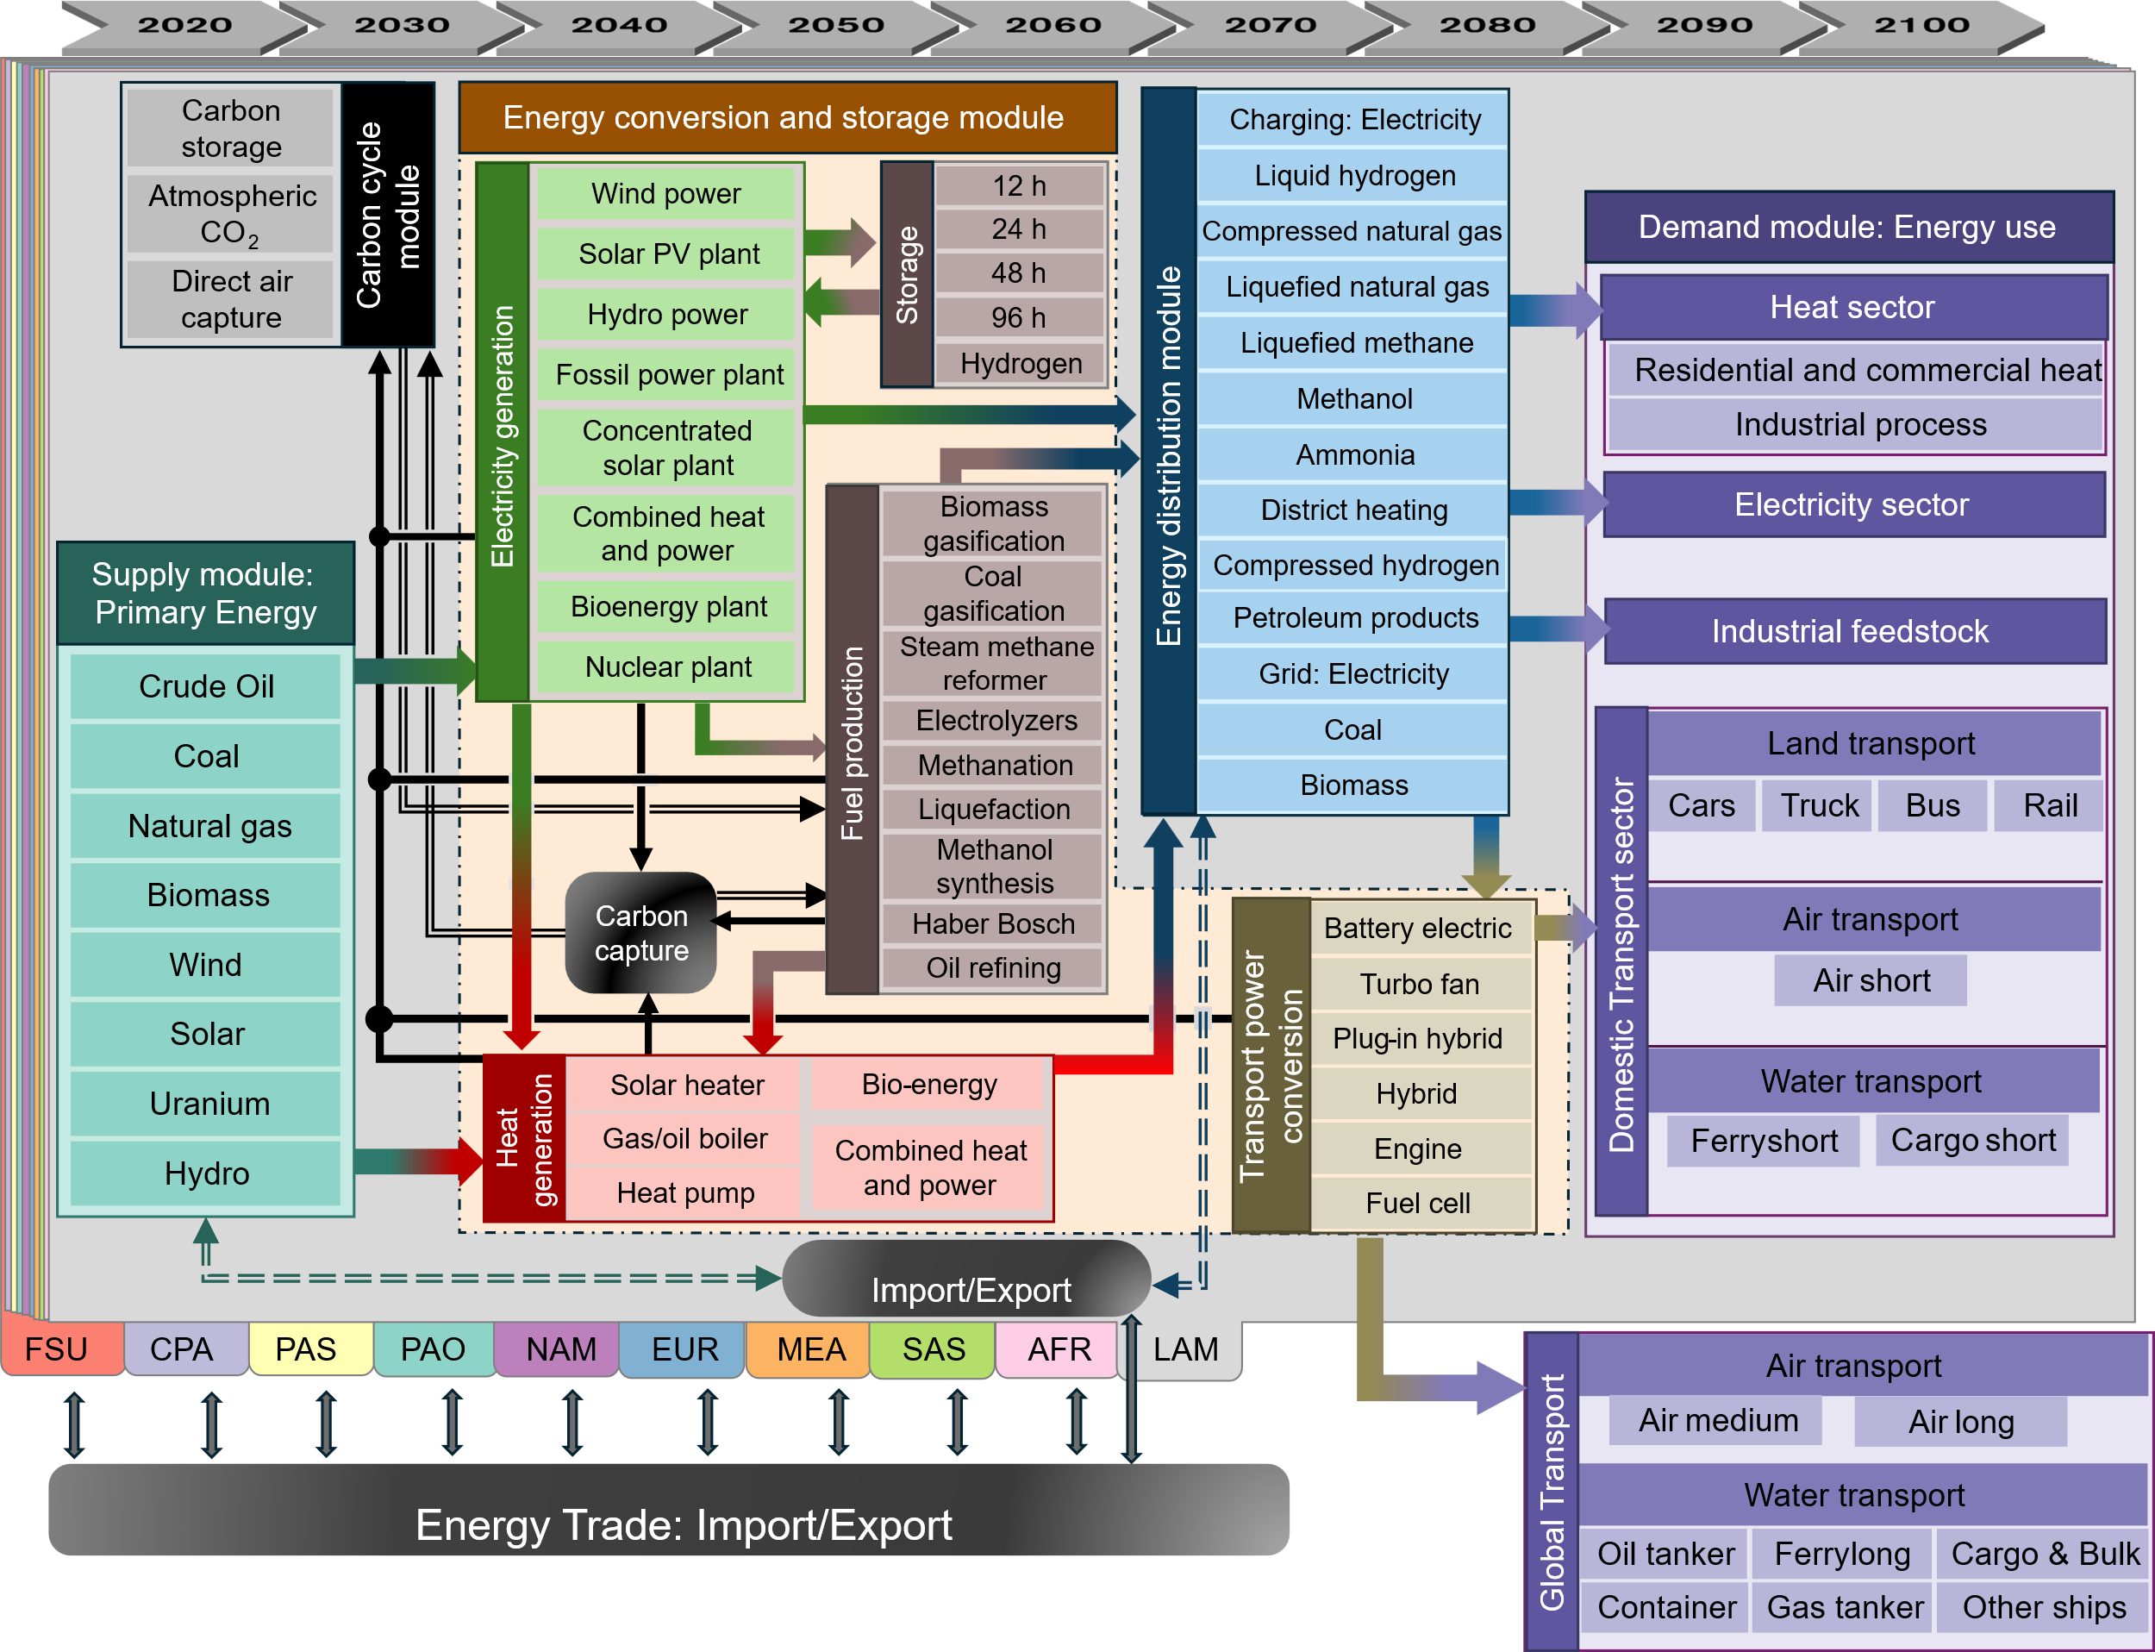
Fig. S1: The basic representation of supply, energy conversion, energy distribution, demand, and other modules in GET 11. PV: photo voltaic, FC: Fuel cells, BEV: Battery electric vehicle, PHEV: Plug-in hybrid, h: hours, NAM: North America, EUR: Europe, PAO: Pacific OECD, CPA: Centrally planned Asia, FSU: Former Soviet Union, LAM: Latin America, AFR: Africa, MEA: the Middle East, SAS: South Asia and PAS: non-OECD Pacific Asia.
Spatial resolution: In the model, the world is divided into 10 geographical regions: North America (NAM), Europe (EUR), Pacific OECD (PAO), centrally planned Asia, mainly China (CPA), the former Soviet Union (FSU), Latin America (LAM), Africa (AFR), the Middle East (MEA), South Asia, mainly India (SAS) and non-OECD Pacific Asia (PAS). The distribution of these 10 regions of the world is illustrated in Fig. 17. The model allows the trade of primary energy carriers and secondary energy carriers (except for electricity) between regions while deciding the investment, operation, supply, and demand. Trade of energy resources is linked with costs according to the mass and volume of fuel transported and the distance between regions. Regional solutions are aggregated to give global results.

Fig. S2: Region definitions in the GET 11 model

Primary energy sources
The model works with the concept of primary energy sources (coal, oil, natural gas, nuclear, wind hydro, solar, and biomass) that are converted using energy conversion technologies into different energy carriers to meet the energy demand in the end-use sectors. All data on primary energy sources are based on GET 10 [7] where assumptions on the regional supply potential of fossil sources are based on estimates made by [8, 9] with a total global supply potential of 80,000, 40,000, 30,000 EJ of coal, oil, and natural gas, respectively. A global bioenergy supply potential of 134 EJ/year is assumed. It may be noted that the potential is divided into grades depending on assumed extraction costs, where regionally varying costs have been assumed for bioenergy whereas costs for fossil sources are assumed to be similar in all regions. Regional Fig.s for the different grades of fossil sources and regional Fig.s for bioenergy are presented in Tables S1 and S2.
Table S 1: Assumptions on yearly supply potential (EJ/year) and extraction cost (USD/GJ) for bioenergy and hydropower potential (EJ) and cost in (USD/GJ).
 | AFR | CPA | EUR | FSU | LAM | MEA | NAM | PAO | PAS | SAS
Bio1 [EJ/yr] | 3 | 5 | 4 | 1 | 4 | 1 | 4 | 1 | 1 | 4
Bio1 [USD/GJ] | 1.6 | 2.2 | 2.4 | 2.1 | 2.4 | 2.5 | 2.7 | 2.7 | 1.9 | 1.5
Bio2 [EJ/yr] | 18 | 2 | 3 | 5 | 11 | 0 | 8 | 4 | 5 | 1
Bio2 [USD/GJ] | 2.7 | 3.7 | 3 | 2.3 | 2 | 12.7 | 3.1 | 3.5 | 2.9 | 3.1
Bio3 [EJ/yr] | 16 | 2 | 3 | 5 | 9 | 0 | 5 | 4 | 4 | 1
Bio3 [USD/GJ] | 3.9 | 6.5 | 4.2 | 3.6 | 3.1 | 13.9 | 5.4 | 4.5 | 3.7 | 4.8
Hydropower [EJ/yr] | 2.6 | 3.8 | 2.8 | 8 | 7.7 | 0.4 | 3 | 0.6 | 2.7 | 1.6

Table S 2: Assumptions on global supply potential (EJ) and extraction cost (USD/GJ) for coal, oil, natural gas and uranium in GET 10.0.
 | AFR | CPA | EUR | FSU | LAM | MEA | NAM | PAO | PAS | SAS
Coal1 [EJ] | 744 | 3795 | 408 | 2952 | 240 | 48 | 5520 | 1080 | 360 | 2325
Coal1 [USD/GJ] | 1.5
Coal2 [EJ] | 1080 | 18305 | 1680 | 13920 | 600 | 240 | 14280 | 2880 | 960 | 8614
Coal2 [USD/GJ] | 3
Oil1 [EJ] | 677 | 188 | 153 | 927 | 903 | 4203 | 628 | 37 | 140 | 44
Oil1 [USD/GJ] | 4
Oil2 [EJ] | 1708 | 904 | 671 | 2257 | 2196 | 6405 | 1525 | 183 | 458 | 246
Oil2 [USD/GJ] | 6
Oil3 [EJ] | 427 | 649 | 183 | 2196 | 2745 | 61 | 7869 | 793 | 31 | 123
Oil3 [USD/GJ] | 10
Gas1 [EJ] | 507 | 73 | 234 | 2379 | 351 | 296 | 351 | 156 | 351 | 123
Gas1 [USD/GJ] | 2.5
Gas2 [EJ] | 1755 | 176 | 975 | 3705 | 1170 | 4095 | 1170 | 390 | 975 | 214
Gas2 [USD/GJ] | 5
Gas3 [EJ] | 1365 | 714 | 122 | 1170 | 2145 | 780 | 2535 | 780 | 585 | 846
Gas3 [USD/GJ] | 7
Uranium1 [EJ] | 140 | 21 | 0 | 29 | 82 | 0 | 214 | 0 | 0 | 0
Uranium1 [USD/GJ] | 0.07
Uranium2 [EJ] | 314 | 72 | 4 | 452 | 143 | 65 | 284 | 0 | 942 | 0
Uranium2 [USD/GJ] | 0.14
Uranium3 [EJ] | 606 | 82 | 50 | 789 | 176 | 76 | 404 | 7 | 977 | 47
Uranium3 [USD/GJ] | 0.23
Uranium4 [EJ] | 612 | 86 | 78 | 1014 | 178 | 79 | 594 | 7 | 981 | 47
Uranium4 [USD/GJ] | 0.4

Representation of the electricity sector
The representation of the electricity sector includes various types of fossil power plants (coal, oil, gas) as well as nuclear and renewable (wind, solar, biomass) electricity production options. Technologies are described by the energy carriers they can potentially convert, and are parameterized using e.g. investment and fuel costs, efficiencies, capacity factors and carbon emissions. Gas, coal, oil and biomass plants can be coupled with carbon capture and storage for lowered or negative emissions. GET has a single demand node for each region and thus the electricity grid is not explicitly modelled.
GET has several categories of solar and wind power: PV rooftop, PV plant A, PV plant B, concentrated solar power (CSP) with storage A, CSP with storage B, onshore wind A, onshore wind B and offshore wind. The A-versions of each technology have direct access to the electricity grid, whereas the B-versions are available at larger distances from demand and therefore require additional transmission investments – 150 $/kWh; the additional cost is based on Holttinen, Kiviluoma [10]. All of these eight types of solar and wind power have five resource classes each. This data is provided by a global geographical information system (GIS) framework developed and explained in detail in Lehtveer, Mattsson [11].
The model uses resource-based time slices, meaning that instead of selecting time slices primarily based on the time-of-day and season, we select slices based on the level of wind and solar generation. For example, a slice called “high solar, medium wind” would aggregate together all hours that are described by this label, irrespective of when during the year they occur. The slicing is performed individually for each model region. Demand variations can in principle be combined with resource slicing by including demand as a third dimension, but in this model version we simply assume that daytime electricity demand (slices with positive solar output) is 15% higher than demand at night (zero solar output) for all regions, which is in accordance with current demand patterns in Europe [12]. In this way, diurnal demand variations are captured without requiring additional slices.
One limitation of using slices is that the treatment of electricity storage becomes difficult when there is no chronology of intra-annual time periods. As a workaround, we retain some of this information by calculating a “slice transfer matrix” based on the time series of slice allocations. To illustrate the concept: suppose we have a 12-hour storage technology and are interested in how slice X can interact with other slices. We iterate over all time periods in a year and count which other slices appear within 12 hours after every occurrence of slice X. This gives an upper bound for the number of hours the storage technology can be used to transfer energy from slice X to any other slice. The model includes 12-, 24-, 48- and 96-hour storage and also has an option to convert electricity to hydrogen and back to electricity for long term storage.

Representation of the transport sector

Road and aviation sector
The transportation demand scenarios are modeled using separate scenarios for passenger and freight movement. The energy demand calculated from transportation activities, except for shipping, is quantified as person-kilometers (pkm) and tonne-kilometers (tkm), with energy intensities expressed as MJ/pkm and MJ/tkm. Total demand for each region is determined based on GDP and population projections (as a driver of the change in transportation activity) from the SSP scenarios in the IIASA SSP database [13-15] as shown in Fig. S3. The demand projections for land transport and aviation assume a continued use of conventional technologies and are based on their efficiency. However, if the model finds it cost-effective with a more efficient powertrain (e.g. battery electric or fuel cell) the demand will decrease according to the increased efficiency. The powertrain technologies are modeled similarly to the energy conversion module, covering various powertrain technologies that are used to convert energy carriers to final energy use, characterized by efficiency, investment cost, and vehicle lifespan. Land transport is divided into five segments: 1.) cars (passenger), 2.) trucks (freight), 3.) buses (passenger), 4.) rail (passenger), 5.) rail (freight). The powertrain technologies included are ICE, FC, hybrid (hyb), and plug-in hybrid electric vehicles (PHEV). The aviation sector is divided into four segments based on the range of operation including 1.) short air (passenger), 2.) medium air (passenger), 3.) long air (passenger), and 4.) cargo air (freight).

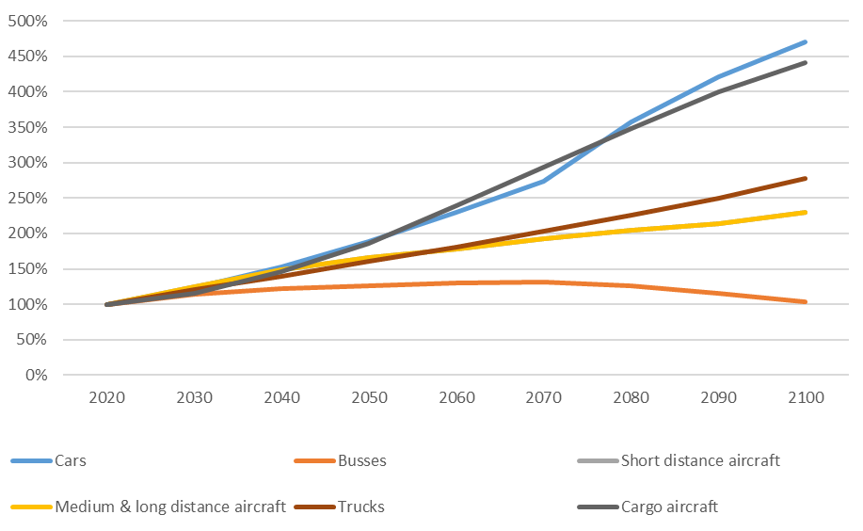
Fig. S3: Change in number of vehicles for the different transport modes in GET 11.0 for SSP2.
Plug-in hybrid electric cars, buses and trucks are modeled to use the battery for 65%, 53% and 53% of their time respectively. It is assumed that all the cars can run on fully battery-electric vehicles and plug-in battery electric vehicles, but only 80% and 90% of the trucks and buses. It is assumed that 20% and 10% of the trucks and buses, respectively, will operate under such conditions (driving range etc.) that fully battery-electric and plug-in hybrid electric vehicles will not be economical.
The transport sector includes personal transportation (cars, buses, rail and air) and goods transportation (trucks, rail, air, short sea ships, deep sea ships and container ships). Cars and buses, trucks, short sea- deep sea- and container ships are represented by technology cost and efficiency data as well as an energy demand while rail (passenger and freight) and air (passenger and freight) are only represented by an energy demand. The relative power train efficiency of fuels and technologies compared with conventional engines for road and aviation sector are shown in Table S3.
Table S 3:Vehicle (other than shipping) and vessel technologies and fuels included in the model with relative power train efficiency compared with petro engines.
trsp_conv |  | p_car | f_road | p_bus | p_air_short | p_air_medium | p_air_long | f_air | p_rail | f_rail
MeOH | ICE | 1.00 | 1.00 | 1.00 | 1 | 1 | 1 | 1 | 1 | 1
MeOH | hyb | 1.30 | 1.04 | 1.04
MeOH | PHEV | 1.30 | 1.04 | 1.04
petro | ICE | 1.00 | 1.00 | 1.00 | 1 | 1 | 1 | 1 | 1 | 1
petro | hyb | 1.30 | 1.04 | 1.04
petro | PHEV | 1.30 | 1.04 | 1.04
CH4 | ICE | 1.00 | 1.00 | 1.00 |  |  |  |  | 1 | 1
CH4 | FC |  |  |  |  |  |  |  | 1.3 | 1.3
elec | BEV | 1.90 | 1.79 | 1.79 | 1.5 |  |  |  | 1.8 | 1.8
CH2 | hyb | 1.30 | 1.04 | 1.04
CH2 | PHEV | 1.30 | 1.04 | 1.04
CH2 | ICE | 1.00 | 1.00 | 1.00 |  |  |  |  | 1 | 1
CH2 | FC | 1.56 | 1.20 | 1.20 |  |  |  |  | 1.3 | 1.3
LH2 | ICE |  |  |  | 0.85 | 0.85 | 0.93 | 0.85

Electricity and hydrogen are energy carriers; for simplicity we include these as "fuels". The model does not distinguish between gasoline, diesel and jet fuels, which are lumped together as petroleum-based fuels (petro). In the model a generic synfuel technology is used as a proxy for any other liquid fuel than petroleum-based liquid fuels such as ethanol, biodiesel, methanol and Fischer-Tropsch liquids. The assumed cost for the components for different transport modes have been updated from GET 10 and is presented in Table S4 (excluding shipping). For more details on the transport sectors other than shipping, refer to GET 10 [7].
Table S 4: Assumed component costs for cars, trucks, buses, and aviation in 2050
 | Cost | Unit
Petro ICE | 55 | $/kW_{mech output}
Synfuels ICE | 55 | $/kW_{mech output}
Natural gas ICE | 55 | $/kW_{mech output}
Hydrogen ICE | 62 | $/kW_{mech output}
Electric engine | 7 | $/kW_{elec}
Reformer | 25 | $/kW_{elec}
Fuel cell stack cost | 95 | $/kW_{elec}
H2 tank | 2500 | $/GJ_{LHV}
Natural gas tank | 1150 | $/GJ_{LHV}
Petro/synfuels tank | 100 | $/GJ_{LHV}
Battery pack-road | 100 | $/kWh
Turbofan engine-aviation | 24 | $/Thrust
Hydrogen Turbofan engine-aviation | 26 | $/Thrust
Battery pack-aviation | 200 | $/kWh

Representation of shipping in GET
The shipping sector in GET 11 is substantially modified for improved representation. In GET 10, the shipping sector is represented by three types of ships, and the energy demands are aggregated to these types based on the IMO Third GHG study [16]. During this work, the shipping module was modified and represented with eight categories: 1) container ships, 2) bulk and general cargo carriers, 3) liquid tankers, 4) gas tankers, 5) passenger-long, 6) passenger-short, 7) cargo short, and 8) other ship types. The categories are based on transport work and the average distance they operate as mentioned in Section 4.3. Seven energy carriers are included in the model: petroleum products (representing HFO and MGO), LNG, MeOH, NH₃, LH₂, CH₂, and electricity (only for short-range vessels). ICE and FC-based propulsion are considered for all vessels, with the addition of a battery-electric option for short-range vessels. Nuclear and hybrid alternatives are excluded as propulsion technologies for ships. The energy carriers and technologies considered in the model for land and air transport are shown in Table S6. The powertrain technologies for converting energy from energy carrier to end-use demand are modeled similarly to the energy conversion module, covering various powertrain technologies and separate energy carriers, defined by efficiency, investment cost, and vessel lifespan.
Table S 5: The energy carriers and the powertrain technologies are considered for shipping.
 | Fossil oil | Methanol |  | Liquid methane |  | Compressed/ Liquid hydrogen |  | Ammonia |  | Battery electric
 | ICE | ICE | FC | ICE | FC | ICE | FC | ICE | FC | Battery electric
Container ships | Yes | Yes | Yes | Yes | Yes | Yes | Yes | Yes | Yes | -
Bulk & general cargo | Yes | Yes | Yes | Yes | Yes | Yes | Yes | Yes | Yes | -
Liquid tankers | Yes | Yes | Yes | Yes | Yes | Yes | Yes | Yes | Yes | -
Gas tankers | Yes | Yes | Yes | Yes | Yes | Yes | Yes | Yes | Yes | -
Ferry-long (passenger) | Yes | Yes | Yes | Yes | Yes | Yes | Yes | - | - | -
Ferry-short (passenger) | Yes | Yes | Yes | Yes | Yes | Yes | Yes | - | - | Yes
Cargo short | Yes | Yes | Yes | Yes | Yes | Yes | Yes | Yes | Yes | Yes
Other ship types | Yes | Yes | Yes | Yes | Yes | Yes | Yes | Yes | Yes | -

Energy-use demand: The total energy demand for shipping is calculated considering three main factors: (1) projected transport work, (2) energy demand per unit of transport work, and (3) projected future energy efficiency. Projection of transport work is performed through a logistic analysis of global transport data, following methods from the Fourth IMO Greenhouse Gas Study [17]. This approach estimates future transport work growth by examining historical relationships between transport work and relevant growth drivers. The approach treats the transport of energy products, non-energy products, and passenger transport differently. Shipping transport demand connected to non-energy products and passenger movements are projected based on historic growth where the per capita GDP serves as the growth driver. The GDP and population projections are taken from the SSP scenarios in the IIASA SSP database [13-15]. Shipping transport demand connected to the movement of energy products is based on global oil, coal, and gas consumption levels taken from the SSP scenarios in the IIASA SSP database [13-15].
Energy demand per unit of transport work is needed to calculate the transport work into energy demand. The energy per unit of transport work is calculated using fleet data and activity from 2012 and 2018, as described in the Fourth IMO Greenhouse Gas Study [17]. This data is used to assign transport work to the eight selected ship type categories defined in GET 11 and to calculate the average energy consumption per unit of transport work for each ship category. Another aspect that will affect the total energy demand is projected improvements in the operational and technical energy efficiencies other than the efficiency of the powertrain already covered in the model. These efficiency improvements are estimated based on the Fourth IMO Greenhouse Gas Study [17]. Finally, the total projected energy demand for each of the eight ship categories, in GET 11, is calculated by multiplying the three factors mentioned above and aggregating them to the global energy demand for each ship categories. The base demand before considering the supplementary trading demand for SSP2 RCP26 scenario is shown in Table S 6.
Table S 6: The base shipping energy demand in EJ considered under SSP2 scenario before iteration.
 | 2020 | 2030 | 2040 | 2050 | 2060 | 2070 | 2080 | 2090 | 2100
Ferry short | 0.13 | 0.19 | 0.24 | 0.30 | 0.36 | 0.43 | 0.50 | 0.58 | 0.66
Ferry long | 0.80 | 0.86 | 1.10 | 1.37 | 1.66 | 1.97 | 2.30 | 2.64 | 3.00
Cargo bulk | 3.90 | 6.26 | 7.53 | 8.99 | 11.04 | 13.11 | 15.38 | 17.54 | 19.65
Oil tanker | 1.50 | 1.85 | 1.57 | 1.35 | 0.97 | 0.64 | 0.27 | 0.09 | 0.03
Gas tanker | 0.57 | 0.61 | 0.77 | 0.96 | 1.15 | 1.24 | 1.30 | 1.34 | 1.37
Cargo short | 0.34 | 0.33 | 0.39 | 0.47 | 0.56 | 0.66 | 0.77 | 0.88 | 1.00
Other ship | 1.94 | 2.23 | 2.77 | 3.42 | 4.19 | 4.95 | 5.78 | 6.64 | 7.53
Container | 1.48 | 2.46 | 3.21 | 3.89 | 4.75 | 5.59 | 6.51 | 7.45 | 8.43

Furthermore, it is assumed that the trade of energy-related transport work will affect shipping demand. The GET model assumes the transportation of hydrogen in the form of methanol, ammonia, or liquid hydrogen between various regions. These trade pattern changes would be due to changes in the demand for primary and energy carriers in the different regions. The variations in primary and secondary energy demands across different locations are influenced by the availability of primary energy resources. The optimization run is iterated (1 iteration) to add these changes in the transport demand. Demand, measured in tonnes-miles, is based on energy traded in mass (energy density and energy trade) and the distance between regions. This is shown in Fig. 19. It can be seen that ammonia and methanol traded between regions in the scenario with the global climate target. It can also be noted that there is a decrease in the coal and oil trade. The change in the net energy demand can also be seen in Fig S4.
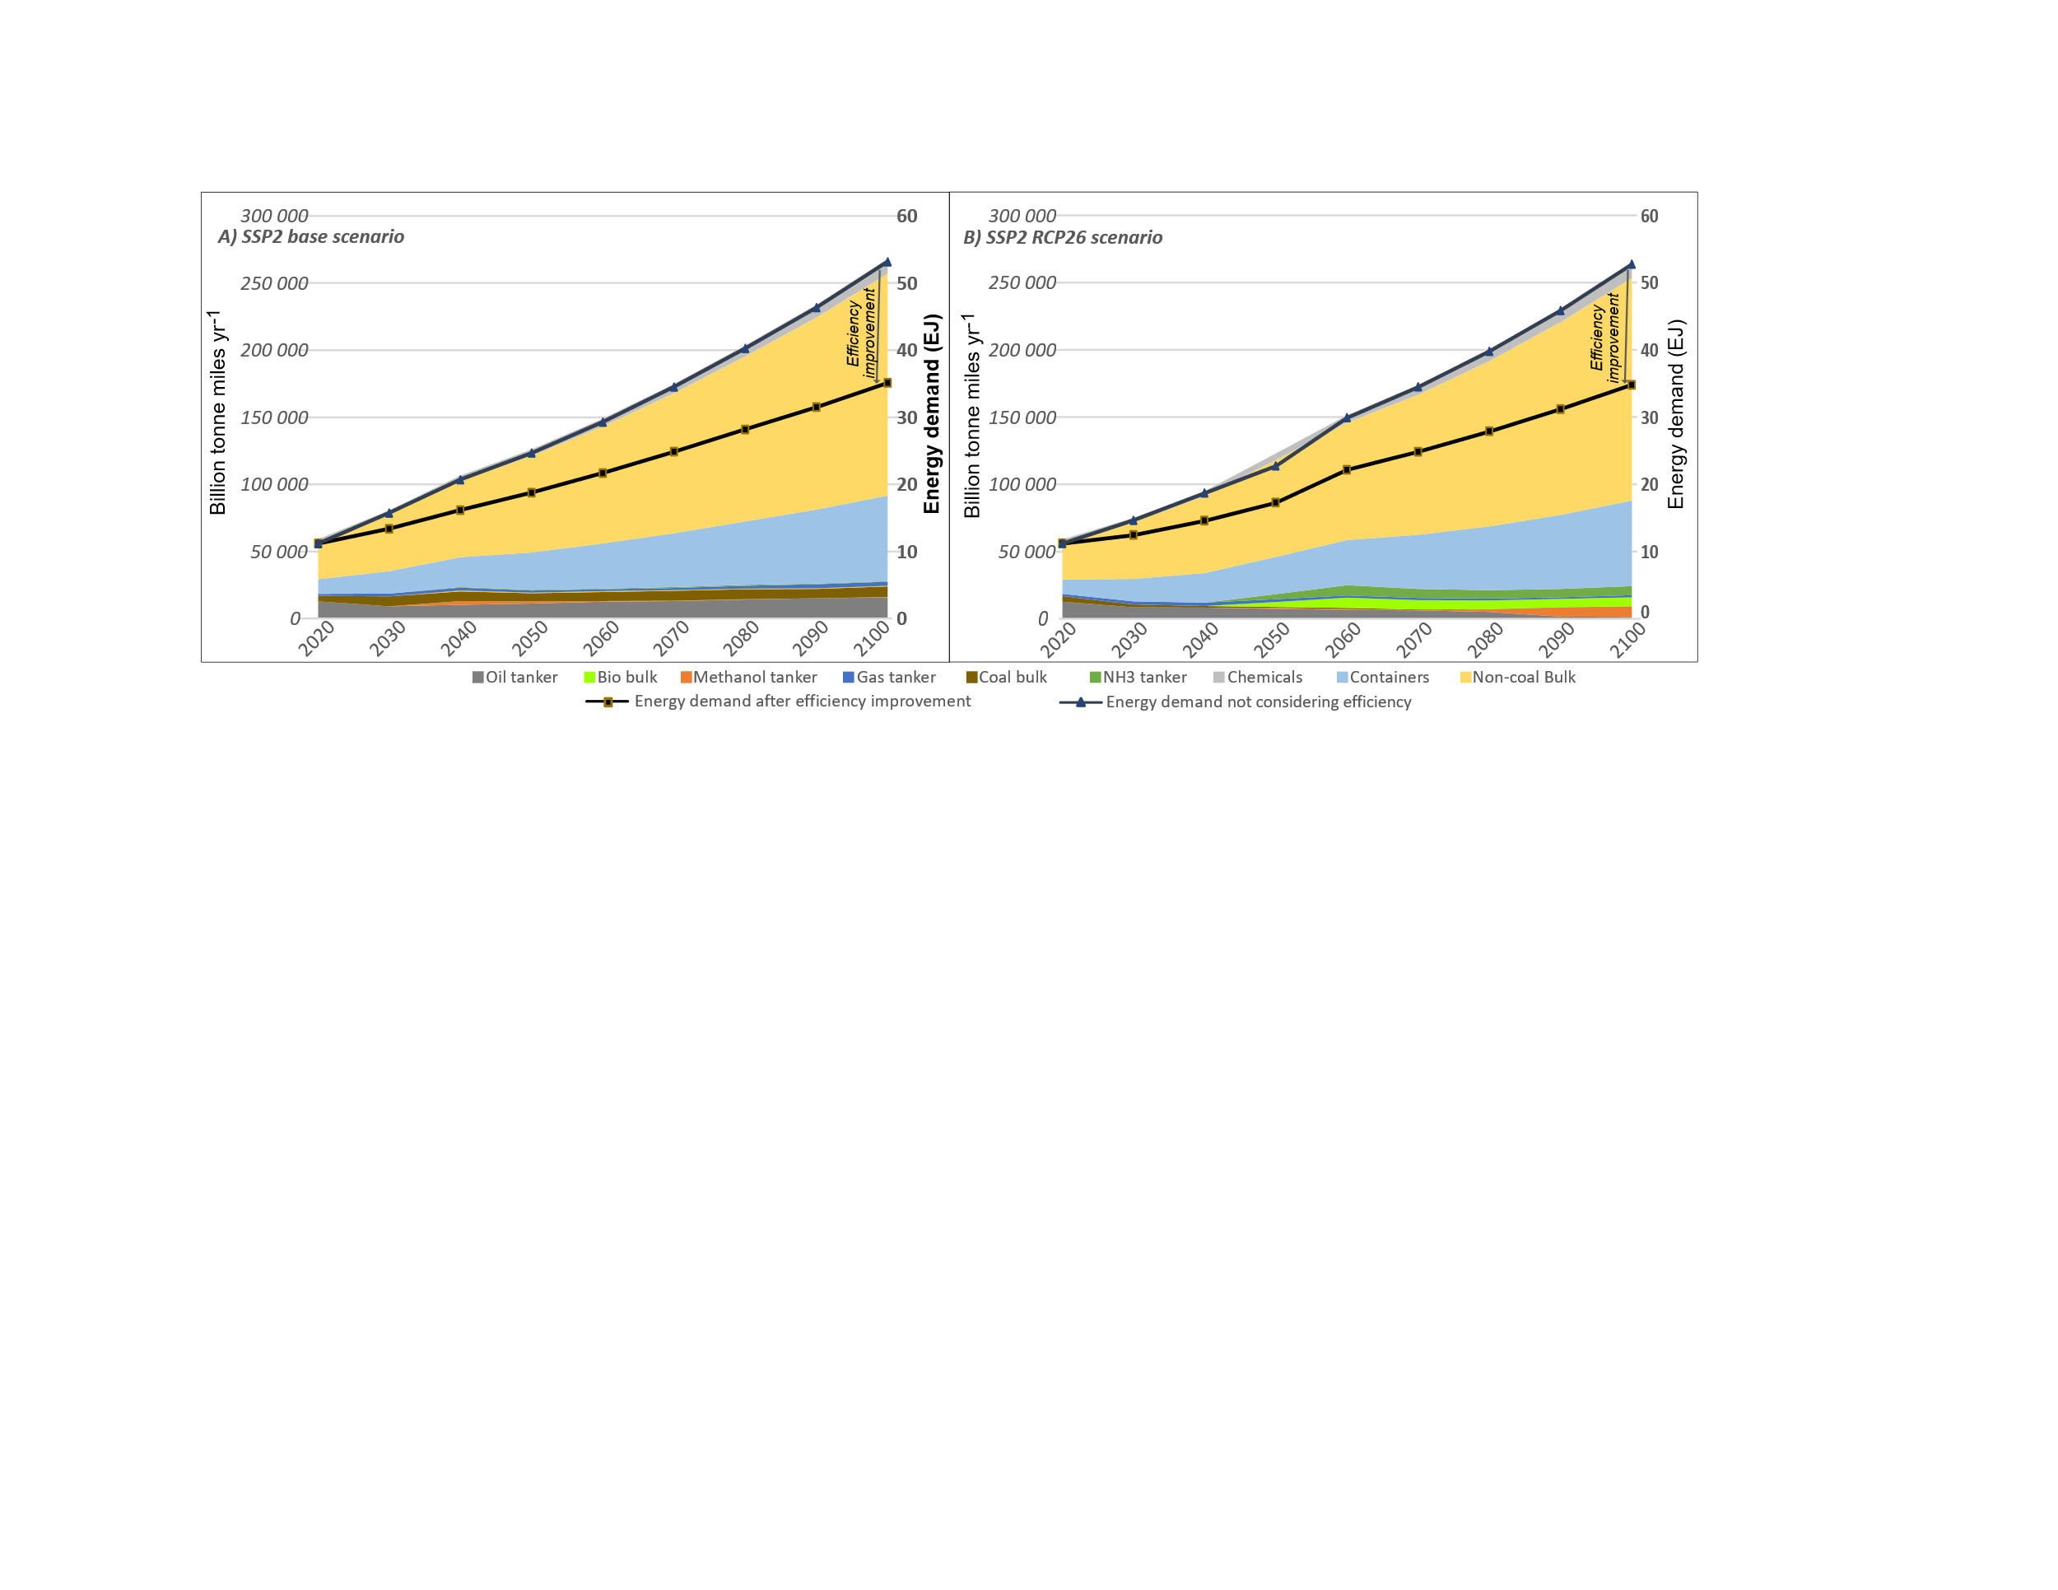
Fig. S4: The transport and energy demand for the shipping sector is considered in the GET model after the iteration: A) SSP2 base scenario with no global climate targets, B) SSP2 RCP26 scenario with global climate target.
The power train cost and efficiencies for the different ship segments used in GET model is given in tables S8 and Table S9 respectively. The costs are based on the cost of different types of components needed including internal combustion engine, electric motor, fuel cells, batteries and fuel tanks.
Table S 7: Investment cost of powertrain for shipping (in 1000$/vessel).
 | Diesel ICE | MeOH ICE | LNG ICE | NH3 ICE | CH2 ICE | LH2 ICE | MeOH SOFC | LNG SOFC | NH3 SOFC | CH2 PEMFC | LH2 PEMFC | BEV
Container | 11100 | 12400 | 20400 | 20500 | 336000 | 123500 | 195600 | 198200 | 197400 | 332800 | 171200
Cargo_bulk | 3600 | 4000 | 6600 | 6300 | 108000 | 39700 | 62900 | 63700 | 63400 | 107000 | 55000
Oiltanker | 4000 | 4400 | 7300 | 7000 | 120000 | 44100 | 69800 | 70800 | 70500 | 118900 | 61100
Gastanker | 4200 | 4600 | 7700 | 7300 | 126000 | 46300 | 73300 | 74300 | 74000 | 124800 | 64200
Othership | 700 | 700 | 1100 | 1000 | 3900 | 2000 | 13900 | 13900 | 13900 | 8500 | 7000
Cargo_short | 1100 | 1100 | 1500 | 1500 | 2400 | 1800 | 20800 | 20800 | 20800 | 10100 | 9600 | 6500
Ferry_short | 500 | 500 | 800 | 800 | 1200 | 900 | 10400 | 10400 | 10400 | 5000 | 4800 | 3900
Ferry_long | 7100 | 7200 | 10600 | 10500 | 38700 | 19800 | 138600 | 138800 | 138700 | 84700 | 70200

Table S 8:Efficiencies assumed for shipping. 2S- 2 stroke engines, 4S- 4 stroke engines.
 | Fossil oil | Methanol |  | Liquid methane |  | Liquid hydrogen |  | Ammonia |  | Battery electric
 | ICE | ICE | FC | ICE | FC | ICE | FC | ICE | FC | Battery electric
Container ships (2S) | 0.48 | 0.48 | 0.58 | 0.48 | 0.60 | 0.48 | 0.55 | 0.44 | 0.60 | -
Bulk and general cargo carriers (2S) | 0.48 | 0.48 | 0.58 | 0.48 | 0.60 | 0.48 | 0.55 | 0.44 | 0.60 | -
Liquid tankers (2S) | 0.48 | 0.48 | 0.58 | 0.48 | 0.60 | 0.48 | 0.55 | 0.44 | 0.60 | -
Gas tankers (2S) | 0.48 | 0.48 | 0.58 | 0.48 | 0.60 | 0.48 | 0.55 | 0.44 | 0.60 | -
Passenger-long (4S) | 0.46 | 0.46 | 0.58 | 0.46 | 0.60 | 0.46 | 0.55 | - | - | -
Passenger-short (4S) | 0.46 | 0.46 | 0.58 | 0.46 | 0.60 | 0.46 | 0.55 | - | - | 0.9
Cargo short (4S) | 0.46 | 0.46 | 0.58 | 0.46 | 0.60 | 0.46 | 0.55 | 0.42 | 0.60 | 0.9
Other ship types (4S) | 0.46 | 0.46 | 0.58 | 0.46 | 0.60 | 0.46 | 0.55 | 0.42 | 0.60 | -

Fuel distribution
Fuel distribution is another aspect considered in the model. Different fuel leakages are introduced in GET 11, assumed to appear in the distribution of gaseous fuels (compressed and liquid hydrogen: 5%, liquid methane: 2%, ammonia: 1%). The grid loss for electricity is assumed as 5% until the final end-use. Distribution costs for energy carriers are assumed being the same as in GET 10, however, an additional cost of 0.5 USD/GJ is considered for the distribution of hydrogen to the fuel production location, and 5 USD/GJ is considered as grid cost for electricity for commercial use and 10 USD/GJ for residential use. In addition, bunkering, filling, and charging infrastructure costs are assumed as in Table S9.
Table S 9:Infrastructure cost for bunkering, filling, and charging.
 | Road transport | Water transport | Air transport
Petroleum ($/kW) | 700 | 100 | 100
Methanol ($/kW) | 1200 | 200 | 200
Compressessed hydrogen ($/kW) | 3500 | 4500 | 4500
Liquid hydrogen ($/kW) | 2700 | 3500 | 3500
Liquid methane ($/kW) | 2200 | 1600 | 1600
Ammonia ($/kW) | 2400 | 400 | 400
Electricity-charging ($/kW) | 500 | 750 | 750

Investment Cost For Energy Conversion
Investment cost for the energy conversion for 2050 is given in Table S10
Table S 10:Efficiencies and investment cost assumed for different energy conversion routes
 |  | Hydrogen | Ammonia | Methanol | Methane
SMR | Efficiency/capacity factor | 0.85/0.8 | - | 0.6/0.8 | -
SMR | Investment cost (€/kW) | 200 | - | 500 | -
SMR with CC | Efficiency/capacity factor | 0.75/0.8 | - | 0.5/0.8 | -
SMR with CC | Investment cost (€/kW) | 400 | - | 1000 | -
Coal gasification | Efficiency/capacity factor | 0.60/0.8 | - | 0.6/0.8 | -
Coal gasification | Investment cost (€/kW) | 1600 | - | 1600 | -
Coal gasification with carbon capture | Efficiency/capacity factor | 0.50/0.8 | - | 0.5/0.8 | -
Coal gasification with carbon capture | Investment cost (€/kW) | 2000 | - | 2000 | -
Biomass gasification | Efficiency/capacity factor | 0.55/0.8 | - | 0.6/0.8 | 0.6/0.8
Biomass gasification | Investment cost (€/kW) | 1600 | - | 2000 | 2500
Biomass gasification with carbon capture | Efficiency/capacity factor | 0.45/0.8 | - | 0.5/0.8 | 0.5/0.8
Biomass gasification with carbon capture | Investment cost (€/kW) | 2000 | - | 2500 | 3000
Oil gasification | Efficiency/capacity factor | 0.75/0.8 | - | - | -
Oil gasification | Investment cost (€/kW) | 700 | - | - | -
Oil gasification with carbon capture | Efficiency/capacity factor | 0.65/0.8 | - | - | -
Oil gasification with carbon capture | Investment cost (€/kW) | 1000 | - | - | -
Electricity -Electrolysis of water | Efficiency/capacity factor | 0.70/0.8 | - | - | -
Electricity -Electrolysis of water | Investment cost (€/kW) | 350 | - | - | -
Hydrogen liquefaction | Efficiency/capacity factor | 0.75/0.9 | - | - | -
Hydrogen liquefaction | Investment cost (€/kW) | 1500 | - | - | -
Hydrogen compression | Efficiency/capacity factor | 0.90/0.9 | - | - | -
Hydrogen compression | Investment cost (€/kW) | 200 | - | - | -
Fuel synthesis from hydrogen | Efficiency/capacity factor | - | 0.85/0.9 | 0.80/0.9 | 0.80/0.9
Fuel synthesis from hydrogen | Investment cost (€/kW) | - | 600 | 300 | 450

Representation of feedstock, industrial process heat and residential–commercial heat
The feedstock, industrial process heat and residential-commercial heat sectors are not model in detail instead a number of assumptions have been based on temperature and process restrictions. These are described and motivated in detail in Hedenus, Karlsson [18] but the most important assumptions are described below. The demand for these sectors is based on the IIASA GGI Scenario Database [19-21].
The maximum amount of coal, crude oil and natural gas that can be used as feedstock is 10%. It is however possible to supply the whole demand with liquid fuels (petroleum-based fuels and synfuels). Biomass, electricity and hydrogen cannot be used directly as feedstock but may be used indirectly as synfuels including electro-fuels. Only 80% of industrial process heat demand can be supplied by solid fuels and the remaining 20% must be supplied by gaseous or liquid fuels in all regions in the model. It is assumed that only 50% of the total demand may be supplied by solid biomass due to temperature restrictions (biomass is problematic for producing temperatures above 400 °C). If larger quantities of biomass are to be used, the biomass must be transformed to hydrogen or synfuels. 50% of the demand for industrial process heat can be supplied with fossil fuels or biomass with carbon capture in the model. These assumptions are based on that carbon capture only can be applied on large industrial plants. The capture rate in the carbon capture facilities is set to 85%. It is also assumed that a minimum of 20% of the solid heat demand are from biomass, representing the heat demand by the pulp and paper industry.
Residential and commercial heat may be produced and supplied in different ways, including local production from for example natural gas, biomass, heat pumps and solar heat or waste heat and centrally generated heat supplied in a district heating system. 80% of the residential and commercial heat demand, in urban areas, in colder regions (North America, all of Europe, centrally planned Asia and the former Soviet union) are assumed to be supplied by district heating. A cost of 5 $/GJ heat is used in the model to distribute heat in a district heating system. There are restrictions to the use of solar heat and heat pumps for urban and rural need for commercial and residential heating (see table S.11-12). Demand projections for electricity, feedstock, and heat are based on the SSP scenarios from the IIASA SSP database [13-15].

Table S 11:Maximum potential for solar heat to supply the urban and rural heat demand (share of total demand).
 | AFR | CPA | EUR | FSU | LAM | MEA | NAM | PAO | PAS | SAS
Urban heat | 0.2 | 0.2 | 0.2 | 0.2 | 0.2 | 0.2 | 0.2 | 0.2 | 0.2 | 0.2
Rural heat | 0.6 | 0.6 | 0.6 | 0.6 | 0.6 | 0.6 | 0.6 | 0.6 | 0.6 | 0.6

Table S 12:Maximum potential for heat pumps to supply the urban and rural heat demand (share of total demand).
 | AFR | CPA | EUR | FSU | LAM | MEA | NAM | PAO | PAS | SAS
Urban heat | 0.2 | 0.2 | 0.2 | 0.2 | 0.2 | 0.2 | 0.2 | 0.2 | 0.2 | 0.2
Rural heat | 0.4 | 0.4 | 0.4 | 0.4 | 0.4 | 0.4 | 0.4 | 0.4 | 0.4 | 0.4

Emission factors
The GET model considers carbon cycle that coverts C in the molecules as CO2 emissions into an atmospheric CO2 concentration. Carbon capture is also considered an option to reduce CO2 emissions in the energy conversion module, where the model can choose to apply carbon capture to natural gas, coal, oil, and biomass plants for heat generation, electricity generation and fuel production. Emissions are only considered for the fuel or resource that contain carbon and is assumed that it will be converted either during conversion (e.g. H2 production from NG ) or use (petrol burned in ICE). Following are the emissions considered (gCO2/MJ): 1) Methanol: 69, 2) petro: 75, 3) NG/Methane: 52, 4) Biomass: 0, and 5) pellets: 0. In case of BECCS negative emission is considered for bio-based sources. Methane emissions are also considered both in supply chain and engine slip as follows: 1) Methane slip for 2S engines: 15 MtCO_{2eq}perEJ , 2) methane slip for 4S engines: 3.75 MtCO_{2eq}perEJ , 3) NG supply leakage: 0.5% leakage (3.12gCO_{2eq}/MJ), and 4) liquefaction and distribution of LNG : 0.5% leakage (3.12gCO_{2eq}/MJ). In case of ammonia engine, emission of nitrous oxide of 0.03gperkWh (4.023 gCO_{2eq}/MJ).

Policy descriptions
Description of policy as in model is described in Table S13. Ship downstream emission used in GFI constrain and levy cost calculation includes direct CO₂ emissions during the fuel conversion in engines/fuel cell and methane slip while using LNG or methane and likely nitrous oxide emission from ammonia engines. The upstream emissions includes CO2 emissions during the energy conversion, methane leakage in the supply chain and also reduce the carbon dioxide that is captured and stored during the energy conversion. DAC is considered a standalone system and is not included in the upstream calculation linked to shipping.

Table S 13:Description of policies
Policy name | Economic measure | Technical measure | Model description
Marine levy | Levy for direct GHG emissions.  2030: 50 $/tCO_{2eq},  2040: 100 $/tCO_{2eq},  2050+: 150 $/tCO_{2eq} | - | Levy added to the upstream emissions from the engine or fuel cell in ships. This includes direct CO2 emissions during the fuel conversion in engines/fuel cell and methane slip while using LNG or methane and likely nitrous oxide emission from ammonia engines. The cost is added to the total cost on the system.
Two-Tier Mechanism | Cost for remedial units based on deficit (non-compliance).  Tier 2 deficit: 380 $/tCO_{2eq}  Tier 1 deficit: 100 $/tCO_{2eq}  Surplus unit rewarded for low emission technologies. | GFI targets for fuel consumed. Two reduction targets with different penalties based on reference (93.3 gCO₂_{eq}/MJ_{fuel}).  Tier 2: Base compliance  Tier 1: Direct compliance (stricter target) | Specific emission factor (gCO2eq/MJ) for the total fuel used in shipping is calculated considering both upstream and downstream emission. Petro in ICE is taken as reference value and the reduction percentage is applied as constraint to the specific emission factor (gCO2eq/MJ). Penalty of 380$/tCO2eq is added when excess emission above the tier 2 level (subtracting total emissions and tier 2 cap emissions level) and 100$/tCO2eq is added when the emission between tier 1 cap emissions and tier 2 cap emissions. A 20% of this fund is assumed to fund zero emission vessels.
Marine levy + GFI | Levy for direct ship GHG emissions 2030: 50$per tCO_{2eq},  2040: 100 $/tCO_{2eq},  2050+: 150 $/tCO_{2eq} | Mandatory for vessels to reach GFI direct compliance (Tier 1). | Levy added to the upstream emissions from the engine or fuel cell in ships. This includes direct CO2 emissions during the fuel conversion in engines/fuel cell and methane slip while using LNG or methane and likely nitrous oxide emission from ammonia engines. The cost is added to the total cost on the system.
High Marine Levy | Levy for direct ship GHG emissions  2030: 150 $/tCO_{2eq},  2040: 200 $/tCO_{2eq},  2050+: 250 $/tCO_{2eq} | - | Levy added to the upstream emissions from the engine or fuel cell in ships. This includes direct CO2 emissions during the fuel conversion in engines/fuel cell and methane slip while using LNG or methane and likely nitrous oxide emission from ammonia engines. The cost is added to the total cost on the system. In addition it is assumed that the ships need to achieve the tier 1 emission reduction target as a constraint.
GFI | - | Mandatory for vessels to reach GFI direct compliance (tier 1). | It is assumed that the ships need to achieve the tier 1 emission reduction target as a constraint.
Marine levy + subsidy | Levy for direct ship GHG emissions  2030: 50 $/tCO_{2eq},  2040: 100 $/tCO_{2eq},  2050+: 150 $/tCO_{2eq}  Levy used to subsidize investment of zero and near zero technologies. | - | Levy added to the upstream emissions from the engine or fuel cell in ships. This includes direct CO2 emissions during the fuel conversion in engines/fuel cell and methane slip while using LNG or methane and likely nitrous oxide emission from ammonia engines. The cost is added to the total cost on the system. A 20% of this fund is assumed to fund zero emission vessels.

The graphical representation of the two-tier mechanism which is under adoption at IMO is shown in Fig. S5. The tier targets are yet to be decided at IMO for 2040 onwards, this will be decided at a later stage. However, our model assumes net-zero by 2050 as tier 1 and 90% in tier 2 as shown in Table S14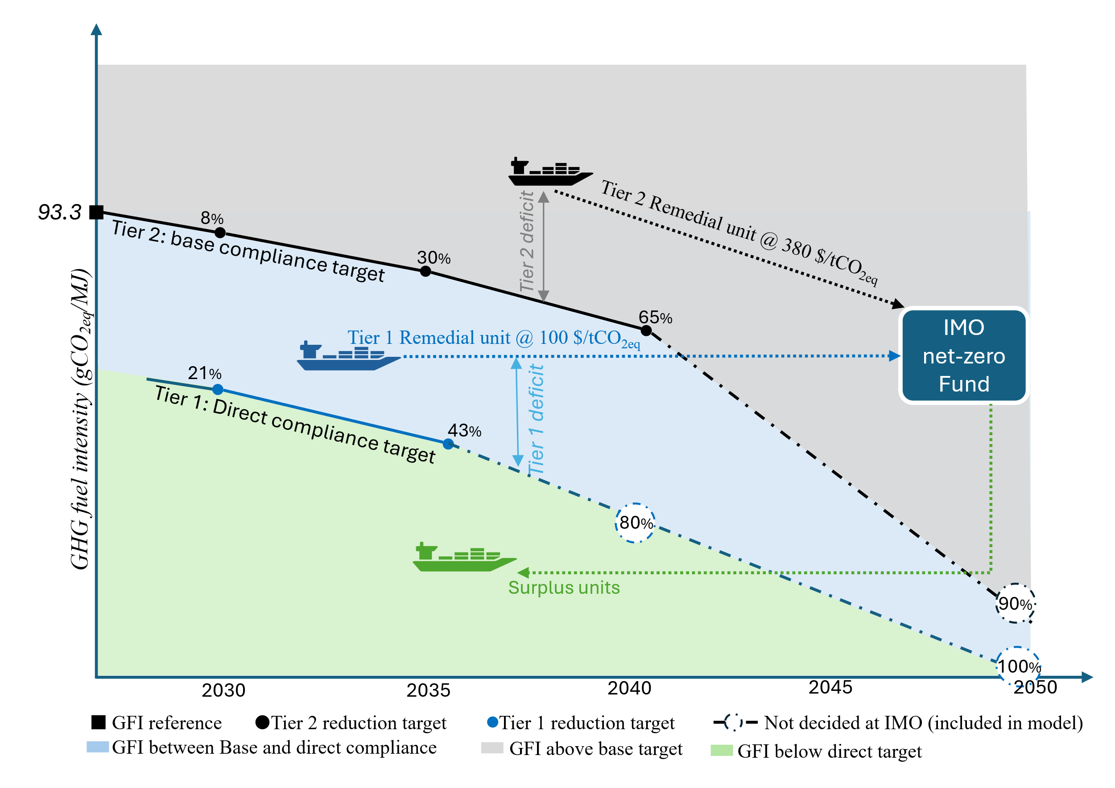
Fig. S5: Schematics of Two-tier mechanism in net-zero IMO framework

Table S 14: Tier 1 and tier 2 GFI reduction targets used in the study.
Year | Tier 1 reduction target | Tier 2 reduction target
2030 | 21% | 8%
2040 | 80% | 65%
2050-2100 | 100% | 90%

Results
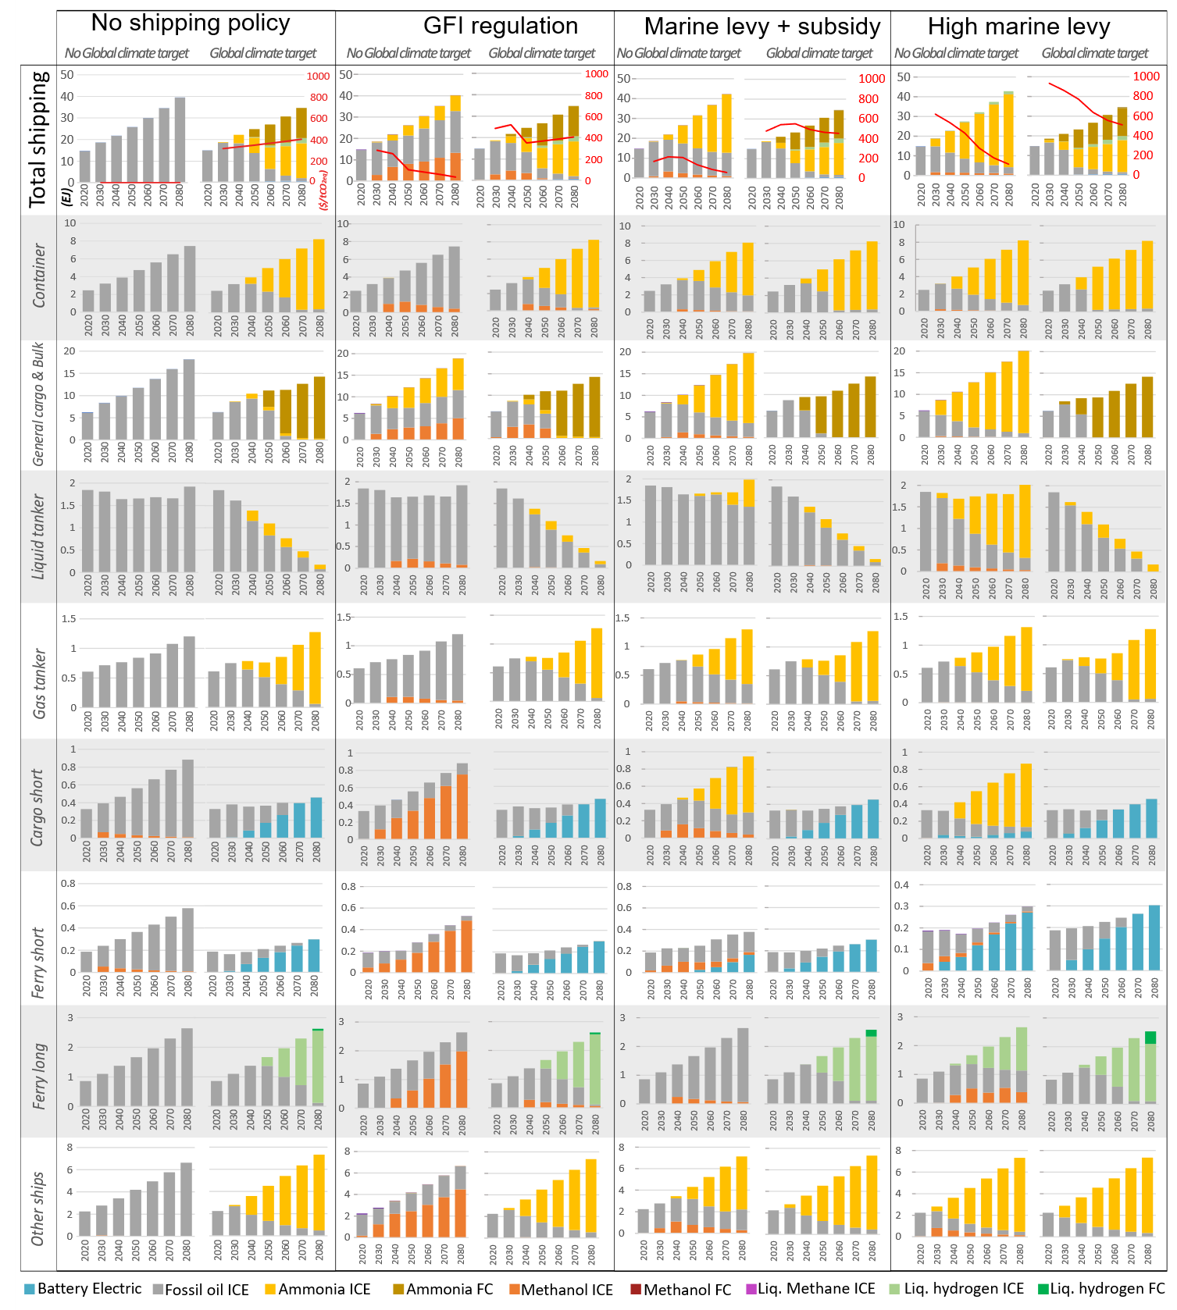
Fig. S6:Energy carriers and technology mixes for global shipping and specific ship categories (in EJ) under different shipping policy scenarios, with and without a global climate target. In the case of liquid tankers, there is a decrease in the transport demand as the global demand for oil for energy purposes decreases. In the case of gas tankers, even though there is less demand for natural gas, model show an increase in ammonia trading. For the bulk tankers, the transport demand for coal is replaced by increased trade in biomass. The red line in the first row for total shipping represents the marginal carbon abatement cost ($/tCO2eq), that is, the cost associated with reducing an additional tonne of CO2 in shipping sector during the specified timestep
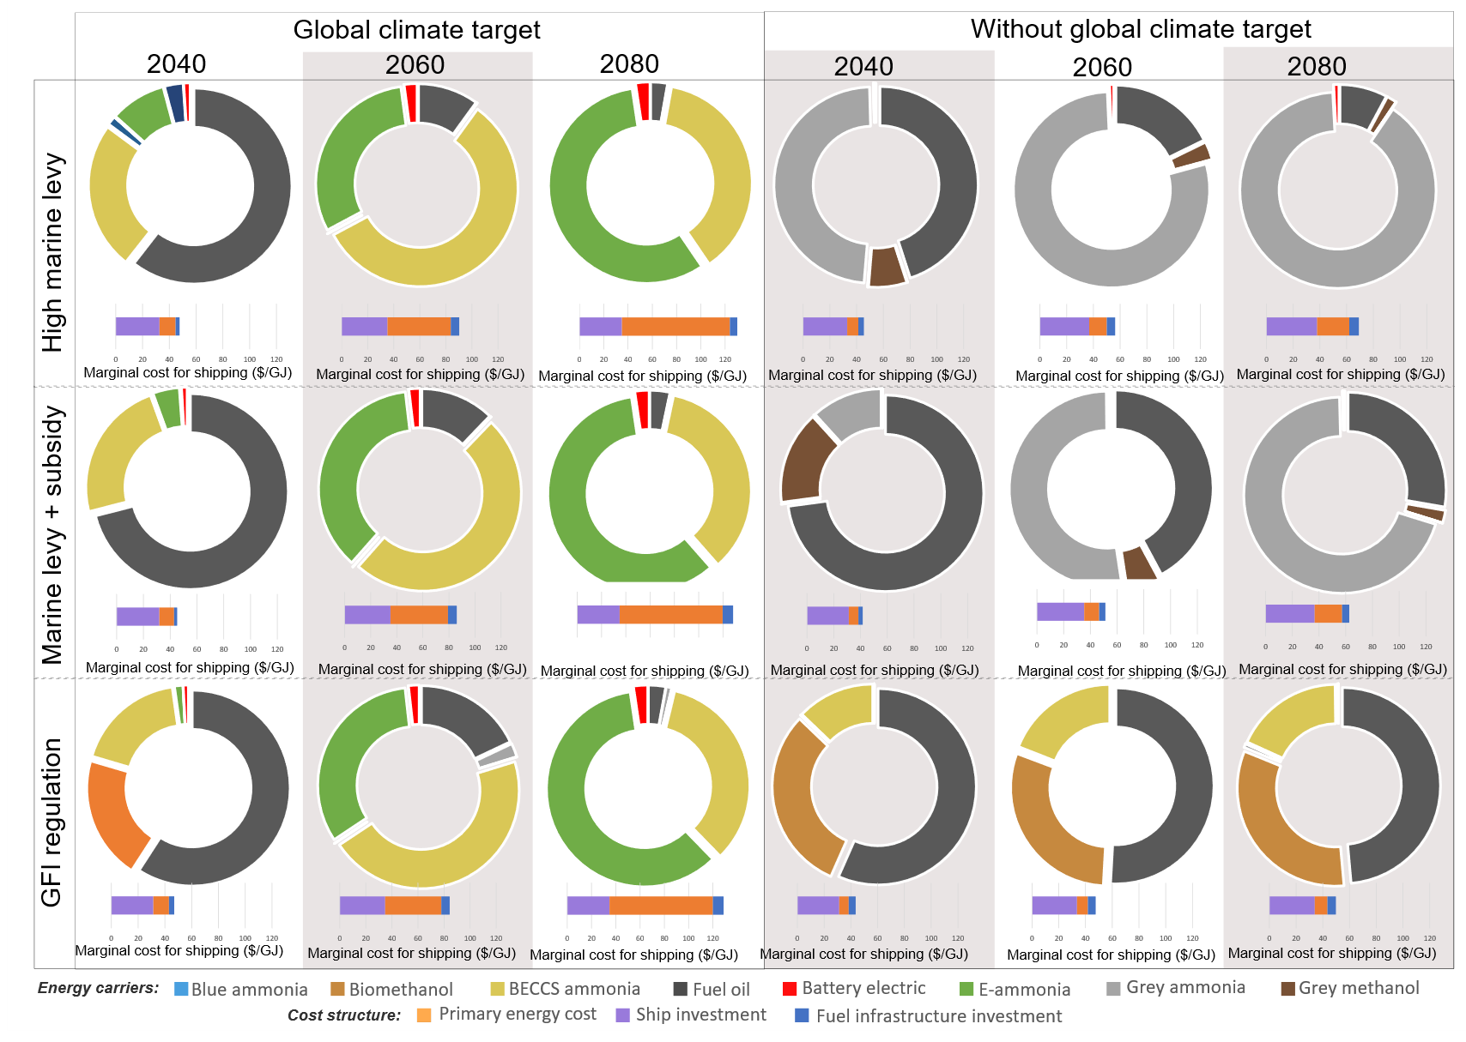
Fig. S7:Fuel production pathways under different scenarios and the related marginal costs for shipping in €/GJ for 2050 and 2080. The marginal cost comprises three parts: the cost associated with investments in ships; the cost for the fuel infrastructure; and the primary energy costs, including the costs for biomass, marginal electricity cost, natural gas, crude oil, etc. The higher cost in the climate scenario is mainly associated with the higher marginal cost of primary energy as different sectors compete for biomass and electricity.
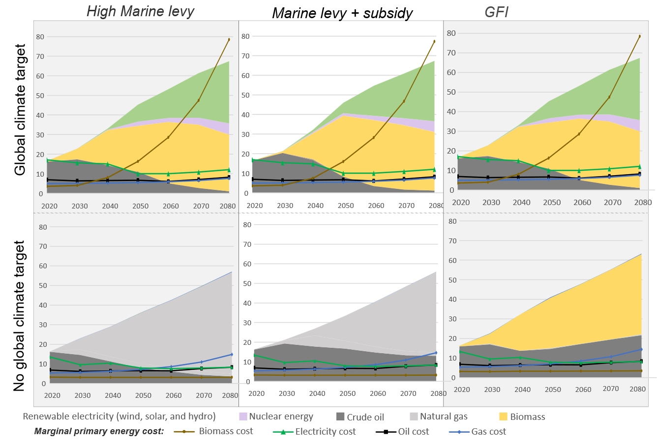
Fig. S8:Primary energy demands required for the different policy scenarios (in EJ), and the marginal energy costs related to the primary energy supply (in €/GJ) between 2020 and 2080.

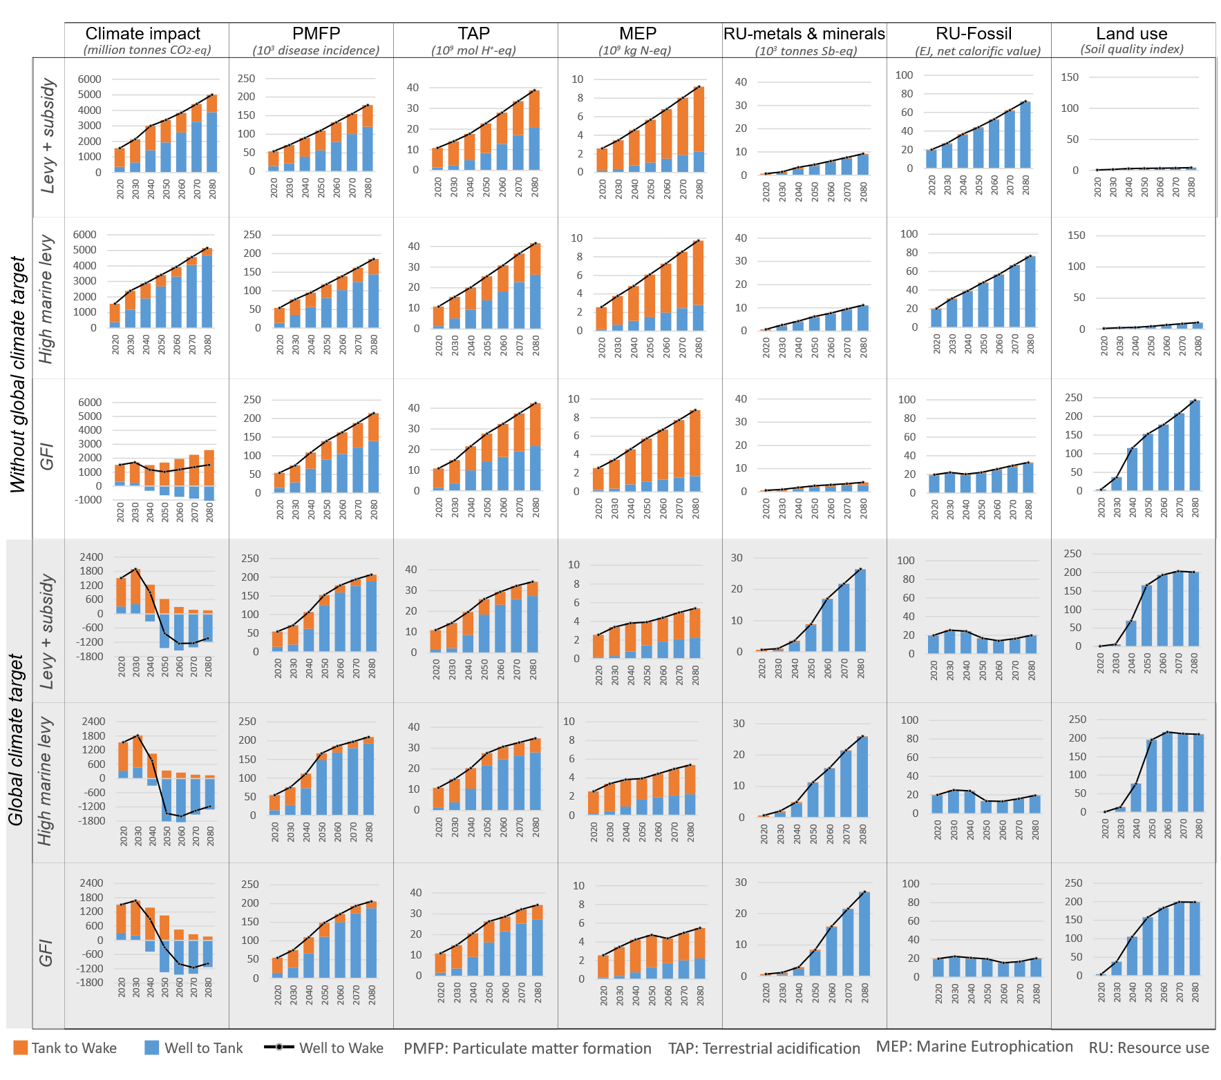
Fig. S9: Life cycle environmental impacts of the shipping energy transition under different policy scenarios, including climate impact, particulate matter formation potential (PMFP), terrestrial acidification potential (TAP), marine eutrophication potential (MEP), material resource use (RU-metals and minerals), fossil energy resource use (RU-fossil), and land use.

References
1. Azar, C., K. Lindgren, and B.A. Andersson, Global energy scenarios meeting stringent CO2 constraints - Cost-effective fuel choices in the transportation sector. Energy Policy, 2003. 31(10): p. 961-976.
2. Lehtveer, M. and F. Hedenus, Nuclear power as a climate mitigation strategy - technology and proliferation risk. Journal of Risk Research, 2014.
3. Hedenus, F., et al., Cost-effective energy carriers for transport - The role of the energy supply system in a carbon-constrained world. International Journal of Hydrogen Energy, 2010. 35(10): p. 4638-4651.
4. Grahn, M., et al., Fuel and Vehicle Technology Choices for Passenger Vehicles in Achieving Stringent CO2 Targets: Connections between Transportation and Other Energy Sectors. Environmental Science & Technology, 2009. 43(9): p. 3365-3371.
5. Taljegard, M., et al., Cost-Effective Choices of Marine Fuels in a Carbon-Constrained World: Results from a Global Energy Model. Environmental Science & Technology, 2014. 48(21): p. 12986-12993.
6. Lehtveer, M., S. Brynolf, and M. Grahn, What Future for Electrofuels in Transport? Analysis of Cost Competitiveness in Global Climate Mitigation. Environmental Science & Technology, 2019. 53(3): p. 1690-1697.
7. Lehtveer, M., S. Brynolf, and M. Grahn, What Future for Electrofuels in Transport? Analysis of Cost Competitiveness in Global Climate Mitigation. Environ Sci Technol, 2019. 53(3): p. 1690-1697.
8. Rogner H-H, et al., Chapter 7: Energy resources and potentials, in Global Energy Assessment: Toward a Sustainable Future, GEA Writing Team, Editor. 2012, Cambridge University Press and IIASA. p. pp.423-512.
9. McGlade, C. and P. Ekins, The geographical distribution of fossil fuels unused when limiting global warming to 2 °C. Nature, 2015. 517: p. 187.
10. Holttinen, H., et al., Design and Operation of Power Systems with Large Amount of Wind Power: Final Summary Report. 2013, IEA: Espoo, Finland.
11. Lehtveer, M., N. Mattsson, and F. Hedenus, Using resource based slicing to capture the intermittency of variable renewables in energy system models. Energy Strategy Reviews, 2017. 18: p. 73-84.
12. Consumption Data - Hourly Load Values. 2014, ENTSO-E - European Network of Transmission System Operators for Electricity.
13. Riahi, K., et al., The Shared Socioeconomic Pathways and their energy, land use, and greenhouse gas emissions implications: An overview. Global Environmental Change, 2017. 42: p. 153-168.
14. Samir, K.C. and W. Lutz, The human core of the shared socioeconomic pathways: Population scenarios by age, sex and level of education for all countries to 2100. Global Environmental Change, 2017. 42: p. 181-192.
15. Cuaresma, J.C., Income projections for climate change research: A framework based on human capital dynamics. Global Environmental Change, 2017. 42: p. 226-236.
16. International Maritime Organization, Third IMO Greenhouse Gas Study 2014. 2014, International Maritime Organization: London.
17. International Maritime Organization, Reduction of GHG emissions from Ships: Fourth IMO GHG Study 2020. 2021, International Maritime Organization: London.
18. Hedenus, F., et al., Cost-effective energy carriers for transport – The role of the energy supply system in a carbon-constrained world. International Journal of Hydrogen Energy, 2010. 35(10): p. 4638-4651.
19. IIASA. GGI Scenario Database Ver 2.0. 2009; Available from: http://www.iiasa.ac.at/Research/GGI/DB/.
20. Riahi, K. and N. Nakicenovic, Greenhouse Gases - Integrated Assessment, Special Issue. Technological Forecasting and Social Change, 2007. 74(7): p. 873-1108.
21. Rao, S., et al., IMAGE and MESSAGE Scenarios Limiting GHG Concentration to Low Levels, IIASA IIASA Interim Report IR-08-020. 2008, International Institute for Applied Systems Analysis, : Laxenburg, Austria.

