Behavior in motivational conflicts is determined by magnitude of potential outcomes and relates to anxiety levels

Supplemental Material

General Materials

Supplementary Tables: Summary of Results Across Studies
To facilitate comparison and clarity across the four studies included in this report, the following tables present a consolidated summary of core findings. Each table organizes results by information type and includes values from all studies:
- Table S1. Behavioral coefficients ($β_{Gain}$, $β_{Loss}$, $β_{Conflict}$) across all four studies, including model statistics.
- Table S2. Correlations between $β_{Gain}$and $β_{Loss}$behavioral predictors across studies.
- Table S3. Reliability of behavior predictors (intra-class correlation coefficients) across task runs within each study.
- Table S4. Correlations between anxiety symptom severity and behavior indices across studies.
- Table S5. Associations between behavior indices and task performance (mean number of coins collected) in each study.
- Table S6. Outcome frequency and magnitude effects across studies.
Study | $β_{Gain}$ (M) | t(df) | p-value | $β_{Loss}$ (M) | t(df) | p-value | $β_{Conflict}$ (M) | t(df) | p-value
1 | 0.58 | t(2891)= 31.35 | p<0.001 | -0.63 | t(2891)= -34.37 | p<0.001 | -0.12 | t(2891)= -10.18 | p<0.001
2 | 0.60 | t(4007)= 37.55 | p<0.001 | -0.65 | t(4007)= -40.43 | p<0.001 | -0.02 | t(4007)= -2.27 | p=0.023
3 | 0.53 | t(10666)= 53.43 | p<0.001 | -0.56 | t(10666)= -56.26 | p<0.001 | -0.02 | t(10666)=-2.37 | p=0.018
4 | 0.57 | t(6186)= 43.61 | p<0.001 | -0.59 | t(6186)= -45.68 | p<0.001 | 0.02 | t(6186)= 1.82 | p=0.070
Table S1. Behavioral predictors across studies. Linear mixed-effects model results for behavioral predictors across all studies. For each study, the table presents the mean beta coefficients (β) for potential gain ($β_{Gain}$), potential loss ($β_{Loss}$), and motivational conflict ($β_{Conflict}$), as well as corresponding t-values (t(df)) and p-values.
$β_{Gain}$: Captures the relationship between potential gain magnitude and chosen proximity to the door; $β_{Loss}$: Captures the relationship between potential loss magnitude and chosen proximity to the door; $β_{Conflict}$: Reflects the behavioral effect of motivational conflict, calculated as 7 minus the absolute difference between gain and loss magnitudes (i.e., higher values indicate stronger conflict).

Study | r(df) | p-value
1 | r(18)=-0.64 | p=0.002
2 | r(35)=-0.82 | p<0.001
3 | r(82)=-0.92 | p<0.001
4 | r(45)=-0.63 | p<0.001

Table S2. Correlations between $β_{Gain}$and $β_{Loss}$behavioral predictors across studies. Pearson correlation coefficients (r(df)) and p-values representing the relationship between $β_{Gain}$ and $β_{Loss }$across each study.
$β_{Gain}$: Captures the relationship between potential gain magnitude and chosen proximity to the door; $β_{Loss}$: Captures the relationship between potential loss magnitude and chosen proximity to the door.

Study | Coefficient | ICC | F(df1,df2) | p(ICC) | t(df) | p(t-test)
1 | $$β_{Gain}$$ | 0.80 | F(19,38)=5.10 | p<0.001 | t(19)s≤1.30 | ps≥0.21
1 | $$β_{Loss}$$ | 0.84 | F(19,38)=6.10 | p<0.001 | t(19)s≤0.83 | ps≥0.42
1 | $$β_{Conflict}$$ | 0.89 | F(19,38)=9.50 | p<0.001 | t(19)s≤0.80 | ps≥0.43
2 | $$β_{Gain}$$ | 0.76 | F(36,36)=4.10 | p<0.001 | t(36)≤1.38 | ps≥0.20
2 | $$β_{Loss}$$ | 0.84 | F(36,36)=6.40 | p<0.001 | t(36)≤0.16 | ps≥0.90
2 | $$β_{Conflict}$$ | 0.78 | F(36,36)=4.60 | p<0.001 | t(36)=2.87 | p=0.007
3 | $$β_{Gain}$$ | 0.92 | F(83,168)=13.00 | p<0.001 | t(83)s≤0.92 | ps≥0.36
3 | $$β_{Loss}$$ | 0.93 | F(83,166)=15.00 | p<0.001 | t(83)s≤1.38 | ps≥0.17
3 | $$β_{Conflict}$$ | 0.85 | F(83,166)=6.90 | p<0.001 | t(83)s≤0.22 | ps≥0.83
4 | $$β_{Gain}$$ | 0.81 | F(45,90)=5.30 | p<0.001 | t(43)s≤1.88 | ps≥0.067
4 | $$β_{Loss}$$ | 0.71 | F(45,90)=3.40 | p<0.001 | t(43)s≤1.82 | ps≥0.075
4 | $$β_{Conflict}$$ | 0.86 | F(45,90)=6.90 | p<0.001 | t(43)s≤1.03 | ps≥0.31

Table S3. Reliability and stability of behavioral predictors across task runs within each study.. This table presents the test–retest reliability (Intraclass Correlation Coefficient; ICC) and stability (paired-samples t-test) of the three behavioral predictors derived from the Doors task: $β_{Gain}$, $β_{Loss}$, and $β_{Conflict}$, across all four studies. ICC values and corresponding F-statistics with degrees of freedom and p-values are reported for each coefficient. Stability across runs is assessed using t-tests comparing coefficient values across runs within participants.
ICC = Intraclass Correlation Coefficient; $β_{Gain}$: Captures the relationship between potential gain magnitude and chosen proximity to the door; $β_{Loss}:$Captures the relationship between potential loss magnitude and chosen proximity to the door; $β_{Conflict}$: Reflects the behavioral effect of motivational conflict, calculated as 7 minus the absolute difference between gain and loss magnitudes (i.e., higher values indicate stronger conflict); n.s. = not significant.

Study | Anxiety measure | Task parameter | Direction of relationship | r/F(df) | p-value
1 | GAD-7 | $$β_{Conflict}$$ | $β_{Conflict}$negatively correlated with anxiety | r(18)=-0.61 | p=0.005
2 | STAI | $$β_{Gain}$$ | $β_{Gain}$ negatively correlated with anxiety | r(35)=-0.34 | p=0.040
2 | STAI | $$β_{Conflict}$$ | $β_{Conflict}$negatively correlated with anxiety | r(35)=-0.22 | p=0.19
3 | STAI | $$β_{Gain}$$ | $β_{Gain}$ positively correlated with anxiety | r(82)=-0.30 | p=0.005
3 | STAI | $$β_{Loss}$$ | $β_{Loss}$ negatively correlated with anxiety | r(82)=-0.30 | p=0.006
3 | GAD-7 | $$β_{Gain}$$ | $β_{Gain}$ positively correlated with anxiety | r(82)=0.27 | p=0.011
3 | GAD-7 | $$β_{Loss}$$ | $β_{Loss}$ negatively correlated with anxiety | r(82)=-0.25 | p=0.024
3 | PHQ-9 | $$β_{Gain}$$ | $β_{Gain}$ positively correlated with anxiety | r(82)=0.22 | p=0.044
3 | PHQ-9 | $$β_{Loss}$$ | $β_{Loss}$ negatively correlated with anxiety | r(82)=-0.25 | p=0.023
4 | Diagnostic interview | $$β_{Gain}$$ | $β_{Gain}$ lower in anxiety group relative to healthy group | F(1,45)=6.83 | p=0.012

Table S4. Associations between anxiety measures and task parameters across studies.. This table summarizes associations between anxiety severity (as measured by GAD-7, STAI, PHQ-9, and diagnostic interview) and behavioral predictor coefficients derived from the task. For each study, the table lists the anxiety measure used, the task parameter examined ($β_{Gain}$, $β_{Loss}$, or $β_{Conflict}$), the direction of the relationship (positive or negative correlation or group difference), the correlation coefficient (r or F), degrees of freedom, and the associated p-value.
STAI=State-Trait Anxiety Inventory – trait subscale; GAD-7 = Generalized Anxiety Disorder 7-item scale; PHQ-9 = Patient Health Questionnaire; df = degrees of freedom; $β_{Gain}$: Captures the relationship between potential gain magnitude and chosen proximity to the door; $β_{Loss}:$Captures the relationship between potential loss magnitude and chosen proximity to the door; $β_{Conflict}$: Reflects the behavioral effect of motivational conflict, calculated as 7 minus the absolute difference between gain and loss magnitudes (i.e., higher values indicate stronger conflict).

Study | $β_{Gain}$-Coins | p-value | $β_{Loss}$-Coins | p-value | $β_{Conflict}$-Coins | p-value
2 | r(35)=0.30 | p=0.071 | r(35)=-0.43 | p=0.008 | r(35)=-0.37 | p=0.024
3 | r(82)=0.51 | p<0.001 | r(82)=-0.53 | p<0.001 | r(83)=-0.02 | p=0.89
4 | r(45)=0.16 | p=0.28 | r(45)=-0.38 | p=0.009 | r(45)=-0.18 | p=0.23

Table S5. Associations between task performance and behavioral predictors across studies. This table presents the correlations between task performance, defined as the total number of coins collected, and behavioral predictor coefficients derived from the task: $β_{Gain}$, $β_{Loss}$, and $β_{Conflict}$. For each study, Pearson correlation coefficients (r), degrees of freedom (df), and p-values are provided.
$β_{Gain}$: Captures the relationship between potential gain magnitude and chosen proximity to the door; $β_{Loss}:$Captures the relationship between potential loss magnitude and chosen proximity to the door; $β_{Conflict}$: Reflects the behavioral effect of motivational conflict, calculated as 7 minus the absolute difference between gain and loss magnitudes (i.e., higher values indicate stronger conflict).

Study | Domain | Outcome type | Mean rating | t(df) | p-value
2 | Frequency | Estimated Gain | M=4.51 | t(32)=-1.77 | p=0.087
2 | Frequency | Estimated Loss | M=6.61 | t(32)=6.00 | p<0.001
2 | Frequency | Estimated Diff | M=2.10 | t(32)=4.56 | p<0.001
2 | Frequency | Actual diff | M=-0.57 | t(36)=0.64 | p=0.52
2 | Magnitude | Estimated Gain | M=3.59 | t(32)=-3.53 | p=0.001
2 | Magnitude | Estimated Loss | M=6.57 | t(32)=3.93 | p<0.001
2 | Magnitude | Estimated Diff | M=-2.98 | t(32)=3.88 | p<0.001
2 | Magnitude | Actual Diff | M=37.24 | t(36)=7.07 | p<0.001
3 | Frequency | Estimated Gain | M=4.91 | t(83)=-0.46 | p=0.65
3 | Frequency | Estimated Loss | M=5.74 | t(82)=4.00 | p<0.001
3 | Frequency | Estimated Diff | M=0.83 | t(82)=2.47 | p=0.016
3 | Frequency | Actual diff | M=-0.60 | t(83)=-0.63 | p=0.53
3 | Magnitude | Estimated Gain | M=4.69 | t(83)=-1.07 | p=0.29
3 | Magnitude | Estimated Loss | M=5.79 | t(83)=3.04 | p=0.003
3 | Magnitude | Estimated Diff | M=-1.10 | t(83)=-2.22 | p=0.029
3 | Magnitude | Actual Diff | M=41.85 | t(83)=7.82 | p<0.001
4 | Frequency | Estimated Gain | M=5.01 | t(47)=0.04 | p=0.97
4 | Frequency | Estimated Loss | M=5.84 | t(47)=5.06 | p<0.001
4 | Frequency | Estimated Diff | M=0.84 | t(47)=2.66 | p=0.011
4 | Frequency | Actual Diff | M=0.47 | t(47)=0.42 | p=0.67
4 | Magnitude | Estimated Gain | M=5.69 | t(47)=1.88 | p=0.066
4 | Magnitude | Estimated Loss | M=5.40 | t(47)=1.13 | p=0.27
4 | Magnitude | Estimated Diff | M=0.29 | t(47)=0.42 | p=0.66
4 | Magnitude | Actual Diff | M=55.37 | t(47)=9.69 | p<0.001

Table S6. Outcome frequency and magnitude effects across studies. This table presents participants’ subjective ratings and objective task data related to the frequency and magnitude of gain and loss outcomes across Studies 2–4. For each study, mean subjective ratings, t-values (t(df)), and p-values are shown for estimated gain and loss outcomes and their differences, alongside comparisons with actual outcomes presented in the task.
Estimated Gain/Loss: retrospective subjective ratings provided by participants on a 0–10 scale; Estimated Diff: the difference between subjective gain and loss ratings; Actual Gain/Loss: the actual number of coins gained/lost; Actual Diff: the objective difference based on task logs; t-tests were performed vs. a midpoint of 5. Estimation data were not collected due to technical reasons for 4 participants in Study 2 and one participant (estimated gain) in Study 3.

Differences in the experimental task across the various studies
There were some minor differences in task transfer across the various studies due to this report reflecting an evolving research program. In Studies 2 and 3, a fairy was displayed at the end of each trial in addition to the number of coins won, while in the other studies, only the number of coins was displayed. In Study 2, for 9 participants, the number of coins earned or lost was not shown on the screen after the door opened due to code error. In Study 1, at the end of the task, participants were not administered the questions about their perception of their performance. In Study 3, task transfer differed in several ways: the task was administered online rather than in the lab, and keyboard arrows were used instead of a joystick.

Supplementary materials by Study
Study 1
Results
All VIF values for predictors in the model were lower than 2.47. In addition to the reported predictors in the main text, reaction time, $β_{RT}$, negatively predicted closeness to the door, M=-0.06, t(2891)=-4.45, p<0.001, suggesting that approach behavior is faster than avoidance behavior. Similarly, the interaction between potential loss magnitude and conflict level, $β_{L×C}$, was a negative predictor of closeness, M=-0.09, t(2891)=-5.86, p<0.001, while the interaction between potential gain magnitude and conflict level, $β_{G×C}$, positively predicted closeness, M=0.14, t(2891)=8.61, p<0.001. Age and sex did not significantly predict behavior, ps>0.73.
In addition to the correlations reported in the main text, $β_{RT}$ correlated negatively with STAI scores, r(18)=-0.45, p=0.049, and with $β_{Loss}$, r(18)=-0.52, p=0.019, suggesting that shorter decision-making time related to greater anxiety symptoms and lower avoidance behavior.

Study 2
Results
See Fig. S1 for descriptive depiction of task behavior by magnitude of potential gains and losses. All VIF values for predictors in the model were lower than 2.46. Replicating Study 1, $β_{RT}$ negatively predicted closeness to the door, M=-0.075, t(4007)=-5.67, p<0.001, as did $β_{L×C}$, M=-0.14, t(4007)=-9.64, p<0.001, while $β_{G×C}$ positively predicted closeness, M=0.14, t(4007)=10.07, p<0.001. As in Study 1, age and sex did not significantly predict behavior, although the latter showed a trend-level association, p=0.070, such that males tended to choose locations closer to the door.

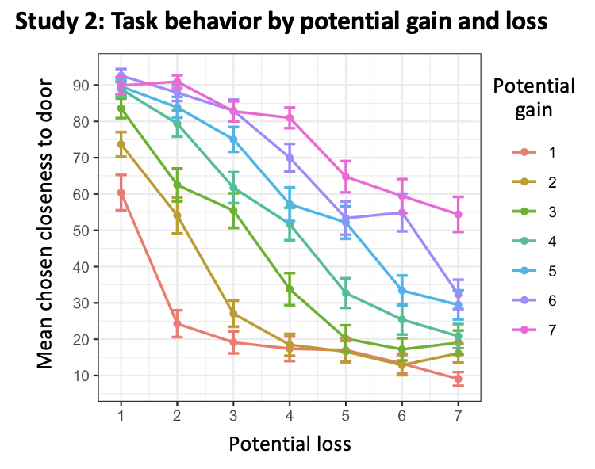

Fig. S1. Study 2 - replication sample: task behavior. Impact of different magnitudes of potential loss and gain (1-7 coins to lose/win) on task behavior (chosen closeness to the door), indicating a pattern of greater chosen closeness with greater potential gain and with smaller potential loss. Bars reflect standard error of the mean.

In addition to the correlations reported in the main text, $β_{L×C}$ correlated positively with STAI scores, r(35)=0.44, p=0.007. Additionally, $β_{RT}$ marginally related to $β_{L×C}$, r(35)=0.31, p=0.061, and $β_{Gain}$ , r(35)=-0.27, p=0.095. $β_{L×C}$ also correlated positively with subjective assessment of loss magnitude, r(31)=0.48, p=0.005 and negatively, but only at trend level, with subjective assessment of gain magnitude, r(31)=-0.31, p=0.082.

Additionally, we examined the participants’ subjective perception of outcomes received (Fig. 3a, top), in terms of their retrospective assessment of outcome frequency (frequency of gains and losses) and magnitude (number of coins gained and lost), vs. actual outcomes received (Fig. 3a, bottom). In terms of outcome frequency, and considering a rating of 5 as the midpoint of each rating scale, participants reported receiving a gain outcome (seeing the fairy figure) somewhat less than expected, M=4.51, t(32)=-1.77, p=0.087 (t-test vs 5), and a loss outcome (seeing the monster figure) more than expected, M=6.61, t(32)=6.00, p<0.001, with a significant difference between these frequency ratings, t(32)=4.56, p<0.001. In reality, there was no difference between the frequency of gain and loss outcomes, p=0.52, suggesting a subjective bias in outcome frequency estimation, particularly on the loss domain. In terms of outcome magnitude assessment, participants reported gaining relatively few coins, M=3.59 (on a 0-10 scale of few to many), t(32)=-3.53, p=0.001, and losing relatively many coins, M=6.57, t(32)=3.93, p<0.001, with a significant difference between these magnitude ratings, t(32)=3.88, p<0.001. This bias is particularly striking, as the actual average number of coins gained was significantly larger than the number of coins lost, t(36)=7.07, p<0.001 (see Table S6 for detailed statistics).
Exploratory analyses of these biases indicated that anxiety severity was positively associated with subjective assessment of loss magnitude, r(31)=0.35, p=0.049 (see Fig. 3b); this correlation remained significant after controlling for the actual magnitude of loss. Further, depressive symptom severity was positively associated with subjective assessment of loss frequency, r(31)=0.36, p=0.043 (see Fig. 3c); this correlation remained significant after controlling for the actual frequency of loss. Actual frequency and magnitude of losses and gains were not associated with anxiety or depressive symptoms severity, rs<0.11, ps>0.50. Together, these findings highlight the potential relevance of subjective biases, regardless of objective experience, to symptoms.

Study 3
Methods
Participants. The STAI trait subscale, GAD-7, and PHQ-9 were administered along with the task via the Pavlovia website (https://pavlovia.org/). Across the sample ,STAI and GAD-7 scores were significantly correlated, r(118)=0.78, p<0.001, as were STAI and PHQ-9 scores, r(118)=0.79, p<0.001, and GAD-7 and PHQ-9 scores, r(118)=0.80, p<0.001.
Results
See Fig. S2 for descriptive depiction of task behavior by magnitude of potential gains and losses. In the mixed-effects model, all VIF values for predictors in the model were lower than 2.46. Replicating the previous studies, $β_{L×C}$ negatively predicted closeness to the door M=-0.10, t(10666)=-11.49, p<0.001, while $β_{G×C}$ positively predicted closeness, M=0.14, t(10666)=15.62, p<0.001.
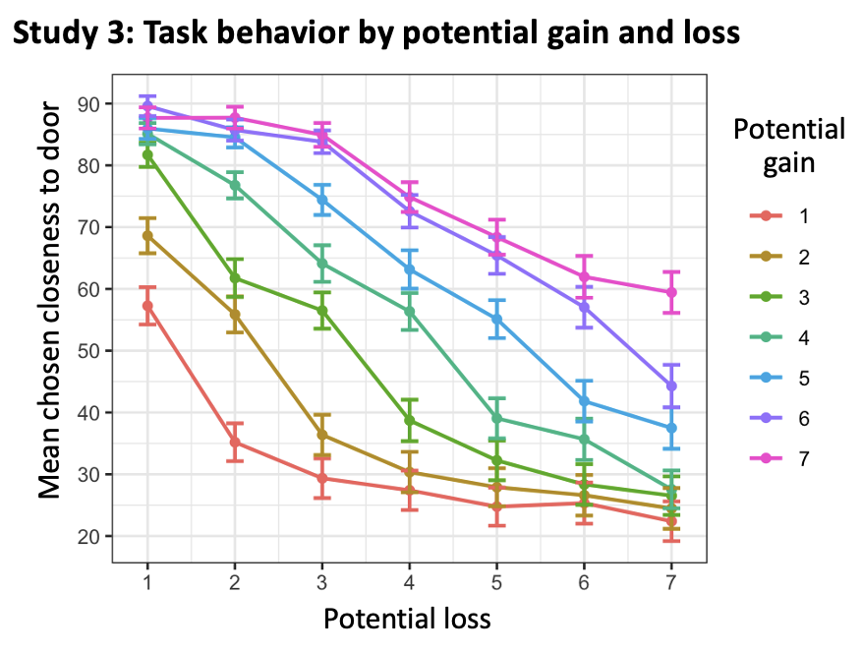

Fig S2. Study 3 - online sample: task behavior. Impact of different magnitudes of potential loss and gain (1-7 coins to lose/win) on task behavior (chosen closeness to the door), indicating a pattern of greater chosen closeness with greater potential gain and with smaller potential loss. Bars reflect standard error of the mean.

Similarly to their association with STAI scores, $β_{Gain}$ correlated positively with anxiety severity as assessed by GAD-7 scores, r(82)=0.27, p=0.011, while $β_{Loss}$ correlated negatively with GAD-7 scores, r(82)=-0.25, p=0.024, and $β_{Conflict}$ did not correlate with anxiety, p=0.21. Likewise, $β_{Gain}$ correlated positively with depressive symptom severity as assessed by PHQ-9 scores, r(82)=0.22, p=0.044, while $β_{Loss}$ showed a negative correlation with PHQ-9 scores, r(82)=-0.25, p=0.023, and $β_{Conflict}$ did not correlate with PHQ-9 scores, p=0.66.
The number of coins collected during the task correlated positively with GAD-7 scores, r(82)=0.36, p<0.001, and with PHQ-9 scores, r(82)=0.31, p=0.004.
Additionally, we examined subjective biases in retrospective assessment of outcome frequency (frequency of gains and losses) and magnitude (number of coins gained and lost), vs. actual outcomes received (Fig. 5). In terms of outcome frequency, and replicating Study 2, participants reported receiving a higher frequency of loss relative to gain outcomes (each rated on a 0-10 frequency scale), t(82)=2.47, p=0.016, while in reality, there was no objective difference in outcome frequencies, p=0.53, suggesting a subjective bias in outcome frequency estimation. This bias was particularly driven by the loss domain, whereby participants reported more losses than expected, M=5.74, t(82)=4.00, p<0.001 (t-test vs. a midpoint of 5), while gain frequency was assessed correctly, M=4.91, p=0.65. A robust loss bias was likewise noted in subjective perception of outcome magnitude. As in Study 2, participants reported that they lost more game money than won (each rated on a 0-10 scale of magnitude), t(83)= 2.22, p=0.029, while the actual number of coins lost was in fact smaller than that won, t(83)=7.82, p<0.001 see Table S6). These biases did not significantly correlate with symptoms, ps>0.24.

As noted in the main text, we excluded participants with at least 80% of trials in which no location locking was made. For completeness, we repeated all analyses with the complete dataset (N=120). The linear mixed-effects model indicated that $β_{Gain}$ was a significant and positive predictor of chosen closeness to the door, M=0.53, t(17514)=56.97, p<0.001, while $β_{Loss}$ was a significant, negative predictor of closeness, M=-0.55, t(17514)=-68.55, p<0.001. Additionally, $β_{Conflict}$ was a significant and negative predictor of closeness, M=-0.02, t(17514)=-3.27, p=0.001, and RT was positively associated with closeness, M=0.04, t(17514)=4.77, p<0.001, while sex and age were not, ps>0.12. $β_{Gain}$ and $β_{Loss}$ were significantly and negatively correlated, r(118)=-0.91, p<0.001. Age and sex were not correlated with $β_{Gain}$, $β_{Loss}$, or $β_{Conflict}$, ps>0.18.
In terms of associations with symptoms, $β_{Gain}$ correlated significantly and positively with anxiety severity (STAI scores), r(118)=0.23, p=0.011, while $β_{Loss}$ correlated negatively with anxiety severity, r(118)=-0.22, p=0.015, and $β_{Conflict}$ did not, p=0.79. Similarly, $β_{Gain}$ correlated positively with STAI scores, r(118)=0.25, p=0.007, while $β_{Loss}$ correlated negatively with anxiety, r(118)=-0.22, p=0.015, and $β_{Conflict}$ was not correlated with anxiety, p=0.20. $β_{Gain}$ correlated positively with PHQ-9 scores, r(118)=0.23, p=0.010, while $β_{Loss}$ correlated negatively with depressive symptom severity, r(118)=-0.23, p=0.011, and $β_{Conflict}$ was not correlated with depressive symptom severity, p=0.95. Task performance, quantified by mean number of coins collected, was positively associated with anxiety severity (STAI scores), r(118)=0.22, p=0.016. The number of collected coins also correlated positively with $β_{Gain}$, r(118)=0.46, p<0.001, and negatively with $β_{Loss}$, r(118)=-0.44, p<0.001.
Finally, in terms of subjective biases in retrospective assessment of outcome frequency participants reported receiving a higher frequency of loss relative to gain outcomes, t(117)=3.32, p=0.001, while in reality, there was no objective difference in outcome frequencies, p=0.44, suggesting a subjective bias in outcome frequency estimation. This bias was particularly driven by the loss domain, whereby participants reported more losses than expected, M=5.73, t(117)=4.86, p<0.001, while gain frequency was estimated correctly, M=4.82, p=0.25. For subjective perception of outcome magnitude, participants reported that they lost more game money than won, t(118)= 2.48, p=0.015, while the actual number of coins lost was in fact smaller than that won, t(118)=10.20, p<0.001. These biases did not significantly correlate with symptoms, ps>0.05.
Taken together, all significant effects identified using the final, “cleaned” version reported in the main text remained significant when considering the full sample. We chose to report in the main text on the former since we believe it more closely reflects meaningful task engagement.

Study 4
Methods
Participants
As noted in the main text, we excluded 3 participants (1 HV, 2 ANX) with non-significant $β_{Gain}$ and $β_{Loss}$ coefficients or insufficient trial numbers (<49). We used a more lenient threshold for inclusion based on number of trials in this study than in Study 3 since the latter involved administration over the online mTurk platform where no control over performance was available. In contrast, for Study 4, a research assistant present in the room monitored for instances where task instructions were not followed, as indicated by a response time over 10s. Of note, same criteria were used for Studies 1 and 2 and did not lead to exclusion of participants.
Diagnosis
All participants were interviewed by trained clinicians using the Kiddie Schedule for Affective Disorders and Schizophrenia for School-Age Children-Present and Lifetime Version (KSADS-PL; Kaufman et al., 1997). Clinicians underwent initial training to achieve acceptable reliability with expert diagnosticians, and all diagnoses were confirmed by a senior psychiatrist (author DSP). Patients met criteria for generalized anxiety, social anxiety, and/or separation anxiety disorder as their primary source of distress. Importantly, subjects were specifically recruited to be free of comorbidities beyond anxiety disorders, consistent with previous clinical trials (Walkup et al., 2001). Healthy participants did not meet criteria for any psychiatric diagnosis. Exclusion criteria for all participants included an IQ < 70, assessed using the Wechsler Abbreviated Scale of Intelligence (WASI; Wechsler, 1999), as well as diagnoses of autism spectrum disorder, posttraumatic stress disorder (PTSD), schizophrenia, or conditions like attention deficit hyperactivity disorder (ADHD) or irritability in oppositional defiant disorder (ODD) severe enough to warrant treatment. Additional exclusions included obsessive-compulsive disorder, major depressive disorder, the use of any psychoactive substances within three months of participation, neurological disorders, a history of trauma, or significant medical illness (Linke et al., 2019; Walkup et al., 2001).

Results
See Fig. S3 for depictions of task behavior as a function of potential gain and loss magnitude. All VIF values for predictors in the model were lower than 2.44. $β_{RT}$ did not predict closeness to the door, p=0.78. As in the previous studies, $β_{L×C}$ negatively predicted closeness, M=-0.11, t(6186)=-9.68, p<0.001, while $β_{G×C}$ positively predicted closeness, M=0.13, t(6186)=11.13, p<0.001. Age and sex did not significantly predict behavior, ps>0.13. In addition to the correlations reported in the main text, $β_{Loss}$ correlated positively with $β_{Conflict}$, r(45)=0.32, p=0.028, while $β_{L×C}$ correlated at trend level with SCARED scores, r(45)=0.25, p=0.084. ANOVA indicated that mean $β_{G×C}$ was more positive in the HV (M=0.15) than in the ANX group (M=0.09), t(45)=2.27, p=0.028, and that mean $β_{L×C}$ was more negative in the HV (M=-0.14) than in the ANX group (M=-0.09), but only at trend level, t(45)=1.89, p=0.065.

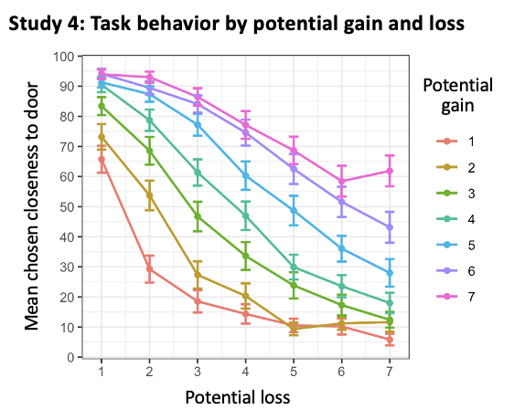
Fig. S3. Pediatric anxiety sample: task behavior. Impact of different magnitudes of potential loss and gain (1-7 coins to lose/win) on task behavior (chosen closeness to the door), indicating a pattern of greater chosen closeness with greater potential gain and with smaller potential loss. Bars reflect standard error of the mean.

As in Studies 2 and 3, we retroactively assessed subjective perception of experienced outcomes (Fig. 6c, top), in terms of estimated outcome frequency (frequency of gains and losses) and magnitude (number of coins gained and lost) vs. actual outcomes received (Fig. 6c, bottom). Replicating Studies 2 and 3, youths exhibited a bias of outcome frequency, overestimating loss outcome frequency (M=5.84 on a 0-10 scale of never to always) relative to gain outcome frequency, while in reality, there was no such difference, p=0.67. Moreover, in terms of estimated outcome magnitude, while youths gained (M=164.8) more coins than lost (M=109.4), t(47)= 9.69, p<0.001, they failed to show a difference in their assessment of outcome magnitude, t(47)=0. 42, p=0. 66 see Table S6). Thus, like adults, youths subjectively estimate their experiences as involving greater loss in terms of frequency and magnitude than what they actually encountered. These biases were not associated with anxiety severity, ps>0.39.

