Supplemental information for
“Footprint of time-reversal symmetry breaking in CsV₃Sb₅ marked in photoemission intensity”

Jaehun Cha^{1, †}, Hyunggeun Lee^{1, †}, Sangjun Sim^{1, †}, Yeahan Sur², Kwang-Tak Kim², Jae-Ho Han¹, Sun-Woo Kim³, Gyubin Lee¹, Jounghoon Hyun⁴, Chan-young Lim⁵, Yeojin Ahn¹, Seonggeon Gim¹, Jonathan D. Denlinger⁶, Sunghun Kim⁷, Kee Hoon Kim^{2,8}, SungBin Lee^{1,*}, Myung Joon Han^{1,*}, and Yeongkwan Kim^{1,*}

¹Department of Physics, Korea Advanced Institute of Science and Technology, Daejeon 34141, Republic of Korea
²Center for Novel States of Complex Materials Research, Department of Physics and Astronomy, Seoul National University, Seoul 08826, Republic of Korea
³Department of Materials Science and Metallurgy, University of Cambridge, 27 Charles Babbage Road, Cambridge, CB3 0FS, UK
⁴Department of Physics and Astronomy, Rice University, Houston, Texas 77005, USA
⁵Donostia International Physics Center, San Sebastián 20018, Spain
⁶Advanced Light Source, Lawrence Berkeley National Laboratory, Berkeley, CA 94720, USA.
⁷Department of Physics, Ajou University, Suwon 16499, Republic of Korea
⁸Institute of Applied Physics, Seoul National University, Seoul 08826, Republic of Korea

†These authors contributed equally to this work.
*E-mail: sungbin@kaist.ac.kr, mj.han@kaist.ac.kr, yeongkwan@kaist.ac.kr

Table of Contents
Supplemental Notes 1-4 :
S1. Mirror symmetry of band structure in ARPES alignment
S2. Visualization of circular dichroism with spectral intensity
S3. Investigation of inversion symmetric pattern in the int-CD distribution
S4. Statistical error for circular dichroism ARPES

Supplmenetal Figures S1-S4

S1. Mirror symmetry of band structure in ARPES alignment
The extrinsic contribution of CD which exhibits an anti-symmetric distribution, has been measured in non-magnetic materials (see in Fig. S1 a - c).^{1–4} The magnitude of this contribution can be affected by several factors, such as the elements of the sample surface, the photon energy, and the incident angle^{5–7} . However, the anti-symmetry of extrinsic CD with respect to the mirror plane of the ARPES setup, which contains the incident plane of light, remains robust.^{5,7} For this reason, the extrinsic term of CD is referred to as the contribution of “geometrical” effect. In this study, we employed the mirror symmetry in the experimental setup and band structure to remove this term and isolate the intrinsic component of CD, as illustrated in Fig. S1 d - e.^{7–10}
To exploit the mirror symmetry of the band structure and separate the extrinsic term from the normalized CD, the symmetry line must be aligned with the mirror plane of the system. To verify the alignment, we obtained the band positions of the parabolic band structure for the M-Γ-M dispersion and the Dirac crossing bands for the K-K dispersion by fitting the momentum distribution curves (MDCs) in the specific region of each band, as shown in Fig. S2 a and S2 d. The band positions obtained from the fitting are illustrated as red circles, and the blue circles represent the medians of paired band positions at the same energies. These medians lie on the $k_{x}=0$ axis with a misalignment error smaller than the momentum resolution. This indicates that the mirror lines of the band structures are well aligned at the centers of the images, at least in the binding energy down to -0.5 eV, which includes the parabolic band, vHs, and Dirac crossing. Consequently, the symmetrization of the ARPES data can be applied to separate the intrinsic and extrinsic CD contributions, as demonstrated in Fig. S2 b and e, whose momentum distributions at the energies of Fermi level and Dirac point are illustrated in Fig. S2 c and f.

S2. Visualization of circular dichroism with spectral intensity
To obtain dichroic information in ARPES data, it is necessary to normalize by the sum of the intensities for two CP lights. However, the normalization of CD reduces the spectral information and inevitably amplifies the irrelevant background without any bands. To mitigate this background term and emphasize the CD at the band position, a two-dimensional color code was employed, as shown in Fig. S3 a. The horizontal axis of the color code represents the spectral intensity, applying gamma correction to indicate the lightness of color, while the vertical axis indicates the value of normalized CD using a blue-white-red color scheme.¹¹
We applied this two-dimensional color code to our CD-ARPES images, as shown in Fig. S3 b-d. Fig. S3 b and S3 c show images of the CD and spectral intensities, respectively. The employment of the two-dimensional CD color code facilitates the visualization of the CD image in Fig. S3 d, where the CD information is encoded on the band spectra.

S3. Investigation of inversion symmetric pattern in the int-CD distribution
As mentioned in the main text, the CD-ARPES technique is capable of detecting the quantity associated with the Berry curvature, which arises due to the breaking of time-reversal symmetry (TRS) or inversion symmetry^{8–10,12,13} . It is important to note that, due to the short mean free path of photoelectrons, ARPES measurements are surface-sensitive. This suggests that inversion symmetry may be broken at the sample surface during the photoemission process. To this end, we examine the inversion symmetry pattern in the int-CD distribution to ascertain that the int-CD signals primarily originate from TRS breaking. The sign of the Berry curvature is flipped by the time-reversal operation 𝑘 → − 𝑘 when TRS is preserved, but spatial inversion symmetry is absent:
$$Ω_{z}\left(k\right)=-Ω_{z}\left(-k\right)$$Then, the local Berry curvatures at the time-reversal pair K and K′ have opposite signs. However, when spatial inversion symmetry is present, but TRS is broken, the Berry curvature does not change sign under the same operation:
$$Ω_{z}\left(k\right)=Ω_{z}\left(-k\right)$$
This indicates that if the Berry curvature at K and K′ has opposite signs, the system's inversion symmetry is broken, while TRS remains intact¹⁴ . Fig. S4 a presents the constant energy map of the int-CD distribution at the binding energy of the Dirac point, E_{B} = E_{F} – E_{DP} ​. To focus on the int-CD signal in proximity to the Dirac points, the images have been magnified in the regions delineated by red boxes in the figure. Fig. S4 a1–a4 demonstrate that the int-CD signals at the K points invariably exhibit a negative sign. To confirm this more precisely, the int-CD signals were averaged, and the results are plotted in Fig. S4 b. The solid circles indicate the averaged values from our measurements, while the hollow circles represent the expected values for the inversion symmetry breaking case. It is evident that the sign of the average int-CD signal is the same for all time-reversal pairs K and K′, which differs from the case of inversion symmetry breaking. This implies that the int-CD signal in our measurements is predominantly attributable to TRS breaking, allowing us to exclude the effect of inversion symmetry breaking in CD-ARPES measurements.
S4. Statistical error for circular dichroism ARPES
Photoemission intensity, as measured in ARPES experiments, corresponds to the number of photoelectrons emitted from a given momentum-energy state under photon irradiation. Since the emission events are discrete and inherently stochastic, the number of detected electrons over a finite acquisition time follows a Poisson distribution. In such a regime, the statistical standard deviation of the measured intensity, $ΔI$, is equal to the square root of the average intensity, $〈I〉$, i.e.,
$${\left(ΔI\right)}^{2}=〈I〉 ≈ I$$
This relationship implies that the signal-to-noise ratio improves as the total number of counts increases, which can be achieved by increasing acquisition time or photon flux.
In CD-ARPES, the dichroic signal is defined as the difference in photoemission intensities between right- and left-circularly polarized light, typically normalized by their sum to suppress systematic intensity fluctuations:
$$I=I_{RCP}+I_{LCP}, I_{CD}=\frac{I_{RCP}-I_{LCP}}{I_{RCP}+I_{LCP}}=\frac{I_{RCP}-I_{LCP}}{I}$$
Here, denote the photoemission intensities measured with right (left)-circular polarization, $I_{RCP\left(LCP\right)}$, respectively. Assuming both photoemission intensity follow independent Poisson distributions, the statistical error of the CD signal, $ΔI_{CD}$, can be derived using standard error propagation:
$$ΔI_{CD}=\sqrt{{\left(\frac{∂I_{CD}}{∂I_{RCP}}\right)}^{2}{\left(ΔI_{RCP}\right)}^{2}+{\left(\frac{∂I_{CD}}{∂I_{LCP}}\right)}^{2}{\left(ΔI_{LCP}\right)}^{2}}$$
Given ${\left(ΔI_{RCP(LCP)}\right)}^{2}=I_{RCP(LCP)}$, we obtain:
$$ΔI_{CD}=\sqrt{{\left(\frac{2I_{LCP}}{I^{2}}\right)}^{2}I_{RCP}+{\left(\frac{2I_{RCP}}{I^{2}}\right)}^{2}I_{LCP}}=\sqrt{\frac{4I_{RCP}I_{LCP}}{I^{3}}}$$
This expression can be further simplified using the identity, $1-I_{CD}^{2}=1-\frac{{\left(I_{RCP}-I_{LCP}\right)}^{2}}{I^{2}}=\frac{4I_{RCP}I_{LCP}}{I^{2}}$, yielding the final compact form:
$$ΔI_{CD}=\sqrt{\frac{1-{I_{CD}}^{2}}{I}}$$
This expression provides a practical and efficient means to evaluate the statistical uncertainty of CD-ARPES measurements, offering crucial insight into the significance of small dichroic signals, particularly in the presence of symmetry-breaking phenomena such as time-reversal symmetry breaking.

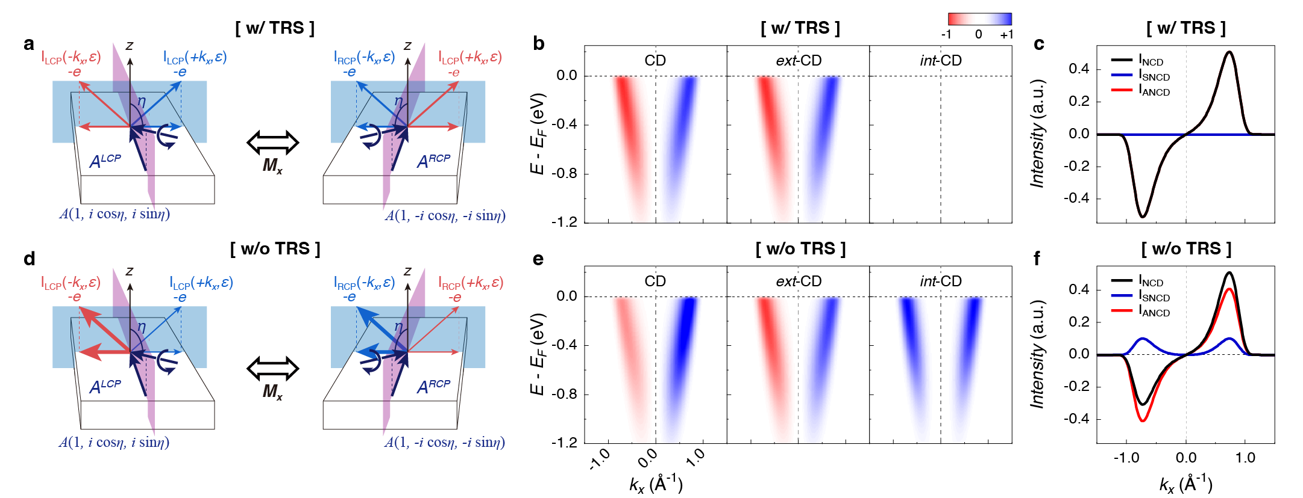
Fig. S1. Geometrical effect in CD-ARPES and CD intensities with/without time-reversal symmetry. a, Experimental geometry of ARPES process for two circularly polarized lights, RCP and LCP with time-reversal symmetry (TRS). The photoemission intensities for RCP and LCP are symmetric about mirror plane with TRS. b, Simulated CD-ARPES intensity and its extrinsic and intrinsic components with TRS. c, The momentum distribution of CD intensity at the Fermi level extracted from the figure b. d, Experimental geometry of ARPES process for two circularly polarized lights, RCP and LCP without TRS. The photoemission intensities for RCP and LCP are asymmetric about mirror plane without TRS. e, Simulated CD-ARPES intensity and its extrinsic and intrinsic components with TRS. f, The momentum distribution of CD intensity at the Fermi level extracted from the figure e.
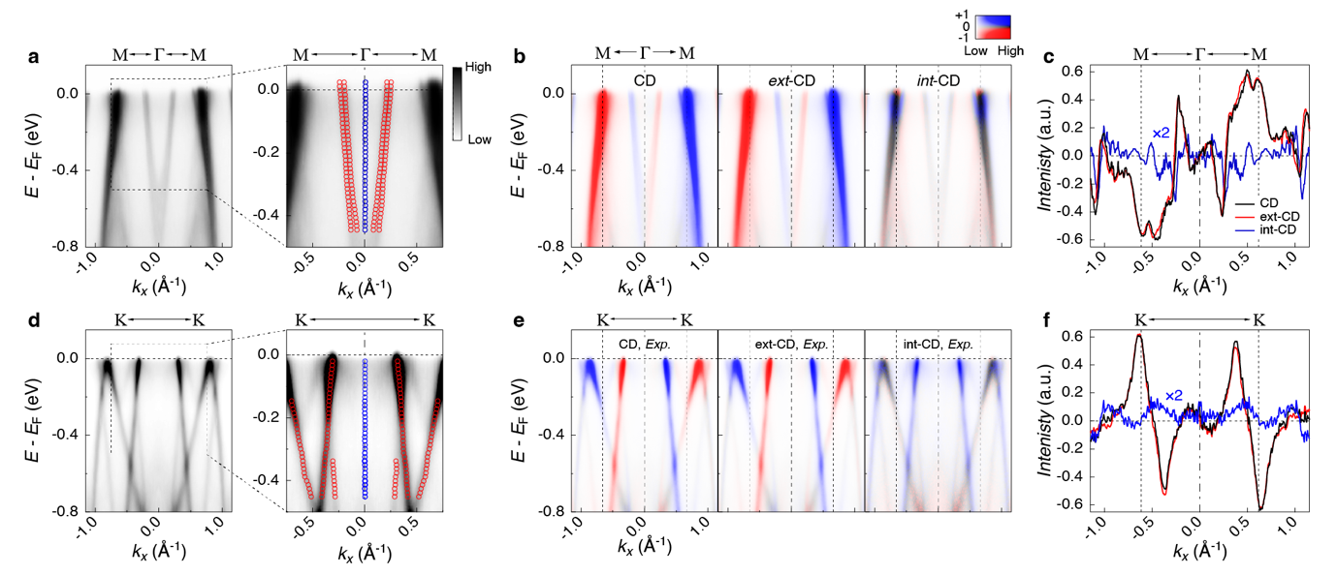
Fig. S2. Mirror symmetry of band structure and geometrical analysis of CD. a. Sum of ARPES spectra by two circularly polarized lights, RCP and LCP, along M-Γ-M path. The right figure is the magnified image in the region enclosed by the dashed box. Red circles are the peak positions of parabolic dispersion at Γ obtained by fitting the momentum distribution curves (MDCs). Blue circles are the middle points of peak position pair for $±k$ and they are located on the axis $k_{x}=0$, which is described by the dot-dashed line. b, CD (left), int-CD (center), and ext-CD (right) of M-Γ-M dispersion by the geometrical analysis of CD intensity. c, Momentum distribution of CD, int-CD, and ext-CD in the figure b at the Fermi energy. The curve of int-CD is magnified by two to visualize their distribution precisely. d, Sum of ARPES spectra by RCP and LCP, along K-K path. The right figure is the magnified image in the region enclosed by the dashed box. Red circles are the peak positions of band dispersions in the figure obtained by fitting the MDCs. Blue circles are the middle points of peak position pair for $±k$ and they are located on the axis $k_{x}=0$, which is described by the dot-dashed line. e, CD (left), int-CD (center), and ext-CD (right) of K-K dispersion by the geometrical analysis of CD intensity. f, Momentum distribution of CD, int-CD, and ext-CD in the figure e at the Fermi energy. The curve of int-CD is magnified by two to visualize their distribution precisely.

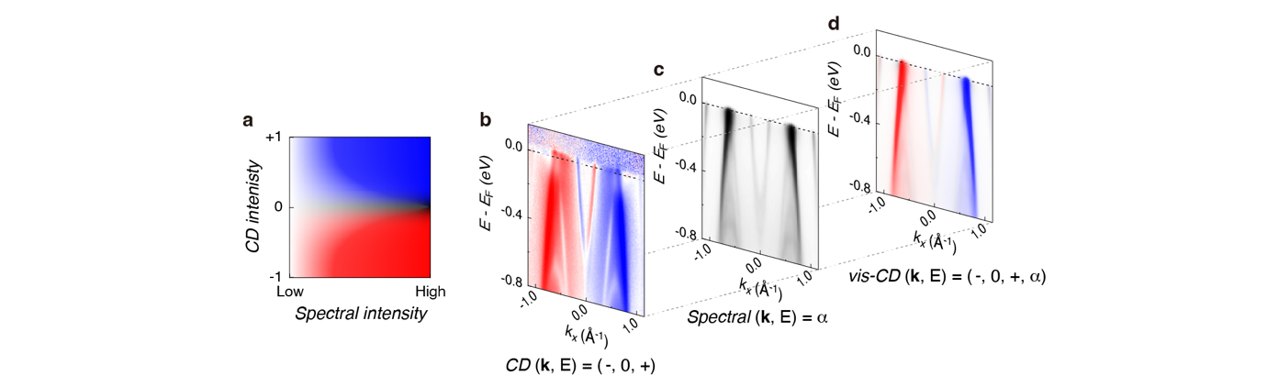
Fig. S3. Visualization of CD-ARPES on spectral intensity. a, Two-dimensional color code to visualize CD-ARPES image with spectral intensity. The horizontal axis is the degree of spectral intensity expressed by lightness of color, and the vertical axis represents the intensity of CD described by blue-white-red color code. Positive (negative) value of CD is represented by blue (red) color, and zero value of CD is expressed by white color. b-c, Visualization of CD-ARPES using two-dimensional color code in the figure a. b, Normalized CD spectrum data which visualized by blue-white-red color code. c, Spectral intensity calculated by the sum of two spectra for RCP and LCP. d, Visualized CD image by combination of b and c images.

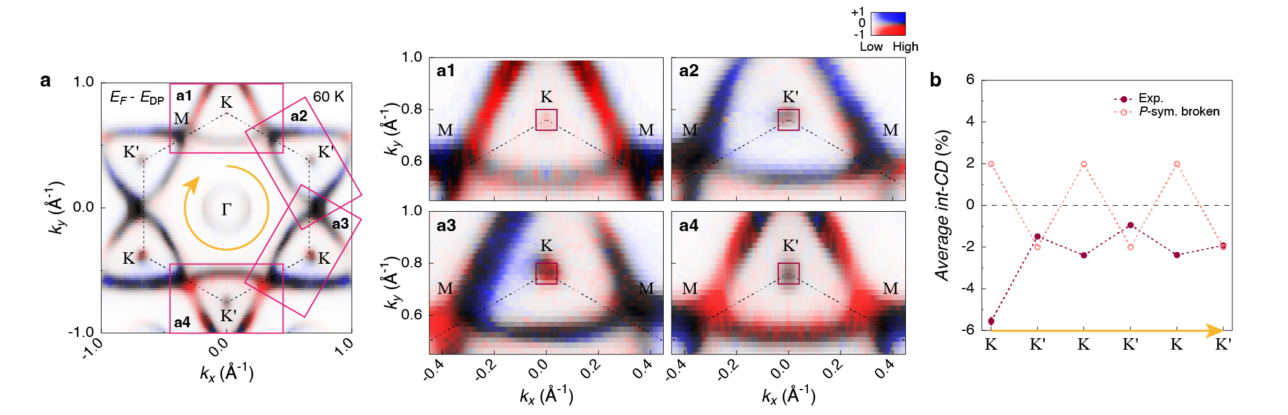
Fig. S4. Inversion symmetric pattern in the int-CD ARPES map. a, Constant energy map of int-CD on the binding energy of Dirac point, E_{B} = E_{F} - E_{DP}, at T = 60 K. The rectangular boxes are drawn in the figure, and they indicate the range of magnification for the images a1 – a4, to focus on the int-CD distribution at the Dirac points. b, Averaged int-CD of each Dirac point and expected value in the inversion symmetry breaking. The region for averaging of int-CD is depicted as red boxes in the figure a1 – a4, which enclose the Dirac points at K points.

Reference for Supplementary Information

1. Daimon, H., Nakatani, T., Imada, S. & Suga, S. Circular dichroism from non-chiral and non-magnetic materials observed with display-type spherical mirror analyzer. J. Electron Spectrosc. Relat. Phenom. 76, 55–62 (1995).
2. Ishida, Y. et al. Classification of the symmetry of photoelectron dichroism broken by light. Preprint at https://arXiv.org/abs/2007.02178 (2020)
3. Fujikawa, T. & Yimagawa, M. Theory of Angle-Resolved X-Ray Photoemission by Multiple Scattering Cluster Method. IV. Circular Dichroism for Non-Magnetic Systems. J. Phys. Soc. Jpn. 63, 4220–4243 (1994).
4. Dubs, R. L., Dixit, S. N. & McKoy, V. Circular Dichroism in Photoelectron Angular Distributions from Oriented Linear Molecules. Phys. Rev. Lett. 54, 1249–1251 (1985).
5. Moser, S. A toy model for dichroism in angle resolved photoemission. J. Electron Spectrosc. Relat. Phenom. 262, 147278 (2023).
6. Kern, C. S. et al. Simple extension of the plane-wave final state in photoemission: Bringing understanding to the photon-energy dependence of two-dimensional materials. Phys. Rev. Res. 5, 033075 (2023).
7. Erhardt, J. et al. Bias-Free Access to Orbital Angular Momentum in Two-Dimensional Quantum Materials. Phys. Rev. Lett. 132, 196401 (2024).
8. Cho, S. et al. Experimental Observation of Hidden Berry Curvature in Inversion-Symmetric Bulk 2H-WSe₂. Phys. Rev. Lett. 121, 186401 (2018).
9. Cho, S. et al. Studying local Berry curvature in 2H-WSe₂ by circular dichroism photoemission utilizing crystal mirror plane. Sci. Rep. 11, 1684 (2021).
10. Fedchenko, O. et al. Observation of time-reversal symmetry breaking in the band structure of altermagnetic RuO₂. Sci. Adv. 10, eadj4883 (2024).
11. Vidal, R. C. et al. Orbital Complexity in Intrinsic Magnetic Topological Insulators MnBi4Te7 and MnBi₆Te₁₀. Phys. Rev. Lett. 126, 176403 (2021).
12. Schüler, M. et al. Local Berry curvature signatures in dichroic angle-resolved photoelectron spectroscopy from two-dimensional materials. Sci. Adv. 6, eaay2730 (2020).
13. Cho, W. et al. Singular Hall Response from a Correlated Ferromagnetic Flat Nodal‐Line Semimetal. Adv. Mater. 36, e2402040 (2024).
14. Xiao, D., Chang, M.-C. & Niu, Q. Berry phase effects on electronic properties. Rev. Mod. Phys. 82, 1959–2007 (2010).

