Supplementary Information

Organic-inorganic hybrid scintillating glass for high-energy particle detection

Hongwei Li^{1,2}, Shichao Lv^{*1,2}, Jianrong Qiu³, Shifeng Zhou^{*1,2}
* Corresponding Author

Supplementary Table 1. The reactants for various organic-inorganic hybrid glass samples.
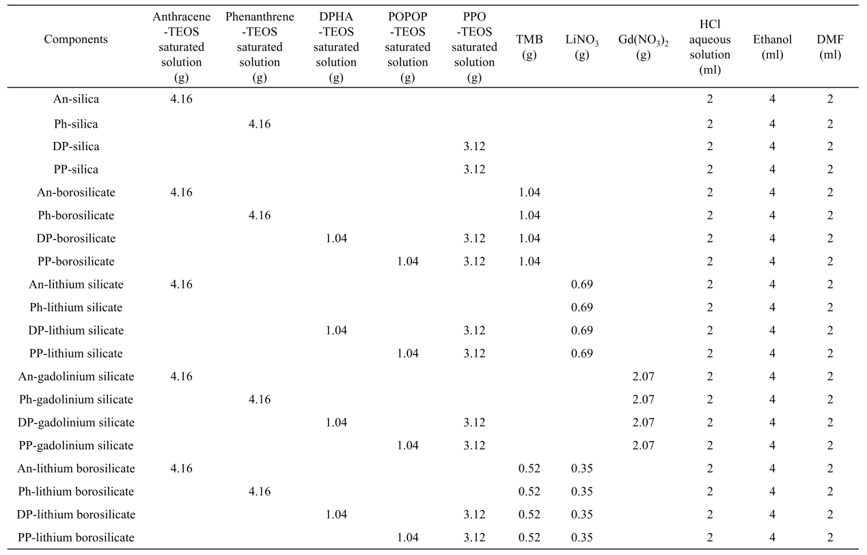

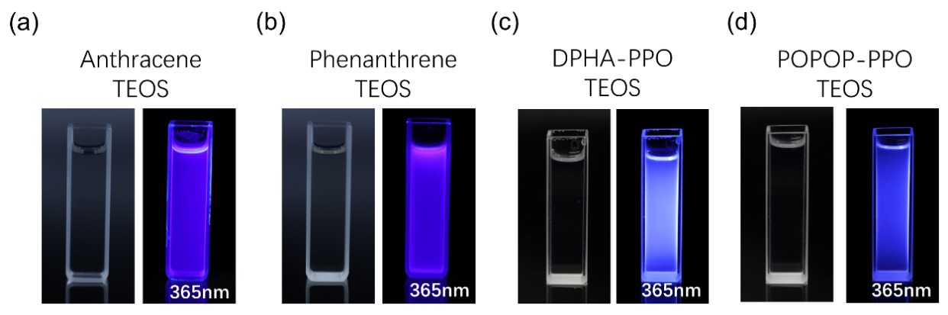
Supplementary Fig. 1. Photographs of organic-TEOS saturated solution under natural light and 365 nm. (a) Anthracene-TEOS saturated solution. (b) Phenanthrene-TEOS saturated solution. (c) DPHA-PPO-TEOS saturated solution. (d) POPOP-PPO-TEOS saturated solution.

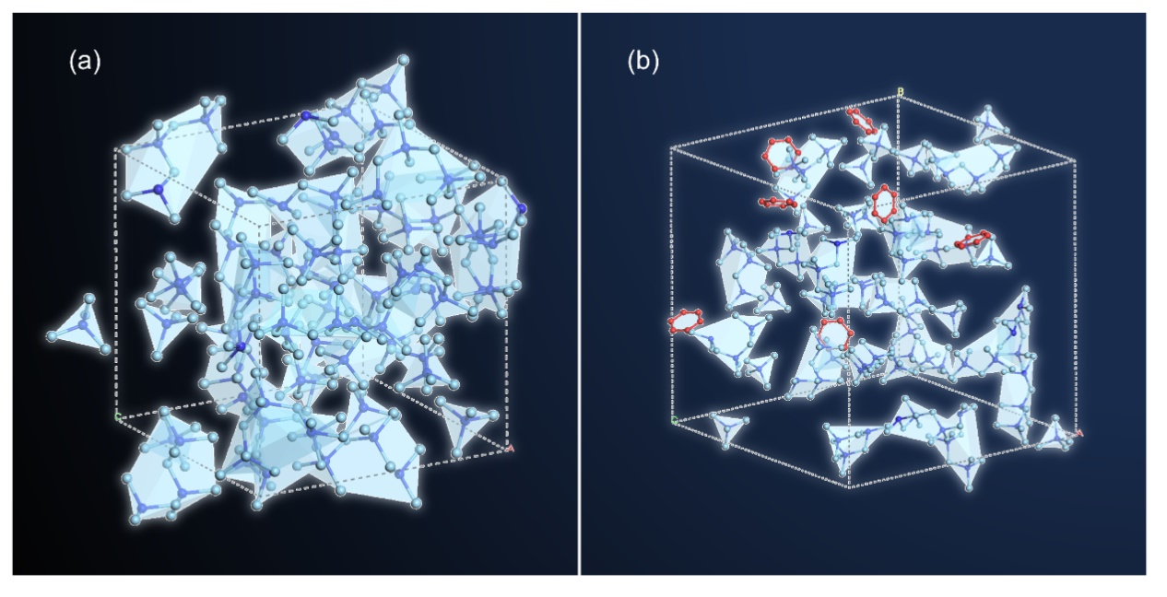
Supplementary Fig. 2. Simulation results by using Molecular Dynamic method. (a) Traditional high-density glass and (b) Low-density organic-inorganic hybrid glass.

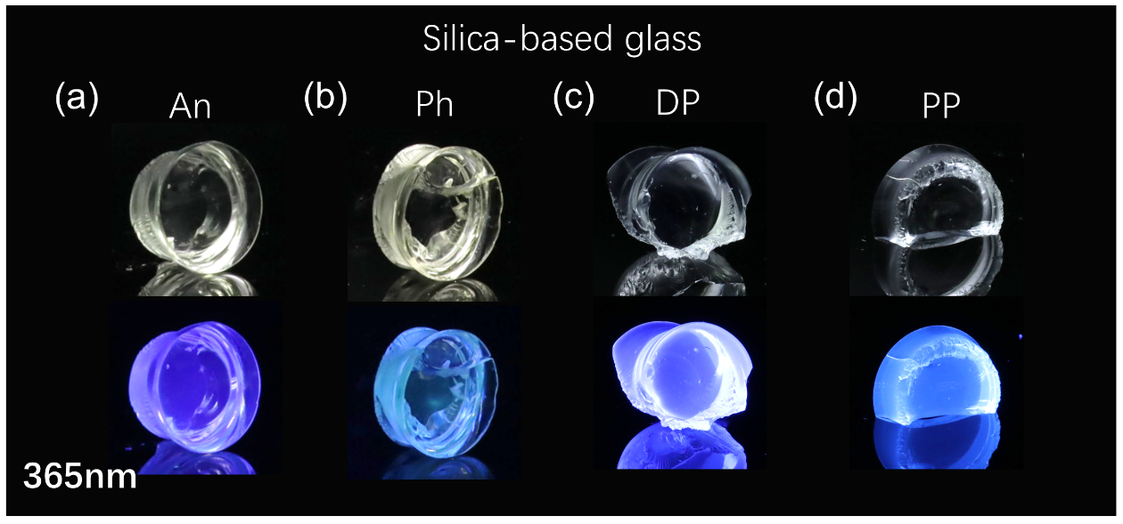
Supplementary Fig. 3. Photographs of silica-based hybrid glass under natural light and 365 nm. (a) Anthracene-silica glass. (b) Phenanthrene-silica glass. (c) DPHA-PPO-silica glass. (d) POPOP-PPO-silica glass.

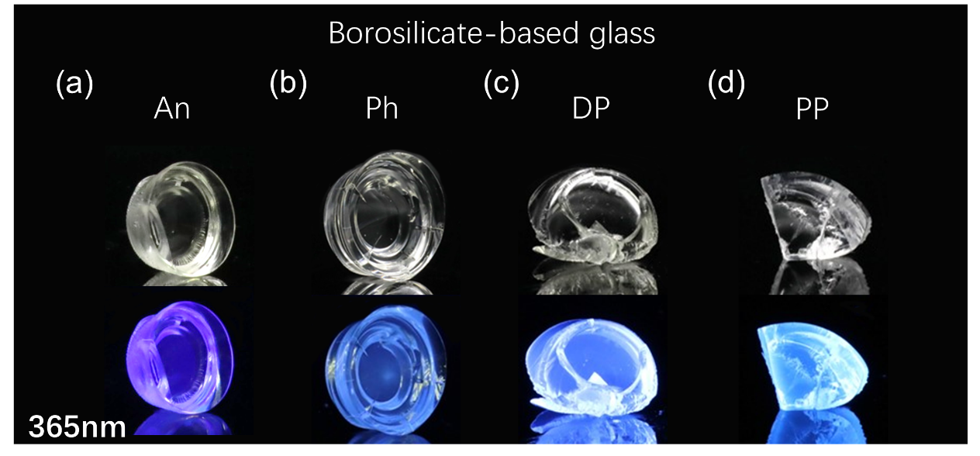
Supplementary Fig. 4. Photographs of borosilicate-based hybrid glass under natural light and 365 nm. (a) Anthracene-borosilicate glass. (b) Phenanthrene-borosilicate glass. (c) DPHA-PPO-borosilicate glass. (d) POPOP-PPO-borosilicate glass.

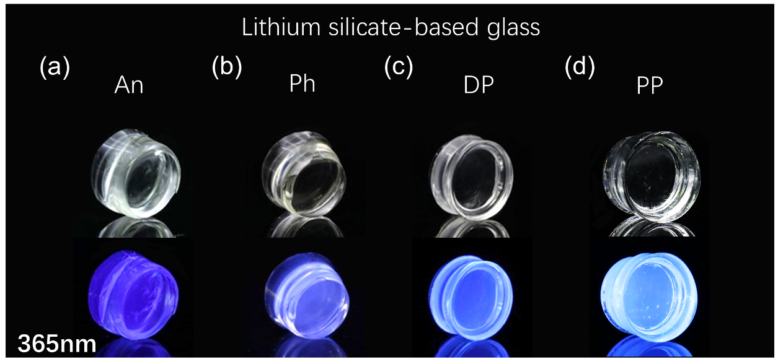
Supplementary Fig. 5. Photographs of lithium silicate-based hybrid glass under natural light and 365nm. (a) Anthracene-lithium silicate glass. (b) Phenanthrene-lithium silicate glass. (c) DPHA-PPO-lithium silicate glass and (d) POPOP-PPO-lithium silicate glass.

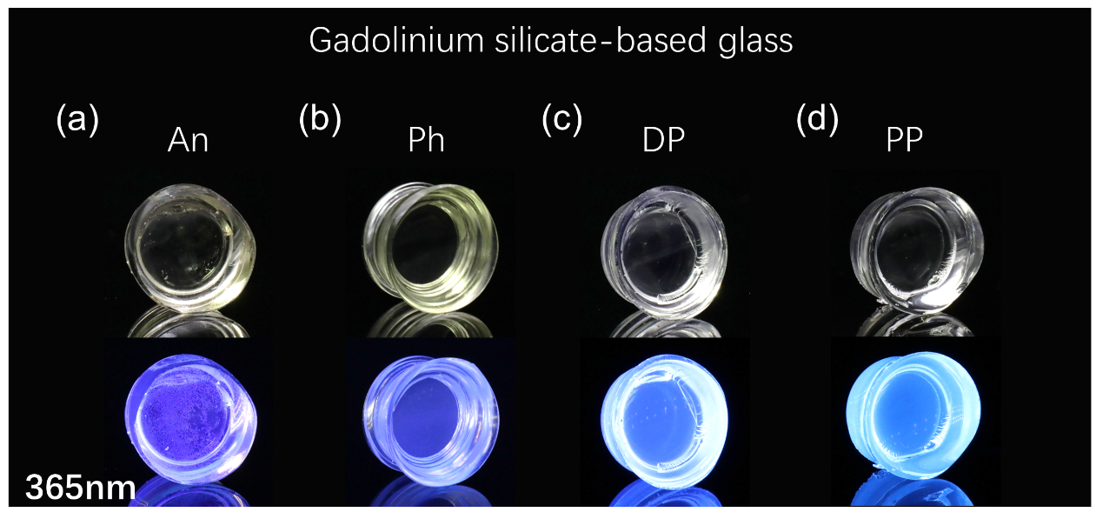
Supplementary Fig. 6. Photographs of gadolinium silicate-based hybrid glass under natural light and 365nm. (a) Anthracene-gadolinium silicate glass. (b) Phenanthrene-gadolinium silicate glass. (c) DPHA-PPO-gadolinium silicate glass and (d) POPOP-PPO-gadolinium silicate glass.

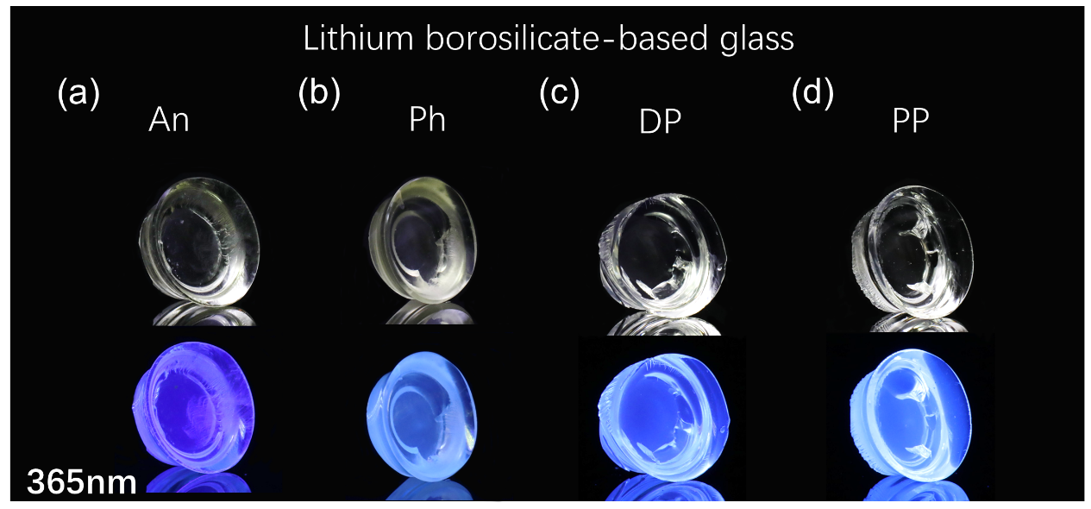
Supplementary Fig. 7. Photographs of lithium borosilicate-based hybrid glass under natural light and 365nm. (a) Anthracene-lithium borosilicate glass. (b) Phenanthrene-lithium borosilicate glass. (c) DPHA-PPO-lithium borosilicate glass and (d) POPOP-PPO-lithium borosilicate glass.

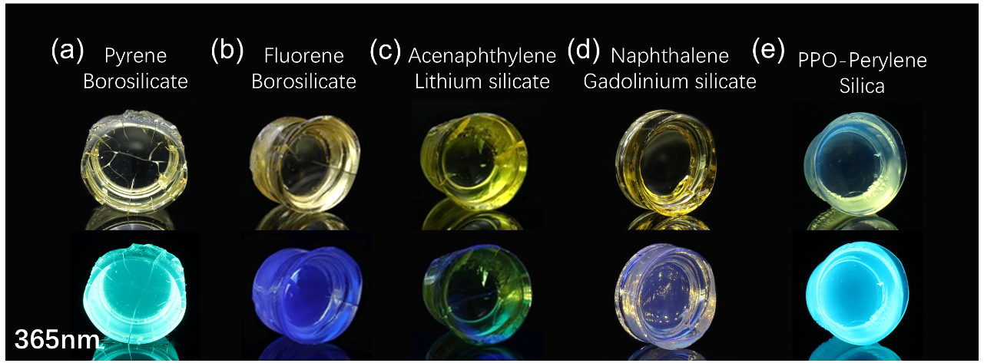
Supplementary Fig. 8. Photographs of other organic-inorganic hybrid glass under natural light and 365nm. (a) Pyrene-borosilicate glass. (b) Fluorene-borosilicate glass. (c) Acenaphthylene-lithium silicate glass. (d) Naphthalene-gadolinium silicate glass glass and (e) PPO-Perylene-silica glass.

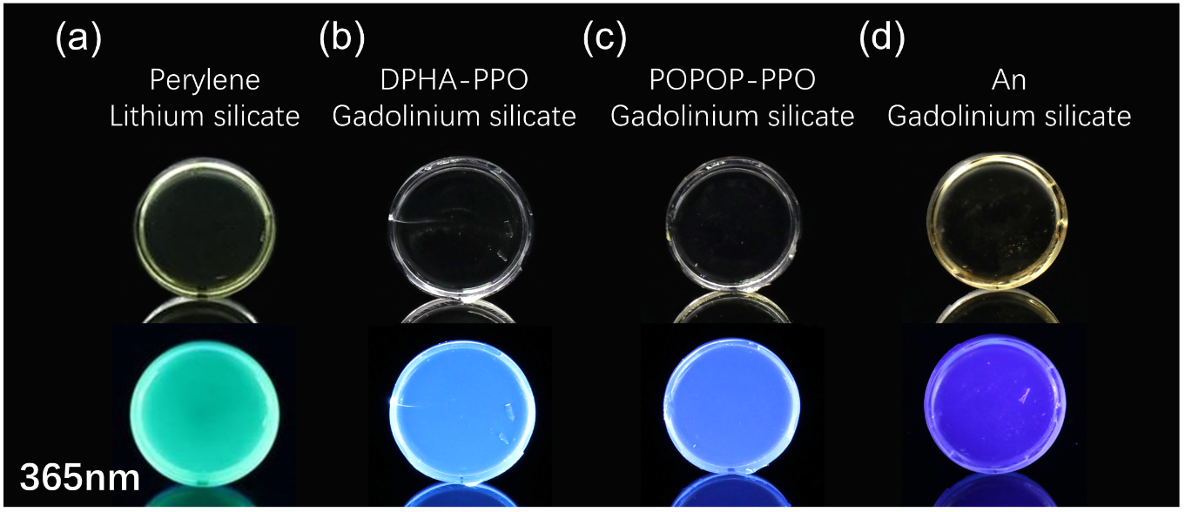
Supplementary Fig. 9. Photographs of flaky organic-inorganic hybrid glass. (a) Pyrene-lithium silicate glass. (b) DPHA-PPO-gadolinium silicate glass. (c) POPOP-PPO-gadolinium silicate glass and (d) Anthracene-gadolinium silicate glass.

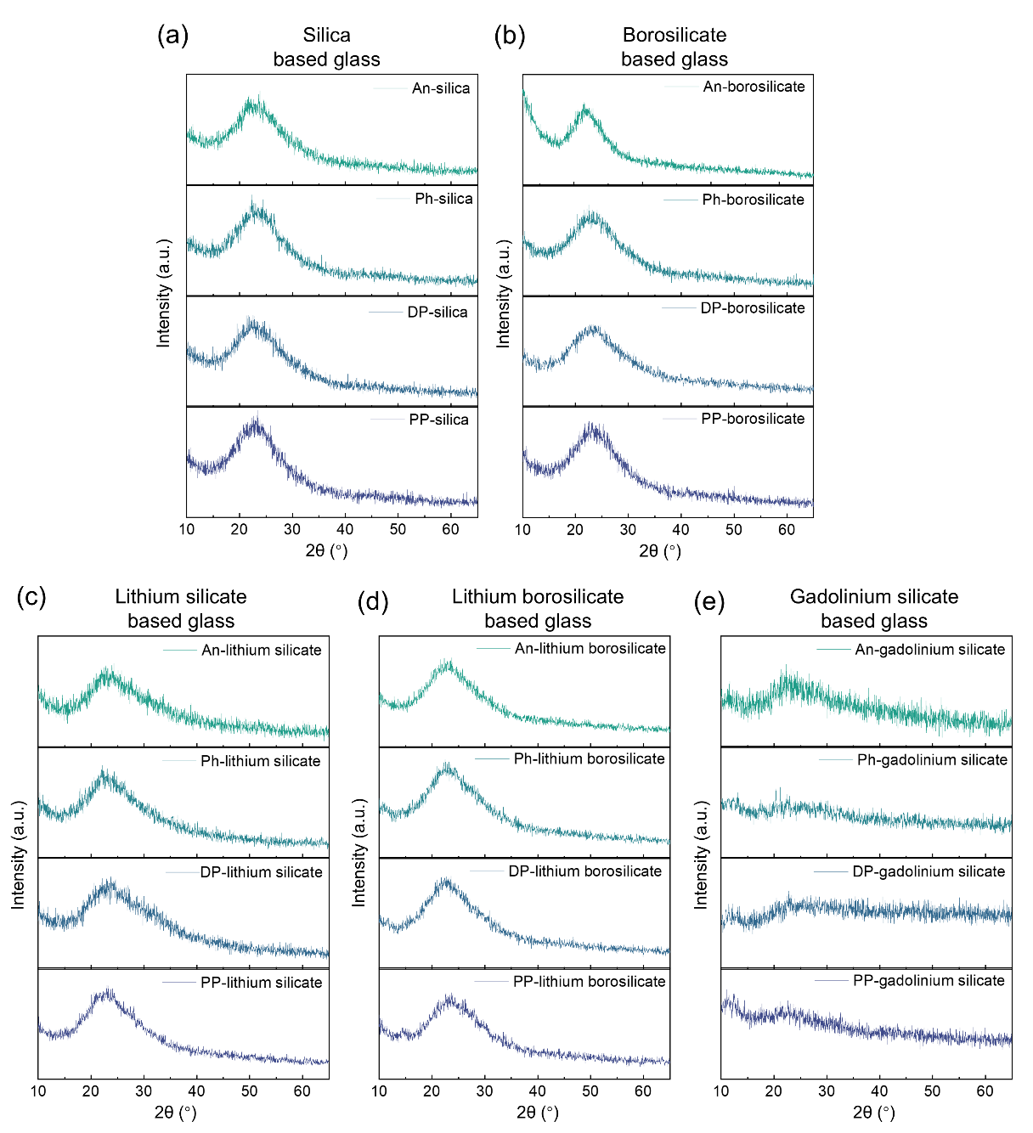
Supplementary Fig. 10. XRD patterns of organic-inorganic hybrid glass. (a) Silica-based glass. (b) Borosilicate-based glass. (c) Lithium silicate-based glass. (d) Lithium borosilicate-based glass. (e) Gadolinium silicate-based glass.

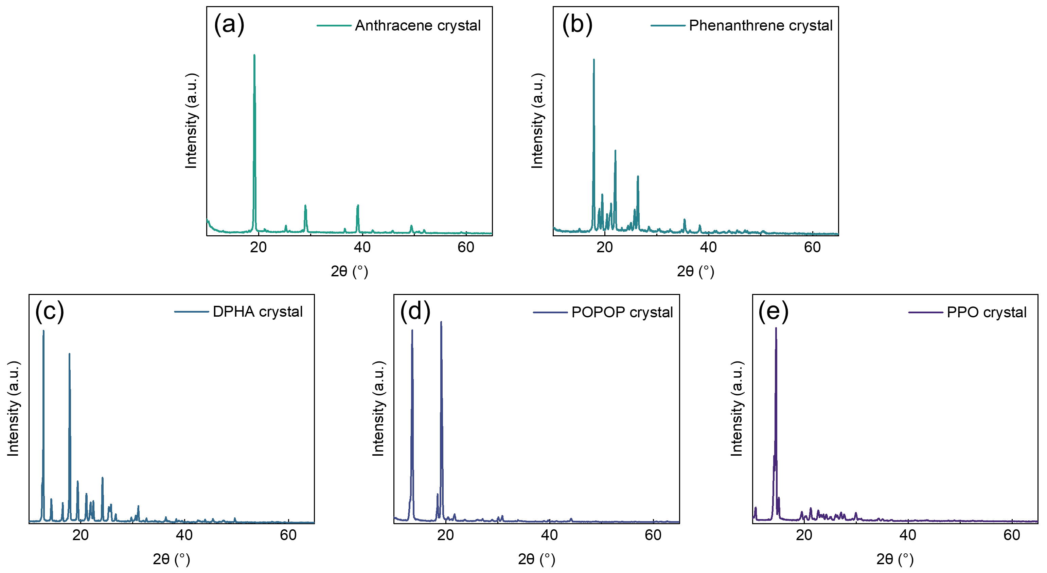
Supplementary Fig. 11. XRD patterns of organic crystal precursors. (a) Anthracene crystal. (b) Phenanthrene crystal. (c) DPHA crystal. (d) POPOP crystal. (e) PPO crystal.

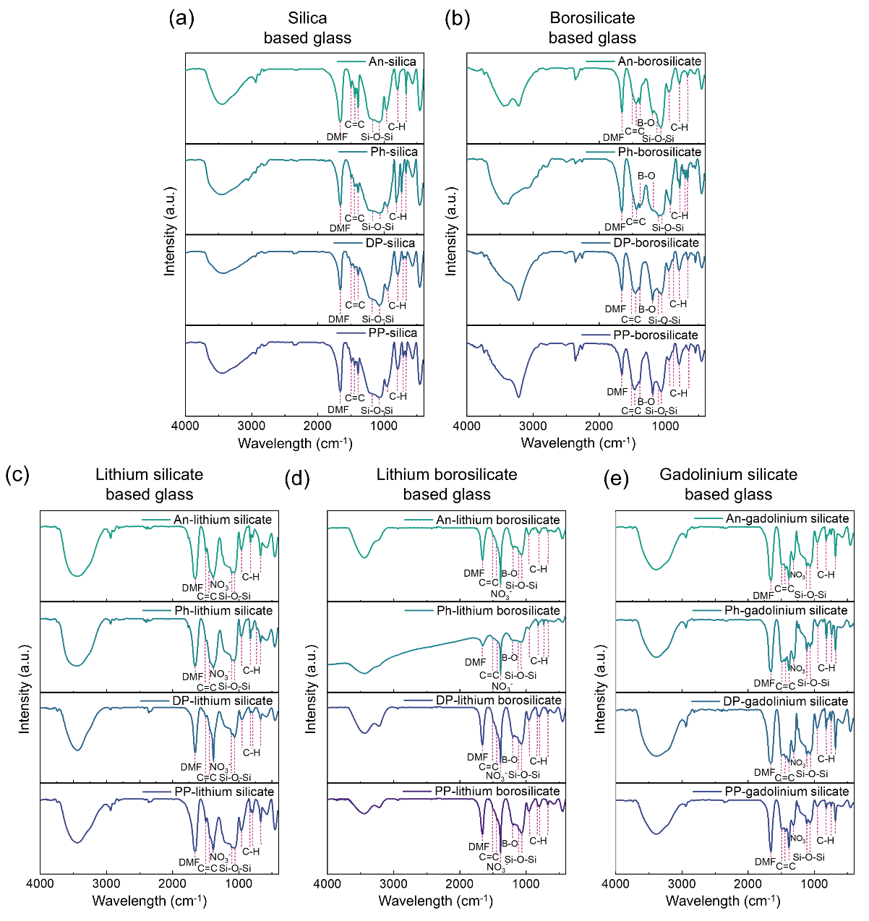
Supplementary Fig. 12. FT-IR spectra of organic-inorganic hybrid glass samples. (a) Silica-based glass. (b) Borosilicate-based glass. (c) Lithium silicate-based glass. (d) Lithium borosilicate-based glass. (e) Gadolinium silicate-based glass.

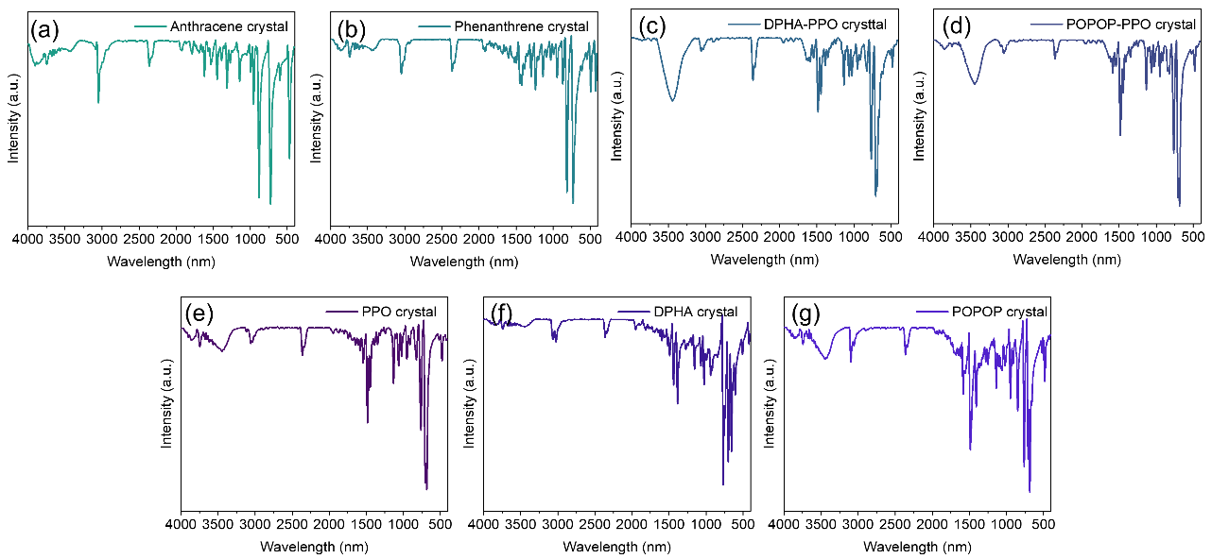
Supplementary Fig. 13. FT-IR spectra of organic crystal precursors. (a) Anthracene crystal. (b) Phenanthrene crystal. (c) DPHA-PPO crystal. (d) POPOP-PPO crystal. (e) PPO crystal. (f) DPHA crystal. (g) POPOP crystal.

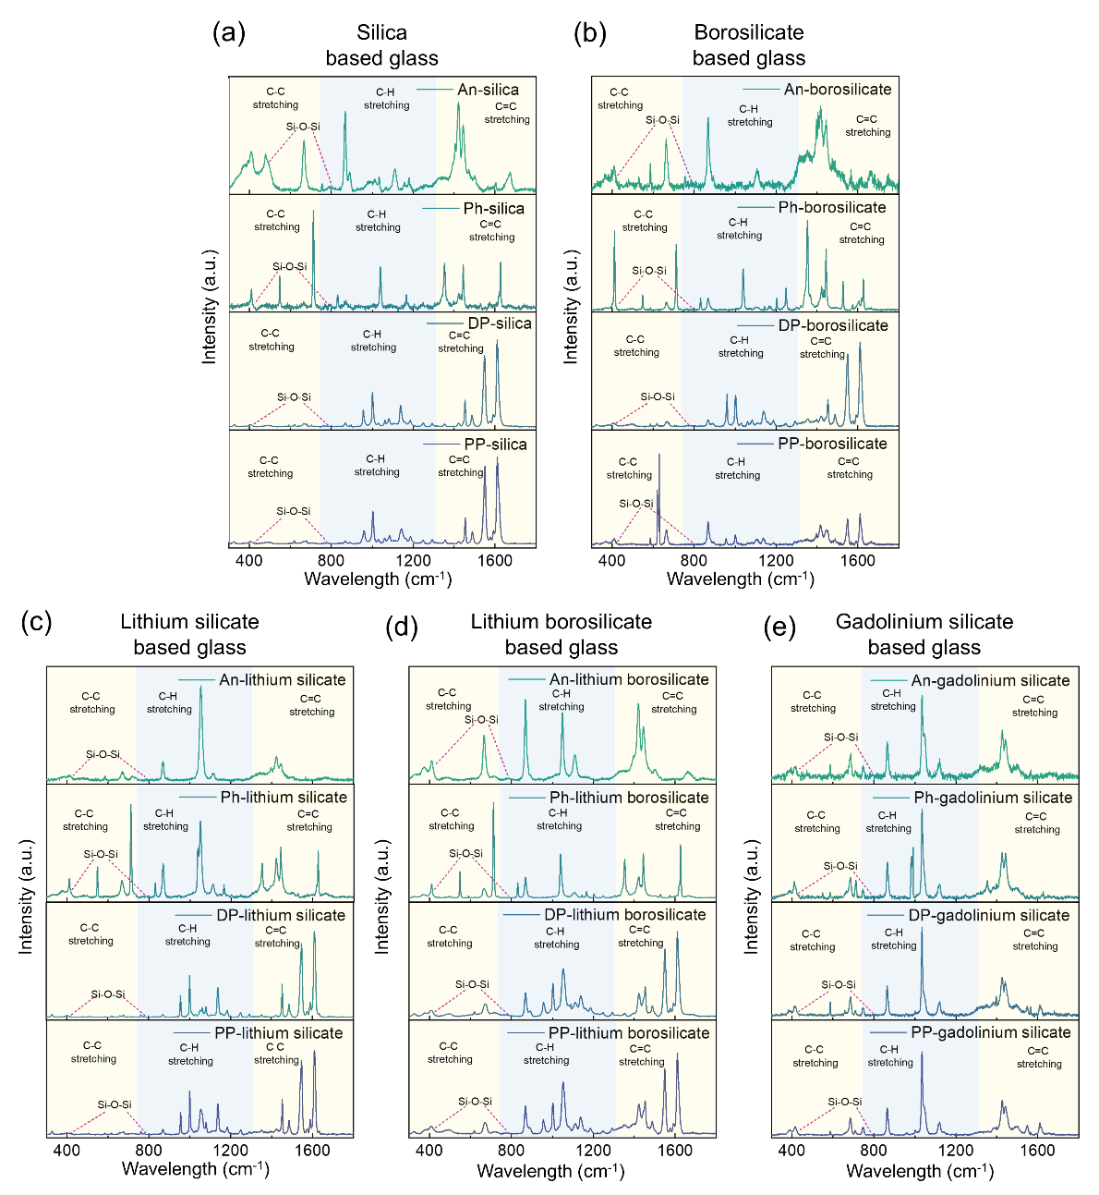
Supplementary Fig. 14. Raman spectra of organic-inorganic hybrid glass system. (a) Silica-based glass. (b) Borosilicate-based glass. (c) Lithium silicate-based glass. (d) Lithium borosilicate-based glass. (e) Gadolinium silicate-based glass.

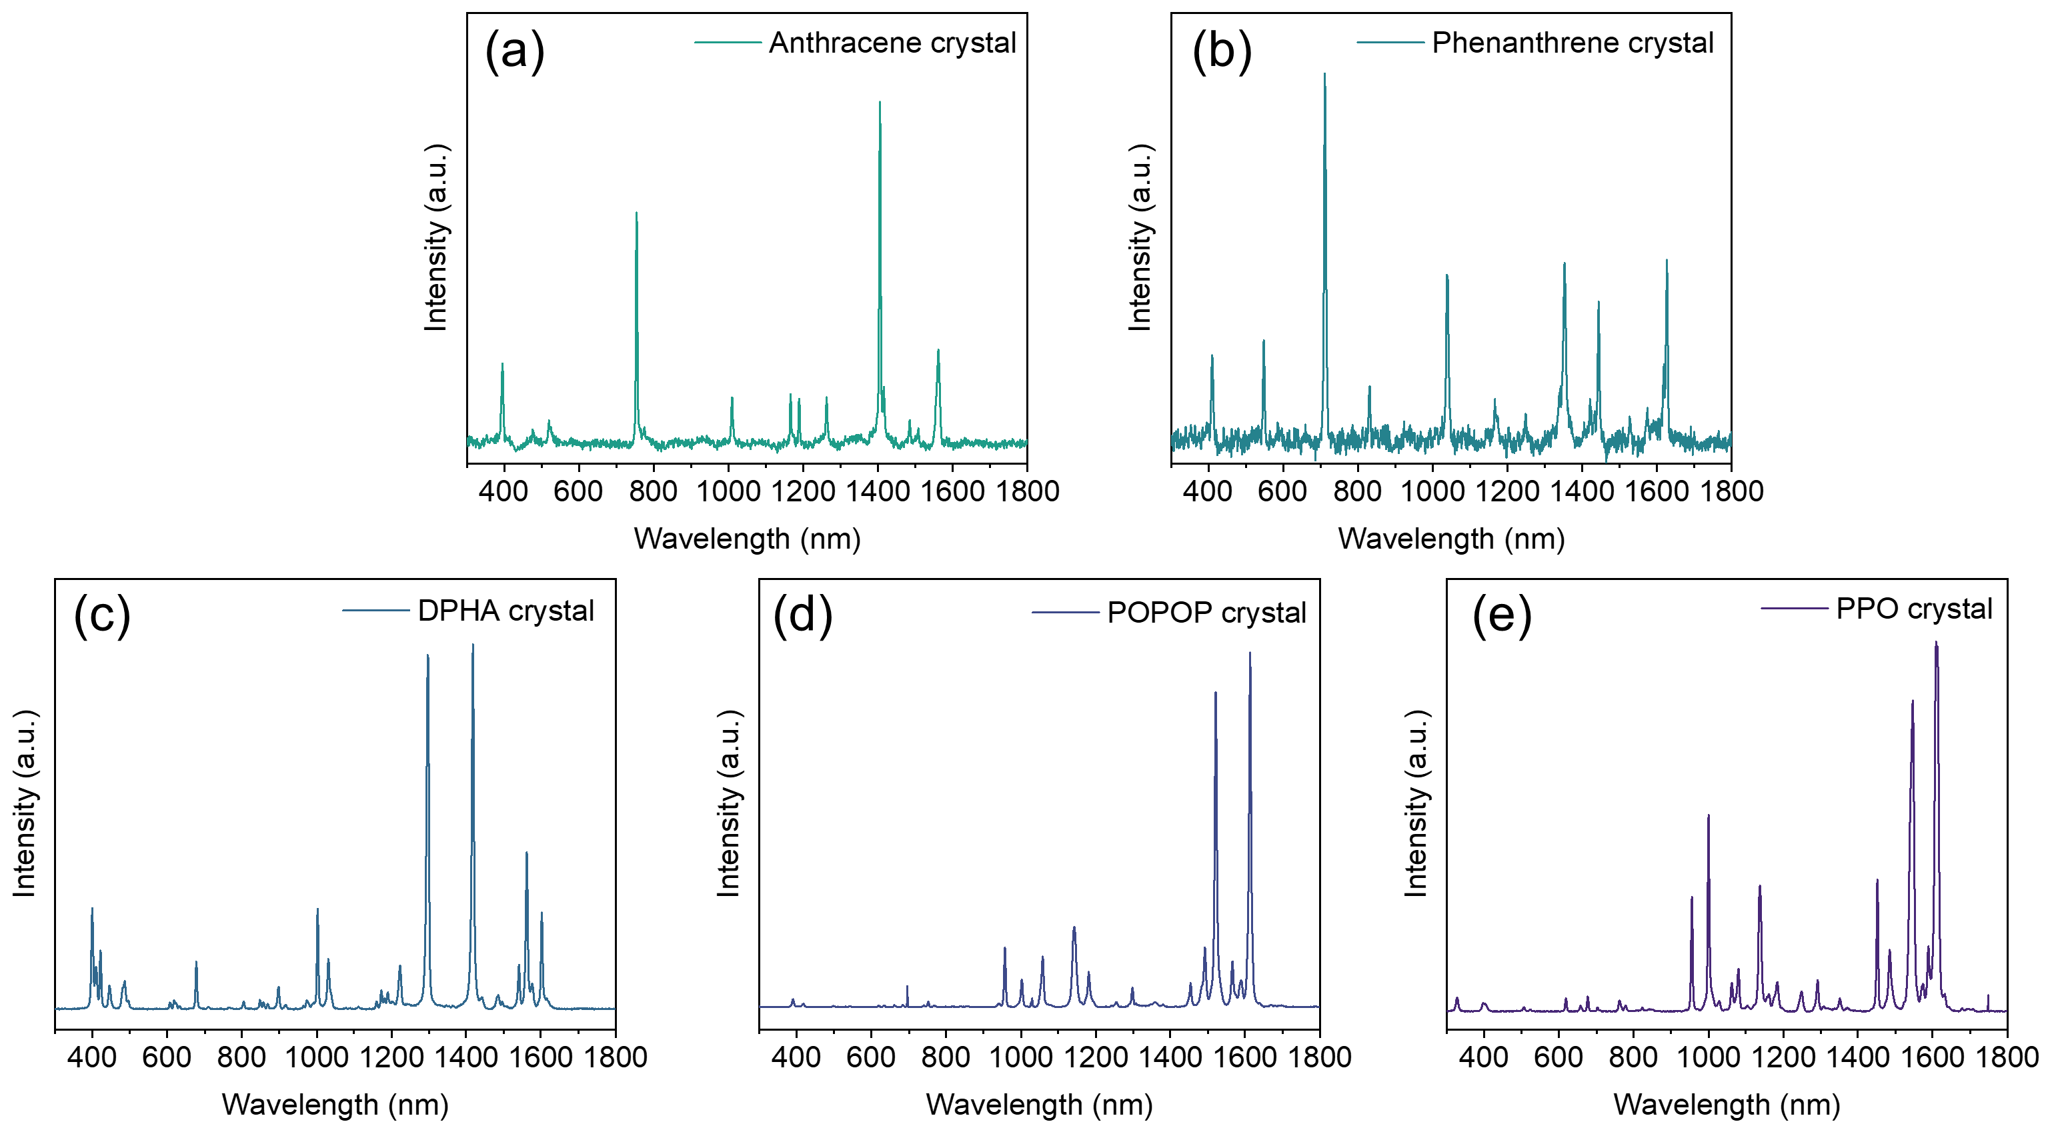
Supplementary Fig. 15. Raman spectra of organic crystal precursors. (a) Anthracene crystal. (b) Phenanthrene crystal. (c) DPHA crystal. (d) POPOP crystal. (e) PPO crystal.

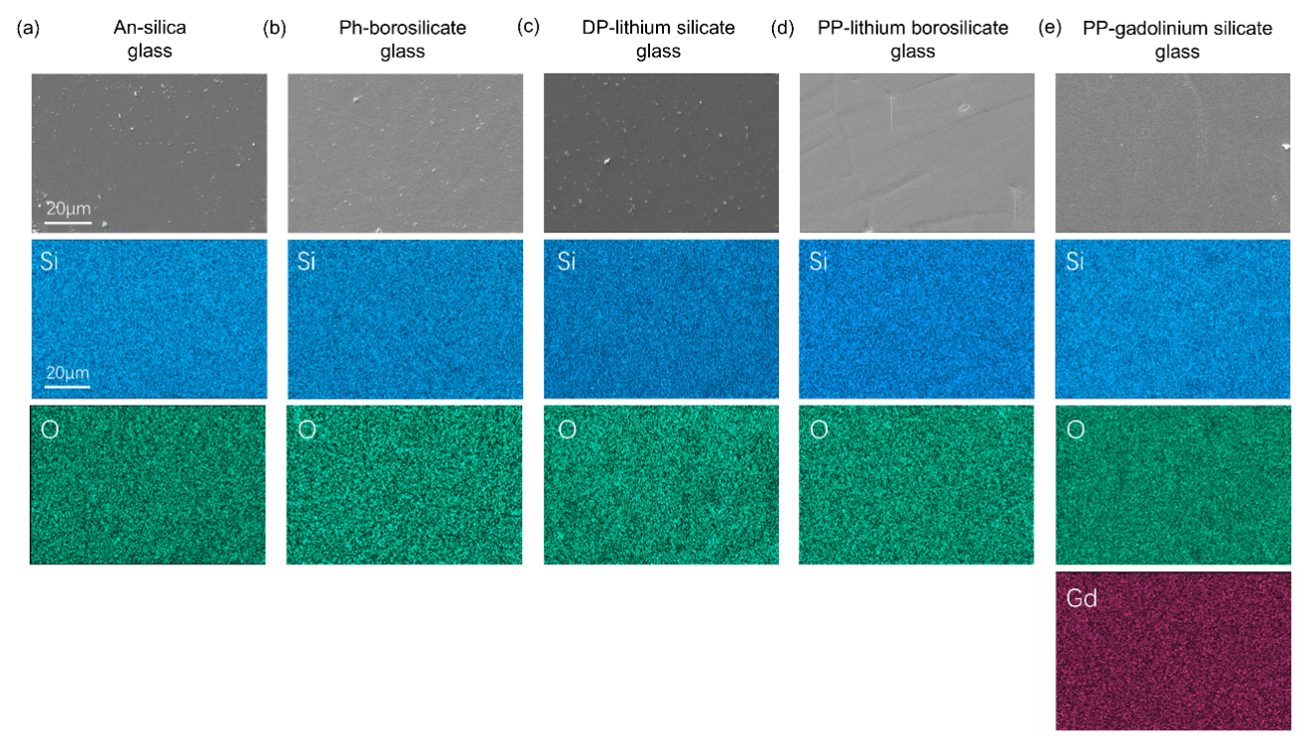
Supplementary Fig. 16. EDS mapping of organic-inorganic hybrid glass.

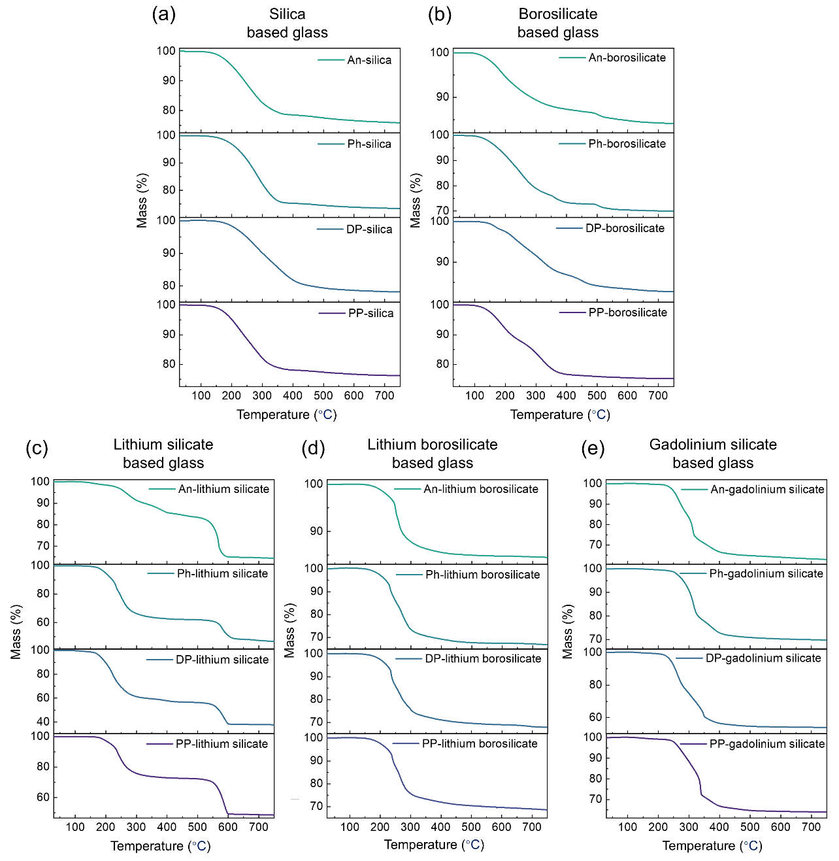
Supplementary Fig. 17. TGA of organic-inorganic hybrid glass. (a) Silica-based glass. (b) Borosilicate-based glass. (c) Lithium silicate-based glass. (d) Lithium borosilicate-based glass. (e) Gadolinium silicate-based glass.

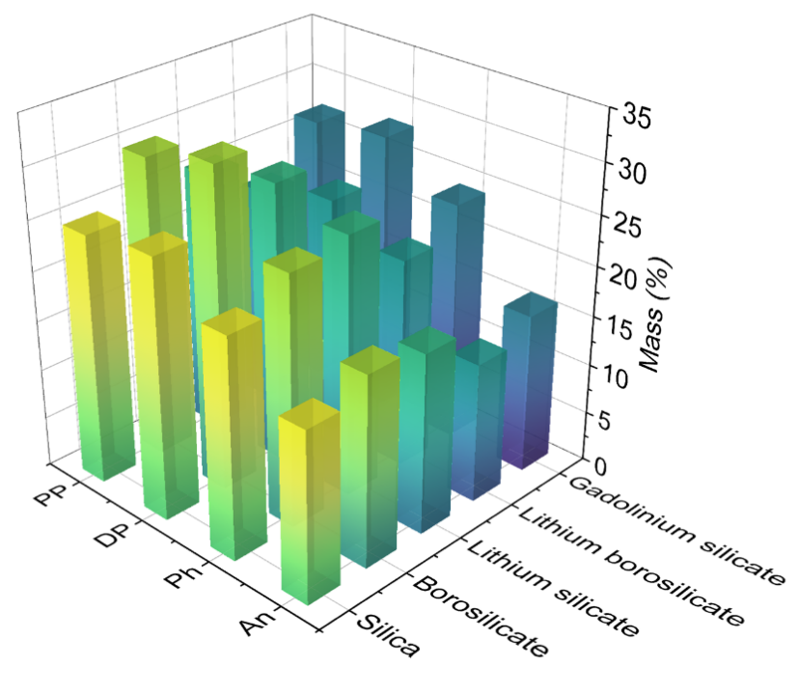
Supplementary Fig. 18. Weight loss statistics chart of organic-inorganic hybrid glass before 500 ºC.

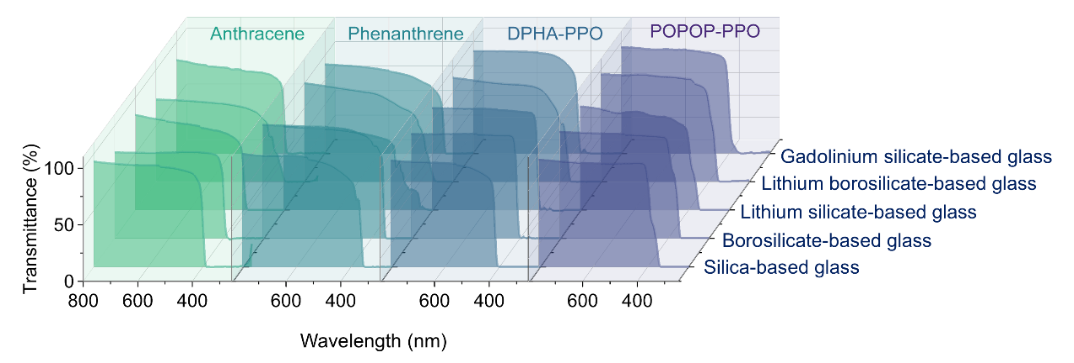
Supplementary Fig. 19. Transmission spectra of organic-inorganic hybrid glass.

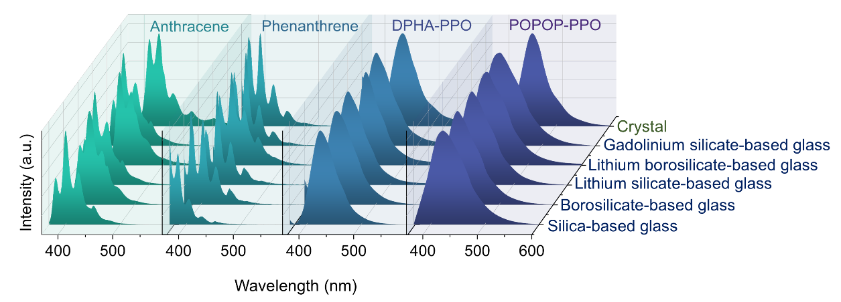
Supplementary Fig. 20. Emission spectra of organic-inorganic hybrid glass under 365 nm excitation. The emission spectra of the organic crystal precursors are also shown for comparison.

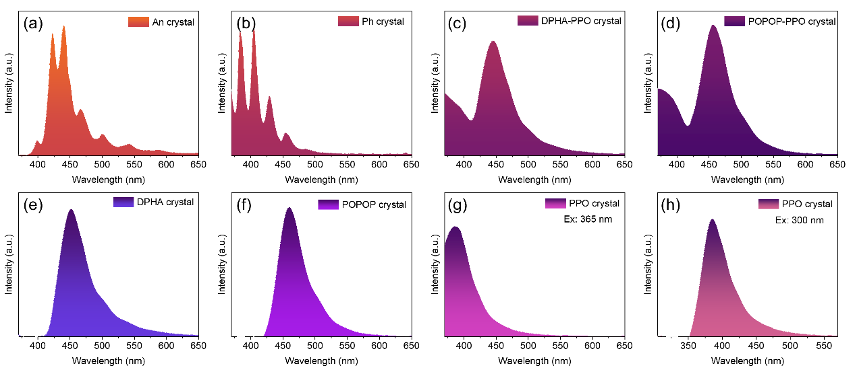
Supplementary Fig. 21. Emission spectra of organic crystal precursors under excitation with 365nm. (a) Anthracene crystal. (b) Phenanthrene crystal. (c) DPHA-PPO mixed crystal. (d) POPOP-PPO mixed crystal. (e) DPHA crystal. (f) POPOP crystal. (g) PPO crystal. (h) Emission spectra of PPO crystal under excitation with 300nm.

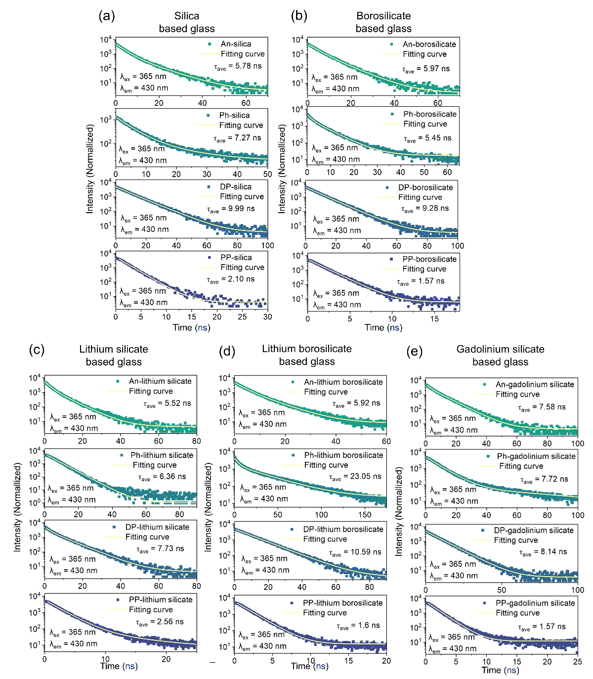
Supplementary Fig. 22. Fluorescence decay curves of organic-inorganic hybrid glass at 430 nm. (a) Silica-based glass. (b) Borosilicate-based glass. (c) Lithium silicate-based glass. (d) Lithium borosilicate-based glass. (e) Gadolinium silicate-based glass.

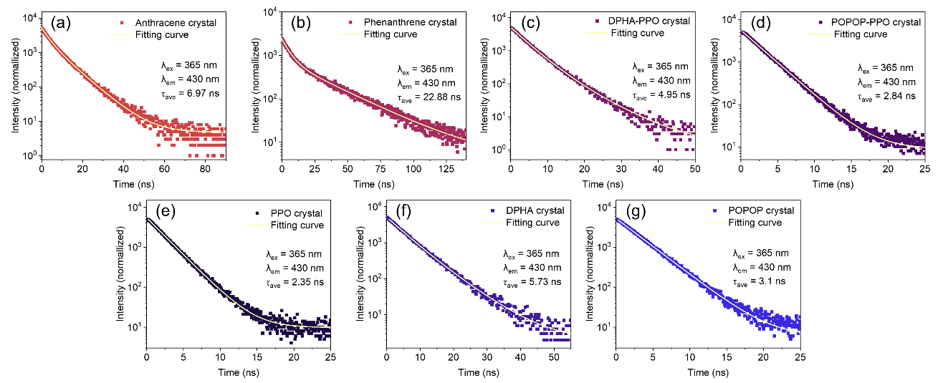
Supplementary Fig. 23 Fluorescence decay curves of organic crystal precursors at 430 nm. (a) Anthracene crystal. (b) Phenanthrene crystal. (c) DPHA-PPO mixed crystal. (d) POPOP-PPO mixed crystal. (e) PPO crystal. (f) DPHA crystal and (g) POPOP crystal.

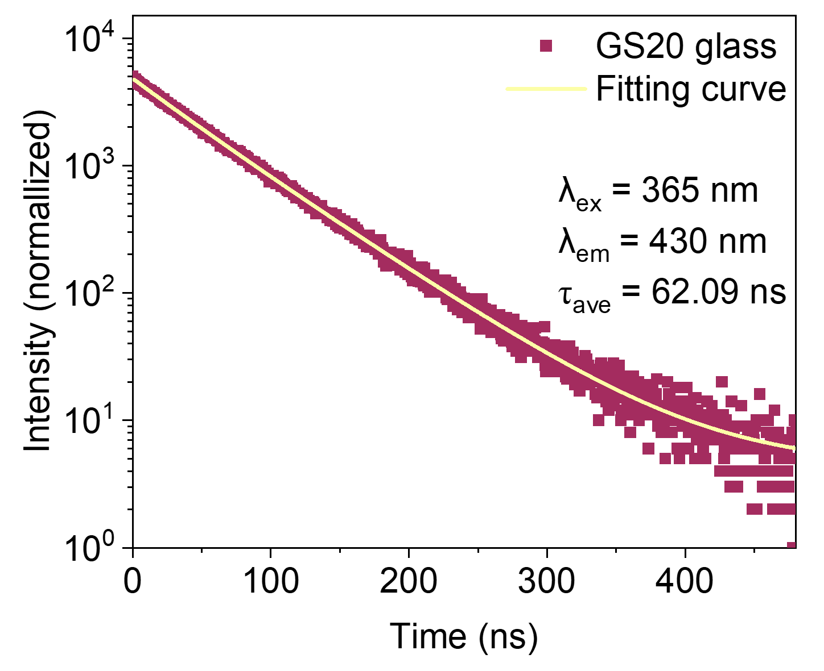
Supplementary Fig. 24. Fluorescence decay curve of GS20 glass at 430 nm.

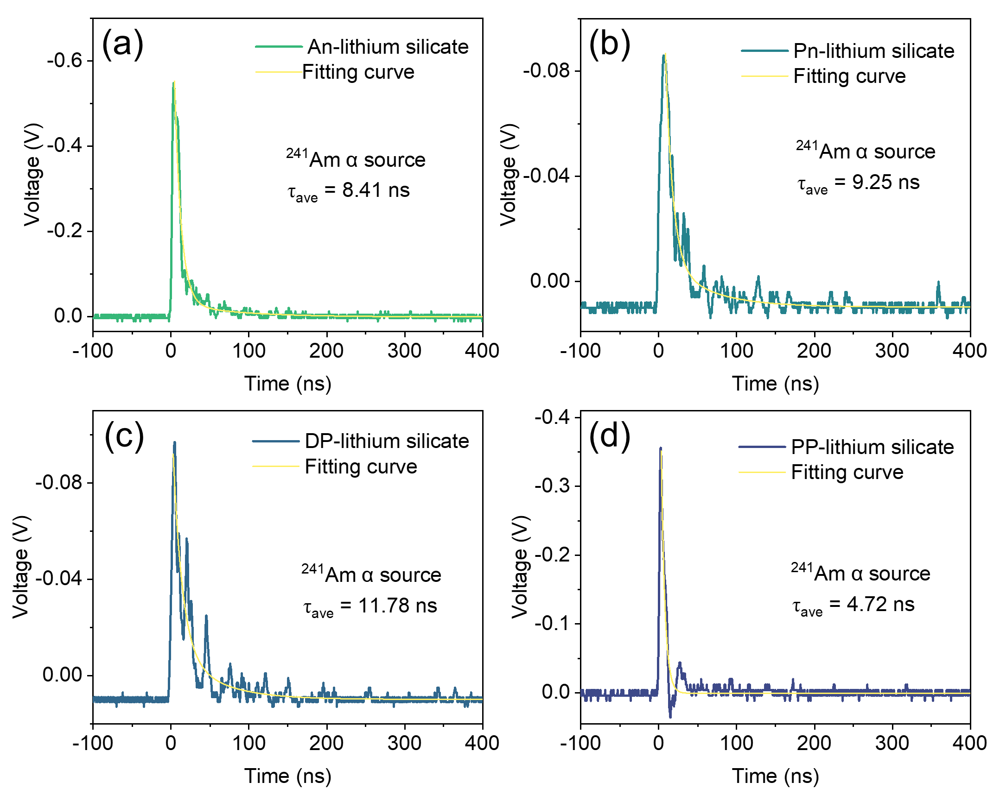
Supplementary Fig. 25. Single pulse signal of the organic-inorganic hybrid glass under irradiation of ²⁴¹Am α particle source. (a) An- lithium silicate glass. (b) Ph-lithium silicate glass. (c) DP- lithium silicate glass and (d) PP- lithium silicate glass.

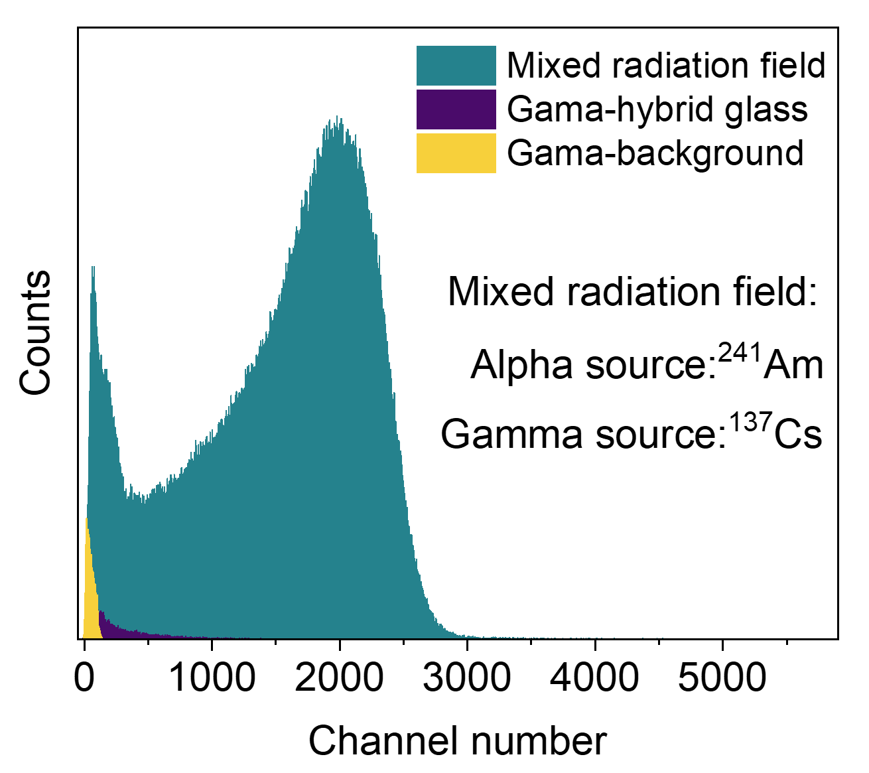
Supplementary Fig. 26. Pulse height spectrum measured by Ph-lithium silicate glass under mixed ionizing irradiation. The background signal is also shown.

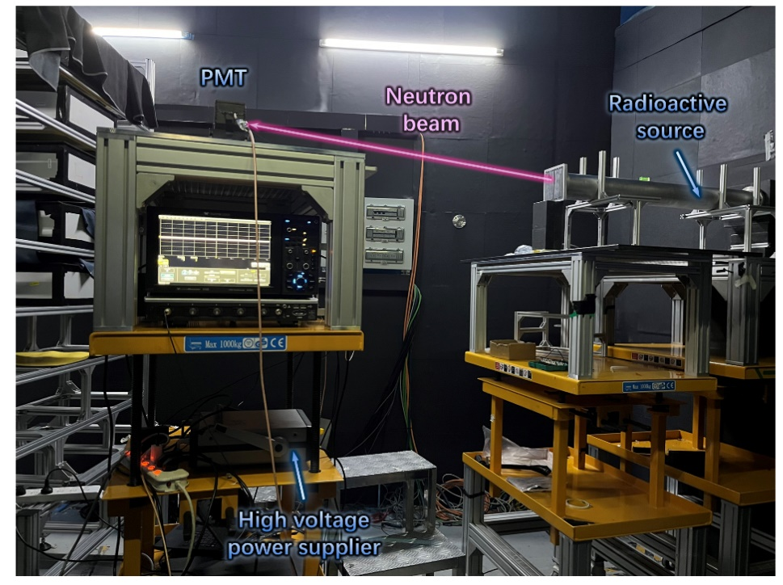
Supplementary Fig. 27. The scene in the application of thermal neutron detection.

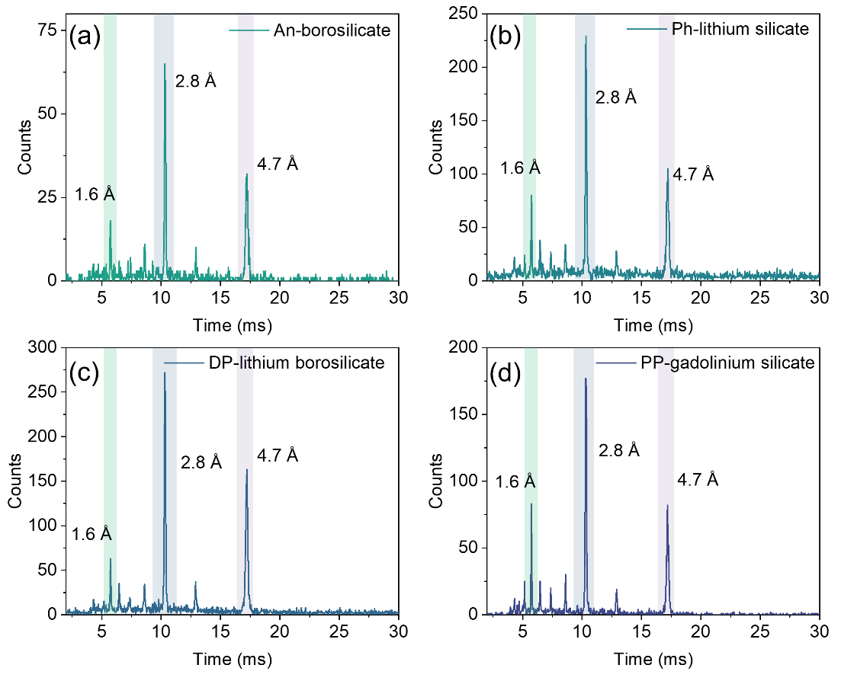
Supplementary Fig. 28. The TOF spectrum was obtained by monitoring neutron beams at CSNS with the organic-inorganic hybrid glass. (a) An-borosilicate glass. (b) Ph-lithium silicate glass. (c) DP-lithium borosilicate glass and (d) PP-gadolinium silicate glass.

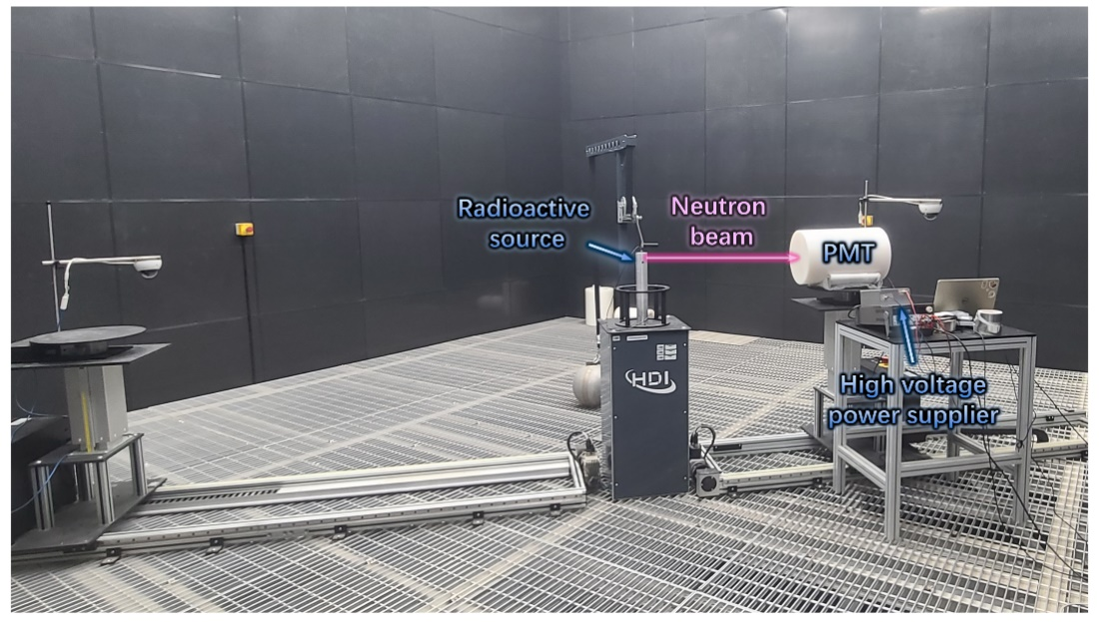
Supplementary Fig. 29. The scene in the application of fast neutron detection.

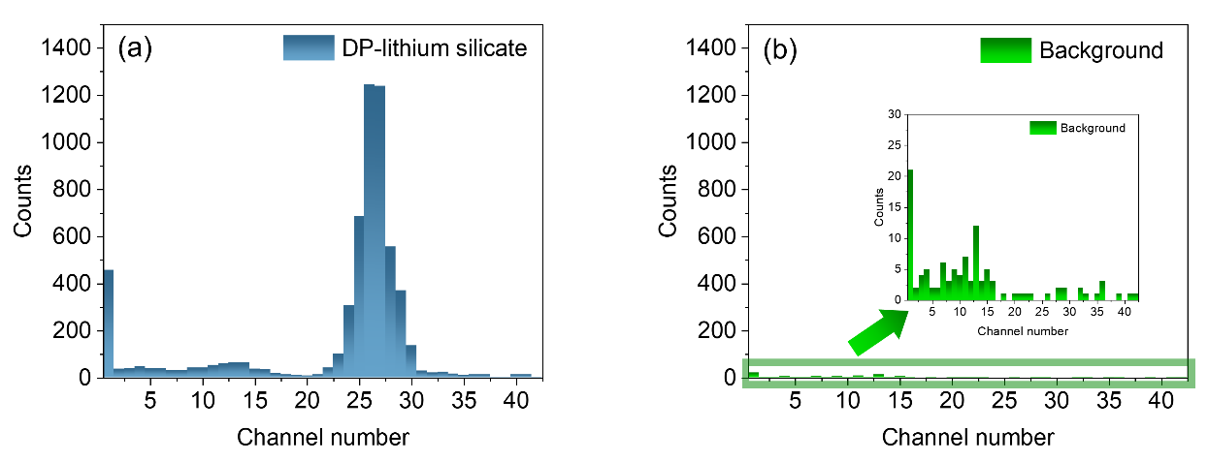
Supplementary Fig. 30. Pulse height spectrum obtained by using DP-lithium silicate glass under fast neutron irradiation. The background signal is also shown for comparsion.

