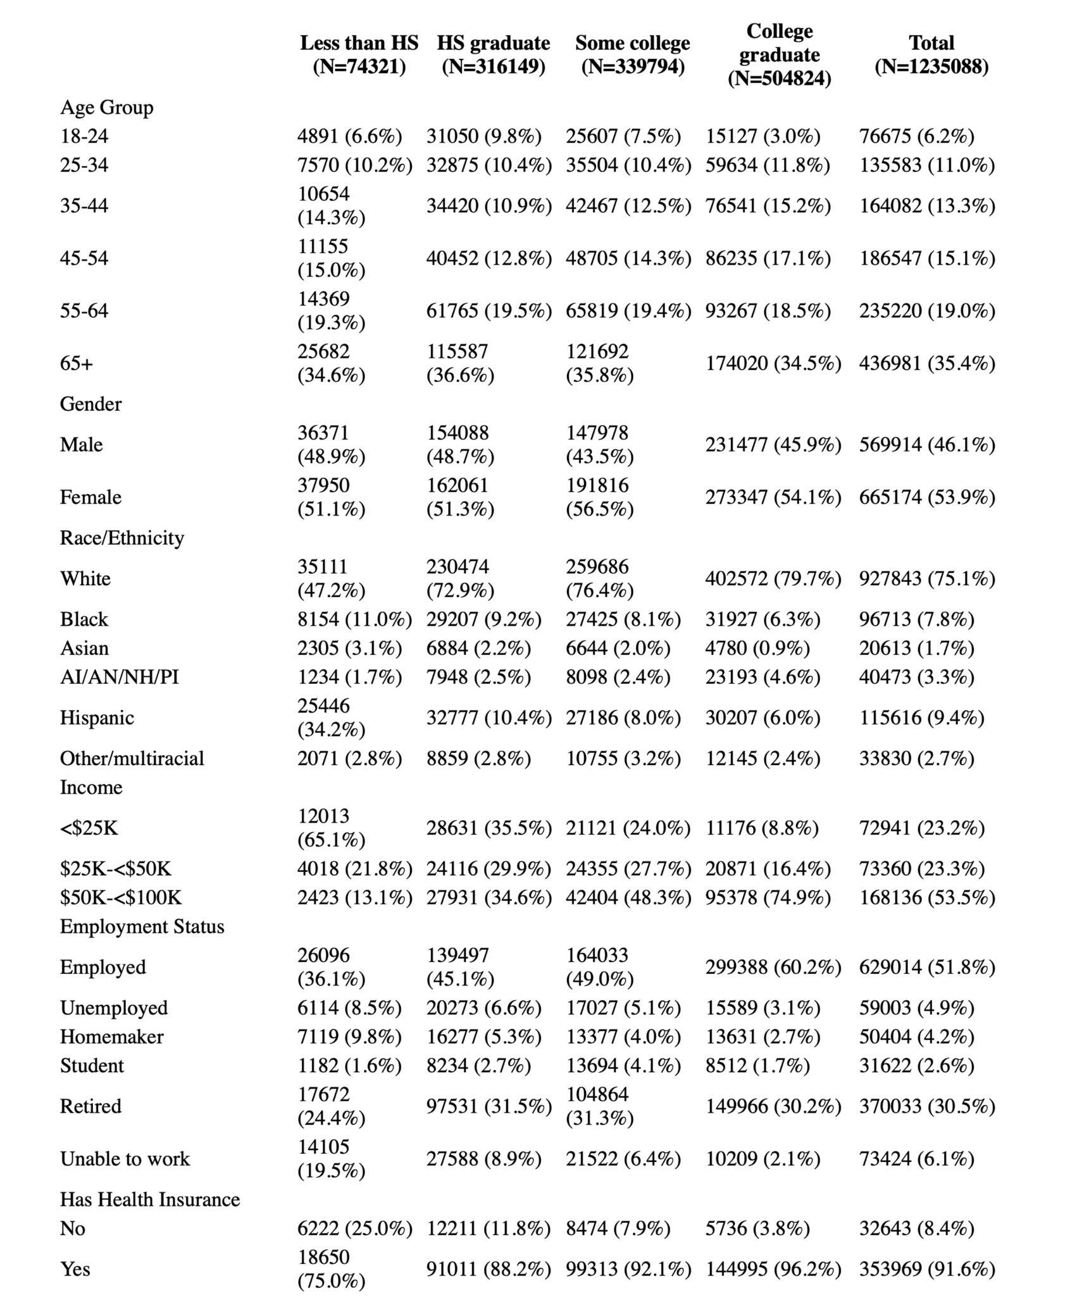
Table 1. Sample Characteristics by Education Level Descriptive Statistics. Showing demographic and socioeconomic characteristics of the BRFSS 2020-2022 sample (N=1,235,088) stratified by education level (less than high school, high school graduate, some college, and college graduate). Prevalence of health behaviors, risk factors, and cardiovascular disease outcomes stratified by education level, including BMI categories, cholesterol levels, diabetes, smoking status, and individual cardiovascular conditions.

