SUPPLEMENTARY INFORMATION

Abiotic sugars in (162173) Ryugu and the primitive CI carbonaceous chondrite Orgueil
Vanessa Leyva, Manuel Robert, Raphaël Pepino, Jana Bocková and Cornelia Meinert*
Université Côte d’Azur, Institut de Chimie de Nice, UMR 7272 CNRS, 06108 Nice, France
*Corresponding author: Cornelia.MEINERT@univ-cotedazur.fr

This file provides detailed information on the extraction, fractionation, and multidimensional gas chromatographic analysis of meteorite and asteroid samples, along with complementary data on sugar recovery experiments.
It contains Supplementary Figs. 1–5.

Supplementary Note 1: Materials and methods 2
1.1 Samples 2
1.2 Chemicals and reagents 2
1.3 Equipment for sample pre-treatment 3
1.4 Sample extraction protocol 3
1.5 Ion exchange chromatography (IEC) purification and fractionation 5
1.6 Detection of sugars and amino acids by enantioselective two-dimensional gas chromatography 6
Supplementary Note 2: Assessment of sugar recovery efficiency in spiked meteorite matrices ……..8
Supplementray References 9

Supplementary Note 1: Materials and methods

1.1 Samples
Aggregate samples of Ryugu grains A0478 (5.7 mg) and A0483 (11.8 mg), consisting of the asteroid surface material collected from the first touchdown site, were allocated by the Astromaterials Science Research Group (ASRG) of the Japan Aerospace Exploration Agency (JAXA) and provided in seal containers under purified nitrogen atmosphere Supplementary Figure 1.
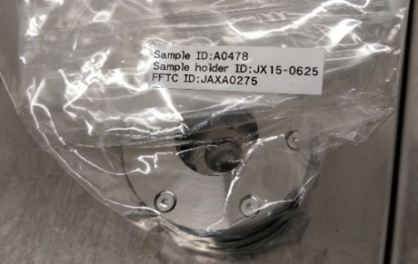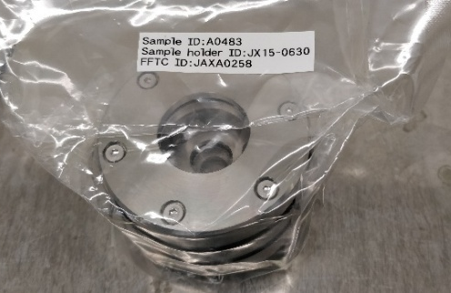
Supplementary Figure 1. Ryugu aggregate samples–A0478 and A0483–provided by the Japan Aerospace Exploration Agency (JAXA).

A 178.3 mg fragment of the Orgueil meteorite, allocated by the Muséum National d’Histoire Naturelle (MNHN) in Paris and stored in a plastic container (Supplementary Figure 2), was analyzed in this study.
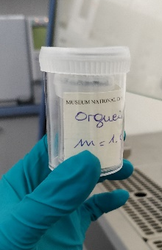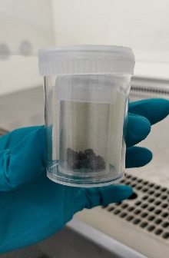
Supplementary Figure 2. Orgueil samples provided by the Muséum National d’Histoire Naturelle (MNHN).
The Ryugu and Orgueil samples were kept in their original packaging inside an incubator (Neuation iTherm CH25) under ultra-dry conditions at 20 °C until analysis. To enhance the detectability of the target molecules, the two Ryugu aggregate samples—A0478 (5.7 mg) and A0483 (11.8 mg)—were combined prior to extraction in a pre-weighed 1 mL V-Vial (WHEATON NextGen V Vial Screw Neck Vials). The transfer was performed using clean tweezers inside a Class II laminar flow safety cabinet (Thermo Scientific MSC-Advantage Class II).
The Orgueil fragment was transferred into a pre-weighed 5 mL V-Vial using clean tweezers inside a Class II laminar flow safety cabinet.

1.2 Chemicals and reagents
All reagents, including pyridine (>99.5%), methylboronic acid (97%), trifluoroacetic anhydride (TFAA) (>99%), acetyl chloride (>99%), as well as the solvents, ethanol (≥99.8%), methanol (>99.9%), ethyl acetate (>99.5%), 2-propanol (>99.9%), chloroform (>99.8%) and dichloromethane (99.9%), and the internal standard, methyl laurate (97%), were purchased from Sigma Aldrich (Merck, Germany) in the highest available purity and used without further purification. The hydrochloric acid solution (6 M, 2 mL ampoules) and ammonia solution (25%, for HPLC LiChropur) employed for the preparation of ion exchange columns were purchased from Sigma Aldrich and Supelco (Merck, Germany), respectively. The water used at all stages of the study—tool cleaning and sample processing—was obtained using a Milli‑Q Direct 8 apparatus (18.2 MΩ cm at 25 °C, <2 ppb total organic carbon). Sugar and amino acid reference standards used to prepare standard mixtures for identification and quantification were purchased in the highest available analytical grade from Sigma Aldrich (Merck, Germany), Lancaster Synthesis, Fluka, and Acros Organics. The purity of all amino acids and sugars was above 97%, except for d-erythrose (75%) and racemic glyceraldehyde (>90%). Details about the origins and purities of sugar and amino acid standards used here are given elsewhere^{1,2}.

1.3 Equipment for sample pre-treatment
All glassware and ceramic equipment were cleaned with 96% ethanol and Milli-Q® water, then wrapped in aluminum foil and heated at 500 °C for 5 hours. Other labware, including needles, caps, spatulas, tweezers, PTFE frits (20 μm pore size, Supelco), and PTFE disposable liners (Supelco), were thoroughly cleaned with HPLC-grade ethanol and Milli-Q® water, dried with nitrogen, and wrapped in pre-burned aluminum foil until further use. Biopure tips (2–200 μL and 50–1000 μL Eppendorf® epT.I.P.S.® Biopur) were employed in all stages of the protocol when needed.
Pre-concentration of large solvent volumes was conducted with a Buchi R-114 rotary evaporator equipped with a B-480 water bath, a Huber mini-chiller, and a Vacuubrand PC 500 series pumping unit (CVC 3000 vacuum regulator). A Universal 320 centrifuge (Hettich 1401) was employed to separate the matrix residue from the extracts. Low frequency ultrasonic extraction was performed using a Fisherbrand FB15049 (Elma Schmidbauer GmbH, Singen) focused ultrasonic system, operating at a fixed frequency of 37 kHz—an adequate mid-range frequency in terms of bubble size, strength, and volume—with an ultrasonic power of 30 W RMS in impulse waveform. Prior to extraction, the water bath was degassed for 1 to 5 minutes to remove entrapped air and dissolved gases, enhancing ultrasonic cavitation efficiency. The system operated in sweep mode. The temperature of the bath was maintained between 15 and 21 °C. 3D printed holders were employed to maintain the position of the sample vials in the bath in a reproducible position. For high temperature extraction at 100 °C an MS-100 Thermo Shaker incubator was employed.

1.4 Sample extraction protocol
Most extraction protocols for amino acids and other organics involve an acid hydrolysis step, which is known to significantly enhance their recovery (3). We opted, however, to omit this step in our protocol for two key reasons: (i) to avoid the deleterious conditions that could potentially degrade fragile sugars and amino acids, and (ii) to prevent the potential racemization of chiral compounds, which is significantly accelerated under both acidic and basic conditions. To compensate for the absence of acid hydrolysis, we performed repeated extraction steps assisted by ultrasonication, focusing on the sample’s free organic content. The extraction protocol applied for analyzing the Ryugu sample is schematically illustrated in Supplementary Figure 3.
A procedural blank (PB) without a matrix was prepared alongside the sample. Two distinct extracts were obtained: a methanolic extract, expected to contain extracted sugars and minor quantities of amino acids, and an aqueous extract, primarily containing amino acids. Methanol was selected as the sole solvent for sugar extraction to minimize the dissolution of inorganic ions from the matrix, which had previously been found to interfere with overall sugar recovery in dedicated recovery experiments using the Orgueil matrix (Supplementary Note 2). Subsequently, multiple water extraction steps including conventional hot-water extraction (100 °C, 21 h; step 2b) were performed to enhance amino acid recovery (steps 2a, 2b, and 2c in Supplementary Figure 3).
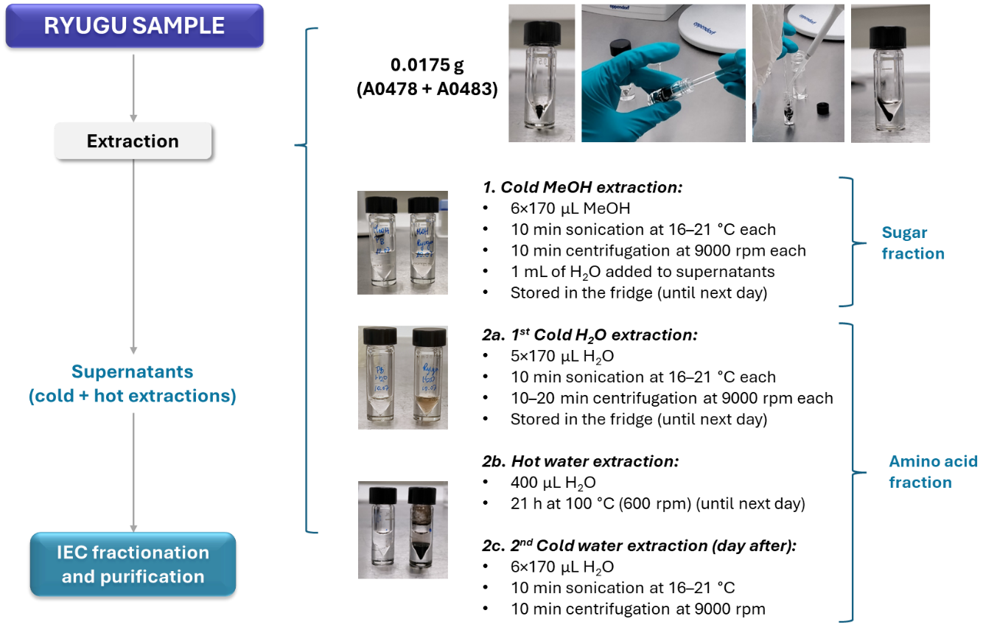
Supplementary Figure 3. Scheme showing the extraction methodology applied to the Ryugu samples and the procedural blank (PB). IEC = Ion Exchange Chromatography.

The detailed water extraction procedure for each step is as follows:
1. Cold methanol extraction (sugar fraction): The asteroid sample matrix was crushed with 170 µL of MeOH using a glass rod to ensure thorough solvent penetration. The sample was then vortex-mixed and sonicated for 10 minutes at 16–21 °C. After sonication, it was centrifuged at 9000 rpm for 10 minutes, and the supernatant was transferred to a 5 mL V-vial. This extraction process was repeated five times, with all extracts combined into the same 5 mL V-vial. To minimize the co-evaporation of volatile compounds during pre-concentration under low pressure, 1 mL of water was added to the methanolic extracts. The sample was then stored in the fridge at 5 °C until subsequent purification and fractionation.
2a. Cold water extraction: After methanolic extraction, the extraction continued five more times on the matrix residue, using water instead of methanol. The resulting supernatants were transferred into a separate 5 mL V-vial. The sample was then stored in the fridge at 5 °C until subsequent purification and fractionation.
2b. Hot water extraction: Next, 400 µL of water was added to the 1 mL vial containing the asteroid residue for hot-water extraction at 100 °C for 21 h, with constant agitation at 600 rpm. The resulting extract was then centrifuged and combined with the cold-water extracts from step 2a.
2c. Cold water extraction: Six additional cold-water extractions were performed on the remaining matrix using 170 µL of water per extraction. The resulting supernatants were combined with the previous aqueous extracts (2a and 2b) for purification and fractionation.
A similar extraction procedure was used for the Orgueil sample with the following modifications: 1 mL V-vials were replaced with 5 mL V-vials, supernatants were recovered in 100 mL glass flasks, and extraction volumes were adjusted to 1.6–1.7 mL of MeOH or water for each cold extraction step to accommodate the larger sample/matrix mass. A total of ten cold-water extractions were performed. For the hot-water extraction, 3.6 mL of water was used.

1.5 Ion exchange chromatography (IEC) purification and fractionation
The solutions containing the extracted organics were then purified and fractionated to remove inorganic ions—such as Fe²⁺, Fe³⁺, and Mg²⁺, which are major components of chondritic mineral matrices (3). This was achieved through ion exchange chromatography (IEC), which also served to separate neutral sugar molecules from charged amino acid zwitterions, enabling the application of ad hoc derivatization methodologies for each molecular family within the collected fractions. The purification/fractionation method employed for the analysis of the Ryugu sample is represented schematically in Supplementary Figure 4.
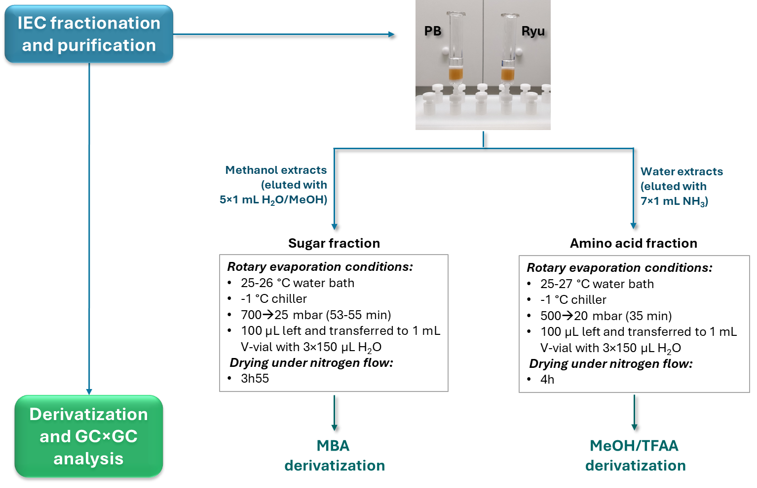
Supplementary Figure 4. Ion exchange chromatography (IEC) for purification and fractionation of the methanol and water extracts of the Ryugu sample.
Preparation of the ion exchange chromatography columns. Two 6 mL solid phase extraction (SPE) glass columns (Supelco), designated for the sample and the procedural blank, were positioned on a Supelco Visiprep 12-port Disposable Liner (DL) vacuum manifold. Then, 1 g of BT AG 50W-X8 cation exchange resin (100–‍200 mesh, Bio-Rad) was placed between two PTFE frits. Disposable PTFE liners (Supelco) were used to direct the flow of eluates. The columns were conditioned according to a protocol adapted from Simkus et al.³. First, the columns were rinsed with 8 mL of ethanol, followed by 8 mL of methanol, and then 10 mL of Milli-Q® water. An alkaline wash was performed to remove H⁺ ions originally present on the resin by adding 8 mL of 2 M NH₄OH, adjusting the pH to 11–12. The columns were then rinsed with 10 mL of ultrapure water (pH = 7). To recharge the resin with H⁺ ions, 8 mL of a freshly prepared 1 M HCl solution (prepared from 6 M HCl ampoules) was passed through the columns until the pH reached 0–1. Finally, the resin was rinsed with 12–15 mL of Milli-Q® water adjusting the pH to 5–6.
Fractionation and purification. The methanolic extracts (approximately 2 mL H₂O/MeOH (1:1, v/v) were loaded onto the corresponding ion exchange chromatography (IEC) columns in 200 μL portions using a Pasteur pipette. Eluates were collected in a 10 mL pear-shaped flask. The 5 mL V-vials containing the extracts were rinsed with 2 × 0.5 mL + 1 × 1 mL of H₂O to optimize compound recovery. The rinses were then eluted through the columns and collected in the same 10 mL flask. Finally, 1 mL of H₂O/MeOH was used to wash the column walls, recovering the sugars from the resin into the same pear-shaped flask, resulting in a final volume of 5 mL of H₂O/MeOH (1:4, v/v) solution. The water extracts from both cold and hot extractions (approximately 2.5 mL) were subsequently eluted through the columns in 200 μL portions. One milliliter of water was used to wash the walls of the columns. The resulting eluate was collected in a separate 10 mL pear-shaped flask, as it was not expected to contain sugars or amino acids, the latter of which should remain retained on the column. Finally, to recover the amino acid fraction, 7×1 mL of 2 M NH_{3(ac)} were eluted through the column and collected in a third 10 mL pear-shaped flask.
Pre-concentration and drying. The resulting sugar and amino acid fractions from the Ryugu samples and the procedural blank were then pre-concentrated to a final volume of ~100 μL using a rotary evaporator. For this, the pressure was gradually reduced from 500 mbar to a final pressure of 25 mbar (25 °C) for the sugar fraction and 20 mbar for the amino acid fraction (26–27 °C). Each concentrated fraction was transferred to a separate 1 mL V-Vial, and the pear-shaped flasks were rinsed with 3 × 150 μL of H₂O to recover any remaining analyte from the inner walls of the flasks. Finally, the samples were fully dried under a gentle flow of nitrogen (for about 4 h) before compound-specific derivatization.
A similar purification and fractionation procedure was applied to the Orgueil sample with the following modifications: The resin amount for the IEC columns was increased from 1 g to 2 g, which required a proportional doubling of the washing and equilibration volumes. A polyethersulfone (PES) syringe filter (Captiva, 0.2 μm pore size, 15 mL) was placed under the glass columns to enhance matrix filtration. The sugar and amino acid fractions were collected in 25 mL pear-shaped flasks. For the sugar fraction, 5 mL of water was added to the methanolic extract, resulting in the precipitation of a white solid, which was then separated. After elution, the flask was rinsed with 5 × 500 μL of water. For the amino acid fraction, the flasks were washed with 5 × 1 mL of water, and amino acids were recovered by eluting 15 × 1 mL of 2M NH₃ through the columns.

1.6 Detection of sugars and amino acids by enantioselective two-dimensional gas chromatography
Derivatization. The sugar fractions of the extracted samples and procedural blanks were derivatized into methylboronate esters (MBA) following the protocol of Garcia et al.². This involved adding 30 μL of a methylboronic acid solution (10 mg mL^{–1} in pyridine) to the dried samples, vigorous vortex-mixing and heating at 60 °C for 30 minutes. After cooling for 10 minutes, the samples were then dried under a gentle stream of nitrogen, leaving approximately 2–3 μL of solvent to prevent the loss of volatile derivatives. Finally, the MBA derivatives were dissolved in 30 μL of ethyl acetate containing methyl laurate (ML) as an internal standard at a concentration of 10^{–6} M.
Amino acids were derivatized into N-trifluoroacetyl-O-methyl (N-TFA-O-Me) esters following the protocol of Pepino et al. (3). First, 120 μL of a methanol/acetyl chloride (MeOH/AcCl) solution (4:1, v/v) were added, and the mixture was vigorously stirred and heated at 110 °C for 1 hour. After cooling for 10 minutes, the sample was dried under a gentle stream of nitrogen, leaving approximately 2 μL of solvent to prevent the loss of volatile derivatives. Next, 120 μL of a dichloromethane/trifluoroacetic acid anhydride (DCM/TFAA) solution (4:1, v/v) were added, stirred for 10 seconds, and heated at 100 °C for 20 minutes. The solution was then cooled and fully dried with nitrogen. Finally, the N-TFA-O-Me ester derivatives were dissolved in 30 μL of chloroform containing methyl laurate as an internal standard at a concentration of 10^{–6} M.
Instrumentation and analysis. The sugar and amino acid fractions from Ryugu and Orgueil samples were analyzed using multidimensional gas chromatography coupled with reflectron time-of-flight mass spectrometry (GC×GC–TOF-MS) equipped with a dual-stage thermal jet modulator (Pegasus BT 4D, Leco Corp.). The injector and ion source temperatures were maintained at 230 °C, while the transfer line was set to 240 °C. Sample volumes of 1 μL were injected in splitless mode. Hydrogen was used as carrier gas at a constant flow rate of 1.2 mL min^{–1}. After each injection, the sample GC vial was immediately recapped and stored at 4 °C to prevent degradation of the amino acid and sugar derivatives before subsequent injections.
For sugar analysis of the Ryugu sample, the GC×GC column configuration consisted of a CP-Chirasil-Dex CB primary column (30 m length × 0.25 mm inner diameter (ID), 0.25 μm film thickness, Agilent Technologies) coupled to a DB-WAX secondary column (1.61 m × 0.1 mm ID, 0.1 μm film thickness, Agilent Technologies). The primary oven was programmed as follows: an initial hold at 55 °C for 1 min, followed by a temperature increase of 10 °C min^{–1} to 90 °C, where it was held for 8 min. The temperature then increased at 2 °C min^{–‍1} to 190 °C, with a final isothermal hold at 190 °C for 15 min. The secondary oven and thermal modulator maintained constant positive temperature offsets of 10 °C and 15 °C, respectively. A modulation period of 5 s was applied. The reflectron TOF-MS operated at a 150 Hz storage rate, with a mass range of 50–500 amu and a microchannel plate detector voltage of approximately 2 kV and a solvent delay of 10 min.
Targeted sugars in the Orgueil samples were analyzed with the following modifications: the primary column length was 27.15 m instead of 30.00 m, and the secondary oven maintained a constant positive temperature offset of 30 °C instead of 10 °C.
For amino acid analyses of Ryugu and Orgueil, the column setup included a Lipodex E primary column (24.95 m length × 0.25 mm inner diameter, Macherey-Nagel) coupled with a DB-WAX secondary column (1.7 m length × 0.12 mm inner diameter, 0.1 μm film thickness, Agilent). The primary oven was programmed as follows: an initial hold at 40 °C for 1 min, then heated to 80 °C at 10 °C min^{–1}, holding for 10 minutes. The temperature was then increased to 120 °C at 1.3 °C min^{–1}, followed by an increase to 152 °C at 0.8 °C min^{–1}, and finally raised to 185 °C at 10 °C min^{–‍1}, where it was held for 10 minutes. The secondary oven was operated with a constant positive temperature offset of 35 °C, and the thermal modulator hot jets had a temperature offset of 15 °C. The modulation period was 6 s. The reflectron TOF-MS operated at a 150 Hz storage rate, with a mass range of 40–‍500 amu, a microchannel plate detector voltage of approximately 2 kV, and a solvent delay of 9 min.
Analyte identification and quantification. Analyte identification was performed by comparing retention times across both chromatographic dimensions and mass spectra (within a 500-ppm mass tolerance) with a mixed analyte standard. Quantification was performed using four-point calibration curves for the target analytes ranging from 10^{–6} M to 5×10^{–8} M, with manual integration conducted via LECO Corp. ChromaTOF™ software. To account for background interference, procedural blank correction was applied by subtracting the peak areas of analytes detected in the procedural blank.

Supplementary Note 2: Assessment of sugar recovery efficiency in spiked meteorite matrices
We conducted spiking experiments using previously extracted Orgueil sample to evaluate the impact of the Orgueil matrix on the sugar and amino acid recoveries. In summary, the nitrogen dried residual Orgueil matrix was divided into two ~60 mg fractions in separate 1 mL V-vials and directly spiked with 30 μL of a 10⁻⁵ M sugar and amino acid standard solution. After settling for 1 h, both samples were re-extracted and analyzed. The results showed a significant matrix effect on sugar recovery. In the absence of a matrix, recoveries ranged from 70–100% for C5 sugars and 40–60% for C3–C4 sugars. However, in the presence of the Orgueil matrix, recoveries dropped dramatically to 0.5–28% for C5 sugars and 0–10% for C3–C4 sugars. Part of the recovery loss may be attributed to direct matrix interference during extraction and/or derivatization. Additionally, residual water retained in the matrix during drying prior to derivatization may substantially hinder MBA derivatization, as demonstrated in our tests with 30 μL sugar standards (5 × 10⁻⁷ M). The presence of as little as 5 μL of water significantly interfered with the reaction, reducing the conversion to sugar boronate derivatives. Previous studies⁴ have shown that water not only acts as a reagent in the hydrolysis of boronate esters but also catalyzes the reaction by markedly lowering the B–O bond dissociation energy barrier.

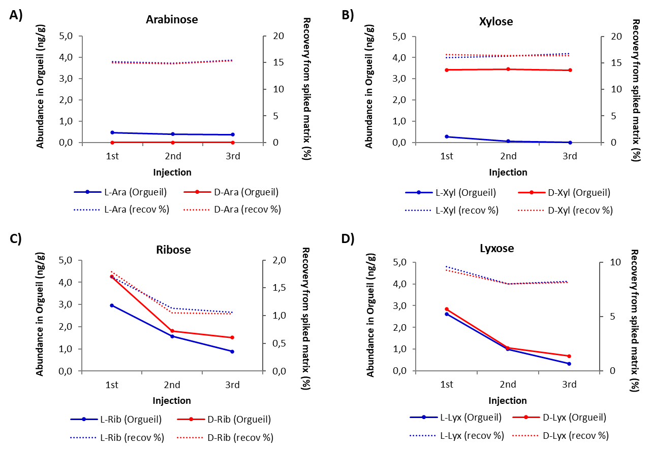
Supplementary Figure 5. Evolution of sugar concentration as MBA derivatives extracted from the Orgueil matrix with time (# injection).

Supplementary References
1. A. D. Garcia, V. Leyva, J. Bocková, R. L. Pepino, C. Meinert, Resolution and quantification of carbohydrates by enantioselective comprehensive two-dimensional gas chromatography. Talanta 271, 125728 (2024).
2. R. Pepino, V. Leyva, A. D. Garcia, J. Bocková, C. Meinert, Resolution, quantification, and reliable determination of enantiomeric excess of proteinogenic and non-proteinogenic amino acids by comprehensive two-dimensional gas chromatography. Journal of Separation Science 45, 4416–4426 (2022).
3. D. N. Simkus, et al., Methodologies for analyzing soluble organic compounds in extraterrestrial samples: Amino acids, amines, monocarboxylic acids, aldehydes, and ketones. Life 9, 47 (2019).
4. H. Li, H. Li, Q. Dai, H. Li, J.-L. Brédas, Hydrolytic stability of boronate ester-linked covalent organic frameworks. Advanced Theory and Simulations 1, 1700015 (2018).

