Supplementary Information for “Alternative Thermodynamic Pathway for Producing Neodymium from Oxide Through Molten Solution Non-Ideality and Hydride Precipitation”

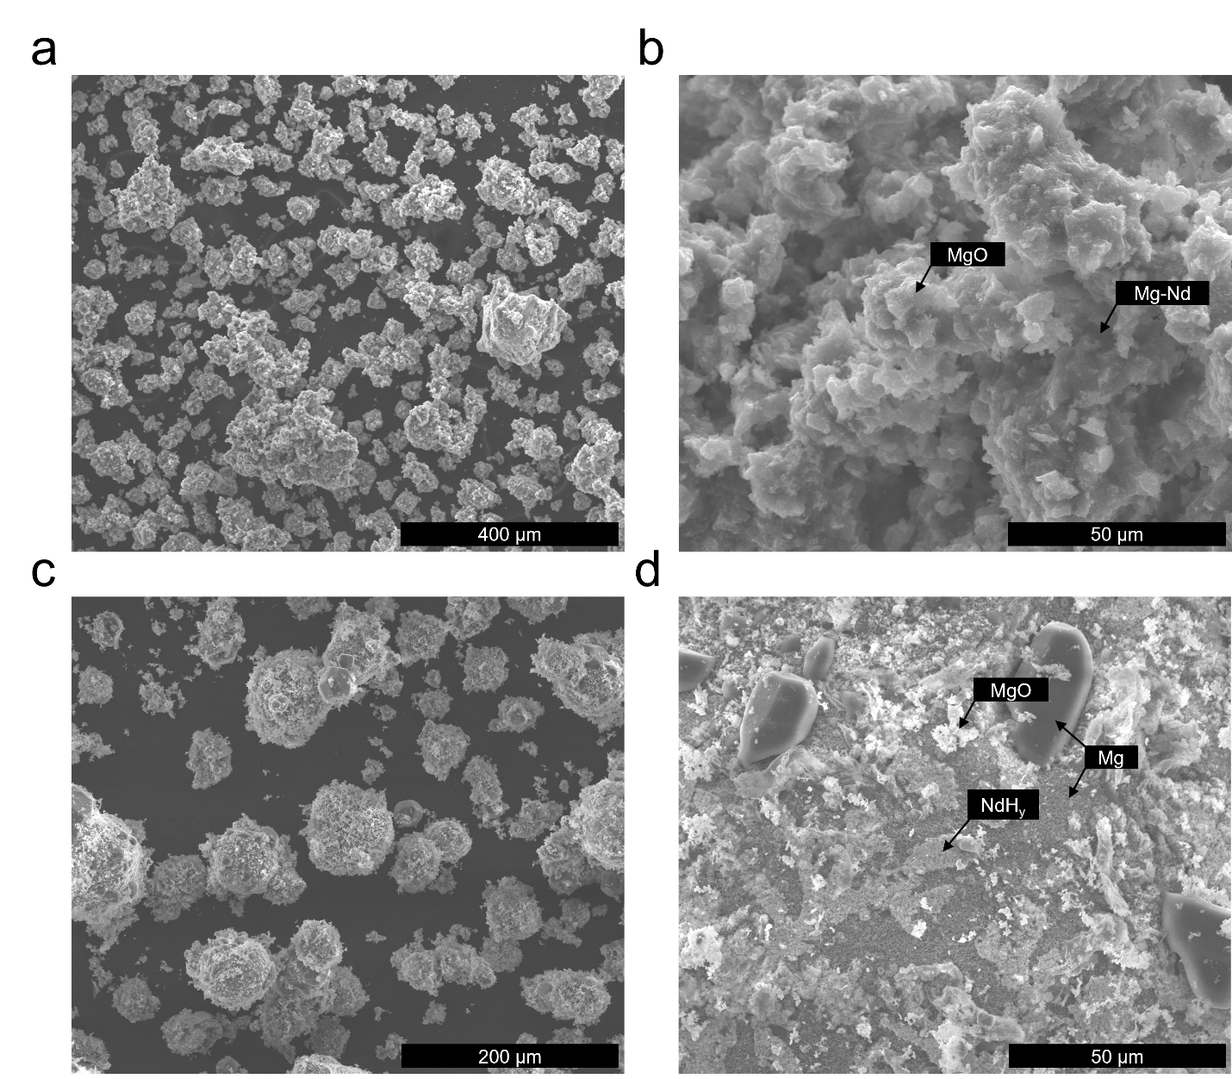
Supplementary Figure 1: a) SEM image of powder reduction product at 695°C under 1 atm. Ar. b) Close-up of a particle from this condition, showing an Mg-Nd particle with an MgO coating. c) SEM image of powder reduction product at 695°C under 1 atm. H₂. d) Close-up of the surface of a particle from this condition, showing MgO and NdH_{y} on the Mg particle surface as well as crystals of Mg formed by redeposition of Mg vapor.

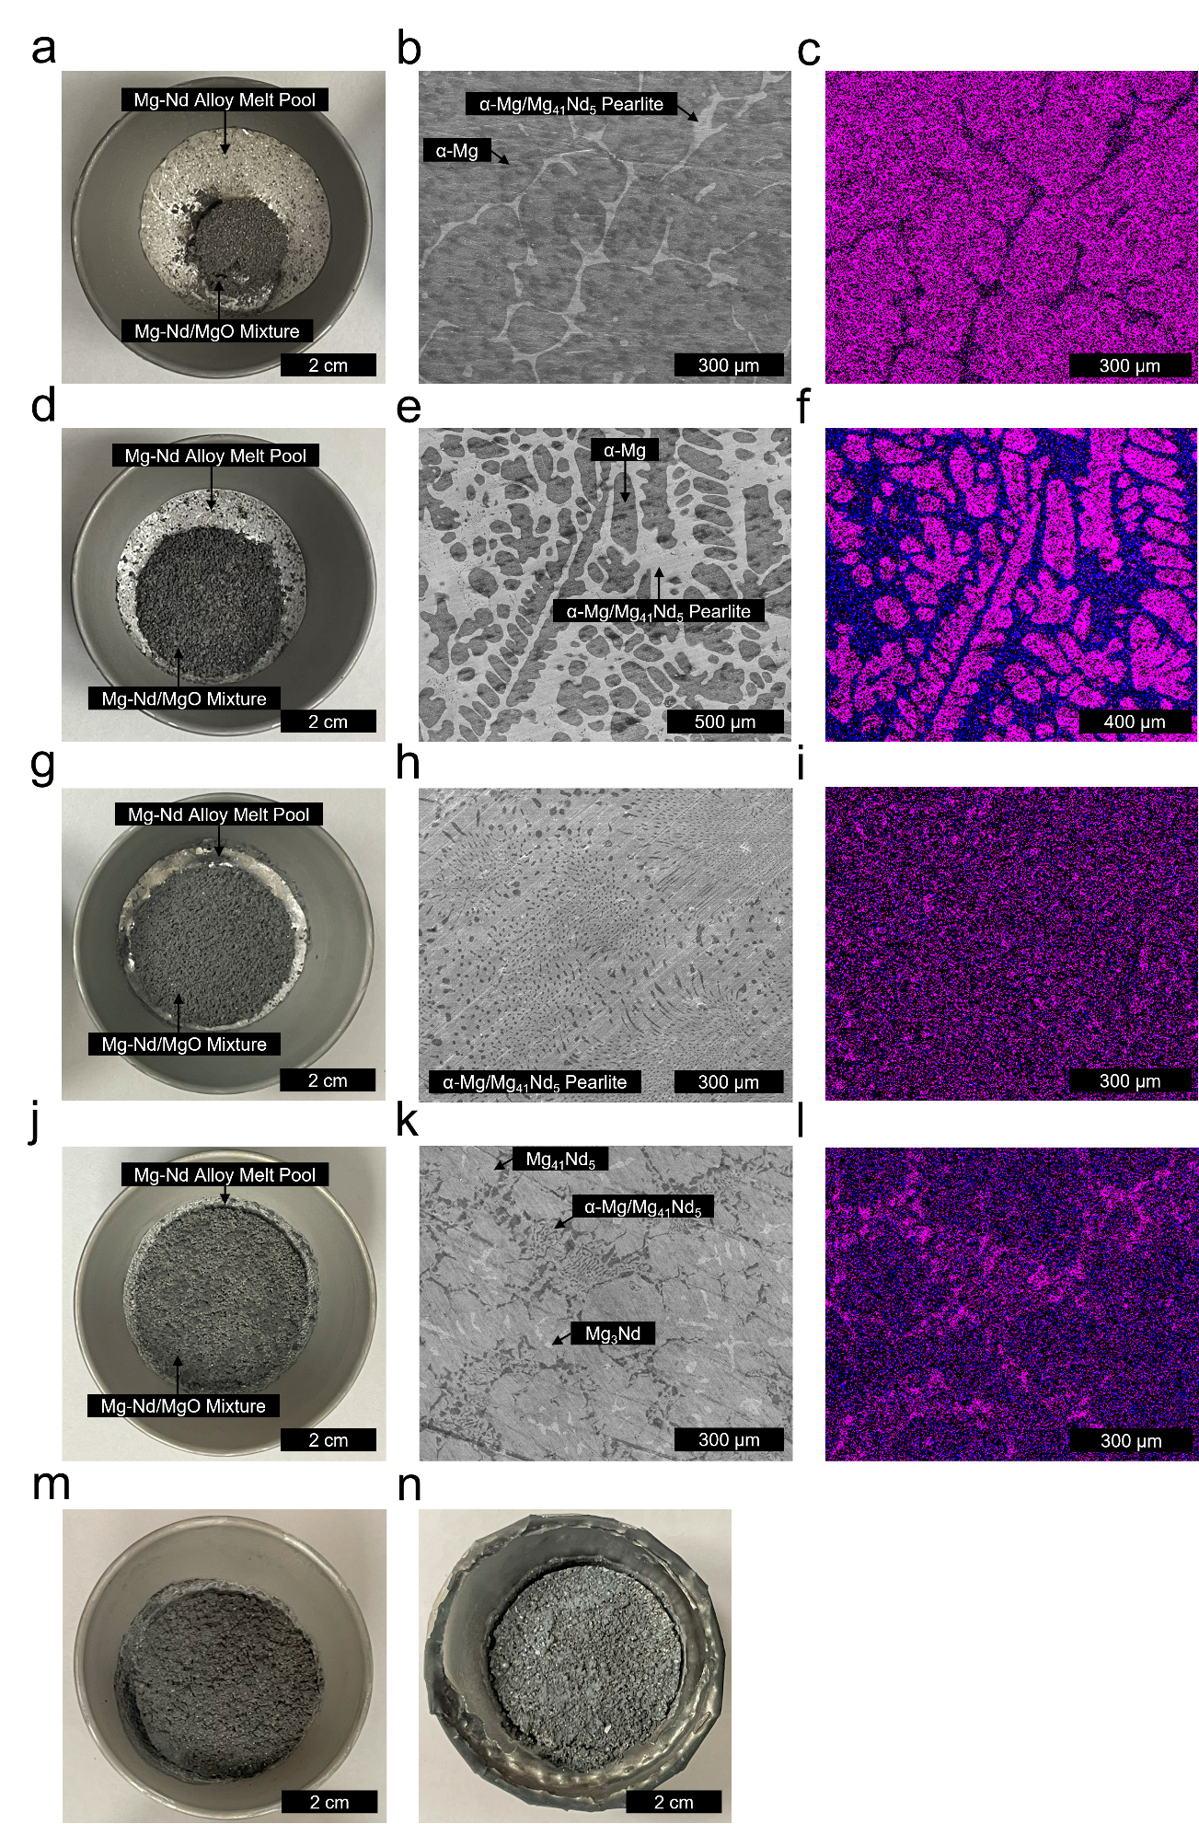

Supplementary Figure 2: a) Crucible after reduction for the 0.014 initial reactant ratio. b) Microstructure at this condition. c) EDS map of this microstructure showing relative enrichment of Nd (blue) and Mg (magenta). d) Crucible after reduction for the 0.054 initial reactant ratio. e) Microstructure at this condition. f) EDS map of this microstructure. g) Crucible after reduction for the 0.095 initial reactant ratio. h) Microstructure at this condition. i) EDS map of this microstructure. j) Crucible after reduction for the 0.135 condition. k) Microstructure at this condition. l) EDS map of this microstructure. m) Crucible after reduction for the 0.18 initial reactant ratio. A sample for microstructural analysis could not be collected, however enough material was collected to quantify Nd concentration. n) Crucible for the 0.22 initial reactant ratio. The lid fused to the crucible due to reaction with the molten alloy; data could not be collected for this condition.

