Supplementary Figures

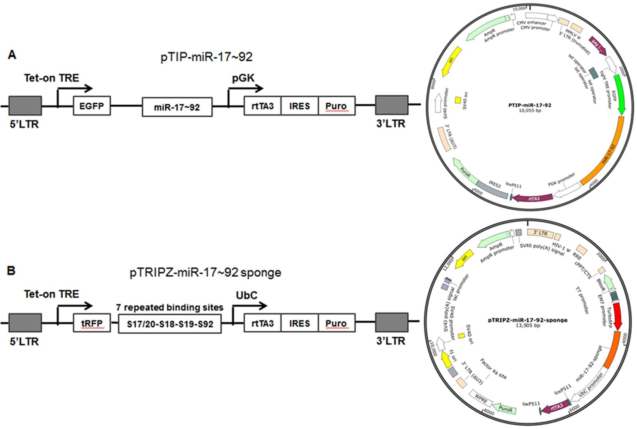
Supplementary Fig. S1 Diagram and map of constructed plasmids expressing miR-17~92 and miR-17~92 sponge. a: Diagram and map of the retrovirus pTIP-miR-17~92 Tet-on recombinant plasmid containing doxycycline-inducible promoter, EGFP reporter gene, puromycin and ampicillin resistance genes, which over-expressed miR-17~92 including miR-17, miR-20a, miR-18, miR-19a, miR-19b and miR-92. b: Diagram and map of the lentivirus pTRIPZ-miR-17~92 sponge Tet-on recombinant plasmid containing doxycycline-inducible promoter, TurboRFP reporter gene, puromycin and ampicillin resistance genes, which expressed a miR-17~92 sponge containing 7 tandem binding sites for each of the four miRNA families in miR-17~92, targeting respectively miR-17/20, miR-18, miR-19 and miR-92 from 5’ to 3’. The pTRIPZ-miR-17~92 sponge could competitively inhibit miR-17~92 in cells.

Supplementary Fig. S2 MiR-17~92 expression and confirmation of constructed cells in ABC-DLBCL. a: Relative miRNAs expression of miR-17~92 including miR-17-5p, miR-19b and miR-92a in four ABC-DLBCL cell lines than primary normal B cells (centroblasts). The miRNAs expression values of centroblasts were set to 1 and corresponding miRNAs expression values of ABC-DLBCL cell lines were normalized by centroblasts values. b: Confirmation of miR-17~92 sponge expression using qRT-PCR in the constructed U2932 and Ly3 cell lines, which were respectively transduced with pTRIPZ-miR-17~92 sponge. c: Confirmation of miR-17~92 expression including miR-17-5p, miR-19b and miR-92a using qRT-PCR in the constructed Ly10 and TMD8 cell lines, which were respectively transduced with pTIP-miR-17~92. All stably transduced cells were detected after inducing with 1μg/ml doxycycline for 48h. All assays were performed in triplicate. *P<0.05, **P≤0.01, ***P ≤ 0.001 and ****P ≤ 0.000.

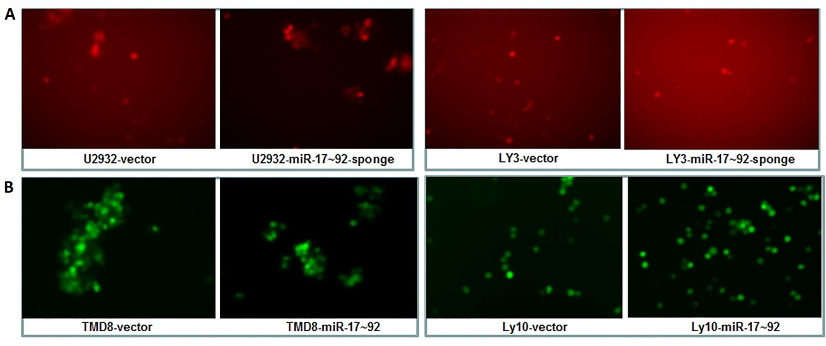
Supplementary Fig. S3 Confirmation of the stably transduced ABC-DLBCL cells using enhanced RFP or GFP assay. a: RFP images of the constructed U2932 and Ly3 cells under fluorescence microscope, which were transduced with pTRIPZ-miR-17~92 sponge. b: GFP images of the constructed TMD8 and Ly10 cells under fluorescence microscope, which were transduced with pTIP-miR-17~92.

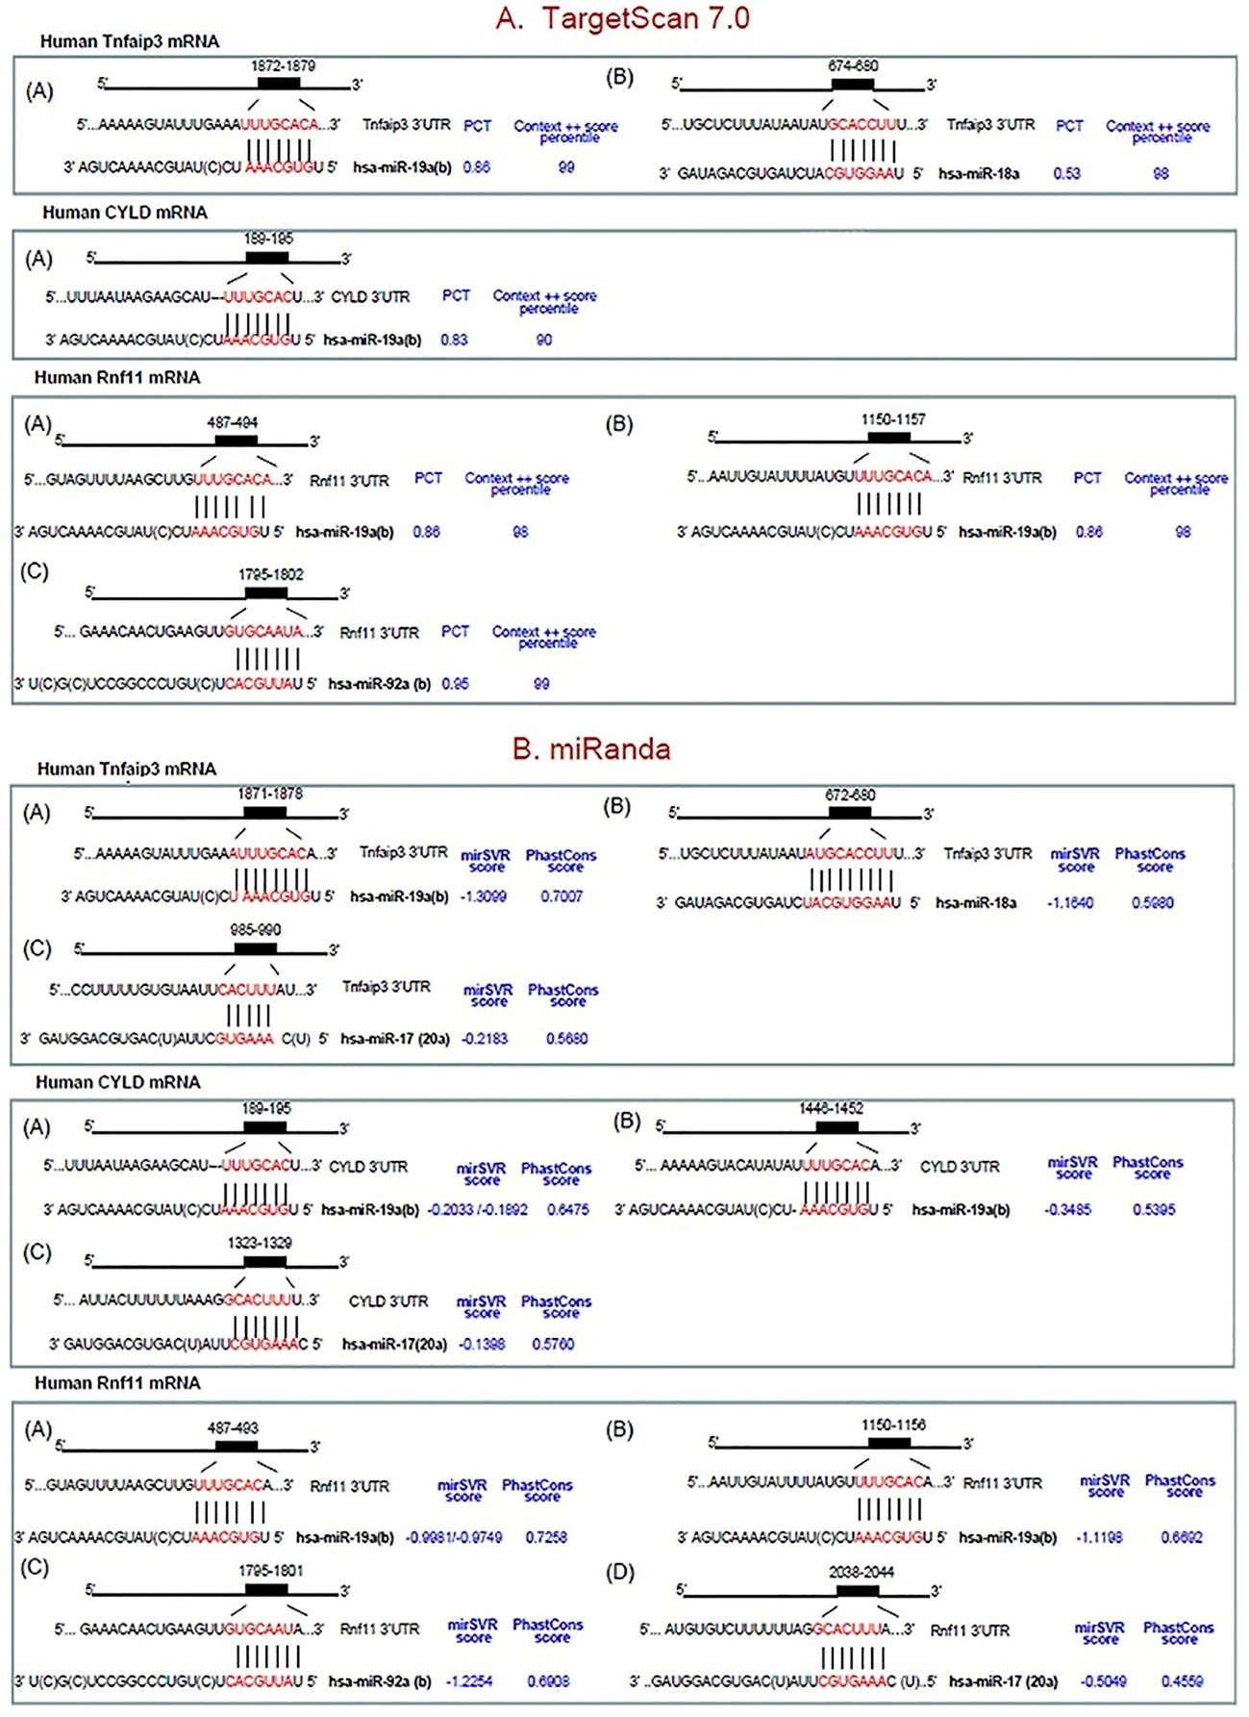
Supplementary Fig. S4 Highly conserved sites of the 3’UTR of TNFAIP3, CYLD and Rnf11 binding to the seed sequence of miR-17~92. a: Predicted binding sites, PCT and context++score percentile values using TargetScan 7.0 (August 2015). b: Predicted binding sites, mirSVR and PhastCons scores using miRanda (August 2010 Release Last Update: 2010-11-01).
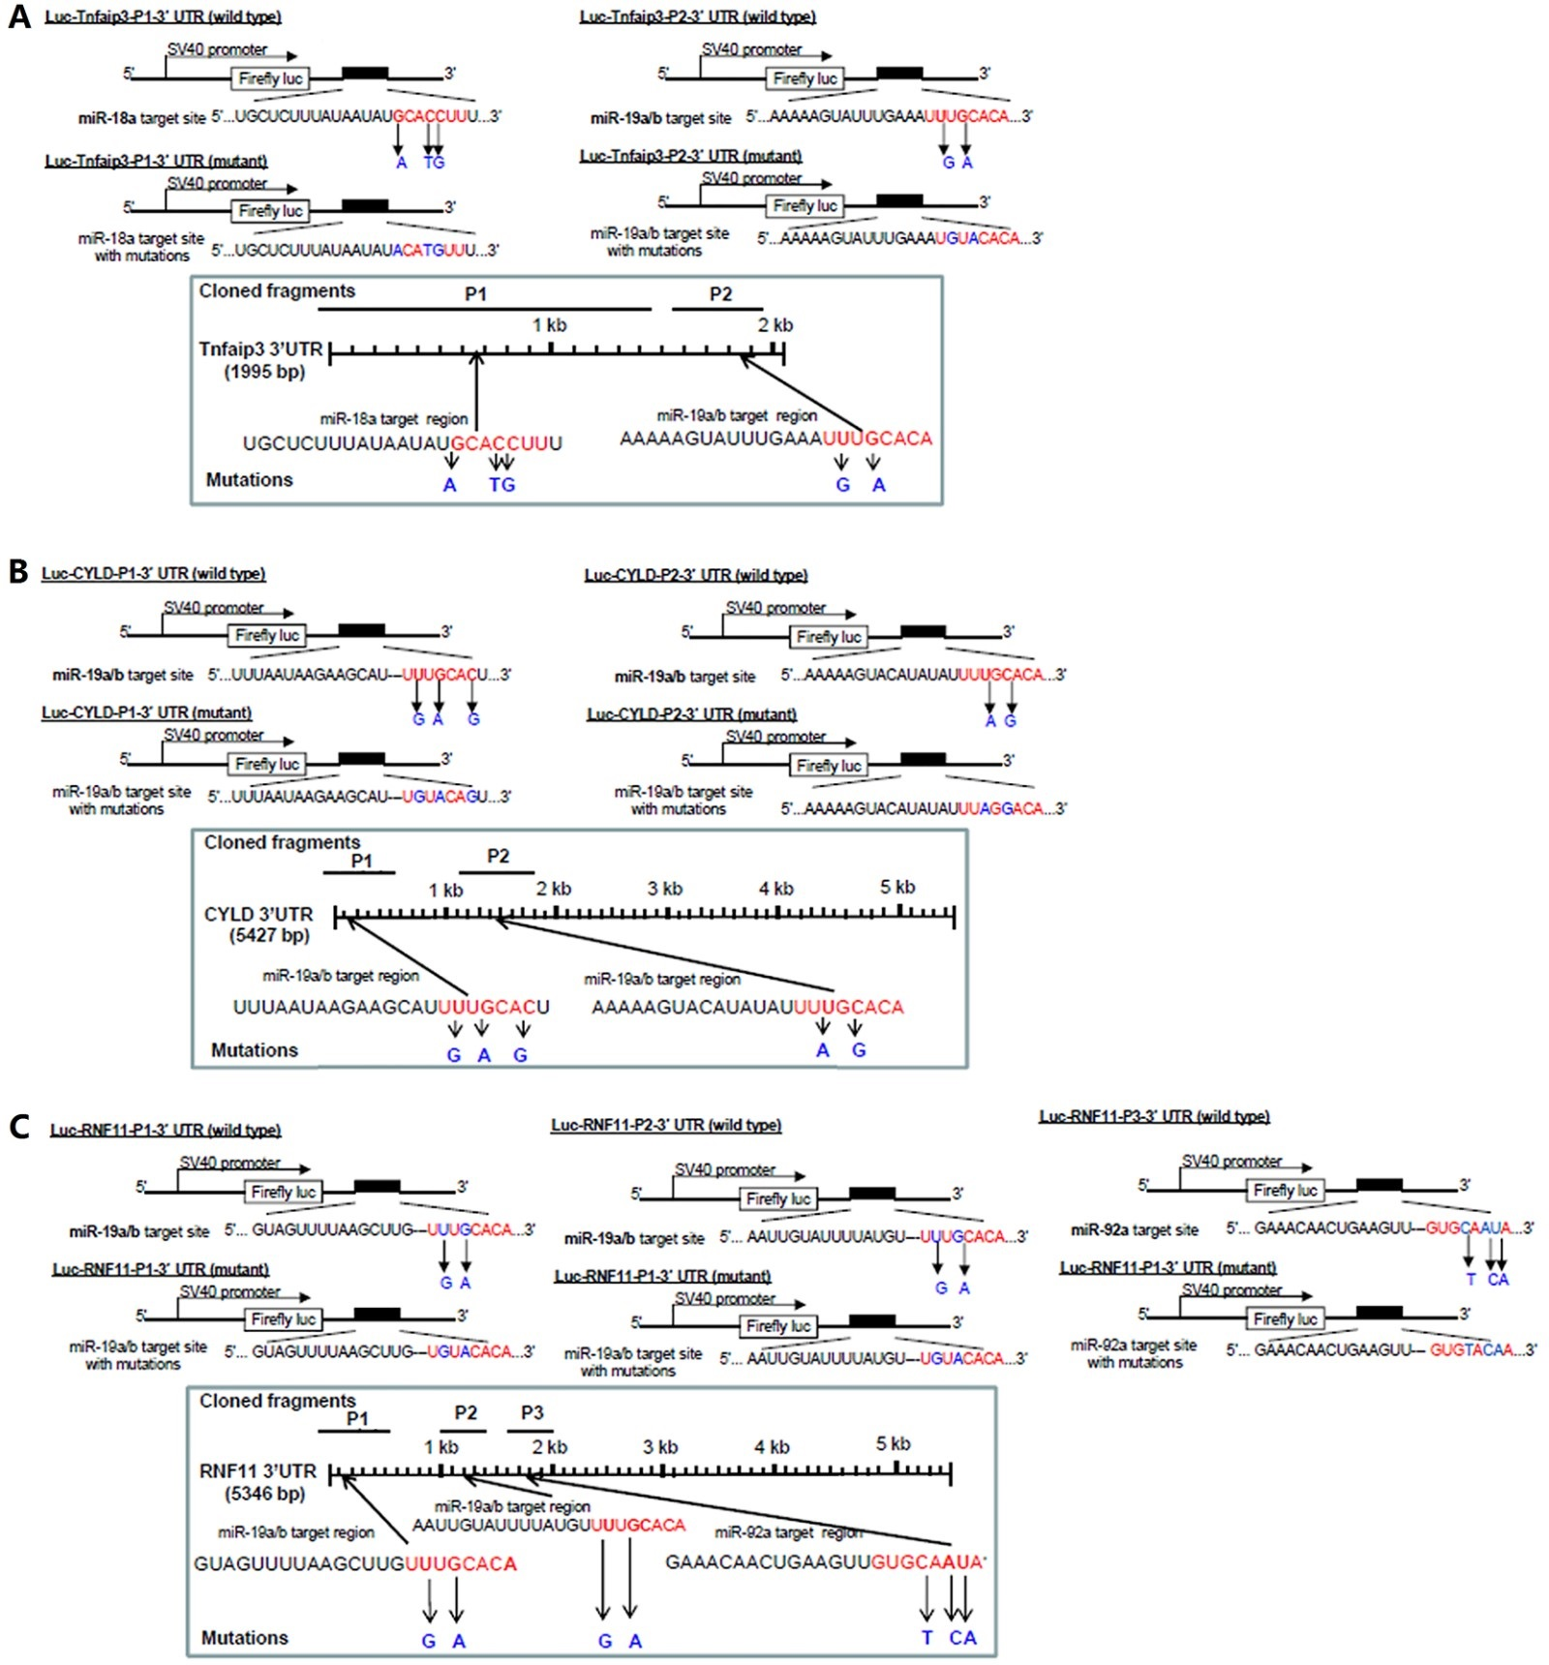
Supplementary Fig. S5 The fragments of cloned wild-type and mutant Luc-Target gene-3’UTR plasmids carrying Target gene-3’UTR conserved sites binding to seed sequence of miR-17~92. a: Two Luc-TNFAIP3-3’UTR plasmids carrying TNFAIP3-3’UTR conserved sites binding to seed sequence of miR-18a/-19a(b). b: Two Luc-CYLD-3’UTR plasmids carrying CYLD-3’UTR conserved sites binding to seed sequence of miR-19a(b). c: Three Luc-RNF11-3’UTR plasmids carrying RNF11-3’UTR conserved sites binding to seed sequence of miR-19a(b)/-92a.

Supplementary Fig. S6 The regulatory relationships between the canonical NF-κB signaling activation by miR-17~92 and the ubiquitin-editing protein approach or BCR approach in ABC-DLBCL. Stably transduced ABC-DLBCL cells were treated with 0.5 μmol/l Ibrutinib (Selleck Chemicals LLC, Houston, USA) for 48h. And then anti-human IgM (5 μg/ml α-IgM, Southern Biotech, Birmingham, AL, USA) was titrated into the medium for 15 min similar to previous report.

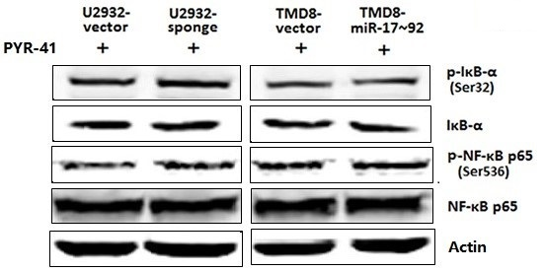
Supplementary Fig. S7 The effect for miR-17~92 activating the canonical NF-κB signaling in ABC-DLBCL cells after PYR-41 treatment. All stably transduced ABC-DLBCL cells were treated with 0.5 μmol/l Ibrutinib for 48h to block BCR signaling. And then the cells were treated with 50 μmol/l PYR-41 (Selleck Chemicals LLC, Houston, USA) for 15 min to inhibit the polyubiquitination, and were induced with 1μg/ml doxycycline for 9h to express the miR-17~92 sponge or miR-17~92. After stimulating with 100 ng/ml TNF-α for 15 min, cell lysates were immunoblotted with antibodies specific for IκB-α, NF-κB p65 and their phosphorylation levels.

