Supplementary data
Table. S1 Summary of all traits measured in this study for species growth in the warm and control site. Data are means± SE. t value with significant stars.
Classification | Traits | C. Hystrix Mean± SE |  |  | O. Pinnata Mean± SE |  |  | P. Massoniana Mean± SE |  |  | S. Superba Mean± SE
Classification | Traits | Control | Warming | t value | Control | Warming | t value | Control | Warming | t value | Control | Warming | t value
Growth | PH | 2.3 ± 0.02 | 2.2 ± 0.1 | 0.61 | 2.09 ± 0.07 | 2.65 ± 0.09 | -4.66** | 1.6 ± 0.02 | 1.9 ± 0.0 | -4.35** | 1.76 ± 0.08 | 2.03 ± 0.04 | -2.94*
Growth | DBH | 3.94 ± 0.4 | 3.92 ± 0.1 | 0.04 | 4.6 ± 0.3 | 6.2 ± 0.5 | -2.59* | 4.3 ± 0.37 | 4.3 ± 0.33 | 0.29 | 3.58 ± 0.2 | 4.5 ± 0.3 | -1.96
Growth | TB | 307 ± 26 | 298 ± 17.5 | 0.27 | 338 ± 20.6 | 457 ± 23.3 | -3.57* | 328 ± 27.7 | 374 ± 27.4 | -1.2 | 264 ± 17.6 | 330 ± 10.2 | -3.2*
Physiology | A | 2.5 ± 0.06 | 2.1 ± 0.02 | 5.13** | 7.06 ± 0.03 | 8.76 ± 0.1 | -10.2*** | 3.9 ± 0.03 | 4.6 ± 0.1 | -6.77** | 5.31 ± 0.08 | 6.96 ± 0.07 | -15.8***
Physiology | gs | 0.11 ± 0.005 | 0.09 ± 0.001 | 3.73* | 0.41± 0.009 | 0.47 ± 0.009 | -4.72** | 0.14 ± 0.009 | 0.19 ± 0.007 | -3.77** | 0.22 ± 0.01 | 0.28 ± 0.009 | -4.08**
Physiology | Rn | 0.08 ± 0.01 | 0.1 ± 0.002 | -1.84 | 0.38 ± 0.01 | 0.51 ± 0.01 | -6.06*** | 0.16 ± 0.008 | 0.21 ± 0.007 | -4.1** | 0.30 ± 0.01 | 0.41 ± 0.009 | -5.22**
Physiology | Fv/Fm | 0.75 ± 0.08 | 0.72 ± 0.01 | 2.15 | 0.83 ± 0.01 | 0.82 ± 0.005 | 2.1 | 0.85 ± 0.008 | 0.83 ± 0.007 | 2.1 | 0.86 ± 0.002 | 0.84 ± 0.003 | 2.96*
Anatomy | CHL A | 0.66 ± 0.05 | 0.79 ± 0.03 | -2.08 | 1.07 ± 0.01 | 1.08 ± 0.005 | -1.11 | 0.76 ± 0.01 | 0.92 ± 0.005 | -6.81** | 0.97 ± 0.03 | 1.05 ± 0.02 | -2.56
Anatomy | CHL B | 0.35 ± 0.02 | 0.57 ± 0.03 | -5.07** | 0.59 ± 0.03 | 0.71 ± 0.003 | -3.52* | 0.34 ± 0.003 | 0.4 ± 0.002 | -15.6*** | 0.46 ± 0.01 | 0.76 ± 0.02 | -10.6***
Anatomy | T CHL | 1.02 ± 0.06 | 1.37 ± 0.07 | -3.5** | 1.6 ± 0.04 | 1.8 ± 0.007 | -3.15* | 1.1 ± 0.008 | 1.3 ± 0.005 | -18.18*** | 1.44 ± 0.04 | 1.82 ± 0.02 | -7.7***
Anatomy | Carotene | 0.6 ± 0.04 | 1 ± 0.02 | -7.25*** | 1.02 ± 0.01 | 1.07 ±0.004 | -2.65* | 0.52 ± 0.01 | 0.95 ± 0.01 | -9.09*** | 0.94 ± 0.04 | 0.97 ± 0.02 | -0.67
Anatomy | SD | 16.2 ± 0.3 | 11.8 ± 0.2 | 10.37*** | 23.2 ± 0.5 | 28.2 ± 0.3 | -7.21*** | 15 ± 0 | 15.6 ± 0.24 | -2.49 | 28.4 ± 0.8 | 33.8 ± 0.5 | -5.14**
Anatomy | SL | 17.6 ± 0.3 | 12.7± 0.2 | 9.45*** | 21.5 ± 0.4 | 25.2 ± 0.2 | -7.39*** | 16.3 ± 0.5 | 21.4 ± 0.21 | -8.09*** | 30.2 ± 0.2 | 33.4 ± 0.4 | -5.98**
Anatomy | LA | 11.6 ± 0.7 | 15.6 ± 0.5 | -4.26** | 40.4 ± 2.6 | 53 ± 0.3 | -4.76** | 1.51 ± 0.1 | 1.8 ± 0.02 | -2.74 | 44.8 ± 2.8 | 52.7 ± 1.07 | -3.8*
Anatomy | SLA | 14.7 ± 0.7 | 15.3 ± 0.2 | -0.81 | 12.7 ± 0.2 | 14.8 ± 0.3 | -4.4** | 1.9 ± 0.09 | 2.8 ± 0.3 | -2.42 | 11.9 ± 0.18 | 12.7 ± 0.16 | -3.09*
Water | Ψpd | -0.94 ± 0.009 | -1.04 ± 0.01 | -7.01*** | -0.49 ± 0.01 | -0.62 ± 0.01 | -8.09*** | -0.74 ± 0.009 | -0.84 ± 0.01 | -6.38*** | -0.35 ± 0.01 | -0.44 ± 0.007 | -6.6***
Water | Ψmd | -1.71 ± 0.01 | -1.89 ± 0.01 | -10.7*** | -0.83 ± 0.01 | -0.96 ± 0.01 | -7.15*** | -1.14± 0.01 | -1.38 ± 0.01 | -10.7*** | -0.74 ± 0.008 | -0.85 ± 0.01 | -7.90***

Fig. S1 Total biomass of Castanopsis hystrix, Ormosia Pinnata, Pinus massoniana and Schima superba grown in the warming site and control site. Error bars are standard error (n= 5). Asterisks (*), (**) and (***) indicate that there are significant differences at p< 0.05, p< 0.01 and p< 0.001 between the warming and the control plots, respectively. Mean values of plasticity of the four species are reported for each trait.
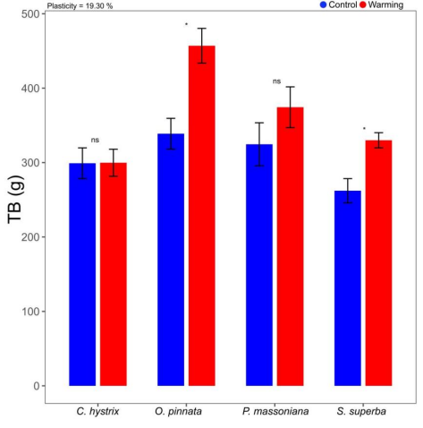
Fig. S2 Leaf area (a), specific leaf area (b), stomatal length (c) and stomatal density (d) for Castanopsis hystrix, Ormosia Pinnata, Pinus massoniana and Schima superba grown in the warming site and control site. Error bars are standard error (n= 5). Asterisks (*), (**) and (***) indicate that there are significant differences at p < 0.05, p < 0.01 and p < 0.001 between the warming and the control plots, respectively. Mean values of plasticity of the four species are reported for each trait.
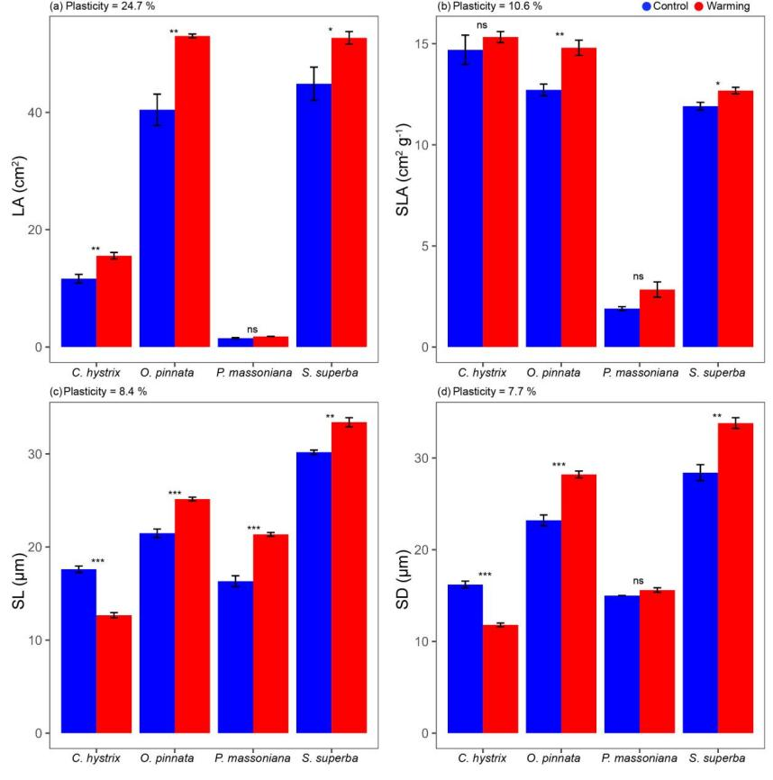
Fig. S3 CHL A (a), CHL B (b), T Chl (c) and Carotenoids (d) for Castanopsis hystrix, Ormosia Pinnata, Pinus massoniana and Schima superba grown in the warming site and control site. Error bars are standard error (n= 5 trees). Asterisks (*), (**) and (***) indicate that there are significant differences at p< 0.05, p< 0.01 and p< 0.001 between the warming and the control plots, respectively. Mean values of plasticity of the four species are reported for each trait.
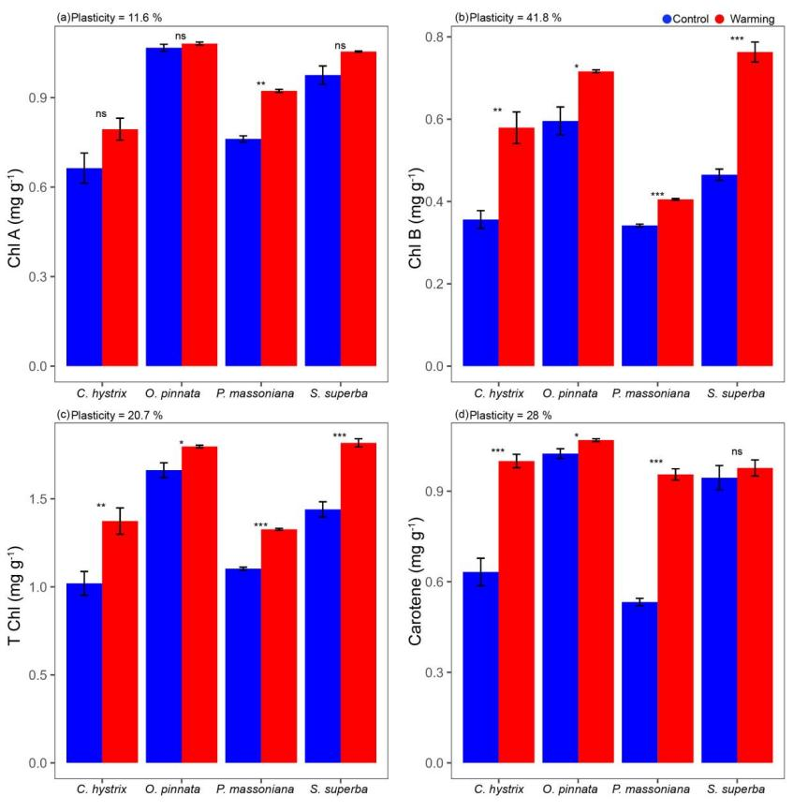
Fig. S4 Ψpd (a) and Ψmd (b) for Castanopsis hystrix, Ormosia Pinnata, Pinus massoniana and Schima superba grown in the warming site and control site. Error bars are standard error (n= 5). Asterisks (*), (**) and (***) indicate that there are significant differences at p< 0.05, p< 0.01 and p< 0.001 between the warming and the control plots, respectively. Mean values of plasticity of the four species are reported for each trait.
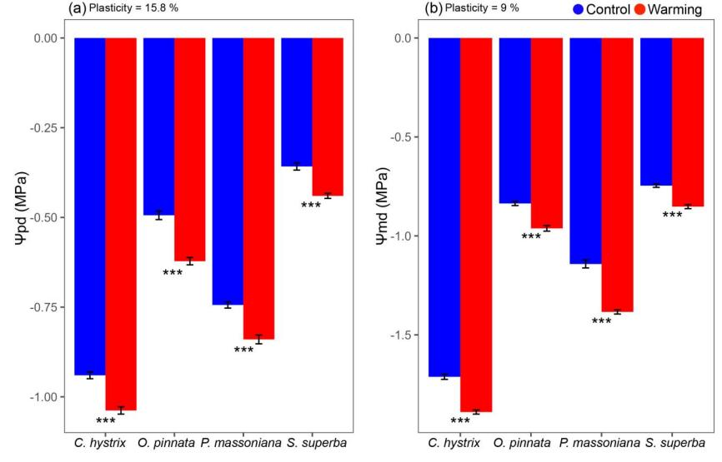
Fig. S5 The relationships of photosynthetic rate A with SL (a) and SD (c) and night respiration (R_{n}) with SL (b) and SD (d). Species under control are shown in blue; Warming condition species in red. Only statistically significant relationships (p< 0.05) are shown as solid lines with shaded areas representing the 95% confidence interval.
