Inhibition of vascular adhesion protein 1 protects dopamine neurons
from the effects of acute inflammation and restores
habit learning in the striatum

Additional Information

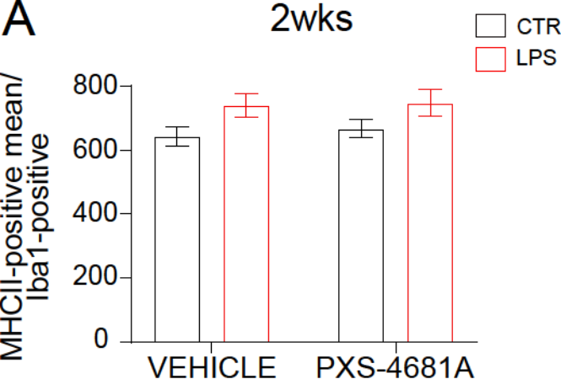
Figure S1. MHCII expression in striatal microglia.
A) Quantification of MHC-II expression in Iba1-positive cells in the striatum at 2 weeks after LPS insult in the SN. Repeated measure Two-way ANOVA: LPS effect F_{(1,19)} = 6.985, p = 0.0165; PXS-4681A effect F_{(1,19)} = 0.0075, p > 0.05; Interaction F_{(1,19)} = 0.08489, p > 0.05.

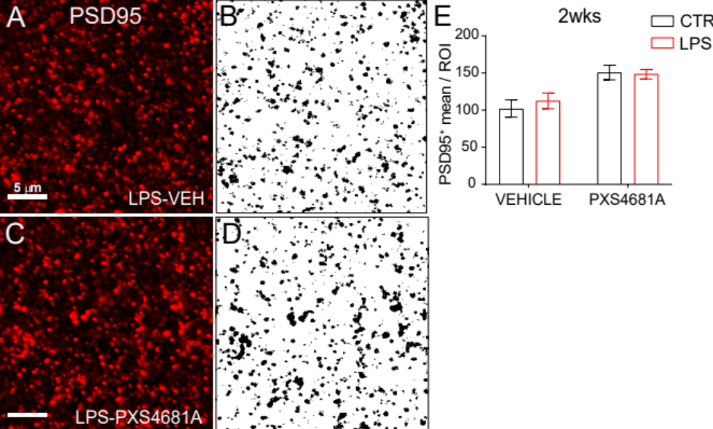
Figure S2. VAP-1 inhibition increases postsynaptic protein in the striatum.
A-D) Immunostaining for PSD-95 in the dorsal striatum and example of quantification as positive area using Image J.
E) Quantification of immunostaining for PSD-95 in the dorsal striatum 2 weeks after LPS insult in the SN. Repeated measure two-way ANOVA: LPS effect F_{(1,23)} = 0.3449, p > 0.05; PXS-4681A effect F_{(1,23)} = 6.060, p = 0.0218; Interaction F_{(1,23)} = 1.158, p > 0.05. LPS-Vehicle (n = 12); LPS-PXS-4681A (n = 13).

