Supplementary information
Precision Connectivity in Arthritis Pain with Permutation and Network Analysis:
A Key Step Toward Clinical Application
Belfin Robinson¹, Emilio G. Cediel¹, William Reuther¹, Aryan Kodali ¹, Ellora Srabani ¹, Olivia Leggio¹, Vibhor Krishna^{2*} and Varina L. Boerwinkle^{1*}.
¹Clinical resting state fMRI service, Department of Neurology, University of North Carolina at Chapel Hill, Chapel Hill, NC, United States.
²Department of Neurosurgery, University of North Carolina at Chapel Hill, Chapel Hill, NC, United States.
*Vibhor Krishna and Varina Boerwinkle are co-senior authors.
Correspondence:
Corresponding Authors
varina_boerwinkle@med.unc.edu
Keywords: rs-fMRI, chronic pain, osteoarthritis, seed analysis, permutation, network analysis

Table S1: Pain region and its location in the brain

Location | Brain region | Abbrev | Hemi | Label | MNI X | MNI Y | MNI Z
Middle frontal gyrus | ventral dorsolateral prefrontal cortex | vDLPFC | L | vDLPFC_L | −41 | 41 | 16
Middle frontal gyrus | ventral dorsolateral prefrontal cortex | vDLPFC | R | vDLPFC_R | 42 | 44 | 14
Middle frontal gyrus | ventrolateral prefrontal cortex | VLPFC | L | VLPFC_L | −48 | 20 | −8
Middle frontal gyrus | ventrolateral prefrontal cortex | VLPFC | R | VLPFC_R | 48 | 20 | −8
Inferior frontal gyrus | opercular pars triangularis | oPT | L | oPT_L | −39 | 23 | 4
Inferior frontal gyrus | opercular pars triangularis | oPT | R | oPT_R | 42 | 22 | 3
Inferior frontal gyrus | ventral pars triangularis | vPT | L | vPT_L | −52 | 13 | 6
Inferior frontal gyrus | ventral pars triangularis | vPT | R | vPT_R | 54 | 14 | 11
Frontal gyrus | orbitofrontal cortex | OFC | L | OFC_L | −24 | 34 | −12
Frontal gyrus | orbitofrontal cortex | OFC | R | OFC_R | 24 | 34 | −12
Precentral gyrus | primary motor cortex | PMC | L | PMC_L | −52 | 0 | 8
Precentral gyrus | primary motor cortex | PMC | R | PMC_R | 54 | 4 | 9
Superior parietal lobe | postcentral somatosensory association cortex | pSAC | L | pSAC_L | −22 | −47 | 65
Superior parietal lobe | postcentral somatosensory association cortex | pSAC | R | pSAC_R | 23 | −43 | 67
Inferior parietal lobe | caudal supramarginal gyrus | cSG | L | cSG_L | −56 | −49 | 38
Inferior parietal lobe | caudal supramarginal gyrus | cSG | R | cSG_R | 57 | −44 | 38
Inferior parietal lobe | rostroventral supramarginal gyrus | rvSG | L | rvSG_L | −53 | −31 | 23
Inferior parietal lobe | rostroventral supramarginal gyrus | rvSG | R | rvSG_R | 55 | −26 | 26
Postcentral gyrus | primary somatosensory cortex (tongue and larvnx region) | SI | L | SI_L | −56 | −14 | 16
Postcentral gyrus | primary somatosensory cortex (tongue and larvnx region) | SI | R | SI_R | 56 | −10 | 15
Postcentral gyrus | primary somatosensory cortex (trunk region) | SI | L | SI_L | −21 | −35 | 68
Postcentral gyrus | primary somatosensory cortex (trunk region) | SI | R | SI_R | 20 | −33 | 69
Postcentral gyrus | secondary somatosensory cortex | SII | L | SII_L | −52 | −26 | 22
Postcentral gyrus | secondary somatosensory cortex | SII | R | SII_R | 56 | −22 | 24
Cingulate gyrus | rostroventral ventral anterior cingulate cortex | rvVACC | L | rvVACC_L | −3 | 8 | 25
Cingulate gyrus | rostroventral ventral anterior cingulate cortex | rvVACC | R | rvVACC_R | 5 | 22 | 12
Cingulate gyrus | caudal ventral anterior cingulate cortex | cvACC | L | cvACC_L | −5 | 7 | 37
Cingulate gyrus | caudal ventral anterior cingulate cortex | cvACC | R | cvACC_R | 4 | 6 | 38
Cingulate gyrus | pregenual dorsal anterior cingulate cortex | pdACC | L | pdACC_L | −6 | 34 | 21
Cingulate gyrus | pregenual dorsal anterior cingulate cortex | pdACC | R | pdACC_R | 5 | 28 | 27
Cingulate gyrus | subgenual dorsal anterior cingulate cortex | sdACC | L | sdACC_L | −4 | 39 | −2
Cingulate gyrus | subgenual dorsal anterior cingulate cortex | sdACC | R | sdACC_R | 5 | 41 | 6
Cingulate gyrus | rostral anterior cingulate cortex | rACC | L | rACC_L | −7 | 27 | 29
Cingulate gyrus | rostral anterior cingulate cortex | rACC | R | rACC_R | 7 | 27 | 29
Cingulate gyrus | caudal ventral posterior cingulate cortex | cvPCC | L | cvPCC_L | −7 | −23 | 41
Cingulate gyrus | caudal ventral posterior cingulate cortex | cvPCC | R | cvPCC_R | 6 | −20 | 40
Cingulate gyrus | posterior midcingulate cortex | pMCC | L | pMCC_L | −3 | −21 | 51
Cingulate gyrus | posterior midcingulate cortex | pMCC | R | pMCC_R | 3 | −21 | 51
Basal ganglia | dorsolateral putamen | dlPu | L | dlPu_L | −28 | −5 | 2
Basal ganglia | dorsolateral putamen | dlPu | R | dlPu_R | 29 | −3 | 1
Periaqueductal gray | ventrolateral periaqueductal gray | vlPAG | L | vlPAG_L | −3 | −32 | −12
Periaqueductal gray | ventrolateral periaqueductal gray | vlPAG | R | vlPAG_R | 3 | −32 | −12
Periaqueductal gray | lateral periaqueductal gray | lPAG | L | lPAG_L | −4 | −31 | −8
Periaqueductal gray | lateral periaqueductal gray | lPAG | R | lPAG_R | 4 | −31 | −8
Periaqueductal gray | dorsolateral periaqueductal gray | dlPAG | L | dlPAG_L | −2 | −32 | −5
Periaqueductal gray | dorsolateral periaqueductal gray | dlPAG | R | dlPAG_R | 2 | −32 | −5
Thalamus | medial prefrontal thalamus | mPFtha | L | mPFtha_L | −7 | −12 | 5
Thalamus | medial prefrontal thalamus | mPFtha | R | mPFtha_R | 7 | −11 | 6
Thalamus | premotor thalamus | mPMtha | L | mPMtha_L | −18 | −13 | 3
Thalamus | premotor thalamus | mPMtha | R | mPMtha_R | 12 | −14 | 1
Thalamus | posterior parietal thalamus | PPtha | L | PPtha_L | 16 | −24 | 6
Thalamus | posterior parietal thalamus | PPtha | R | PPtha_R | 15 | −25 | 6
Thalamus | caudal temporal thalamus | cTtha | L | cTtha_L | −12 | −22 | 13
Thalamus | caudal temporal thalamus | cTtha | R | cTtha_R | 10 | −14 | 14
Thalamus | lateral prefrontal thalamus | lPFtha | L | lPFtha_L | −11 | −14 | 2
Thalamus | lateral prefrontal thalamus | lPFtha | R | lPFtha_R | 13 | −16 | 7
Amygdala | medial amygdala | mAmyg | L | mAmyg_L | −19 | −2 | −20
Amygdala | medial amygdala | mAmyg | R | mAmyg_R | 19 | −2 | −19
Amygdala | lateral amygdala | lAmyg | L | lAmyg_L | −27 | −4 | − 20
Amygdala | lateral amygdala | lAmyg | R | lAmyg_R | 28 | −3 | −20
Hippocampus | rostral hippocampus | rHipp | L | rHipp_L | −22 | −14 | −19
Hippocampus | rostral hippocampus | rHipp | R | rHipp_R | 22 | −12 | −20
Hippocampus | caudal hippocampus | cHipp | L | cHipp_L | −28 | −30 | −10
Hippocampus | caudal hippocampus | cHipp | R | cHipp_R | 29 | −27 | −10
Insula | Hypergranular insula | G | L | G_L | −36 | −20 | 10
Insula | Hypergranular insula | G | R | G_R | 37 | −18 | 8
Insula | Ventral agranular insula | vIa | L | vIa_L | −32 | 14 | −13
Insula | Ventral agranular insula | vIa | R | vIa_R | 33 | 14 | −13
Insula | Dorsal agranular insula | dIa | L | dIa_L | −34 | 18 | 1
Insula | Dorsal agranular insula | dIa | R | dIa_R | 36 | 18 | 1
Insula | Ventral dysgranular and granular insula | vId/vIg | L | vId/vIg_L | −38 | −4 | −9
Insula | Ventral dysgranular and granular insula | vId/vIg | R | vId/vIg_R | 39 | −2 | −9
Insula | Dorsal granular insula | dIg | L | dIg_L | −38 | −8 | 8
Insula | Dorsal granular insula | dIg | R | dIg_R | 39 | −7 | 8
Insula | Dorsal dysgranular insula | dId | L | dId_L | −38 | 5 | 5
Insula | Dorsal dysgranular insula | dId | R | dId_R | 38 | 5 | 5

Table S2: AAL atlas regions and its location in the brain and its coordinates.
Brain Region | Location | MNI X | MNI Y | MNI Z
Amygdala_L | Amygdala | −23 | −1 | −17
Amygdala_R | Amygdala | 27 | 1 | −18
Angular_L | Inferior parietal lobe | −44 | −61 | 36
Angular_R | Inferior parietal lobe | 46 | −60 | 39
Calcarine_L | Occipital lobe | −7 | −79 | 6
Calcarine_R | Occipital lobe | 16 | −73 | 9
Caudate_L | Basal ganglia | −11 | 11 | 9
Caudate_R | Basal ganglia | 15 | 12 | 9
Cerebellum_10_L | Cerebelum | −22 | −34 | −42
Cerebellum_10_R | Cerebelum | 27 | −34 | −41
Cerebellum_3_L | Brainsteam | −8 | −37 | −19
Cerebellum_3_R | Brainsteam | 13 | −34 | −19
Cerebellum_4_5_L | Brainsteam | −14 | −43 | −17
Cerebellum_4_5_R | Brainsteam | 18 | −43 | −18
Cerebellum_6_L | Cerebelum | −22 | −59 | −22
Cerebellum_6_R | Cerebelum | 26 | −58 | −24
Cerebellum_7b_L | Cerebelum | −31 | −60 | −45
Cerebellum_7b_R | Cerebelum | 34 | −63 | −48
Cerebellum_8_L | Cerebelum | −25 | −55 | −48
Cerebellum_8_R | Cerebelum | 26 | −56 | −49
Cerebellum_9_L | Cerebelum | −10 | −49 | −46
Cerebellum_9_R | Cerebelum | 10 | −49 | −46
Cerebellum_Crus1_L | Cerebelum | −35 | −67 | −29
Cerebellum_Crus1_R | Cerebelum | 38 | −67 | −30
Cerebellum_Crus2_L | Cerebelum | −28 | −73 | −38
Cerebellum_Crus2_R | Cerebelum | 33 | −69 | −40
Cingulum_Ant_L | Cingulate gyrus | −4 | 35 | 14
Cingulum_Ant_R | Cingulate gyrus | 8 | 37 | 16
Cingulum_Mid_L | Cingulate gyrus | −5 | −15 | 42
Cingulum_Mid_R | Cingulate gyrus | 8 | −9 | 40
Cingulum_Post_L | Cingulate gyrus | −5 | −43 | 25
Cingulum_Post_R | Cingulate gyrus | 7 | −42 | 22
Cuneus_L | Occipital lobe | −6 | −80 | 27
Cuneus_R | Occipital lobe | 14 | −79 | 28
Frontal_Inf_Oper_L | Inferior frontal gyrus | −48 | 13 | 19
Frontal_Inf_Oper_R | Inferior frontal gyrus | 50 | 15 | 21
Frontal_Inf_Orb_L | Inferior frontal gyrus | −36 | 31 | −12
Frontal_Inf_Orb_R | Inferior frontal gyrus | 41 | 32 | −12
Frontal_Inf_Tri_L | Inferior frontal gyrus | −46 | 30 | 14
Frontal_Inf_Tri_R | Inferior frontal gyrus | 50 | 30 | 14
Frontal_Med_Orb_L | Orbitofrontal cortex | −5 | 54 | −7
Frontal_Med_Orb_R | Orbitofrontal cortex | 8 | 52 | −7
Frontal_Mid_L | Middle frontal gyrus | −33 | 33 | 35
Frontal_Mid_Orb_L | Middle frontal gyrus | −31 | 50 | −10
Frontal_Mid_Orb_R | Middle frontal gyrus | 33 | 53 | −11
Frontal_Mid_R | Middle frontal gyrus | 38 | 33 | 34
Frontal_Sup_L | Frontal gyrus | −18 | 35 | 42
Frontal_Sup_Medial_L | Frontal gyrus | −5 | 49 | 31
Frontal_Sup_Medial_R | Frontal gyrus | 9 | 51 | 30
Frontal_Sup_Orb_L | Orbitofrontal cortex | −17 | 47 | −13
Frontal_Sup_Orb_R | Orbitofrontal cortex | 18 | 48 | −14
Frontal_Sup_R | Frontal gyrus | 22 | 31 | 44
Fusiform_L | Temporal lobe | −31 | −40 | −20
Fusiform_R | Temporal lobe | 34 | −39 | −20
Heschl_L | Temporal lobe | −42 | −19 | 10
Heschl_R | Temporal lobe | 46 | −17 | 10
Hippocampus_L | Hippocampus | −25 | −21 | −10
Hippocampus_R | Hippocampus | 29 | −20 | −10
Insula_L | Insula | −35 | 7 | 3
Insula_R | Insula | 39 | 6 | 2
Lingual_L | Occipital lobe | −15 | −68 | −5
Lingual_R | Occipital lobe | 16 | −67 | −4
Occipital_Inf_L | Occipital lobe | −36 | −78 | −8
Occipital_Inf_R | Occipital lobe | 38 | −82 | −8
Occipital_Mid_L | Occipital lobe | −32 | −81 | 16
Occipital_Mid_R | Occipital lobe | 37 | −80 | 19
Occipital_Sup_L | Occipital lobe | −17 | −84 | 28
Occipital_Sup_R | Occipital lobe | 24 | −81 | 31
Olfactory_L | Orbitofrontal cortex | −8 | 15 | −11
Olfactory_R | Orbitofrontal cortex | 10 | 16 | −11
Pallidum_L | Basal ganglia | −18 | 0 | 0
Pallidum_R | Basal ganglia | 21 | 0 | 0
Paracentral_Lobule_L | Precentral gyrus | −8 | −25 | 70
Paracentral_Lobule_R | Precentral gyrus | 7 | −32 | 68
ParaHippocampal_L | Temporal lobe | −21 | −16 | −21
ParaHippocampal_R | Temporal lobe | 25 | −15 | −20
Parietal_Inf_L | Inferior parietal lobe | −43 | −46 | 47
Parietal_Inf_R | Inferior parietal lobe | 46 | −46 | 50
Parietal_Sup_L | Superior parietal lobe | −23 | −60 | 59
Parietal_Sup_R | Superior parietal lobe | 26 | −59 | 62
Postcentral_L | Postcentral gyrus | −42 | −23 | 49
Postcentral_R | Postcentral gyrus | 41 | −25 | 53
Precentral_L | Precentral gyrus | −39 | −6 | 51
Precentral_R | Precentral gyrus | 41 | −8 | 52
Precuneus_L | Superior parietal lobe | −7 | −56 | 48
Precuneus_R | Superior parietal lobe | 10 | −56 | 44
Putamen_L | Basal ganglia | −24 | 4 | 2
Putamen_R | Basal ganglia | 28 | 5 | 2
Rectus_L | Orbitofrontal cortex | −5 | 37 | −18
Rectus_R | Orbitofrontal cortex | 8 | 36 | −18
Rolandic_Oper_L | Precentral gyrus | −47 | −8 | 14
Rolandic_Oper_R | Precentral gyrus | 53 | −6 | 15
Supp_Motor_Area_L | Frontal gyrus | −5 | 5 | 61
Supp_Motor_Area_R | Frontal gyrus | 9 | 0 | 62
SupraMarginal_L | Inferior parietal lobe | −56 | −34 | 30
SupraMarginal_R | Inferior parietal lobe | 58 | −32 | 34
Temporal_Inf_L | Temporal lobe | −50 | −28 | −23
Temporal_Inf_R | Temporal lobe | 54 | −31 | −22
Temporal_Mid_L | Temporal lobe | −56 | −34 | −2
Temporal_Mid_R | Temporal lobe | 57 | −37 | −1
Temporal_Pole_Mid_L | Temporal lobe | −36 | 15 | −34
Temporal_Pole_Mid_R | Temporal lobe | 44 | 15 | −32
Temporal_Pole_Sup_L | Temporal lobe | −40 | 15 | −20
Temporal_Pole_Sup_R | Temporal lobe | 48 | 15 | −17
Temporal_Sup_L | Temporal lobe | −53 | −21 | 7
Temporal_Sup_R | Temporal lobe | 58 | −22 | 7
Thalamus_L | Thalamus | −11 | −18 | 8
Thalamus_R | Thalamus | 13 | −18 | 8
Vermis_1_2 | Cerebelum | 2 | −39 | −20
Vermis_10 | Cerebelum | 1 | −46 | −32
Vermis_3 | Cerebelum | 2 | −40 | −11
Vermis_4_5 | Cerebelum | 2 | −52 | −6
Vermis_6 | Cerebelum | 2 | −67 | −15
Vermis_7 | Cerebelum | 2 | −72 | −25
Vermis_8 | Cerebelum | 2 | −64 | −34
Vermis_9 | Cerebelum | 2 | −55 | −35

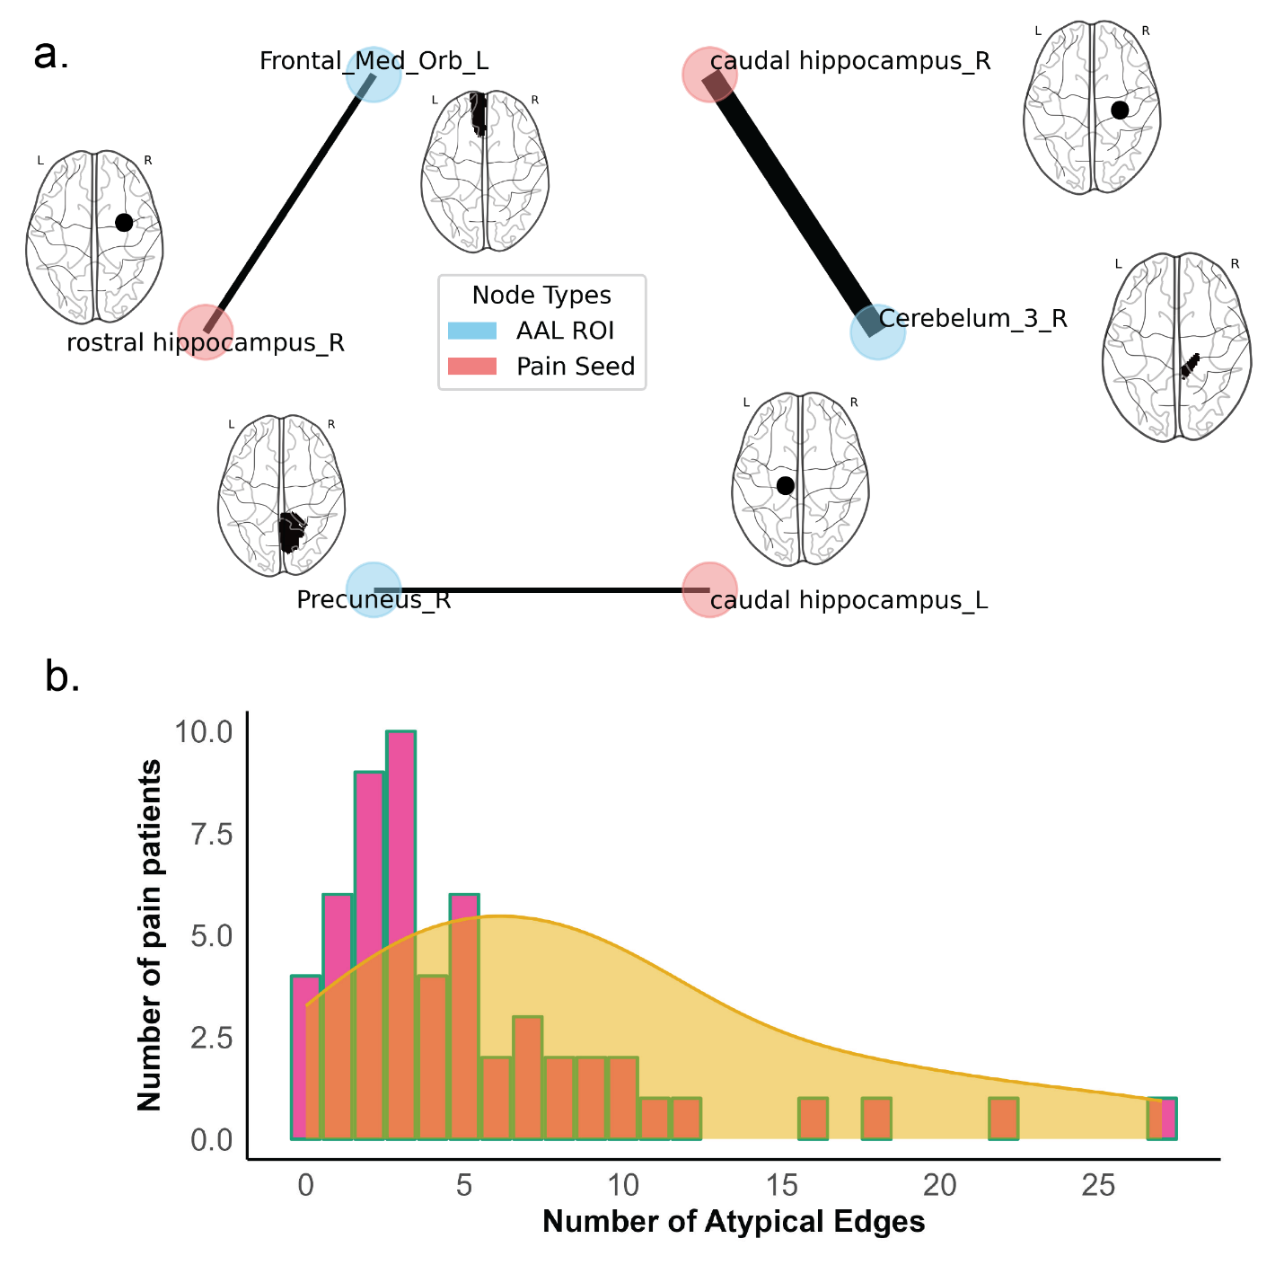
Figure S1. Atypical connections in osteoarthritis pain patient cohort. a.) This diagram displays connections that are significantly different (p<0.05) when compared to a set of healthy controls. b.) Distribution of Atypical Neural Edges among OA pain patients. This figure illustrates the frequency of atypical neural edges detected across pain patients. The x-axis represents the number of atypical edges, and the y-axis denotes the number of pain patients. The histogram (pink bars) quantifies the distribution of these atypical edges per patient. Overlaying the histogram, the yellow density plot indicates a left-skewed distribution, with a prominent peak observed between 5 and 7 atypical edges.
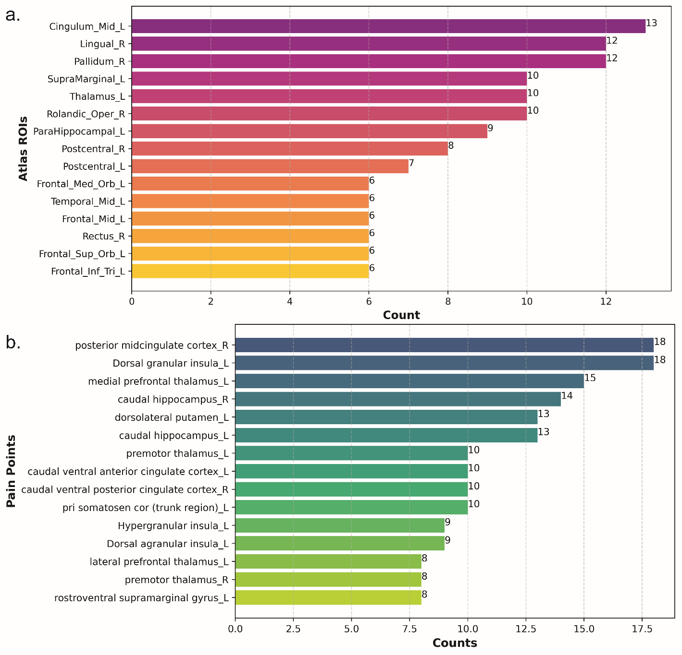
Figure S2. Regions of Interest Frequently Manifesting as Atypical Connections in Osteoarthritis Pain Patients. a.) This part of the figure displays the distribution of atypical neural connections within the AAL atlas ROIs. The x-axis represents the count of appearances within atypical edges, while the y-axis lists the specific Regions of Interest (ROIs). Each bar is annotated on the right with the exact number of representations across the cohort, quantifying the prevalence of each ROI in the study. b.) Similar to part (a), this section focuses on the pain seed ROIs. The x-axis shows the count of appearances in atypical edges, and the y-axis catalogs the ROIs involved in pain processing. Numbers on the right side of each bar indicate the frequency of each ROI’s appearance across the cohort, illustrating the relative involvement of specific pain-related regions in atypical neural activities.

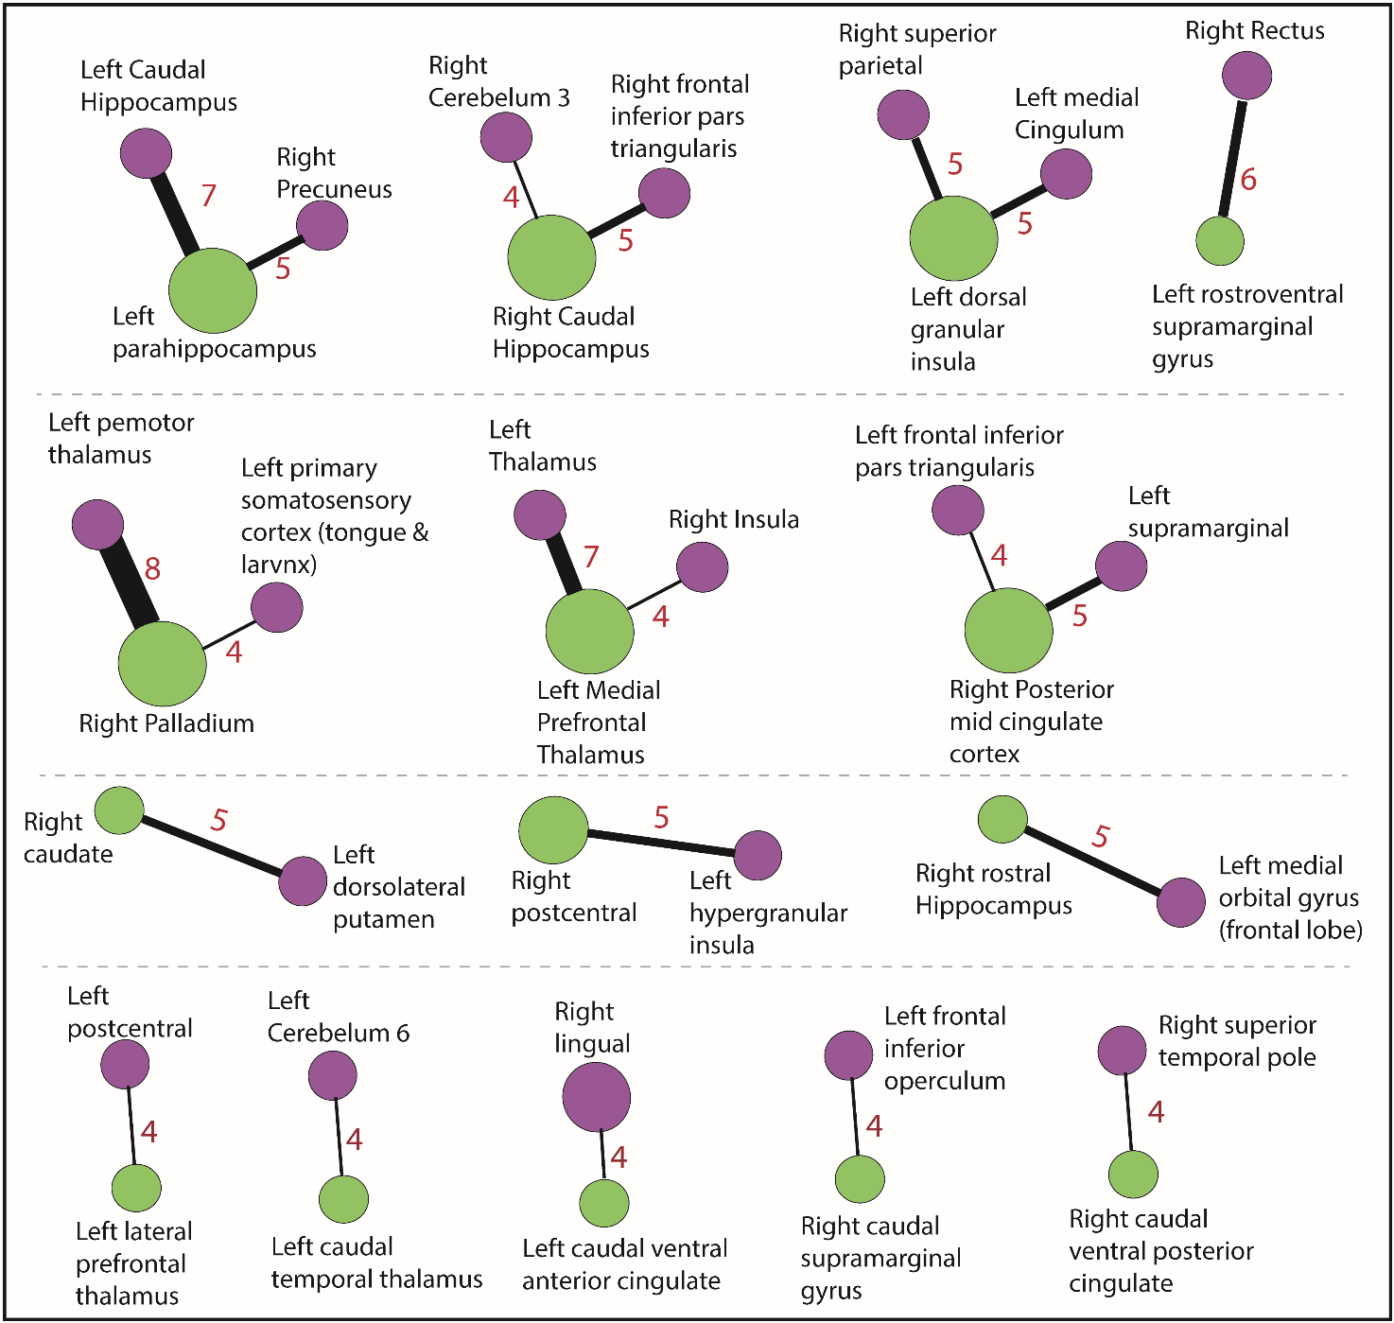
Figure S3. Atypical connections repeated more than three times across study subjects. The larger the node size, the more frequently the region is represented in atypical connections across the patient cohort. The width of the link and the weight in the link (numeral in red) represent the number of times this atypical connection is repeated across the patient cohort.

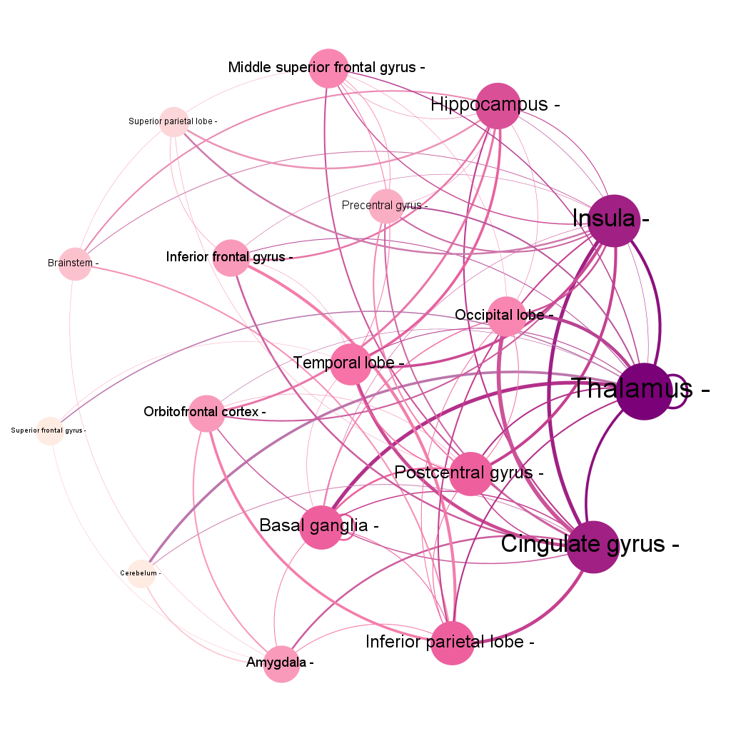Figure S4. Atypical Connections Between Different Brain Regions in Study Subjects. This graph illustrates the atypical connections identified in the osteoarthritis patient cohort across various brain regions. Larger nodes indicate regions with a greater number of connections, while thicker edges represent more frequently repeated connections between two regions. Notably, regions such as the thalamus, cingulate gyrus, insula, hippocampus, and inferior parietal lobe exhibit a higher degree of connectivity with other brain regions. Additionally, strong connections, such as those between the thalamus and basal ganglia, cingulate gyrus and insula, thalamus and insula, thalamus and cingulate gyrus, and thalamus and occipital lobe, are observed to occur more frequently.

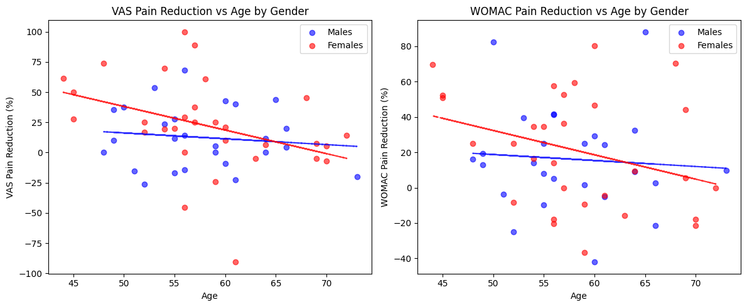
Figure S5: Age correlations with pain reduction stratified by gender. (A) Scatterplot showing the relationship between age and VAS pain reduction. A significant negative correlation was observed in females (r = –0.383, p = 0.037), indicating reduced pain improvement with increasing age. No significant correlation was found in males (r = –0.119, p = 0.562). (B) Scatterplot showing the relationship between age and WOMAC pain reduction. Although females showed a trend toward a negative correlation (r = –0.321, p = 0.084), it was not statistically significant. No significant correlation was found in males (r = –0.074, p = 0.720).
Mean ages were comparable across groups (Males: 57.6 ± 6.3 years; Females: 58.2 ± 7.6 years). p < 0.05 was considered statistically significant.
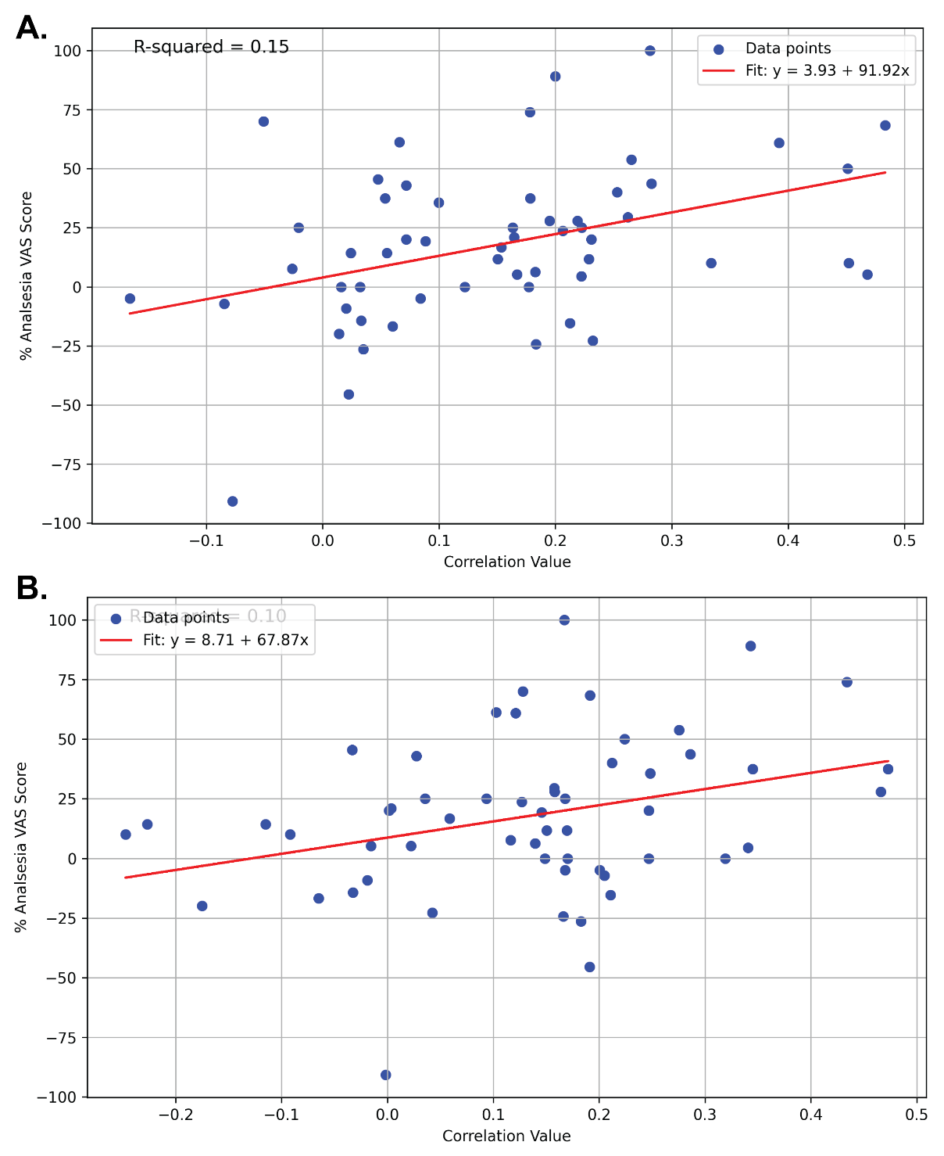
Figure S6: Associations between brain connectivity and VAS pain reduction. (A) Scatterplot showing the relationship between resting-state functional connectivity between the left medial orbitofrontal cortex and the right hippocampus and VAS pain reduction (R² = 0.15). (B) Scatterplot showing the association between connectivity of the left inferior frontal operculum and the caudal supramarginal gyrus with VAS pain reduction (R² = 0.10). These modest associations suggest that while certain network alterations correlate with symptom improvement, most connectivity differences do not directly reflect clinical pain relief.

Figures 1 – 4

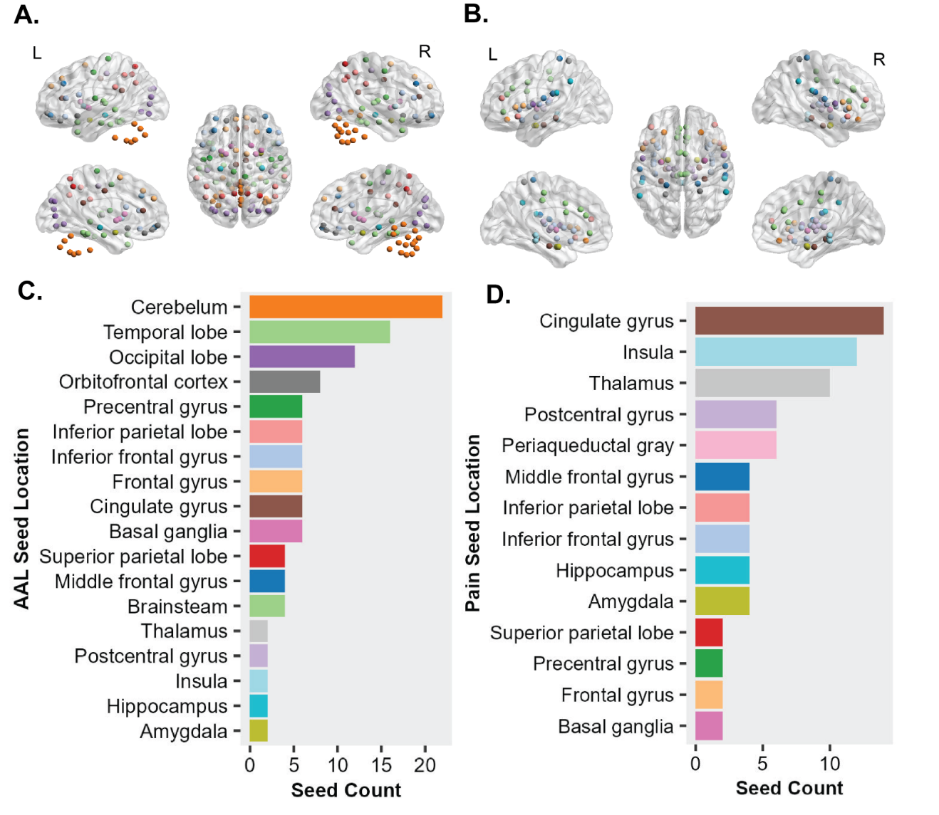
Figure 1. Regions of Interest (ROIs) for Resting-State fMRI Seed Analysis. (A.) The AAL atlas depicting 116 parcellated brain region ROI points. (B.) Locations of seed points in the brain associated with pain perception, based on Dai et al., 2018. (C.) Location-based grouping of whole brain AAL ROIs, with colors in figure 1B indicating the same location groups. (D.) Location-based grouping of pain seeds, with colors in figure 1B indicating the same location groups.

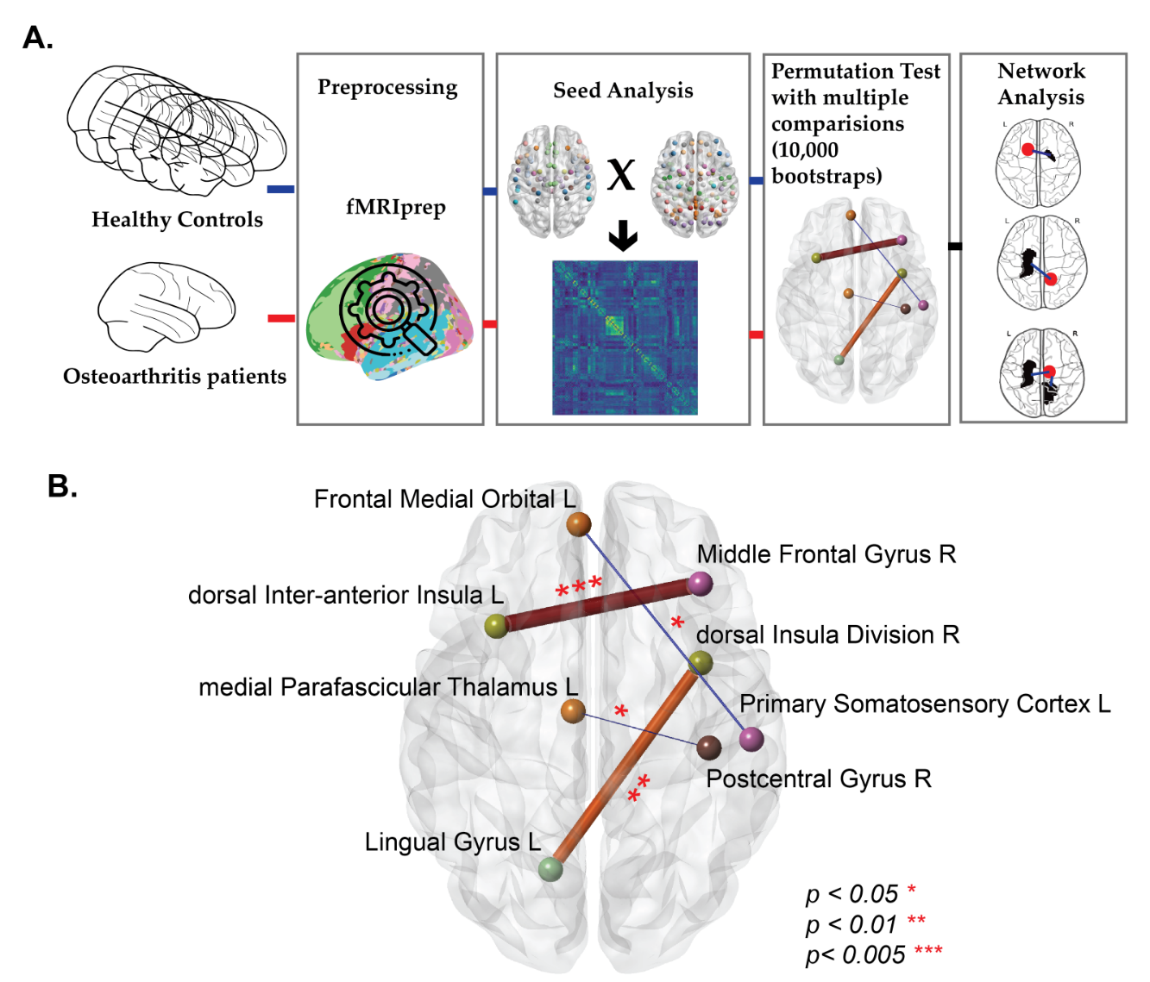
Figure 2: A. Study Analysis Flow Summary. Methodological framework for analyzing atypical functional connections between osteoarthritis patients and healthy controls. B. This diagram displays connections that are significantly different (p<0.05) in one patient when compared to a set of healthy controls.

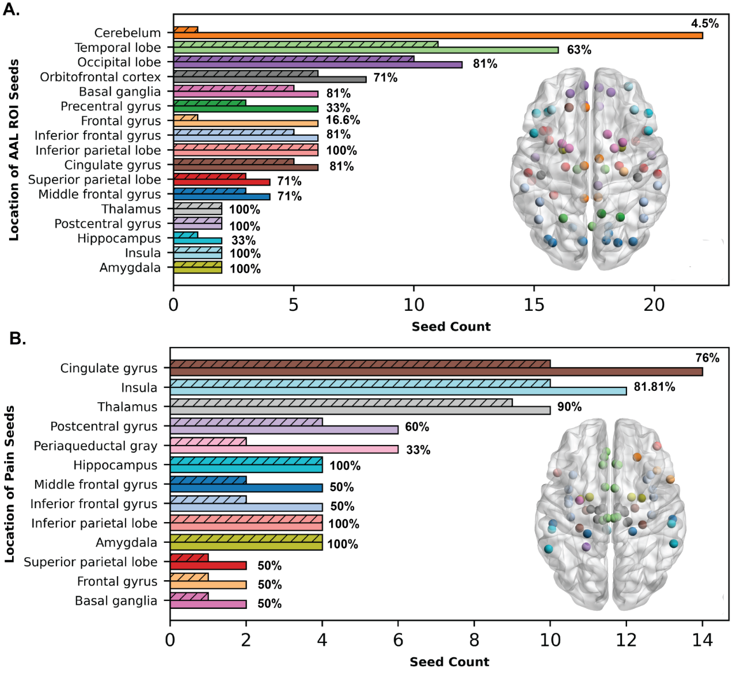
Figure 3. Atypical Connection Representation in Region Groups Before and After Analysis. (A) This panel illustrates the percentage representation of atypical connections identified through permutation analysis, relative to the total AAL atlas regions used in each group. Solid bars represent the initial atlas region groups used as ROIs for the analysis, while dotted bars indicate the representation of these regions in atypical connections identified post-analysis. The inner brain plot with nodes represents the AAL ROIs (color-coded based on their brain location) that are involved in atypical connections across the osteoarthritis patient cohort. (B) This panel shows the representation of pain seed nodes in the cohort, comparing their presence before (solid bars) and after (patterned bars) the analysis. The inner brain plot with nodes represents the pain seeds (color-coded based on their brain location) that are involved in atypical connections across the osteoarthritis patient cohort.

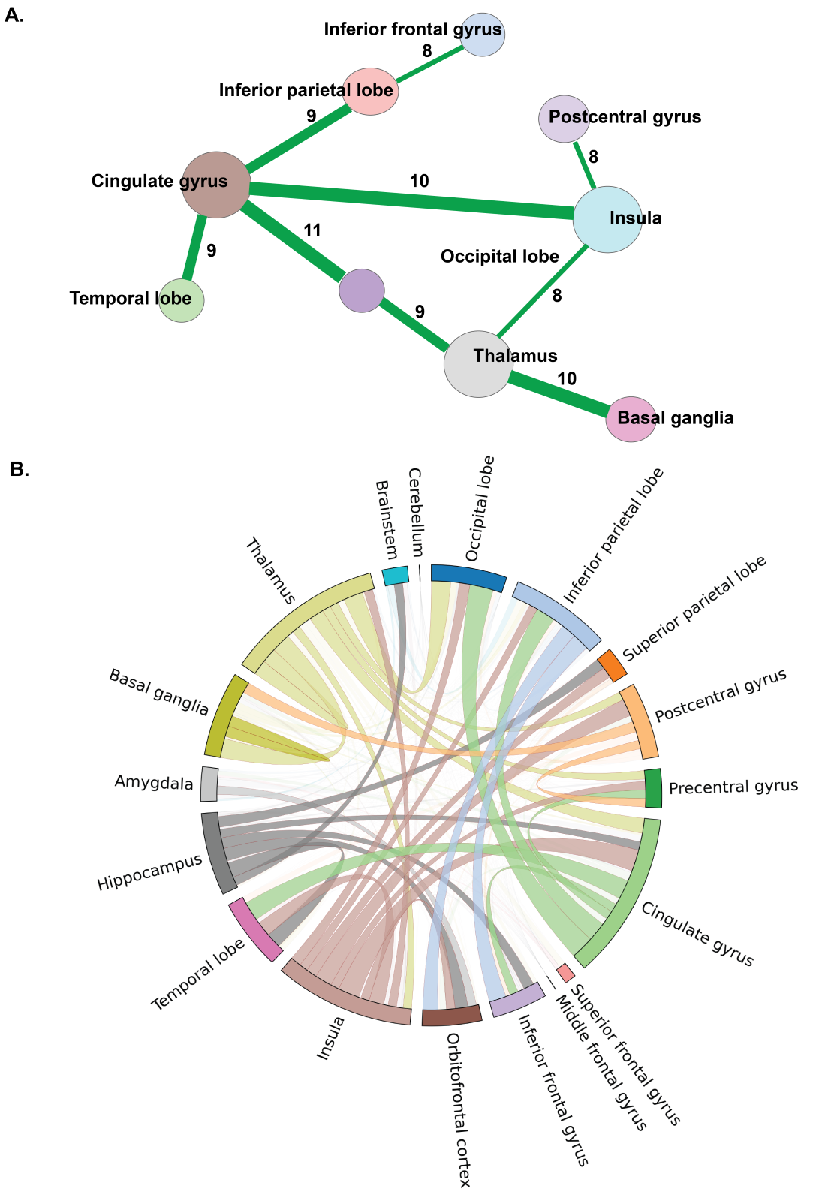
Figure 4. Atypical connections repeated more than 7 times across study subjects. (A.) The larger the node size, the more frequently the region is represented in atypical connections across the patient cohort. The width of the link and the weight in the link (numeral in black) represent the number of times this atypical connection is repeated across the patient cohort. (B.) Atypical connections between different brain regions in study subjects. This plot includes connections that occurred more than four times between regions. The cingulate gyrus, insula, and thalamus shared more connections with various other regions, whereas the middle frontal gyrus, superior frontal gyrus, and brainstem showed fewer connections with other regions.

