Supplementary Information
Sonication-induced J-aggregation in nonhalogenated solvents boosts exciton delocalization for high-efficiency organic solar cells

Mingxu Zhou¹, Xinyue Xu², Dongrui Wang¹, Jiali Song³, Jiawei Qiao¹, Ruyue Zhang⁴, Yue Wu⁵, Jiwei Cui⁴, Christopher R. Hall², Hang Yin¹, Xiaoyan Du¹, Wei Qin¹, Kun Gao¹, Feng Chen¹, Muthupandian Ashokkumar², Trevor A. Smith², Kangning Zhang^{1*}, Yanming Sun^{3*}, Xiaotao Hao^{1, 2*}

¹School of Physics, State Key Laboratory of Crystal Materials, Shandong University, Jinan, Shandong, 250100, P. R. China
²School of Chemistry, The University of Melbourne, Parkville, Victoria 3010, Australia
³School of Chemistry, Beihang University, Beijing, 100191, P. R. China
⁴Key Laboratory of Colloid and Interface Chemistry of the Ministry of Education, School of Chemistry and Chemical Engineering, Shandong University, Jinan, Shandong 250100, China
⁵College of food science and technology, Nanjing Agricultural University, Nanjing, 210095, China

*Corresponding authors: zhangkn@sdu.edu.cn (K. Zhang), sunym@buaa.edu.cn (Y. Sun), haoxt@sdu.edu.cn (X. Hao)

Supplementary Methods

Materials
Organic photovoltaic (OPV) materials PM6, L8-BO, BTP-eC9, PY-IT, PY-DT, and the electron-transporting material PDINN, were sourced from Solamar Materials (Beijing) Inc. The conductive polymer PEDOT:PSS (CleviosTM P VP Al 4083) was acquired from Xi’an Polymer Light 2 Technology Corp. The substrate material, commercial ITO glass with dimensions of 25 × 25 mm, was procured from Youxuan Technology Co. Ltd. O-Xylene (o-xy) and 1,8- diiodooctane (DIO) were bought from Sigma-Aldrich. All materials were employed in their pristine state, without undergoing any additional purification processes.

Optimal conditions of sonication
Previous studies have shown that as ultrasound frequency increases, physical effects generated by acoustic cavitation decrease while the chemical effects strengthen¹. To minimize chemical interactions and prevent chemical bond damage in the material, we selected lower ultrasonic frequencies and tested the in-situ PL spectra (supplementary Fig 23). The redshift of PL spectra under 40kHZ is most pronounced, indicating this condition yields the optimal effect. By adjusting the sonication power and duration in the ultrasonic machine with a capacity of 3.2 L, we arrived at the optimal condition of sonication: 40 kHz, 720 W, 3 min.

Fabrication of devices
The solar cells were fabricated utilizing a standard configuration of ITO/PEDOT:PSS/active layer/PDINN/Ag, adhering to the subsequent procedure. Initially, the ITO substrates underwent a rigorous cleaning process, which involved sonication (ultrasonic bath) in deionized water, acetone, anhydrous ethanol, and isopropanol for 20 minutes each. This was followed by a 15-minute treatment with ultraviolet light-ozone to ensure surface cleanliness and activation. Subsequently, the PEDOT:PSS layer, serving as the hole-transporting layer, was applied onto the ITO substrates via spin-coating at a speed of 4000 rpm for 50 seconds. The PEDOT:PSS-coated ITO substrates were then subjected to annealing in air for 15 minutes to enhance the film's conductivity and morphology. The substrates were swiftly transferred into a nitrogen-filled glove box to prevent ambient contamination. For the active layer, the total D/A ratio was kept at 1:1 in LBL processed devices. The PM6 concentrations are 10 mg/ml and 9 mg/ml for small-molecule NFAs and polymer NFAs, respectively. Concentrations 14 mg/ml and 13 mg/ml of PM6 (with 20 wt% D18 in ternary films) were used for 300 nm films. These solutions were stirred at 80 °C for a minimum of 12 hours to ensure thorough mixing and dissolution. The stirred acceptor-solution was treated by sonication. The construction of LBL architecture commenced with the spin-coating of the PM6 layer, dissolved in o-xy, onto the PEDOT:PSS layer. This was succeeded by the deposition of the L8-BO layer, also in o-xy, followed by thermal annealing at 120 °C for 5 minutes to improve the film uniformity and crystallinity. Facilitated by the swelling effect of the o-xy solution on the PM6 layer, the infiltration of L8-BO into the PM6 layer was instrumental in establishing the LBL device configuration. Thereafter, the PDINN solution (1.5 mg ml⁻¹ in methanol) was spin-coated onto the active layer at 3000 rpm for 30 seconds to form the electron-transporting layer. In the final step, a 100 nm thick Ag electrode layer was deposited under high vacuum conditions within an evaporation chamber, completing the solar cell structure. This process ensures the formation of a robust and efficient electron collection layer, critical for the cell performance.

Measurement of OPV devices
J–V measurements were performed under AM 1.5 G (100 mW cm⁻²) conditions using a 3A solar simulator from Sofn Instruments Co., Ltd., within a nitrogen-filled glove box at ambient temperature. The measurements were integrated with a computer-controlled Keithley 2400 source meter, following the calibration of light intensity with a standard monocrystalline silicon reference cell. The scanning range was set from -1.0 V to 1.0 V. The external quantum efficiency (EQE) profiles were obtained utilizing a 7-SCSpec test system, which was calibrated using a standard silicon diode. To evaluate the thermal stability of the devices, they underwent continuous thermal aging at 80 °C on a hot plate inside the nitrogen-filled glove box. Photostability assessments involved exposing the devices to an array of white LEDs under simulated illumination conditions of 100 mW cm⁻². The FTPS-EQE data were recorded employing a PECT-600 Fourier-transform photocurrent spectroscopy system. Frequency-dependent capacitance spectra were acquired through impedance spectroscopy techniques. Transient photocurrent (TPC) and transient photovoltage (TPV) measurements were conducted using an integrated apparatus known as Paios.

Aggregation energy-computational methods and details
The total Hamiltonian of the NFA molecular aggregate (see Supplementary Fig 1) is written as:
$$H=H_{M1}+H_{M2}+H_{Inter} (1)$$
where and separately indicate the intra-molecular Hamiltonian of M1 and M2 molecules. is the inter-molecular interaction Hamiltonian. For M1 or M2 molecule (see Supplementary Fig 2), the blue and orange segments separately represent the central fused ring group (D) and the electron-pull terminal groups (A), and the black segments represent the π-bridges connecting D and A groups. To highlight both the electron-lattice (e-l) interactions and the electron-electron (e-e) interactions in the molecule, an extended version of the well-known Su-Schrieffer-Heeger (SSH) tight-binding model is employed. In such a framework, the total molecular Hamiltonian can be written as:
$$H_{j}=H_{j,A}+H_{j\text{,}\text{π}}+H_{j\text{,D}}+H_{j\text{,e-e}}+H_{j,\text{latt}} (2)$$
j denotes the molecular index (M1 or M2). $H_{j\text{,A}}$ describes the Hamiltonian of the molecular A groups (1≤n≤7 and 29≤n≤35 in the case of j=M1, 37≤n≤43 and 65≤n≤71 in the case of j=M2), written as:
$$H_{j\text{,A}}=-\sum_{n,s}{\left[t_{0}-α\left(u_{n+1}-u_{n}\right)-t_{1}\cos\left(nπ/2\right)\right]\left(C_{n+1,s}^{+}C_{n,s}+C_{n,s}^{+}C_{n+1,s}\right)}-\sum_{n,s}{Δ_{\text{on}}^{'}C_{n,s}^{+}C_{n,s}} (3a)$$
$H_{j\text{,π}}$ describes the Hamiltonian of the molecular π-bridges (8≤n≤10 and 26≤n≤28 in the case of j=M1, 44≤n≤46 and 62≤n≤64 in the case of $j\text{=M2}$), written as:
$$H_{j\text{,}\text{π}}=-\sum_{n,s}{\left[t_{0}-α\left(u_{n+1}-u_{n}\right)\right]\left(C_{n+1,s}^{+}C_{n,s}+C_{n,s}^{+}C_{n+1,s}\right) (3b)}$$
$H_{j\text{,D}}$ describes the Hamiltonian of the molecular D group (11≤n≤25 in the case of j=M1, 47≤n≤61 in the case of $j\text{=M2}$), written as:
$$H_{j\text{,D}}=-\sum_{n,s}{\left[t_{0}-α\left(u_{n+1}-u_{n}\right)+{\left(-1\right)}^{n+1}t_{2}\right]\left(C_{n+1,s}^{+}C_{n,s}+C_{n,s}^{+}C_{n+1,s}\right)}+\sum_{l=1}^{4}{t_{3}\left(C_{4l+7,s}^{+}C_{4l+10,s}+C_{4l+10,s}^{+}C_{4l+7,s}\right)}+\sum_{l=1}^{3}{t_{3}\left(C_{4l+9,s}^{+}C_{4l+12,s}+C_{4l+12,s}^{+}C_{4l+9,s}\right)}+\sum_{l=1}^{4}{Δ_{\text{on}}\left(C_{4l+7,s}^{+}C_{4l+7,s}+C_{4l+10,s}^{+}C_{4l+10,s}\right)}+\sum_{l=1}^{3}{Δ_{\text{on}}\left(C_{4l+9,s}^{+}C_{4l+9,s}+C_{4l+12,s}^{+}C_{4l+12,s}\right)} (3c)$$
$C_{n,s}^{+}\left(C_{n,s}\right)$ denotes the creation (annihilation) operator of an electron at site with spin $\left(s=↑,↓\right)$. refers to the nearest-neighbour electron hopping integral for a uniform bond structure, $α$ is the e-l interaction constant and $u_{n}$ is the displacement of site n. and are the symmetry-breaking parameters separately introduced to reflect the lattice features of the molecular A groups and D group. in Equation (3c) is introduced to describe the electron hopping between the neighbouring sites of a heteroatom. $Δ_{on}$ in Equation (3c) is introduced to describe the heteroatom contribution to the electron-push ability of D group, and $Δ_{\text{on}}^{'}$ in Equation (3a) to describe the fluorinated or chlorinated contribution to the electron-pull ability of A groups.
$H_{j,e-e}$ describes the e-e interactions employed by the Hartree-Fock approximation, written as:
$$H_{j\text{,e-e}}=U\sum_{n}{\left(C_{n,↑}^{+}C_{n,↑}-\frac{1}{2}\right)\left(C_{n,↓}^{+}C_{n,↓}-\frac{1}{2}\right)}+V_{∥}\sum_{n}{\left(C_{n}^{+}C_{n}-1\right)\left(C_{n+1}^{+}C_{n+1}-1\right)} (4)$$
U represents the on-site Coulomb interaction strength, and $V_{∥}$ the nearest-neighbor off-site Coulomb interaction strength.$H_{j\text{,latt}}$ describes the molecular lattice Hamiltonian, where only the elastic potential energy is considered, classically written as:
$$H_{j\text{,latt}}=\frac{K}{2}\sum_{n}{{\left(u_{n+1}-u_{n}\right)}^{2}} (5)$$
K is the elastic constant between the nearest-neighbour sites.
For a NFA molecular aggregate, the inter-molecular interaction Hamiltonian $H_{Inter}$ is described as:
$$H_{\text{Inter}}=-t_{⊥}\sum_{n^{'},s}{\left(C_{\text{M1},n^{'},s}^{+}C_{\text{M2},n^{'},s}+C_{\text{M2,}n^{'},s}^{+}C_{\text{M1},n^{'},s}\right)}+V_{⊥}\sum_{n^{'}}{\left(C_{\text{M1},n^{'}}^{+}C_{\text{M1},n^{'}}-1\right)\left(C_{\text{M2},n^{'}}^{+}C_{\text{M2},n^{'}}-1\right)} (6)$$
$t_{⊥}$ and $V_{⊥}$ separately indicates the inter-molecular electron hopping integral and e-e interaction strength between the vertical-neighbour sites of two molecules. It should be noted that $\sum_{n^{'}}{ }$means the summation only for the sites over the coupling region between molecules, by which we can describe different inter-molecular aggregation modes, including the H-aggregation and the J-aggregation (see Supplementary Fig 1).

Parameter details:
In all simulations, unless otherwise specified, the values of model parameters are set as $t_{0}=2.5\text{ eV}$,$α=41.0\text{ eV/nm}$,$K=2100\text{ eV/nm}$,$t_{1}=t_{2}=0.05\text{ eV}$,$t_{3}=0.1\text{ eV}$, and $U=1.5\text{ eV}$. The intra-molecular offsite Coulomb interaction strength $V_{∥}$ and the inter-molecular Coulomb interaction strength $V_{⊥}$ are treated as Ohno potentials $V_{∥(⊥)}=U/\sqrt{1+κ{\left(d_{∥(⊥)}/d_{0}\right)}^{2}}$ with $κ=2$, $d_{∥}=d_{0}=0.122\text{ nm}$ ($κ$ is the screening factor, $d_{0}$ the average nearest-neighbour lattice constant, and $d_{⊥}$ the inter-molecular distance between vertical-neighbor sites). The inter-molecular electron hopping integral between vertical-neighbor sites is described as $t_{⊥}=\frac{t_{0}}{10}\exp\left(1-\frac{d_{⊥}}{5}\right)$.

Iteratively solving the static equations:
Considering the electronic eigenstate of a molecule $\left|ϕ_{μ,s}\right\rangle$, we can expand it on the Wannier basis, that is, $\left|ϕ_{μ,s}\right\rangle =\sum_{n}{Z_{μ,n,s}\left|n\right\rangle }$. As such, the electronic eigenstates are obtained by solving the eigenequation of the electronic Hamiltonian, written as:
$$-t_{n-1,n}Z_{μ,n-1,s}-t_{n,n+1}Z_{μ,n+1,s}-Δ_{\text{on}}^{'}Z_{μ,n,s}δ\left(n,int\right)+\left[t_{3}Z_{μ,n-3,s}+Δ_{\text{on}}Z_{μ,n,s}\right]\left[δ\left(\frac{n-10}{4},int\right)+δ\left(\frac{n-12}{4},int\right)\right]+\left[t_{3}Z_{μ,n+3,s}+Δ_{\text{on}}Z_{μ,n,s}\right]\left[δ\left(\frac{n-7}{4},int\right)+δ\left(\frac{n-9}{4},int\right)\right]+\left[U\left(ρ_{n,n,-s}-\frac{1}{2}\right)+V_{∥}\sum_{n}{\left(ρ_{n+1,n+1}+ρ_{n-1,n-1}-2\right)}\right]Z_{μ,n,s}+\left[V_{⊥}\left(ρ_{n^{'},n^{'}}-1\right)-t_{⊥}\right]Z_{μ,n^{'},s}=ε_{μ}Z_{μ,n,s} (7)$$
where,
$$t_{n,n+1}=\left\{\begin{aligned}{t_{0}-α\left(u_{n+1}-u_{n}\right)-t_{1}\cos\left(nπ/2\right) \atop \left(1≤n≤7, 29≤n≤35, 37≤n≤43 and\text{ 65}≤n≤71\right)} \\ {t_{0}-α\left(u_{n+1}-u_{n}\right) \atop \left(8≤n≤10, 26≤n≤28,\text{ 44}≤n≤46 and\text{ 62}≤n≤64\right)} \\ {t_{0}-α\left(u_{n+1}-u_{n}\right)+{\left(-1\right)}^{n+1}t_{2} \atop \left(11≤n≤25 and\text{ 47}≤n≤61\right)}\end{aligned}\right.$$
$ρ_{n,n,s}=\sum_{μ}{Z_{μ,n,s}^{*}f_{μ}Z_{μ,n,s}}$ is the density matrix, where $f_{μ}$ (0 or 1) denotes the electron occupation function of electronic eigenstate $\left|ϕ_{μ,s}\right\rangle$. If (;$1≤\text{int}≤8$,$29≤\text{int}≤44$ and $65≤\text{int}≤72$), $δ\left(l,\text{int}\right)=1$, while if $l≠\text{int}$, $δ\left(l,\text{int}\right)=0$. If $l^{'}=\text{int}$ ($l^{'}=\frac{n-7}{4}, \frac{n-10}{4}$; $\text{int=1, 2, 3, 4, 10, 11, 12, 13}$), $δ\left(l^{'},\text{int}\right)=1$, while if $l^{'}≠\text{int}$, $δ\left(l^{'},\text{int}\right)=0$. If $l^{″}=\text{int}$ ($l^{″}=\frac{n-9}{4}, \frac{n-12}{4}$; $\text{int=1, 2, 3, 10, 11, 12}$), $δ\left(l^{″},\text{int}\right)=1$, while if $l^{″}≠\text{int}$, $δ\left(l^{″},\text{int}\right)=0$. The sites over the coupling region between molecules are denoted as $n'$. $ε_{μ}$ indicates the eigen-energy of the electronic eigenstate $\left|ϕ_{μ,s}\right\rangle$.
In addition, by minimizing the total energy of the molecule, where the fixed boundary is employed, we can obtain the lattice balance equation:
$$u_{n+1}-u_{n}=\frac{2α}{K}\left(\frac{1}{N-1}\sum_{n,s}{ρ_{n,n+1,s}}-\sum_{s}{ρ_{n,n+1,s}}\right) (8)$$
is the total site number of one molecule.

Aggregation energy calculation for the NFA molecular H-aggregation and J-aggregation:
$$E=\sum_{μ}^{occ}{ε_{μ}}+\frac{1}{2}\sum_{n}{K{\left(u_{n+1}-u_{n}\right)}^{2}}-U\sum_{n}{\left(ρ_{n,n,↑}-\frac{1}{2}\right)\left(ρ_{n,n,↓}-\frac{1}{2}\right)}$$
$-V_{∥}\sum_{n}{\left(ρ_{n,n}-1\right)\left(ρ_{n+1,n+1}-1\right)}$ (9)
$$E_{H(J)}^{\text{Ex}}=\sum_{μ}^{occ}{ε_{μ}}+\frac{1}{2}\sum_{j,n}{K{\left(u_{j,n+1}-u_{j,n}\right)}^{2}}-U\sum_{j,n}{\left(ρ_{j,n,n,↑}-\frac{1}{2}\right)\left(ρ_{j,n,n,↓}-\frac{1}{2}\right)}-V_{∥}\sum_{j,n}{\left(ρ_{j,n,n}-1\right)\left(ρ_{j,n+1,n+1}-1\right)}-V_{⊥}\sum_{n^{'}}{\left(ρ_{\text{M1},n^{'},n^{'}}-1\right)\left(ρ_{\text{M2,}n^{'},n^{'}}-1\right)} (10)$$
$$ΔE_{H}^{\text{Ex}}=E_{H}^{\text{Ex}}-\left(E^{\text{Ex}}+E^{\text{Gr}}\right) (11-1)$$
$$ΔE_{J}^{\text{Ex}}=E_{J}^{\text{Ex}}-\left(E^{\text{Ex}}+E^{\text{Gr}}\right)…..(11-2)$$

Equation (9) shows the total energy of a single NFA molecule, which might lie in different states, including the ground state ($E^{\text{Gr}}$) and the excited state ($E^{\text{Ex}}$). “$occ$” indicates the sum only for the occupied electronic states. Equation (10) shows the total energy of one NFA molecular aggregate, which lies in an excited state ($E_{H}^{\text{Ex}}$ for H-aggregation, and $E_{J}^{\text{Ex}}$ for J-aggregation).
Therefore, the aggregation energy of the NFA molecular H-aggregation $ΔE_{H}^{\text{Ex}}$ is obtained by Equation (11-1), and the aggregation energy of the NFA molecular J-aggregation $ΔE_{J}^{\text{Ex}}$ obtained by Equation (11-2).

Measurement of in-situ characterization
In-situ UV-vis absorption measurements were conducted using the high-resolution Maya2000 Pro spectrometer in transmission mode, achieving a time resolution of 0.02 seconds. This spectrometer consists of a light source and a detector, which are positioned above and below the substrate, respectively, aligned along the same vertical axis. During the experiment, the solution was introduced into the slot while a film was deposited onto a glass substrate. Throughout the coating process, the detector recorded transmission spectra within the wavelength range of 400 to 1050 nm. The UV-vis absorption spectra were subsequently derived from these transmission spectra using the formula:
$$A\left(λ\right)=-\log_{10}\left(T\right) (12)$$
where A_{λ} represents absorbance at a specific wavelength (λ), and T denotes calculated transmittance. The light source and detector were activated prior to film deposition; thus, establishing that time zero corresponds to when the first solution transmission spectrum was captured by the detector. Prior to this moment, only noise was observed in the transmission spectra.

Measurement of grazing incidence wide-angle X-ray scattering (GIWAXS)
The GIWAXS measurements were performed using a film-depth dependent light absorption spectrometer, the Xeuss 2.0 from Xenocs Inc., under vacuum conditions. X-rays with a wavelength of 1.54189 Å were employed, and the sample-detector distance was calibrated utilizing silver behenate as a standard reference. The samples were fabricated on silicon substrates using blend solutions that were identical to those employed in the device fabrication process. The thermal aging conditions applied to the films closely mirrored those experienced by organic solar cells (OSCs).
GIWAXS analysis elucidates the molecular arrangement and crystalline nature of the active layer. The d-spacing, corresponding to the π-π stacking peak, denotes the interlayer molecular distance and can be determined using the following equation:
$$d=\frac{2π}{q_{z}\left(010\right)} (13)$$
Here, q_{z} (010) represents the position of the π-π stacking peak in reciprocal space. The findings indicate that the π-π stacking distances in the (010) orientation are consistent across all examined films. Furthermore, we employed the Scherrer formula to calculate the crystalline coherence length (CCL) and quantitatively assess the crystallinity of blend films:
$$CCL=\frac{2πk}{FWHM} (14)$$
In this equation, k is a shape factor set at 0.9, while FWHM refers to the full width at half maximum of the π-π stacking peak.

Measurement of grazing incidence small-angle X-ray scattering (GISAXS)
The 1D GISAXS profiles are derived using the Debye-Anderson-Brumberger (DAB) and fractal models, as referenced in Equations with the assistance of the fitting software SASView (Version 4.2.2). The initial term associated with the DAB model, is employed to simulate scattering from the polymer domain. In this context, ξ represents the average correlation length, q denotes the scattering wave vector, and Ai serves as an independently adjustable fitting parameter. The subsequent term in the equation corresponds to the fractal model, indicating the presence of fractal-like structures related to the non-fullerene acceptor. P(g, R) and S(q, R) denote the form factor and fractal structure factor, respectively. The parameters n and D characterize both the correlation length and fractal dimension of these fractal-like acceptor aggregates. Additionally, the Guinier radius (Rg) is utilized to describe the average domain size of the acceptor phase.
$$I\left(q\right)=\frac{A_{1}}{{\left[1+{\left(qξ\right)}^{2}\right]}^{2}}+A_{2}\left\langle P\left(q,R\right)\right\rangle S\left(q,R,η,D\right)+B (15)$$
$$s\left(q\right)=1+\frac{\sin\left[\left(D-1\right)\tan^{-1}\left(qη\right)\right]b±\sqrt{b^{2}-4ac}}{{\left(qR\right)}^{D}}\frac{DΓ\left(D-1\right)}{{\left[1+\frac{1}{{\left(qη\right)}^{2}}\right]}^{\frac{\left(D-1\right)}{2}}} (16)$$
$$R_{g}=\sqrt{\left(\frac{D\left(D+1\right)}{2}\right)}η (17)$$

Measurement of the film-depth-dependent light absorption spectroscopy (FLAS)
The FLAS spectra were obtained using a film-depth dependent light absorption spectrometer (PU100, Puguangweishi Co. Ltd). Low-pressure in-situ oxygen plasma etching was employed to extract the depth-resolved absorption spectrum of the organic active layer, a method that has been reported in previous studies. According to the Beer-Lambert law:
$$A\left(λ\right)=-\log\left(\frac{I_{T}}{I_{0}}\right) (18)$$
where A represents the optical density, I₀ is the incident light intensity, and I_{T} is the transmitted light intensity. The relationship can be expressed as:
$$T\left(λ\right)=\frac{I_{T}\left(λ\right)}{I_{0}\left(λ\right)} (19)$$
By controlling the etching duration, the active layer is progressively etched away into sublayers through a soft plasma generated by oxygen glow discharge. This process allows for segmentation of the active layer into multiple layers. The etching process is monitored in real-time by a light absorption spectrometer. Assuming that each sublayer has an absorbance denoted as (A₁, A₂, ..., A_{n}), the total transmitted light intensity can be calculated as follows:
$$T\left(λ\right)=Π_{ⅈ=1}^{n}T_{i}\left(λ\right)=Π_{ⅈ=1}^{n}{10}^{-A_{i}(λ)} (20)$$
Thus, we derive:
$$A\left(λ\right)=-\log_{10}\left(Π_{ⅈ=1}^{n}T_{i}\left(λ\right)\right){=\sum_{i=1}^{n}{A_{i}\left(λ\right)} (21)}$$
The absorbance of the entire active layer corresponds to the cumulative absorbance of all sublayers. Consequently, this methodology enables determination of the absorption spectra for each sub-layer at varying depths within the active layer.

Calculation of hole transfer rate and efficiency
SCLC measurements were performed to extract the charge carrier mobilities, which can be expressed by equation:
$$J_{d}=\frac{9}{8}ε_{0}ε_{r}μ_{0}\exp\left(0.89β\sqrt{F}\right)F^{2} (22)$$
where J is the space-charge-limited current density, d is the thickness of active layer, ε₀ is the dielectric constant of vacuum, ε_{r} is the relative dielectric constant of the polymers, μ₀ is the zero-field mobility, β is the Poole-Frankel (PF) slope, and F is the average electric field.

Calculation of non-radiative recombination rate
Generally, the luminescence intensity of acceptor films is governed by radiative recombination involving luminescent excitons and free carriers, which can be expressed through a straightforward rate equation:
$$\frac{ⅆn\left(t\right)}{ⅆt}=-A_{nonrad}\left(t\right)-B_{rad}n{\left(t\right)}^{2} (23)$$
Where n(t) represents the photoexcitation density of excitons and free carriers while A_{nonrad} and B_{rad} denote non-radiative and radiative recombination constants, respectively. The exact solution to this equation is:
$$n\left(t\right)=\frac{n\left(0\right)\exp\left(-A_{nonrad}t\right)}{1+\frac{B_{rad}}{A_{nonrad}}n\left(0\right)\left[1-\exp\left(-A_{nonrad}t\right)\right]} (24)$$

Calculation of trap density (N_{t})
The density of states (DoS) can be derived from capacitance spectroscopy performed in a dark environment. The frequency axis is related to the energy axis through the following equation:
$$E\left(ω\right)=kT\ln\left(\frac{2v_{0}}{ω}\right) (25)$$
Here, ω denotes the angular frequency, calculated as ω=2πf, and ν₀ represents the attempt-to-escape frequency, which is set at 10⁹ Hz. The trap density at a given energy E_{ω} can be determined using:
$$N_{t}\left(E_{ω}\right)=-\frac{v_{bi}}{q}\frac{ⅆC_{ω}}{ⅆω}\frac{ⅆω}{kT} (26)$$
In this context, d refers to the thickness of the active layer, while V_{bi} is the built-in voltage obtained through Mott-Schottky analysis. Subsequently, the energy distribution can be characterized by a Gaussian function:
$$N_{t}\left(E_{ω}\right)=N_{t}\exp\left[-\frac{{\left(E_{t}-E\right)}^{2}}{2σ^{2}}\right] (27)$$
Wherein N_{t} signifies the total density, E_{t} represents the centroid of the DoS, and σ denotes the disorder parameter.
Molecular dynamics simulation
Gromacs2022 was selected as the molecular dynamics simulation software, utilizing the General Amber Force Field (GAFF) for small molecules. A simulation box with dimensions of 10 nm × 10 nm × 180 nm was constructed, ensuring that the edges of the box were at least 1.2 nm away from the molecular boundaries. Each system contained 20 L8-BO molecules and 6147 o-xylene molecules. Periodic pressure variations were simulated using square wave patterns to replicate ultrasonic conditions. The Particle-Mesh Ewald (PME) method was employed to address electrostatic interactions, and energy minimization was conducted using the steepest descent algorithm with a maximum of 50,000 steps. Both Coulombic force cutoff and van der Waals radius cutoff were set to 1 nm. Subsequently, the system underwent equilibration through both canonical ensemble (NVT) and isothermal-isobaric ensemble (NPT) methods, followed by a molecular dynamics (MD) simulation lasting for 100 ns under standard temperature and pressure conditions. The non-bonded interaction cutoff was established at 10 Å. A Langevin thermostat maintained the simulation temperature at 300 K while pressure control was achieved using the C-rescale method.

Supplementary Figures

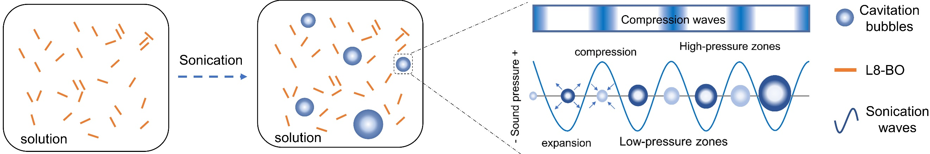
Supplementary Fig. 1 Ultrasonic cavitation effect. Ultrasonic waves generate periodic pressure changes in the solution and forms cavitation bubbles that can grow and collapse rapidly, providing a carrier for the subsequent regulation of molecular aggregation.

Supplementary Fig. 2 Raman spectrum. Raman spectrum of L8-BO solution without or with sonication.

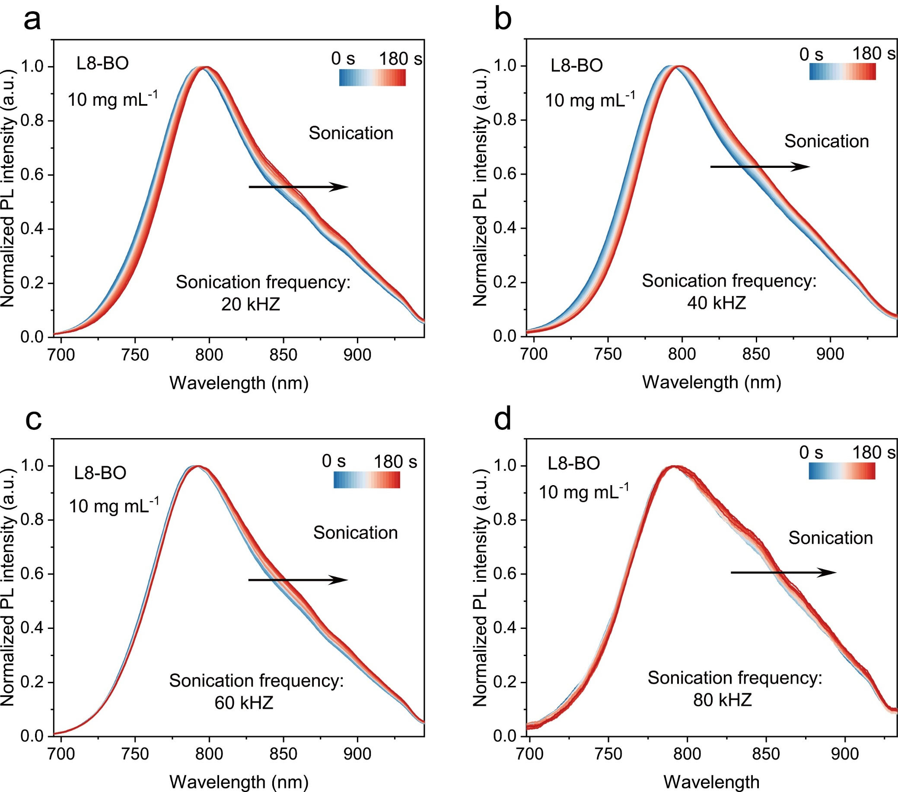
Supplementary Fig. 3 In-situ PL spectra. Evolution of the PL spectra of the L8-BO solution during sonication with different frequencies (power: 300W).

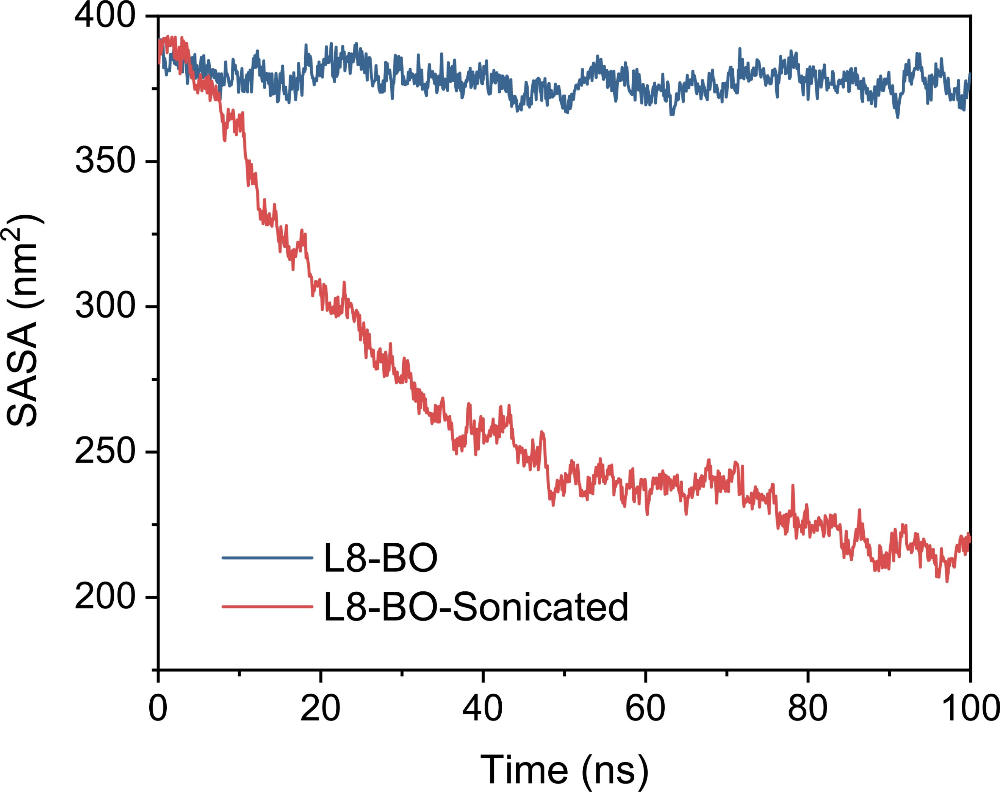
Supplementary Fig. 4 Molecular dynamics simulation parameters. The Solvent Accessible Surface Area (SASA) of the system.

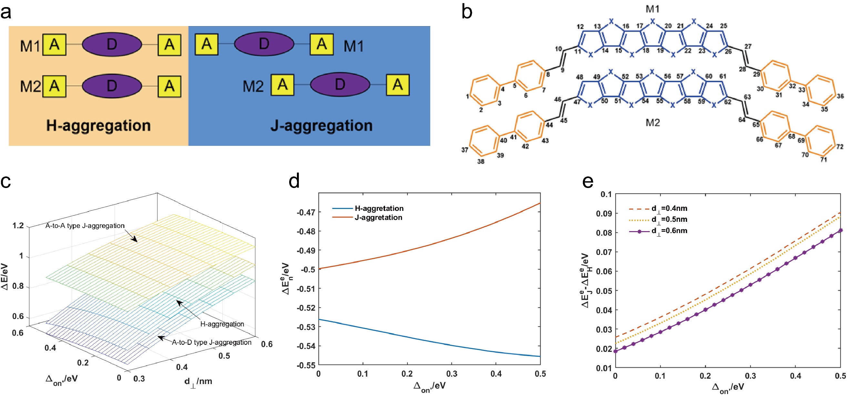
Supplementary Fig. 5 Quantum chemical computation. a, Two kinds of inter-molecular aggregation modes of A-D-A type NFA molecules, including the H-aggregation and the J-aggregation. b, The simplified model description for two A-D-A type NFA molecules (M1 and M2). The blue and orange segments in one molecule separately represent the electron-push central fused ring group (D) and the electron-pull terminal groups (A). c, Comparison of the results of different aggregation modes. d, The aggregation energy at various values for different system (d⊥=3 Å). e, The difference in aggregation energy between J-aggregation and H-aggregation under different conditions.
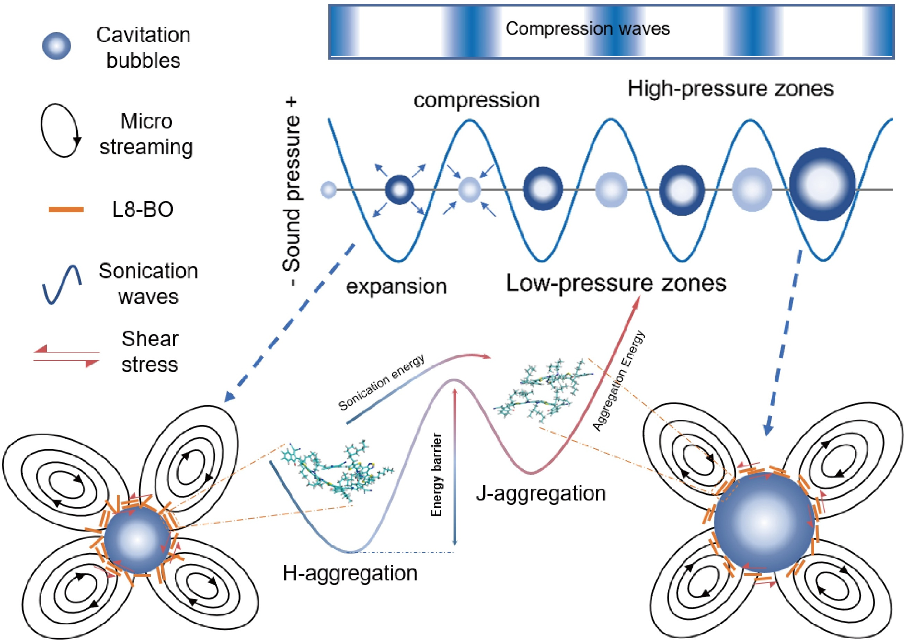
Supplementary Fig. 6 Schematic diagram of ultrasonic cavitation effect. In the absence of sonication, the molecular arrangements are relatively disordered and exist partial H-aggregation. During sonication, cavitation bubbles form in the solvent. The periodic compression and expansion of these bubbles create a significant velocity gradient between the bubble surface and surrounding liquid, inducing microstreaming and shear stress. This microstreaming pushes molecules to aggregate on the bubble surface. When disordered molecules are subjected to the shear stress, they become aligned and form ordered J-aggregation. Simultaneously, H-aggregation can overcome the energy barrier upon acquiring energy and slide to J-aggregation.

Supplementary Fig. 7 Temperature-dependent PL spectra. Normalized temperature-dependent PL spectra of L8-BO in o-xy.

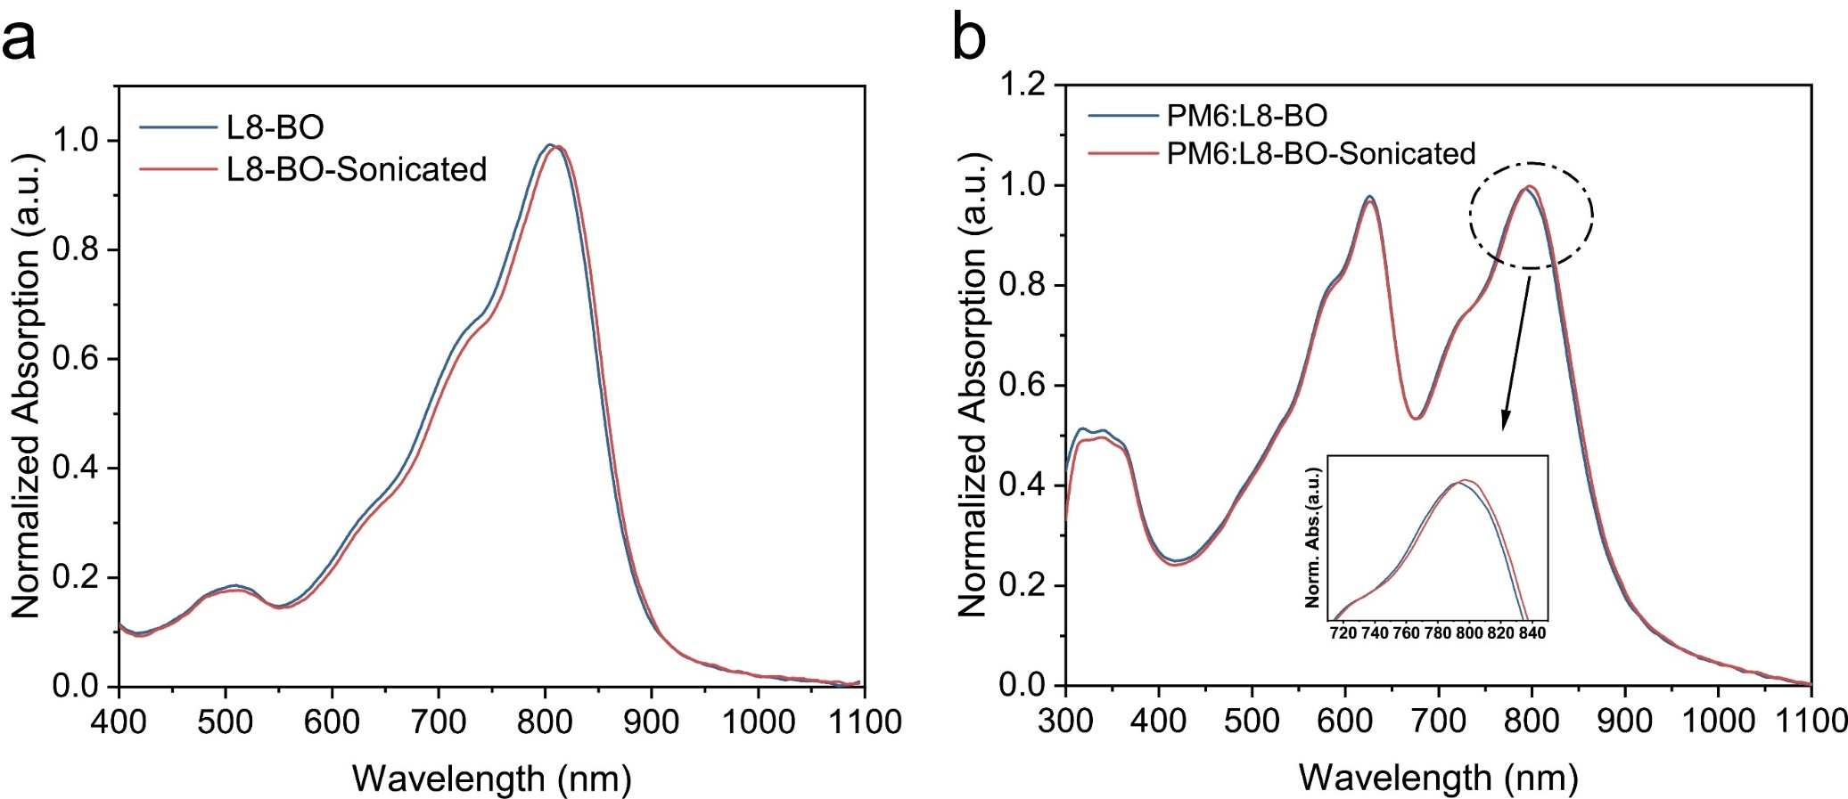
Supplementary Fig. 8 Absorption spectra. UV-vis absorption curves of a, neat and b, blend films without or with sonication.

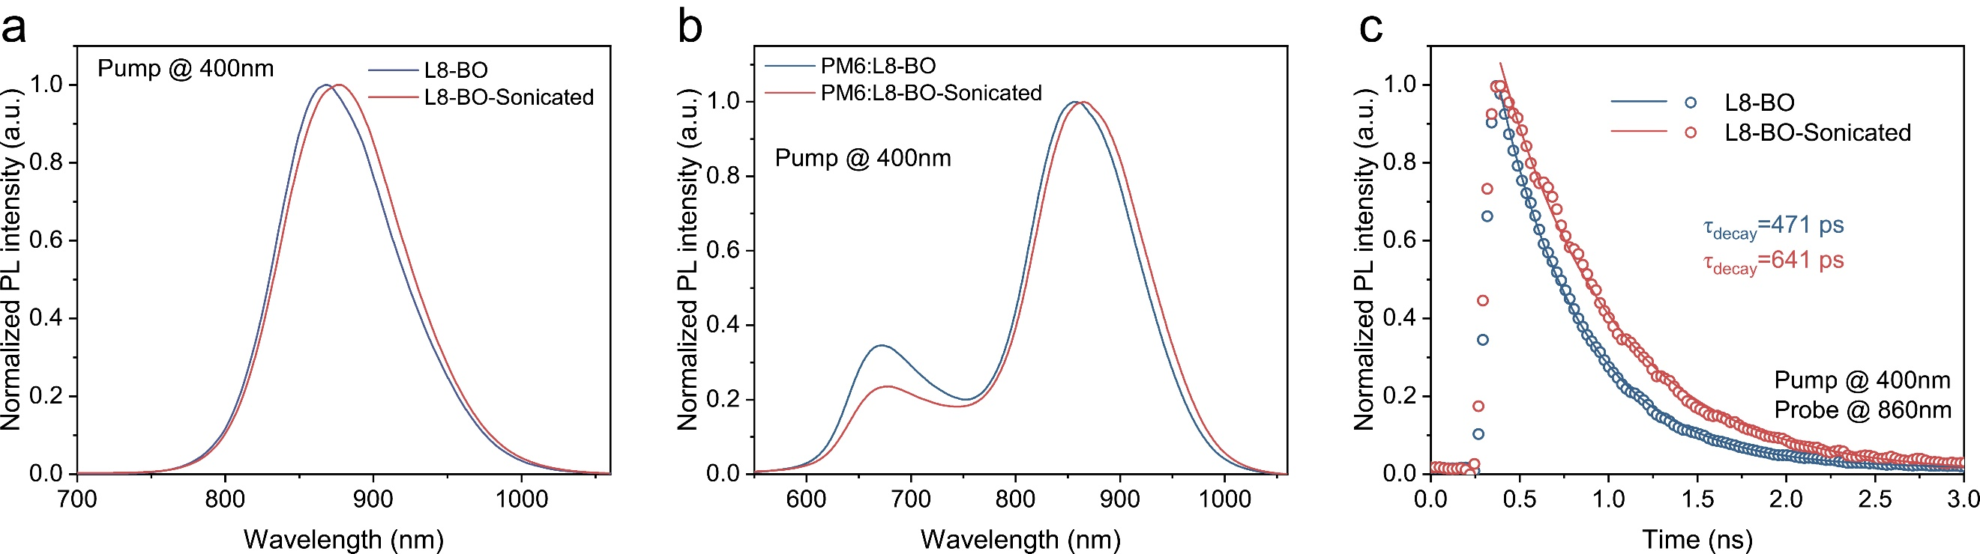Supplementary Fig. 9 Photoluminescence spectra. a-b, Photoluminescence of neat and blend films. c The TRPL curves of L8-BO film with or without sonication.

Supplementary Fig. 10 GIWAXS measurements of neat films. OOP (out-of plane) and IP (in-plane) extracted line-cut profiles of the corresponding films.

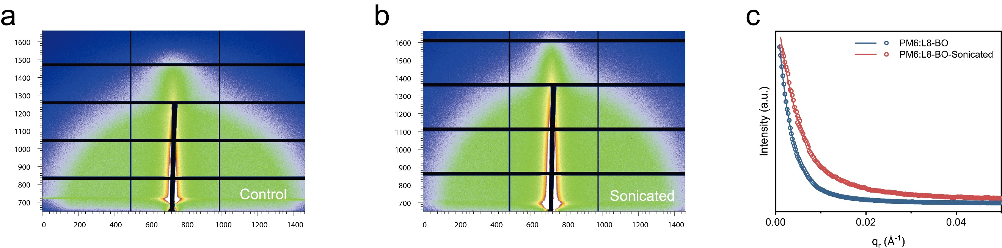
Supplementary Fig. 11 GISAXS measurements of blend films. a-b, 2D GISAXS pattern of PM6:L8-BO without or with sonication. c, In-plane 1D profiles of GISAXS along Q_{xy} axis.
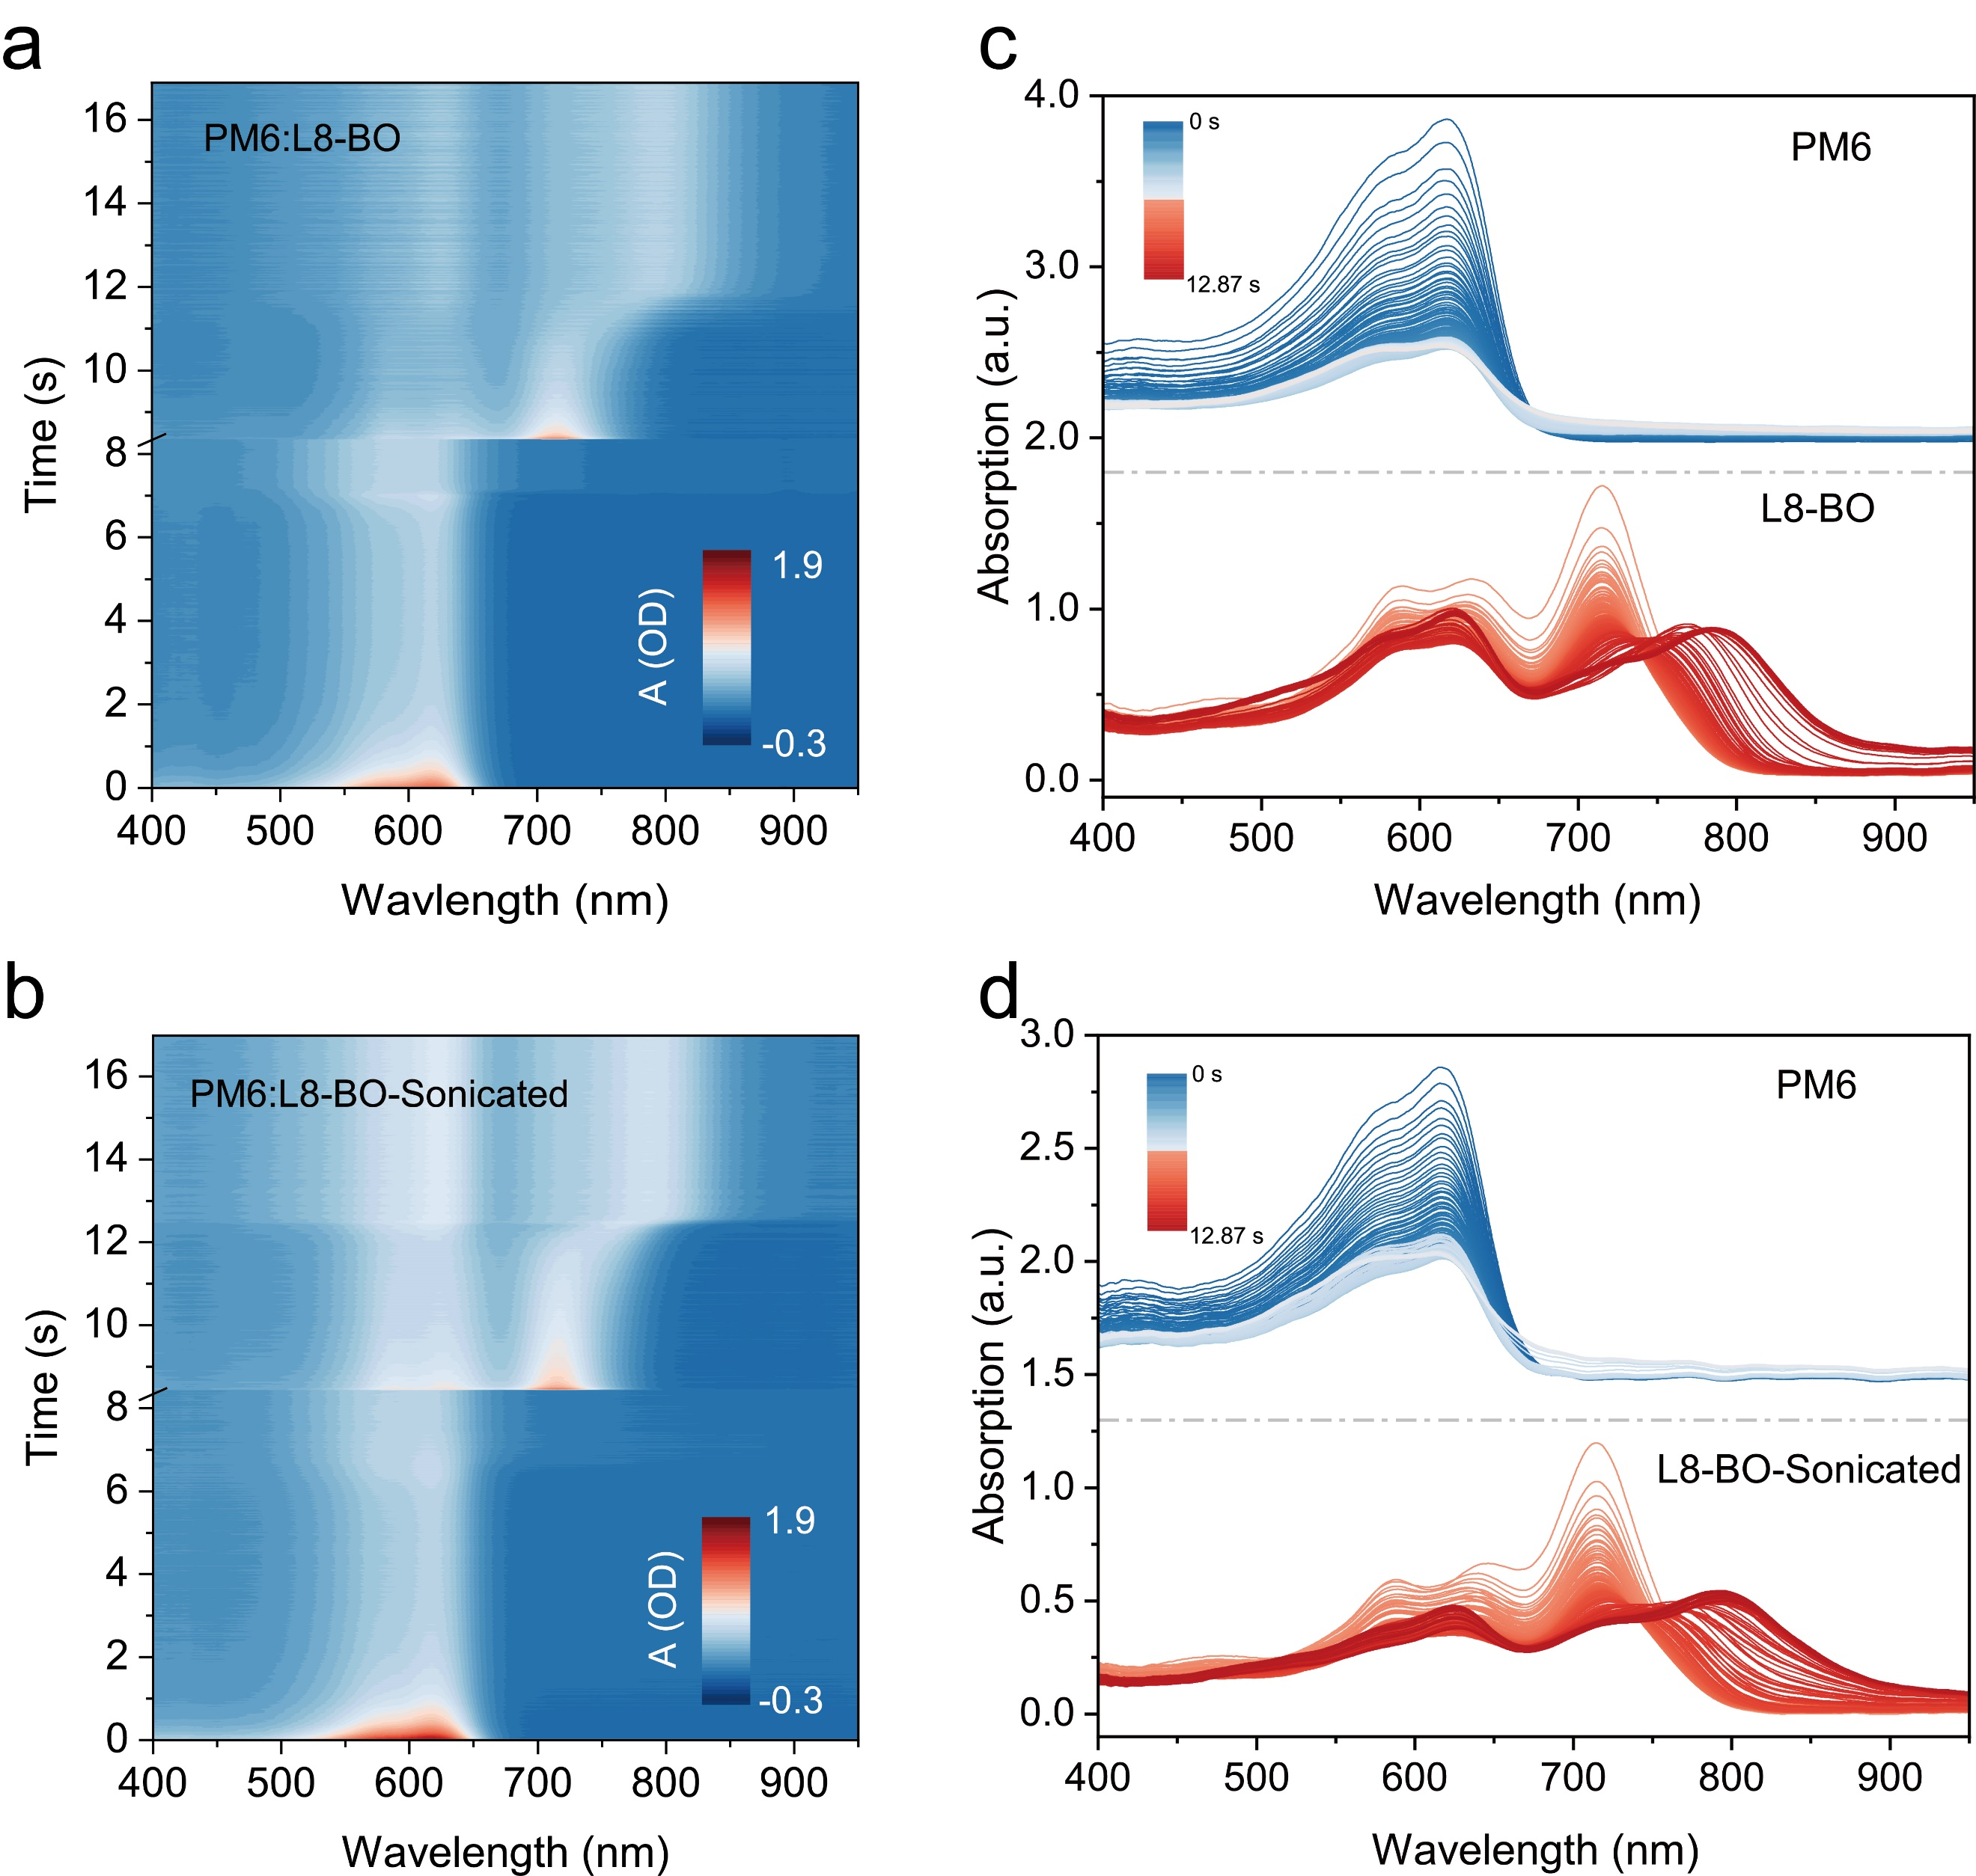
Supplementary Fig. 12 In-situ UV-vis absorption spectra and extraction of crystallization process. a-b, Time-dependent contour maps of UV–vis absorption spectra during spin coating for PM6:L8-BO without or with sonication. c-d, UV–vis absorption peak location of acceptors for PM6:L8-BO without or with sonication.

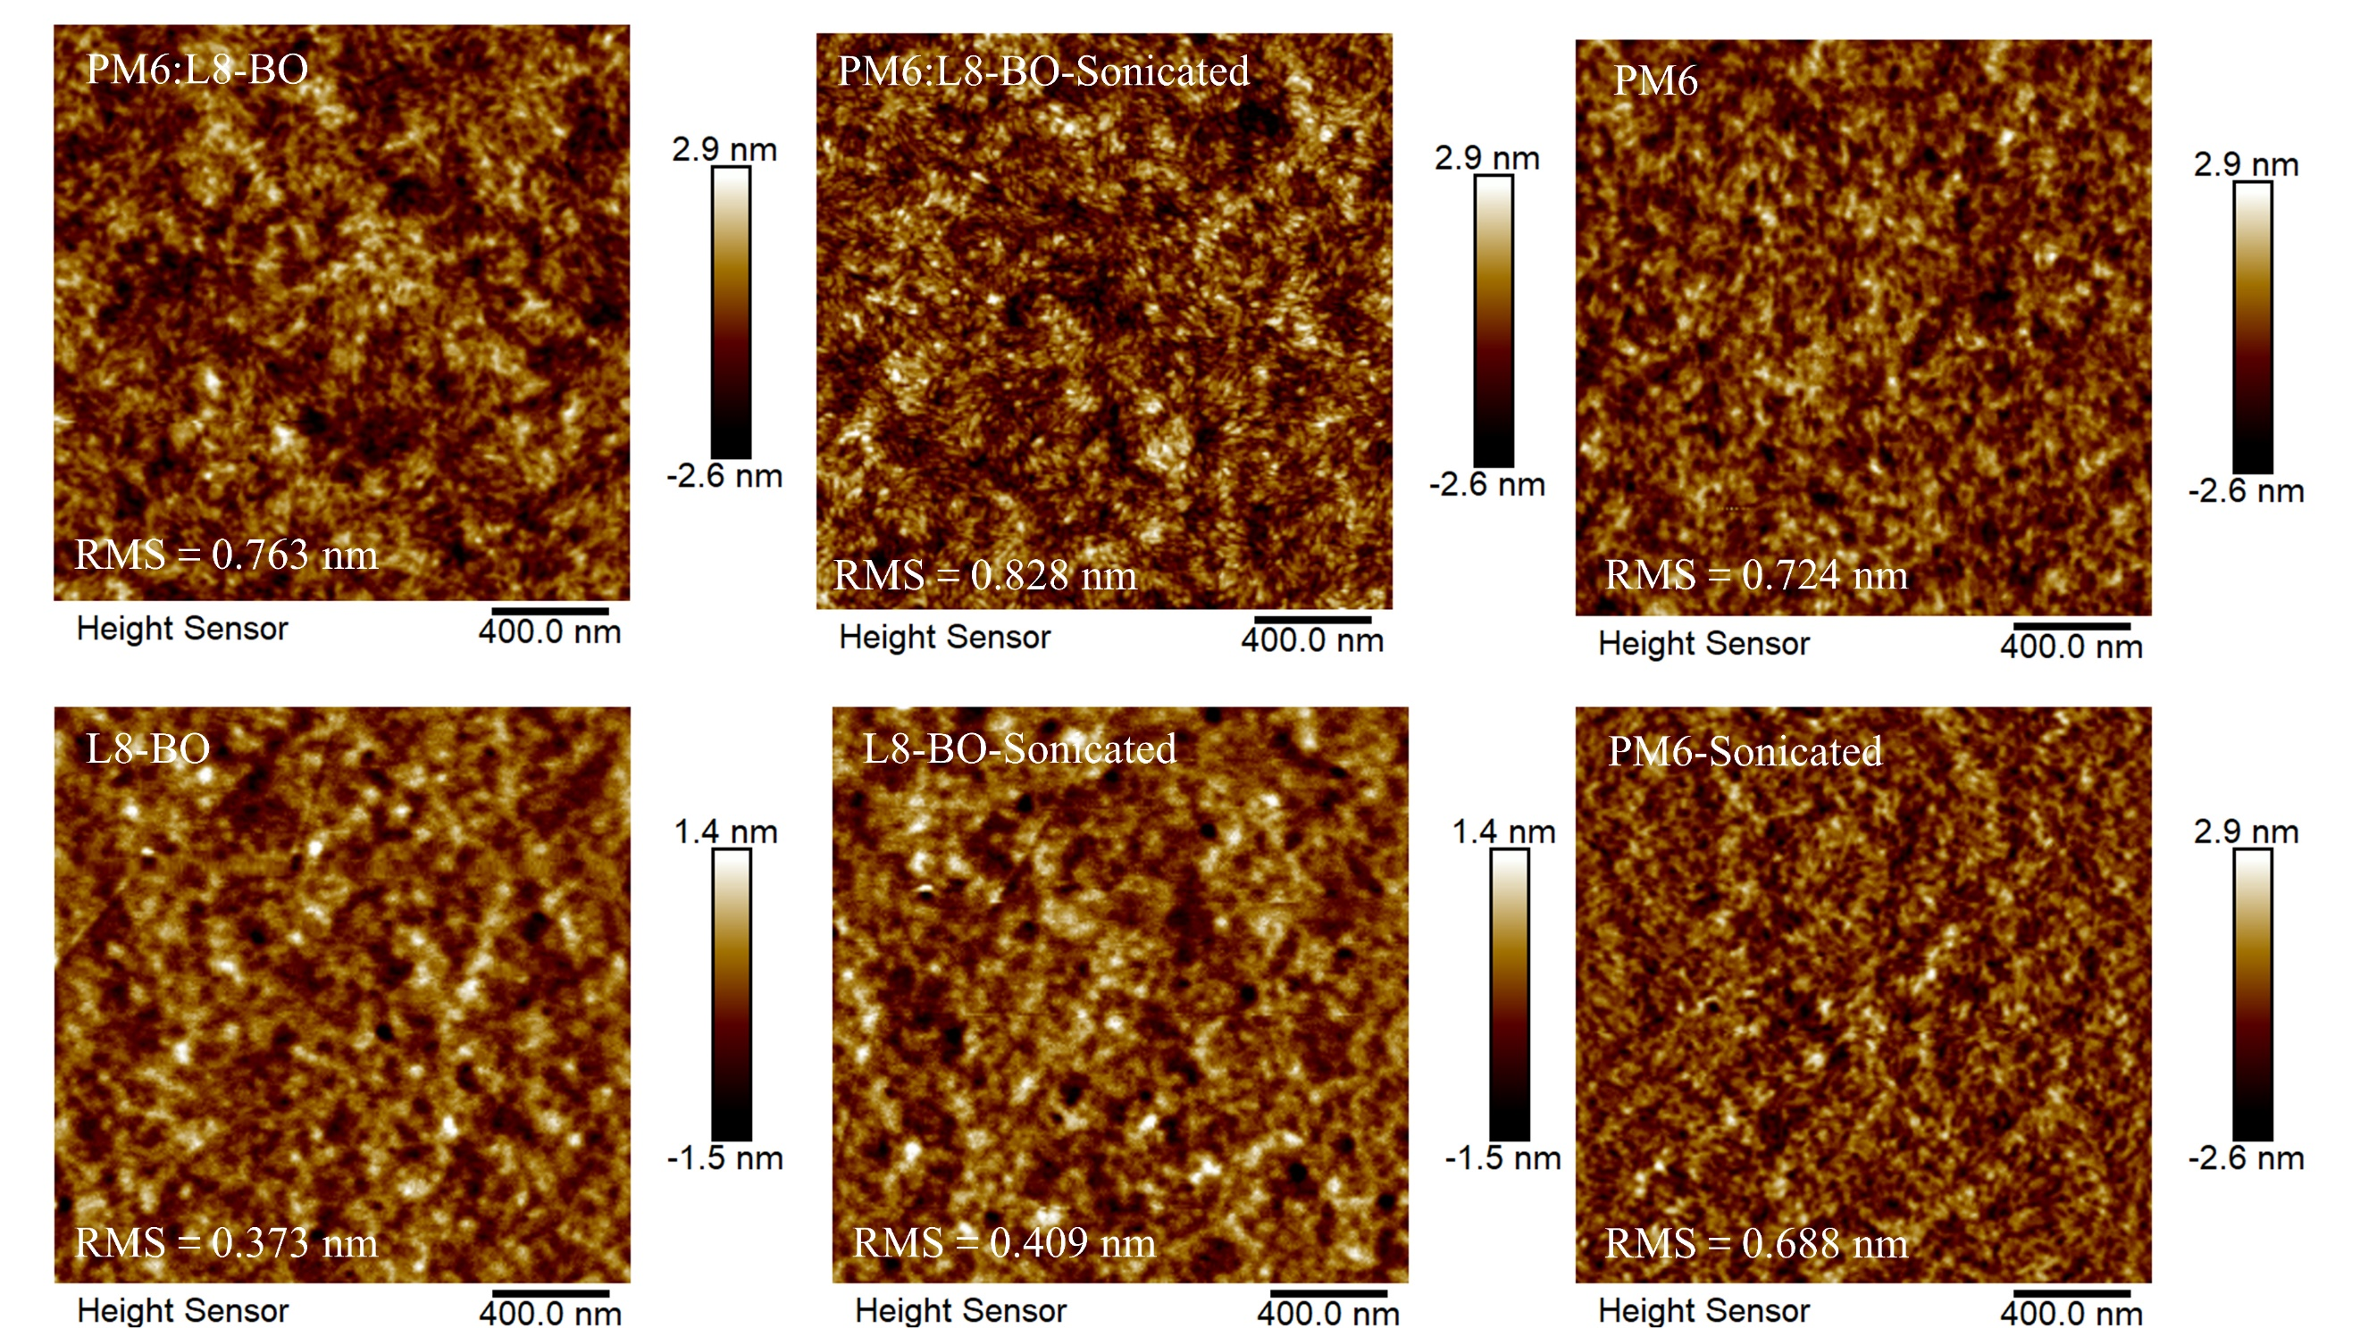
Supplementary Fig. 13 Atomic force microscope patterns. The AFM height images of neat and blend films without or with sonication.

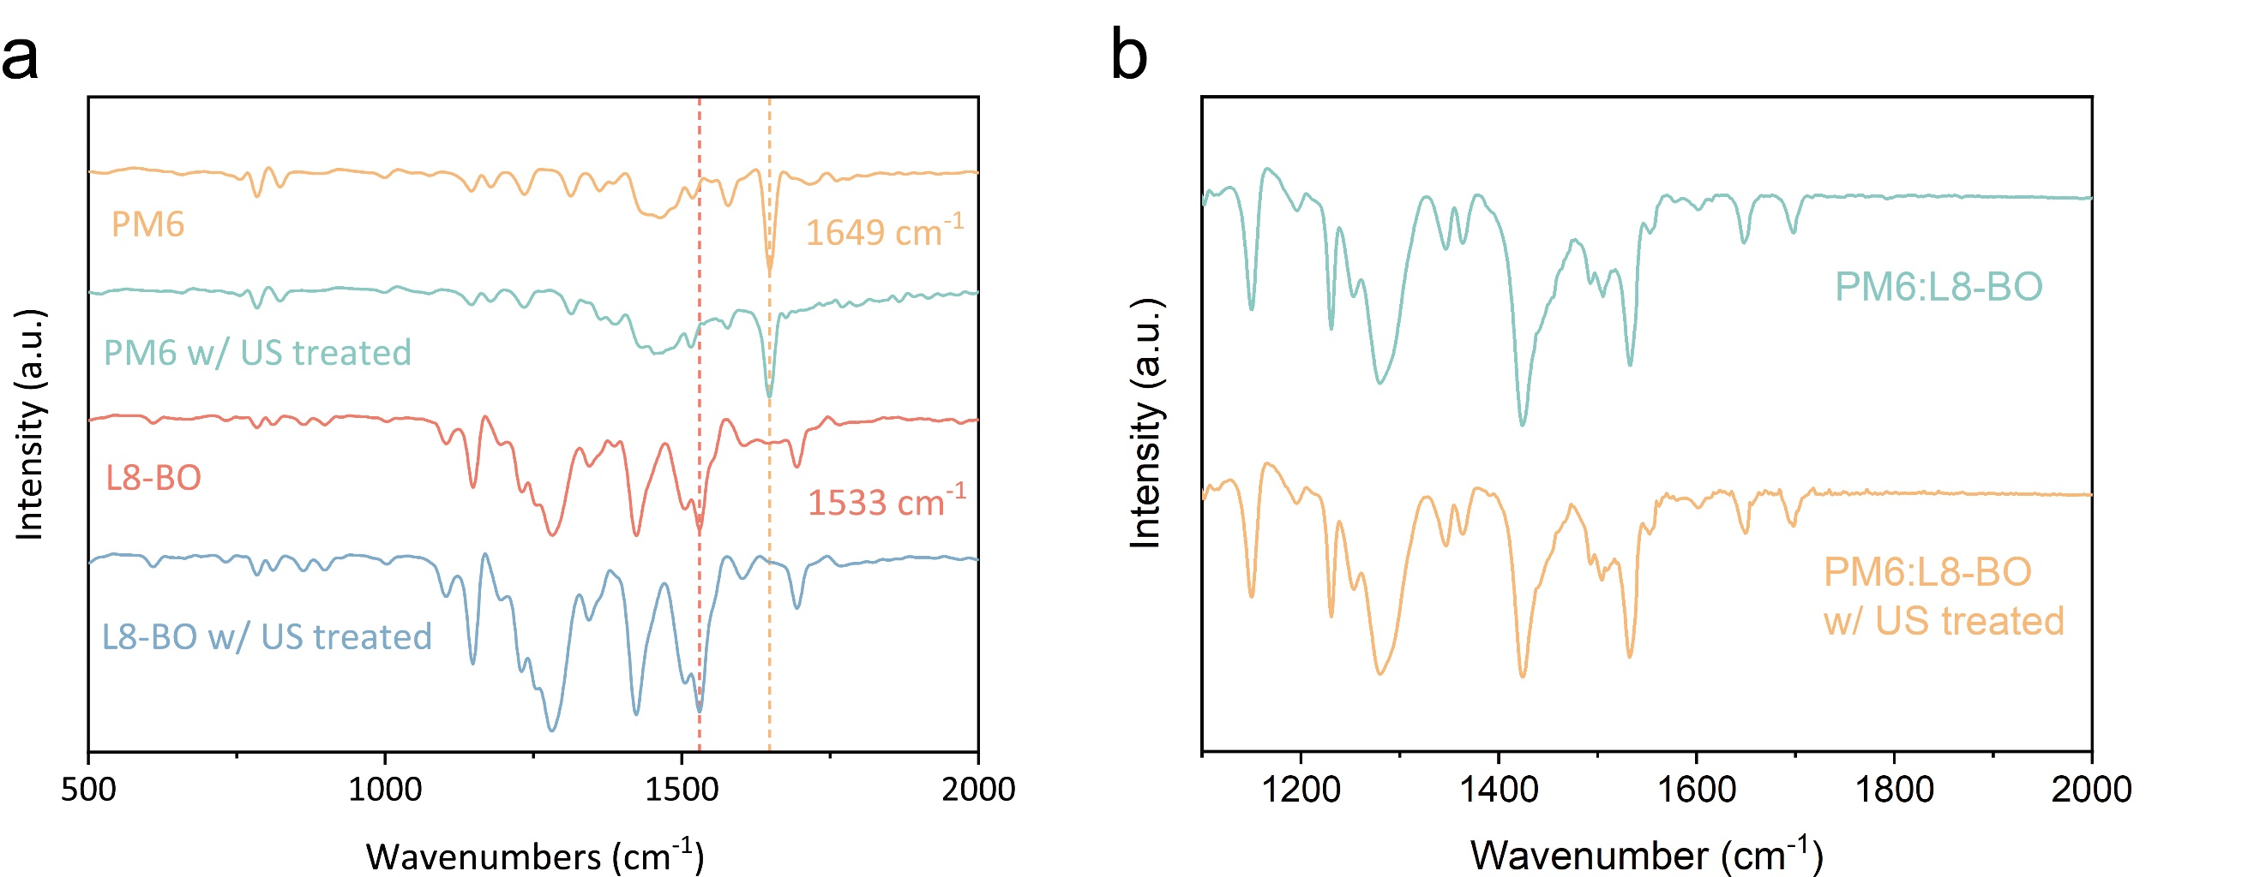
Supplementary Fig. 14 Fourier transform infrared spectra. FTIR of a, neat and b, blend films, PM6 shows a unique peak at 1649 cm⁻¹ from alkene vibrations, L8-BO shows a unique peak at 1533 cm⁻¹ from C=C bond stretching.

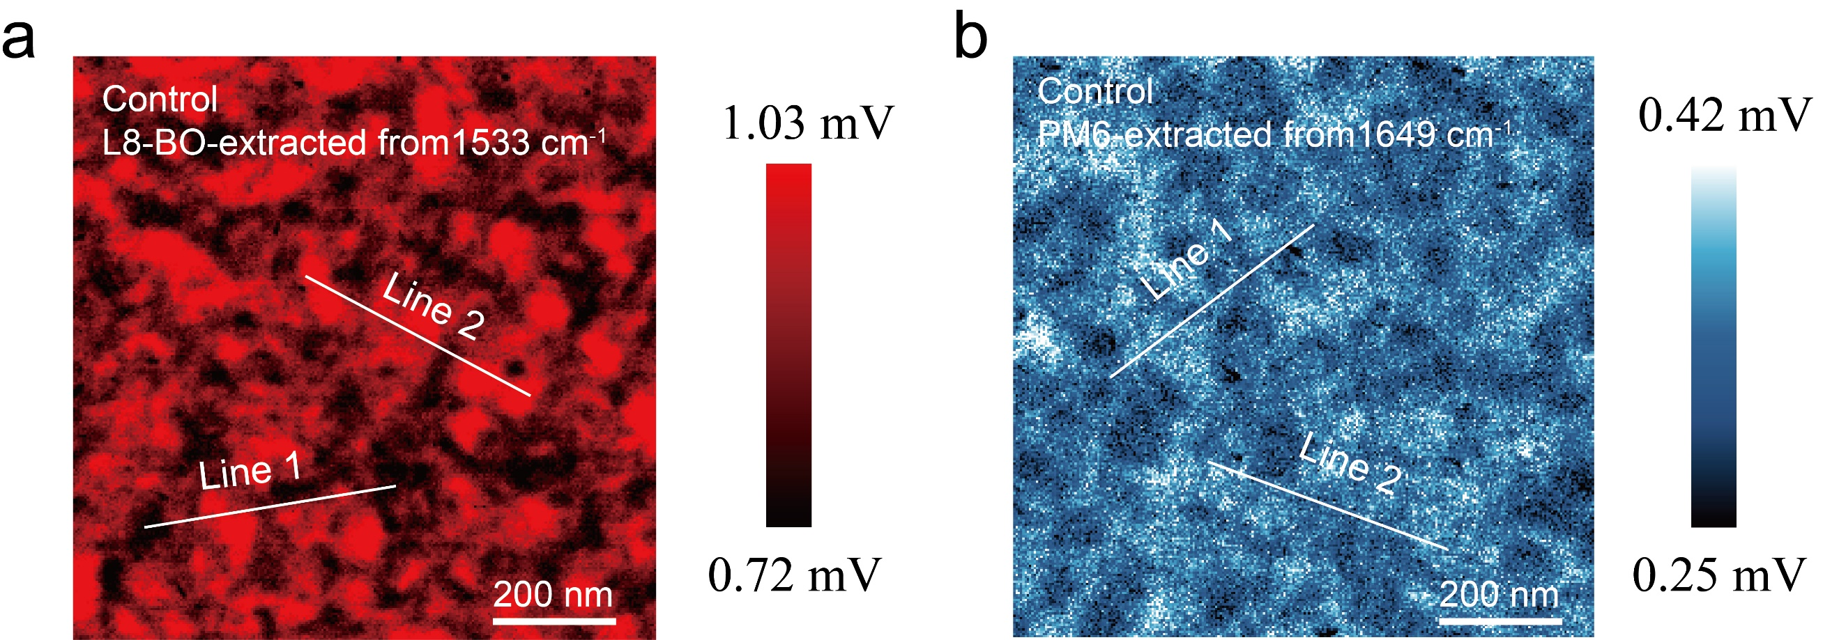
Supplementary Fig. 15 Photo-induced force microscopy image. Control PiFM images at a wavenumber of 1,533 cm⁻¹ (representing L8-BO) and 1,649 cm⁻¹ (representing PM6).

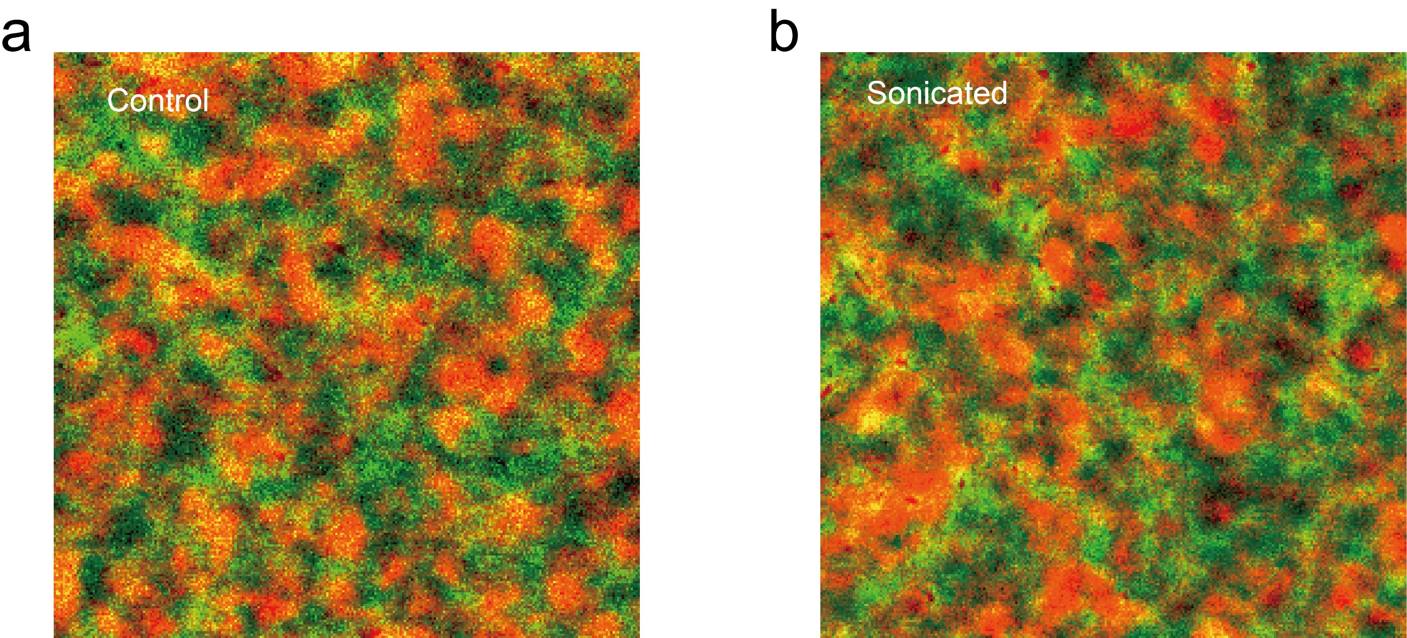
Supplementary Fig. 16 Integrated PiFM images. The combination of donor and acceptor PiFM images.
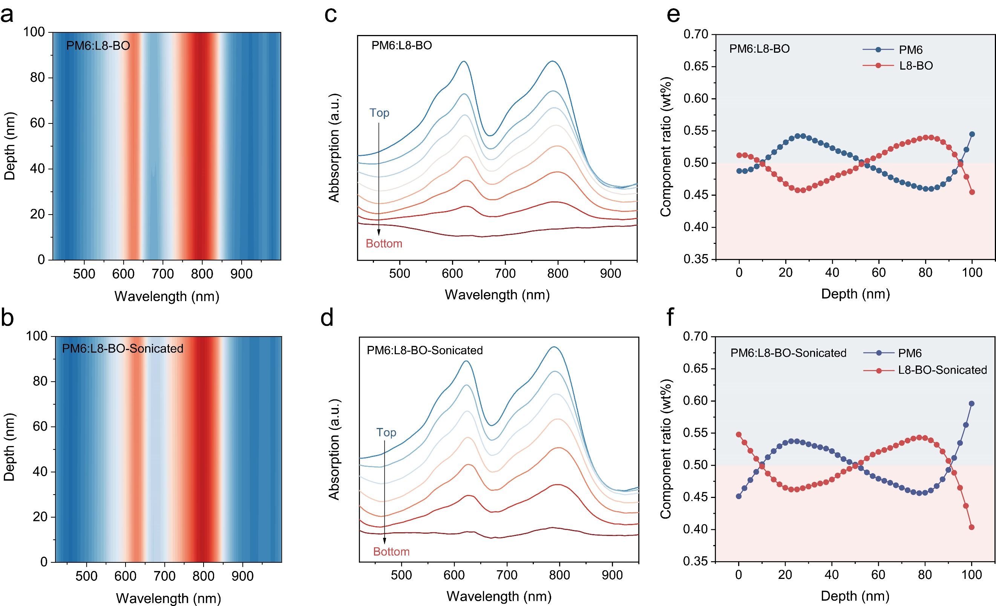
Supplementary Fig. 17 Film depth dependent optical investigations. a-b, 2D Depth-dependent absorption characteristics of the sub-layers. c-d, Control and sonicated film-depth-dependent absorption spectrum. The bottom is the near-substrate side of the active layer, and top is the far-substrate side. e-f, Vertical composition profiles as extracted from FLAS spectra for PM6:L8-BO films without or with sonication.

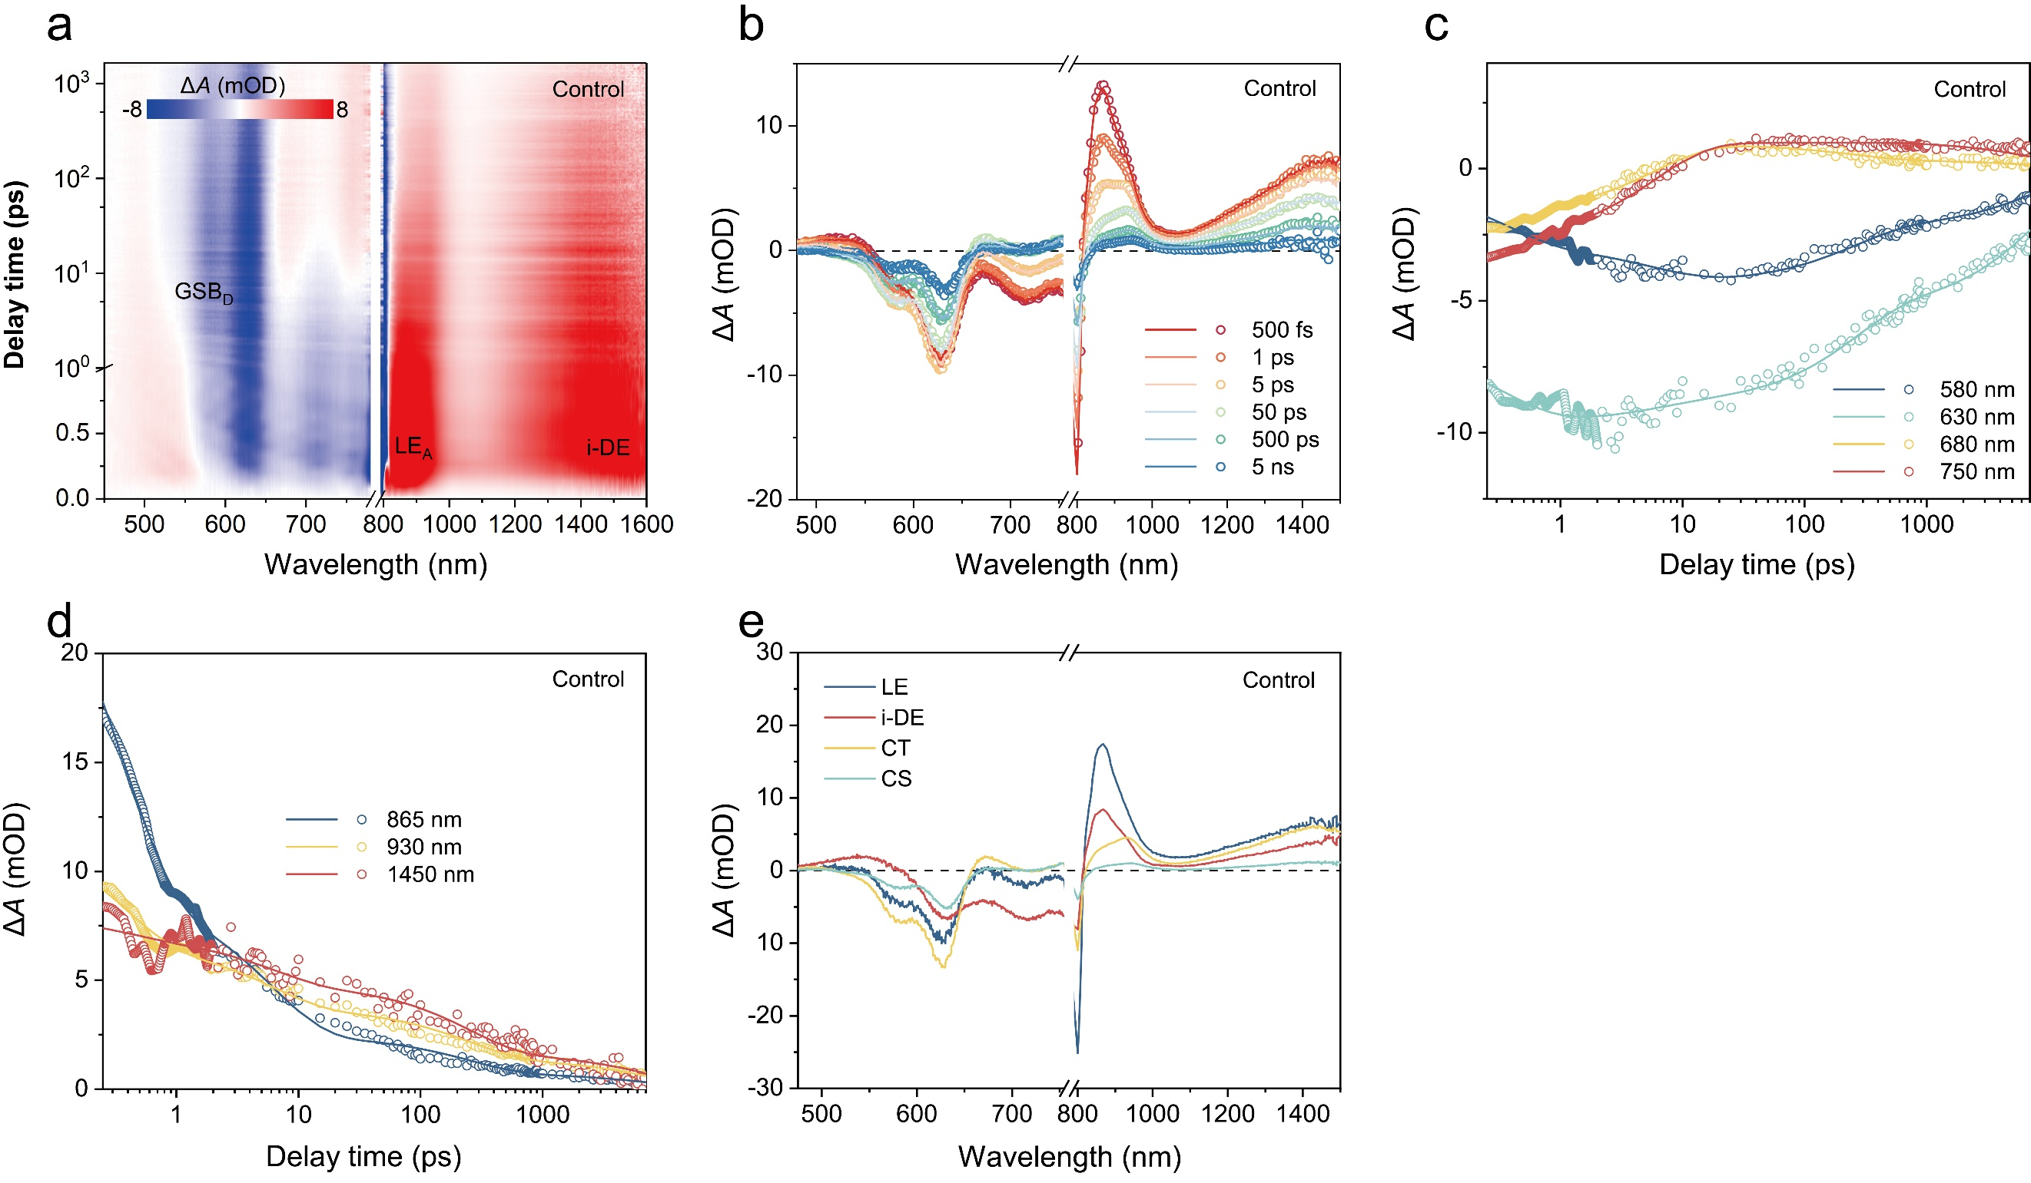
Supplementary Fig. 18 Global fitting model for control system. a, Control-2D TA profile extracted from TA spectrum. b, TA spectrum with fitting curves at different time delays were pumped at 800 nm. c-d, TA dynamics and its fitting curves probed at visible and infrared regions. e, The LE, i-DE, CT and CS signals extracted from TA spectrum by global fitting.

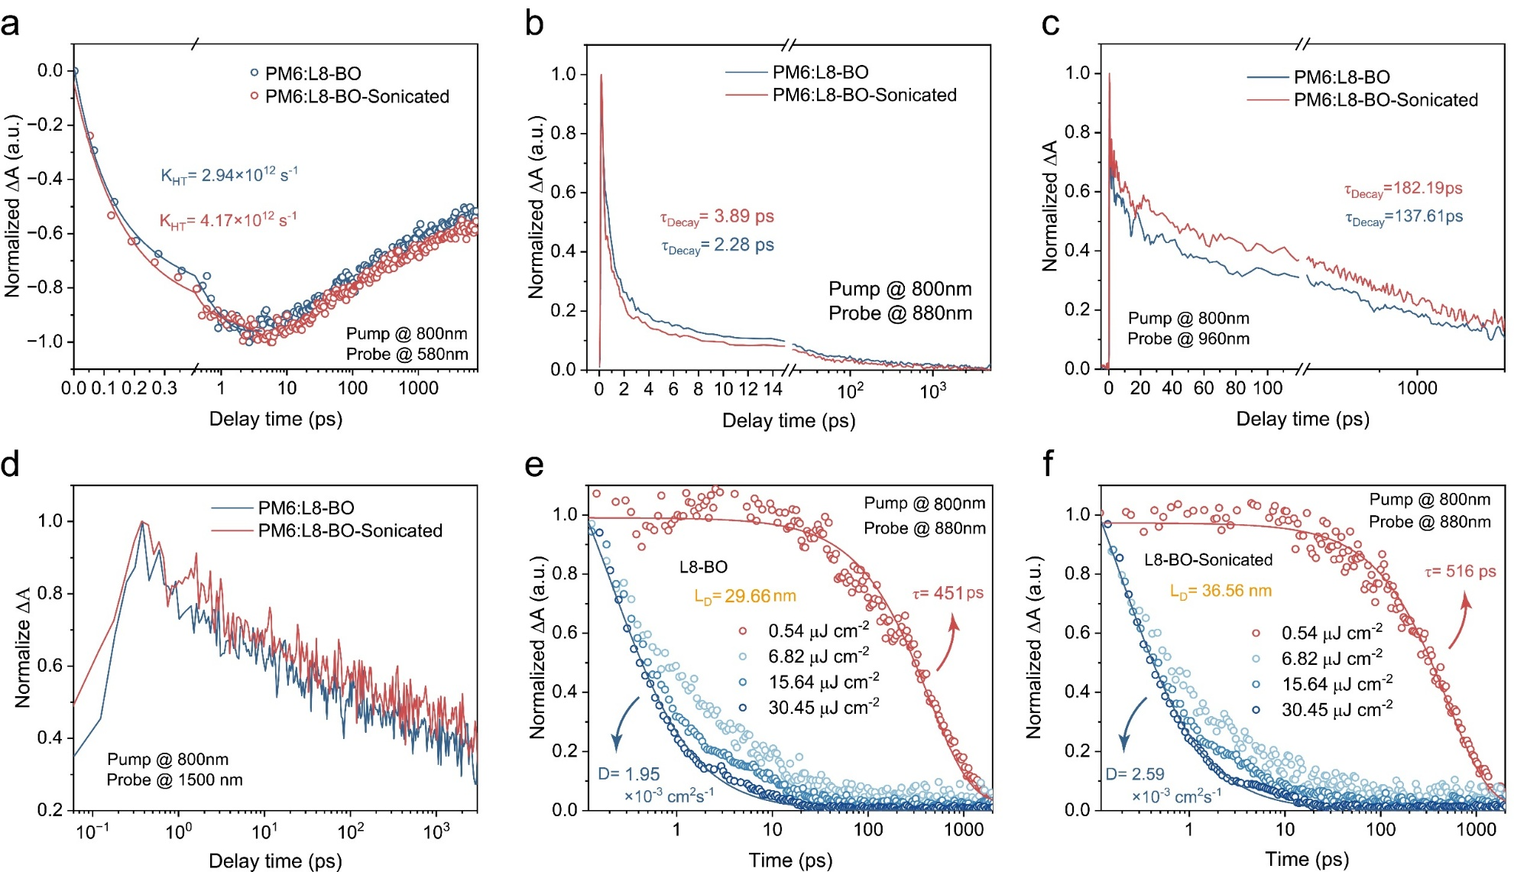
Supplementary Fig. 19 Femtosecond transient absorption spectra measurements of blend films. a-d, Decay dynamics probed at 580 nm, 880 nm, 960 nm, 1500 nm from PM6:L8-BO films without or with sonication. e-f, Pump-fluence-dependent TA kinetics of L8-BO films without or with sonication, probed at 880 nm.

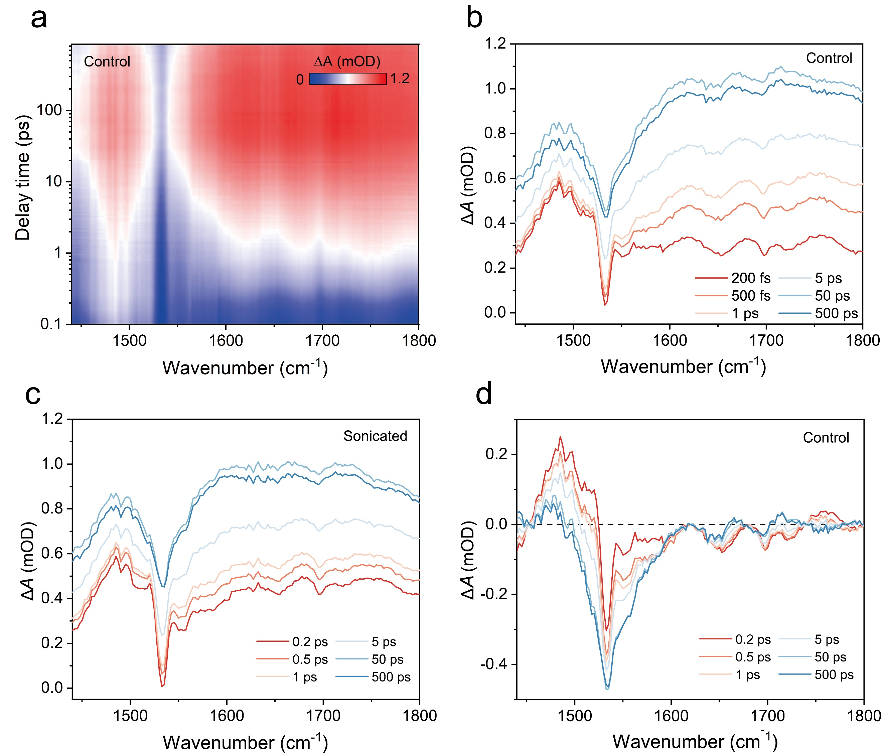
Supplementary Fig. 20 Transient infrared spectra measurements of control system. a, Sonicated-2D color plots of TRIR data for PM6:L8-BO films. b-c, The corresponding TRIR spectrum at different delay time without or with sonication. d, The TRIR spectrum after deconvoluting the signals of polarons for PM6:L8-BO films without sonication.

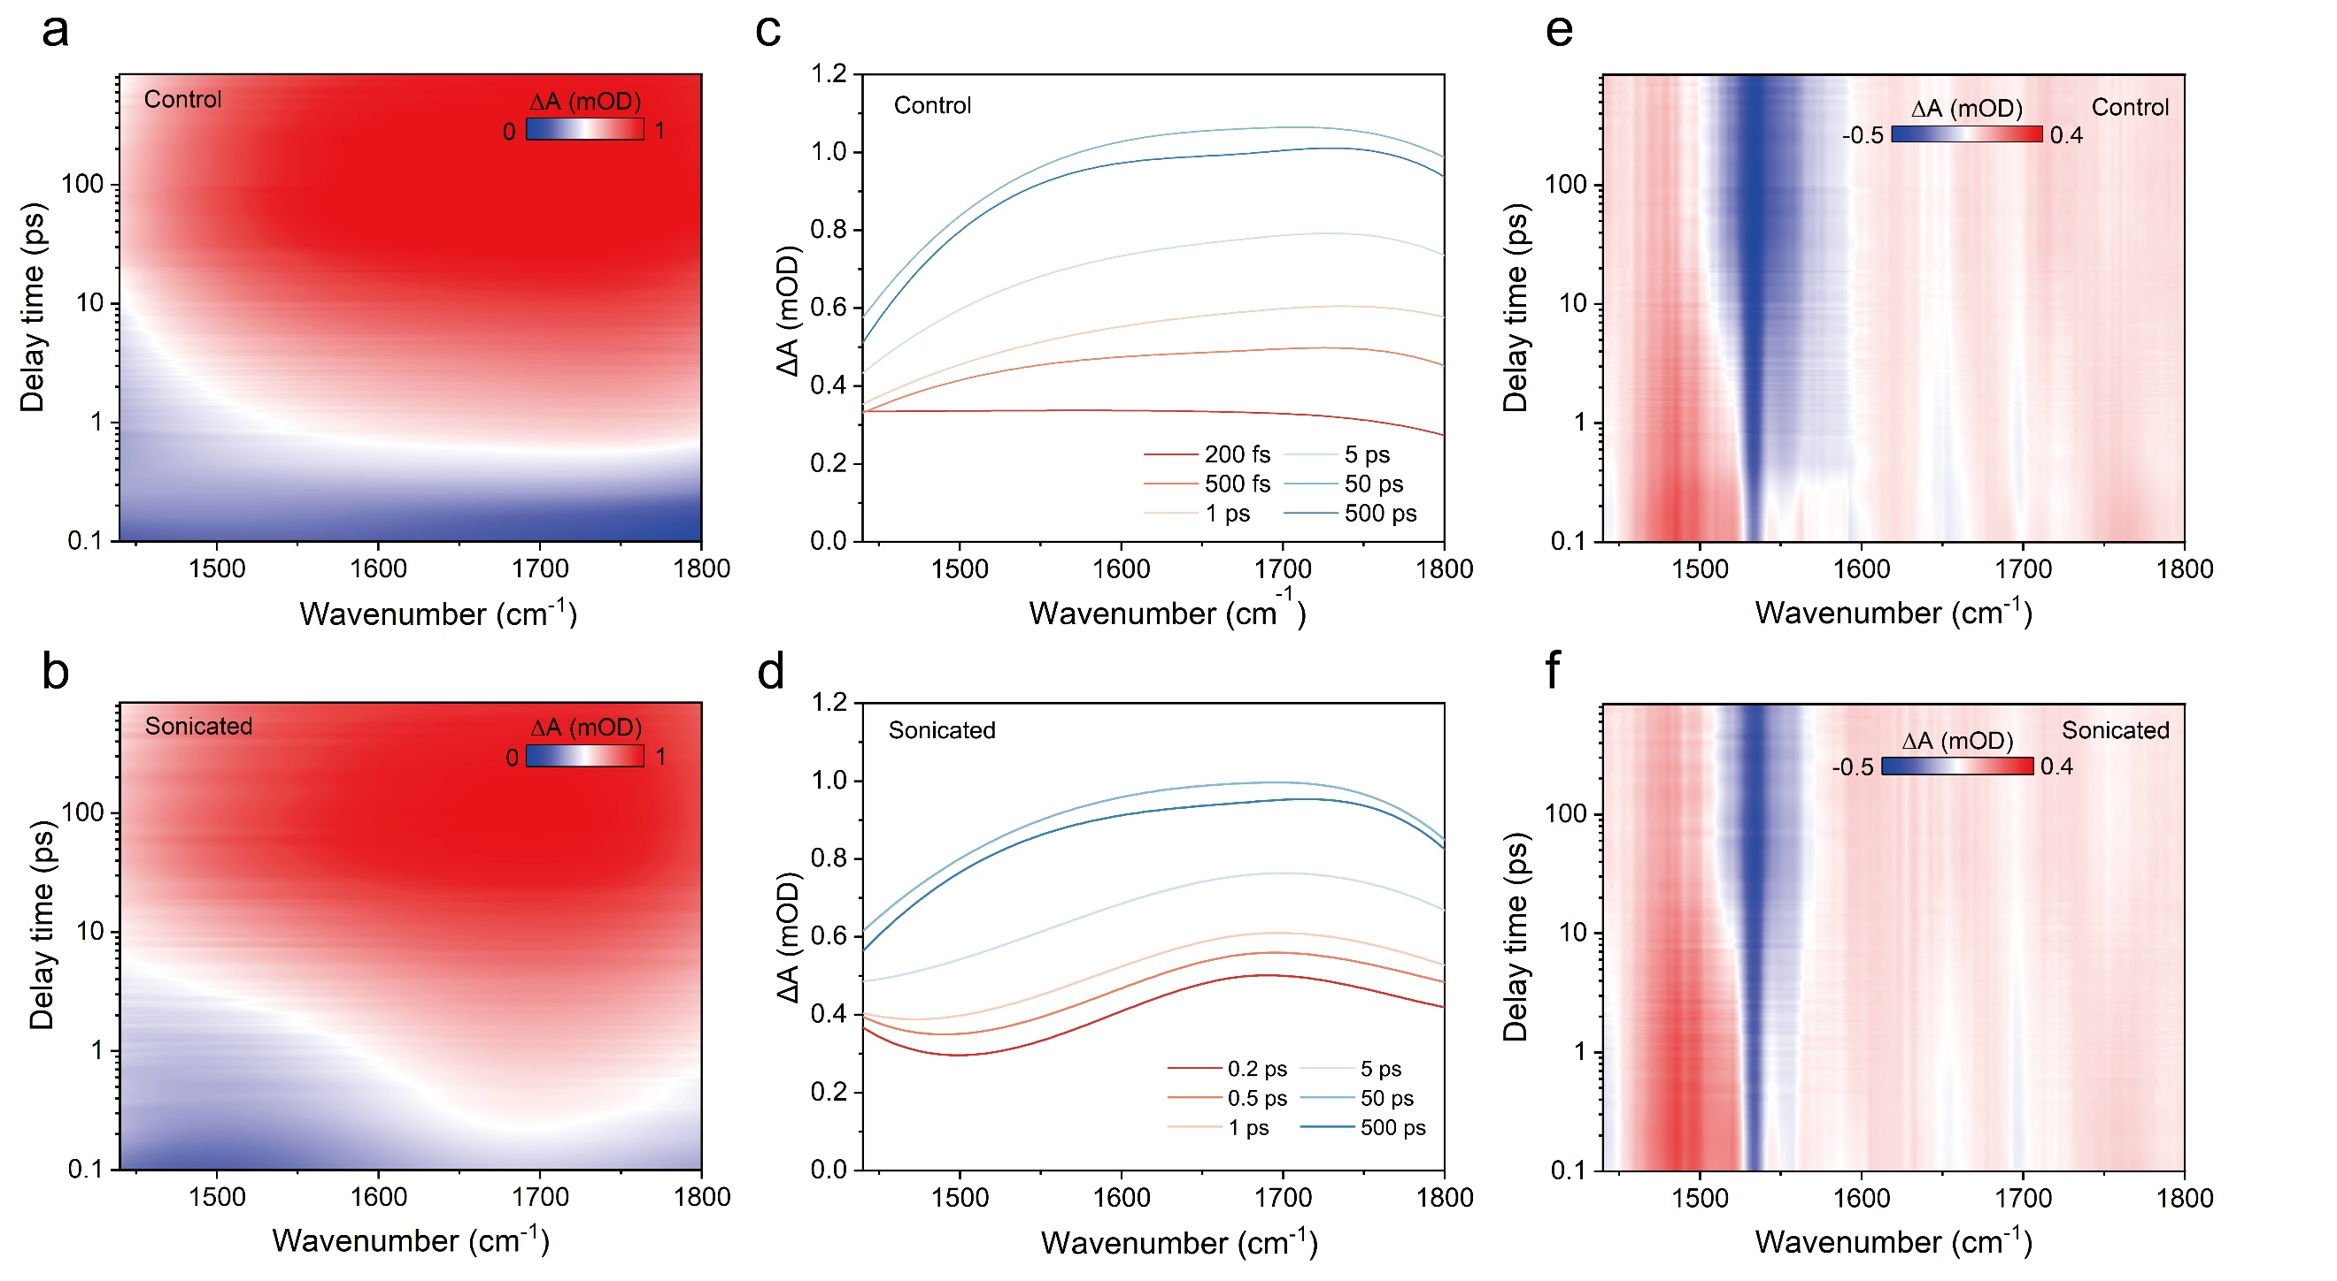
Supplementary Fig. 21 Correlation deconvolution processing of TRIR spectra. a-b, The polaron color plot of PM6:L8-BO films without or with sonication. c-d, The corresponding polaron spectrum extracted from 2D polaron images. e-f, 2D color plots of TRIR data after deconvoluting the signals of polarons for PM6:L8-BO films without or with sonication.

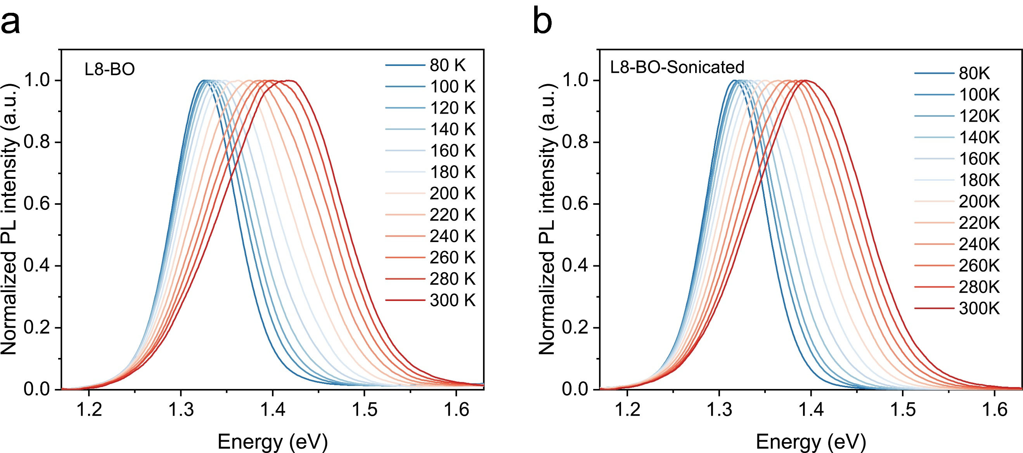
Supplementary Fig. 22 Temperature-dependent PL spectra. Normalized temperature-dependent PL spectrum of L8-BO films a, without or b, with sonication, pumped at 400 nm.

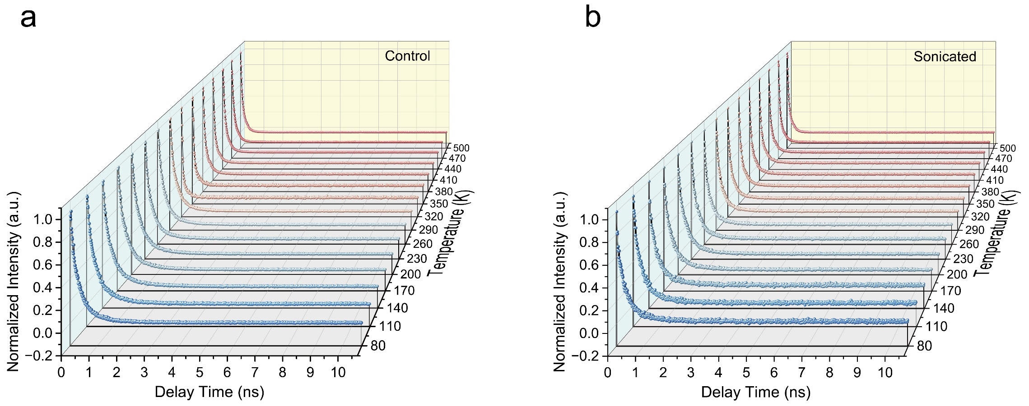
Supplementary Fig. 23 Temperature-dependent TRPL spectra. Normalized temperature-dependent TRPL spectrum of L8-BO films a, without or b, with sonication, pumped at 400 nm.

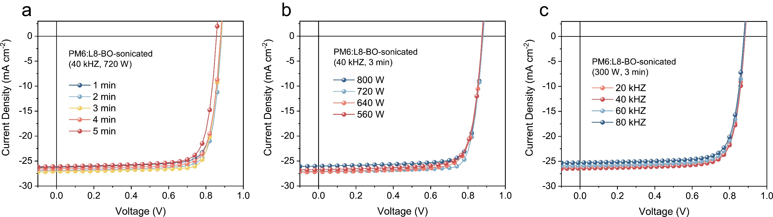
Supplementary Fig. 24 J–V curves of the devices prepared under different sonication conditions. The J-V curves of devices with different sonication a, time b, powers c, and frequencies.

Supplementary Fig. 25 The exciton dissociation efficiency test of binary devices. The relationship between J_{ph} and V_{eff} for PM6:L8-BO device without or with sonication.

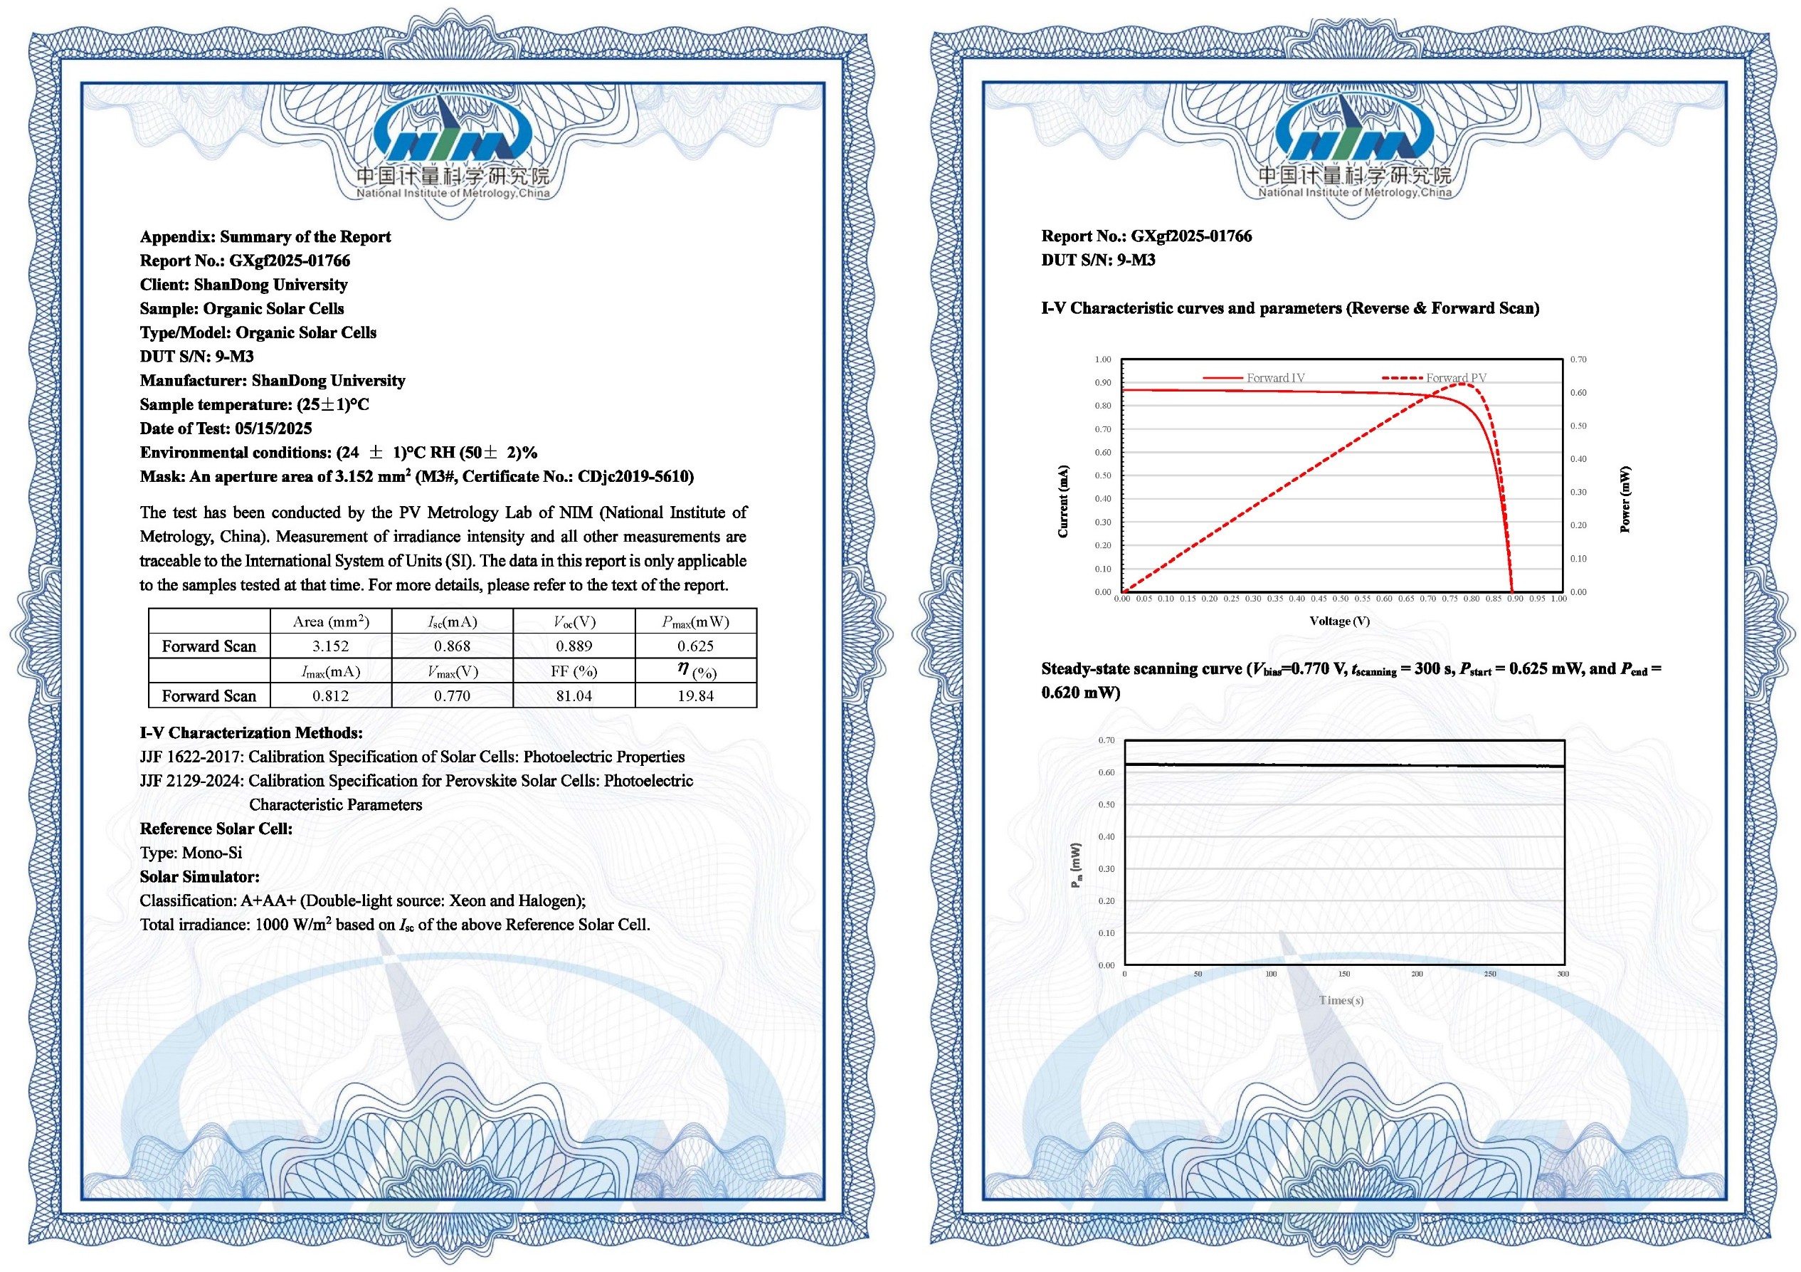
Supplementary Fig. 26 Device efficiency certification. Certificated result of PM6:D18:L8-BO-sonicated-based device from National Institute of Metrology (NIM), China.

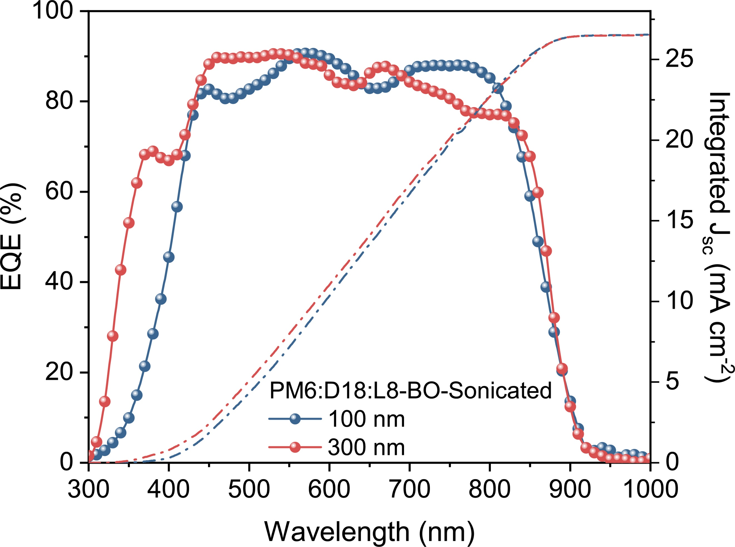
Supplementary Fig. 27 The external quantum efficiency of ternary devices. EQE curves of different ternary active layer thickness with sonication.

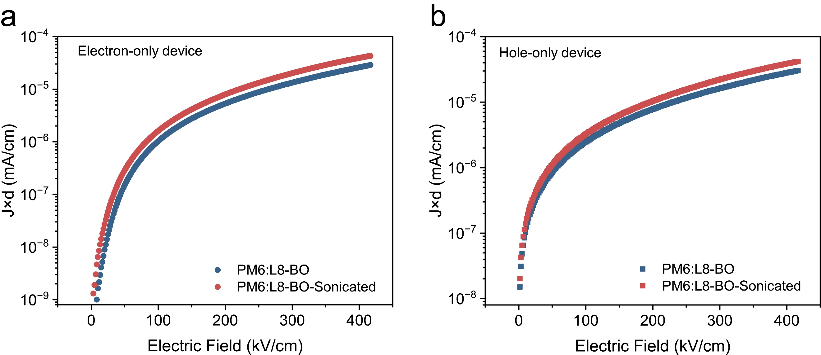
Supplementary Fig. 28 The mobilities of binary devices. The voltage versus current density for a, electron-only and b, hole-only devices based on PM6:L8-BO without or with sonication.

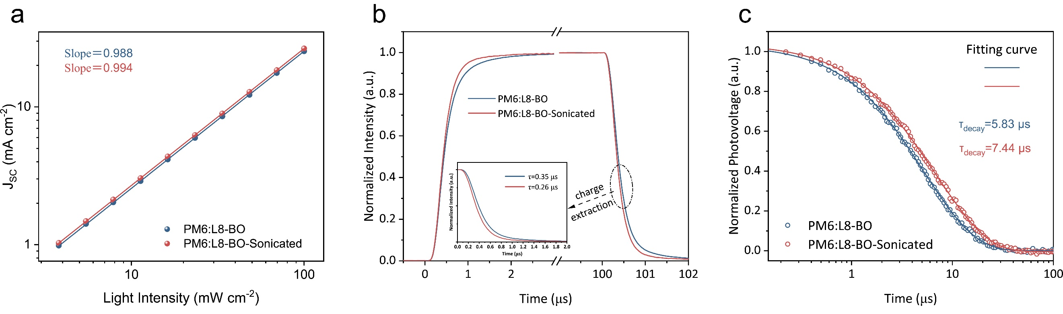
Supplementary Fig. 29 Electrical characterization of binary devices. a, Measurements of light-intensity-dependent J_{SC} for different conditions. b-c, Transient photocurrent (TPC) curves and Transient photovoltage (TPV) curves of PM6:L8-BO device without or with sonication.

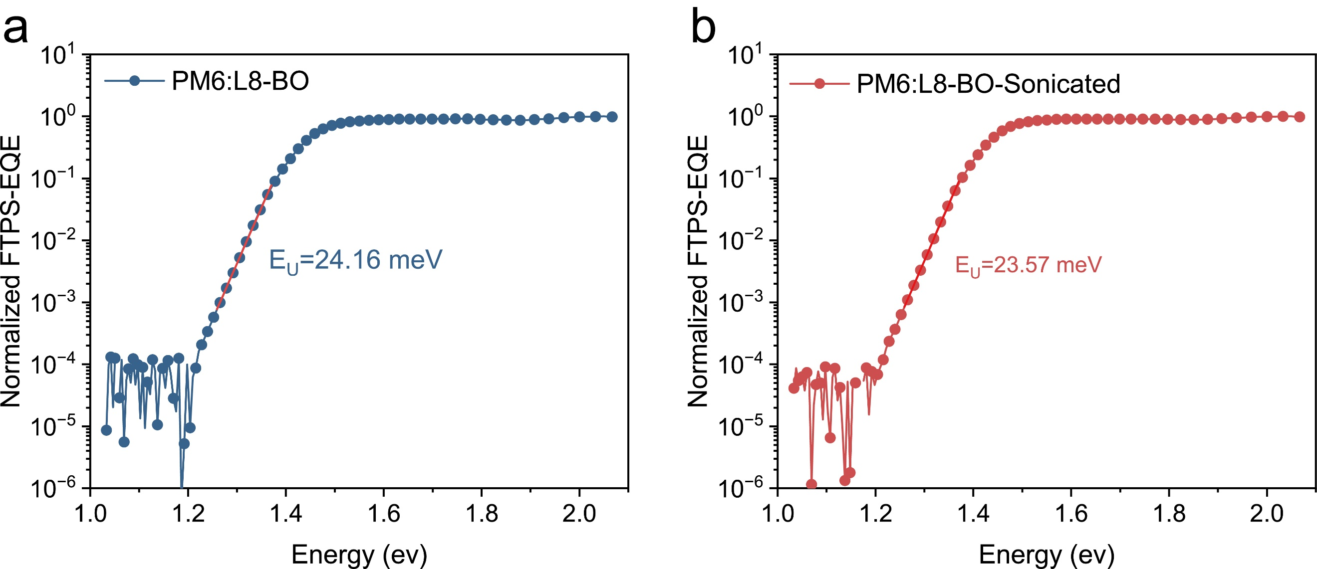
Supplementary Fig. 30 The E_{u} of binary devices. Normalized FTPS-EQE spectrum of the a, control and b, sonicated devices.

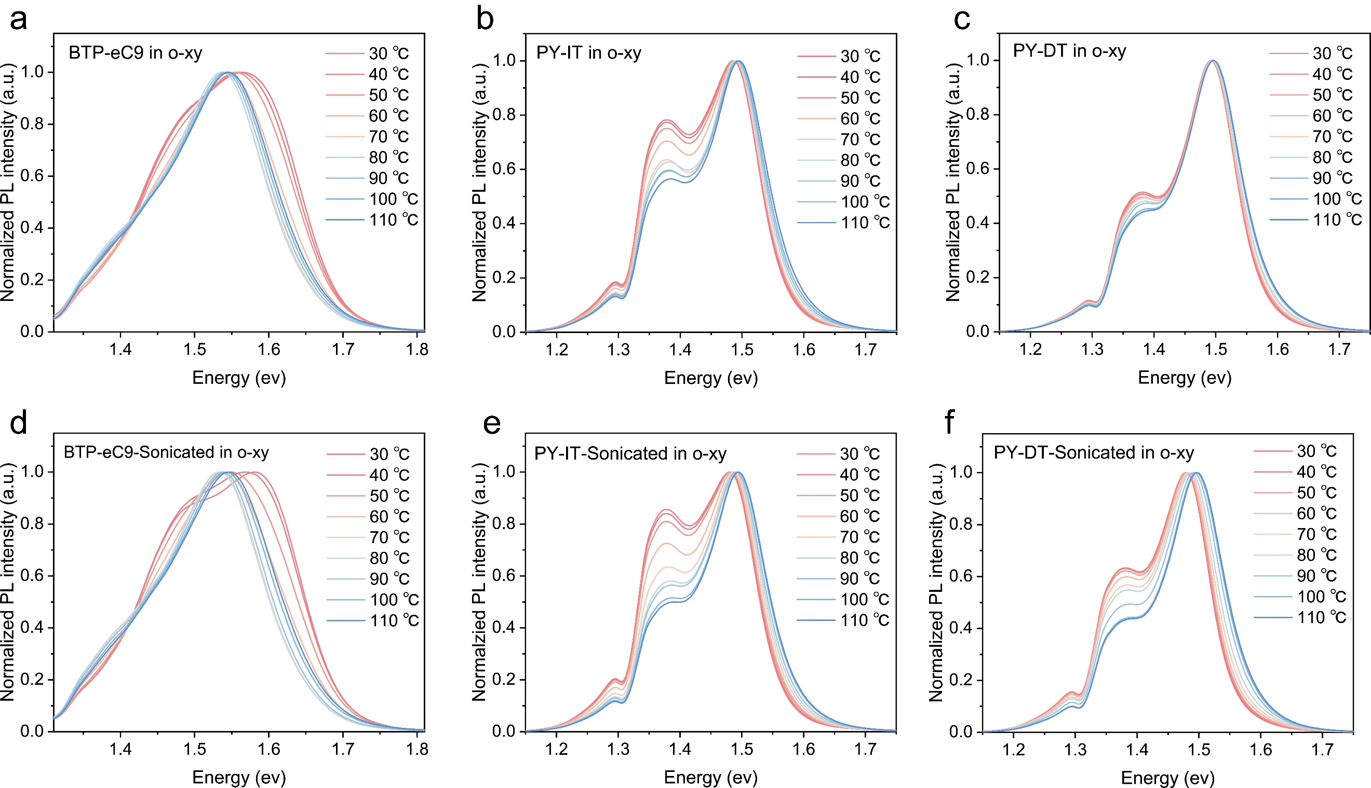
Supplementary Fig. 31 Temperature-dependent PL spectra Normalized temperature-dependent PL spectrum of a, BTP-eC9, b, PY-IT and c, PY-DT in o-xy.

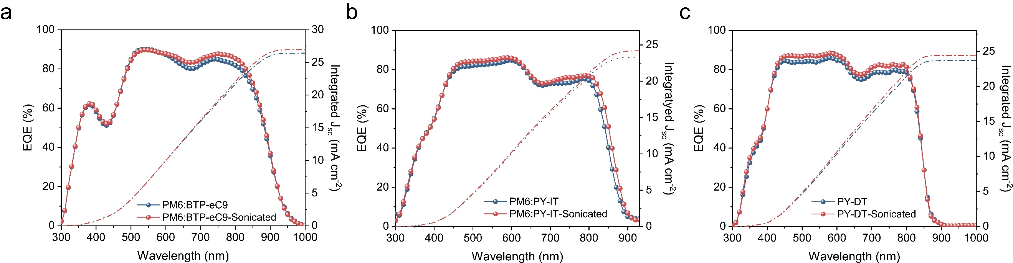
Supplementary Fig. 32 The external quantum efficiency of other binary devices. The EQE spectra of different systems.

Supplementary Tables

Supplementary Table 1. Ratio of peak I₀₋₁ and I₀₋₀ extracted from the temperature-related PL spectrum of L8-BO solution without or with sonication.
 | Condition | 30 ℃ | 40 ℃ | 50 ℃ | 60 ℃ | 70 ℃ | 80 ℃ |  | 90 ℃ | 100 ℃ |  | 110 ℃
I₀₋₁/I₀₋₀ | L8-BO | 0.786 | 0.795 | 0.811 | 0.815 | 0.821 | 0.825 | 0.815 |  |  | 0.810 | 0.806
I₀₋₁/I₀₋₀ | L8-BO-sonicated | 0.849 | 0.871 | 0.888 | 0.909 | 0.908 | 0.881 | 0.858 |  |  | 0.849 | 0.838

Supplementary Table 2. Summary of GIWAXS π-π stacking information in the OOP direction for neat films.
Active layer | q (Å⁻¹) | d-spacing (Å) | FWHM (Å⁻¹) | CCL (Å)
L8-BO | 1.750 | 3.590 | 0.283 | 19.98
L8-BO-sonicated | 1.767 | 3.556 | 0.265 | 21.34

Supplementary Table 3. Summary of GIWAXS π-π stacking information in the OOP direction for blend films.
Active layer | q (Å⁻¹) | d-spacing (Å) | FWHM (Å⁻¹) | CCL (Å)
Control | 1.751 | 3.588 | 0.262 | 21.58
Sonicated | 1.788 | 3.514 | 0.245 | 23.08

Supplementary Table 4. Fitting parameters of GISAXS profiles of the corresponding blend films.
Active layer | ξ (nm) | η (nm) | D | 2R_{g} (nm)
Control | 12.15 | 16.87 | 1.96 | 28.73
Sonicated | 16.72 | 23.72 | 1.77 | 37.13

Supplementary Table 5. Parameters of charge transfer and exciton dynamics for blend films probe at 585 nm.
Active layer | τ₁ (ps) | A₁ (%) | τ₂ (ps) | A₂ (%) | τ_{AVG} (ps) | K_{HT} (ps⁻¹)
Control | 0.17 | 59.87 | 0.60 | 40.13 | 0.34 | 2.94
Sonicated | 0.13 | 84.47 | 0.86 | 15.53 | 0.24 | 4.17

Supplementary Table 6. Parameters of acceptor localized exciton decay dynamics for blend films probed at 880 nm.
Active layer | τ₁ (ps) | A₁ (%) | τ₂ (ps) | A₂ (%) | τ_{AVG} (ps)
Control | 0.72 | 81.93 | 18.25 | 18.07 | 3.89
Sonicated | 0.45 | 82.72 | 11.04 | 17.28 | 2.28

Supplementary Table 7. Fitting parameters for the pump fluence-dependent TA decay curve probed at 880nm.
Active layer | τ (ps) | k (×10⁹ s⁻¹) | D (×10⁻³ cm² s⁻¹) | L_{D} (nm)
Control | 451 | 2.22 | 1.95 | 29.66
Sonicated | 516 | 1.94 | 2.59 | 36.56

Supplementary Table 8. Fitting parameters of temperature-related Peak Location for neat films.
Active layer | E(0) (meV) | α (meV) | Θ (k)
L8-BO | 1.32 | 151.2 | 438.2
L8-BO-Sonicated | 1.31 | 113.3 | 391.6

Supplementary Table 9. Photovoltaic parameters of PM6:L8-BO-based organic solar cells (explored under different ultrasonic frequencies using o-xy) under AM 1.5G/100 mW cm⁻² illumination.
Active layer | Condition  (300W, 3min) | J_{SC}  (mA cm⁻²) |  | V_{OC}  (V) | FF  (%) |  | PCEª  (%)
PM6:L8-BO (o-xy) | L8-BO-Sonicated  (20kHZ) | 26.13 | 0.880 |  |  | 78.38 | 18.02  (17.89 ± 0.12)
PM6:L8-BO (o-xy) | L8-BO-Sonicated  (40kHZ) | 26.42 | 0.882 |  |  | 78.45 | 18.28  (18.01 ± 0.16)
PM6:L8-BO (o-xy) | L8-BO-Sonicated  (60kHZ) | 25.83 | 0.880 |  |  | 78.13 | 17.76  (17.61 ± 0.15)
PM6:L8-BO (o-xy) | L8-BO-Sonicated  (80kHZ) | 25.24 | 0.877 |  |  | 78.06 | 17.28  (17.02 ± 0.21)
ªAverage PCEs with standard deviations determined using 10 individual devices.

Supplementary Table 10. Photovoltaic parameters of PM6:L8-BO-based organic solar cells (explored under different conditions using o-xy) under AM 1.5G/100 mW cm⁻² illumination.
Active layer | Condition  (40KHZ) | J_{SC}  (mA cm⁻²) |  | V_{OC}  (V) | FF  (%) |  | PCEª  (%)
PM6:L8-BO (o-xy) | As cast | 25.36 | 0.878 |  |  | 78.56 | 17.50  (17.15 ± 0.33)
PM6:L8-BO (o-xy) | L8-BO-Sonicated  (720W, 1min) | 26.23 | 0.879 |  |  | 79.19 | 18.26  (17.94 ± 0.25)
PM6:L8-BO (o-xy) | L8-BO-Sonicated  (720W, 2min) | 26.87 | 0.883 |  |  | 80.23 | 19.04  (18.81 ± 0.19)
PM6:L8-BO (o-xy) | L8-BO-Sonicated  (720W, 3min) | 27.05 | 0.881 |  |  | 81.53 | 19.43  (19.12 ± 0.26)
PM6:L8-BO (o-xy) | L8-BO-Sonicated  (720W, 4min) | 26.53 | 0.878 |  |  | 79.61 | 18.54  (18.25 ± 0.21)
PM6:L8-BO (o-xy) | L8-BO-Sonicated  (720W, 5min) | 26.07 | 0.882 |  |  | 78.94 | 18.15  (17.83 ± 0.24)
PM6:L8-BO (o-xy) | L8-BO-Sonicated  (3min, 800W) | 26.01 | 0.879 |  |  | 79.41 | 18.16  (17.87±0.17)
PM6:L8-BO (o-xy) | L8-BO-Sonicated  (3min, 640W) | 27.17 | 0.875 |  |  | 79.14 | 18.81  (18.45 ± 0.31)
PM6:L8-BO (o-xy) | L8-BO-Sonicated  (3min, 560W) | 26.71 | 0.876 |  |  | 79.02 | 18.49  (18.26 ± 0.16)
PM6:L8-BO (o-xy) | PM6-Sonciated  (720W, 1min) | 25.17 | 0.875 |  |  | 77.41 | 17.05  (16.88 ± 0.14)
PM6:L8-BO (o-xy) | PM6-Sonciated  (720W, 3min) | 25.03 | 0.876 |  |  | 77.08 | 16.90  (16.61 ± 0.28)
PM6:L8-BO (o-xy) | PM6-Sonciated  (720W, 5min) | 24.84 | 0.874 |  |  | 76.76 | 16.66  (16.37 ± 0.23)
ªAverage PCEs with standard deviations determined using 10 individual devices.

Supplementary Table 11. Photovoltaic parameters of OPV devices for blend films.
Active layer | J_{sat}  (mA cm⁻²) | J_{ph}*  (mA cm⁻²) | J_{ph}#  (mA cm⁻²) | P_{diss}  (%) | P_{coll}  (%)
Control | 25.76 | 25.36 | 23.29 | 98.44 | 90.42
Sonicated | 27.47 | 27.05 | 25.73 | 98.54 | 93.73
*short-circuit condition, #maximal power output condition, P_{diss} = J_{ph}*/J_{sat}, P_{coll} = J_{ph}#/J_{sat}

Supplementary Table 12. Summary of PCEs of binary non-halogenated solvent processed OSCs under AM 1.5 G illumination.
Active layer | Solvent | J_{SC}  (mA cm⁻²) | V_{OC} (V) | FF  (%) | PCE  (%) | Ref
T1:BTP-4F-12 | o-XY | 24.50 | 0.865 | 72.00 | 15.30 | 2
PM6:BTP BO-4Cl | Tol | 26.10 | 0.854 | 77.70 | 17.33 | 3
PM6-Ir1.5:Y6-C2 | Tol | 26.23 | 0.840 | 74.80 | 16.52 | 4
PM6:DTY6 | o-XY | 24.94 | 0.860 | 75.50 | 16.10 | 5
PM6:BTIC-2Cl-γCF3 | Tol | 25.09 | 0.840 | 76.99 | 16.31 | 6
PTQ10:Y6-BO | o-XY | 25.75 | 0.861 | 63.50 | 14.08 | 7
PM6:BTP-eC9 | o-XY | 25.75 | 0.839 | 76.00 | 16.41 | 8
PM6:BTP-EHBO-4F | o-XY | 26.12 | 0.850 | 75.78 | 16.82 | 9
PM6:Y6 | o-XY | 23.38 | 0.810 | 68.31 | 13.15 | 10
PBQx-TCl:BTP-eC9 | Tol | 26.00 | 0.820 | 75.20 | 16.00 | 11
PM6:BTP-4Cl | TMB | 25.52 | 0.852 | 75.10 | 16.33 | 12
PM6:YSe-C6 | o-XY | 25.94 | 0.850 | 73.00 | 16.11 | 13
PM6:Y6 | o-XY | 26.29 | 0.803 | 76.20 | 16.16 | 14
PM6:Y6 | Tol | 26.49 | 0.787 | 73.20 | 15.26 | 14
PM6:Y6 | Tol | 25.57 | 0.811 | 75.50 | 15.71 | 15
PM6:Y6 | o-XY | 24.61 | 0.812 | 76.40 | 15.30 | 15
PM6:BO-4Cl | o-XY | 26.73 | 0.841 | 79.00 | 17.67 | 16
PM6:BTP-eC9 | Tol | 26.69 | 0.846 | 75.60 | 17.07 | 17
PM6:Y6 | o-XY+CS₂ | 25.60 | 0.840 | 76.80 | 16.50 | 18
PM6-OEG5:BTP-eC9 | Tol | 27.08 | 0.840 | 78.00 | 17.74 | 19
PM6:eC11 | o-XY | 26.23 | 0.846 | 77.30 | 17.15 | 20
PM6:BTP-eC9 | Tol | 26.00 | 0.830 | 73.30 | 16.10 | 21
PM6:Y6 | p-XY | 22.75 | 0.800 | 61.81 | 11.25 | 22
PL1:BTP-eC9-4F | o-XY | 27.11 | 0.876 | 76.41 | 18.14 | 23
PM6:BTP-eC9-4F | o-XY | 26.93 | 0.820 | 68.61 | 15.16 | 23
D18:BTP-eC9-4F | o-XY | 26.10 | 0.827 | 74.95 | 16.18 | 23
PM6:A1 | o-XY | 24.50 | 0.860 | 76.50 | 16.80 | 24
PM6:BTP-eC9 | o-XY | 26.77 | 0.840 | 76.33 | 17.15 | 25
PM6:Y6-HU | o-XY | 25.60 | 0.870 | 77.90 | 17.40 | 26
PM6:Y6 | o-XY | 26.14 | 0.811 | 77.30 | 16.37 | 27
D18:L8-BO | p-XY+CS2 | 26.25 | 0.885 | 75.30 | 17.50 | 28
PM6:BTP-eC9-HD | Tol | 26.64 | 0.830 | 78.76 | 17.48 | 29
PM6:BTP-eC9 | o-XY | 27.15 | 0.845 | 79.20 | 18.16 | 30
PM6:L8-BO | o-XY | 25.10 | 0.858 | 77.80 | 16.75 | 30
PM6:Y6-HU | o-XY | 26.68 | 0.851 | 76.52 | 17.38 | 31
D18:BTP-eC9 | o-XY | 25.24 | 0.840 | 76.24 | 16.17 | 32
PM6:BO-4Cl | o-XY | 26.48 | 0.838 | 76.74 | 17.03 | 33
PM6:CH7 | o-XY | 25.82 | 0.881 | 76.88 | 17.49 | 34
PM6:BTP-SO-2F | o-XY | 24.54 | 0.909 | 78.90 | 17.60 | 35
PTF5:Y6-BO | o-XY | 28.00 | 0.840 | 77.20 | 18.20 | 36
PM6:EV-i | o-XY | 26.60 | 0.897 | 76.56 | 18.27 | 37
PM6:L15 | o-XY | 25.95 | 0.930 | 77.26 | 18.72 | 38
PM6:L8-Ph | o-XY | 26.40 | 0.870 | 80.41 | 18.40 | 39
D18-Cl:L8-BO-X | Tol | 26.78 | 0.893 | 79.60 | 19.04 | 40
PM6:G-Trimer | o-XY | 25.75 | 0.896 | 79.30 | 19.01 | 41
D18:DTC11 | o-XY+CS₂ | 27.50 | 0.858 | 80.50 | 19.00 | 42
PM6:N-HD | o-XY | 26.10 | 0.890 | 78.70 | 18.30 | 43
PM6:BO-4Cl | o-XY | 28.35 | 0.853 | 77.76 | 18.81 | 44
PM6:BTP-eC9 | Tol | 28.00 | 0.860 | 80.50 | 19.40 | 45
PM6:Y6-HU | o-XY | 27.00 | 0.870 | 79.00 | 18.60 | 46
PM6:IPC2Cl-BBO-IC2Cl | o-XY | 24.80 | 0.889 | 70.63 | 15.50 | 47
PM6:BTP-eC9 | o-XY | 26.98 | 0.852 | 78.65 | 18.07 | 48
PM6:L8-BO | o-XY | 25.09 | 0.870 | 78.73 | 17.24 | 49
PM6:BTP-eC9 | o-XY | 27.65 | 0.851 | 79.00 | 18.60 | 50
PM6:Y6-BO | o-XY | 26.80 | 0.840 | 78.50 | 17.90 | 51
PBQx-TCl:FM24-Cl | o-XY | 25.66 | 0.905 | 78.85 | 18.30 | 55
D18-Cl:BTP-T-BO | Tol | 24.75 | 0.917 | 79.50 | 18.05 | 53
PM6:L8-PhMe | o-XY | 26.86 | 0.901 | 79.67 | 19.27 | 54
PM6:BTP-TO2 | Tol | 27.24 | 0.870 | 80.43 | 19.13 | 55
PM6:BTA-E3 | o-XY | 28.99 | 0.852 | 80.63 | 19.92 | 56
PM1:BTP-eC9 | Tol | 28.76 | 0.851 | 80.17 | 19.63 | 57

Supplementary Table 13. Summary of PCEs of ternary non-halogenated solvent processed OSCs under AM 1.5 G illumination.
Active layer | Solvent | J_{SC}  (mA cm⁻²) | V_{OC} (V) | FF  (%) | PCE  (%) | Ref
PM6:A-2ThCl:A4Cl:PC₇₁BM | Tol | 26.33 | 0.860 | 77.00 | 17.43 | 58
PM6:Y6:BTO:PC₇₁BM | p-XY | 27.12 | 0.850 | 75.75 | 17.41 | 59
PM6:5BDTBDD:BTP-BO4Cl | o-XY | 26.83 | 0.843 | 77.43 | 17.54 | 60
PM6:BO-4Cl:L8-BO | o-XY | 27.14 | 0.842 | 78.28 | 17.89 | 32
PM6:BO-4Cl:Y6-1O | o-XY | 26.75 | 0.851 | 80.00 | 18.25 | 61
PtzBI-dF:CH1007:PC₇₁BM | o-XY+TMB | 28.15 | 0.820 | 77.80 | 18.00 | 62
PM6:PY-V-γ: PJ1-γ | Tol | 25.50 | 0.940 | 75.30 | 18.10 | 63
PBQx-TF:PBDB-TF:PY-IT | Tol | 24.50 | 0.931 | 79.60 | 18.20 | 64
PM6:PTQ10:eC9 | o-XY | 27.86 | 0.855 | 80.20 | 19.10 | 29
PM6:BTP-eC9:BTP-BO3FO | o-XY | 28.31 | 0.857 | 79.80 | 19.24 | 65
PM6:L8-BO-X:Tri-V | o-XY | 27.56 | 0.890 | 80.80 | 19.82 | 66
PM6:L8-BO:BTO-BO | Tol | 27.14 | 0.881 | 81.23 | 19.42 | 67
PM6：D18-Cl：L8-BO | Tol +CS₂ | 27.29 | 0.872 | 79.10 | 18.82 | 68
PM6:D18-Cl:NA3 | o-XY | 27.55 | 0.911 | 78.70 | 19.75 | 69
PBQx-TF:eC9-2Cl:ATIC-C11 | Tol | 26.87 | 0.901 | 79.62 | 19.28 | 70
PM6:CH8-4:L8-BO-D | o-XY | 27.70 | 0.906 | 79.60 | 20.00 | 71
PM7-TTz50:BTP-eC8-4F:L8-BO | Tol | 27.10 | 0.902 | 78.40 | 19.10 | 72
PM6:BDTF-CA2O:BTP-ec9 | Tol | 28.73 | 0.857 | 79.91 | 19.67 | 73
P5TCN-HD:eC9-2Cl:L8-BO-F | Tol | 26.18 | 0.874 | 79.17 | 18.12 | 74
PM6:D18:L8-BO:BTP-BO-4Cl | CPME:CS2 | 27.45 | 0.882 | 79.99 | 19.31 | 75

Supplementary Table 14. Hole mobility (μ_{h}) and electron mobility (μ_{e}) of the blend films.
Active layer | μ_{h}ª (×10⁻⁴ cm² V⁻¹ s⁻¹) | μ_{e}ª (×10⁻⁴ cm² V⁻¹ s⁻¹) | μ_{h/}μ_{e}
Control | 6.27 ± 0.34 | 5.43 ± 0.16 | 1.16
Sonicated | 8.59 ± 0.25 | 8.19 ± 0.21 | 1.05

Supplementary Table 15. Fitting results of transient photovoltage (TPV) and transient photocurrent (TPC) of the corresponding blend films.
Active layer | τ₁ (μs) | τ₂ (μs)
Control | 0.35 | 5.83
Sonicated | 0.26 | 7.44

Supplementary Table 16. Ratio of I₀₋₁ and I₀₋₀ peaks extracted from the temperature-related PL spectra of different acceptor solution without or with sonication.
 | Condition | 30 ℃ | 40 ℃ | 50 ℃ | 60 ℃ | 70 ℃ | 80 ℃ |  | 90 ℃ | 100 ℃ |  | 110 ℃
I₀₋₁/I₀₋₀ | BTP-eC9 | 0.823 | 0.799 | 0.714 | 0.611 | 0.551 | 0.538 | 0.564 |  |  | 0.564 | 0.590
I₀₋₁/I₀₋₀ | BTP-eC9-Sonicated | 0.870 | 0.845 | 0.724 | 0.624 | 0.563 | 0.562 | 0.571 |  |  | 0.576 | 0.597
I₀₋₁/I₀₋₀ | PY-IT | 0.782 | 0.773 | 0.751 | 0.704 | 0.635 | 0.627 | 0.593 |  |  | 0.596 | 0.562
I₀₋₁/I₀₋₀ | PY-IT -Sonicated | 0.856 | 0.840 | 0.810 | 0.726 | 0.634 | 0.578 | 0.561 |  |  | 0.511 | 0.494
I₀₋₁/I₀₋₀ | PY-DT | 0.514 | 0.506 | 0.496 | 0.494 | 0.491 | 0.480 | 0.470 |  |  | 0.448 | 0.039
I₀₋₁/I₀₋₀ | PY-DT -Sonicated | 0.631 | 0.633 | 0.621 | 0.598 | 0.566 | 0.547 | 0.491 |  |  | 0.438 | 0.432

Supplementary Table 17. Photovoltaic parameters of PM6:NFAs-based organic solar cells (prepared under different conditions using o-xy) under AM 1.5G/100 mW cm⁻² illumination.
Active layer | J_{SC}  (mA cm⁻²) | Jsc^{Cal}  (mA cm⁻²) | V_{OC}  (V) | FF  (%) | PCEª  (%)
PM6:BTP-eC9 | 27.31 | 26.44 | 0.852 | 78.22 | 18.20  (17.91 ± 0.24)
PM6:BTP-eC9-Sonicated | 27.91 | 26.99 | 0.859 | 80.54 | 19.31  (19.05 ± 0.21)
PM6:PY-IY | 23.45 | 23.45 | 0.946 | 75.37 | 17.14  (16.85 ± 0.26)
PM6:PY-IT -Sonicated | 24.30 | 24.30 | 0.952 | 77.91 | 18.32  (18.03 ± 0.27)
PM6:PY-DT | 24.15 | 23.70 | 0.949 | 76.97 | 17.64  (17.41 ± 0.14)
PM6:PY-DT-Sonicated | 25.08 | 24.45 | 0.953 | 78.28 | 18.71  (18.34 ± 0.33)
^{Cal}Integrated J_{SC} values obtained using external quantum efficiency measurements.
ªAverage PCEs with standard deviations determined using 10 individual devices.

Supplementary References
1. Gaddale, P. et al. Recent progress in intensifying synthesis of acrylic microspheres for catalysis. Adv. Mater. Interfaces 10, 2202125 (2023).
2. Hong, L. et al. Eco-compatible solvent-processed organic photovoltaic cells with over 16% efficiency. Advanced Materials 31, 1903441 (2019).
3. Xu, X. et al. Highly efficient non-fullerene organic solar cells enabled by a delayed processing method using a non-halogenated solvent. Energy Environ. Sci. 13, 4381–4388 (2020).
4. Sun, R. et al. Achieving eco-compatible organic solar cells with efficiency >16.5% based on an iridium complex-incorporated polymer donor. Sol. RRL 4, 2000156 (2020).
5. Dong, S. et al. Single-component non-halogen solvent-processed high-performance organic solar cell module with efficiency over 14%. Joule 4, 2004–2016 (2020).
6. Chen, H. et al. 17.1 %-efficient eco-compatible organic solar cells from a dissymmetric 3D network acceptor. Angew. Chem. Int. Ed. 60, 3238–3246 (2021).
7. Yang, P. et al. Toward all aerosol printing of high-efficiency organic solar cells using environmentally friendly solvents in ambient air. J. Mater. Chem. A 9, 17198–17210 (2021).
8. Zhang, Y. et al. Graded bulk-heterojunction enables 17% binary organic solar cells via nonhalogenated open air coating. Nat. Commun. 12, 4815 (2021).
9. Su, Y. et al. Green-solvent-processable organic photovoltaics with high performances enabled by asymmetric non-fullerene acceptors. ACS Appl. Mater. Interfaces 13, 59043–59050 (2021).
10. Li, Y. et al. Additive and high-temperature processing boost the photovoltaic performance of nonfullerene organic solar cells fabricated with blade coating and nonhalogenated solvents. ACS Appl. Mater. Interfaces 13, 10239–10248 (2021).
11. Xu, Y. et al. A new conjugated polymer that enables the integration of photovoltaic and light-emitting functions in one device. Adv. Mater. 33, 2101090 (2021).
12. Ma, R. et al. Air-processed efficient organic solar cells from aromatic hydrocarbon solvent without solvent additive or post-treatment: insights into solvent effect on morphology. Energy Environ. Mater. 5, 977–985 (2022).
13. Kim, C. et al. Green solvent-processed, high-performance organic solar cells achieved by outer side-chain selection of selenophene-incorporated Y-series acceptors. J. Mater. Chem. A 9, 24622–24630 (2021).
14. Bao, S. et al. Volatilizable solid additive-assisted treatment enables organic solar cells with efficiency over 18.8% and fill factor exceeding 80%. Adv. Mater. 33, 2105301 (2021).
15. Fan, H. et al. Anthracene-assisted morphology optimization in photoactive layer for high-efficiency polymer solar cells. Adv. Funct. Mater. 31, 2103944 (2021).
16. Wang, D. et al. High-performance organic solar cells from non-halogenated solvents. Adv. Funct. Mater. 32, 2107827 (2022).
17. Zhang, J. et al. Reducing photovoltaic property loss of organic solar cells in blade-coating by optimizing micro-nanomorphology via nonhalogenated solvent. Adv. Energy Mater. 12, 2200165 (2022).
18. Song, X. et al. Investigation of tunable halogen-free solvent engineering on aggregation and miscibility towards high-performance organic solar cells. Nano Energy 91, 106678 (2022).
19. Lee, J. et al. Intrinsically stretchable and non-halogenated solvent processed polymer solar cells enabled by hydrophilic spacer-incorporated polymers. Adv. Energy Mater. 12, 2202224 (2022).
20. Ma, R. et al. In situ and ex situ investigations on ternary strategy and co-solvent effects towards high-efficiency organic solar cells. Energy Environ. Sci. 15, 2479–2488 (2022).
21. Yu, Y. et al. High-efficiency organic photovoltaic cells processed using a non-halogen solvent. Materials Chemistry and Physics 282, 125971 (2022).
22. Sun, W. et al. Host-guest active layer enabling annealing-free, nonhalogenated green solvent processing for high-performance organic solar cells. Chin. J. Chem. 40, 2963–2972 (2022).
23. Lu, H. et al. Random terpolymer enabling high-efficiency organic solar cells processed by nonhalogenated solvent with a low nonradiative energy loss. Adv. Funct. Mater. 32, 2203193 (2022).
24. Park, J. et al. 2D outer side chain-incorporated Y acceptors for highly efficient organic solar cells with nonhalogenated solvent and annealing-free process. Adv Energ. Sust. Res. 3, 2200070 (2022).
25. Li, H. et al. A general enlarging shear impulse approach to green printing large-area and efficient organic photovoltaics. Energy Environ. Sci. 15, 2130–2138 (2022).
26. Abbas, Z. et al. Optimized vertical phase separation via systematic Y6 inner side-chain modulation for non-halogen solvent processed inverted organic solar cells. Nano Energy 101, 107574 (2022).
27. Li, X. et al. Solid additive-assisted morphology optimization enables efficient nonhalogen solvent-processed polymer solar cells. J. Mater. Chem. C 11, 539–545 (2023).
28. Su, Y. et al. High-efficiency organic solar cells processed from a halogen-free solvent system. Sci. China Chem. 66, 2380–2388 (2023).
29. Shi, J. et al. Facile side chains optimization of y-series acceptor enables high performance binary non-halogenated solvent-processed organic solar cells with excellent fill factor of 79%. Sol. RRL 7, 2300206 (2023).
30. Ma, R. et al. Revealing the underlying solvent effect on film morphology in high-efficiency organic solar cells through combined ex situ and in situ observations. Energy Environ. Sci. 16, 2316–2326 (2023).
31. Rasool, S. et al. Morphologically controlled efficient air-processed organic solar cells from halogen-free solvent system. Adv. Energy Mater. 13, 2203452 (2023).
32. Sun, M. et al. Overcoming disordered preaggregation in liquid state for highly efficient organic solar cells printed from nonhalogenated solvents. Adv. Energy Mater. 13, 2203465 (2023).
33. Li, X. et al. High-performance layer-by-layer organic solar cells enabled by non-halogenated solvent with 17.89% efficiency. Chem. Eng. J. 452, 139496 (2023).
34. Zhang, S. et al. A large area organic solar module with non-halogen solvent treatment, high efficiency, and decent stability. Sol. RRL 7, 2300029 (2023).
35. Hai, J. et al. Ending group modulation of asymmetric non-fullerene acceptors enables efficient green solvent processed organic solar cells. Chem. Eng. J. 462, 142178 (2023).
36. Rehman, Z. et al. Trifluoromethyl-substituted conjugated random terpolymers enable high-performance small and large-area organic solar cells using halogen-free solvent. Adv. Sci. 10, 2302376 (2023).
37. Zhuo, H. et al. Giant molecule acceptor enables highly efficient organic solar cells processed using non-halogenated solvent. Angew. Chem. Int. Ed. 62, e202303551 (2023).
38. Liu, B. et al. Isomerized green solid additive engineering for thermally stable and eco-friendly all-polymer solar cells with approaching 19% efficiency. Adv. Mater. 35, 2308334 (2023).
39. Wu, X. et al. Introducing a phenyl end group in the inner side chains of A-DA’D-A acceptors enables high-efficiency organic solar cells processed with nonhalogenated solvent. Adv. Mater. 35, 2302946 (2023).
40. Luo, S. et al. Auxiliary sequential deposition enables 19%-efficiency organic solar cells processed from halogen-free solvents. Nat. Commun. 14, 6964 (2023).
41. Wang, C. et al. Unique assembly of giant star-shaped trimer enables non-halogen solvent-fabricated, thermal stable, and efficient organic solar cells. Joule 7, 2386–2401 (2023).
42. Zhong, Z. et al. Non-halogen solvent processed binary organic solar cells with efficiency of 19% and module efficiency over 15% enabled by asymmetric alkyl chain engineering. Adv. Energy Mater. 13, 2302273 (2023).
43. Zahra, S. et al. Inner/outer side chain engineering of non-fullerene acceptors for efficient large-area organic solar modules based on non-halogenated solution processing in air. Adv. Sci. 11, 2405716 (2024).
44. Jia, Z. et al. Eco-friendly volatile additive enabling efficient large-area organic photovoltaic module processed with non-halogenated solvent. Energy Environ. Sci. 17, 3908–3916 (2024).
45. Gao, S. et al. Ameliorated trap density and energetic disorder via a strengthened intermolecular interaction strategy to construct efficient non-halogenated organic solar cells. Energy Environ. Sci. 17, 5542–5551 (2024).
46. Haris, M. et al. Morphological modulation enabled by non-halogenated solvent-processed simple solid additives for high-efficiency organic solar cells. EcoMat 6, e12436 (2024).
47. Gopikrishna, P. et al. Halogenated 9H-Indeno[1,2-b]Pyrazine-2,3-dicarbonitrile end groups based asymmetric non-fullerene acceptors for green solvent-processable, additive-free, and stable organic solar cells. Small 20, 2401080 (2024).
48. Zhang, L. et al. Regulating pre-aggregation in non-halogenated solvent to enhance the efficiency of organic solar cells. Appl. Phys. Lett. 124, 013902 (2024).
49. Zhang, L. et al. Improving efficiency and flexibility of non-halogenated solvent-processed dual-layer organic solar cells through solvent vapor annealing. Organic Electronics 130, 107075 (2024).
50. Xu, L. et al. Volatile solid-assisted molecular assembly enables eco-friendly processed organic photovoltaic cells with high efficiency and photostability. Adv. Funct. Mater. 34, 2314178 (2024).
51. Haris, M. et al. Amplifying high-performance organic solar cells through differencing interactions of solid additive with donor/acceptor materials processed from non-halogenated solvent. Adv. Energy Mater. 14, 2401597 (2024).
52. Gong, Y. et al. C-shaped ortho-benzodipyrrole-based acceptors with different electronic effects of top substituents for as-cast green-solvent processed high-performance organic solar cells. Energy Environ. Sci. 17, 6844–6855 (2024).
53. Jiang, X. et al. Aggregation regulation of acceptor via thiophene-substituted alkyl chains enables high-performance toluene-processed organic solar cells without additive and post-treatment. Adv. Funct. Mater. 34, 2409723 (2024).
54. Wu, X. et al. Inner side chain modification of small molecule acceptors enables lower energy loss and high efficiency of organic solar cells processed with non-halogenated solvents. Angew. Chem. Int. Ed. 64, e202416016 (2025).
55. Zhang, R. et al. Equally high efficiencies of organic solar cells processed from different solvents reveal key factors for morphology control. Nat. Energy 10, 124–134 (2025).
56. He, H. et al. Dynamic hydrogen-bonding enables high-performance and mechanically robust organic solar cells processed with non-halogenated solvent. Nat. Commun. 16, 787 (2025).
57. Li, H. et al. High efficiency non-halogenated solvent processed organic solar cells through synergistic effects of layer-by-layer and solid additive. Adv. Funct. Mater. 13, 2505226.
58. Wang, D. et al. High-performance and eco-friendly semitransparent organic solar cells for greenhouse applications. Joule 5, 945–957 (2021).
59. Chen, H. et al. A guest-assisted molecular-organization approach for >17% efficiency organic solar cells using environmentally friendly solvents. Nat. Energy 6, 1045–1053 (2021).
60. Xia, H. et al. Novel oligomer enables green solvent processed 17.5% ternary organic solar cells: synergistic energy loss reduction and morphology fine-tuning. Adv. Mater. 34, 2107659 (2022).
61. Wang, D. et al. High-performance organic solar cells from non-halogenated solvents. Adv. Funct. Mater. 32, 2107827 (2022).
62. Fan, B. et al. Enabling high efficiency of hydrocarbon-solvent processed organic solar cells through balanced charge generation and non-radiative Loss. Adv. Energy Mater. 11, 2101768 (2021).
63. Zhao, C. et al. 18.1% ternary all-polymer solar cells sequentially processed from hydrocarbon solvent with enhanced stability. Adv. Energy Mater. 13, 2300904 (2023).
64. Ma, L. et al. High-efficiency and mechanically robust all-polymer organic photovoltaic cells enabled by optimized fibril network morphology. Adv. Mater. 35, 2208926 (2023).
65. Zou, B. et al. Step-by-step modulation of crystalline features and exciton kinetics for 19.2% efficiency ortho-xylene processed organic solar cells. Nano Micro Lett. 16, 30 (2023).
66. Song, J. et al. Non-halogenated solvent-processed organic solar cells with approaching 20 % efficiency and improved photostability. Angew. Chem. Int. Ed. 63, e202404297 (2024).
67. Chen, H. et al. Heterogeneous nucleating agent for high-boiling-point nonhalogenated solvent-processed organic solar cells and modules. Adv. Mater. 36, 2402350 (2024).
68. Zhang, Z. et al. Synchronous regulation of donor and acceptor microstructure using thiophene-derived non-halogenated solvent additives for efficient and stable organic solar cells. Adv. Funct. Mater. 34, 2401823 (2024).
69. Luo, Z. et al. Approaching 20% efficiency in ortho-xylene processed organic solar cells by a benzo[a]phenazine-core-based 3D network acceptor with large electronic coupling and long exciton diffusion length. Adv. Mater. 36, 2407517 (2024).
70. Lang, Y. et al. Balanced miscibility and crystallinity by 2D acceptors enabled halogen-free solvent-processed organic solar cells to achieve 19.28% efficiency. Adv. Mater. 37, 2413270 (2025).
71. Wang, J. et al. Isomerism effect of 3D dimeric acceptors for non-halogenated solvent-processed organic solar cells with 20 % efficiency. Angew. Chem. Int. Ed. 64, e202423562 (2025).
72. Wu, J. et al. Balance processing and molecular packing via structural disordering in a random terpolymer for over 19% efficiency non-halogenated solvent organic solar cells. Adv. Energy Mater. 25, 2500024 (2025).
73. Hu, H. et al. 17.68% efficiency nonhalogenated solvent-processed organic solar cell modules driven by seed crystal strategy. Adv. Mater. 37, 2420308 (2025).
74. Li, J. et al. Nucleation driving force-controlled fibril network formation using a non-halogenated solvent enables polythiophene solar cells with over 18% efficiency. Energy Environ. Sci. 18, 4384–4395 (2025).
75. Zhang, Z. et al. Hansen parameter-engineered binary solvents enable 19.3% efficient organic solar cells with green processability. Adv. Funct. Mater. 54, 2504967 (2025).

