Title: Association Between Organophosphorus Flame Retardant Exposure and Chronic Kidney Disease in U.S. Adults: NAHENS data from 2011--2016
Supplementary Tables 1-2
Supplementary Table 1. Detection of OPFRs metabolites in urine of the general US population(n=2516)
Characteristics | Total | Non-CKD | CKD | P-value
DPHP | 0.72 [0.42, 1.33] | 0.72 [0.42, 1.35] | 0.71 [0.41, 1.15] | 0.780
BDCPP | 0.87 [0.46, 1.75] | 0.88 [0.47, 1.76] | 0.81 [0.37, 1.43] | 0.122
BCPP | 0.17 [0.09, 0.32] | 0.17 [0.09, 0.33] | 0.15 [0.07, 0.24] | 0.012
BCEP | 0.39 [0.20, 0.80] | 0.40 [0.21, 0.80] | 0.31 [0.17, 0.87] | 0.281
DBUP | 0.12 [0.06, 0.22] | 0.12 [0.07, 0.22] | 0.13 [0.06, 0.25] | 0.748
Creatinine adjustments have been made in µg/g creatinine.

Supplementary Table 2. Associations between urinary OPFRs metabolite concentrations and ACR
Variable | Model 1 |  |  | Model 2 |  |  | Model 3
Variable | β(95%CI) | P | P for trend | β(95%CI) | P | P for trend | β(95%CI) | P | P for trend
DPHP
Q1 | 1.00 |  |  | 1.00 |  |  | 1.00
Q2 | -4.50 (-18.84-9.84) | 0.530 | 0.510 | -4.45 (-19.75-10.85) | 0.560 | 0.674 | -5.31 (-21.62-11.01) | 0.512 | 0.728
Q3 | 10.03 (-10.22-30.28) | 0.324 |  | 10.84 (-9.04-30.72) | 0.277 |  | 9.81 (-9.14-28.77) | 0.299
Q4 | -7.94 (-19.28-3.40) | 0.165 |  | -7.02 (-19.57-5.52) | 0.264 |  | -6.72 (-20.16-6.72) | 0.316
BDCPP
Q1 | 1.00 |  |  | 1.00 |  |  | 1.00
Q2 | -18.18 (-53.76-17.39) | 0.309 | 0.249 | -17.23 (-52.63-18.16) | 0.331 | 0.329 | -13.37 (-46.27-19.53) | 0.414 | 0.316
Q3 | -14.30 (-50.64-22.04) | 0.432 |  | -14.03 (-51.85-23.79) | 0.457 |  | -15.47 (-55.80-24.87) | 0.440
Q4 | -21.38 (-56.58-13.82) | 0.227 |  | -19.71 (-57.42-17.99) | 0.297 |  | -19.67 (-58.57-19.23) | 0.310
BCPP
Q1 | 1.00 |  |  | 1.00 |  |  | 1.00
Q2 | 1.39 (-11.42-14.20) | 0.828 | 0.823 | 1.02 (-12.29-14.32) | 0.878 | 0.713 | 0.60 (-13.34-14.53) | 0.931 | 0.744
Q3 | -0.44 (-12.42-11.55) | 0.942 |  | 0.81 (-11.76-13.37) | 0.897 |  | 0.22 (-14.62-15.06) | 0.976
Q4 | 3.82 (-22.36-30.01) | 0.770 |  | 5.62 (-21.68-32.93) | 0.679 |  | 5.12 (-22.44-32.68) | 0.707
BCEP
Q1 | 1.00 |  |  | 1.00 |  |  | 1.00
Q2 | -6.79 (-29.63-16.04) | 0.552 | 0.117 | -6.51 (-28.93-15.90) | 0.560 | 0.120 | -6.11 (-29.64-17.41) | 0.600 | 0.148
Q3 | -17.73 (-43.96-8.51) | 0.180 |  | -18.19 (-44.74-8.36) | 0.174 |  | -18.23 (-46.57-10.11) | 0.199
Q4 | -18.97 (-45.22-7.28) | 0.152 |  | -20.24 (-48.39-7.90) | 0.154 |  | -19.16 (-48.30-9.99) | 0.190
DBUP
Q1 | 1.00 |  |  | 1.00 |  |  | 1.00
Q2 | -20.57 (-46.88-5.73) | 0.122 | 0.265 | -19.53 (-45.19-6.13) | 0.132 | 0.272 | -23.09 (-51.26-5.07) | 0.105 | 0.192
Q3 | -22.99 (-49.39-3.42) | 0.086 |  | -21.76 (-47.01-3.49) | 0.089 |  | -23.89 (-49.78-1.99) | 0.069
Q4 | -10.95 (-32.10-10.20) | 0.302 |  | -9.67 (-28.87-9.53) | 0.315 |  | -13.69 (-35.75-8.36) | 0.215
Model 1: not adjusted. Model 2: adjusted for age, matital status and PIR. Model 3: adjusted for age, matital status, PIR, BMI, physical activity, CVD, hypertension, diabetes.

Supplementary Figures 1-4
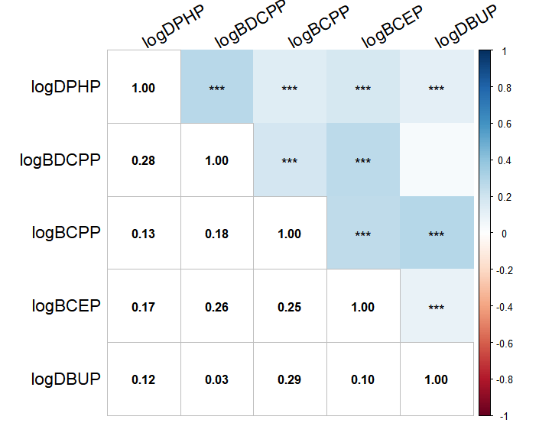
Supplementary Figure 1. Spearman correlation among OPFRs metabolites
*<0.05,**<0.01,***<0.001

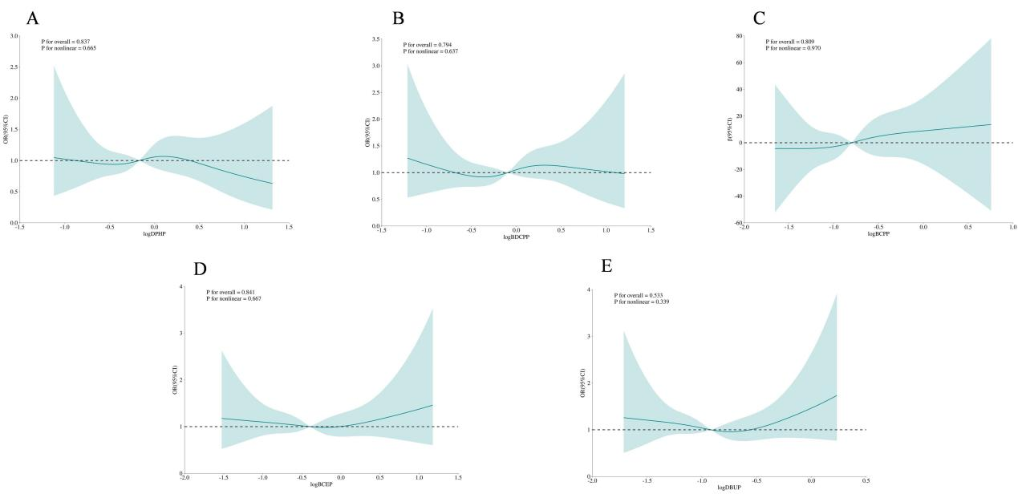
Supplementary Figure 2. Restricted cubic spline curves for CKD
Supplementary Figure 2A: DPHP-CKD RCS diagram; Supplementary Figure 2B: BDCPP-CKD RCS diagram;Supplementary Figure 2C: BCPP-CKD RCS diagram; Supplementary Figure 2D: BCEP-CKD RCS diagram; Supplementary Figure 2E: DPHP-CKD RCS diagram. Adjusted for age, matital status, PIR, BMI, physical activity, CVD, hypertension, diabetes during analysis.

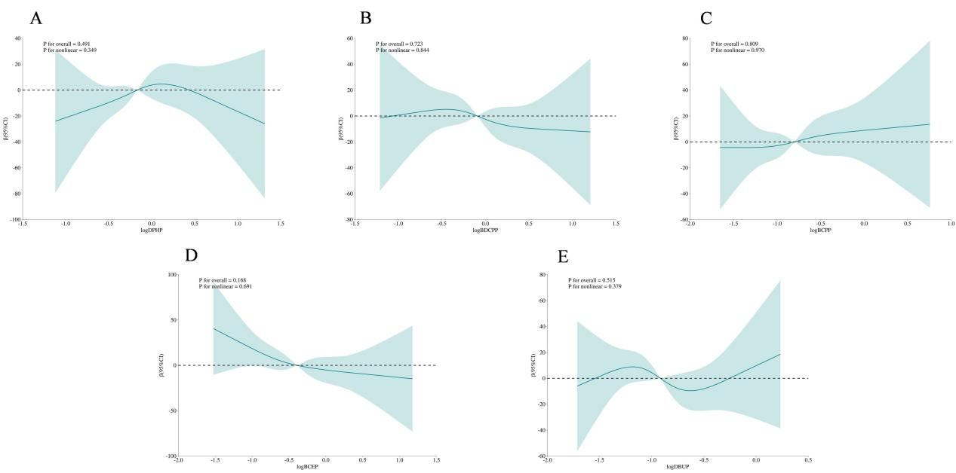
Supplementary Figure 3. Restricted cubic spline curves for ACR
Supplementary Figure 3A: DPHP-ACR RCS diagram; Supplementary Figure 3B: BDCPP-ACR RCS diagram; Supplementary Figure 3C: BCPP-ACR RCS diagram; Supplementary Figure 3D: BCEP-ACR RCS diagram; Supplementary Figure 3E: DPHP-ACR RCS diagram. Adjusted for age, matital status, PIR, BMI, physical activity, CVD, hypertension, diabetes during analysis.

Supplementary Figure 4.
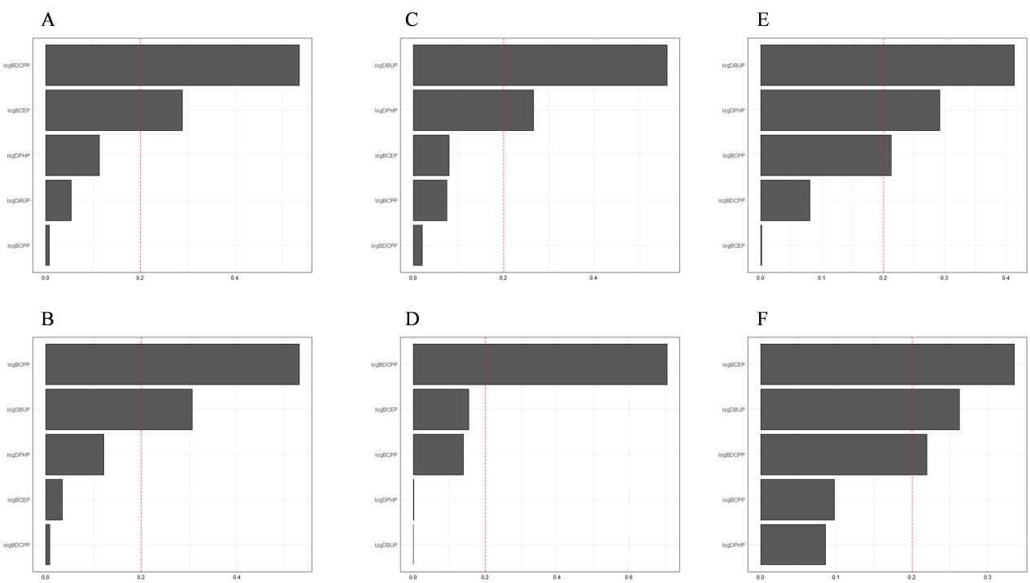
Supplementary Figure 4A: OPFRs metabolite-CKD forward WQS regression plot; Supplementary Figure 4B: OPFRs metabolite-CKD negative WQS regression plot; Supplementary Figure 4C: OPFRs metabolite-eGFR forward WQS regression plot; Supplementary Figure 4D: OPFRs metabolite-eGFR negative WQS regression plot; Supplementary Figure 4E: OPFRs metabolite-ACR forward WQS regression plot. Supplementary Figure 4F: OPFRs metabolite-ACR negative WQS regression plot. Adjusted for age, matital status, PIR, BMI, physical activity, CVD, hypertension, diabetes during analysis.

