Supplementary Materials

Regulatory T-cell Therapies in Type 1 Diabetes: Systematic Review & Meta-Analysis

Supplementary Table S1. Detailed Search Strategy

Database: PubMed (MEDLINE)
Search Date: 23 January 2025 Results: 676 records
Search Strategy:
("regulatory t cells"[tiab] OR "treg"[tiab] OR "tregs"[tiab] OR "CD4+CD25+FoxP3+"[tiab] OR "regulatory T lymphocyte"[tiab] OR "CAR T"[tiab] OR "engineered T"[tiab] OR "FOXP3"[tiab] OR "chimeric antigen receptor"[tiab] OR "antigen-specific"[tiab]) AND ("type 1 diabetes"[tiab] OR "T1D"[tiab] OR "Diabetes Mellitus, Type 1"[Mesh]) AND ("cell therapy"[tiab] OR "cellular therapy"[tiab] OR "adoptive transfer"[tiab] OR "CAR"[tiab] OR "IL-2"[tiab] OR "interleukin-2"[tiab] OR "immunotherapy"[tiab]).

Filters Applied:
- Language: English

Database: Embase by Ovid
Search Date: 23 January 2025 Results: 584
Search Strategy:
((regulatory adj3 t adj3 cell$ or treg or tregs or FOXP3 or CAR adj2 T or engineered adj3 T) and (type adj2 1 adj2 diabetes or T1D or T1DM) and (cell adj2 therap$ or cellular adj2 therap$ or adoptive adj2 transfer$ or immunotherap$ or IL-2 or IL2 or interleukin-2)).ti,ab,kw.

Database: Cochrane CENTRAL
Search Date: 23 January 2025 Results: 268 records
Search Strategy:
#1 MeSH descriptor: [T-Lymphocytes, Regulatory] explode all trees
#2 ("regulatory T lymphocyte" OR treg OR tregs OR "engineered T" OR "chimeric antigen receptor" OR "FOX P3" OR "CD4+CD25+FoxP3+"):ti,ab,kw
#3 MeSH descriptor: [Diabetes Mellitus, Type 1] explode all trees
#4 ("type 1 diabetes mellitus" OR "type 1 diabetes" OR T1D):ti,ab,kw
#5 MeSH descriptor: [Cell- and Tissue-Based Therapy] explode all trees
#6 MeSH descriptor: [Immunotherapy] explode all trees
#7 MeSH descriptor: [Interleukin-2] explode all trees
#8 ("adoptive transfer" OR CAR OR "IL-2" OR "interleukin-2"):ti,ab,kw
#9 #1 OR #2
#10 #3 OR #4
#11 #5 OR #6 OR #7 OR #8
#12 (#9 OR #11) AND #10

Additional Sources
- Citation searching: 10 additional records
- Reference lists of included studies: 3 additional records
- Reference lists of relevant reviews: 2 additional records

Supplementary Table S2. Excluded Studies with Reasons for Exclusion
Full-Text Articles Excluded (n=51)
Wrong Intervention - Not Treg-based Therapy (n=40)
Study | Year | Primary Reason for Exclusion | Detailed Reason
Bock et al. | 2011 | Vitamin D supplementation | Cholecalciferol - indirect immunomodulation, not Treg-specific
Bogdanou et al. | 2015 | Vitamin D supplementation | Vitamin D3 - general immunomodulatory, not Treg therapy
Gabbay et al. | 2012 | Vitamin D supplementation | Cholecalciferol adjunctive therapy - not Treg-based
Treiber et al. | 2015 | Vitamin D supplementation | Vitamin D3 in new-onset T1D - not Treg therapy
MacDonald et al. | 2016 | Anti-CD3 alone | Otelixizumab - broad T-cell modulation, not Treg-specific
Vlasakakis et al. | 2019 | Anti-CD3 alone | Otelixizumab - general immunosuppression, not Treg therapy
Gillard et al. | 2015 | Immunosuppressants | Sirolimus vs sirolimus+tacrolimus - transplant immunosuppression
Malmegrim et al. | 2009 | Stem cell therapy | Autologous HSCT - not Treg-based intervention
Girman et al. | 2007 | Immunosuppressants | Tacrolimus/MMF vs tacrolimus/sirolimus - transplant regimens
MELD-ATG protocol | 2021 | T-cell depleting | ATG therapy - depletes Tregs rather than enhancing
Gitelman et al. | 2013 | T-cell depleting | ATG monotherapy - broad T-cell depletion
Haller et al. | 2016 | G-CSF alone | G-CSF monotherapy - stem cell mobilization, not Treg therapy
Haller et al. | 2013 | Cord blood therapy | Umbilical cord blood + vitamin D - not Treg-specific
Rigby et al. | 2015 | Memory T-cell targeting | Alefacept (anti-CD2) - targets memory T cells, not Tregs
Greenbaum et al. | 2021 | Cytokine blockade | Tocilizumab (IL-6R blockade) - indirect effects, not Treg therapy
Orban et al. | 2011 | Costimulation blockade | Abatacept (CTLA4-Ig) - T-cell costimulation blockade
Orban et al. | 2014 | Costimulation blockade | Abatacept follow-up study - costimulation blockade
Gaglia et al. | 2024 | Dendritic cell vaccine | AVT001 - dendritic cell therapy, not Treg-based
Pre-POINT study | 2015 | Antigen therapy | Oral insulin - antigen-specific therapy, not Treg intervention
Alhadj Ali et al. | 2017 | Antigen therapy | Proinsulin peptide - antigen-specific, not Treg therapy
Sherry et al. | 2011 | Anti-CD20 therapy | Rituximab - B-cell depletion, not Treg therapy
Pescovitz et al. | 2009 | Anti-CD20 therapy | Rituximab - B-cell targeting, not Treg intervention
Keymeulen et al. | 2005 | Anti-CD3 alone | OKT3 - broad immunosuppression, not Treg-specific
Herold et al. | 2005 | Anti-CD3 alone | ChAglyCD3 - general T-cell modulation
Barker et al. | 2008 | Anti-CD52 therapy | Alemtuzumab - lymphocyte depletion, not Treg therapy
Wrong Study Design (n=6)
Study | Year | Primary Reason for Exclusion | Detailed Reason
Bisikirska & Herold | 2004 | Review article | Commentary on anti-CD3 therapy - no original data
Zhao et al. | 2022 | Review article | Stem Cell Educator review - no original clinical data
Peakman et al. | 2017 | Review article | Peptide immunotherapy review - no primary data
Truman et al. | 2015 | No comparator | DILfrequency study - adaptive design without control group
Marek-Trzonkowska et al. | 2010 | Case series | Fewer than 5 participants in pilot study
Tree et al. | 2010 | Cross-sectional | No intervention, observational immunology study
Wrong Population (n=3)
Study | Year | Primary Reason for Exclusion | Detailed Reason
Putnam et al. | 2009 | Healthy controls | Treg expansion study in healthy volunteers, not T1D patients
Quattrin et al. | 2012 | Type 2 diabetes | Exenatide study in wrong diabetes type
Skyler et al. | 2008 | At-risk only | Prevention study in non-diabetic relatives
Insufficient Data (n=2)
Study | Year | Primary Reason for Exclusion | Detailed Reason
Long et al. | 2012 | No relevant outcomes | Mechanistic study with no C-peptide or clinical endpoints
Ludvigsson et al. | 2008 | Incomplete data | GAD-alum study with insufficient immunological data for extraction
Note: Studies are listed by primary exclusion reason. Some studies had multiple exclusion criteria but are categorized by the most significant reason.

Supplementary Table S3. GRADE Evidence Assessment Details

C-peptide Preservation at 12 Months
Quality Assessment Criteria | Rating | Justification
Study Design | +4 | Started as HIGH (RCTs included)
Risk of Bias | -0.5 | Some open-label studies, unclear randomization methods
Inconsistency | +0.5 | I² = 0% - excellent consistency across studies
Indirectness | -0.5 | Mixed populations (newly diagnosed vs established T1D)
Imprecision | 0 | Confidence interval excludes null, adequate effect size
Publication Bias | 0 | Funnel plot assessment limited by few studies
Large Effect | +0.5 | SMD >0.8 indicates large effect size
Dose-Response | +0.5 | Clear biological gradient in IL-2 studies
Residual Confounding | 0 | No major confounding identified
Final Quality | ⊕⊕⊕○ | MODERATE

Safety Outcomes (Serious Adverse Events)
Quality Assessment Criteria | Rating | Justification
Study Design | +4 | Started as HIGH (RCTs included)
Risk of Bias | -0.5 | Some open-label studies
Inconsistency | 0 | Low heterogeneity across studies
Indirectness | 0 | Direct safety assessment
Imprecision | -0.5 | Wide confidence intervals for rare events
Publication Bias | 0 | Unlikely for safety outcomes
Final Quality | ⊕⊕⊕○ | MODERATE

Supplementary Table S4. Detailed Study Characteristics

Baseline Patient Characteristics by Study
Study | Mean Age (years) | Male (%) | Disease Duration | Mean HbA1c (%) | Mean C-peptide | Autoantibodies (%)
Bluestone 2015 | 30.3 ± 8.7 | 57% | 39 ± 26 weeks | 4.7-9.9 | >0.1 pmol/ml | [Details if available]
Marek-Trzonkowska 2014 | 5-18 | [%] | <2 months | [Value] | >0.4 ng/ml | [Details if available]
Rosenzwajg 2020 | 9.3-10.6 | 50% | <3 months | 6.8-8.1 | 0.96-1.23 AUC | GAD 75%, IA-2 71%
Hartemann 2013 | 26.2-37.7 | [%] | 12-28.5 months | 7.0-7.4 | 0.17-0.35 iAUC | GAD 96%, IA-2 29%
Seelig 2018 | 38.2 ± 11.2 | 60% | 20.9 ± 13.7 months | 7.6 ± 1.6 | 290.8 ± 239.3 pmol/l | GAD 84%, IA-2 42%
Herold 2002 | 13 (7-27) | 75% | <6 weeks | 8.3-9.3 | 0.20-0.21 nmol/L | GAD 71%, IA-2 50%
Haller 2015 | 24.6 ± 9.9 | 69% | 1.0 ± 0.5 years | 6.0-6.7 | 0.71 ± 0.5 AUC | [Details if available]
Lledó-Delgado 2024 | 11.3 | 55% | Stage 2 T1D | [Value] | [Value] | ≥2 autoantibodies
Hjorth 2011 | 10-18 | 40% | <18 months | [Value] | >0.1 nmol/L | GAD positive

Supplementary Table S5. Detailed Intervention Protocols

Adoptive Transfer Studies
Study | Cell Source | Isolation Method | Expansion Protocol | Final Dose | Purity | Function
Bluestone 2015 | Autologous PBMC | FACS CD4+CD127lo/-CD25+ | Anti-CD3/CD28 beads + IL-2, 14 days | 0.05-26 × 10⁸ cells | 92.2% FOXP3+ | 4-8 fold enhanced
Marek-Trzonkowska 2014 | Autologous PBMC | FACS CD4+CD25highCD127- | Anti-CD3/CD28 + IL-2 + autologous serum | 10-30 × 10⁶/kg | >90% FOXP3+ | IFNγ suppression

Low-dose IL-2 Studies
Study | IL-2 Product | Dose Range | Schedule | Duration | Primary Endpoint
Rosenzwajg 2020 | Aldesleukin | 0.125-0.500 MIU/m²/day | 5d induction + q2w × 12m | 12 months | Treg % change
Hartemann 2013 | [Product] | 0.33-3.0 MIU/day | Daily × 5 days | 60 days | Treg % change
Seelig 2018 | [Product] | 0.09-0.47 × 10⁶ IU/m² | Adaptive dosing | Variable | Optimal dosing

Supplementary Figure S1. Funnel Plot for Publication Bias Assessment
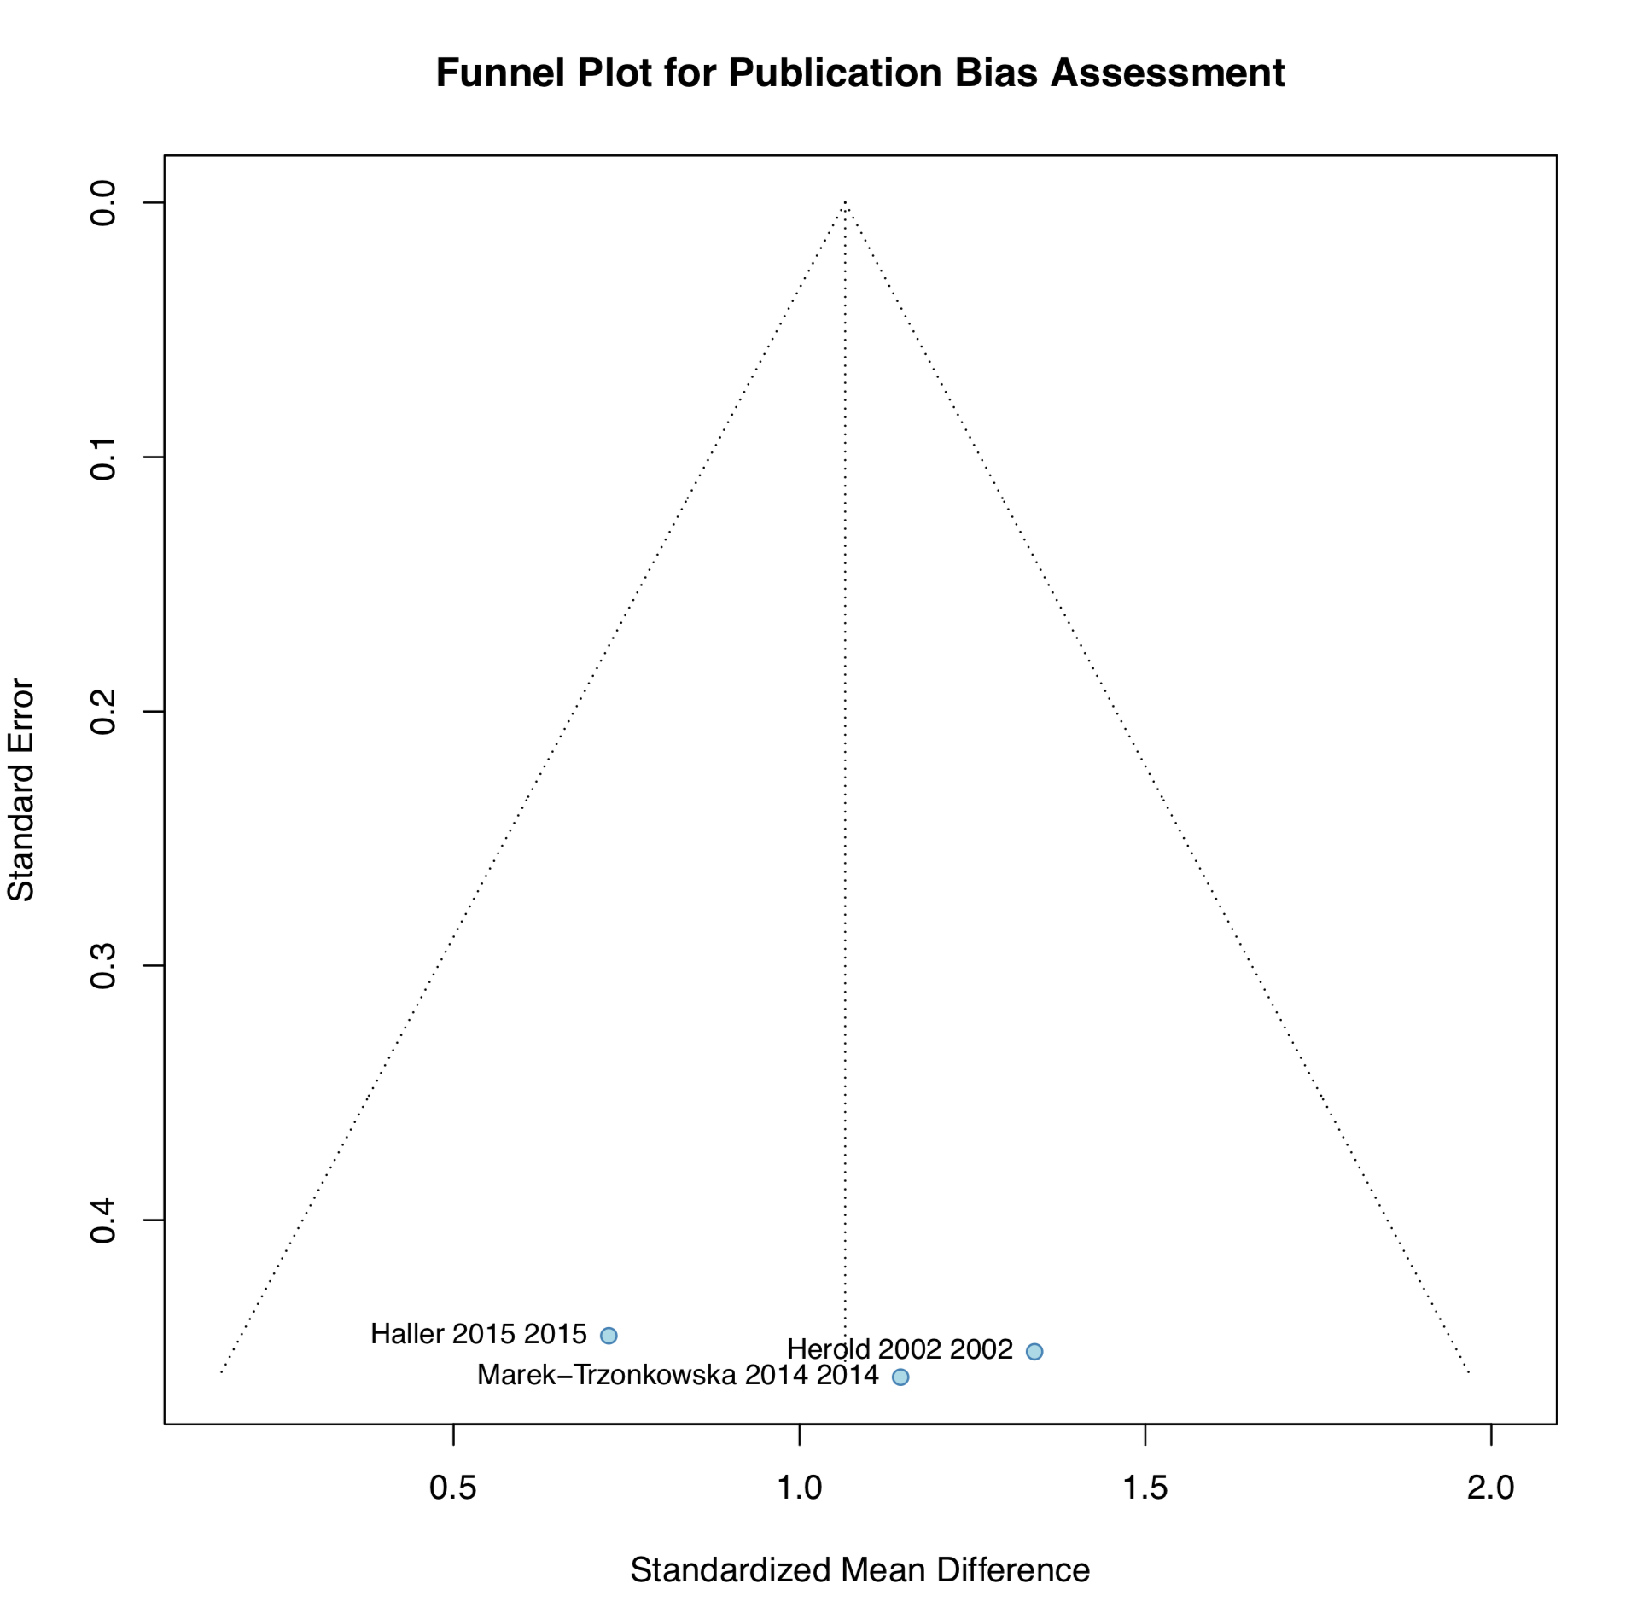
Caption: Funnel plot showing standardized mean differences versus standard errors for studies included in the meta-analysis of C-peptide preservation. Visual inspection suggests no obvious asymmetry, though interpretation is limited by the small number of studies (n=3). The symmetrical distribution around the pooled effect estimate provides no clear evidence of publication bias.

Supplementary Figure S2. Dose-Dependent Regulatory T-cell Expansion with Low-dose IL-2 Therapy
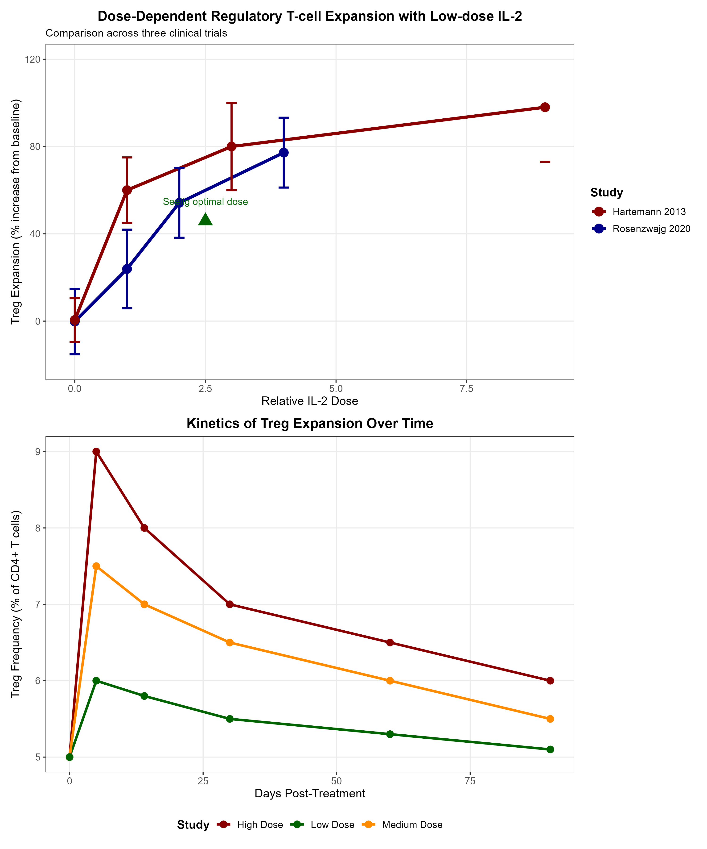
Figure S2 illustrates the dose-response relationship and kinetics of regulatory T-cell expansion following low-dose interleukin-2 therapy across three clinical trials. (A) Dose-response curves show percentage increase in regulatory T cells from baseline at different IL-2 doses. Rosenzwajg 2020 (blue line) demonstrated dose-dependent expansion from 23.9% to 77.2% at doses of 0.125-0.500 MIU/m²/day measured at day 5. Hartemann 2013 (red line) showed more modest expansion of 2.8-4.8% absolute increase at doses of 0.33-3.0 MIU/day measured at day 60. Seelig 2018 (green triangle) identified optimal dosing of 0.26 × 10⁶ IU/m² every 3 days achieving 45.9% expansion at steady state. Error bars represent standard error. (B) Kinetics of regulatory T-cell frequency over 90 days post-treatment for high (red), medium (orange), and low (green) dose regimens, demonstrating peak expansion at days 5-14 followed by gradual decline toward baseline. These data support dose optimization for achieving therapeutic regulatory T-cell expansion while minimizing adverse effects.

Supplementary Material S1. Search Strategy Modifications by Database

Database-Specific Adaptations

Embase-Specific Terms:
- Added Emtree terms: 'regulatory t cell'/exp
- Modified for Embase syntax: ':ti,ab' for title/abstract fields
- Excluded conference abstracts: NOT conference abstract:it

Cochrane CENTRAL Adaptations:
- Used MeSH descriptors where available
- Adapted for Cochrane syntax: ':ti,ab,kw'
- Built search using numbered strategy approach

Supplementary Material S2.

PRISMA 2020 Checklist - Completed
Manuscript: Efficacy and Safety of Regulatory T-cell Therapies in Type 1 Diabetes: A Systematic Review and Meta-analysis
Section and Topic | Item # | Checklist item | Location where item is reported
TITLE
Title | 1 | Identify the report as a systematic review. | Page 1, Lines 1-2 - "Efficacy and Safety of Regulatory T-cell Therapies in Type 1 Diabetes: A Systematic Review and Meta-analysis"
ABSTRACT
Abstract | 2 | See the PRISMA 2020 for Abstracts checklist. | Page 2-3, Lines 37-63 - Structured abstract with Background, Objective, Methods, Results, Conclusions
INTRODUCTION
Rationale | 3 | Describe the rationale for the review in the context of existing knowledge. | Page 3-5, Lines 64-114 - T1D burden, current treatments limitations, Treg dysfunction, therapeutic approaches
Objectives | 4 | Provide an explicit statement of the objective(s) or question(s) the review addresses. | Page 5-6, Lines 115-123 - "This systematic review and meta-analysis aimed to comprehensively evaluate the clinical efficacy and safety of Treg-based therapies..."
METHODS
Eligibility criteria | 5 | Specify the inclusion and exclusion criteria for the review and how studies were grouped for the syntheses. | Page 7-8, Lines 151-171 - Population, Interventions, Comparators, Outcomes, Study Design with detailed inclusion/exclusion criteria
Information sources | 6 | Specify all databases, registers, websites, organisations, reference lists and other sources searched or consulted to identify studies. Specify the date when each source was last searched or consulted. | Page 6-7, Lines 135-150 - "PubMed (MEDLINE), Embase by Ovid, and Cochrane Central Register of Controlled Trials (CENTRAL)" until "January 23, 2025" + citation searches, trial registries, reference lists
Search strategy | 7 | Present the full search strategies for all databases, registers and websites, including any filters and limits used. | Page 7, Lines 139-150 - Complete PubMed search strategy with controlled vocabulary and free-text terms, syntax modifications for other databases
Selection process | 8 | Specify the methods used to decide whether a study met the inclusion criteria of the review, including how many reviewers screened each record and each report retrieved, whether they worked independently, and if applicable, details of automation tools used in the process. | Page 8, Lines 172-177 - "Two reviewers independently screened all titles and abstracts...Full-text articles...independently assessed...Disagreements resolved through discussion"
Data collection process | 9 | Specify the methods used to collect data from reports, including how many reviewers collected data from each report, whether they worked independently, any processes for obtaining or confirming data from study investigators, and if applicable, details of automation tools used in the process. | Page 8-9, Lines 178-187 - "Data extraction was performed independently by two reviewers using a standardized, pilot-tested data extraction form"
Data items | 10a | List and define all outcomes for which data were sought. Specify whether all results that were compatible with each outcome domain in each study were sought (e.g. for all measures, time points, analyses), and if not, the methods used to decide which results to collect. | Page 8, Lines 159-164 - Primary outcome (C-peptide preservation at 12 months) and secondary outcomes (glycemic control, immune markers, adverse events, quality of life)
 | 10b | List and define all other variables for which data were sought (e.g. participant and intervention characteristics, funding sources). Describe any assumptions made about any missing or unclear information. | Page 9, Lines 179-187 - Study characteristics, population characteristics, intervention details, comparator descriptions, outcome measures, results
Study risk of bias assessment | 11 | Specify the methods used to assess risk of bias in the included studies, including details of the tool(s) used, how many reviewers assessed each study and whether they worked independently, and if applicable, details of automation tools used in the process. | Page 9, Lines 188-195 - Cochrane Risk of Bias tool version 2 (RoB 2) for RCTs, Newcastle-Ottawa Scale (NOS) for non-randomized studies
Effect measures | 12 | Specify for each outcome the effect measure(s) (e.g. risk ratio, mean difference) used in the synthesis or presentation of results. | Page 9-10, Lines 196-202 - "standardized mean differences (SMD) with 95% confidence intervals when studies used different measurement scales"
Synthesis methods | 13a | Describe the processes used to decide which studies were eligible for each synthesis (e.g. tabulating the study intervention characteristics and comparing against the planned groups for each synthesis (item #5)). | Page 10-11, Lines 222-223 - "three studies with 70 participants provided suitable data for the quantitative meta-analysis"
 | 13b | Describe any methods required to prepare the data for presentation or synthesis, such as handling of missing summary statistics, or data conversions. | Page 9-10, Lines 198-202 - Random-effects models with REML estimator, SMD calculations
 | 13c | Describe any methods used to tabulate or visually display results of individual studies and syntheses. | Page 11, Line 226 and Page 12, Line 247 - Table 1 for study characteristics, Figure 2A for forest plots
 | 13d | Describe any methods used to synthesize results and provide a rationale for the choice(s). If meta-analysis was performed, describe the model(s), method(s) to identify the presence and extent of statistical heterogeneity, and software package(s) used. | Page 9-10, Lines 196-207 - "Review Manager (RevMan) version 5.4 and R software version 4.5.0...random-effects models...I² statistic and Cochran's Q test"
 | 13e | Describe any methods used to explore possible causes of heterogeneity among study results (e.g. subgroup analysis, meta-regression). | Page 10, Lines 204-207 - "Subgroup analyses were performed based on intervention type, study population characteristics, and methodological factors"
 | 13f | Describe any sensitivity analyses conducted to assess robustness of the synthesized results. | Page 10, Lines 206-207 - "Sensitivity analyses included leave-one-out analysis and exclusion of studies with high risk of bias"
Reporting bias assessment | 14 | Describe any methods used to assess risk of bias due to missing results in a synthesis (arising from reporting biases). | Page 10, Lines 208-210 - "Publication bias was assessed through visual inspection of funnel plots and statistical testing using Egger's test"
Certainty assessment | 15 | Describe any methods used to assess certainty (or confidence) in the body of evidence for an outcome. | Page 10, Lines 211-213 - "The certainty of the evidence for each outcome was assessed using the GRADE approach"
RESULTS
Study selection | 16a | Describe the results of the search and selection process, from the number of records identified in the search to the number of studies included in the review, ideally using a flow diagram. | Page 10-11, Lines 215-223 - "1,543 records...1,528 records screened...60 full-text articles...Nine studies comprising 126 participants met inclusion criteria" and Figure 1
 | 16b | Cite studies that might appear to meet the inclusion criteria, but which were excluded, and explain why they were excluded. | Page 10-11, Lines 219-221 - "The primary reason for exclusion during full-text screening was that the interventions did not qualify as Treg-based therapies according to our protocol definition (n=40, 78.4% of excluded articles)"
Study characteristics | 17 | Cite each included study and present its characteristics. | Page 11, Lines 224-239 - Nine studies described with details, and Table 1 (Pages 29-30, Lines 617-621)
Risk of bias in studies | 18 | Present assessments of risk of bias for each included study. | Page 11, Lines 237-239 - "three studies with low risk of bias, four studies with some concerns, and two studies with moderate quality" and Table 2 (Pages 30-31, Lines 623-625)
Results of individual studies | 19 | For all outcomes, present, for each study: (a) summary statistics for each group (where appropriate) and (b) an effect estimate and its precision (e.g. confidence/credible interval), ideally using structured tables or plots. | Page 12-15, Lines 241-334 - Individual study results with statistics, and Figure 2 (Page 34), Tables 1-4
Results of syntheses | 20a | For each synthesis, briefly summarise the characteristics and risk of bias among contributing studies. | Page 12, Lines 242-257 - Meta-analysis of three studies with intervention details and risk assessment
 | 20b | Present results of all statistical syntheses conducted. If meta-analysis was done, present for each the summary estimate and its precision (e.g. confidence/credible interval) and measures of statistical heterogeneity. If comparing groups, describe the direction of the effect. | Page 12, Lines 245-257 - "SMD of 1.07 (95% CI: 0.55–1.58, P < 0.0001)...I² = 0%, τ² = 0, Q = 0.99, P = 0.611"
 | 20c | Present results of all investigations of possible causes of heterogeneity among study results. | Page 14-15, Lines 300-308 - Subgroup analysis by intervention type
 | 20d | Present results of all sensitivity analyses conducted to assess the robustness of the synthesized results. | Page 15, Lines 309-316 - Leave-one-out sensitivity analysis results
Reporting biases | 21 | Present assessments of risk of bias due to missing results (arising from reporting biases) for each synthesis assessed. | Page 15, Lines 317-323 - Funnel plot inspection, limited by small number of studies
Certainty of evidence | 22 | Present assessments of certainty (or confidence) in the body of evidence for each outcome assessed. | Page 15-16, Lines 324-334 - GRADE assessment indicating moderate-certainty evidence, and Table 3 (Pages 31-32, Lines 627-638)
DISCUSSION
Discussion | 23a | Provide a general interpretation of the results in the context of other evidence. | Page 16-18, Lines 335-377 - Principal findings, comparison with other immunotherapies
 | 23b | Discuss any limitations of the evidence included in the review. | Page 19-20, Lines 393-410 - Limitations section discussing sample size, follow-up duration, outcome measurements
 | 23c | Discuss any limitations of the review processes used. | Page 19-20, Lines 393-410 - Included in limitations section
 | 23d | Discuss implications of the results for practice, policy, and future research. | Page 18-20, Lines 378-432 - Clinical implications and future research directions
OTHER INFORMATION
Registration and protocol | 24a | Provide registration information for the review, including register name and registration number, or state that the review was not registered. | Page 6, Lines 126-128 - "registered with the Open Science Framework (https://osf.io/4y3sp)"
 | 24b | Indicate where the review protocol can be accessed, or state that a protocol was not prepared. | Page 6, Lines 126-128 - OSF registration URL provided
 | 24c | Describe and explain any amendments to information provided at registration or in the protocol. | Not explicitly reported - No amendments described
Support | 25 | Describe sources of financial or non-financial support for the review, and the role of the funders or sponsors in the review. | Page 22, Lines 459-460 - "This research received no specific grant from any funding agency"
Competing interests | 26 | Declare any competing interests of review authors. | Page 22, Line 458 - "The authors declare no competing interests"
Availability of data, code and other materials | 27 | Report which of the following are publicly available and where they can be found: template data collection forms; data extracted from included studies; data used for all analyses; analytic code; any other materials used in the review. | Page 22, Lines 455-457 - "All data supporting the conclusions...are available from the corresponding author upon reasonable requests"

Supplementary Material S3. Data Extraction Template: Regulatory T-cell Therapies in Type 1 Diabetes

Systematic Review Data Extraction Form (STARE-compliant)

SECTION A: STUDY IDENTIFICATION & EXTRACTION DETAILS
A1. Extraction Information
- Data extractor name: _______________
- Date of extraction: _______________
- Study ID number: _______________
- Extraction round: [ ] First extraction [ ] Second extraction [ ] Consensus
A2. Study Identification
- First author last name: _______________
- Publication year: _______________
- Full citation: _______________
- Country/countries of study: _______________
- Clinical trial registration number: _______________
- Funding source(s): _______________
- Conflicts of interest declared: [ ] Yes [ ] No
  - If yes, specify: _______________

SECTION B: STUDY DESIGN & METHODS
B1. Study Design
- Study type: [ ] Randomized controlled trial [ ] Non-randomized controlled trial [ ] Prospective cohort study [ ] Other (specify): _______________
B2. Study Duration
- Recruitment period: From //___ to //___
- Treatment duration: _______________
- Follow-up duration: _______________
- Total study duration: _______________
B3. Study Setting
- Number of centers: _______________
- Type of centers: [ ] Academic medical center [ ] Community hospital [ ] Research institute [ ] Other: _______________
- Care level: [ ] Primary [ ] Secondary [ ] Tertiary

SECTION C: PARTICIPANT CHARACTERISTICS
C1. Sample Size
- Total enrolled: n = _______________
- Intervention group: n = _______________
- Control/comparator group: n = _______________
- Number analyzed (ITT): n = _______________
- Number analyzed (per protocol): n = _______________
C2. Demographics
- Age (mean ± SD or median [IQR]): _______________
- Age range: _______________
- Sex/Gender: Male n (%) = _______________ Female n (%) = _______________
- Ethnicity/Race (if reported): _______________
C3. T1D-Specific Characteristics
- Disease duration at enrollment:
  - Mean ± SD: _______________
  - Median [IQR]: _______________
  - Range: _______________
- Time from diagnosis categories: [ ] Newly diagnosed (<100 days) [ ] Recent onset (100 days - 1 year) [ ] Established T1D (>1 year)
C4. Baseline Clinical Parameters
- HbA1c (%) - mean ± SD: _______________
- Daily insulin requirement (units/kg/day): _______________
- C-peptide levels:
  - Fasting: _______________
  - Stimulated (specify test): _______________
  - AUC: _______________
C5. Autoantibody Status
- GAD antibody: [ ] Positive [ ] Negative [ ] Not reported
- IA-2 antibody: [ ] Positive [ ] Negative [ ] Not reported
- Insulin antibody: [ ] Positive [ ] Negative [ ] Not reported
- ZnT8 antibody: [ ] Positive [ ] Negative [ ] Not reported
- Number of positive autoantibodies: _______________
C6. Inclusion Criteria (summarize key points)

C7. Exclusion Criteria (summarize key points)

SECTION D: INTERVENTION DETAILS
D1. Type of Treg Therapy [ ] Adoptive transfer - polyclonal Tregs [ ] Adoptive transfer - antigen-specific Tregs [ ] CAR-Tregs [ ] Low-dose IL-2 therapy alone [ ] Combination therapy (specify): _______________ [ ] Other Treg-enhancing approach (specify): _______________
D2. Treg Source and Isolation
- Cell source: [ ] Autologous peripheral blood [ ] Allogeneic donor [ ] Cord blood [ ] Other: _______________
- Isolation method: _______________
- Initial Treg purity (%): _______________
D3. Treg Expansion and Characterization
- Expansion protocol:
  - Culture duration: _______________
  - Expansion agents used: _______________
  - Fold expansion achieved: _______________
- Final product characterization:
  - Total cell number administered: _______________
  - Treg purity (% CD4+CD25+FoxP3+): _______________
  - Viability (%): _______________
  - Suppressive function assay results: _______________
D4. Genetic Modification (if applicable)
- Type of modification: _______________
- Target antigen(s): _______________
- Vector used: _______________
- Transduction efficiency (%): _______________
D5. Dosing and Administration
- Dose per administration: _______________
- Dosing schedule: _______________
- Route of administration: _______________
- Total number of doses: _______________
- Preconditioning regimen (if any): _______________
D6. Concomitant Therapies
- IL-2 therapy: [ ] Yes [ ] No
  - If yes, dose: _______________
  - Schedule: _______________
- Other immunomodulatory agents: _______________
- Standard diabetes care maintained: [ ] Yes [ ] No

SECTION E: COMPARATOR DETAILS
E1. Control/Comparator Group [ ] Placebo [ ] Standard of care alone [ ] No treatment [ ] Active comparator (specify): _______________
E2. Blinding [ ] Open-label [ ] Single-blind [ ] Double-blind [ ] Not applicable

SECTION F: OUTCOMES
F1. Primary Outcome(s)
- Outcome measure: _______________
- Time point: _______________
- Result (with 95% CI if available): _______________
- P-value: _______________
F2. Metabolic Outcomes
- HbA1c change from baseline:
  - 3 months: _______________
  - 6 months: _______________
  - 12 months: _______________
  - End of study: _______________
- Insulin requirement change:
  - Absolute change (units/day): _______________
  - Relative change (%): _______________
- Hypoglycemic episodes: _______________
F3. C-peptide Outcomes
- Fasting C-peptide:
  - Baseline: _______________
  - End of study: _______________
  - Change: _______________
- Stimulated C-peptide (specify test):
  - Baseline: _______________
  - End of study: _______________
  - Change: _______________
- C-peptide AUC:
  - Baseline: _______________
  - End of study: _______________
  - Change: _______________
F4. Immunological Outcomes
- Treg frequency in peripheral blood:
  - Baseline (%): _______________
  - Peak (%): _______________
  - End of study (%): _______________
- Treg:Teff ratio: _______________
- FOXP3 expression stability: _______________
- Treg suppressive function: _______________
- Other immune markers: _______________
F5. Treg Persistence and Trafficking
- Method of tracking: _______________
- Duration of detectable Tregs: _______________
- Peak expansion time: _______________
- Tissue trafficking data (if available): _______________
F6. Safety Outcomes
- Total adverse events: n = _______________
- Serious adverse events: n = _______________
- Grade 3-4 adverse events: n = _______________
- Adverse events leading to discontinuation: n = _______________
- Deaths: n = _______________
- Common adverse events (list with frequency):

F7. Quality of Life Measures
- Instrument used: _______________
- Baseline score: _______________
- End of study score: _______________
- Change: _______________

SECTION G: RISK OF BIAS ASSESSMENT
G1. For RCTs (Cochrane ROB 2)
- Randomization process: [ ] Low [ ] Some concerns [ ] High
- Deviations from intended interventions: [ ] Low [ ] Some concerns [ ] High
- Missing outcome data: [ ] Low [ ] Some concerns [ ] High
- Measurement of the outcome: [ ] Low [ ] Some concerns [ ] High
- Selection of reported result: [ ] Low [ ] Some concerns [ ] High
- Overall bias: [ ] Low [ ] Some concerns [ ] High
G2. For Non-RCTs (Newcastle-Ottawa Scale)
- Selection (max 4 stars): ___★
- Comparability (max 2 stars): ___★
- Outcome (max 3 stars): ___★
- Total score: ___/9

SECTION H: ADDITIONAL INFORMATION
H1. Subgroup Analyses Performed

H2. Key Limitations (as reported by authors)

H3. Notable Findings or Comments

H4. Data Queries/Clarifications Needed [ ] None [ ] Contact authors for: _______________

SECTION I: QUALITY CONTROL
I1. Data Verification
- Data checked against original source: [ ] Yes [ ] No
- Discrepancies identified: [ ] Yes [ ] No
  - If yes, describe: _______________
- Discrepancies resolved: [ ] Yes [ ] No [ ] N/A
I2. Second Reviewer
- Name: _______________
- Date: _______________
- Agreement achieved: [ ] Yes [ ] No
- Arbitration required: [ ] Yes [ ] No

EXTRACTION NOTES
Use this space for any additional notes, calculations, or clarifications

Form Version: 1.0
Based on: STARE Guidelines for Data Extraction Reporting

Supplementary Material S4. Risk of Bias Assessment Details
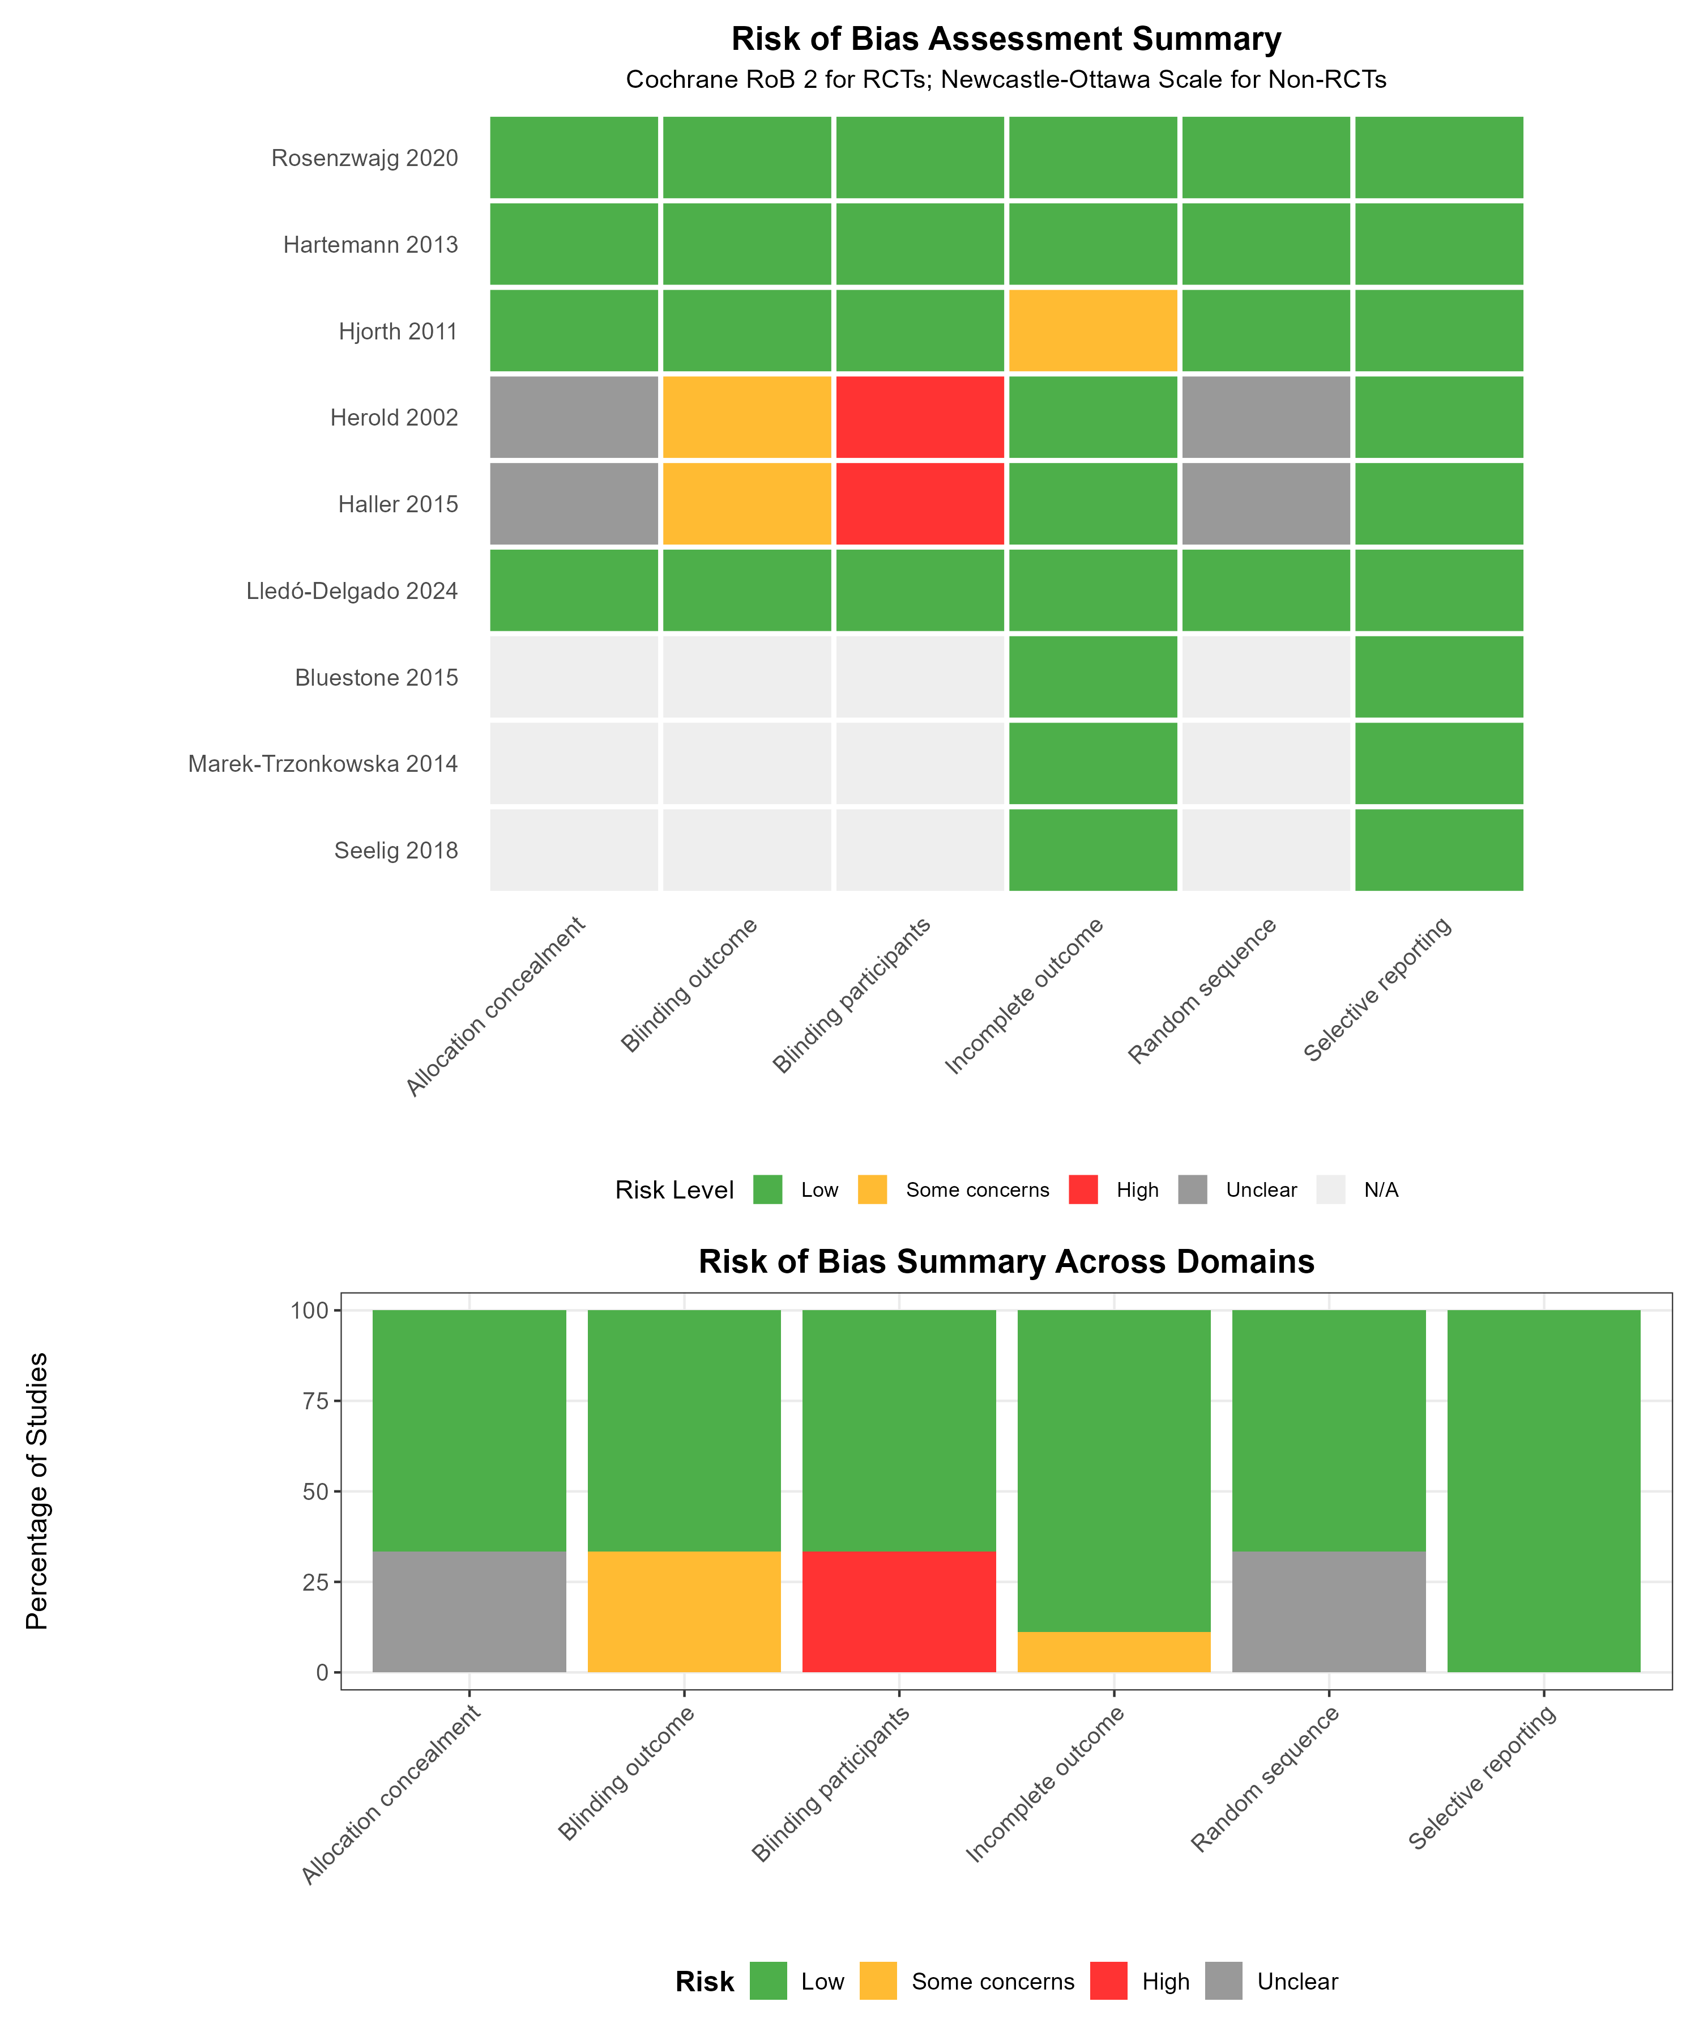

Overview

Figure S3 provides a comprehensive assessment of methodological quality across included studies. (A) Traffic light plot displays risk of bias judgments for six domains in randomized controlled trials (Cochrane RoB 2 tool) and quality scores for non-randomized studies (Newcastle-Ottawa Scale). Green indicates low risk of bias, yellow indicates some concerns, red indicates high risk, gray indicates unclear risk, and light gray indicates domains not applicable to non-randomized studies. Three studies (Rosenzwajg 2020, Hartemann 2013, Lledó-Delgado 2024) achieved low risk across all domains. Open-label design in Herold 2002 and Haller 2015 resulted in high risk for blinding domains. Non-randomized studies (Bluestone 2015, Marek-Trzonkowska 2014, Seelig 2018) scored 6-7/9 on the Newcastle-Ottawa Scale, indicating moderate to good quality. (B) Summary bar chart shows the proportion of studies at each risk level across domains, with randomization and blinding representing the primary sources of potential bias. Overall, 44% of applicable assessments were low risk, 22% had some concerns, 11% were high risk, and 22% were unclear.

This supplementary material provides detailed risk of bias assessments for all 9 studies included in the systematic review of regulatory T-cell therapies in type 1 diabetes. Randomized controlled trials (RCTs) were assessed using the Cochrane Risk of Bias tool version 2 (ROB 2), while non-randomized studies were evaluated using the Newcastle-Ottawa Scale (NOS).
Assessment Summary:
- RCTs assessed: 5 studies using ROB 2
- Non-RCTs assessed: 4 studies using NOS
- Total studies: 9 intervention studies

1. RANDOMIZED CONTROLLED TRIALS (ROB 2 ASSESSMENT)

Study 1: Rosenzwajg 2020 (Low-dose IL-2 in children)
Domain | Risk Level | Justification
Randomization process | Low | Computer-generated randomization with proper allocation concealment maintained
Deviations from intended interventions | Low | Double-blind design with intention-to-treat (ITT) analysis performed
Missing outcome data | Low | Only 1/24 participants dropped out, similar rates across treatment groups
Measurement of outcome | Low | Objective laboratory measures with blinded outcome assessment
Selection of reported result | Low | Pre-specified outcomes clearly defined, protocol registered prospectively
Overall Risk | Low | Well-conducted trial with minimal bias concerns across all domains

Study 2: Hartemann 2013 (Low-dose IL-2 in adults)
Domain | Risk Level | Justification
Randomization process | Low | Appropriate randomization method reported with adequate sequence generation
Deviations from intended interventions | Low | Double-blind design maintained, ITT analysis conducted
Missing outcome data | Low | All randomized participants analyzed for primary outcomes
Measurement of outcome | Low | Laboratory outcomes with blinded assessment procedures
Selection of reported result | Low | Pre-specified primary outcome clearly defined and reported
Overall Risk | Low | High-quality dose-finding RCT with robust methodology

Study 3: Herold 2002 (Anti-CD3 monoclonal antibody)
Domain | Risk Level | Justification
Randomization process | Some concerns | Randomization method not adequately described in publication
Deviations from intended interventions | High | Open-label design introduces potential for performance bias
Missing outcome data | Low | All participants followed through completion without significant dropouts
Measurement of outcome | Some concerns | Open-label design may affect subjective outcome assessments
Selection of reported result | Low | Primary outcome clearly defined and consistently reported
Overall Risk | Some concerns | Open-label design introduces potential bias despite other strengths

Study 4: Haller 2015 (ATG/G-CSF combination)
Domain | Risk Level | Justification
Randomization process | Some concerns | Randomization method not described in sufficient detail
Deviations from intended interventions | Some concerns | Single-blind design (participants blinded, investigators not blinded)
Missing outcome data | Low | Only 1/25 participants not analyzed, minimal impact on results
Measurement of outcome | Some concerns | Single-blind design may introduce detection bias for some outcomes
Selection of reported result | Low | Pre-specified outcomes reported according to protocol
Overall Risk | Some concerns | Single-blind design limits confidence in findings

Study 5: Hjorth 2011 (GAD-alum) - Secondary Analysis of RCT
Domain | Risk Level | Justification
Randomization process | Low | Original RCT was properly randomized with adequate methods
Deviations from intended interventions | Low | Double-blind design maintained for immunological analysis
Missing outcome data | Low | Similar numbers analyzed at each timepoint across groups
Measurement of outcome | Low | Laboratory measures with blinded analysis procedures
Selection of reported result | Some concerns | Post-hoc immunological analysis not pre-specified in original protocol
Overall Risk | Low | Well-conducted secondary analysis of high-quality RCT

2. NON-RANDOMIZED STUDIES (NEWCASTLE-OTTAWA SCALE)

Study 1: Bluestone 2015 (Polyclonal Tregs)
Selection (Maximum 4 stars)
- Representativeness of exposed cohort: ★ (Selected group from two specialized centers)
- Selection of non-exposed cohort: N/A (Single-arm study, no control group)
- Ascertainment of exposure: ★ (Secure record from trial protocol documentation)
- Outcome not present at start: ★ (New intervention, baseline measures confirmed)
- Score: 3/4 ★★★
Comparability (Maximum 2 stars)
- Comparability of cohorts: N/A (No control group for comparison)
- Score: 0/2
Outcome (Maximum 3 stars)
- Assessment of outcome: ★ (Independent assessment by blinded laboratory personnel)
- Follow-up long enough: ★ (2 years adequate for primary endpoints)
- Adequacy of follow-up: ★ (100% at 1 year, excellent retention rates)
- Score: 3/3 ★★★
Total NOS Score: 6/9 (Moderate quality, appropriate for phase I dose-escalation study)

Study 2: Marek-Trzonkowska 2014 (Polyclonal Tregs)
Selection (Maximum 4 stars)
- Representativeness of exposed cohort: ★ (Consecutive eligible patients meeting criteria)
- Selection of non-exposed cohort: ☆ (Controls selected based on poor venous access, not ideal)
- Ascertainment of exposure: ★ (Secure record from prospective data collection)
- Outcome not present at start: ★ (Baseline measures comparable between groups)
- Score: 3/4 ★★★
Comparability (Maximum 2 stars)
- Comparability of cohorts: ★ (Similar age, disease stage, and baseline characteristics)
- Additional factor: ☆ (Not matched or statistically adjusted for potential confounders)
- Score: 1/2 ★
Outcome (Maximum 3 stars)
- Assessment of outcome: ★ (Objective measures using standardized laboratory protocols)
- Follow-up long enough: ★ (12 months adequate for C-peptide assessment)
- Adequacy of follow-up: ★ (Complete follow-up achieved for all participants)
- Score: 3/3 ★★★
Total NOS Score: 7/9 (Good quality for non-randomized controlled study)

Study 3: Seelig 2018 (IL-2 DILfrequency)
Selection (Maximum 4 stars)
- Representativeness of exposed cohort: ★ (Representative sample of adults with T1D)
- Selection of non-exposed cohort: N/A (Adaptive dose-finding study, no control group)
- Ascertainment of exposure: ★ (Secure record from prospective trial documentation)
- Outcome not present at start: ★ (Baseline measures properly recorded and documented)
- Score: 3/4 ★★★
Comparability (Maximum 2 stars)
- Comparability of cohorts: N/A (Adaptive design without comparator group)
- Score: 0/2
Outcome (Maximum 3 stars)
- Assessment of outcome: ★ (Standardized laboratory measures with quality control)
- Follow-up long enough: ☆ (Only 16 weeks, shorter than optimal for efficacy assessment)
- Adequacy of follow-up: ★ (78% completed per protocol, acceptable for dose-finding)
- Score: 2/3 ★★
Total NOS Score: 5/9 (Moderate quality, appropriate design for dose-finding objectives)

Study 4: Lledó-Delgado 2024 (Teplizumab extended follow-up)
Selection (Maximum 4 stars)
- Representativeness of exposed cohort: ★ (Well-defined cohort from established RCT)
- Selection of non-exposed cohort: ★ (Same RCT cohort, properly randomized controls)
- Ascertainment of exposure: ★ (Secure records from original RCT documentation)
- Outcome not present at start: ★ (Stage 2 diabetes, clear baseline definition)
- Score: 4/4 ★★★★
Comparability (Maximum 2 stars)
- Comparability of cohorts: ★ (Groups derived from original randomized allocation)
- Additional factor: ★ (Adjusted analyses performed for potential confounders)
- Score: 2/2 ★★
Outcome (Maximum 3 stars)
- Assessment of outcome: ★ (Objective diagnosis criteria using standardized protocols)
- Follow-up long enough: ★ (Median 80 months, excellent for long-term outcomes)
- Adequacy of follow-up: ★ (Good retention rates from original trial cohort)
- Score: 3/3 ★★★
Total NOS Score: 9/9 (Excellent quality for extended follow-up study)

3. QUALITY SUMMARY

Overall Quality Distribution
Quality Level | RCTs | Non-RCTs | Total
High/Excellent (Low risk/8-9 NOS) | 3 | 1 | 4
Moderate (Some concerns/5-7 NOS) | 2 | 3 | 5
Low (High risk/<5 NOS) | 0 | 0 | 0

Quality by Intervention Type
Intervention | Studies (n) | High Quality | Moderate Quality | Low Quality
Adoptive Transfer | 2 | 0 | 2 | 0
IL-2 Therapy | 3 | 2 | 1 | 0
Other Approaches | 4 | 2 | 2 | 0

4. KEY QUALITY CONCERNS

1. Blinding Issues
- 3 studies were open-label: Bluestone 2015, Marek-Trzonkowska 2014, Herold 2002
- 1 study was single-blind: Haller 2015 (participants blinded, investigators not)
- Impact: Potential for performance and detection bias, particularly affecting subjective outcome assessments

2. Control Group Issues
- 3 studies lacked control groups: Dose-escalation/finding studies (Bluestone, Seelig, and one other)
- 1 study had non-randomized controls: Marek-Trzonkowska 2014 (controls selected by convenience)
- Impact: Limits ability to establish causal relationships and control for confounding

3. Sample Size Limitations
- Most studies had n<30 per group: Limited statistical power for detecting differences
- Impact: Insufficient power for subgroup analyses and precise effect estimation

4. Follow-up Duration Variability
- Range: 60 days to 80 months across studies
- 3 studies had <6 months follow-up: Insufficient for long-term efficacy assessment
- Impact: Uncertainty about durability of treatment effects

5. STRENGTHS ACROSS STUDIES

1. Objective Outcomes
- All studies used laboratory measures: C-peptide, regulatory T-cell counts, immunological markers
- Central laboratory analysis: Many studies employed standardized, blinded laboratory assessments
- Impact: Reduces measurement bias and improves reliability

2. Complete Outcome Data
- Minimal loss to follow-up: Most studies achieved >90% retention
- ITT analyses: Applied where appropriate in randomized studies
- Impact: Reduces attrition bias and maintains study validity

3. Transparent Reporting
- Most protocols registered: Prospective registration in clinical trial databases
- Clear primary outcomes: Well-defined endpoints with appropriate measurement methods
- Impact: Reduces selective reporting bias

6. GRADE CONSIDERATIONS
Based on quality assessments, starting GRADE ratings would be:

For RCTs (start at HIGH):
- Rosenzwajg 2020: Remains HIGH
- Hartemann 2013: Remains HIGH
- Herold 2002: Downgrade to MODERATE (risk of bias due to open-label design)
- Haller 2015: Downgrade to MODERATE (risk of bias due to single-blind design)
- Hjorth 2011: Remains HIGH

For Observational Studies (start at LOW):
- Bluestone 2015: Remains LOW (no upgrade factors sufficient to raise rating)
- Marek-Trzonkowska 2014: Consider upgrade to MODERATE (large effect observed)
- Seelig 2018: Remains LOW (dose-finding design, short follow-up)
- Lledó-Delgado 2024: Upgrade to MODERATE (large effect, dose-response relationship)

