Supplementary information

Table S1. Sequence of shRNAs against Ptprt mRNA
gene | Target sequence (Blue)
scramble | ccgggcgcgatagcgctaataatttctcgagaaattattagctatcgcgctttttg
mouse ptprt | ccggcctcatttctatcaggtgatactcgagtatcacctgatagaaatgaggtttttg

TableS2. Sequences of quantitative real time PCR primers
mRNA gene | Sense primer | Antisense primer
mouse Smagp | 5'-cggactggaaagatctgaccc-3' | 5'-cccttctgcaggctcataggt-3'
mouse pax4 | 5'-ctgccctgtaggatttgtta-3' | 5'-ccccaatacacttggttcca-3'
mouse ptprt | 5'-gcagtgtgaatcagctagggg-3' | 5'-agcggaacaggaacaaggaa-3'
mouse gapdh | 5'-aggtcggtgtgaacggatttg-3' | 5'-gaagcccttccagagctgttc-3'
mouse psmb9 | 5'-gatgctgcgggcaggagcacc-3' | 5'-ggcggccatgtcagctatggc-3'
mouse mir6379 | 5'-ccagcaaacagttggttgagt-3' | 5'-tcaccaaagagtatctgagggtg-3'
mouse polr3gl | 5'-agttgaccttcaacatggaggc-3' | 5'-acttgtctgagtaacgttccaca-3'
mouse shisal2a | 5'-cgcctgctcgagctacgtgag-3' | 5'-cactgctgccgtggacaggcc-3'

Supplementary materials
Figure S1
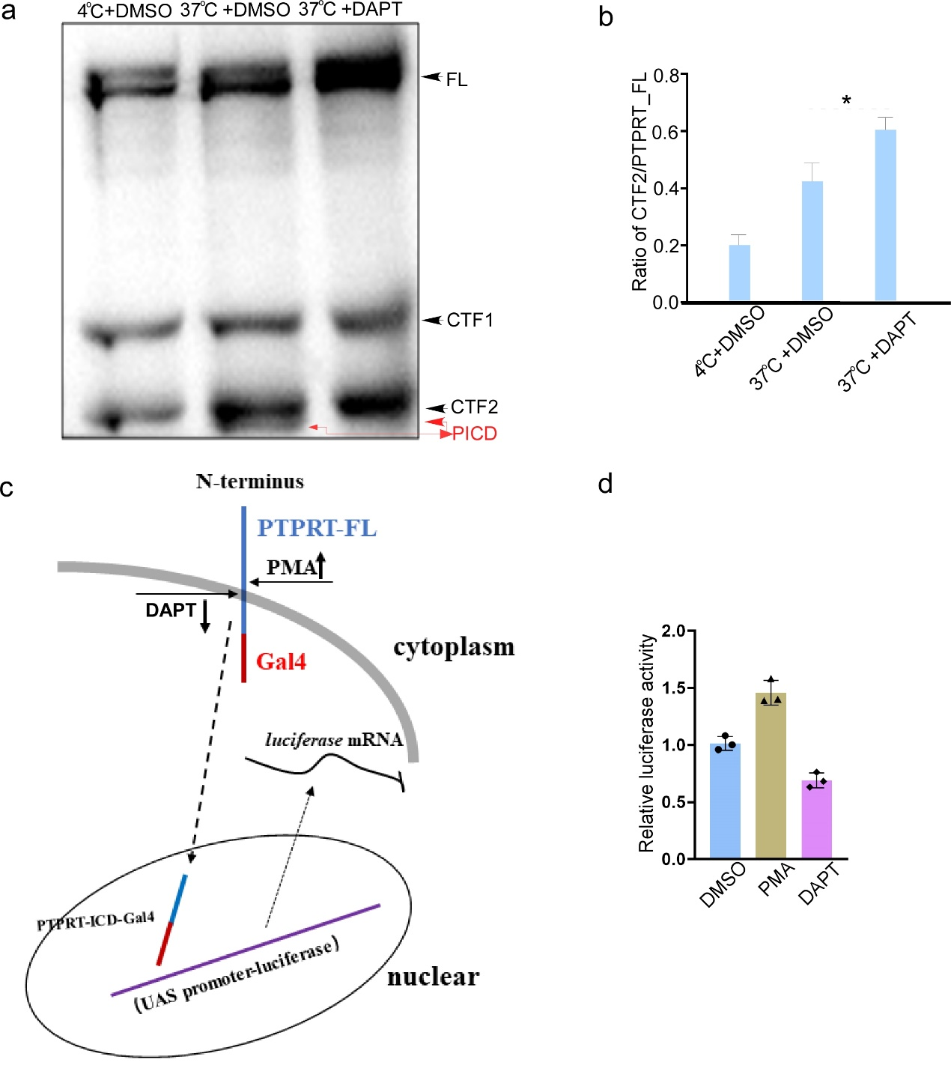
Figure S1. Nuclear function of PTPRT intracellular domain induced by ADAM10 and presenilin 1/γ-secretase
- Protein extracts from HEK 293 cells with indicated pretreatments were assayed by Western blot for the presence of PTPRT, and its fragments CTF1 and CTF2 (PICD). b. The schematic of nuclear translocation and function of PTPRT intracellular domain induced by ADAM10 and presenilin 1/γ-secretase. c. The relative luciferase activities of luciferase reporters containing UAS promoter-luciferase, and HEK 293 cells transfected with PICD-Gal4. Results are presented as mean ±S.D. (n= 3 independent experiments, *p<0.01). d. Quantification of the immunobloted intensities of CTF2 shown in panel C). Error bars denote S.E.M. (n = 3 independent experiments; *, P < 0.05).
Figure S2
Figure S2
Figure S2. PICD alter the expression of genes involved in neuronal circuit formation
a. The GO annotation contains the Ptprt gene on chromosome 2. b. The number genes annotated to top 10 biological processes, cellular component, and molecular functions, respectively, on chromosome 2. c-d. Hierarchical clustering heat map of all down-regulated and up-regulated genes regulated by PICD. e. Heatmap of all gene expression has the same GO annotation with ptprt gene on chromosome 2 .f. The number of genes annotated to top 15 pathways on chromosome 2. g. Heatmap of expressions for genes have the same GO annotations with Smagp gene on chromosome 15. h. The number of genes annotated to top 15 pathways on chromosome 15.

Figure S3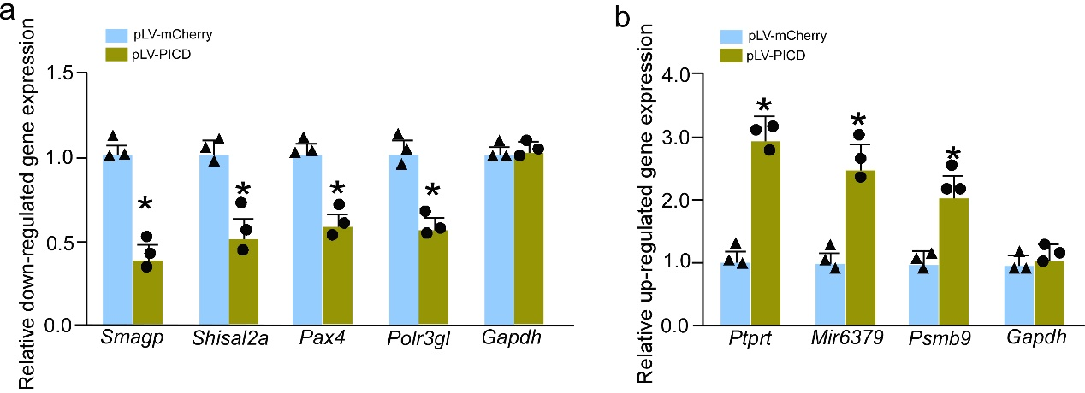
Figure S3. Effect of PICD on targeted genes’ mRNA expression
- Quantitative real-time PCR was performed with specific primers for downregulated mouse Smagp, Shisal2a, Pax4 and Polr3gl mRNA expression. Total RNA was extracted from N2a cells transfected with pLV-mCherry or pLV-PICD-mCherry. Gapdh mRNA was used as internal control. Data represent mean ± S.E.M. of three independent experiments. * P < 0.01, unpaired t-test.b. Quantitative real-time PCR was performed with specific primers for upregulated mouse Ptprt, Mir6379 and Psmb9 mRNA expression. Total RNA was extracted from N2a cells transfected with pLV-mCherry or pLV-PICD-mCherry. Gapdh mRNA was used as internal control. Data represent mean ± S.E.M. of three independent experiments. * P < 0.01, unpaired t-test.

Figure S4
Figure S4. Effect of AAV-PICD on pSTAT3^{Y705} in APP/PS1 mice. AAV-PICD could significantly decrease the pSTAT3^{Y705} accumulation in APP/PS1 mouse brain.

