Supplementary Materials for

Evidence for cable bacteria inhabiting deep in anoxic sediment reveals a novel ecological niche

Alexis Fonseca^{1,2}*, Martijn Hermans¹*, Francisco J.A. Nascimento^{1,2}, Christian Stranne^{1,3,4}, Alf Norkko⁵, Bo G. Gustafsson^{1,6} & Christoph Humborg¹

¹Baltic Sea Centre, Stockholm University, Stockholm, Sweden
²Department of Ecology, Environment and Plant Sciences, Stockholm University, Stockholm, Sweden
³Department of Geological Sciences, Stockholm University, Stockholm, Sweden
⁴Bolin Centre for Climate Research, Stockholm University, Stockholm, Sweden
⁵Tvärminne Zoological Station, University of Helsinki, Hanko, Finland
⁶Baltic Nest Institute, Stockholm University, Stockholm, Sweden

*Corresponding authors. Email: alexis.fonseca@su.se and martijn.hermans@su.se

francisco.nascimento@su.se
christian.stranne@geo.su.se
alf.norkko@helsinki.fi
bo.gustafsson@su.se
christoph.humborg@su.se

Taxonomic identification and quantification of cable bacteria in Koljö Fjord

Cable bacteria identification and abundance was further analysed in Koljö Fjord, assembling the rRNA gene reads (obtained by SortMeRNA ) using rnaSPAdes (spades V 4.0.0; Bushmanova et al., 2019) with “-k 31,55,77,97,127”. 16S rRNA gene sequences were identified with Barrnap V0.9 (https://github.com/tseemann/barrnap) and aligned against the SILVA_138.1_SSURef_NR99 database, augmented with 34 Ca. Electrothrix spp. 16S rRNA gene sequences, using BLASTN V2.15.0+ (Chen et al., 2015) with “-max_target_seqs 1.” 16S rRNA gene sequence matching with Ca. Electrothrix spp. with >90% identity, e-value < 1x10e-10 and query cover > 95% were selected and quantified using CoverM (Aroney et al., 2025) with the mode “contig” and method transcripts per million “-m tpm,” previous mapping of original rRNA gene reads against the assembled and annotated Ca. Electrothrix spp. 16S rRNA sequences. Thirteen partial 16S rRNA Ca. Electrothrix gene sequences ranging from 411 bp to 941 base pairs (bp) were obtained (Supplementary Data 2).

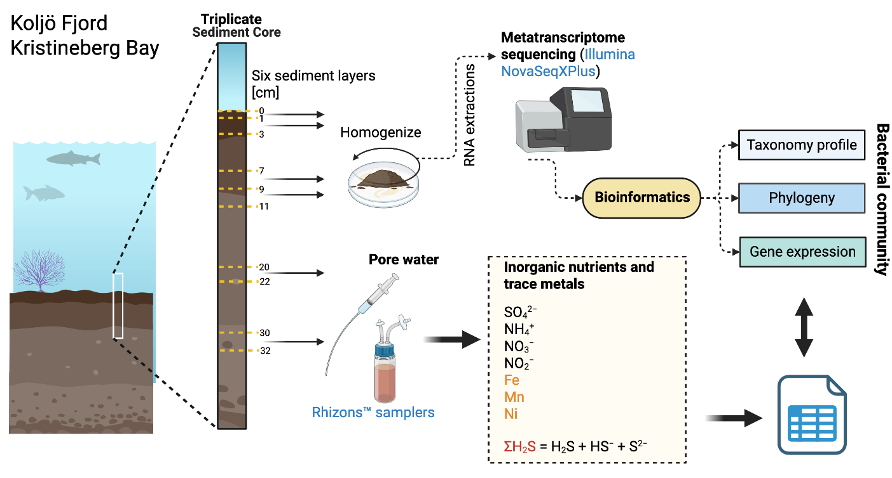

Figure S1 | Scheme of the workflow for the collection and analysis of samples from Koljö Fjord and Kristineberg Bay. In the case of core 2 from Kristineberg Bay, a sediment sample was obtained from the 0 to 2 cm layer, in contrast to the 0–1 cm layer sampled from cores 1 and 3.

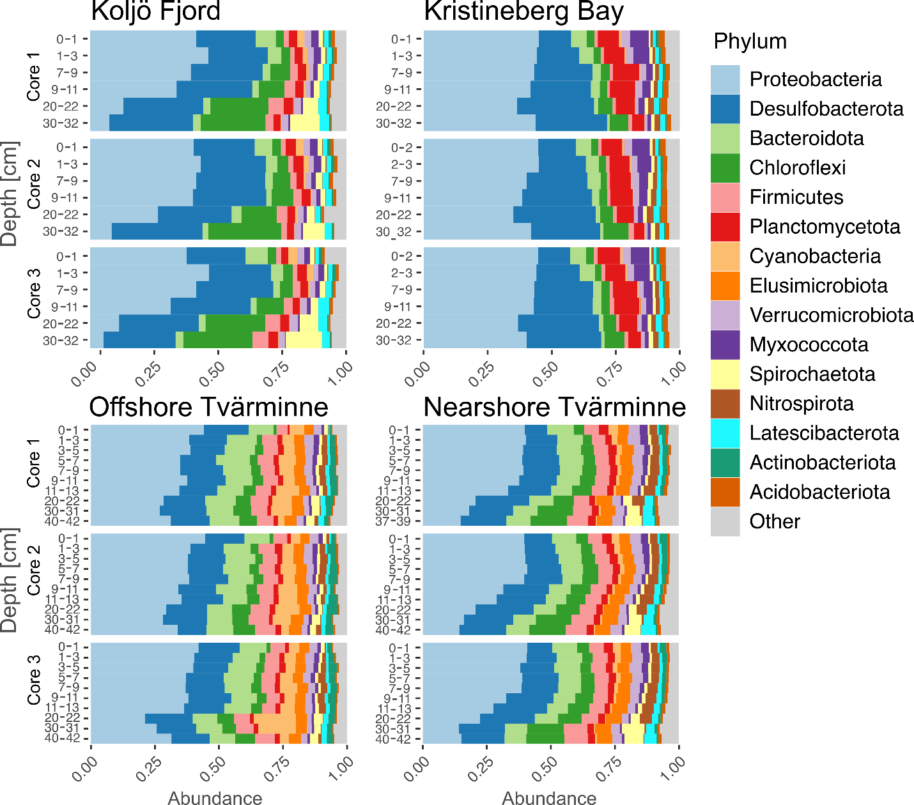

Figure S2 | The 15 most abundant phyla by depth and location. The taxa are ranking from the most abundant to less and deploy in relative abundance.

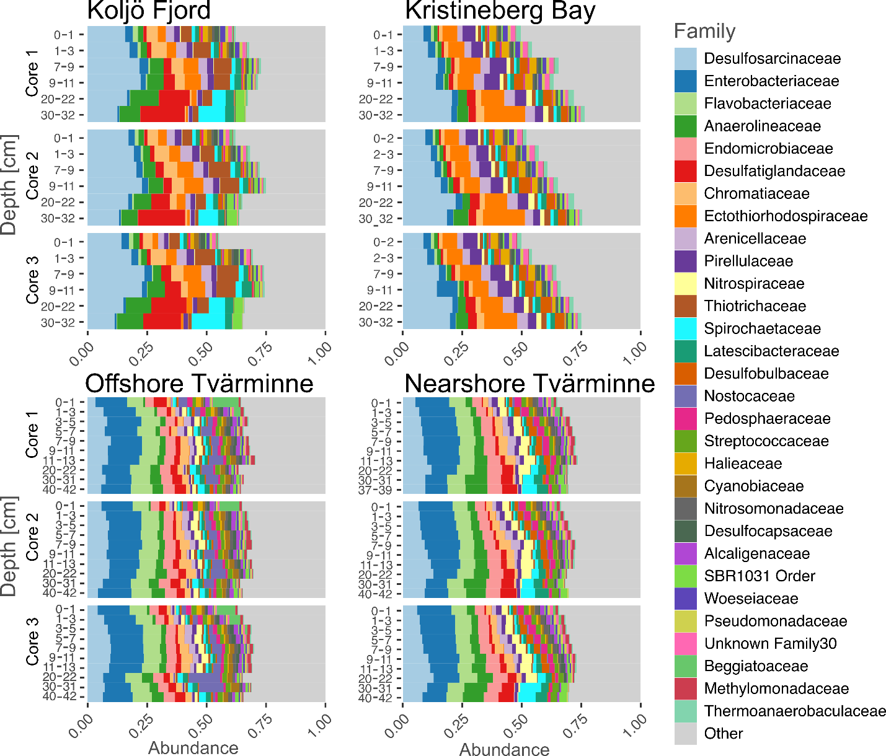

Figure S3 | The 30 most abundant families by depth and location. The taxa are ranking from the most abundant to less and deploy in relative abundance.

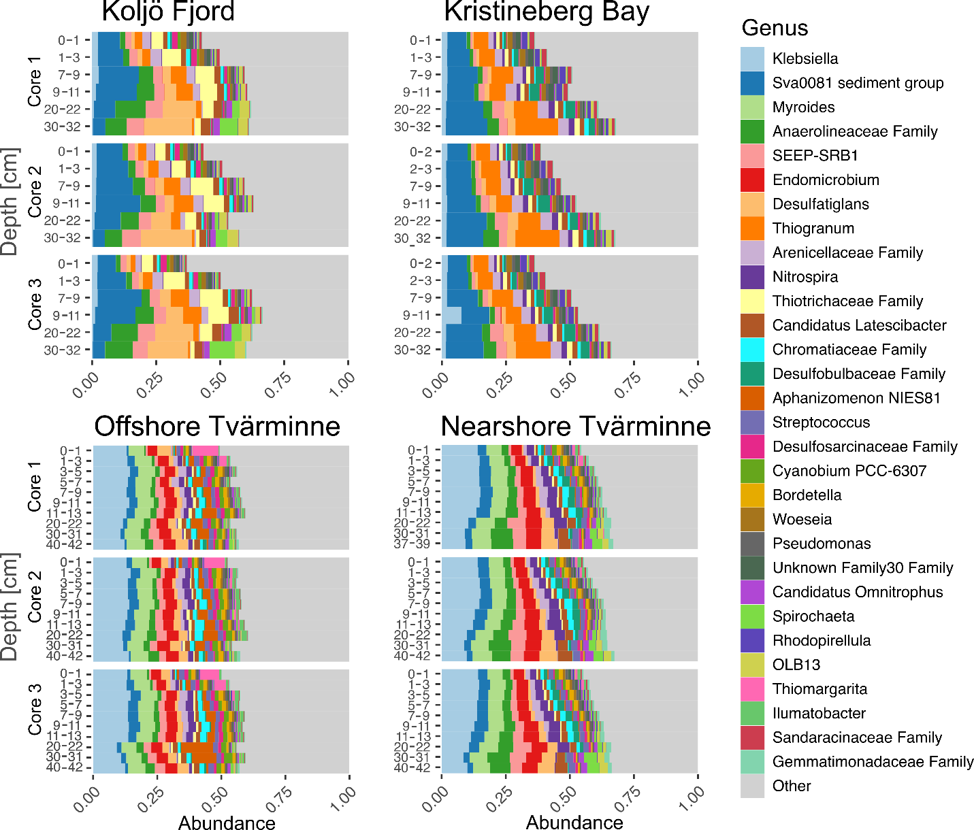

Figure S4 | The 30 most abundant genera by depth and location. The taxa are ranking from the most abundant to less and deploy in relative abundance.

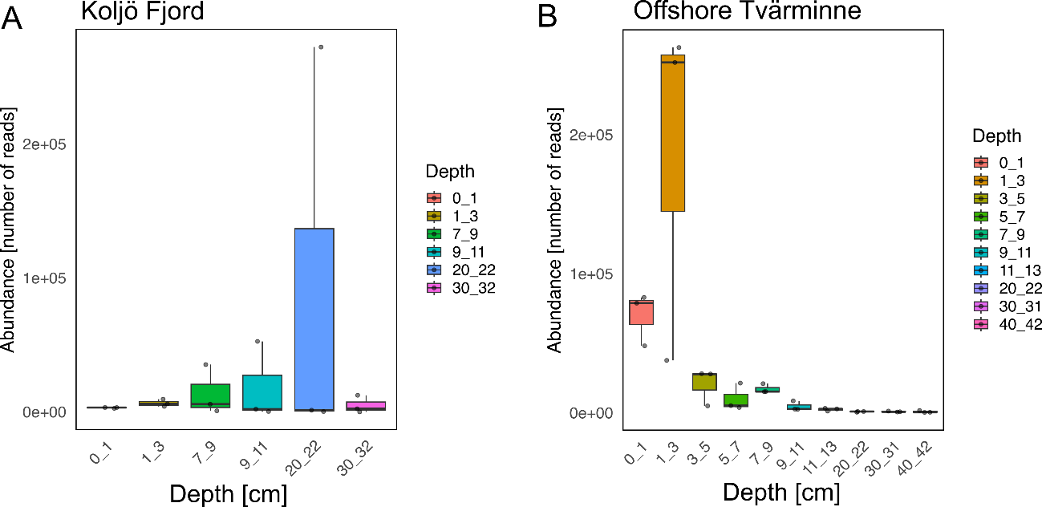

Figure S5 | Candidatus Electrothrix abundance as assigned by Kraken2 and Bracken in Köljo Fjord and Offshore Tvärminne. The 16S rRNA gene sequences were identified through total SSU rRNA using Kraken2 and Bracken programmes at (A) Koljö Fjord and (B) the Offshore Tvärminne station.

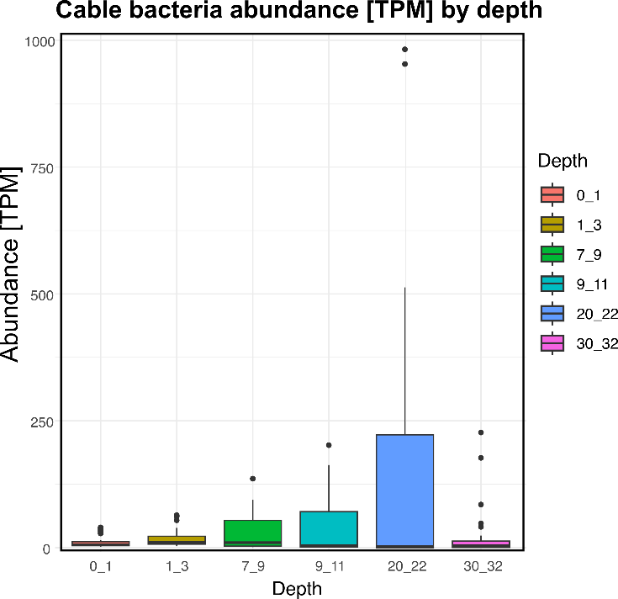

Figure S6 | Abundance of partial 16S rRNA genes of Candidatus Electrothrix in Köljo Fjord. Thirteen partial 16S rRNA gene sequences were obtained and quantified. rRNA sequences were previously separated using SortMeRNA and subsequently assembled using rnaSpades.py. 16S rRNA genes were identified using Barrnap V0.9, annotated using BLASTN and the SILVA_138.1_SSURef_NR99 database as a reference, and augmented with 34 Ca. Electrothrix. Abundance was quantified using CoverM in transcripts per million (TPM) by depth.

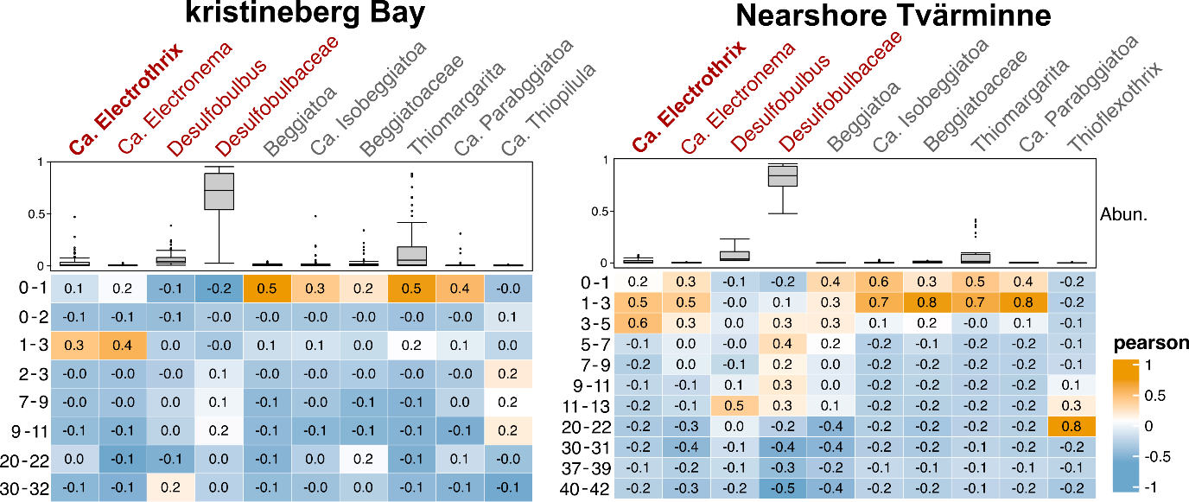

Figure S7 | Pearson correlations. Correlations among depths and the abundance of Candidatus Electrothrix and three other genera from the Desulfobulbaceae family (indicated in red) and the six most abundant genera from the Beggiatoaceae family in Kristineberg Bay and the Nearshore Tvärminne station.

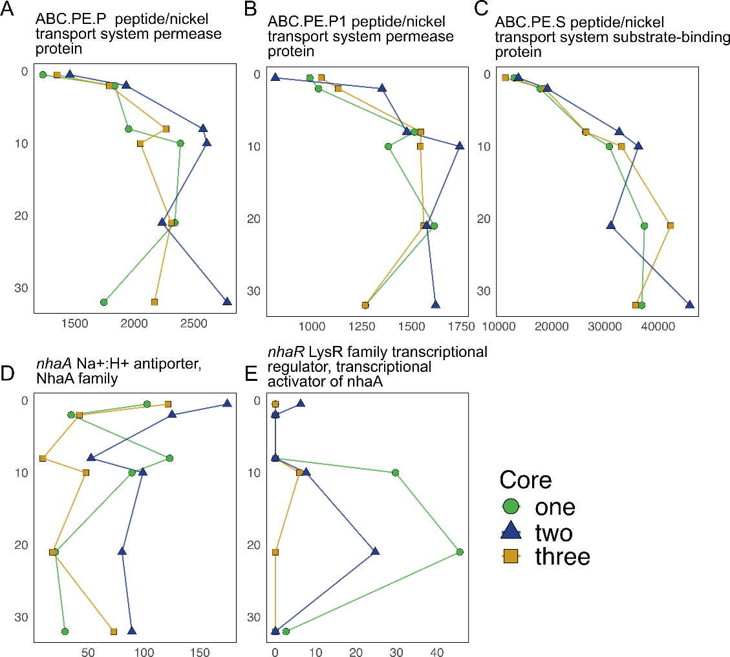

Figure S8 | Gene expression profiles linked to nickel and marine adaptation in Köljo Fjord. A-C) Gene expression profiles by depth of genes associated with sulfur, D-F) nickel metabolism and G-H) marine adaptation.

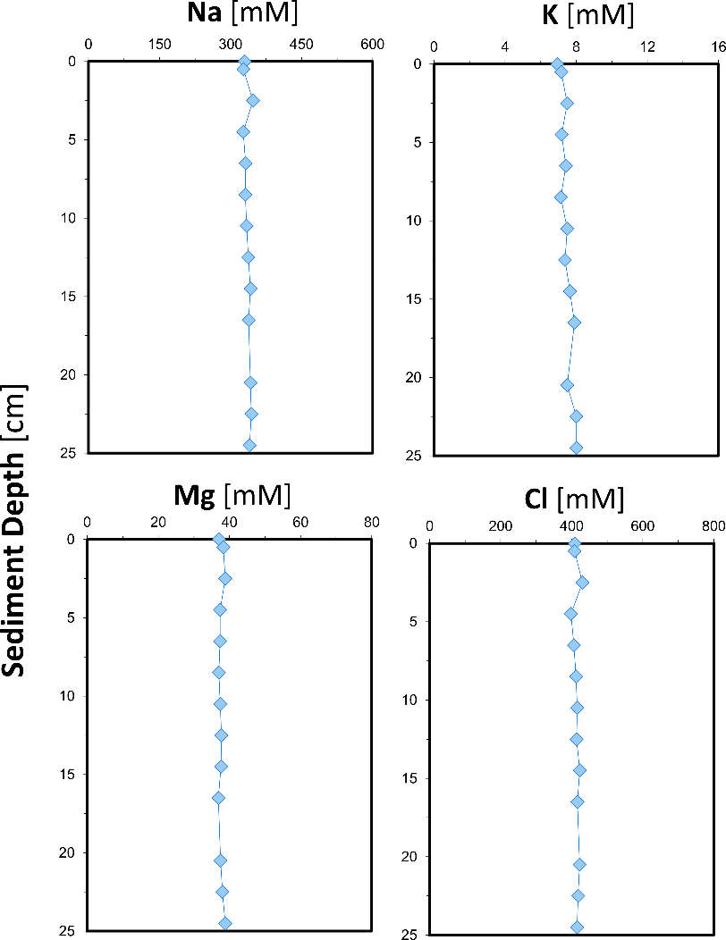

Figure S9 | Porewater profiles of Sodium (Na), potassium (K), magnesium (Mg), and chloride (Cl) concentrations (mM) by sediment depth in Koljö Fjord.

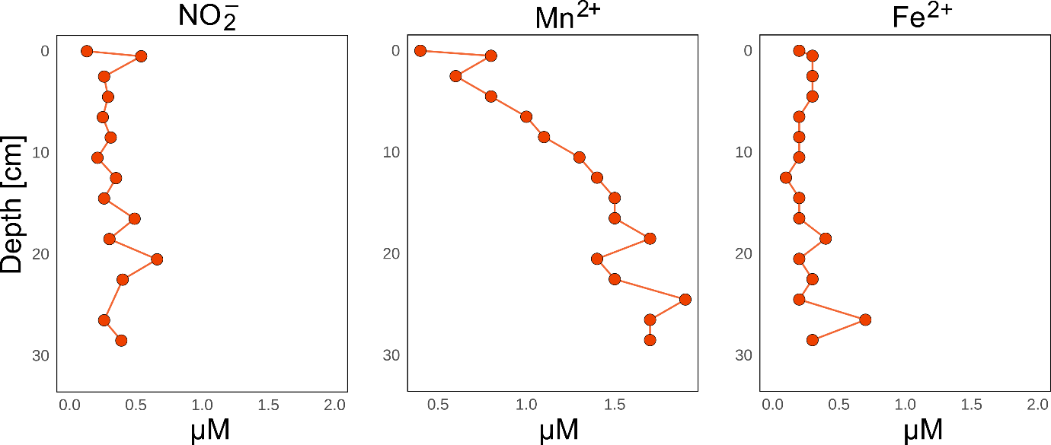

Figure S10 | Porewater profiles of nitrate (NO₂⁻), manganese (Mn²⁺) and iron (Fe²⁺) concentrations in Koljö Fjord.

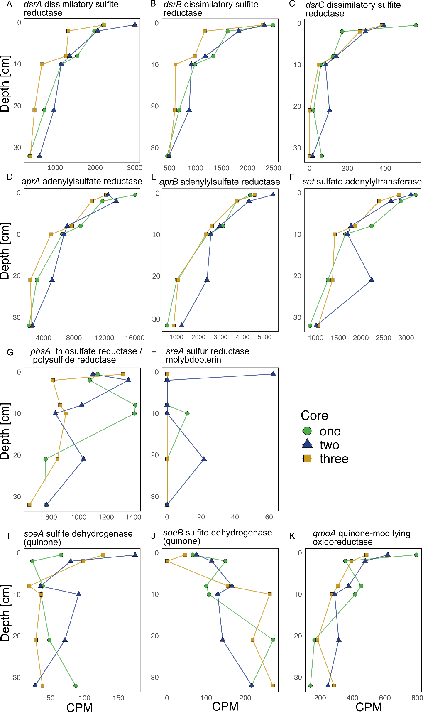

Figure S11 | Gene expression profiles linked to sulfur in Köljo Fjord. Gene expression profiles by depth of genes associated with sulfur metabolism.

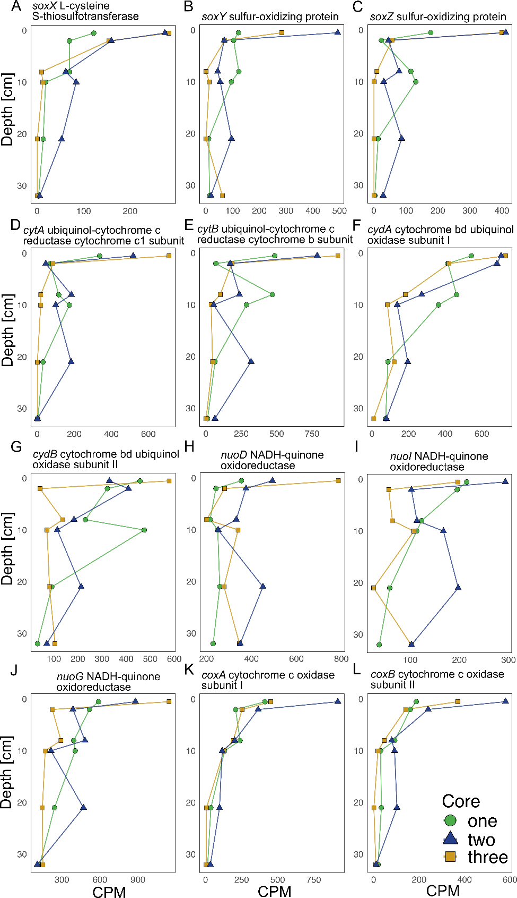

Figure S12 | Gene expression profiles linked to sulfur and electron transfer in Köljo Fjord. A-C) Gene expression profiles by depth of genes associated with sulfur metabolism and D-L) electron transfer

Table S1 | Characteristics of the stations studied. Stations on the west coast of Sweden (SE) and the Tvärminne archipelago in southern Finland (FI). BW = Bottom water.

Station | Water depth [m] | Latitude | Longitude | BW salinity | BW O₂ [mg/L] | BW redox conditions
Koljö Fjord (SE) | 12 | 58°15'28" | 11°34'5" | 32.7 | 1.4 | hypoxic
Kristineberg Bay (SE) | 40 | 58°14'58" | 11°26'32" | 24.0 | 4.4 | oxic
Nearshore (FI)* | 13.5 | 59°55'22" | 23°20'18" | 5.9 | 4.2 | oxic
Offshore (FI)* | 22.5 | 59°51'28" | 23°22'31" | 6.2 | 1.7 | hypoxic

*Sampling and data reported by Hermans et al. (2024)

Table S2 | Kruskal-Wallis test of Candidatus Electrothrix abundance in Offshore Tvärminne station samples. Chi-squared = 26.385, df = 9, p-value = 0.001767. Duncan’s test on Kruskal-Wallis multiple comparison p-values adjusted with the Benjamini-Hochberg method.

Depth Comparison [cm] |  | Z | P.unadj | P.adj
0-1 | 1-3 | -0.13912167 | 0.889354006 | 0.9095666
0-1 | 11-13 | 2.13319892 | 0.032908412 | 0.13462532
1-3 | 11-13 | 2.27232059 | 0.023067154 | 0.12975274
0-1 | 20-22 | 3.01430282 | 0.002575706 | 0.02318135
1-3 | 20-22 | 3.15342449 | 0.00161367 | 0.02420505
11-13 | 20-22 | 0.8811039 | 0.378261586 | 0.50064033
0-1 | 3-5 | 0.83473001 | 0.403869739 | 0.51926109
1-3 | 3-5 | 0.97385168 | 0.330130188 | 0.47922124
11-13 | 3-5 | -1.29846891 | 0.194126254 | 0.41598483
20-22 | 3-5 | -2.17957281 | 0.029289142 | 0.13180114
0-1 | 30-31 | 2.92155504 | 0.003482887 | 0.02612165
1-3 | 30-31 | 3.06067671 | 0.002208374 | 0.02484421
11-13 | 30-31 | 0.78835612 | 0.430488428 | 0.53811054
20-22 | 30-31 | -0.09274778 | 0.926103938 | 0.92610394
3-5 | 30-31 | 2.08682503 | 0.036903954 | 0.13838983
0-1 | 40-42 | 3.15342449 | 0.00161367 | 0.03630757
1-3 | 40-42 | 3.29254616 | 0.000992846 | 0.04467807
11-13 | 40-42 | 1.02022557 | 0.307621493 | 0.4773437
20-22 | 40-42 | 0.13912167 | 0.889354006 | 0.93071931
3-5 | 40-42 | 2.31869448 | 0.020411608 | 0.13121748
30-31 | 40-42 | 0.23186945 | 0.816639415 | 0.89631155
0-1 | 5-7 | 1.25209502 | 0.210535243 | 0.41191678
1-3 | 5-7 | 1.39121669 | 0.164159728 | 0.36935939
11-13 | 5-7 | -0.8811039 | 0.378261586 | 0.51581125
20-22 | 5-7 | -1.7622078 | 0.078034194 | 0.19508549
3-5 | 5-7 | 0.41736501 | 0.676411447 | 0.80101356
30-31 | 5-7 | -1.66946002 | 0.095026246 | 0.22506216
40-42 | 5-7 | -1.90132947 | 0.057258871 | 0.16104057
0-1 | 7-9 | 0.97385168 | 0.330130188 | 0.49519528
1-3 | 7-9 | 1.11297335 | 0.265719875 | 0.45989978
11-13 | 7-9 | -1.15934724 | 0.246314673 | 0.46184001
20-22 | 7-9 | -2.04045114 | 0.041305413 | 0.14298027
3-5 | 7-9 | 0.13912167 | 0.889354006 | 0.95287929
30-31 | 7-9 | -1.94770336 | 0.051450468 | 0.1543514
40-42 | 7-9 | -2.17957281 | 0.029289142 | 0.14644571
5-7 | 7-9 | -0.27824334 | 0.780825569 | 0.87842877
0-1 | 9-11 | 1.85495558 | 0.06360257 | 0.16835974
1-3 | 9-11 | 1.99407725 | 0.046143613 | 0.14831876
11-13 | 9-11 | -0.27824334 | 0.780825569 | 0.90095258
20-22 | 9-11 | -1.15934724 | 0.246314673 | 0.44336641
3-5 | 9-11 | 1.02022557 | 0.307621493 | 0.49439169
30-31 | 9-11 | -1.06659946 | 0.286152744 | 0.47692124
40-42 | 9-11 | -1.29846891 | 0.194126254 | 0.39707643
5-7 | 9-11 | 0.60286056 | 0.546601452 | 0.66478555
7-9 | 9-11 | 0.8811039 | 0.378261586 | 0.53193035

Table S3 | Results of the Kruskal-Wallis test performed on the abundance of Candidatus Electrotrhix, based on the 13 partial 16S rRNA gene sequences identified in samples from Koljö Fjord stratified by depth. Duncan's test was conducted on Kruskal-Wallis multiple comparison p-values, which were adjusted using the Benjamini-Hochberg method.

Depth | Comparison [cm] | Z | P.unadj | P.adj
0-1 | 1-3 | -1.5802906 | 0.1140403312 | 0.285100828
0-1 | 20-22 | 0.837068 | 0.4025543276 | 0.503192909
1-3 | 20-22 | 2.4173586 | 0.0156336053 | 0.078168026
0-1 | 30-32 | 1.9523208 | 0.0509001249 | 0.152700375
1-3 | 30-32 | 3.5326114 | 0.0004114768 | 0.006172151
20-22 | 30-32 | 1.1152528 | 0.2647421033 | 0.397113155
0-1 | 7-9 | -0.6845692 | 0.4936158383 | 0.569556736
1-3 | 7-9 | 0.8957214 | 0.3704015517 | 0.505093025
20-22 | 7-9 | -1.5216372 | 0.1281000146 | 0.274500031
30-32 | 7-9 | -2.63689 | 0.0083669961 | 0.062752471
0-1 | 9-11 | 0.5865342 | 0.5575166144 | 0.59733923
1-3 | 9-11 | 2.1668248 | 0.0302482188 | 0.11343082
20-22 | 9-11 | -0.2505339 | 0.8021745106 | 0.802174511
30-32 | 9-11 | -1.3657867 | 0.172005928 | 0.322511115
7-9 | 9-11 | 1.2711033 | 0.2036918979 | 0.339486497

References

Bushmanova, E., Antipov, D., Lapidus, A., Prjibelski, A.D., 2019. rnaSPAdes: a de novo transcriptome assembler and its application to RNA-Seq data. GigaScience 8, giz100. https://doi.org/10.1093/gigascience/giz100

Chen, Y.-L., Lee, C.-C., Lin, Y.-L., Yin, K.-M., Ho, C.-L., Liu, T., 2015. Obtaining long 16S rDNA sequences using multiple primers and its application on dioxin-containing samples. BMC Bioinformatics 16, S13. https://doi.org/10.1186/1471-2105-16-S18-S13

Aroney, S.T.N., Newell, R.J.P., Nissen, J.N., Camargo, A.P., Tyson, G.W., Woodcroft, B.J., 2025. CoverM: read alignment statistics for metagenomics. Bioinformatics 41, btaf147. https://doi.org/10.1093/bioinformatics/btaf147

Hermans, M., Stranne, C., Broman, E., Sokolov, A., Roth, F., Nascimento, F.J.A., Mörth, C.-M., Ten Hietbrink, S., Sun, X., Gustafsson, E., Gustafsson, B.G., Norkko, A., Jilbert, T., Humborg, C., 2024. Ebullition dominates methane emissions in stratified coastal waters. Science of The Total Environment 945, 174183. https://doi.org/10.1016/j.scitotenv.2024.174183

