Supporting information for
Nanofiber Template-induced Preparation of ZnO Nanocrystal and its Application in Photocatalysis
Mingyi Chen ^{a#}, Peng Liu ^{b#}, Ji-Huan He ^{b}, Hsing-Lin Wang ª, Xin Wang* ^{c}, Rouxi Chen* ª
ª Department of Materials Science and Engineering, Southern University of Science and Technology, Shenzhen, 518055 China
^{b} National Engineering Laboratory for Modern Silk, College of Textile and Clothing Engineering, Soochow University, Suzhou, 215123 China
^{c} Songshan Lake Materials Laboratory, Dongguan, 523808 China

Preparation of PVDF/Zn(CH₃COO)₂ nanofiber membrane
The PVDF/Zn(Ac)₂ nanofiber membranes with different concentrations (3 wt.%, 6 wt.%, 10 wt.%, 14 wt.%) were characterized by SEM, as shown in Figure S1. The uniformity of nanofiber membrane is optimal when the spinning solution concentration is 10 wt.%. In addition, the optimal PVDF/Zn(Ac)₂ nanofiber membranes with different concentrations of zinc acetate are characterized by SEM, as shown in Figure S2. The results show that the uniformity and mechanical properties of membrane are excellent when the mass ratio of PVDF to zinc acetate in the solution is 10:3.
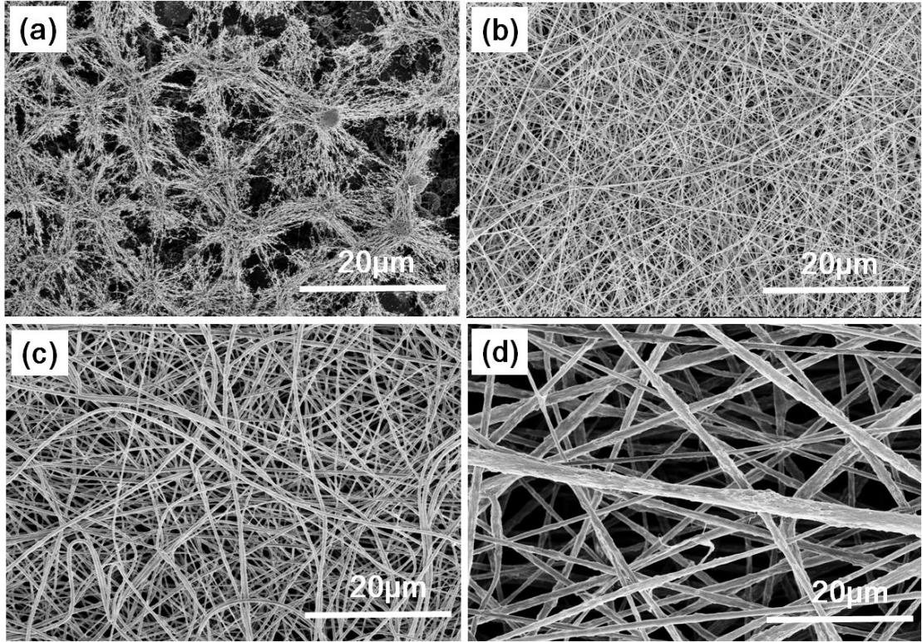
Figure S1. SEM images of PVDF/Zn(Ac)₂ nanofiber mat electrospun from solution of different concentrations: (a) 3 wt.%, (b)6 wt.%, (c)0 wt.% and (d) 4 wt.%.
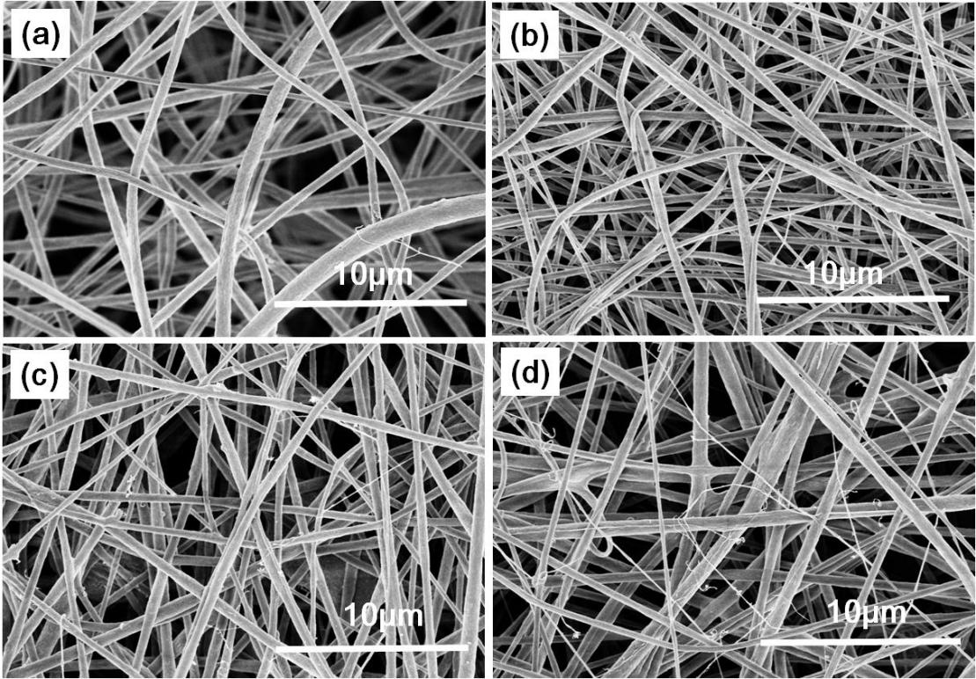
Figure S2. SEM images of PVDF/Zn(Ac)₂ nanofiber mat electrospun from solutions with different zinc acetate content, m(PVDF)/m(Zn(Ac)₂): (a) 10:1, (b) 10:3, (c) 10:5, (d) 10:7.

ZnO-loaded PVDF nanofiber membrane
The PVDF/Zn(Ac)₂ nanofiber membrane was thermally treated from 60 °C to 200 °C at an interval of 20 °C for 24 h. The as-prepared nanofiber was examined by SEM (Figure S3) and TEM (Figure S4) observation, followed by mechanical and photocatalytic property measurements.
The PVDF/Zn(Ac)₂ fiber membranes thermally treated at 140 °C for 1h, 12h, and 36h were observed by SEM (Figure S5) and subject to mechanical test. The results indicate that the heat treatment temperature has a more critical effect on the formation of ZnO crystals and the morphology of PVDF/Zn(Ac)₂ nanofiber membranes, although the heat treatment time will affect the size and quantity of ZnO crystals. Thermal treatment at a temperature over 140 °C may cause the zinc acetate to be hydrolyzed or decomposed into low-crystalline nano-ZnO, resulting in increase in tensile strength and decrease in the elongation at break.
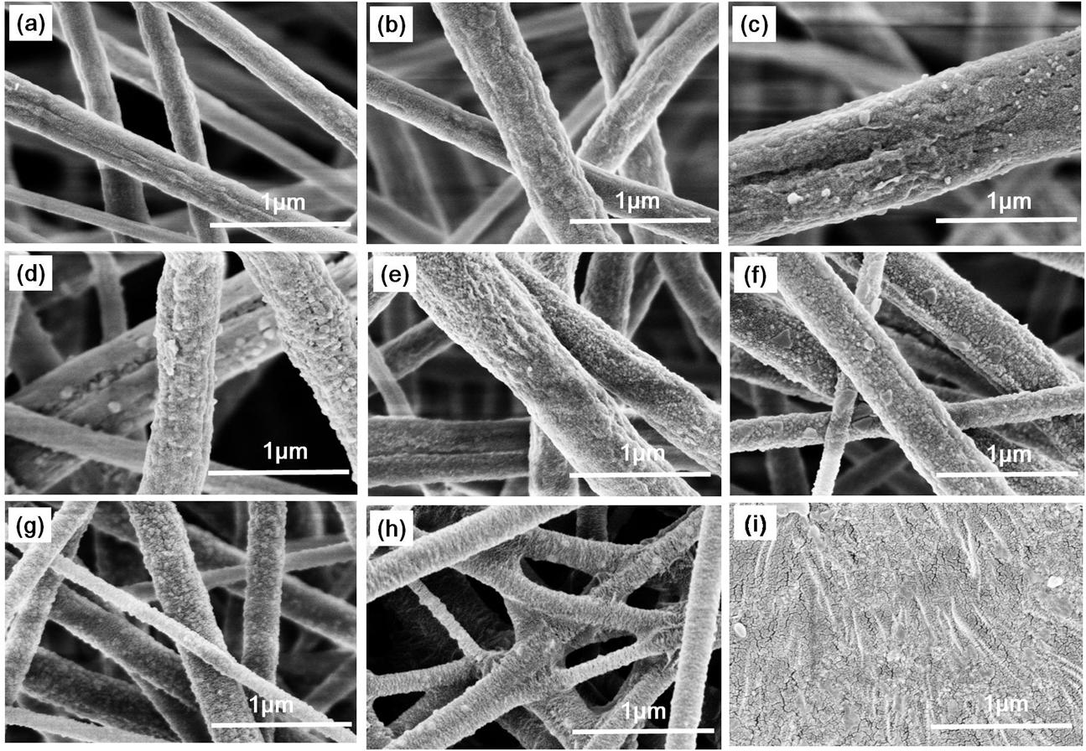
(e)
Figure S3. SEM images of PVDF/Zn(Ac)₂ nanofiber mat with different thermal treatments for 24 h. (a), no thermal treatment, (b)-(i), thermally treated at 60 °C, 80 °C, 100 °C, 120 °C, 140 °C, 160 °C, 180 °C and 200 °C. (A)-(I), corresponding TEM images of (a)-(i).
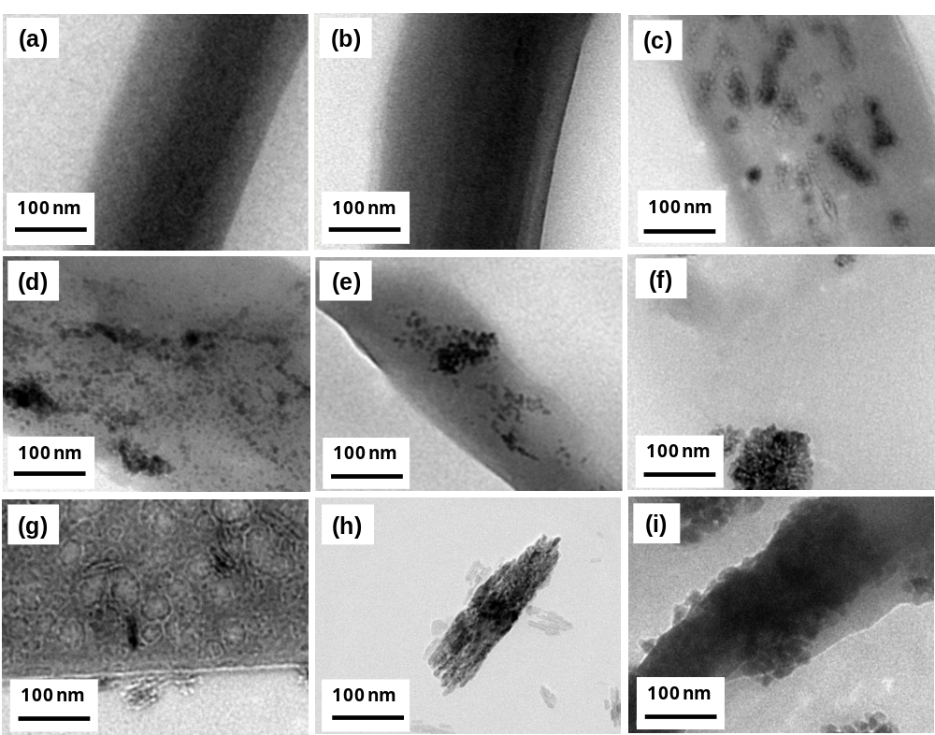
Figure S4. TEM images of PVDF/Zn(Ac)₂ nanofiber mat with different thermal treatments for 24 h. (a), SEM image without thermal treatment. (b)-(i), SEM images thermally treated at 60 °C, 80 °C, 100 °C, 120 °C, 140 °C, 160 °C, 180 °C and 200 °C. (A)-(I): corresponding TEM images of (a)-(i).
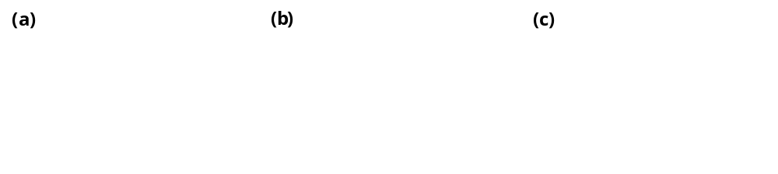
Figure S5. SEM images of PVDF/Zn(Ac)₂ nanofiber mat thermally treated at 140 °C for 1 h (a), 12 h (b) and 36 h (c).
Factors affecting the growth of ZnO nanorods
The solution prepared by ZnCl₂, HMTA and ammonia water is used as the growth solution for ZnO nanostructures, and the effects of the concentration of crystal growing solution, volume of ammonia solution, hydrothermal reaction temperature and time, and the heat treatment film at different temperatures on the highly oriented ZnO nanorods grown on the fiber were discussed.
The influence of the M(ZnCl₂:HMTA) molar ratio on the structure of ZnO nanorods was studied, as shown in Figure S6. Four M(ZnCl₂:HMTA) ratios were employed: 1:3, 1:2, 1:1 and 2:1. The solution with 5 mL of ammonia and a total volume of 100 mL was subject to hydrothermal reaction for 3 h.
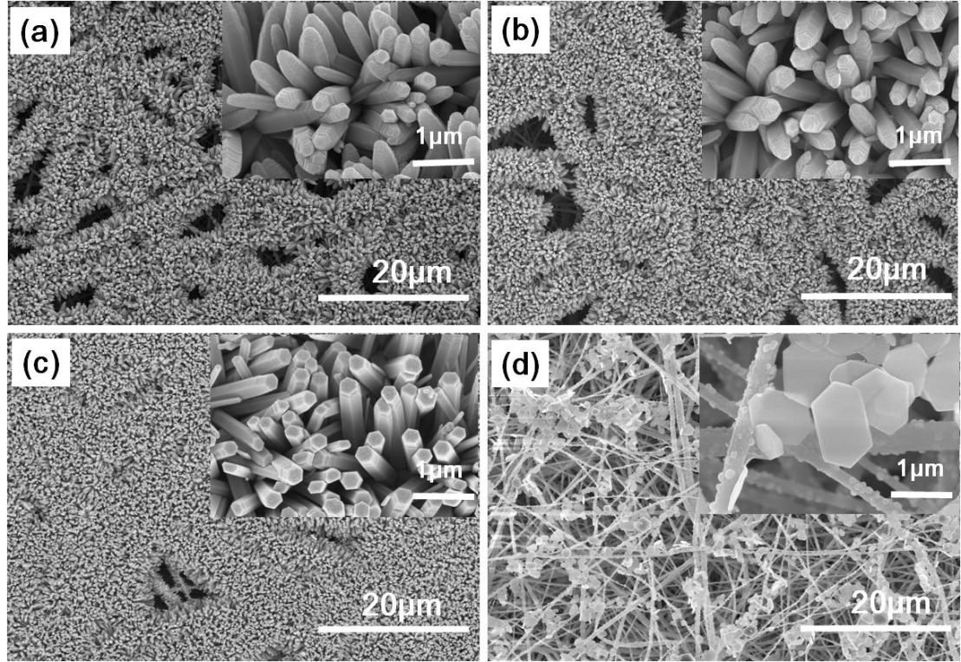
Figure S6. SEM images of ZnO nanorods from growing solution with M(ZnCl₂):M(HMTA) molar ratio of 1:3 (a), 1:2 (b), 1:1 (c) and 2:1 (d).

The influence of hydrothermal temperature on the nanostructure of ZnO was investigated with a ZnCl₂:HMTA molar ratio of 1:1 at a total concentration of 0.1 M, as shown in Figure S7.
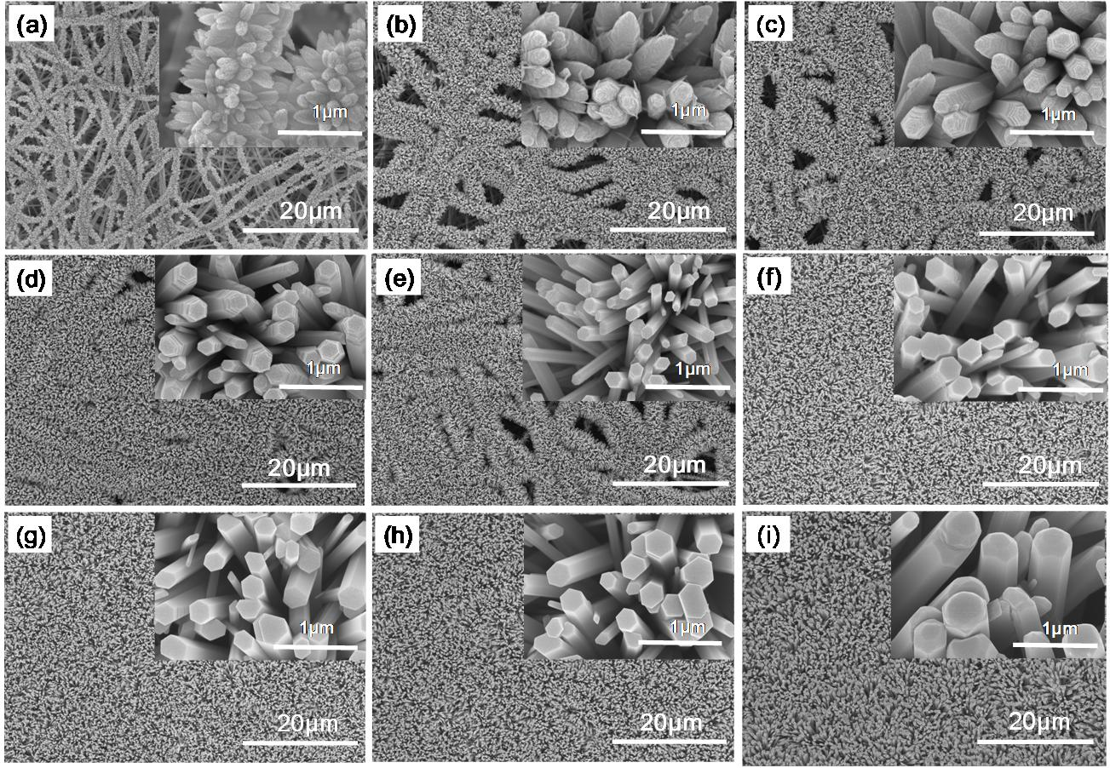
Figure S7. SEM images of ZnO nanorods prepared from hydrothermal temperature of 50 °C (a), 60 °C (b), 70 °C (c), 80 °C (d), 100 °C (e), 110 °C (f), 120 °C (g), 130 °C (h) and 140 °C (i).

Influence of volume of ammonia solution on the nanostructure of ZnO was studied, as shown in Figure S8.
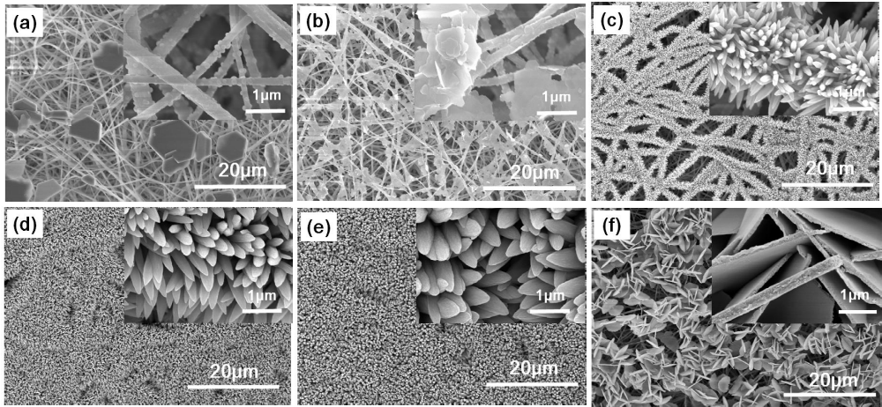
Figure S8. SEM images of ZnO nanorods prepared from growing solutions with ammonia volume of 0 mL (a), 1 mL (b), 2 mL (c), 3 mL (d), 4 mL (e) and 7 mL (f).

The nanostructure of ZnO prepared from different growing time was compared, as shown in Figure S9.
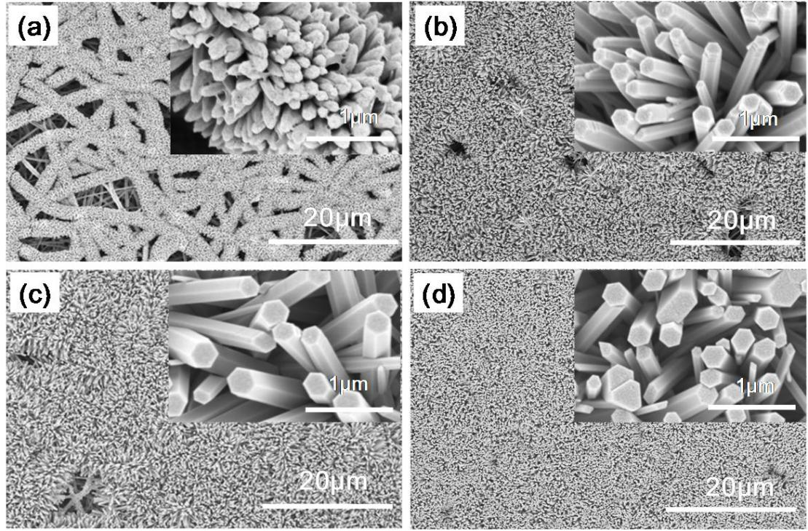
Figure S9. SEM images of ZnO nanorods hydrothermally prepared for 1 h (a), 3 h (b), 5 h (c) and 12 h (d).
The morphologies of ZnO prepared on nanofiber mat pre-treated for 18 h at different temperature are shown in Figure S10.
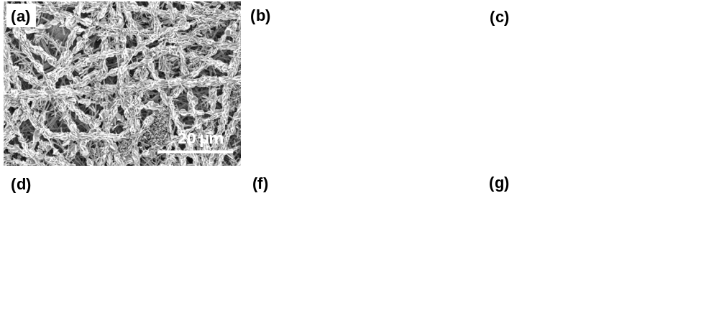
Figure S10. SEM images of ZnO nanorods prepared from PVDF/Zn(Ac)₂ nanofiber mats without previous thermal treatment (a), and with thermal treatment at 60 °C (b), 80 °C (c), 140 °C (d) and 200 °C (e). SEM image of ZnO nanofilm prepared on aluminum foil (f).

Growing behavior of ZnO nanorods
The untreated PVDF/Zn(Ac)₂ nanofiber mat and the PVDF/Zn(Ac)₂ nanofiber mats with ZnO nanorods were subjected to TGA and DSC measurements, as shown in Figures S11 and S12. The weight loss, exothermic and endothermic peaks of the four nanofiber mats demonstrate that the oxidative decomposition of zinc acetate first leads to ZnO crystals, generating an obvious endothermic peak in DSC, followed by complete oxidative decomposition and generation of new substance along with liberation of heat. The weight loss in this stage is mainly attributed to the complete oxidative decomposition of the fiber and the oxidative decomposition of all zinc acetate into highly crystalline ZnO. Moreover, the thermally treated nanofiber mats are found to give more ZnO nanorods, whereas the weights of the ZnO nanorods obtained from zinc acetate coated nanofiber mat and the blended nanofiber mat are similar.
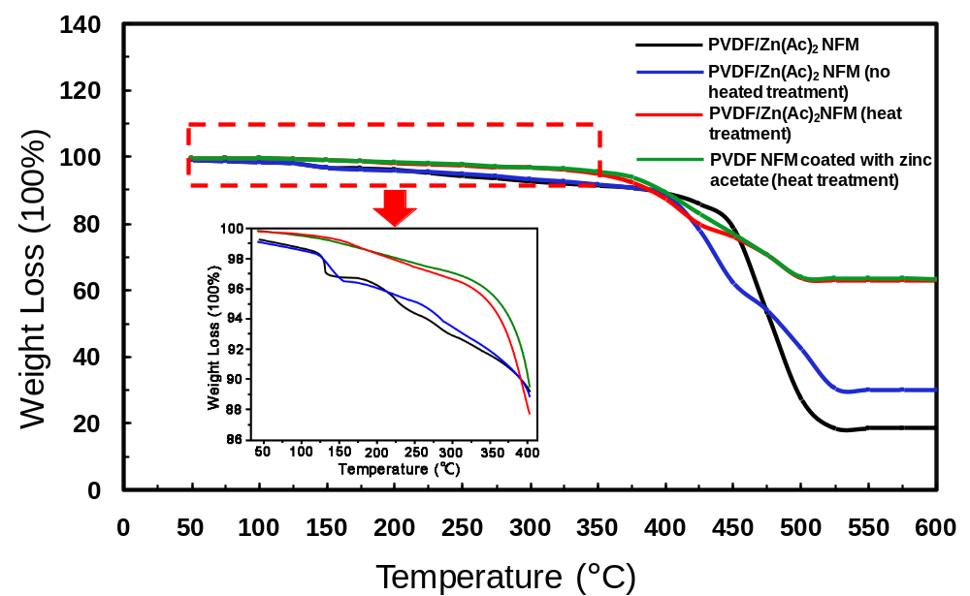
Figure S11. TGA thermograms of nanofibers treated under different conditions. Black, pristine PVDF/Zn(Ac)₂ nanofiber mat. Blue, ZnO nanorods prepared on pristine PVDF/Zn(Ac)₂ nanofiber mat. Red, ZnO nanorods prepared on thermally treated PVDF/Zn(Ac)₂ nanofiber mat. Green, ZnO nanorods prepared on thermally treated PVDF nanofiber mat coated with Zn(Ac)₂.

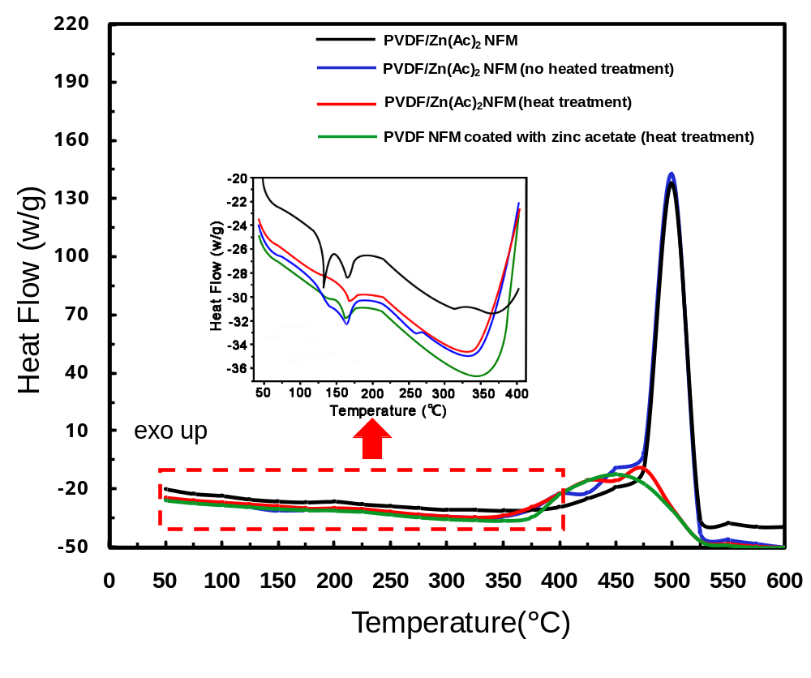
Figure S12. DSC curves of PVDF composite nanofiber mats. Black, pristine PVDF/Zn(Ac)₂ nanofiber mat. Blue, ZnO nanorods prepared on pristine PVDF/Zn(Ac)₂ nanofiber mat. Red, ZnO nanorods prepared on thermally treated PVDF/Zn(Ac)₂ nanofiber mat. Green, ZnO nanorods prepared on thermally treated PVDF nanofiber mat coated with Zn(Ac)₂.

The XRD diffractograms of the ZnO and PVDF composite nanofiber mats is shown in Figure S13. Among all the products, only the hydrothermally treated PVDF/Zn(Ac)₂ fiber mat shows nine obvious diffraction peaks that correspond to the crystalline structure of ZnO. In addition, the peak intensity of (002) is somewhat greater than that of (101), indicating that the growth of the hydrothermally synthesized ZnO nanorods with a hexagonal wurtzite structure is primarily along the c-axis.

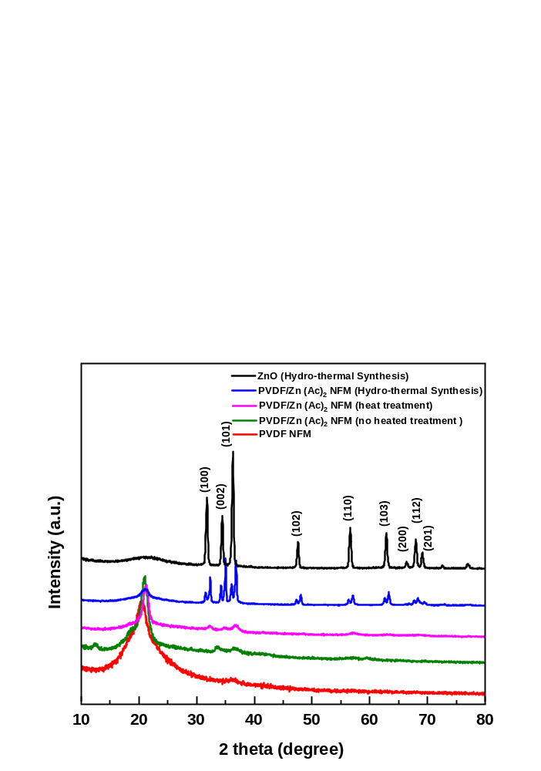
Figure S13. XRD diffractograms of ZnO and PVDF composite nanofiber mats. Black, pristine ZnO prepared from hydrothermal reaction. Blue, ZnO nanorods prepared from hydrothermal reaction of PVDF/Zn(Ac)₂. Pink, PVDF/Zn(Ac)₂ nanofiber mat thermally treated at 140 °C. Green, pristine PVDF/Zn(Ac)₂ nanofiber mat. Red, neat PVDF nanofiber mat.

Photocatalytic performance
To examine the effect of ZnO nanorods on photocatalytic degradation of Rhodamine B, two groups of experiment were carried out, as shown in Figure S14. The first group shows the comparison between the ZnO nanorod-loaded PVDF nanofiber membranes with different weights (1 g, 2 g and 3 g) and pristine ZnO powder (1 g) synthesized by hydrothermal method, whereas the second group shows the difference between the ZnO nanorod-loaded PVDF nanofiber membranes with the same weight (2 g) but different hydrothermal reaction time (1 h, 3 h and 5 h). Subsequently, the nanofiber membranes with the powder of these two experiments are added to the rhodamine B solution with a concentration of 10 mg/L and a total volume of 30 mL.

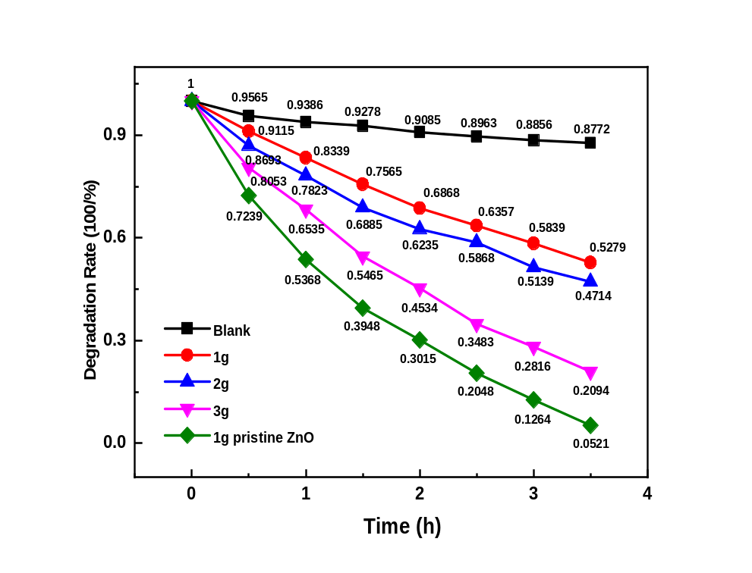
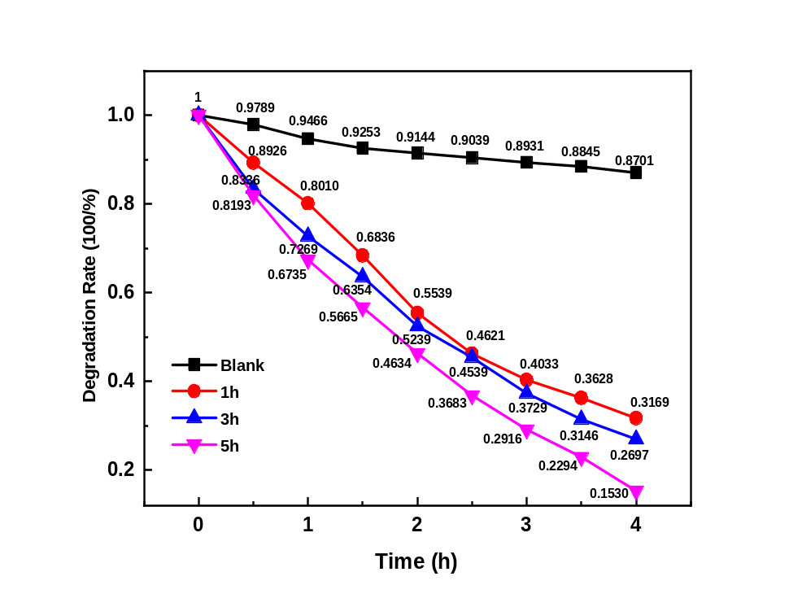
Figure S14. Photocatalytic degradation of Rhodamine B by ZnO nanorods. Top, degradation catalyzed by ZnO nanorod-loaded PVDF nanofiber membranes with different weights and by pristine ZnO powder. Bottom, degradation catalyzed by 2 g of ZnO nanorod-loaded PVDF nanofiber membranes with different hydrothermal reaction time.

