Supplementary files

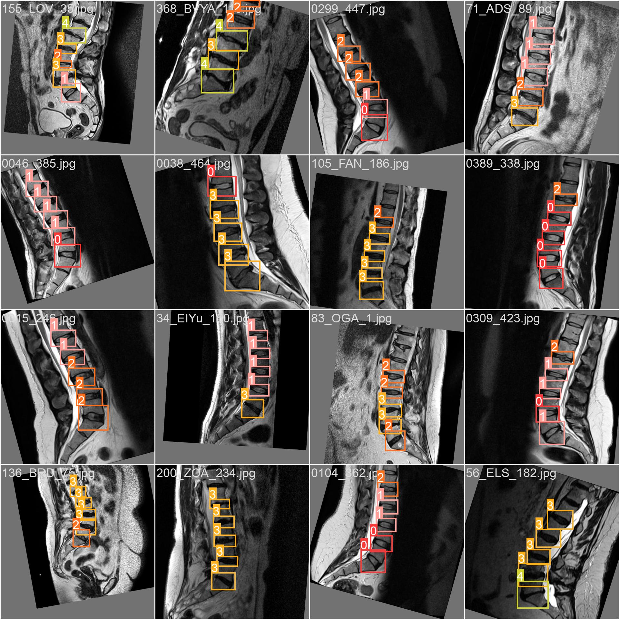

Figure 1. Examples of Data Augmentation Techniques Applied to MRI Images

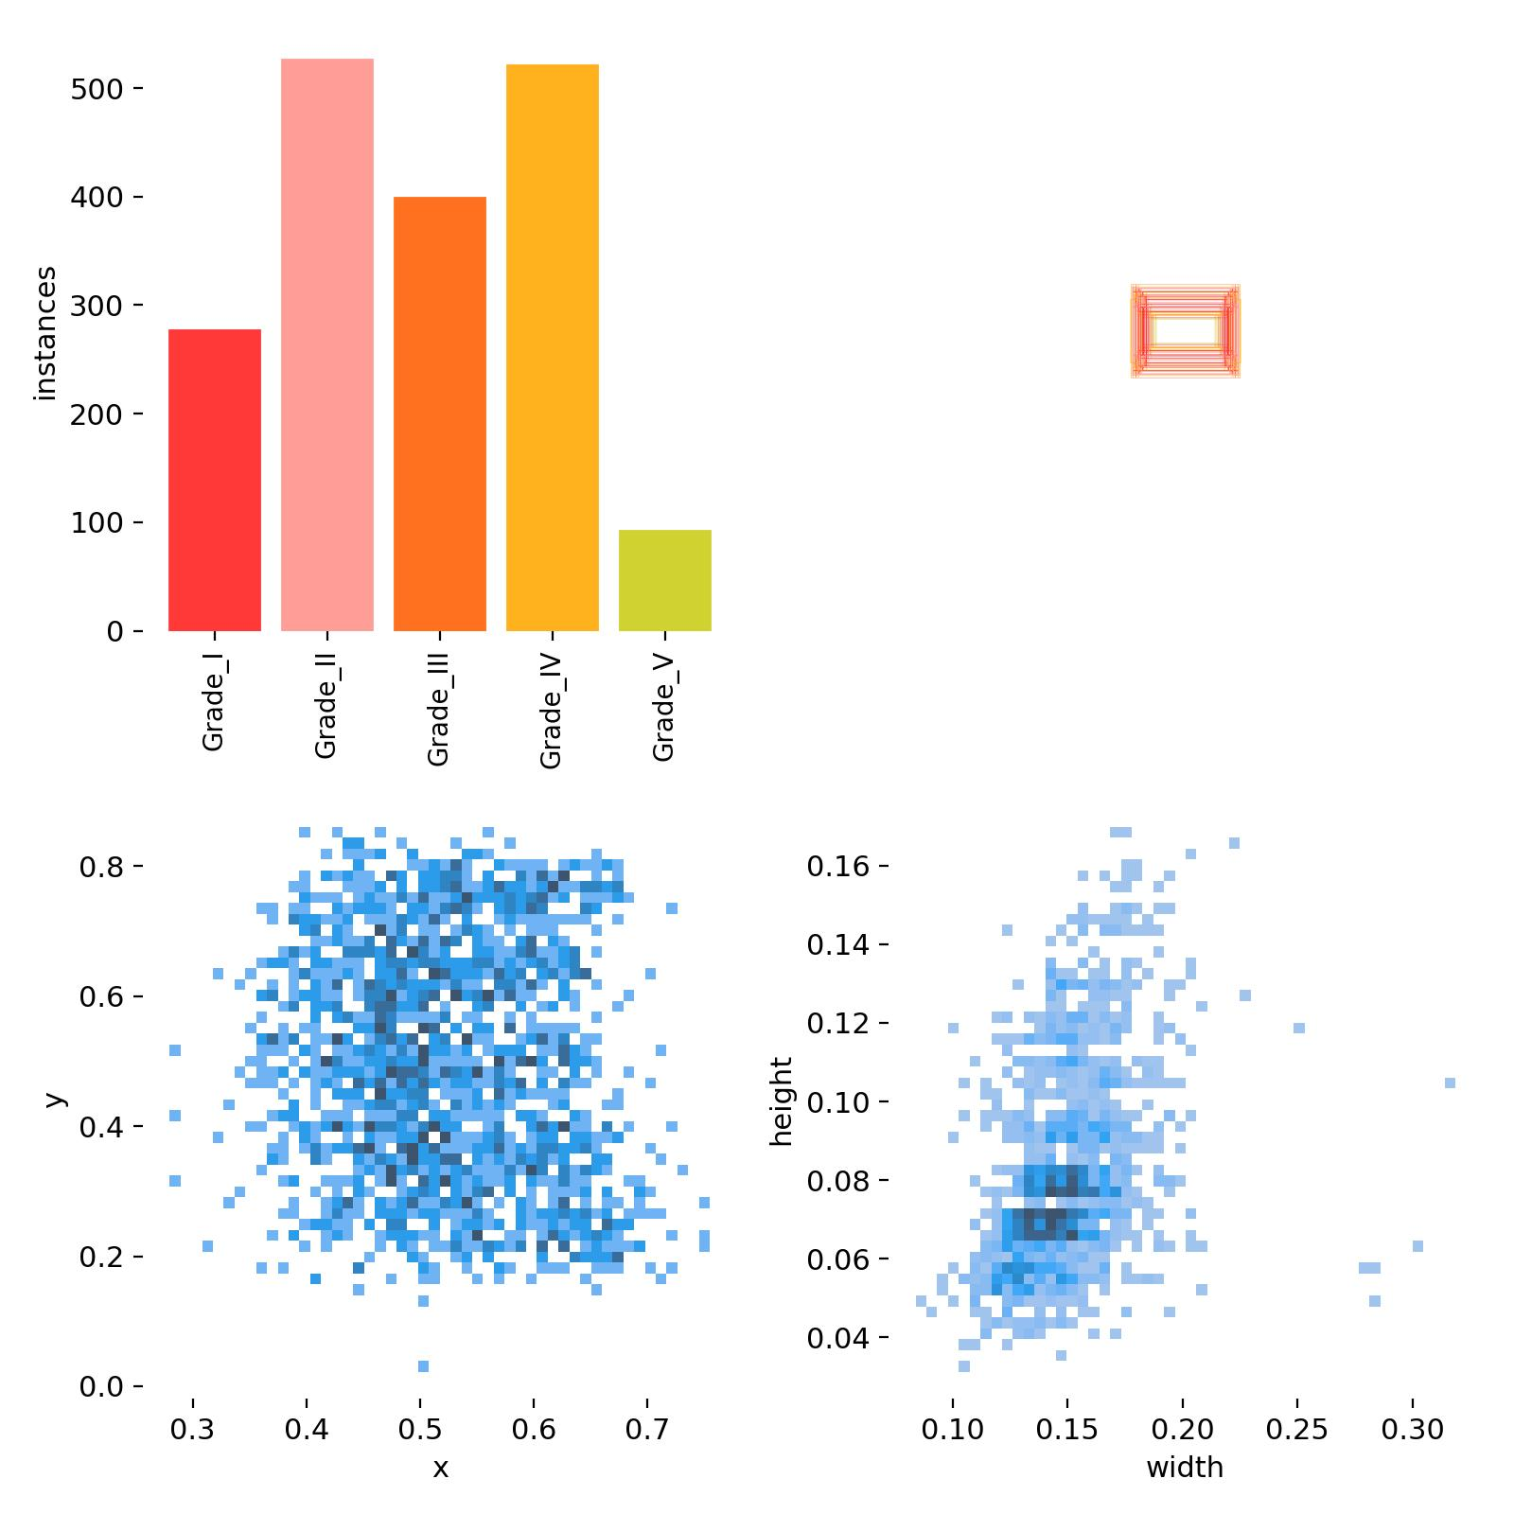
Figure 2: А detailed analysis of the dataset, showcasing the distribution of Pfirrmann grades across intervertebral discs alongside the normalized dimensions of bounding boxes. Furthermore, it illustrates the distribution of center coordinates (x, y) for these bounding boxes, as well as their normalized heights and widths, with values ranging from 0 to 1—a format aligned with the YOLO object detection framework

