Supplementary notes 1 – Evaluating Slice Averaging Strategies for Model Performance
This study evaluates how slice averaging impacts the classification performance of the YOLOv8x model for intervertebral disc degeneration. The model was trained on MRI slices selected by medical experts for accurate classification, but during automated inference, expert-driven slice selection is not possible. To address this, we tested several slice averaging strategies: using only the central slice, adding one, two, or three adjacent slices on each side, and including all slices from the MRI volume. Predictions from the selected slices were aggregated by determining the most frequently predicted class (mode) for each lumbar disc across the slices.
Performance was measured using Precision, Recall, and F1-score, and compared to the model's performance on expert-selected slices, yielding Precision = 0.75 and Recall = 0.808. Results are summarized in Table 2.

Averaging Strategy | Precision | Recall | F1-score
Central Slice | 0.73 | 0.70 | 0.71
Central ±1 Slice | 0.73 | 0.71 | 0.72
Central ± 2 Slice | 0.74 | 0.73 | 0.73
Central ±3 Slice | 0.71 | 0.69 | 0.70
Entire Volume | 0.71 | 0.68 | 0.69
Table 2. Classification metrics for different slice averaging strategies.

The results indicate that the Central ±2 Slice strategy produced the highest performance, with Precision of 0.74, Recall of 0.73, and F1-score of 0.73. This suggests that including neighboring slices enhances classification by providing more contextual information. Averaging with three adjacent slices or using the entire volume decreased performance (Precision: 0.71, Recall: 0.68, F1-score: 0.69), likely due to the inclusion of irrelevant or noisy slices.
The model's performance on expert-selected slices was higher (Precision: 0.75, Recall: 0.808), highlighting the benefit of expert selection. However, the Central ± 2 Slice strategy offers a practical compromise, optimizing model performance by balancing accuracy and computational efficiency. This approach delivers strong classification results without the need for manual slice selection during automated inference, minimizing the risks associated with using too many slices, and making it a robust solution for automated clinical applications.

Supplementary notes 2 – Web service
To facilitate the practical application of our trained model, we developed SpineScan, a web-based service designed for automated analysis of spinal MRI scans. SpineScan is accessible at spine-scan.science.nprog.ru and provides clinicians with an intuitive platform for evaluating spinal health through advanced image processing and machine learning techniques.
Upon accessing SpineScan, users are prompted to upload a folder containing DICOM files representing a spinal MRI scan (Figure 3). The system is engineered to handle the complexities associated with DICOM data, ensuring seamless ingestion and processing of the uploaded images.
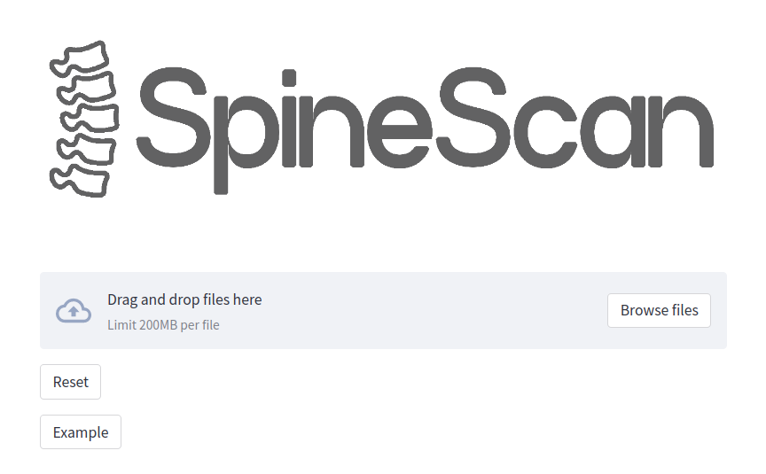
Figure 3. Illustration of the DICOM folder upload interface in SpineScan.
Once the DICOM files are uploaded, SpineScan employs an automated filtering mechanism to identify and select series with T2-weighted imaging. The model scans the metadata of each series to determine the weighting and filters out non-T2 series, thereby streamlining the dataset for subsequent analysis.
Among the selected T2-weighted series, SpineScan further analyzes each to determine the series that yields the most confident predictions. This selection is based on the model's confidence scores, which reflect the reliability of the predictions made for each series. By identifying the series with the highest confidence, SpineScan ensures that the subsequent analysis is grounded in the most accurate and trustworthy data available.
To enhance the robustness of the predictions, SpineScan implements the Central ±2 Slice strategy, which aggregates the model's outputs across five consecutive slices within the optimal series. This strategy involves selecting the central slice and the two adjacent slices on either side, providing a balanced context for classification. The averaging process mitigates the impact of anomalies or noise present in individual slices, thereby producing a more stable and reliable classification outcome. The aggregated results are then presented in a comprehensive table format, facilitating easy interpretation and review by clinicians (Figure 4).
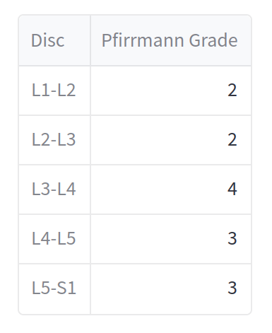
Figure 4. Example of the results table displaying averaged predictions across five slices.
In addition to the tabulated results, SpineScan provides a comprehensive visual summary of the model's predictions by displaying the five slices selected through the Central ±2 Slice strategy. Each slice is annotated with bounding boxes and classified according to the Pfirrmann grading system, allowing clinicians to verify the model's assessments and gain insights into the specific regions of interest identified by the algorithm (Figure 5). Furthermore, SpineScan presents critical metadata associated with the analyzed series, including the Series Instance UID, which uniquely identifies the selected series, and the Number of Slices, providing context on the volume of data processed. Displaying this metadata ensures transparency in the analysis process and facilitates traceability for clinical records and future reference.
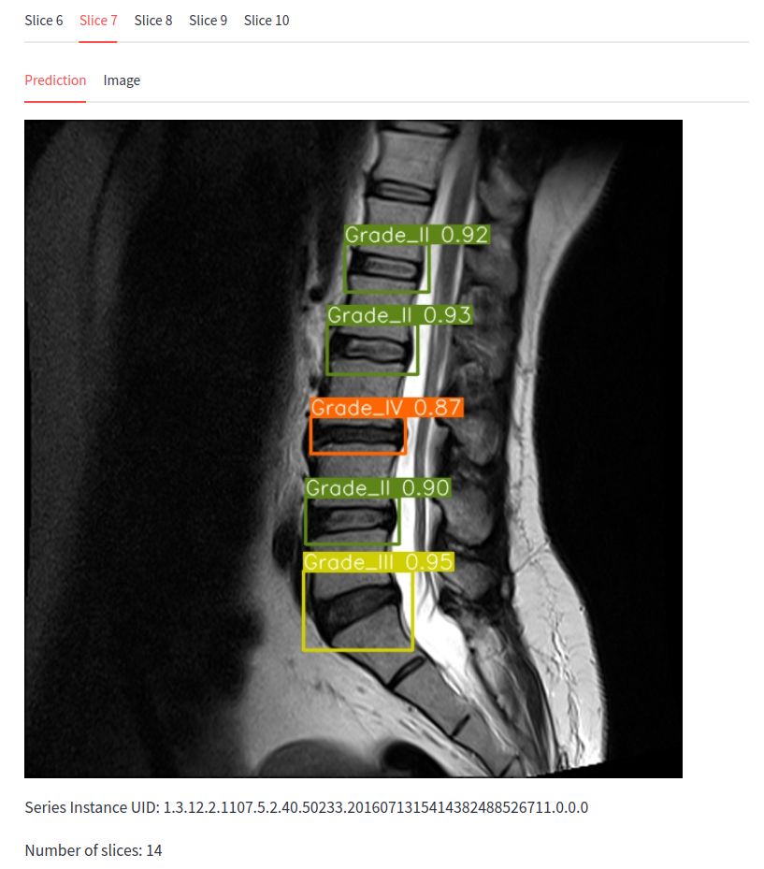
Figure 5. Visualization of five MRI slices with bounding boxes and Pfirrmann class annotations, along with Series Instance UID and Number of Slices for the selected series.

