Supporting Information for
Topologically Enhanced Giant Broadband Second-Harmonic Generation in Weyl Semiconductor Tellurium
Delang Liang^{1,2}, Mingyang Qin², Yong Liu¹, Weiming Wang^{3,4}, Bin Cheng⁵, Xiao Zhuo², Shiyu Wang², Zipu Fan², Huawei Liu¹, Guisen Chen¹, Qinsheng Wang⁷, Changgan Zeng⁵, Anlian Pan^{1,5†}, Jinluo Cheng^{3,4†}, and Dong Sun^{2,8,9†}

¹Key Laboratory for Micro-Nano Physics and Technology of Hunan Province, Hunan Institute of Optoelectronic Integration, College of Materials Science and Engineering, Hunan University, Changsha, China
²International Center for Quantum Materials, School of Physics, Peking University, Beijing, China.
³Key Laboratory of Luminescence Science and Technology, Chinese Academy of Sciences, Changchun, China.
⁴State Key Laboratory of Luminescence Science and Applications, Changchun Institute of Optics, Fine Mechanics and Physics, Chinese Academy of Sciences, Changchun, China.
⁵CAS Key Laboratory of Strongly Coupled Quantum Matter Physics, and Department of Physics, University of Science and Technology of China, Hefei, Anhui, China
⁶School of Physics and Electronics, Hunan Normal University, Changsha, China
⁷Key Laboratory of Advanced Optoelectronic Quantum Architecture and Measurement (Ministry of Education), School of Physics, Beijing Institute of Technology, Beijing, China
⁸Collaborative Innovation Center of Quantum Matter, Beijing, China
⁹Frontiers Science Center for Nano-optoelectronics, School of Physics, Peking University, Beijing, China

†Email: sundong@pku.edu.cn; jlcheng@ciomp.ac.cn; anlian.pan@hnu.edu.cn;

CONTENTS
1. Basic characterization of Te flakes 3
1.1 Crystal structural characterization 3
1.2 Crystallographic orientation identification with polarization-dependent Raman spectra 3
1.3 Thickness characterization. 6
2. Polarization-dependent SHG response 6
2.1 Symmetry analysis 6
2.2 Measurement of Polarization state of SHG signals 9
2.3 Highly anisotropic SHG response 10
2.4 Crystal symmetry confirmation with polarization dependent SHG measurements 12
3. Calculation of SHG conversion efficiency 12
4. Calculation of SHG susceptibility 13
5. Exclude Berry curvature dipole-dominated SHG 14
6. Numerical simulations of SHG susceptibility for different doping and relaxation time model 15
Table S1 | SHG susceptibility and conversion efficiency of different nonlinear materials 17
References 18

1. Basic characterization of Te flakes
In this section, we present basic characterization of the crystal structure and identify the high single-crystalline quality, crystallographic orientation, and the thickness of the Te flakes used in this work. Below are the details of these characterizations.
1.1 Crystal structural characterization
To confirm the crystal structure and chemical composition of the Te nanoflakes, we conducted measurements of high-angle annular dark-field scanning transmission electron microscopy (HAADF-STEM) imaging, selective area electron diffraction (SAED) pattern analysis and energy dispersive spectrometer (EDS) spectra. The atomic chain structure and layered nature of the Te flake can be confirmed by cross-sectional HAADF-STEM image with an almost defect-free atomic arrangement, as shown in Fig. S1a. The interplanar spacings along the (001) plane and interlayer lattice distances were measured to be approximately 6.2 Å and 3.9 Å, respectively, which is consistent with previously reported data¹. The SAED pattern in Fig. S1b displays bright rectangular diffraction spots, where the two spots nearest to the diffraction center correspond to the (010) and (001) planes of the Te crystal. The corresponding EDS spectra (Fig. S1c) confirming a strong signal for the tellurium element. These results collaboratively indicate that the Te flakes synthesized by the hydrothermal method exhibit high-quality single-crystalline characteristics.
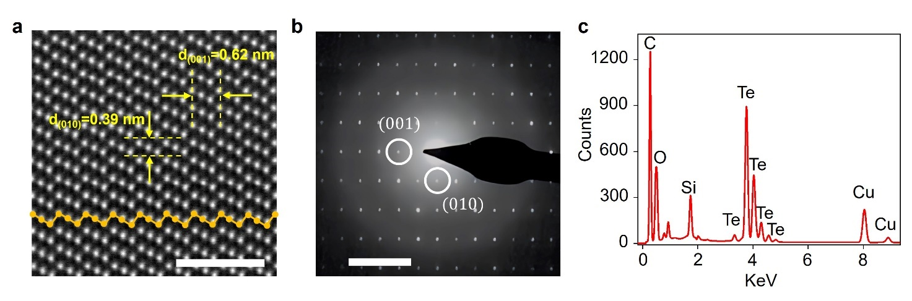
Fig. S1 | Crystal structural characterization of Te flakes. a, Cross-sectional HAADF-STEM image of the Te crystal viewed along the a-axis. False-colored (in yellow) atoms are superimposed on the original STEM image to highlight the helical atomic chain. b, The corresponding SAED pattern of a. Scale bars: 2 nm (a), 5 nm⁻¹ (b). c, The EDS spectra confirming the chemical composition of Te flake.
1.2 Crystallographic orientation identification with polarization-dependent Raman spectra
To identify the crystallographic orientation of the Te flake, polarization-dependent Raman spectroscopy was carried out by rotating an achromatic half-wave plate in the common optical path of the incident laser and scattered Raman signal (as shown in Fig. S2), where the polarization directions were simultaneously changed. The transmission axes of the polarizer and analyzer were maintained in the horizontal direction, corresponding to a parallel configuration². The Raman spectra of the Te flake (Fig. S3a) show three typical Raman-active modes located at 92 cm⁻¹ (E₁ (TO) mode), 121 cm⁻¹ (A₁ mode) and 143 cm⁻¹ (E₂ mode), which are consistent with previous reports^{1, 3, 4}. Figures S3b-d show polarization-dependent Raman peak intensities in polar coordinate diagrams under a parallel configuration, where all three vibration modes exhibit angle-dependent double symmetry. The initial polarization direction of the laser is perpendicular to the long edge of the Te flake, as shown in Fig. 1d of the main text.
The observed Raman signal depends on the lattice symmetry and the measurement geometry. The Raman intensity (I) of the phonon vibration mode is determined by $I\sim {\left|e_{i}∙ R ∙e_{s}\right|}^{2}$, where $e_{i}$and $e_{s}$represent the polarization directions of the incident and the scattered light, respectively, and $R$ represents the related Raman tensor. Theoretically, Te crystals belong to the D₃ point group, and thus, the corresponding Raman tensors are ^{4, 5}:
$R(A_{1})=\left(\begin{matrix} a & 0 & 0 \\ 0 & a & 0 \\ 0 & 0 & b\end{matrix}\right)$, $R(E(x))=\left(\begin{matrix}c & 0 & 0 \\ 0 & -c & d \\ 0 & d & 0\end{matrix}\right)$, $R(E(y))=\left(\begin{matrix}0 & -c & -d \\ -c & 0 & 0 \\ -d & 0 & 0\end{matrix}\right)$ (1)
where a, b, c, and d represent the elements of the Raman tensor. In the parallel polarized configuration, $e_{s}$= $e_{i}$= ($\cos{θ}$, 0, $\sin{θ}$) when the propagation direction of the incident laser is perpendicular to the crystal’s a-c plane. Here, θ denotes the angle between the polarization direction of the incident light and the a-axis of the crystal. The intensities of the three characteristic Raman modes can be written as a function of θ following the equations below^{1, 5, 6}:
$I(A_{1})∝{|a\cos^{2}θ+b\sin^{2}θ|}^{2}$ (2)
$I(E_{1}(TO))∝{|c\cos^{2}θ|}^{2}$ (3)
$I(E_{2})∝{{|c\cos^{2}θ|}^{2}+|2d sinθ cosθ|}^{2}$ (4)
As marked by the solid line in Fig. S3b-d, the polarization-dependent Raman intensities of the E₁ (TO), A₁, and E₂ modes can be well fitted by equations (S2) - (S4), respectively. Obviously, the peak Raman intensities of the E₁ (TO) mode reach a maximum at $θ=0^{°}$, which is along the crystallographic a-axis, as marked by the red arrow in Fig. 1d of the main text.
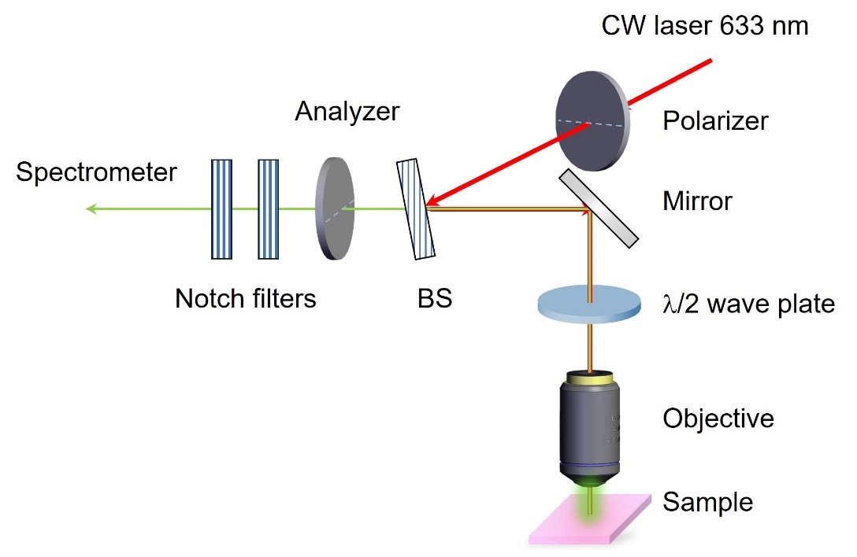
Fig. S2 | Schematics of the polarization-dependent Raman spectroscopy measurement setup. BS: beam splitter. In the parallel configuration, the transmission axes of the polarizer and the analyzer are aligned horizontally. The achromatic half-wave plate is rotated using a motorized rotation stage in this setup.
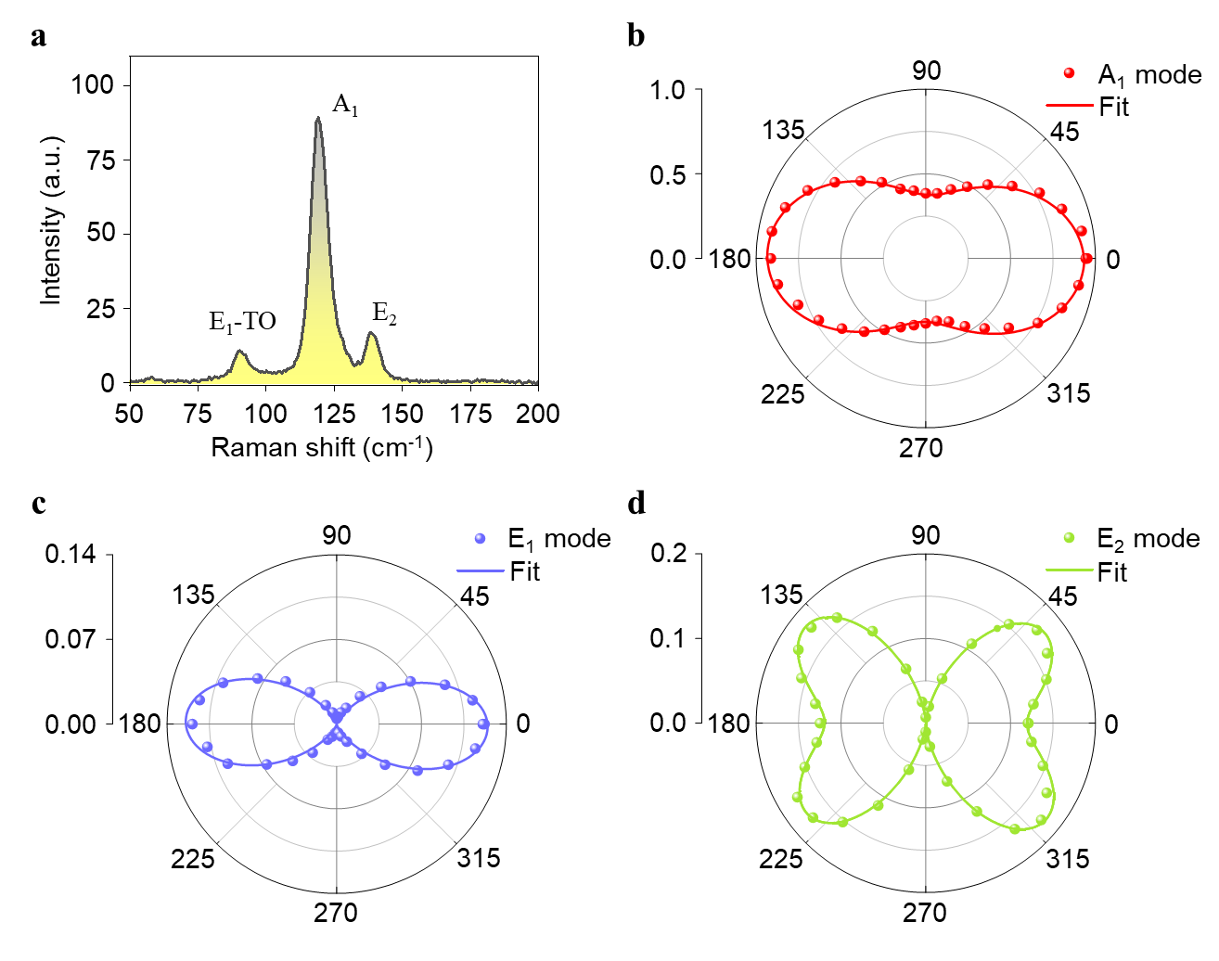
Fig. S3 | Polarization-dependent Raman spectra. a, Raman spectrum of a Te flake. b-d, Polarization-dependent Raman peak intensity of the A₁ (b), E₁(TO) (c) and E₂ (d) modes under the parallel configuration. The polarization angle of the incident laser is set to be zero degree aligned with the crystallographic a-axis, as marked in Fig. 1d of the maintext.
1.3 Thickness characterization.
Figure S4a presents an optical image of a Te flake used in our optical measurement, showing a distinct long edge in its geometrical morphology. The thickness of the Te flake is 18 nm, as confirmed by the atomic force microscopy (AFM) image shown Fig. S4b and S4c.
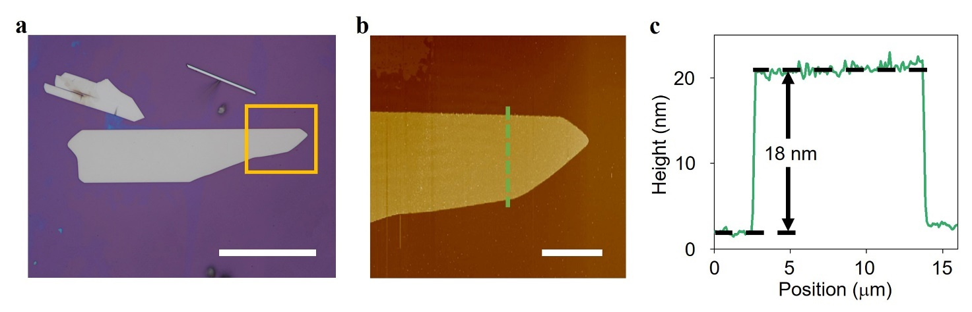
Fig. S4 | Thickness of Te flake. a, The optical image of Te flakes. b, The AFM image of the area marked by the yellow rectangular in a. c, The height profile along the green line marked in b. Scale bar: 50 μm (a), and 10 μm (b).

2. Polarization-dependent SHG response
In this section, we present details and additional results of polarization-dependent SHG measurements and related symmetry analysis.
2.1 Symmetry analysis
In general, the polarization characteristics of SHG are determined by the crystal symmetry of the material. The relationship between the SHG signal and the fundamental beam can be understood by analyzing the second-order nonlinear susceptibility tensor $χ_{ijk}^{(2)}$. The lattice structure of Te flakes belongs to the D₃ point group. By taking $x (z)$ axes along the crystallographic a (c)-axis and the y-axis along $\hat{y}=\hat{z}×\hat{x}$, the tensor $χ_{ijk}^{(2)}$ has eight nonzero elements among which only two are independent⁷: $χ_{xxx}^{(2)}=-χ_{xyy}^{\left(2\right)}=-χ_{yxy}^{\left(2\right)}=-χ_{yyx}^{\left(2\right)}$and $χ_{xyz}^{(2)}=χ_{xzy}^{\left(2\right)}=-χ_{yzx}^{\left(2\right)}=-χ_{yxz}^{\left(2\right)}$. The nonlinear polarization of second-harmonic wave (2ω) can be expressed as:
$P\left(2ω\right)=\left(\begin{matrix}P_{x}\left(2ω\right) \\ P_{y}\left(2ω\right) \\ P_{z}\left(2ω\right)\end{matrix}\right)=ϵ_{0}\left(\begin{matrix}χ_{xxx}^{(2)} & {-χ}_{xxx}^{(2)} & 0 & χ_{xyz}^{(2)} & 0 & 0 \\ 0 & 0 & 0 & 0 & χ_{xyz}^{(2)} & -χ_{xxx}^{(2)} \\ 0 & 0 & 0 & 0 & 0 & 0\end{matrix} \right)\left(\begin{matrix}{E_{x}(ω)}^{2} \\ {E_{y}(ω)}^{2} \\ {E_{z}(ω)}^{2} \\ 2E_{y}(ω)E_{z}(ω) \\ 2E_{x}(ω)E_{z}(ω) \\ 2E_{x}(ω)E_{y}(ω)\end{matrix}\right)$(5)
where $E_{x}(ω)$, $E_{z}(ω)$, and $E_{y}(ω)$ are components of the electrical fields. Notably, all tensor elements $χ_{zjk}^{(2)}$ are zero, which indicates that the second harmonic polarization along the crystallographic c-axis should vanish.
In our experiment, the relative direction of the incident fundamental light, the laboratory coordinate system X, Y, Z-axes, and the crystal coordinates x, y, z-axes are indicated in Fig. S5. When the incident light is linearly polarized, the polarization direction intersects with X-axis by an angle $α,$ and the intersect angle between the x-axis and X-axis is $θ$. Then, $E_{x}\left(ω\right)=E(ω)∙\cos{(α+θ)}$, $E_{z}\left(ω\right)=E(ω)∙\sin{(α+θ)}$ and $E_{y}\left(ω\right)=0$. Therefore, in the crystallographic ac plane, the polarizations along the a- and c-axes are:
$P_{x}\left(2ω\right)=ϵ_{0}χ_{xxx}^{(2)}{E_{x}(ω)}^{2}={ϵ_{0}χ_{xxx}^{\left(2\right)}{\left|E\left(ω\right)\right|}^{2}cos}^{2}(α+θ)$ (6)
$P_{z}\left(2ω\right)=0$ (7)
Clearly, from equations (S6) and (S7), only the electric field component of the fundamental beam parallel to the a-axis ($E_{x}\left(ω\right)$) can induce SH polarization parallel to the a-axis ($P_{x}\left(2ω\right)$). This demonstrates that the polarization direction of the SHG signal is always linearly polarized along the a-axis regardless of the polarization of fundamental excitation.
Nevertheless, we still carried out a polarization state analysis of SHG signal based on our measurement setup. The polarization state of the SHG signal was measured by rotating a half-wave plate (HWP) placed before the analyzer on the SHG signal path instead of a rotating analyzer to exclude the influence of the polarization-dependent effect of the spectrometer. The fast axis of the HWP is aligned an angle $β$ with the X-axis and the polarization of the analyzer is set parallel to the laboratory X-axis. For SHG light field $E(2ω)=$($E_{X}\left(2ω\right), E_{Y}\left(2ω\right), 0)$passing through the HWP and polarizer, the transmitted electric field can be written as follows:
$E(2ω)=\left(\begin{matrix}1 & 0 & 0 \\ 0 & 0 & 0 \\ 0 & 0 & 0\end{matrix}\right)\left(\begin{matrix}\cos\left(2β\right) & -\sin\left(2β\right) & 0 \\ \sin\left(2β\right) & \cos\left(2β\right) & 0 \\ 0 & 0 & 1\end{matrix}\right)\left(\begin{matrix}E_{X}\left(2ω\right) \\ E_{Y}\left(2ω\right) \\ 0\end{matrix}\right)$ (8)
and the detected SH signal is
$I_{2ω}∝{\left|\cos\left(2β\right) E_{X}\left(2ω\right)-\sin\left(2β\right)E_{Y}\left(2ω\right)\right|}^{2}$ (9)
In this measurement, the crystallographic a-axis of Te flakes is set parallel to the laboratory X-axis with taking $θ=0^{°}$. The SH field in the laboratory coordinate system is given by:
$E_{X}\left(2ω\right)∝P_{x}\left(2ω\right)={ϵ_{0}χ_{xxx}^{(2)}{\left|E(ω)\right|}^{2}cos}^{2}(α)$ (10)
$E_{Y}\left(2ω\right)∝P_{z}\left(2ω\right)=0$ (11)
The polarization component of the SHG signal under linearly polarized light excitation is:
$I_{2ω}^{LP}∝{\left|E(2ω)\right|}^{2}∝χ_{xxx}^{(2)}{\left|E(ω)\right|}^{4}\cos^{2}(2)\cos^{4}(α)$ (12)
Similarly, under circularly polarized light excitation: $E_{x}\left(ω\right)=E(ω)/\sqrt{2}$ and $E_{z}\left(ω\right)=±iE(ω)/\sqrt{2}$. The polarization component of the SHG signal under right or left circularly polarized light excitation is:
$I_{2ω}^{RCP/LCP}∝{\left|E(2ω)\right|}^{2}∝\frac{1}{4} χ_{xxx}^{(2)}{\left|E(ω)\right|}^{4}\cos^{2}(2)$ (13)
Meanwhile, the total SHG intensity as a function of the excitation polarization ($α$) is:
$I_{2ω}^{total}∝{\left|P_{x}\left(2ω\right)\right|}^{2}+{\left|P_{z}\left(2ω\right)\right|}^{2}∝{χ_{xxx}^{(2)}\left|E(ω)\right|}^{4}\cos^{4}\left(α\right)$ (14)
In polarization dependent SHG measurement to confirm the crystal symmetry, the excitation polarization direction is fixed along the X-axis ($α=0$); then, $E_{x}\left(ω\right)=E(ω)∙\cos{()}$, $E_{z}\left(ω\right)=E(ω)∙\sin{()}$ and $E_{y}\left(ω\right)=0$. The transmission axis of the analyzer in the detection channel is set either parallel ($P_{//}\left(2ω\right)$) or perpendicular$(P_{⊥}\left(2ω\right))$ to the excitation polarization, corresponding to parallel and perpendicular configurations. Therefore, the parallel and the perpendicular components of the SHG intensity should follow the following equations:
$I_{2ω}^{//}∝{\left|P_{//}\left(2ω\right)\right|}^{2}∝{χ_{xxx}^{(2)}\left|E(ω)\right|}^{4}\cos^{6}(θ)$ (15)
and the perpendicular component is
$I_{2ω}^{⊥}∝{\left|P_{⊥}\left(2ω\right)\right|}^{2}∝χ_{xxx}^{(2)}{\left|E(ω)\right|}^{4}{(sin(θ)\cos^{2}(θ))}^{2}$ (16)

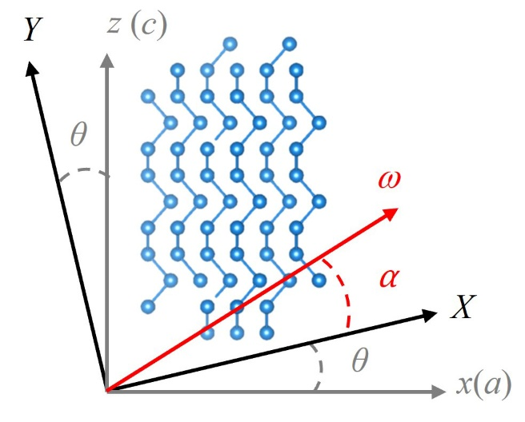
Fig. S5 | Schematic diagram of the crystal coordinates (x, y, z), laboratory coordinates (X, Y, Z), and light polarization. The angle θ defines the orientation of the crystallographic a-axis relative to the laboratory X-axis, whereas α denotes the polarization angle of the fundamental beam with respect to the X-axis.
2.2 Measurement of Polarization state of SHG signals
The schematic of the polarization-dependent SHG measurement setup is shown in Figure. S6. As illustrated in Fig. 1g of the main text, the SHG signals are highly linearly polarized along the a-axis, regardless of the linear polarization direction of the fundamental excitation. This linearly polarized character of the SHG signal is also maintained when the polarization of the fundamental beam is changed to circular polarization (Fig. S7a). The results are well fitted by equation (S13) derived from symmetry analysis, as shown by the solid lines in Fig. S7a. Notably, SHG intensities under right-circular (σ⁺) and left-circular (σ⁻) are equal, each corresponds to one-quarter of the maximum SHG intensity observed at linear polarization excitations α = 0°, as only the polarization component along the a-axis of the excitation light contributes to the SHG.

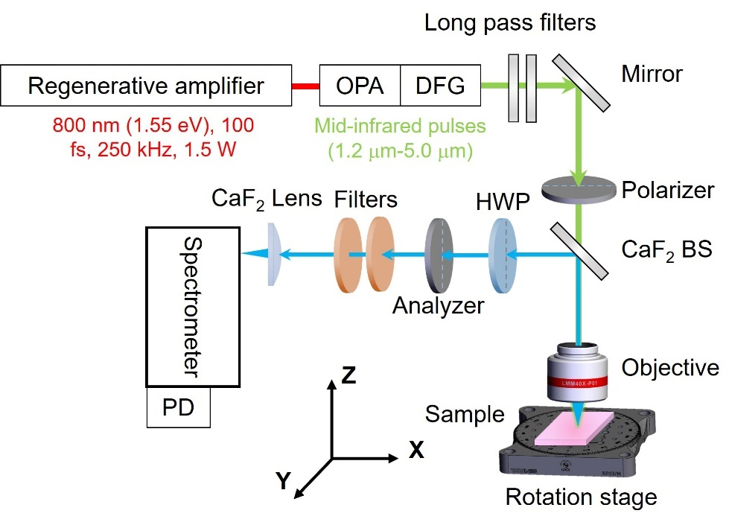
Fig. S6 | Schematic of the polarization-dependent SHG measurement setup. OPA: optical parametric amplifier, DFG: difference frequency generation, BS: beam splitter, HWP: half-wave plate, PD: InGaAs photodetector. Several filters are used to discriminate the residual fundamental beam. The SHG signal is detected by an InGaAs photodetector.
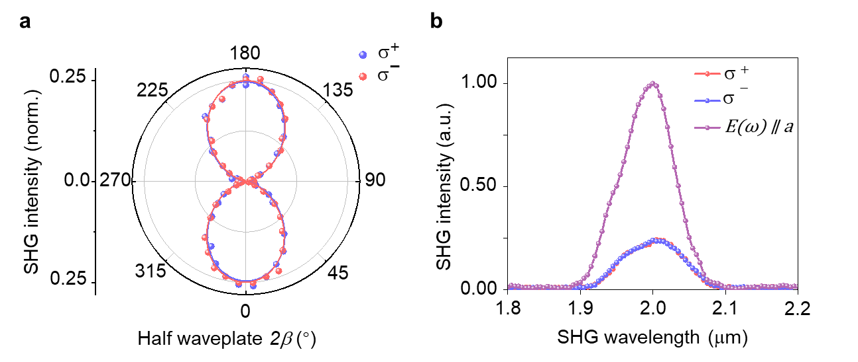
Fig. S7 | The circular polarization-dependent SHG response. a, Polarization state of SHG signals under σ⁺ and σ– excitation. b, SHG intensity under σ⁺ and σ–, as well as linear polarization ( $E(ω)$ ∥ a) along the a-axis excitation.
2.3 Highly anisotropic SHG response
In this session, we studied the dependence of SHG response on the excitation polarization. Figure S8 shows the total SHG intensity as a function of the excitation polarization angle (α) with no analyzer used before the detector to capture the overall SHG intensity. The SHG intensity reaches its maximum when the excitation polarization is along the a-axis and drops to zero when aligned with the c-axis, exhibiting strong anisotropic response. The data is well fitted by equation (S14) with the symmetry analysis detailed in S2.1.
As mentioned in the above, the polarization dependent SHG measurement also provides an alternative approach to determine the crystallographic axis of Te flake. The polarized SHG image was further measured in a 90°-folded Te flake, where one part is folded roughly perpendicular to the other part, as shown in Fig. S9. In the spatial mapping measurement, the total SHG was collected at three different linear polarization directions (α = 0°, 90°, 45°), as well as σ⁺ and σ– polarizations. These polarization-dependent SHG image results clearly illustrate the polarization characteristics described above, and help identify the crystallographic axis of the flake.
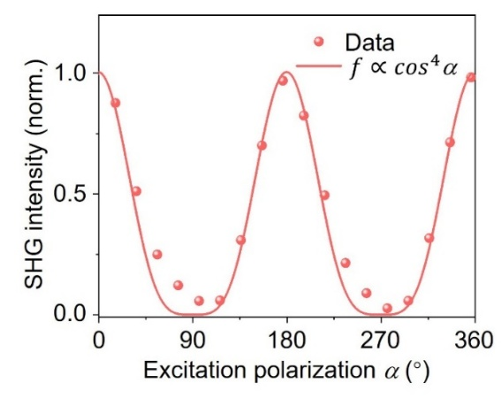
Fig. S8 | The total SHG intensity under different polarization angles of excitation. 0° is along the cystallographic a-axis.
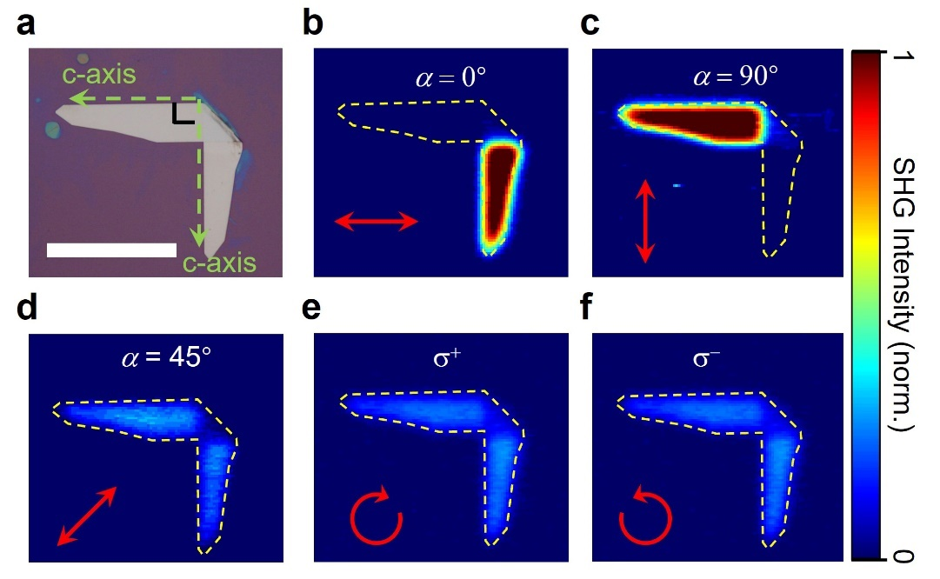
Fig. S9 | Polarized SHG spatial imaging from Te flakes. a, Optical image of a 90°-folded Te flake along the crystallographic c-axis (indicated by the dashed arrows). Scale bar: 50 μm. b-f, Mappings of the total SHG intensity for linearly polarized light at angles of 0° (b), 90° (c), and 45° (d) and for the σ⁺ (e) and σ– (f) polarization states of the fundamental beam. The red symbols denote the corresponding polarization states of the fundamental excitation beam.
2.4 Crystal symmetry confirmation with polarization dependent SHG measurements
Finally, we verify the crystal symmetry of Te flakes through polarization dependent SHG measurement under parallel (//) or perpendicular (⊥) configurations (Fig. S10). The SHG signal shows two-lobes under a parallel (red dots) configuration and four-lobes under a perpendicular (blue dots) configuration, respectively. This is consistent with the crystal symmetry analysis and the fitting with equations (S15) and (S16), as plotted by the solid red ($I_{2ω}^{//}$) and blue ($I_{2ω}^{⊥}$) lines in Fig. S8. The polarization-resolved SHG pattern at 1.2-μm and 2-μm excitation are the same as the pattern observed at 4-μm excitation, suggesting that polarization characteristics are determined by the crystal symmetry which should be insensitive to the excitation wavelength.
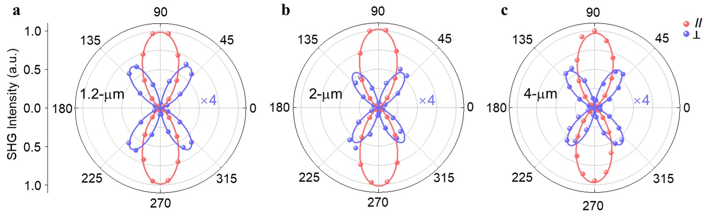
Fig. S10 | Polarization dependence of the SHG intensity at different fundamental wavelengths. The polarization dependence of the SHG intensity is measured at 1.2-μm (a), 2-μm (b) and 4-μm (c) fundamental wavelengths under parallel and crossed configurations.

3. Calculation of SHG conversion efficiency
We define the conversion efficiency $η_{SHG}={P_{2ω}}/{P_{ω}}$ for comparison of the SHG conversion capability of different materials, where $P_{2ω}$ and $P_{ ω}$ represent the average power of the SHG and the fundamental light, respectively. To obtain the absolute SHG power $P_{2ω}$from the Te flake, we introduce a laser beam with the same wavelength as the SHG signal for a calibration reference. The reference laser beam goes through the same optical path as that is used for the SHG measurements and keeps the same polarization direction with SHG signal. The average power was denoted as $P_{ref}$ after passing through the same objective and then a mirror with nearly perfect reflectance replaced the sample to reflect the reference laser. All other detection conditions were kept identical to those used in the SHG measurements, except that an additional neutral density (ND) filter with attenuation factor N was introduced to reduce the illuminating intensity that reaches the detector. The resulting signal obtained by the CCD camera/InGaAs detector was denoted as ${ I}_{2}$ for the calibration laser beam. Then, we can estimate the actual SHG power $P_{2ω}$ from the Te flake by proportionally scaling the calibration signal ${ I}_{2}$ to the detected SHG signal ${ I}_{1}$ in the SHG measurement. The estimated SHG conversion efficiency is expressed as $P_{2ω}={I_{1} P_{ref}}/{I_{2} N}$.

4. Calculation of SHG susceptibility
To estimate the magnitude of the second-order nonlinear susceptibility $χ^{(2)}$, we must consider the interference effect of the fundamental and second harmonic (SH) light in the four layers (the refractive indices $n_{0}$/$n_{1}$/$n_{2}$/$n_{3}$ for the air/Te/SiO₂/Si) structure and neglect phase matching owing to the reduced nanoflake thickness, as shown in Fig. S8. For the fundamental wavelength, interference occurs between the incident fundamental light and its reflected light, and for the second harmonic wavelength, interference occurs between the upward SH light and the reflected downward SH light. Under this diagram, we employed the transfer matrix method and Green function technique to calculate the thickness-dependent SHG intensities for an ultrathin film and obtained⁸:
$I_{2ω}=\frac{1}{2ε_{0}c}{\left|{\left(1+R_{ω}\left(d_{1}\right)\right)}^{2}(1+R_{2ω}(d_{1}))\right|}^{2}{\left|\frac{πd_{1}χ^{(2)}}{λ_{2ω}}\right|}^{2}I_{ω}^{2}$ (17)
Here, $I_{ω}$($I_{2ω}$) is the intensity of the fundamental beam (SHG) field, $d_{1}$ is the thickness of Te flakes, $λ_{2ω}$ is the SHG wavelength, $ε_{0}$ is the vacuum permittivity, $c$ is the speed of light in vacuum, and $R_{ω}$ and $R_{2ω}$ are the total reflection coefficients of the whole structure at frequencies $ω$ and $2ω$, respectively.
To obtain the total reflection coefficients$R_{ω}(d_{1})$ of the four-layer structure, we used the transfer matrix method to connect the electric fields of different layers at frequency $ω$:
$\left(\begin{matrix}E_{0}^{+} \\ E_{0}^{-}\end{matrix}\right)=M∙\left(\begin{matrix}0 \\ E_{3}^{-}\end{matrix}\right)$ (18)
$M=\frac{1}{t_{01}}\left[\begin{matrix}1 & r_{01} \\ r_{01} & 1\end{matrix}\right]∙\left[\begin{matrix}e^{ik_{1}d_{1}} & 0 \\ 0 & e^{-ik_{1}d_{1}}\end{matrix}\right]∙\frac{1}{t_{12}}\left[\begin{matrix}1 & r_{12} \\ r_{12} & 1\end{matrix}\right]∙\left[\begin{matrix}e^{ik_{2}d_{2}} & 0 \\ 0 & e^{-ik_{2}d_{2}}\end{matrix}\right]∙\frac{1}{t_{23}}\left[\begin{matrix}1 & r_{23} \\ r_{23} & 1\end{matrix}\right]$ (19)
where $M$ is the total transfer matrix of the whole structure; $E_{i}^{+}$ and $E_{i}^{-}$ represent the electric fields of layer $i$ propagating in the upward and downward directions, respectively; $r_{ij}=\frac{n_{ω,i}-n_{ω,j}}{n_{ω,i}+n_{ω,j}}$ and $t_{ij}=\frac{2n_{ω,i}}{n_{ω,i}+n_{ω,i}}$ are the reflection coefficient and the transmission coefficient at the interface between two layers $i$ and $j$, respectively; $k_{i}={2πn_{ω,i}}/{λ_{ω}}$ are the wavevectors of the fundamental light ($ω$); and the refractive index ($n_{1}$) of Te flakes can be obtained from previous reports⁹, with $n_{1}$=4.8 at 2 μm. $d_{2}$=285 nm represents the thickness of the SiO₂ layer. The total reflection coefficient for fundamental light (ω) is:
$$R_{ω}(d_{1})=\frac{r_{01}+r_{01}r_{12}r_{23}e^{2ik_{2}d_{2}}+\left(r_{12}+r_{23}e^{2ik_{2}d_{2}}\right)e^{2ik_{1}d_{1}}}{1+r_{01}r_{12}e^{2ik_{1}d_{1}}+r_{01}r_{23}e^{2ik_{1}d_{1}}e^{2ik_{2}d_{2}}+r_{12}r_{23}e^{2ik_{2}d_{2}}} (20)$$
Similarly, the total reflection coefficient for the second harmonic light (2ω) is:
$$R_{2ω}\left(d_{1}\right)=\frac{R_{01}+R_{01}R_{12}R_{23}e^{2iK_{2}d_{2}}+\left(R_{12}+R_{23}e^{2iK_{2}d_{2}}\right)e^{2iK_{1}d_{1}}}{1+R_{01}R_{12}e^{2iK_{1}d_{1}}+R_{01}R_{23}e^{2iK_{1}d_{1}}e^{2iK_{2}d_{2}}+R_{12}R_{23}e^{2iK_{2}d_{2}}} (21)$$
where $R_{ij}=\frac{n_{2ω,i}-n_{2ω,j}}{n_{2ω,i}+n_{2ω,j}}$, $T_{ij}=\frac{2n_{2ω,i}}{n_{2ω,i}+n_{2ω,i}}$ and $K_{i}={2πn_{2ω,i}}/{λ_{2ω}}$ are the reflection coefficient, transmission coefficient and wavevectors at 2ω (SH light), respectively.
The intensity of the fundamental beam is estimated to be:
$I_{ω}=\frac{P_{ω}}{νt_{ω}S_{ω}}$ , (22)
where $P_{ω}$ represents the average power of the fundamental beam, $ν$ = 250 kHz is the repetition frequency. $t_{ω}$ is the pulse width of the fundamental beam, which is 150-200 fs for the NIR region (1.2-2.4 μm) and 200-280 fs for the MIR region (2.5-4.9 μm) measured via interferometric autocorrelation using either InGaAs or InSb photodetector. $S_{ω}=πr^{2}$ is the spot area of the focused Gaussian light, and $r$ is the spot radius, ranging from 2.8 μm to 8.3 μm, corresponding to pump wavelengths from 1.2 μm to 4.9 μm.
Similarly, the SHG intensity $I_{2ω}$ is estimated as:
$I_{2ω}=\frac{P_{ 2ω}}{νt_{2ω}S_{2ω}}$ , (23)
where $P_{2ω}$ is the average power of the SHG, which is measured using the method outlined in Supplementary Note 3. $t_{2ω}=t_{ω}/\sqrt{2}$ and $S_{2ω}=S_{ω}/2$, represent the pulse width and spot area of the SHG, which also exhibit Gaussian spatial and temporal profiles.
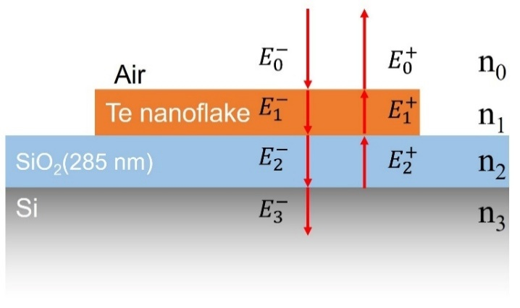
Fig. S11 | Diagram of the sample structure and sketch of the electric fields in each layer. $E_{i}^{+}$ and $E_{i}^{-}$ represent the electric fields of layer $i$ propagating in the positive and negative directions, respectively.
5. Exclude Berry curvature dipole-dominated SHG
Fu et al.’s work attribute the giant SHG response to the large Berry curvature dipole (BCD) located around the Weyl points⁶, and the second-order nonlinear susceptibility is described by
$χ_{abc}=-ε_{adc}\frac{e^{3}τ}{2\left(1+iωτ\right)}\int_{k}{f_{0}\left(∂_{b}Ω_{d}\right)}$ (24)
which is proportional to BCD ($D_{bd}=\int_{k}{f_{0}\left(∂_{b}Ω_{d}\right)}$). However, equation (S24) shows that the BCD -dominated SHG arises from intraband resonant transitions from electrons near the Fermi surface, and the corresponding susceptibility exhibits a Drude-type photon energy dependence¹⁰. Therefore, for a Weyl semimetal, BCD induced SHG will play key role when the Fermi surface lies in the vicinity of the Weyl nodes and the excitation photon energy is very low (e.g., THz photons). These conditions are not satisfied in their experiments. Although their experimental results in the near infrared (NIR) wavelength range (0.7-2.5 μm) appear to follow the Drude-type photon energy dependence in Equation (24), which gives greater $χ^{(2)}$ values at lower photon energies. However, such dependence conflicts with our experimental results, when the fundamental wavelength is extended into the mid-infrared (MIR) wavelength (2.5-4.9 μm, corresponding to photon energies as low as 0.25 eV) and the measured $χ^{(2)}$ values exhibit a decreasing trend for longer wavelengths and a pronounced peak at 2.2 μm. These MIR experimental results directly exclude the possibility that the giant SHG response was induced by the BCD. Instead, our work provides clear evidence that the enhanced SHG responses in these wavelengths arise from huge interband Berry connections around the Weyl points.

6. Numerical simulations of SHG susceptibility for different doping and relaxation time model
In this section, we show more details about the numerical calculation of SHG susceptibility. Different from previous works¹¹, our expressions take into account of the effects of doping in Te. Due to the natural hole doping of Te flakes and the carrier density as high as 10¹⁸ cm⁻³, the Fermi level (E_{f}) is approximately 5-40 meV below the valence band edge^{12, 13}. So, when adjusting Fermi level from intrinsic to heavy p-doping semiconductor, the calculated $χ^{(2)}$ values (Fig. S12a) show noticeable variation in the low-energy range (0.2-1.1 eV), but with negligible effects in the high-energy range.
The relaxation time is a phenomenological parameter used in evaluating the SHG susceptibility, and in fact, it is also taken as a fitting parameter for the experiments. Microscopically, the relaxation time depends on many factors, including the electron density of states¹⁴ and scattering channels; thus, it should be a parameter that depends on the electron energy or the excitation photon energy. For the high-photon-energy excitation range, a correction to the relaxation time should be taken into account; compared with low-energy excitations, the excited high-energy electrons can relax more efficiently because of the greater electron density of states and more scattering channels, and the phenomenological relaxation time can be much shorter. To count for this effect, the phenomenological relaxation time ($τ$) is chosen as photon energy dependent function as follows:
$$\frac{ℏ}{τ}=0.033 eV+c\left(1-\frac{1}{e^{33.68*\left(\frac{ℏω}{eV}-0.79\right)}+1}\right) (25)$$
from which the relaxation time ($τ_{h}$) at high energy range ($ℏω>0.79$ eV) changes from 20 fs to about 1 fs. Here, 33.68 represents the value of $eV/k_{B}T$ at T = 300 K. The parameter c was set to 0, 1/3, 2/3, and 1 eV, corresponding to different choices for $τ_{h}$in high-energy range. Here, the energy of 0.79 eV is used to distinguish the two regions of the relaxation times because the photon transition below 0.79 eV mostly occurs between the lowest two conduction bands and the highest two valence bands, whereas the optical transition with energies above 0.79 eV introduces new scattering channels to other bands; the relaxation time is chosen at the level of femtoseconds considering the high excess energy and carrier density following an ab initio calculation of MoS₂^{15, 16}. Figure S13b shows the variation in the calculated $χ^{(2)}$ under these different $τ$ values, with the value (c=1 eV, $τ_{h}$=0.64 fs) matching well with the experimental data in the high-energy range.
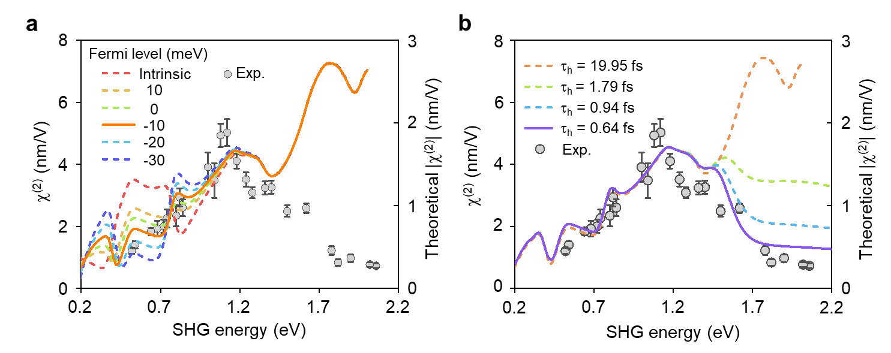
Fig. S12 | Numerical calculation of the SHG susceptibility at different parameters. a, The comparison of the experimentally extracted $χ^{(2)}$ and the theoretically calculated $χ^{(2)}$ at different Fermi levels by setting the zero energy (E_{f} = 0 meV) at the valence band edge. b, The comparison of theoretically calculated $χ^{(2)}$ at different $τ_{h}$ in high-energy range.
Table S1 | SHG susceptibility and conversion efficiency of different nonlinear materials
Material | Thickness* | $χ^{(2)}$ (pm/V) ** | $η_{SHG}$ (%)*** | Fundamental Wavelength (μm) | Reference
Te | 18 nm | 5024 $±$437 | 5×10⁻³ | 2.0 | This work
Te | 18 nm | 1405 $±$115 |  | 4.6 | This work
Te | 10 nm | 5580 |  | 2.3 | Ref. ⁶
Te | bulk | 1843$±$586 |  | 10.6 | Ref. ¹⁷
GaSe | FL | 80$±$18 |  | 1.46 | Ref. ¹⁸
GaSe | 14 L | 18.2 | 6×10⁻⁷ | 1.56 | Ref. ¹⁹
GaSe | 20 nm | 88 | 4.5×10⁻⁵ | 2.0 | This work
WSe₂ | ML | 68 | 4×10⁻⁸ | 1.5 ^{R} | Ref. ²⁰
MoS₂ | ML | 29 | 3×10⁻⁹ | 1.56 | Ref.²¹
MoS₂ | ML | 78 |  | 1.4 ^{R} | Ref.²²
MoS₂ | ML | 6.3 |  | 1.6 | Ref.²³
WS₂ | FL | 680 |  | 1.12 | Ref.²⁴
WS₂ | ML | 300 |  | 0.88^{R} | Ref.²⁵
MoSe₂ | ML | 37 | 9.4×10⁻¹¹ | 1.56 | Ref.²⁶
MoTe₂ | ML | 2500 |  | 1.55 | Ref. ²⁷
NbOI₂ | 20 nm | 190 | 6×10⁻³ | 1.05^{R} | Ref.²⁸
CrI₃ | 2 L (4K) | 2000 |  | 0.9 | Ref.²⁹
SnP₂Se₆ | 35 nm | 1300 |  | 1.55 | Ref. ³⁰
NbOCl₂ | 110 nm | 400 |  | 0.808 | Ref.³¹
PbSe₂ | 4 L | 51.7 |  | 0.88 | Ref.³²
ε-InSe | 20 nm | 13 |  | 0.8 | Ref.³³
SnSe₂ | 11 L | 19$±2$ |  | 1.04 | Ref.³⁴
GaTe | 14 nm | 1.15 | 1.8×10⁻¹⁰ | 1.56 | Ref.³⁵
TaAs | bulk | 7200 |  | 0.8 | Ref.³⁶
GaAs | bulk | 238 |  | 1.533 | Ref.³⁷
GaAs | bulk | 173 |  | 2.12 | Ref.³⁸
GaP | bulk | 155 |  | 2.12 | Ref.³⁸
GaP | bulk | 131 |  | 3.39 | Ref.³⁸
* L=layer, ML=monolayer, FL=few-layer.
** Note $χ^{(2)}$ = 2𝑑_{eff}, where 𝑑_{eff} is the effective second-order nonlinear coefficient.
*** This denotes the maximum attainable efficiencies measured at input powers, beyond which the SHG intensity deviates from quadratic behavior due to thermal effects.
^{R} indicates that the SHG energy is in resonance with the excitonic states of the material system.

References
1. Wang Y. X., et al. Field-effect transistors made from solution-grown two-dimensional tellurene. Nat. Electron. 1, 228-236 (2018).
2. Liu X. L., et al. Different angle-resolved polarization configurations of raman spectroscopy: A case on the basal and edge plane of two-dimensional materials. Chin. Phys. B. 26, 067802 (2017).
3. Du Y. C., et al. One-dimensional van der waals material tellurium: Raman spectroscopy under strain and magneto-transport. Nano Lett. 17, 3965-3973 (2017).
4. Pine A. S., Dresselhaus G. Raman spectra and lattice dynamics of tellurium. Phys. Rev. B. 4, 356-371 (1971).
5. Richter W. Extraordinary phonon raman scattering and resonance enhancement in tellurium. J. Phys. Chem. Solids. 33, 2123 (1972).
6. Fu Q. D., et al. Berry curvature dipole induced giant mid-infrared second-harmonic generation in 2D Weyl semiconductor. Adv. Mater. 35, 2306330 (2023).
7. Boyd R. W. Nonlinear optics 3rd e (Academic, 2008).
8. Song Y., et al. Interference tunable second harmonic generation for two-dimensional materials in layered structures. Opt. Express. 31, 19746-19753 (2023).
9. Tutihasi S., et al. Optical properties of tellurium in the fundamental absorption region. Phys Rev. 177, 1143-1150 (1969).
10. Sodemann I., Fu L. Quantum nonlinear Hall effect induced by berry curvature dipole in time-reversal invariant materials. Phys. Rev. Lett. 115, 216806 (2015).
11. Cheng M. J., et al. Large second-harmonic generation and linear electro-optic effect in trigonal selenium and tellurium. Phys. Rev. B. 100, 035202 (2019).
12. Ma J. C., et al. Unveiling Weyl-related optical responses in semiconducting tellurium by mid-infrared circular photogalvanic effect. Nat. Commun. 13, 5425 (2022).
13. Cheng B., et al. Topological field-effect transistor based on quasi-two-dimensional tellurium flakes. Phys. Rev. Appl. 17, 054044 (2022).
14. Ando T., Zheng Y., Suzuura H. Dynamical conductivity and zero-mode anomaly in honeycomb lattices. J. Phys. Soc. Jpn. 71, 1318-1324 (2002).
15. Attaccalite C., Grüning M. Nonlinear optics from an ab initio approach by means of the dynamical berry phase: Application to second- and third-harmonic generation in semiconductors. Phys. Rev. B. 88, 235113 (2013).
16. Grüning M., Attaccalite C. Second harmonic generation in h-bn and MoS₂ monolayers: Role of electron-hole interaction. Phys. Rev. B. 89, 081102(R) (2014).
17. McFee J. H., Boyd G. D., Schmidt P. H. Redetermination of the nonlinear optical coefficients of Te and GaAs by comparison with Ag₃SbS₃. Appl. Phys. Lett. 17, 57-59 (1970).
18. Tang Y. H., et al. Layer- and frequency-dependent second harmonic generation in reflection from GaSe atomic crystals. Phys. Rev. B. 94, 125302 (2016).
19. Karvonen L., et al. Investigation of second- and third-harmonic generation in few-layer gallium selenide by multiphoton microscopy. Sci. Rep. 5, 10334 (2015).
20. Seyler K. L., et al. Electrical control of second-harmonic generation in a WSe₂ monolayer transistor. Nat. Nanotechnol. 10, 407-411 (2015).
21. Woodward R. I., et al. Characterization of the second- and third-order nonlinear optical susceptibilities of monolayer MoS₂ using multiphoton microscopy. 2D Mater. 4, 011006 (2017).
22. Lafeta L., et al. Second- and third-order optical susceptibilities across excitons states in 2D monolayer transition metal dichalcogenides. 2D Mater. 8, 035010 (2021).
23. Clark D. J., et al. Near bandgap second-order nonlinear optical characteristics of MoS₂ monolayer transferred on transparent substrates. Appl. Phys. Lett. 107, 131113 (2015).
24. Fan X., et al. Broken symmetry induced strong nonlinear optical effects in spiral WS₂ nanosheets. ACS Nano. 11, 4892-4898 (2017).
25. Yao K. Y., et al. Continuous wave sum frequency generation and imaging of monolayer and heterobilayer two-dimensional semiconductors. ACS Nano. 14, 708-714 (2020).
26. Autere A., et al. Optical harmonic generation in monolayer group-vi transition metal dichalcogenides. Phys. Rev. B. 98, 115426 (2018).
27. Song Y., et al. Second harmonic generation in atomically thin MoTe₂. Adv. Opt. Mater. 6, 1701334 (2018).
28. Abdelwahab I., et al. Giant second-harmonic generation in ferroelectric NbIO₂. Nat. Photonics. 16, 644–650 (2022).
29. Sun Z., et al. Giant nonreciprocal second-harmonic generation from antiferromagnetic bilayer CrI₃. Nature. 572, 497 (2019).
30. Zhu C.-Y., et al. Two-dimensional semiconducting SnP₂Se₆ with giant second-harmonic-generation for monolithic on-chip electronic-photonic integration. Nat. Commun. 14, 2521 (2023).
31. Guo Q., et al. Ultrathin quantum light source with van der waals NbOCl₂ crystal. Nature. 613, 53-59 (2023).
32. Yu J., et al. Giant nonlinear optical activity in two-dimensional palladium diselenide. Nat. Commun. 12, 1083 (2021).
33. Hao Q. Y., et al. Phase identification and strong second harmonic generation in pure epsilon-inse and its alloys. Nano Lett. 19, 2634-2640 (2019).
34. Biswas R., et al. Strong near band-edge excited second-harmonic generation from multilayer 2H Tin diselenide. Sci. Rep. 11, (2021).
35. Susoma J., et al. Second and third harmonic generation in few-layer gallium telluride characterized by multiphoton microscopy. Appl. Phys. Lett. 108, 073103 (2016).
36. Wu L., et al. Giant anisotropic nonlinear optical response in transition metal monopnictide Weyl semimetals. Nat. Phys. 13, 350-355 (2016).
37. Shoji I., et al. Absolute scale of second-order nonlinear-optical coefficients. Journal of the Optical Society of America B-Optical Physics. 14, 2268-2294 (1997).
38. Choy M. M., Byer R. L. Accurate second-order susceptibility measurements of visible and infrared nonlinear crystals. Phys. Rev. B. 14, 1693-1706 (1976).

