Supplementary data
Supplementary Table 1: Oligonucleotide sequence (5`–>3`) purchased from Eurofins Genomics
Genes | Forward | Reverse
RPL13A | TTGGACTTTCCACCTGGTCATAT | GTGTACAACAGCAAGCTCATGCT
CXCL16 | CATCGGTTCAGTTCATGAATCG | GGAGCTGGAACCTCGTGTAGTATAG
CLDN10 | TTTGCGCTCTTTGGAATGAA | ATCCCAGCCAAACAAGCAAT
CDC42EP3 | TGTCCTGGTTGTGGTCAAGACT | CCTGAGGTTACGGCCAAGTG
EPSTI1 | CAGAGGCGCACAAGTGCATA | TCCTGCTCCGCAATTCTTTG
PALMD | TTATGATGATGGGCAAAAGTCAGT | CATCGGTGCCATTGTATGCT
ZAN | TGTGGTTGCTATGGGTTTCATC | GATACGGGAGGAAGCTCTGGTA
GADPH | CCAGGTGGTCTCCTCTGACTTC |  | GCTTGACAAAGTGGTCGTTGAG

Supplementary table 2: Descriptive Clinical Signs for Toxicity Observation

Time Point | Treatment Group | Posture | Locomotion | Fur Condition | Respiration | Eye/Nose Discharge | Feeding/Drinking Behaviour | Overall Appearance
30 minutes | CYA+Keto / CyX | Normal | Normal | Smooth/Shiny | Normal | None | Normal | Normal
4 hours | CYA+Keto / CyX | Normal | Normal | Smooth/Shiny | Normal | None | Normal | Normal
24 hours | CYA+Keto / CyX | Normal | Normal | Smooth/Shiny | Normal | None | Normal | Normal
48 hours | CYA+Keto-treated | Slightly hunched | Slightly reduced movement | Slightly rough | Normal | None | Mild reduction in feeding | Mildly dull
 | CyX-treated | Slightly hunched | Slightly reduced movement | Slightly rough | Normal | None | Mild reduction in feeding | Mildly dull
Day 7 | CYA+Keto-treated | Occasionally hunched | Intermittently sluggish | Coarse/rough patches | Normal | None | Reduced feeding behaviour noted | Moderately dull
 | CyX-treated | Slightly hunched | Slightly sluggish | Mildly rough | Normal | None | Slightly reduced feeding | Slightly dull
Day 14 | CYA+Keto / CyX | Normal | Normal | Smooth | Normal | None | Normal | Normal

Supplementary Table 3: A260/A280 ratio raw data of fresh (day 0) and thawed frozen breast cancer tissue (day7 &14).
Cold Ischemic Time (mins) | 20 | 23 | 26 | 29 | 32 | 35 | 38 | 42 | 45
Sample number | 1 | 2 | 3 | 4 | 5 | 6 | 7 | 8 | 8
Day 0 - A260/A280 Ratio | 1.96 | 1.82 | 1.73 | 1.84 | 1.94 | 1.92 | 1.93 | 1.94 | 1.92
Day 7 - A260/A280 Ratio | 1.87 | 1.92 | 1.76 | 1.82 | 1.80 | 1.91 | 1.79 | 1.83 | 1.89
Day 14 - A260/A280 Ratio | 1.85 | 1.81 | 1.89 | 1.75 | 1.69 | 1.89 | 1.95 | 1.86 | 1.75

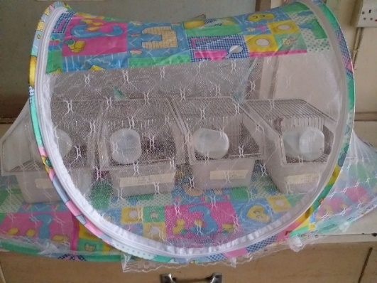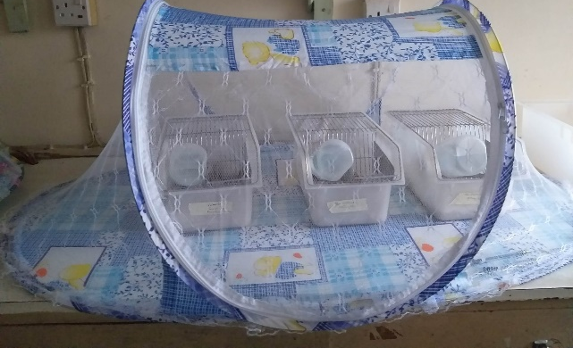
Supplementary Figure 1: Further care and protection of animal housed in mosquito nets to prevent mosquitoes bites and other rodents

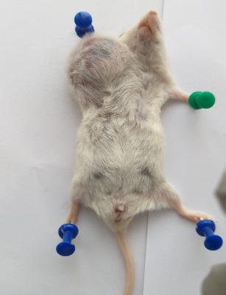
Supplementary Figure 2: Mortality recorded for 1st passage (P0) – TNPDX0c on the 79th day. Tumour size - 3656.08 mm3

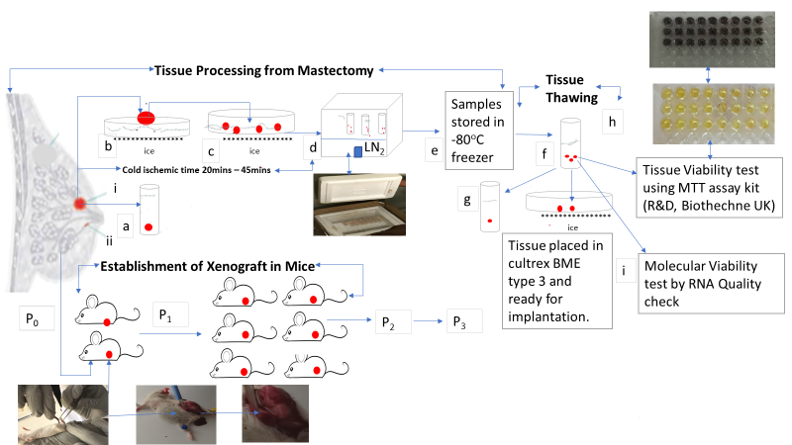
Supplementary Figure 3: Illustrates Workflow of cryopreservation of breast cancer tissue to xenograft development. (ai) Surgically removed breast cancer tissue from mastectomy; (aii) breast cancer tissue for histopathological analysis fixed in 10% buffered formalin; (b) Surgically removed tissues immediately washed in 4ºC cold HBSS ; (c) Tissue transferred into 4ºC cold RPMI 1640 containing 10/100 ul/ml penicillin and streptomycin was cut into 2mm³over ice. (d) The breast tissue fragments were transferred into cryovials containing cold freezing medium 10% Dimethyl sulfoxide (DMSO) in 90% Fetal Bovine Serum (FBS) before snap freezing in liquid nitrogen fumes (LN₂) in a Styrofoam box with a cover containing the LN₂ and Styrofoam sample tray suspended on a metal block (e) Final storage in – 80ºC freezer. (f) Frozen tissue thawed in less than 60 seconds under room temperature; (g) Thawed frozen tissue was fixed in 10% buffered formalin for histology analysis. (h) some of the tissues were tested for tissue viability using MTT ^{TACS®} proliferation assay kit (R & D, Biotechne, UK) showing the conversion yellow tetrazolium salt 3-[4,5-di-methylthiazol-2yl]-2,5-diphenyl-tetrazolium bromide (MTT) purple formazan dye by metabolic active tissues . (i) Molecular viability evaluated using Quan-iT TM RNA Assay kit with Qubit 3.0 fluorimeter (Invitrogen inc., CA) or BioPhotometer plus (Eppendorf, Germany). Establishment of xenograft in mice demonstrating the surgical implantation of thawed frozen tissue in a mouse anesthetized with ketamine preceding development of xenograft, P₀ represents first passage from human to mouse and P₁ subsequent passages from mice to mice.

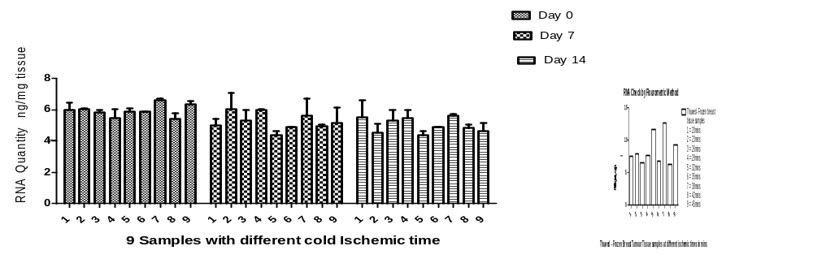
Supplementary Figure 4: RNA concentration of fresh (day 0) and thawed frozen (day7 and day 14) breast cancer tissue in triplicate processed and cryopreserved at varying cold ischaemic time. which was analysed for significant differences from the fresh tissues (control) using two- way ANOVA/Bonferroni Post-test (Graph Pad Prism 5.0) P > 0.05

