Table 1. Condition optimization
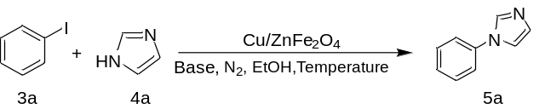
Entryª | Base | Cu/Fe₂O₄ (mg) | Temp. (ºC) | Time (h) | Yield (%)^{b}
1^{c} | Cs₂CO₃ | 100 | 120 | 12 | 93
2^{d} | Cs₂CO₃ | 100 | 120 | 12 | 94
3e | Cs₂CO₃ | 100 | 120 | 12 | 94
4^{f} | Cs₂CO₃ | 100 | 120 | 12 | 70
5 | Cs₂CO₃ | 100 | 120 | 12 | 94
6 | K₂CO₃ | 100 | 120 | 12 | 21
7 | NaOH | 100 | 120 | 12 | 23
8 | KOH | 100 | 120 | 12 | 20
9 | Cs₂CO₃ | 125 | 120 | 12 | 94
10 | Cs₂CO₃ | 100 | 130 | 12 | 94
11 | Cs₂CO₃ | 100 | 120 | 15 | 94
12 | Cs₂CO₃ | 100 | 110 | 12 | 47
13 | Cs₂CO₃ | 100 | 120 | 9 | 88
14^{g} | Cs₂CO₃ | 100 | 120 | 12 | 92
15^{h} | Cs₂CO₃ | 100 | 120 | 12 | 94
ª Reaction conditions: 3a (1.5 mmol), 4a (1.0mmol), Cs₂CO₃ (2.0 mmol), EtOH (1.0 mL) in N₂.^{b} Isolated yields. ^{c} 1,10-phenanthroline (0.5 mmol), ^{d} p-toluenethiol (0.5 mmol), ^{e} thioanisole (0.5 mmol), ^{f} proline (0.5 mmol). ^{g} 3a (1.0 mmol), ^{h} 3a (2.0 mmol).

Table 2. Scope of copper catalyzed cross-coupling of aryl halides with N-nucleophiles.
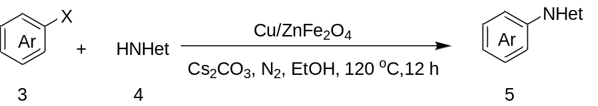
Entryª | Ar-X | Product |  | Yield (%)^{b}
1 | 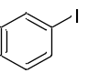 | 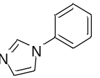 | 5a | 94
2 | 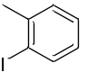 | 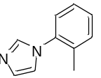 | 5b | 88
3 | 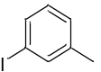 | 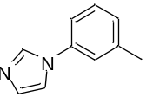 | 5c | 91
4 | 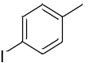 | 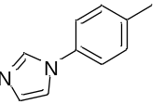 | 5d | 88
5 | 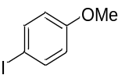 | 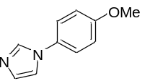 | 5e | 87
6 | 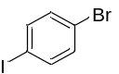 | 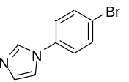 | 5f | 88
7 | 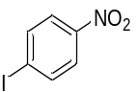 | 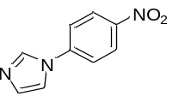 | 5g | 89
8 | 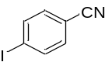 | 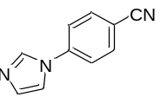 | 5h | 85
9 | 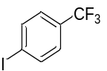 | 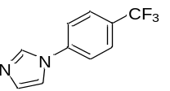 | 5i | 83
10 | 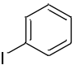 | 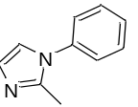 | 5j | 86
11 | 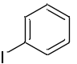 | 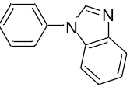 | 5k | 80
12 | 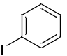 | 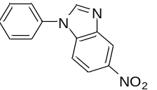 | 5l | 84
13 | 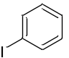 | 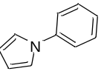 | 5m | 94
14 | 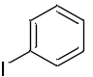 | 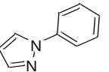 | 5n | 94
15 | 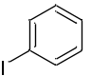 | 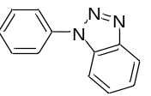 | 5o | 75
16 | 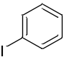 | 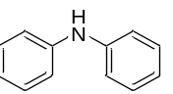 | 5p | 77
17 | 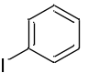 | 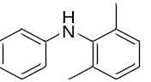 | 5q | 65
18 | 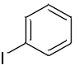 | 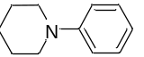 | 5r | 92
19 | 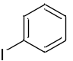 | 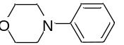 | 5s | 88
20 |  | 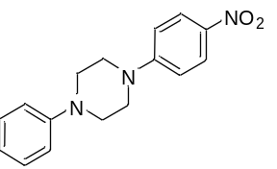 | 5t | 60
21 | 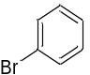 | 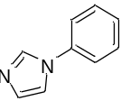 | 5a | 50
22 | 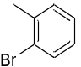 | 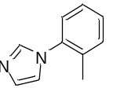 | 5b | 70
23 | 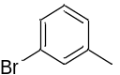 | 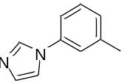 | 5c | 72
24 | 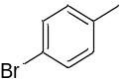 | 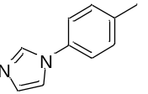 | 5d | 61
25 | 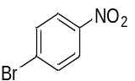 | 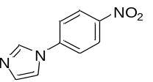 | 5g | 62
26 | 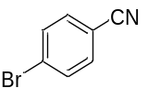 | 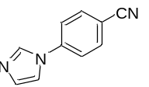 | 5h | 63
27 | 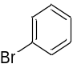 | 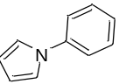 | 5m | 74
28 | 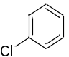 | 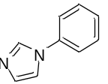 | 5a | 10
ª Reaction conditions: 3 (1.5 mmol), 4 (1.0 mmol), Cs₂CO₃ (2.0 mmol), Cu/ZnFe₂O₄ (100 mg),
EtOH (1.0 mL), 120 ºC under N₂ for 12 h. ^{b} Isolated yields.

