Table 1. Optimization of the Reaction Conditionsª
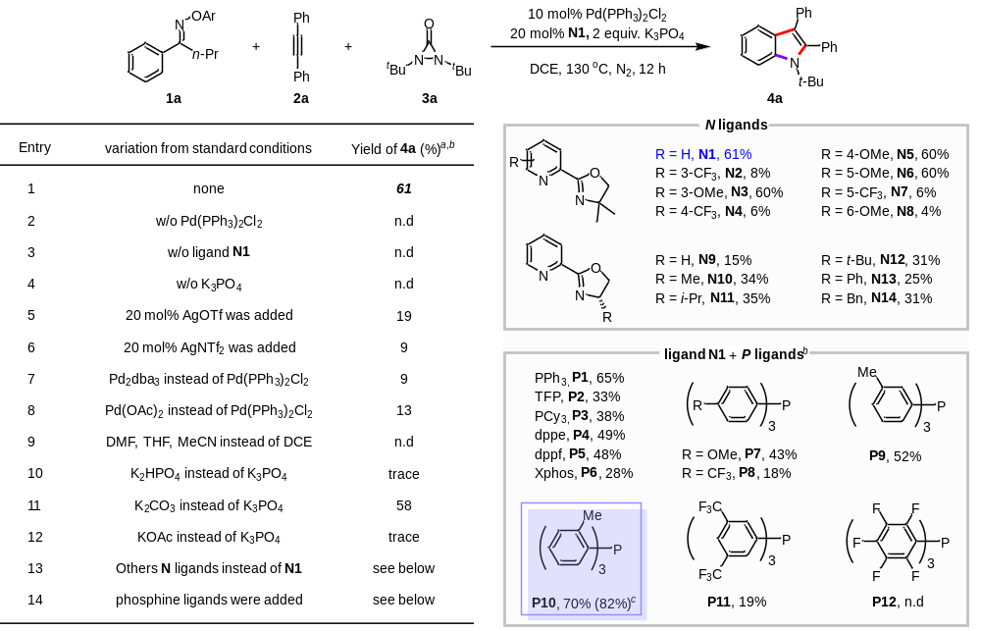
ªReaction conditions: 1a (0.1 mmol), 2a (0.1 mmol), 3a (0.1 mmol), Pd(PPh₃)₂Cl₂ (10 mol%), K₃PO₄ (0.2 mmol), N1 (20 mol%), DCE (3 mL), N₂, 130 ºC, 12 h, yield was determined by GC-MS. ^{b}PdCl₂ (10 mol%) instead of Pd(PPh₃)₂Cl₂. ^{c}2a (0.12 mmol), 3a (0.12 mmol), N1 (15 mol%), P10 (15 mol%), isolated yield.

Table 2. Antimicrobial evaluation of the DA-based derivatives
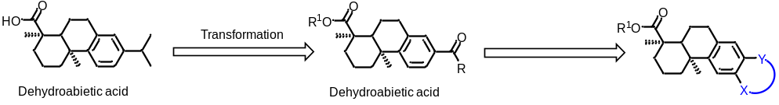
Compounds | MIC (μg/mL)
Compounds | S. aureusª | E.faecalis VB^{b} | S.pyogenes^{c}
DA | 128 | 128 | 64
7a | 4 | 1 | 2
7b | 16 | 2 | 4
7c | 64 | 2 | 2
7d | >256 | >256 | >256
7e | >256 | 256 | 256
7f | 64 | 64 | 32
7g | 32 | 32 | 16
7h | >256 | 256 | 256
7i | >256 | 256 | 256
6r | >256 | 256 | 4
6s | >256 | 128 | 16
6s-1 | >256 | 256 | 32
6s-2 | >256 | 128 | 32
6t | >256 | 256 | 16
6t-1 | >256 | 256 | 16
Vancomycin | 1 | 16 | 0.25

ªS. aureus: S. aureus USA300 LAC. ^{b}E.faecalis VB: E.faecalis VB ATCC 29212 ^{c}S. pyogenes: S. pyogenes ATCC 12344.
