Supplementary information
for
Zeolite-encapsulated Ir Single Atom Catalysts toward Efficient and Stable Propane Dehydrogenation

Table of Contents
Supplementary Methods 3
Supplementary Figures 11
Supplementary Tables 43
Supplementary References 49

Supplementary Methods
Characterization
The diffraction X-ray diffraction (XRD) patterns of the catalysts were obtained on Philips X’Pert MPD diffractometer in the 2θ ranging from 5° to 60°, with 40 kV and 40 mA Cu-Kα radiation beam (λ=1.5406 Å). The nitrogen adsorption-desorption tests were performed on Micromeritics ASAP 2460 to analyze the specific area and pore structure properties. The X-ray photoelectron spectra (XPS) were measured on ThermoFisher ESCALAB 250Xi+ instrument with vacuum transfer table to measure the electronic properties of active metal sites. The XPS spectra of samples (before and after H₂ in-situ reduction) were obtained after argon ion sputtering for 250 s. The catalysts were reduced under 10% H₂/Ar flow (50 mL min⁻¹) at 600 °C for 2 hours and then were transferred to test cabin under vacuum. All peaks were fitted on the basis that the binding energy of C1s peak was calibrated to 284.6 eV. The metal loadings of Ir and Ge on the reduced catalysts were tested by inductively coupled plasma-optical emission spectroscopy (ICP-OES) on Agilent 5110. The spectra of X-ray absorption fine structure (XAFS) spectra on the Ir L₃-edge were measured at the Shanghai Synchrotron Radiation Facility (BL17B). The spectra data were fitted with the assistance of ATHENA, ARTEMIS and HEPHAESTUS.¹ The wavelet transform data of EXAFS was analyzed on HAMA Fortran version.^{2,3} The zeolite morphology and distribution of metal sites on the samples were observed by Transmission Electron Microscope (TEM) on JEOL JEM-F200 (200 kV). The images of spherical aberration corrected high angle annular dark field scanning transmission electron micrographs (AC HAADF-STEM) were taken on JEOL ARM200F (200 kV). The spent catalysts were tested on Q500-1688-TGA instrument to get the relative coke data. The temperature program ranged from 30 °C to 800 °C (10 °C min⁻¹) with an air flow of 50 mL min⁻¹. The temperature programmed surface reaction of propane (C₃H₈-TPSR) was conducted on an automatic chemisorption instrument (DAS-7200, Hunan Huasi) with an online mass spectrometer (Hiden HPR-20 EGA). 7 mg catalyst (20-40 meshes) was filled into quartz reaction tube and were reduced in H₂ atmosphere (10 vol% H₂/N₂, flow rate = 50 mL min⁻¹) at 600 °C for 2 h. The gas was then switched to N₂ (with a flow rate of 40 mL min⁻¹) to remove residual H specie until cooling to 50 °C. Then the C₃H₈ flow was introduced into to the catalysts with a programmed rising temperature from 50 °C to 650 °C at a rate of 5 °C min⁻¹. An online mass spectrometer was employed to detect the signals of m/z=2 (H₂), 16(CH₄), 28(N₂), 29(C₃H₆) and 41(C₃H₈). Fourier transform infrared (FT-IR) spectra were obtained on ThermoFisher Scientific is50 spectrophotometer. The skeleton information of zeolite was collected with KBr as the background. FT-IR with CO as the probe molecule was conducted to identify the structure of active metal in the in-situ system. 20 mg sample was pressed into a circular sheet with a diameter of 13 mm and loaded into the in-situ cell. The sample was reduced under 20 vol% H₂/N₂ (50 mL min⁻¹) flow at 600 °C for 2 h. Secondly, the valve controlling H₂ was closed, and N₂ (with a flow rate of 40 mL min⁻¹) was kept to remove residual H specie until cooling to 50 °C. The background spectrum was collected under a 40 mL min⁻¹ N₂ flow at 50 °C. Thirdly, the gas was switched to CO for 30 minutes, followed by a transition to N₂ flow. The desorption spectra of CO under nitrogen purge were recorded via infrared spectroscopy until the CO intensity remained constant. FT-IR with propane dehydrogenation were performed in the in-situ tank at 550 °C. As the same step in FT-IR of CO spectra, the catalyst wafer (20 mg) was first reduced at 550 °C for 2 h (10 mL H₂+40 mL N₂). After N₂ purge for 30 minutes, the background spectrum and sample spectra were collected under 50 mL N₂. The spectra were recorded all the time after adding 3 mL C₃H₈ into the flow. The FT-IR of CO spectra on IrGe@S-1-C₃H₈ were collected after reacting with propane for 1 hour at 550 °C in the in-situ transmission cell. After cooling to 50 °C, the background was recorded under the N₂ purge and the rest steps were consistent with the regular steps as above experimental section. ²⁹Si NMR experiments were conducted on JEOL JNM ECZ600R 600 MHz spectrometer. ¹⁹F NMR was performed on the catalysts after exchanging F ions as previously reported in the literature.^{4,5} Fluoride was incorporated in the structure of as-made catalysts as following. Firstly, catalysts were mixed with NH₄F solution (1 mol L⁻¹, 25 mLg⁻¹) and heated in the Teflon-lined stainless steel autoclave at 170 °C for 12 h. After cooling to room temperature, the solid was washed with water for three times and dried at 80 °C overnight. The ¹⁹F solid-state magic angle spinning nuclear magnetic resonance (SS MAS NMR) spectra were obtained on Bruker AVANCE NEO 500WB system with a magnetic field strength of 11.7 T. The spin rate of the samples was 20 kHz, and the csecho pulse sequence was used. The π/2 pulse was 3.3 us, with the recycle delay of 5 s, and a total of 4096 scans were performed to each sample. The chemical shift was referenced to ammonium trifluoroacetate at -74.3 ppm.
Catalytic test
The PDH reaction was carried out on the fixed bed with a 6 mm inner diameter quartz reactor. The mixture of 80 mg of catalyst (20-40 mesh) and 1.5 g quartz sand (20-40 mesh) were filled into the reaction tube and treated in 10 mL min⁻¹ H₂ and 40 mL min⁻¹ N₂ flow at 600 °C for 2 h. For regeneration treatment, the atmosphere was changed to 40 mL min⁻¹ N₂ for 2 h after reaction and then switched to CO₂ (40 mL min⁻¹) for 6 h under 600 °C. The reaction started after reducing with H₂ and repeated reaction--regeneration cycle for several times. In PDH kinetic tests, the catalyst was pretreated for 2 h at 600 °C and then lowered the temperature to 400-460 °C. The flow rate of C₃H₈ was changed (1-35 mL min⁻¹), and the total flow rate remained unchanged (100 mL min⁻¹) through N₂ balanced. The conversion rate of C₃H₈ is controlled below 10% in the kinetic interval. The dependence of reaction rates on H₂ partial pressure was conducted at 460 °C changing the H₂ flow rate (2-20 mL min⁻¹) with constant C₃H₈ flow (5 mL min⁻¹) and total flow rate constant (100 mL min⁻¹) with N₂ balanced. According to the Madon-Boudart criterion, flow rate test was performed to verify the absence of external heat transfer limitations by increasing the reactant flow rate (F) and catalyst volume (V) while keeping the WHSV constant.
Propane conversion (Conv), propylene selectivity (Select), k_{d} (the deaction rate of catalysts) and STY (the number of moles of propylene produced per gram of NMs per hour) was calculated from the following equations:
$Propane conversion=\frac{{FC3H8}_{in}-{FC3H8}_{out}}{{FC3H8}_{in}}$ (S1)
$Propylene selectivity=\frac{{FC3H6}_{out}}{{FC3H8}_{in}-{FC3H8}_{out}}$ (S2)
$k_{d}=\frac{\ln\left(\frac{1-{Conv}_{final}}{{Conv}_{final}}\right)-\ln\left(\frac{1-{Conv}_{initial}}{{Conv}_{initial}}\right)}{t}$ (S3)
$STY=\frac{{FC3H6}_{out}}{M_{catal}*{wt}_{metal}}$ (S4)
FC3H8_{in}, FC3H8_{out}, FC3H6_{out}; Conv_{final}, Conv_{initial}; M_{catal}, wt_{metal} represent the molar flow rate of inlet C₃H₈, outlet C₃H₈, outlet C₃H₆; the initial and final conversion on the stream; the weight of catalyst added in the reactor, the mass loading of metal, respectively.
Derivation of kinetic equations for propane dehydrogenation
The following section demonstrates the fundamental steps involved in the catalytic dehydrogenation of propane on the isolated Ir sites in Silicalite-1, as outlined by Langmuir's kinetic assumptions. The symbols C₃H₈, H₂, C₃H₆, *Ir, C₃H₈-*Ir, C₃H₇-H-*Ir, C₃H₆-2H-*Ir, C₃H₆-*Ir, and H₂-*Ir are used to represent the following: propane, hydrogen, propylene, Ir sites, propane absorbed on Ir sites, propyl and H absorbed on Ir sites, propylene and 2H absorbed on Ir sites, propylene absorbed on Ir sites and hydrogen absorbed on Ir sites.
C₃H₈(g) + *Ir $\underset{↔}{K_{1}}$ C₃H₈-*Ir | Propane adsorption
C₃H₈-*Ir $\underset{↔}{K_{2}}$ C₃H₇-H-*Ir | First C–H bond cleavage
C₃H₇-H*Ir $\underset{↔}{K_{3}}$ C₃H₆-2H-*Ir | Second C–H bond cleavage
C₃H₆-2H-*Ir $\underset{↔}{K_{4}}$ C₃H₆-*Ir +H₂ | H₂ desorption
C₃H₆-*Ir $\underset{↔}{K_{5}}$ C₃H₆(g) +*Ir | Propylene desorption
Assuming the first C–H bond cleavage is the rate-limiting step and other steps are quasi-equilibrated.
The rate equation:
$r=$k₂ [C₃H₈-*Ir] (S5)
Based on the assumptions, the steps are quasi-equilibrated:
$K_{1}=\frac{[C_{3}H_{8}-*Ir]}{P_{C3H8}[*Ir]}$ (S6)
$K_{3}=\frac{[C_{3}H_{6}-2H-*Ir]}{{[C}_{3}H_{7}-H-*Ir]}$ (S7)
$K_{4}=\frac{P_{H2}[C_{3}H_{6}-*Ir]}{[C_{3}H_{6}-2H-*Ir]}$ (S8)
$K_{5}=\frac{P_{C3H6}[*Ir]}{[C_{3}H_{6}-*Ir]}$ (S9)
The active sites balance is:
[*Ir]_{total} = [*Ir ] + [C₃H₈-*Ir] + [C₃H₇-H-*Ir] + [C₃H₆-2H-*Ir] + [C₃H₆-*Ir]
= [*Ir ] (1 + K₁P_{C3H8} + K₃⁻¹K₄⁻¹K₅⁻¹P_{H2}P_{C3H6} + K₄⁻¹K₅⁻¹P_{H2}P_{C3H6} + K₅⁻¹P_{C3H6}) (S10)
Combined the equation (S5-S10), the rate expression can be simplified as:
$\frac{r}{{[*Ir]}_{total}}=\frac{k_{2}K_{1}P_{C3H8}}{1+K_{1}P_{C3H8}}$ (S11)
The symbols r, k₂, K₁, and P_{C3H8} are denoted as propene production rate, rate constant for the first C−H bond cleavage as rate-limiting step, propane adsorption equilibrium constant, and propane partial pressure, respectively.
Calculation methods
Spin-polarized density functional theory (DFT) calculations were performed using the Vienna Ab initio Simulation Package (VASP 6.3.3). The revPBE generalized gradient approximation (GGA) was employed for electron exchange-correlation interactions, with Grimme’s D3 dispersion correction incorporated to account for van der Waals forces. A plane-wave basis set with a cutoff energy of 400 eV and a Γ-point sampling scheme were adopted for Brillouin zone integration. Geometric optimizations were conducted until residual forces on all atoms fell below 0.05 eV Å⁻¹. Transition states were located using the climbing nudged elastic band method followed by refinement with the improved dimer algorithm, and each TS was verified by the presence of a single imaginary vibrational frequency along the reaction coordinate (see Supplementary Table 5 for vibrational analysis).
The MFI zeolite framework was modeled using a Si₉₆O₁₉₂ cell. Guided by experimental characterizations and prior studies, Ge doping was simulated by substituting Si atoms at the T9 and T10 crystallographic sites with 0–4 Ge atoms, generating xGe-MFI (x = 0–4) configurations.⁶ Single Ir atoms were anchored within the 4-MRs of the Ge-substituted MFI structure (Supplementary Figure 9). Formation energy calculations identified Ir₁-Ge₄-MFI as the most thermodynamically stable configuration, which was consequently selected to represent the as-synthesized IrGe@S-1 catalyst. Under reaction conditions, the Ir₁-Ge₄-MFI-O_{vac} structure would in-situ form via removal of framework oxygen atoms by *H species generated during propane dehydrogenation, which was modeled to simulate the active site of IrGe@S-1 catalyst under steady PDH conditions. For comparative studies, a four-layer Ir(111) slab (15 Å vacuum spacing) was constructed to mimic Ir nanoparticles, with the bottom two layers fixed to approximate bulk-like behavior.
The structural stability of Ir atom in different MFI substrates was assessed using the formation energy with respect to bulk metallic Ir., calculated by equation (S12)
ΔE_{f}= E_{IrGe-MFI} – E_{Ge-MFI} – E_{Ir,bulk} (S12)
Where E_{IrGe-MFI}, E_{Ge-MFI} and E_{Ir,bulk} represent the energies of a IrGe-MFI, Ge-MFI and the single Ir atom in bulk Ir.

Supplementary Figures
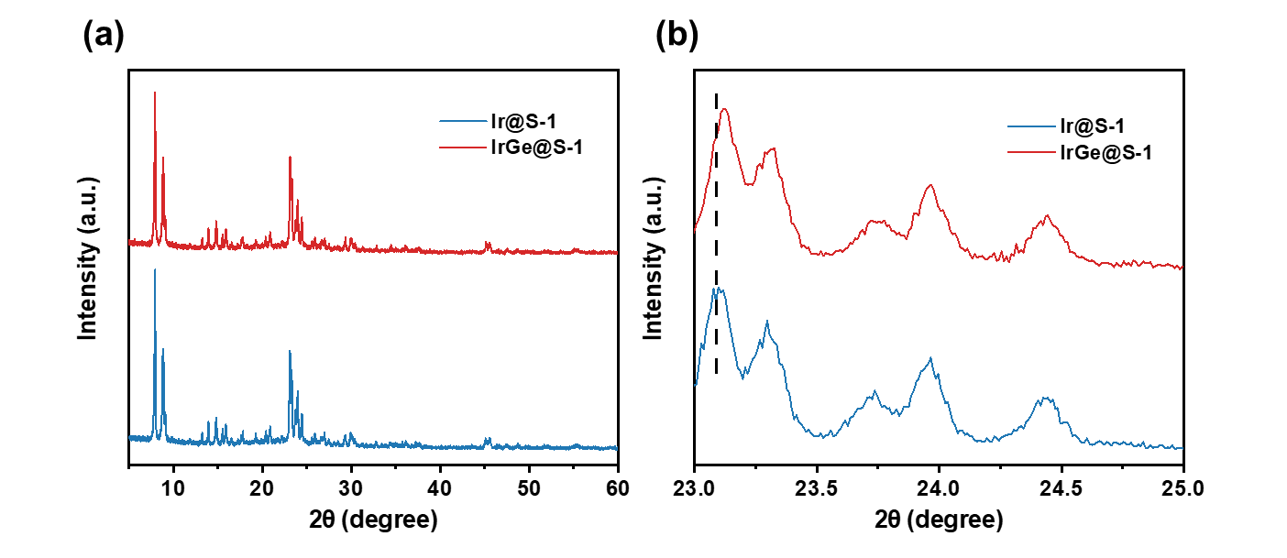
Supplementary Figure 1 (a) XRD patterns of Ir@S-1 and IrGe@S-1; (b) Enlarged view in the region of 23-25 º.

Supplementary Figure 2 N₂ adsorption-desorption isotherms of IrGe@S-1 samples with different Ge loadings in the synthesis gel.

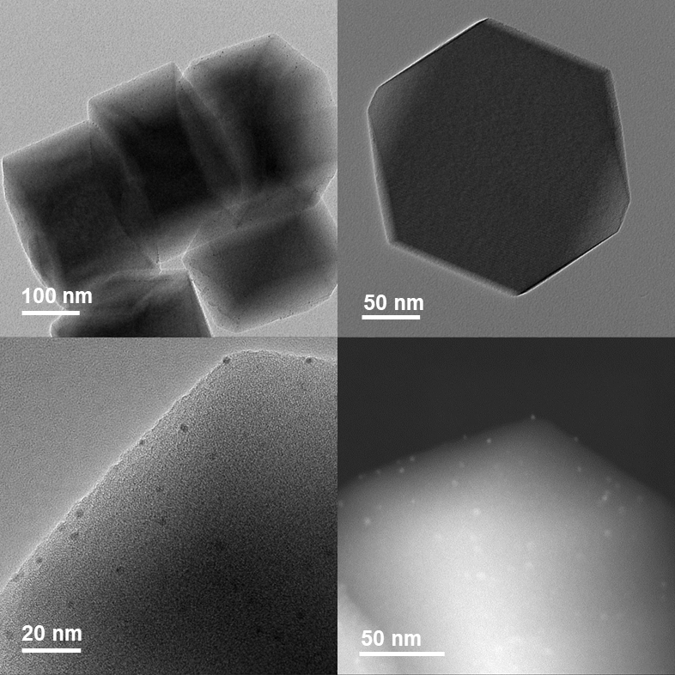
Supplementary Figure 3 TEM and STEM images of Ir@S-1.

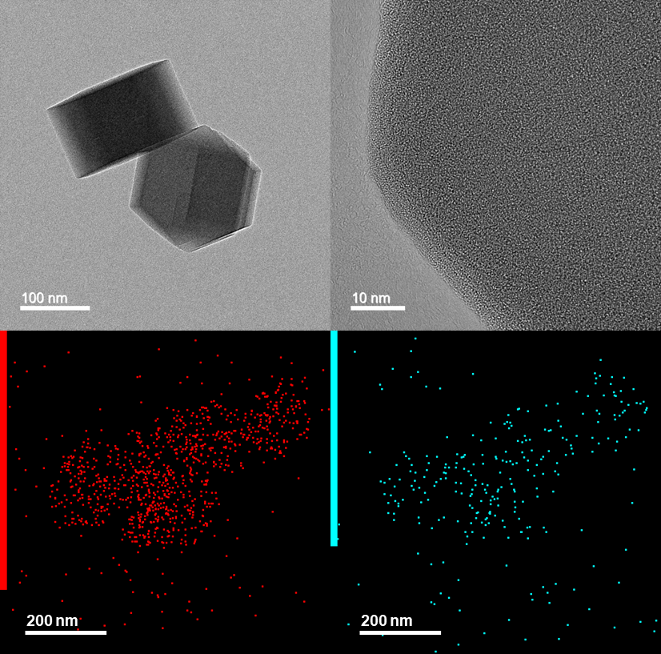
Supplementary Figure 4 TEM and energy dispersive spectroscopy mapping images of Ir0.25Ge@S-1 (Ge loading in the synthesis gel is 0.25%).
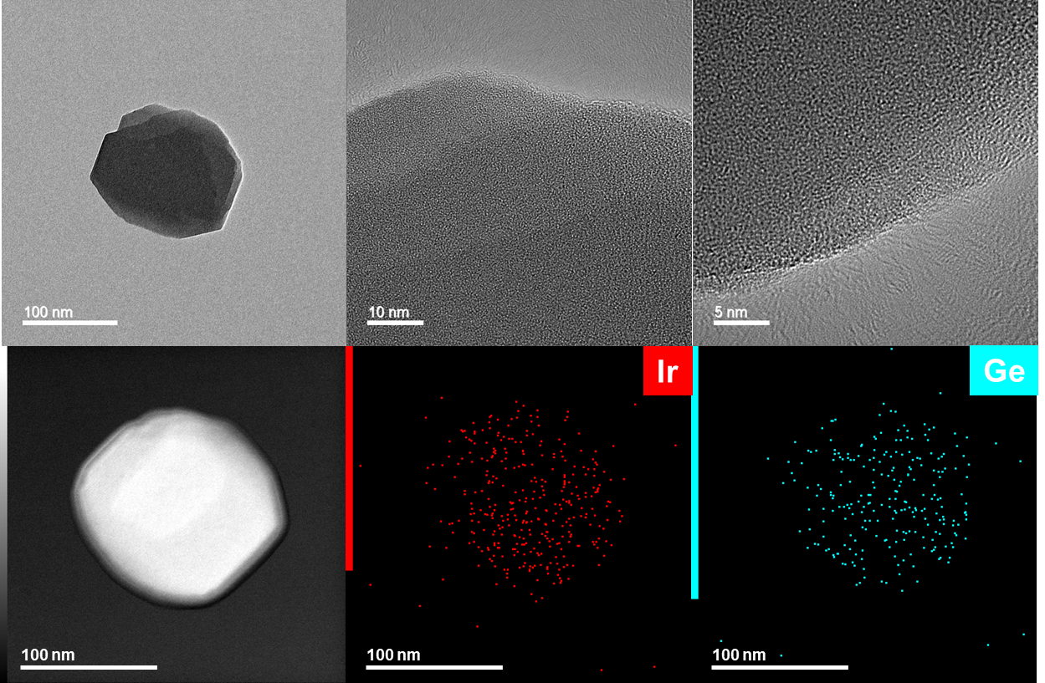
Supplementary Figure 5 TEM, STEM and energy dispersive spectroscopy mapping images of Ir10Ge@S-1 sample
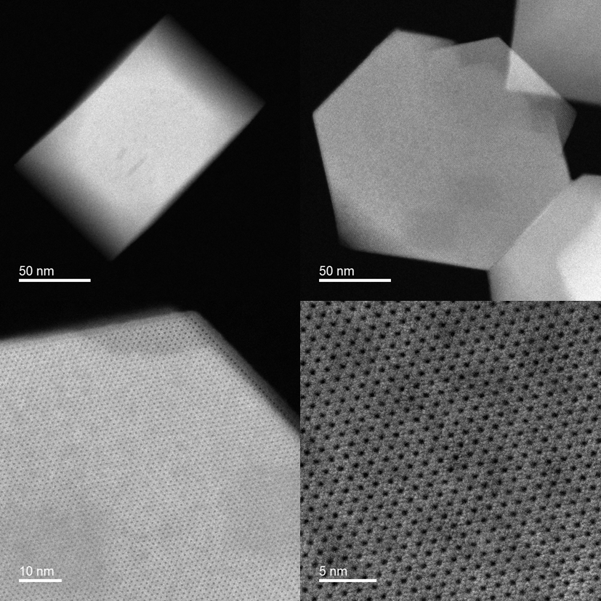
Supplementary Figure 6 AC HAADF-STEM images of Ir10Ge@S-1 sample.
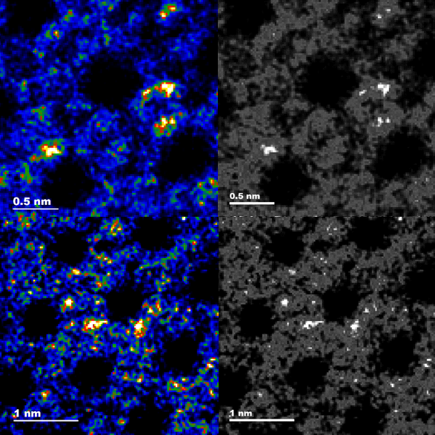
Supplementary Figure 7 AC HAADF-STEM images of Ir10Ge@S-1 sample.

Supplementary Figure 8 ²⁹Si NMR spectra of Ir@S-1 and IrGe@S-1 samples.

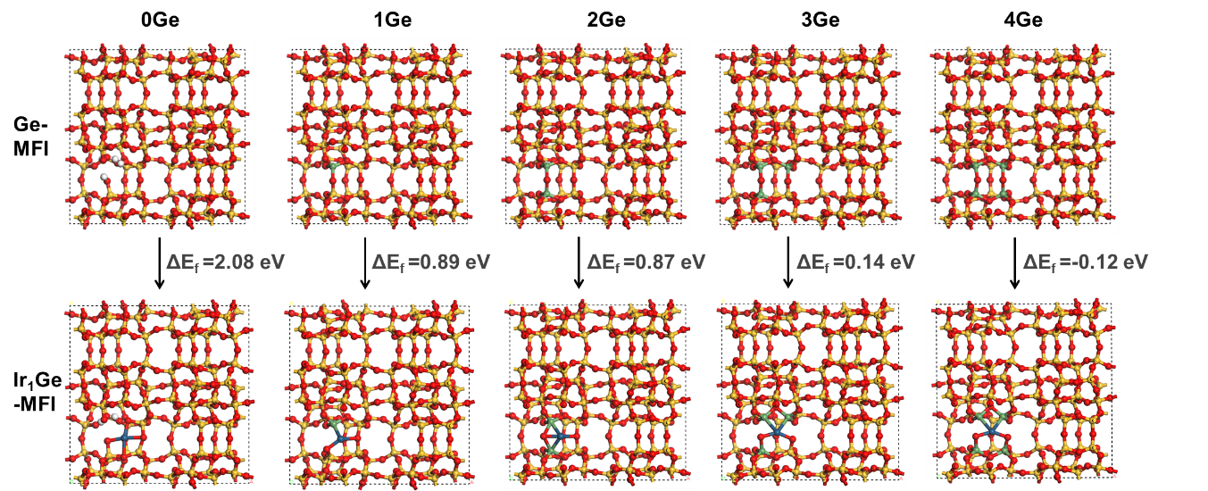
Supplementary Figure 9 The model of Ge-MFI with different amounts of Ge atoms in the 4-MRs and the formation energy of Ir atom bonded on the Ge-MFI. ΔE_{f} were calculated as equation (S12).

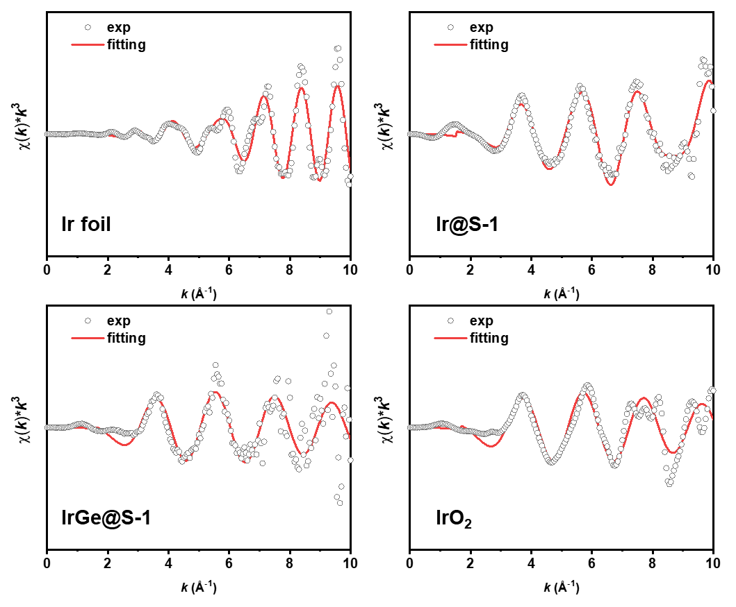
Supplementary Figure 10 k³-weighted k-space Ir L₃-edge experimental and fitting spectra of Ir samples and references.

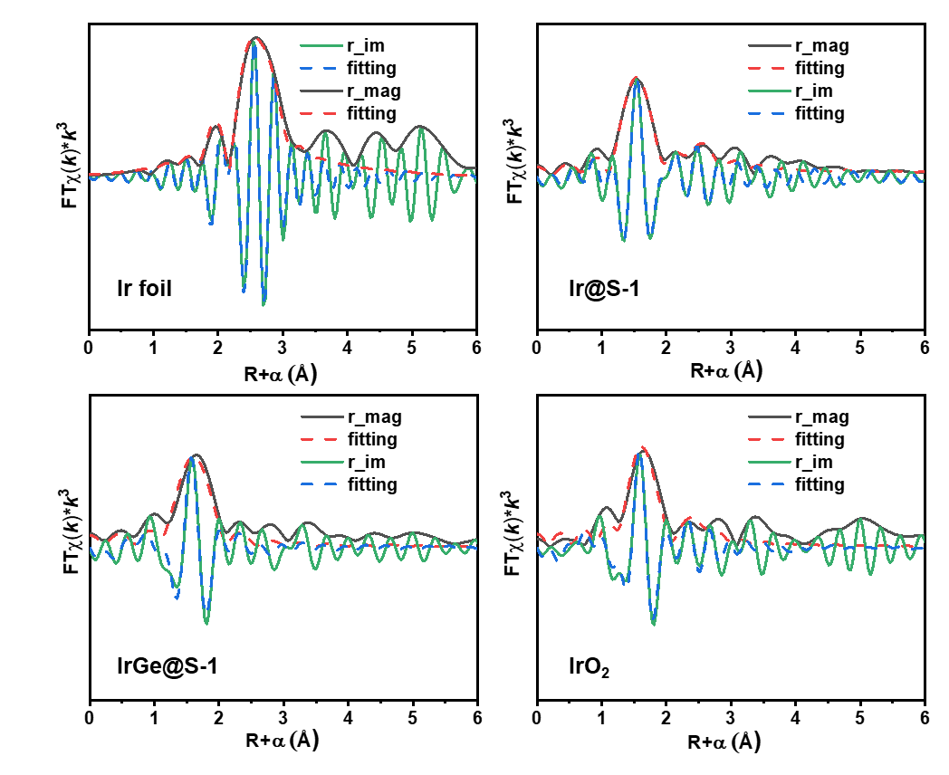
Supplementary Figure 11 R-space Ir L₃-edge experimental and fitting spectra of Ir samples and references.

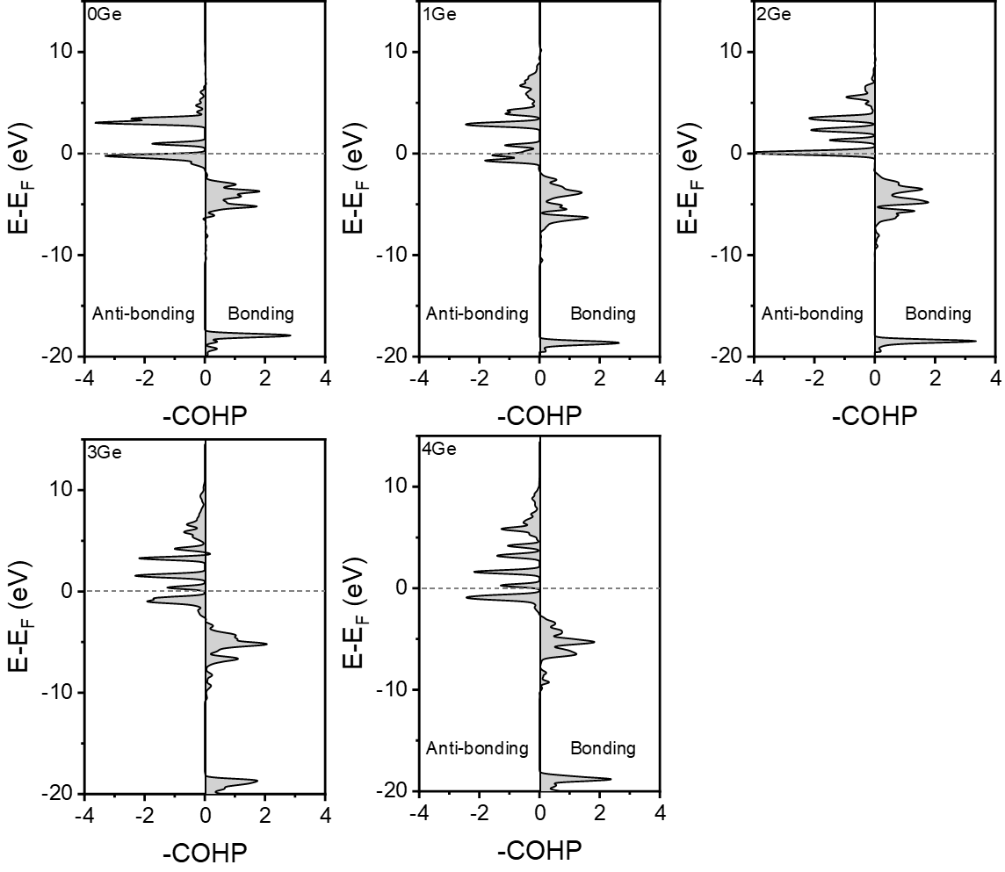
Supplementary Figure 12 Crystal orbital Hamilton population (COHP) analysis on IrGe-MFI with varying Ge atoms in 4-MRs of MFI zeolite.

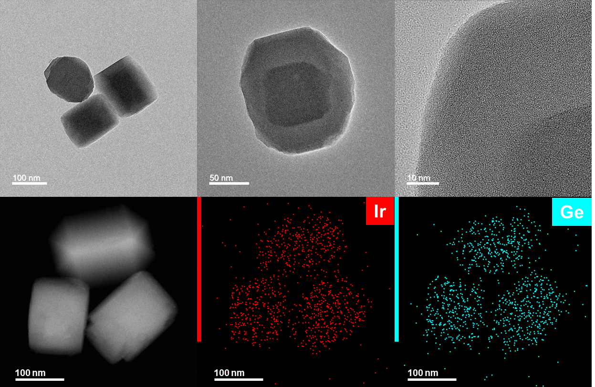
Supplementary Figure 13 TEM, STEM and energy dispersive spectroscopy mapping images of Ir15Ge@S-1.

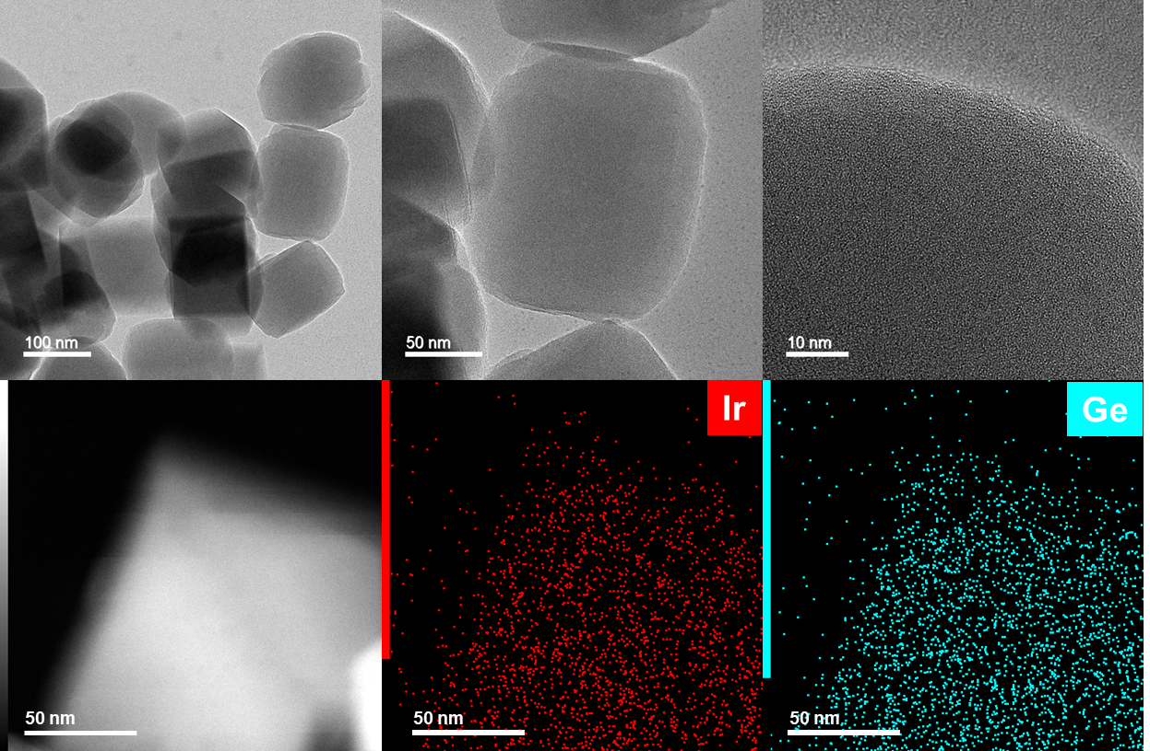
Supplementary Figure 14 TEM, STEM and energy dispersive spectroscopy mapping images of Ir20Ge@S-1.

Supplementary Figure 15 Catalytic performance and deactivation rate constant in PDH over Ir-based bimetallic catalysts synthesized via the one-pot route.

Supplementary Figure 16 The regeneration cycle of optimized IrGe@S-1 catalyst at 600 °C and an extremely high WHSV of 300 h⁻¹. After three times of regeneration, the reaction was performed at WHSV of 15 h⁻¹ and different temperatures.

Supplementary Figure 17 Catalytic performance of IrGe@S-1 in ethane dehydrogenation at 550 °C and 600 °C. Reaction conditions: pure C₂H₆, WHSV=30 h⁻¹.

Supplementary Figure 18 Catalytic performance of IrGe@S-1 in n-butane dehydrogenation at 500 °C and 550 °C. Reaction conditions: pure C₄H₁₀, WHSV=30 h⁻¹.

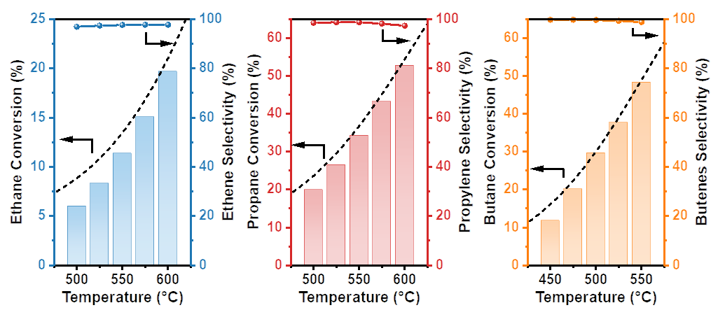
Supplementary Figure 19 Dependence of alkane conversion and olefin selectivity on reaction temperature in the dehydrogenation of ethane, propane, and n-butane over the IrGe@S-1 catalyst. Reaction conditions: pure alkane, WHSV=30 h⁻¹, the dotted line represents the equilibrium conversion.

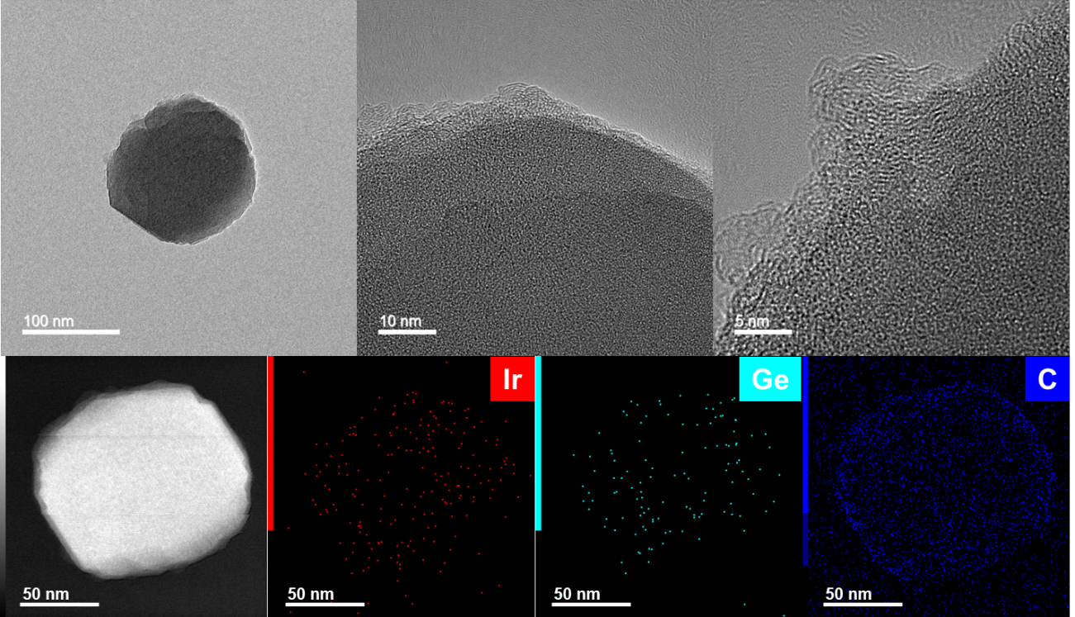
Supplementary Figure 20 TEM, STEM and energy dispersive spectroscopy mapping analyses of IrGe@S-1 after PDH reaction at 600 ºC for 18 hours.

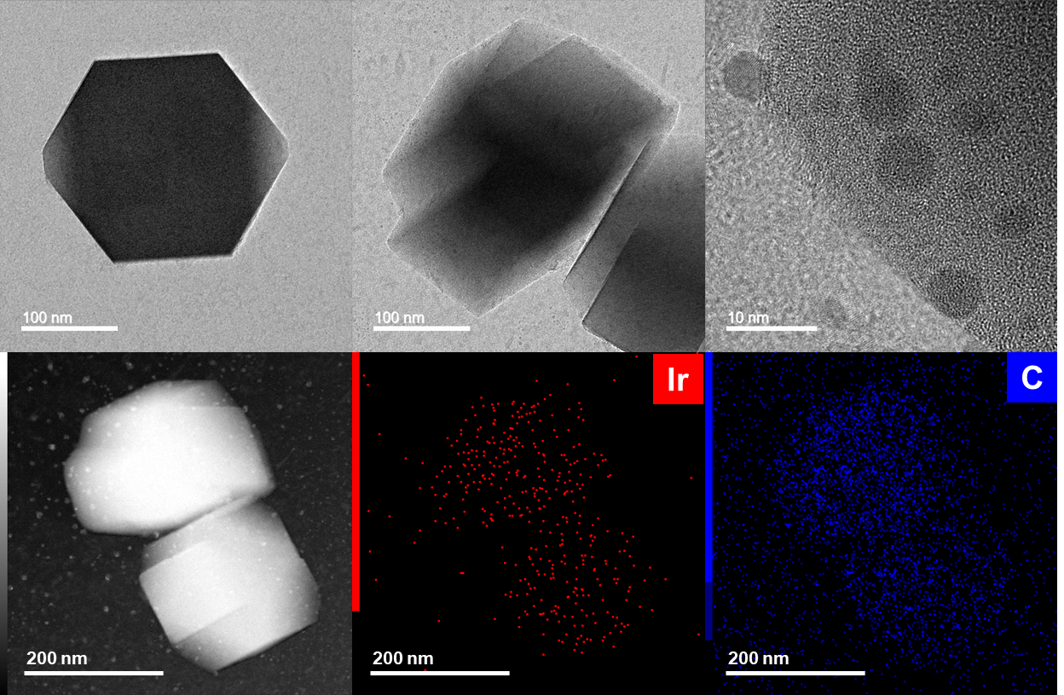
Supplementary Figure 21 TEM, STEM and energy dispersive spectroscopy mapping analyses of Ir@S-1 after PDH reaction at 600 ºC for 18 hours.

Supplementary Figure 22 TG curves of spent catalysts.

Supplementary Figure 23 Flow rate test according to Madon-Boudart criterion. Reaction condition: T = 460 °C, W/F_{C3H8} = 0.004 g_{cat}·min·mL⁻¹, WHSV = 30 h⁻¹, P = 1 atm, C₃H₈:N₂ = 1:5.

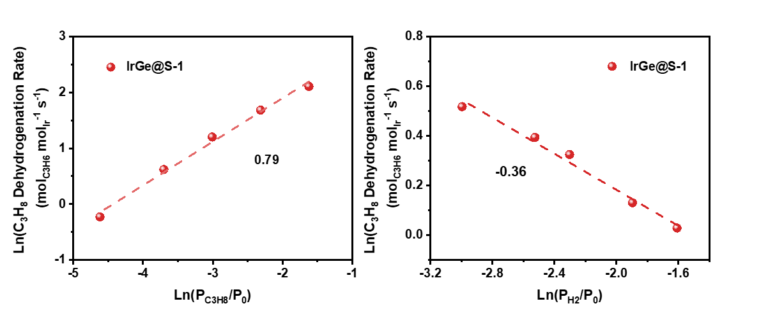
Supplementary Figure 24 Dependence of PDH rates on propane and H₂ partial pressure at 460 °C over IrGe@S-1 catalyst.

Supplementary Figure 25 Rate of propene formation catalyzed by IrGe@S-1 as a function of propane partial pressure at various temperatures.

Supplementary Figure 26 Arrhenius plot of propane dehydrogenation rate constants.

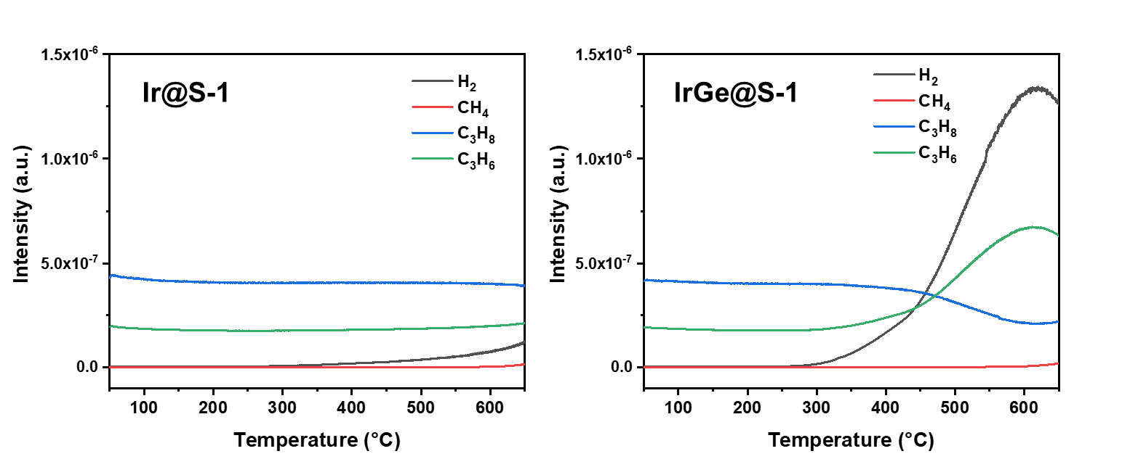
Supplementary Figure 27 TPSR profiles of propane dehydrogenation over Ir@S-1 and IrGe@S-1 catalysts.

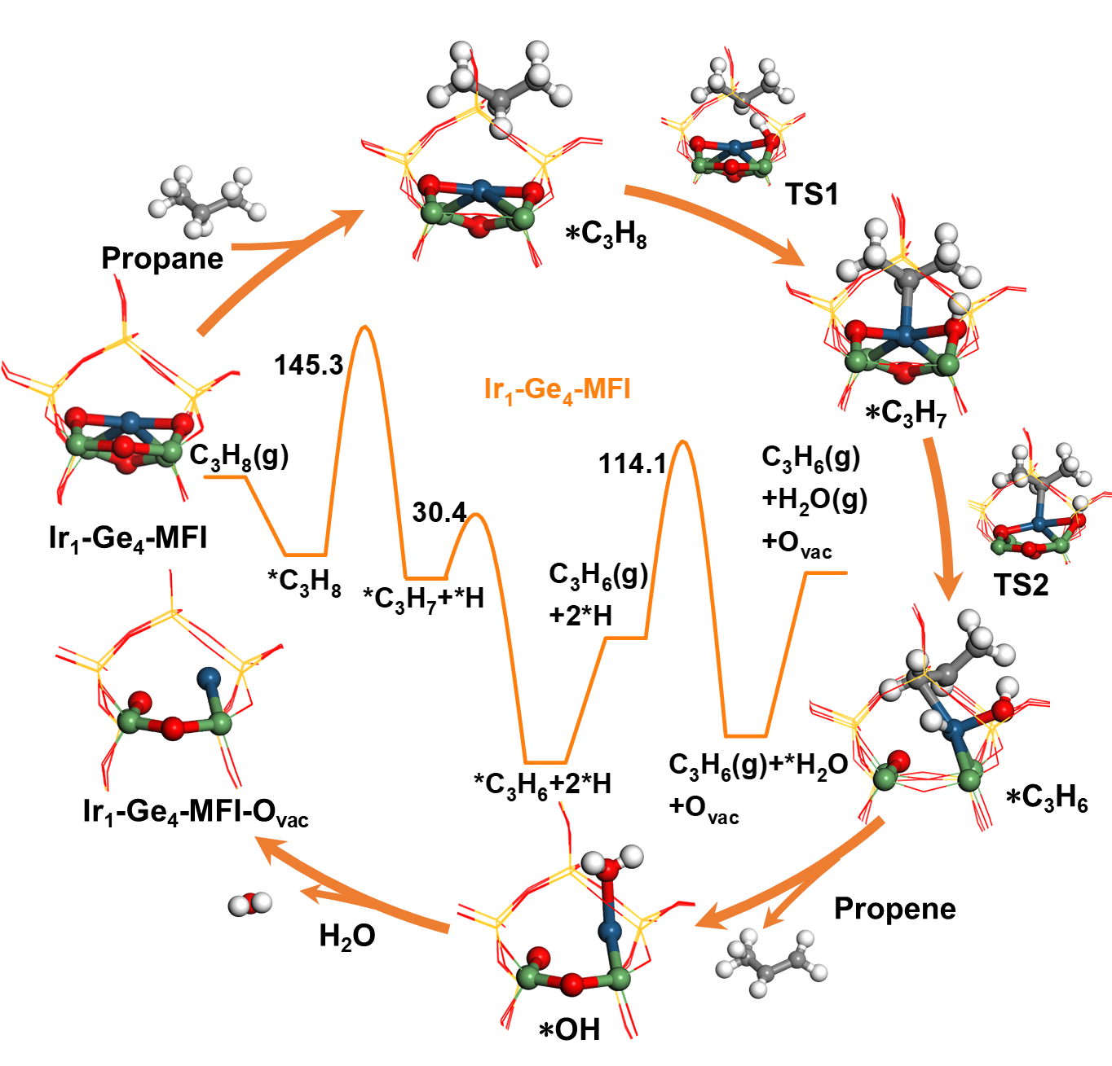
Supplementary Figure 28 Calculated potential energy diagram for PDH reaction over Ir₁-Ge₄-MFI and the configurations of reaction intermediates.

Supplementary Figure 29 Top view of the geometry and charge density difference for Ir₁-Ge₄-MFI-O_{vac} model (Formation of the oxygen vacancy after the first reaction with propylene). The yellow and cyan regions represent electron accumulation and depletion, respectively.

Supplementary Figure 30 FT-IR spectra of feeding propane to IrGe@S-1 at 550 °C.

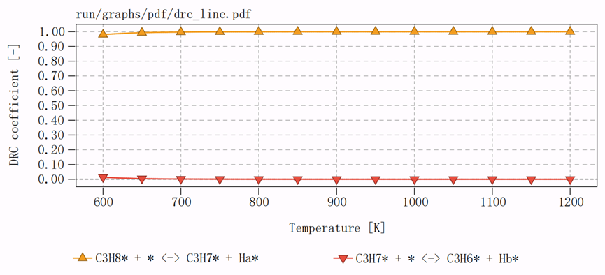
Supplementary Figure 31 Rate-control degree analysis on Ir₁-Ge₄-MFI-O_{vac} site

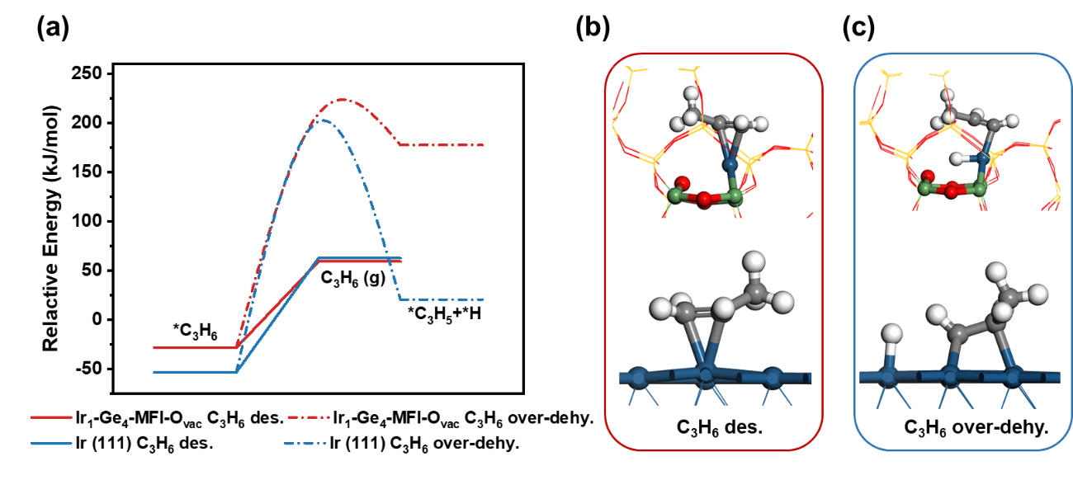
Supplementary Figure 32 (a) The energy barriers for over dehydrogenation (C₃H₆ over-dehy.) and desorption of propylene (C₃H₆ des.) on Ir₁-Ge₄-MFI-O_{vac} and Ir (111) slab; (b) The model of propylene desorption on Ir₁-Ge₄-MFI-O_{vac} and Ir (111) slab; (c) The model of propylene over-dehydrogenation on Ir₁-Ge₄-MFI-O_{vac} and Ir (111) slab.

Supplementary Tables
Supplementary Table 1 Structure properties of selected zeolite samples
 | S_{BET} ª  (m² g⁻¹) | S_{ext} ^{b}  (m² g⁻¹) | V_{total} ^{c}  (cm³ g⁻¹) | V_{micro} ^{d} (cm³ g⁻¹)
Ir@S-1 | 357 | 64 | 0.245 | 0.144
Ir0.25Ge@S-1 | 401 | 69 | 0.267 | 0.151
Ir5Ge@S-1 | 379 | 78 | 0.344 | 0.148
Ir10Ge@S-1 | 372 | 78 | 0.320 | 0.147
Ir15Ge@S-1 | 379 | 75 | 0.330 | 0.152
Ir20Ge@S-1 | 394 | 85 | 0.351 | 0.152
ª S_{BET} (BET surface area) was calculated by the BET equation under (0.06<P/P₀<0.25).
^{b} S_{ext} (external surface area) was estimated by t-plot method.
^{c} V_{total} was the total pore volume calculated under P/P₀ of 0.99.
^{d} V_{micro} (micropore volume) was calculated by t-plot method.

Supplementary Table 2 Measured metal loadings in selected samples
 | Ir loading (wt%) | Ge loading (wt%)
Ir@S-1 | 0.38 | 0
Ir3Ge@S-1 | 0.23 | 0.49
Ir5Ge@S-1 | 0.19 | 0.77
Ir10Ge@S-1 | 0.20 | 1.43
Ir15Ge@S-1 | 0.17 | 1.88
Ir20Ge@S-1 | 0.17 | 2.50
Ir10Ge@S-1-Spent | 0.15 | 1.40

Supplementary Table 3 Summary of EXAFS fit parameters at Ir L₃-edge of selected samples ª
Sample | Path | CN ^{b} | R-factor ^{c} | ∆E (eV) | Δσ²× 10⁻³  (Å²) ^{d} | R (Å)
Ir@S-1 | Ir-O | 0.6 | 0.015 | 9.0 | 4.7±3.2 | 2.00±0.04
Ir@S-1 | Ir-Ir | 1.4 | 0.015 | 9.0 | 8.7±6.9 | 2.71±0.47
IrGe@S-1 | Ir-O | 1.6 | 0.018 | 9.9 | 3.3±3.0 | 2.00±0.02
a: The data ranges used in these fittings are 3.0 ≤ k ≤ 12.0 Å⁻¹ and 1.0 ≤ R ≤ 3 Å. S₀² was fixed at 0.91, obtained from the Ir foil measured at the same time. b: coordination number; c: indicative of fitting goodness; d: Debye-Waller factor.

Supplementary Table 4 Comparison of PDH performance over zeolite supported precious metal (PM) catalysts
Catalyst | Zeolite type | PM (wt.%) | Temp (℃) | WHSV (h⁻¹) | Feed composition | Conversion  (%) | Selectivity (%) | Operation  time (h) | STY (mol_{C3H6} g_{PM}⁻¹ h⁻¹) | Deactivation constant  (h⁻¹) | Ref
Ir@S-1 | MFI | 0.25 | 600 | 20 | Pure C₃H₈ | 19.7-8.0 | 93.0-89.4 | 6 | 29.96 | 0.1758 | This work
Ir10Ge@S-1 | MFI | 0.25 | 600 | 20 | Pure C₃H₈ | 50.2-49.2 | 97.0-98.3 | 18 | 79.33 | 0.0027 | This work
Ir10Ge@S-1 | MFI | 0.25 | 600 | 600 | Pure C₃H₈ | 20.6-10.8 | 99.1-98.1 | 12 | 1249.17 | 0.0631 | This work
Ir10Ge@S-1 | MFI | 0.25 | 580 | 20 | Pure C₃H₈ | 37.0-30.2 | 96.4-97.4 | 836 | 72.70 | 0.0003 | This work
K-PtSn@MFI | MFI | 0.4 | 600 | 29.5 | C₃H₈/He=24/76 | 38.7-31.9 | >97 | 25 | 3.5 | 0.012 | ⁷
K-PtSn@MFI | MFI | 0.42 | 600 | 1.7 | C₃H₈/N₂=5/16 | 71-42 | 88-95 | 65 | 0.311 | 0.019 | ⁸
Pt-Sn@S-1(4 μm) | MFI | 0.25 | 600 | 5.3 | Pure C₃H₈ | 44.5 | 97.7 | 200 | 21.9 | 0.0002 | ⁹
Pt-Na/Sn-ZSM-5 | MFI | 0.5 | 590 | 3 | C₃H₈/H₂=4/1 | 41.7-39.0 | 95.3-93.8 | 9 | 0.294 | 0.012 | ¹⁰
PtSnNa/SUZ-4 | SZR | 0.5 | 590 | 3 | C₃H₈/H₂=1/3 | 24.7-20.2 | 90-94.7 | 9 | 0.164 | 0.029 | ¹¹
0.3Pt/0.5Sn-Si-beta | BEA | 0.28 | 550 | 1 | C₃H₈/N₂=5/95 | 27.5-25.2 | 99.1-99.9 | 24 | 0.13 | 0.007 | ¹²
PtSn/TS-1 | MFI | 0.5 | 590 | 3 | C₃H₈/H₂/N₂=1/1/4 | 53.5-47.7 | 92.5 | 7 | 0.40 | 0.033 | ¹³
PtSn_{1.00}/ZSM-5 | MFI | 0.416 | 570 | 7.07 | C₃H₈/H₂/N₂=1/1/8 | 46 | 98 | 72 | 0.942 | 0.0175 | ¹⁴
Pt/Sn-ZSM-5 | MFI | 0.3 | 600 | 5.2 | C₃H₈/N₂=1/5.5 | 68-43 | 95.5-99.7 | 25 | 1.36 | 0.041 | ¹⁵
Pt-Sn/ZSM-5 | MFI | 0.5 | 590 | 3.0 | C₃H₈/H₂=4/1 | 33.1-26.3 | 47.7 | 6 | 0.24 | 0.054 | ¹⁶
Pt/Sn-S-1 | MFI | 0.45 | 600 | 3.2 | Pure C₃H₈ | 42 | 90-95 | 70 | 0.33 | 0.012 | ¹⁷
Pt/Sn_{2.00}-beta | BEA | 0.5 | 550 | 140 | C₃H₈/H₂/He=1/1/8 | 51.1-46.1 | 95.4-98.6 | 24 | 16.45 | 0.0083 | ¹⁸
Pt@Sn-Beta | BEA | 0.375 | 500 | 0.19 | C₃H₈/N₂=1/19 | 47 | >99 | 300 | 0.0255 | 0.001 | ¹⁹
0.53Pt/68Sn-HMS | HMS | 0.53 | 550 | 9 | C₃H₈/H₂/N₂=4/2/4 | 23.6 | 97.9 | 85.3 | 0.487 | 0.0009 | ²⁰
0.5Pt2Sn‐1Na/SUZ‐4 | SZR | 0.5 | 590 | 3 | C₃H₈/H₂=1/3 | 24.6-20.6 | 81.3-89.7 | 10 | 0.14 | 0.0229 | ²¹
0.2Pt2.4Zn-SPP | MFI | 0.19 | 550 | 54 | C₃H₈/He=5/15 | 24.50 | 99.20 | 11.67 | 8.145 | 0.001 | ²²
0.3Pt0.5Zn@S-1 | MFI | 0.3 | 550 | 6.5 | C₃H₈/N₂=11/19 | 45-42 | 99.0-99.9 | 60 | 1.53 | 0.002 | ²³
PtZn@S-1-Fin | MFI | 0.45 | 550 | 120 | Pure C₃H₈ | 27.1-22.8 | 99.0-98.0 | 13 | 8.61 | 0.0177 | ²⁴
PtZn@S-1 | MFI | 0.5 | 600 | 5.9 | C₃H₈/H₂/N₂=1/1/2 | 46.2-39.8 | 98.7-99.4 | 90 | 0.79 | 0.003 | ²⁵
PtLa/mz-deGa | MFI | 1 | 580 | 11 | Pure C₃H₈ | 42.6-16.1 | >98 | 480 | 0.55 | 0.0028 | ²⁶
PtZn₄@S-1-H | MFI | 0.72 | 550 | 3.6 | C₃H₈/N₂=1/3 | 47.7-40.4 | 93.2-99.2 | 216.7 | 0.25 | 0.001 | ²⁷
PtZn₄@S-1-H | MFI | 0.72 | 550 | 108 | C₃H₈/N₂=1/3 | 21.2-11.8 | 98.3-98.6 | 10.33 | 3.55 | 0.072 | ²⁷
Pt_{0.2}Zn_{0.8}@S-1 | MFI | 0.18 | 550 | 3.6 | C₃H₈/N₂=1/3 | 43-34 | 98-99 | 30 | 1.05 | 0.012 | ²⁸
PtNa/Zn-ZSM-5 | MFI | 0.5 | 590 | 3 | C₃H₈/H₂=4/1 | 40.6-37.6 | 93-97 | 10 | 0.279 | 0.013 | ²⁹
ZnPt/HZSM-5 | MFI | 0.1 | 525 | 0.24 | C₃H₈/N₂=1/19 | 55.9-43 | 84.7-93.2 | 65 | 0.14 | 0.008 | ³⁰
0.04Pt-0.36Zn-DeAlBEA | BEA | 0.73 | 550 | 216 | C₃H₈/He=25/75 | 18.18-17.53 | 99.5-99.4 | 11.25 | 6.81 | 0.004 | ³¹
PtZn/0.02TS-170 | MFI | 0.5 | 600 | 12 | C₃H₈/H₂/N₂=1/1/4 | 54.4-20.5 | 98.2-96.3 | 96.8 | 1.579 | 0.0158 | ³²
0.7Pt0.7Zn/MZ | MFI | 0.7 | 580 | 13 | Pure C₃H₈ | 35-15 | 98-92 | 600 | 0.816 | 0.001 | ³³
0.1Pt-2Zn/Si-Beta | BEA | 0.09 | 550 | 2.4 | C₃H₈/He=1/9 | 65-37 | 98-99 | 150 | 1.891 | 0.008 | ³⁴
PtZn-DML-140 | MWW | 0.5 | 600 | 11.8 | C₃H₈/H₂/N₂=1/1/1 | 40 | 95 | 60 | 1.10 | <0.001 | ³⁵
Pt/Fe-3 | MFI | 0.12 | 580 | 17 | Pure C₃H₈ | 39.2-36.5 | 90.2-98.2 | 74 | 7.508 | 0.0015 | ³⁶
PtFe@Pt/SBA-15 | SBA-15 | 0.75 | 600 | 3.48 | C₃H₈/H₂/N₂=26/26/48 | 35-31 | 85-87 | 1.33 | 0.170 | 0.136 | ³⁷
PtFe₃@S-1-L | MFI | 0.63 | 550 | 180 | Pure C₃H₈ | 26.6-25.3 | 99.6-99.5 | 20.3 | 9.29 | 0.0033 | ³⁸
PtFe₃@S-1-L | MFI | 0.63 | 580 | 11 | Pure C₃H₈ | 43.1-30.8 | 91.9-94.5 | 404.4 | 0.88 | 0.0013
Pt/TS-1-50 | MFI | 0.47 | 590 | 4 | C₃H₈/H₂/N₂=1/1/4 | 35.6 | 90.6 | 85 | 0.34 | 0.007 | ³⁹
0.5Pt0.5InK@S-1 | MFI | 0.33 | 550 | 6.75 | C₃H₈/N₂=1/3 | 41.77-39.18 | 95.7-99.5 | 20 | 1.02 | 0.0025 | ⁴⁰
0.1Pt0.4CuK@S-1 | MFI | 0.1 | 550 | 5.4 | C₃H₈/N₂=1/3 | 45.4-39.5 | 85.7-96.2 | 20 | 2.75 | 0.0049 | ⁴¹
0.5Pt0.5Ce/Beta | BEA | 0.401 | 550 | 1.18 | C₃H₈/H₂/Ar=1/1/38 | 71.1 | 81.2 | 20 | 0.199 | 0.141 | ⁴²
PtGa@MFI | MFI | 0.47 | 600 | 5.9 | C₃H₈/H₂/N₂=1/1/2 | 22.5 | 98 | 20 | 0.357 | 0.02 | ⁴³
1.5Ga0.1Pt@S-1 | MFI | 0.092 | 600 | 0.65 | C₃H₈/N₂=1/19 | 45.9-41.6 | 92-95 | 24 | 1.111 | 0.0068 | ⁴⁴
Pt₄-Ge₂-d4r@UTL | UTL | 0.382 | 500 | 0.75 | C₃H₈/N₂=1/19 | 58-54 | 87-99 | 4500 | 0.122 | 0.000036 | ⁴⁵
Pt@Ge-MFI | MFI | 0.375 | 585 | 200 | Pure C₃H₈ | 40.8-40.2 | 98 | 12 | 337.63 | 0.0202
0.1Ir0.8Sn@S-1 | MFI | 0.1 | 550 | 2.7 | C₃H₈/N₂=1/3 | 40.8−36.2 | 97.9−98.6 | 3 | 24.91 | 0.0640 | ⁴⁶
0.1Ir0.8Sn@S-1 | MFI | 0.1 | 600 | 7.2 | C₃H₈/H₂=2/1 | 43.1−40.1 | 92.6−95.5 | 53 | 70.42 | 0.0023 | ⁴⁶
In/Rh_{0.35%}@S-1 | MFI | 0.35 | 550 | 150 | Pure C₃H₈ | 2-12 | 93 | 200 | 117 | - | ⁴⁷

Supplementary Table 5 PDH performance of IrGe@S-1 at low reaction temperaures
Temperature (°C) | PDH conversion (%) | Selectivity (%)
300 | 1.3 | 99.6
350 | 5.0 | 99.3
400 | 9.2 | 99.1
Reaction condition: WHSV = 5 h⁻¹, P = 1 atm, C₃H₈:N₂ = 1:99

Supplementary Table 6 The only one imaginary frequency corresponds to every transition state, here TS1, TS2 and TS3 respectively corresponds to transition states of propane C-H cleavage, propyl C-H cleavage and *H removal
Model | Transition states | Imaginary frequency (cm⁻¹)
Ir (111) | TS1 | 667.2i
Ir (111) | TS2 | 712.8i
Ir (111) | TS3 | 582.6i
Ir₁-Ge₄-MFI | TS1 | 1554.0i
Ir₁-Ge₄-MFI | TS2 | 139.1i
Ir₁-Ge₄-MFI | TS3 | 1216.1i
Ir₁-Ge₄-MFI-O_{vac} | TS1 | 230.9i
Ir₁-Ge₄-MFI-O_{vac} | TS2 | 323.4i
Ir₁-Ge₄-MFI-O_{vac} | TS3 | 412.6i

Supplementary References
1 Ravel, B. & Newville, M. ATHENA, ARTEMIS, HEPHAESTUS: data analysis for X-ray absorption spectroscopy using IFEFFIT. J Synchrotron Radiat. 12, 537-541 (2005).
2 Xia, Z. et al. Wavelet analysis of extended X-ray absorption fine structure data: Theory, application. Physica B: Condensed Matter 542, 12-19 (2018).
3 Funke, H. et al. A new FEFF-based wavelet for EXAFS data analysis. J Synchrotron Radiat. 14, 426-432, (2007).
4 Liu, X. et al. Probing Ge distribution in zeolite frameworks by post-synthesis introduction of fluoride in as-made materials. Chem. Mater. 24, 3016-3022 (2012).
5 Liu, X. et al. Evidence for F⁻/SiO⁻ anion exchange in the framework of as-synthesized all-silica zeolites. Angew. Chem. Int. Ed 50, 5900-5903 (2011).
6 Dib, E. et al. Germanium atoms exceed the tetrahedral coordination in MFI zeolite. J. Am. Chem. Soc. 147, 3274-3282 (2025).
7 Liu, L. et al. Structural modulation and direct measurement of subnanometric bimetallic PtSn clusters confined in zeolites. Nat. Catal. 3, 628-638 (2020).
8 Liu, L. et al. Regioselective generation and reactivity control of subnanometric platinum clusters in zeolites for high-temperature catalysis. Nat. Mater. 18, 866-873 (2019).
9 Xu, Z. et al. Pt migration-lockup in zeolite for stable propane dehydrogenation catalyst. (2025) https://doi.org/10.1038/s41586-025-09168-8.
10 Zhang, Y. et al. Sn-modified ZSM-5 as support for platinum catalyst in propane dehydrogenation. Ind. Eng. Chem. Res. 50, 7896-7902 (2011).
11 Zhou, H. L. et al. PtSnNa@SUZ-4-catalyzed propane dehydrogenation. Appl. Catal. A-Gen. 527, 30-35 (2016).
12 Wang, Y. S. et al. Framework-confined Sn in Si-beta stabilizing ultra-small Pt nanoclusters as direct propane dehydrogenation catalysts with high selectivity and stability. Catal. Sci. Technol. 9, 6993-7002 (2019).
13 Li, J. C. et al. Size effect of TS-1 supports on the catalytic performance of PtSn/TS-1 catalysts for propane dehydrogenation. J. Catal. 352, 361-370 (2017).
14 Wang, T. et al. Bimetallic PtSn nanoparticles confined in hierarchical ZSM-5 for propane dehydrogenation. Chin. J. Chem. Eng. 41, 384-391 (2022).
15 Zhu, J. et al. Ultrafast encapsulation of metal nanoclusters into MFI zeolite in the course of Its crystallization: catalytic application for propane dehydrogenation. Angew. Chem. Int. Ed 59, 19669-19674 (2020).
16 Zhang, Y. W. et al. Comparative study of bimetallic Pt-Sn catalysts supported on different supports for propane dehydrogenation. J. Mol. Catal. A-Chem. 381, 138-147 (2014).
17 Lezcano-González, I. et al. Structure-activity relationships in highly active platinum-tin MFI-type zeolite catalysts for propane dehydrogenation. ChemCatChem 14, e202101828 (2022).
18 Xu, Z. K. et al. Propane dehydrogenation over Pt clusters localized at the Sn single-site in zeolite framework. ACS Catal. 10, 818-828 (2020).
19 Ma, Y. et al. Skeleton-Sn anchoring isolated Pt site to confine subnanometric clusters within *BEA topology. J. Catal. 397, 44-57 (2021).
20 Li, Y. et al. Molecularly defined approach for preparation of ultrasmall Pt-Sn species for efficient dehydrogenation of propane to propene. J. Catal. 418, 290-299 (2023).
21 Zhou, H. et al. PtSnNa/SUZ-4: An efficient catalyst for propane dehydrogenation. Chinese J. Catal. 38, 529-536 (2017).
22 Qi, L. et al. Dehydrogenation of propane and n-Butane catalyzed by isolated PtZn₄ sites supported on self-pillared zeolite pentasil nanosheets. ACS Catal. 12, 11177-11189 (2022).
23 Wang, Y. et al. Ultrasmall PtZn bimetallic nanoclusters encapsulated in silicalite-1 zeolite with superior performance for propane dehydrogenation. J. Catal. 385, 61-69, (2020).
24 Zhang, B. et al. Boosting propane dehydrogenation over PtZn encapsulated in an epitaxial high-crystallized zeolite with a low surface barrier. ACS Catal. 12, 1310-1314 (2022).
25 Zhang, B. F. et al. PtZn intermetallic nanoalloy encapsulated in silicalite-1 for propane dehydrogenation. AIChE J. 67, e17295 (2021).
26 Ryoo, R. et al. Rare-earth-platinum alloy nanoparticles in mesoporous zeolite for catalysis. Nature 585, 221-224 (2020).
27 Sun, Q. et al. Subnanometer bimetallic platinum-zinc clusters in zeolites for propane dehydrogenation. Angew. Chem. Int. Ed 132, 19618-19627 (2020).
28 Wei, X. et al. Bimetallic clusters confined inside silicalite-1 for stable propane dehydrogenation. Nano Res. 16, 10881–10889 (2023).
29 Zhang, Y. et al. Structure and catalytic properties of the Zn-modified ZSM-5 supported platinum catalyst for propane dehydrogenation. Chem. Eng. J. 270, 352-361 (2015).
30 Chen, C. et al. New insight into the enhanced catalytic performance of ZnPt/HZSM-5 catalysts for direct dehydrogenation of propane to propylene. Catal. Sci. Technol. 9, 1979-1988 (2019).
31 Qi, L. et al. Propane dehydrogenation catalyzed by isolated Pt atoms in ≡SiOZn–OH nests in dealuminated zeolite Beta. J. Am. Chem. Soc. 143, 21364-21378 (2021).
32 Zhu, X. et al. Propane dehydrogenation over PtZn localized at Ti sites on TS-1 zeolite. Catal. Sci. Technol. 11, 4482-4490 (2021).
33 Han, S. W. et al. PtZn intermetallic compound nanoparticles in mesoporous zeolite exhibiting high catalyst durability for propane dehydrogenation. ACS Catal. 11, 9233-9241 (2021).
34 Xie, L. et al. Optimizing zeolite stabilized Pt-Zn catalysts for propane dehydrogenation. J. Energy Chem. 57, 92-98 (2021).
35 Min, H.-K. et al. Progressive formation of active and stable PtZn bimetallic nanoclusters by exsolution during propane dehydrogenation. Chem. Eng. J. 466, 143241 (2023).
36 Yang, G.-Q. et al. Promotional nature of Sn on Pt/CeO₂ for the oxidative dehydrogenation of propane with carbon dioxide. Nano Res. 16, 6237–6250 (2023).
37 Cai, W. et al. Subsurface catalysis-mediated selectivity of dehydrogenation reaction. Sci. Adv. 4, eaar5418 (2018).
38 Xu, M. et al. Zinc migration mediates isolated [PtFe₃] in zeolite for propane dehydrogenation. ACS Catal. 15, 3215-3226 (2025).
39 Hou, W. et al. Highly stable and selective Pt/TS-1 catalysts for the efficient nonoxidative dehydrogenation of propane. Chem. Eng. J. 474, 145648 (2023).
40 Zhang, K. et al. Generation of subnanometer metal clusters in silicoaluminate zeolites as bifunctional catalysts. JACS Au 3, 3213-3226 (2023).
41 Zhou, J. et al. Enhanced performance for propane dehydrogenation through Pt clusters alloying with copper in zeolite. Nano Res. 16, 6537-6543 (2023).
42 Wang, P. et al. Constructing PtCe cluster catalysts by regulating metal-support interaction via Al in zeolite for propane dehydrogenation. Chem. Eng. Sci. 269, 118450 (2023).
43 Zhang, B. et al. Subsurface-regulated PtGa nanoparticles confined in silicalite-1 for propane dehydrogenation. ACS Appl. Mater. Inter. 13, 16259-16266 (2021).
44 Wang, Y. et al. Enhanced performances of bimetallic Ga-Pt nanoclusters confined within silicalite-1 zeolite in propane dehydrogenation. J. Colloid Interface Sci. 593, 304-314 (2021).
45 Ma, Y. et al. Germanium-enriched double-four-membered-ring units inducing zeolite-confined subnanometric Pt clusters for efficient propane dehydrogenation. Nat. Catal. 6, 506–518 (2023).
46 Zhang, Y. et al. Propane dehydrogenation on Ir single-atom catalyst modified by atomically dispersed Sn promoters in silicalite-1 zeolite. AIChE J. 70, e18431 (2024).
47 Zeng, L. et al. Stable anchoring of single rhodium atoms by indium in zeolite alkane dehydrogenation catalysts. Science 383, 998-1004 (2024).

