Additional file 1

From Genome to Gene Expression: The Genomic Landscape of a Hybrid Species of Eucalyptus urophylla × Eucalyptus grandis and Its Divergence from Parental Species Hybrid

Guo Liu^{1,2}, Jianzhong Luo^{1,2*}, Wanhong Lu¹, Yan Lin¹, Lei Zhang³, Jingyi Pan¹, Jiangbo Zhai¹
1 Research Institute of Fast-growing Trees, Chinese Academy of Forestry, Zhanjiang, 524022, China
2 State Key Laboratory of Tree Genetics and Breeding aboratory, Chinese Academy of Forestry, Beijing, 100091, China
3 Guangxi State-owned Dongmen Forest Farm, Chongzuo, 532199, China
*Correspondence author: Jianzhong Luo, E-mail: luojzec@caf.ac.cn.

Fig. S1: Assembly results of the E. urograndis genome. (A) Genomescope analysis of heterozygosity; (B) Scatter diagram of GC content and sequencing depth. (C) Hi-C interaction heatmap of E. urograndis. The darker the red color, the stronger the interaction intensity. The interaction intensity within the same chromosome is more pronounced than between staining, and the chromosome boundary is more obvious, resulting in an ideal mounting effect.

Fig. S2: Annotation quality comparison of protein-coding genes. The messenger RNA (mRNA) length, CDS length, exon length, and intron length among 5 species: E. urograndis, E. grandis, P. granatum, P. trichocarpa, H. brasiliensis.
Fig. S3: The KEGG enrichment (A) and GO annotation (B) results of the E. urograndis genome.
Fig. S4: The 20 significantly enriched pathways with p-values of annotated and enriched genes in the E. urograndis genome.

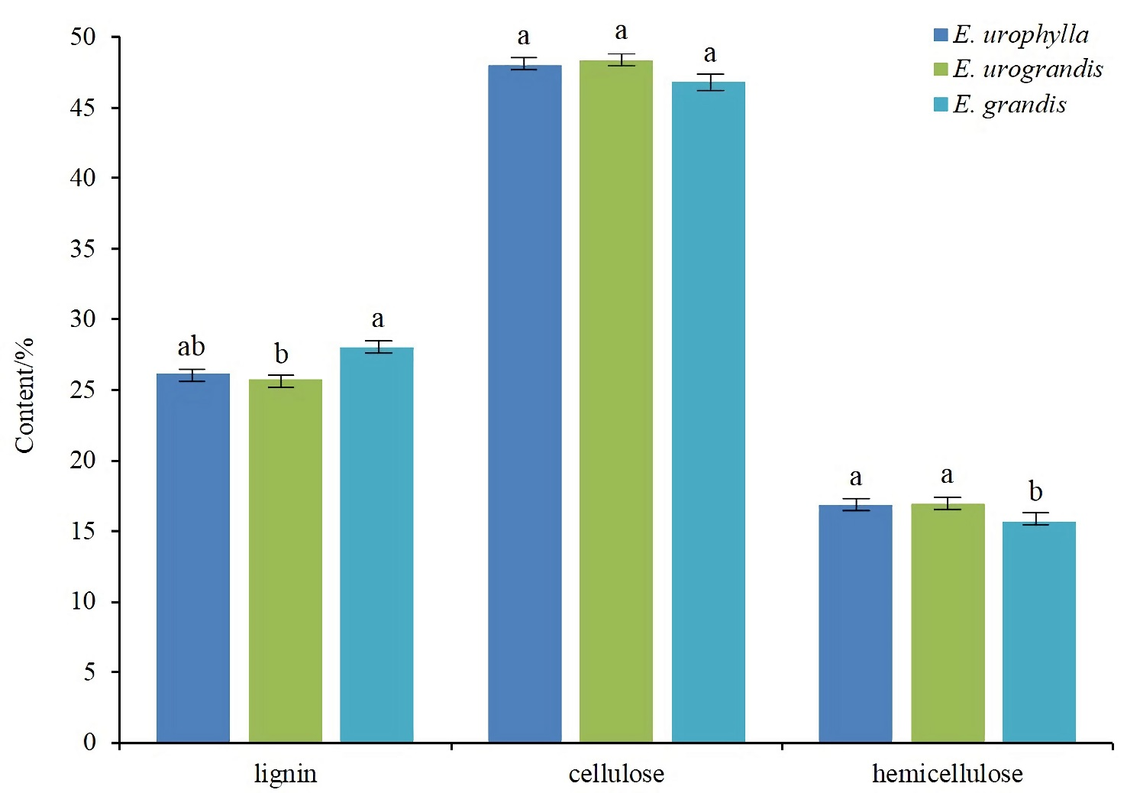
Fig. S5: The results of three major main wood chemical compositions components of in the immature xylem of E. urophylla, E. urograndis and E. grandis. The same letters in the figure indicate no significant difference, and the different letters indicate significant differences. The date was subjected to the method of multiple comparison of LSD. Error bars indicate standard error derived from three replicates.

